[1] "Data description:"

[1] "animeID - id of the anime"

[1] "name - name of the anime"

[1] "title_english - english title"

[1] "title_japanese - japanese title"

[1] "title_synonysm - alternate titles in english"

[1] "type - type of the anime (e.g. TV, Movie, OVA, ONA)"

[1] "source - source of the anime (e.g. original, manga, ranobe)"

[1] "producers - production studio(s)"

[1] "genre - genre"

[1] "studio - executive studio(s)"

[1] "episodes - number of episodes"

[1] "status - status of the show (airing, finished, on pause"

[1] "airing - boolean of the airing"

[1] "start_date - date when the airing started"

[1] "end_date - date when the airing finished"

[1] "duration - duration of the anime"

[1] "ratint - age rating of the show"

[1] "score - score of the show"

[1] "scored_by - number of people who voted"

[1] "rank - overall rank of the show"

[1] "popularity - popularity index of the show"

[1] "members - those who added the show to 'watched' list"

[1] "favorites - those who added the show to 'favorites' list"

[1] "synopsis - synopsis of the show"

[1] "background - background of the show"

[1] "premiered - date of the premiere"

[1] "broadcast - days of the broadcast"

[1] "related - related shows"

[1] "Data tyding:"

[1] "Removing unneccessary data"

[1] "Removing duplicates (they exist, because anime categorized by genres, and it can have multiple)"

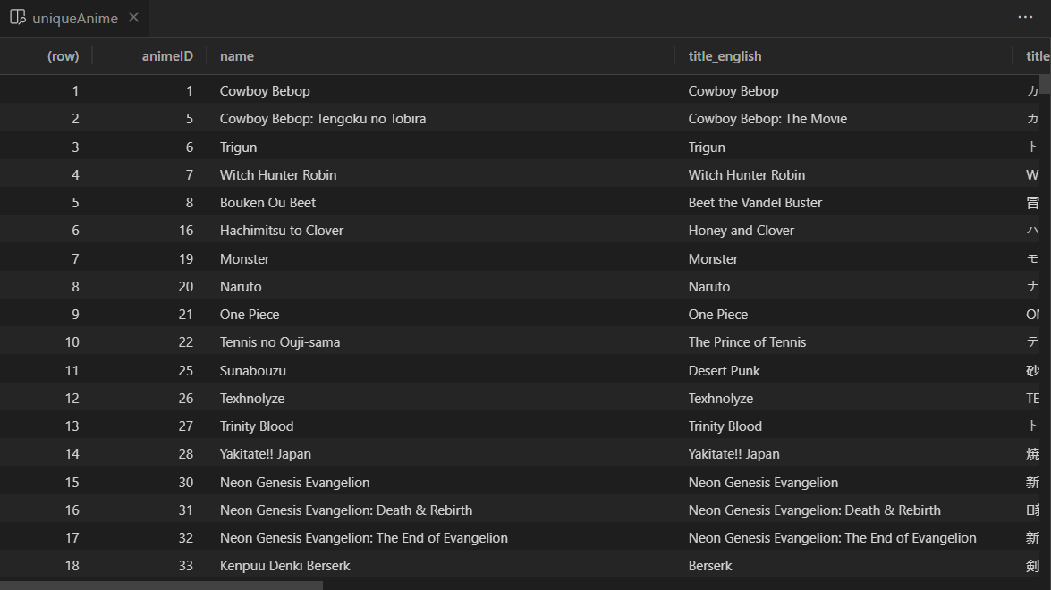

[1] "Let's select only shows with type 'TV'"

[1] "Data visualisation:"

[1] "Most popular shows"

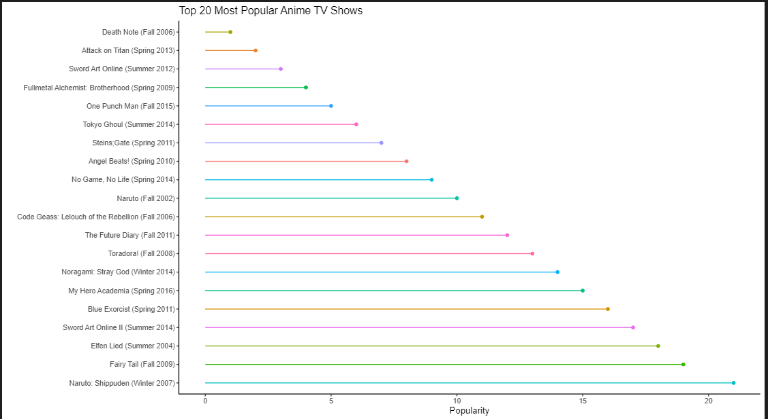

[1] "Most popular shows which are currently airing"

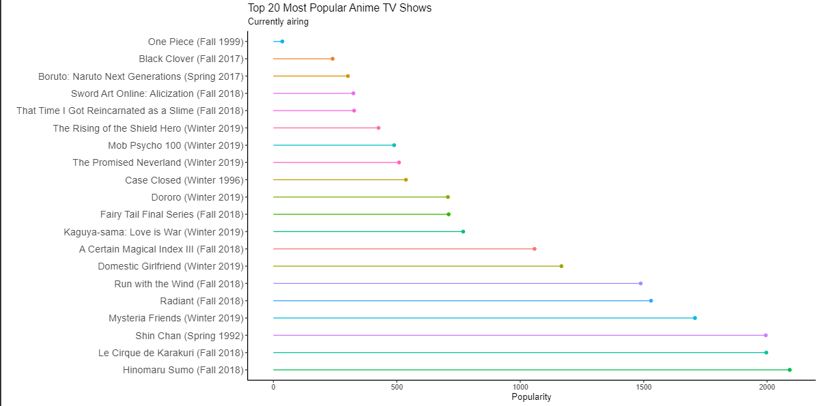

[1] "It seems, dataset is pretty old, because the latest anime is for 2019"

[1] "Correlation between the number of views and highest score of popular shows"

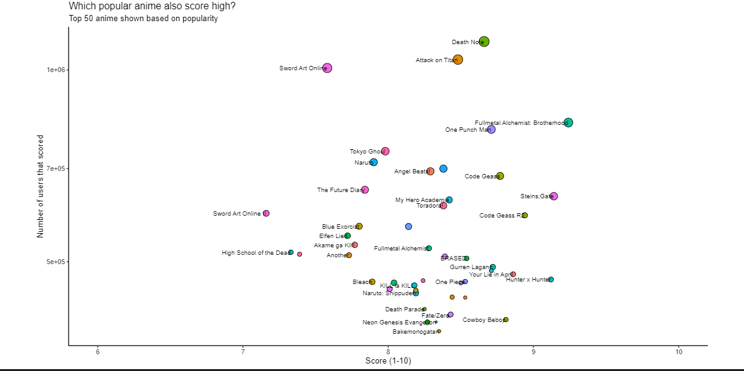

[1] "Comparison of twenty most favorite vs most members vs most scored"

