[1] "1. Merges the training and the test sets to create one data set."

Start

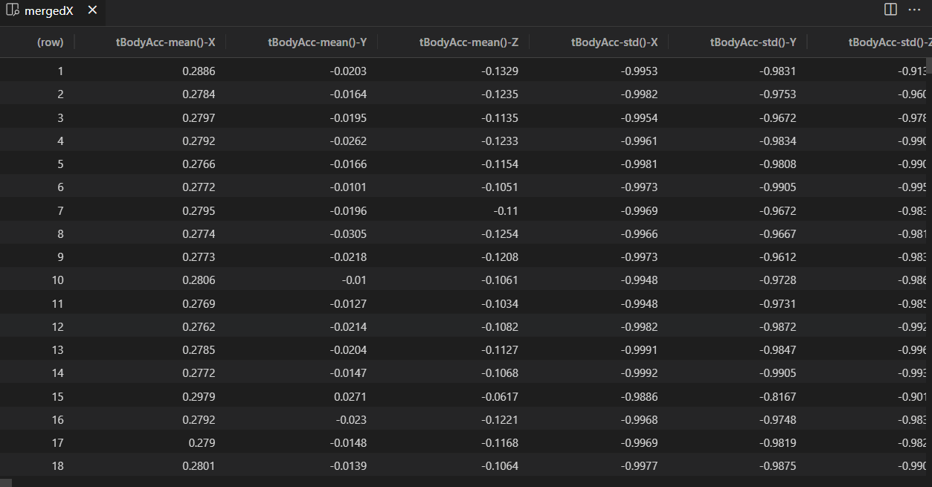

End

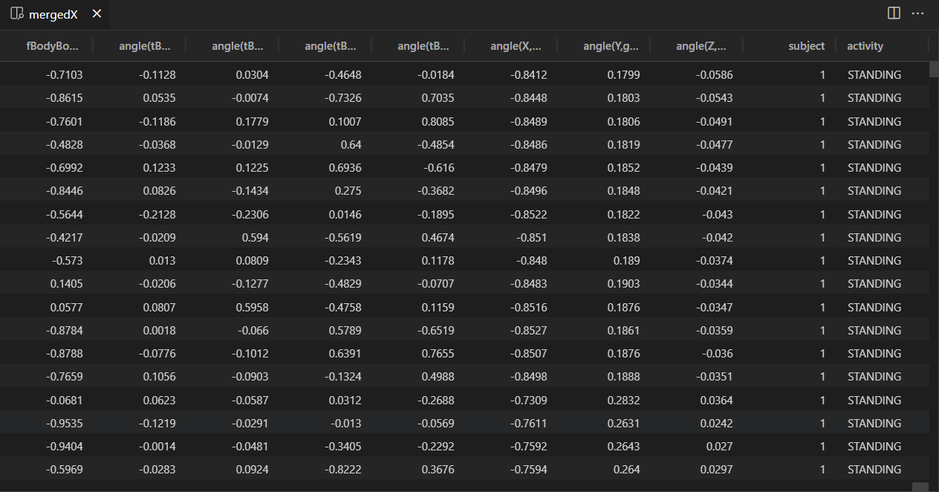

[1] "2. Extracts only the measurements on the mean and standard deviation for each measurement."

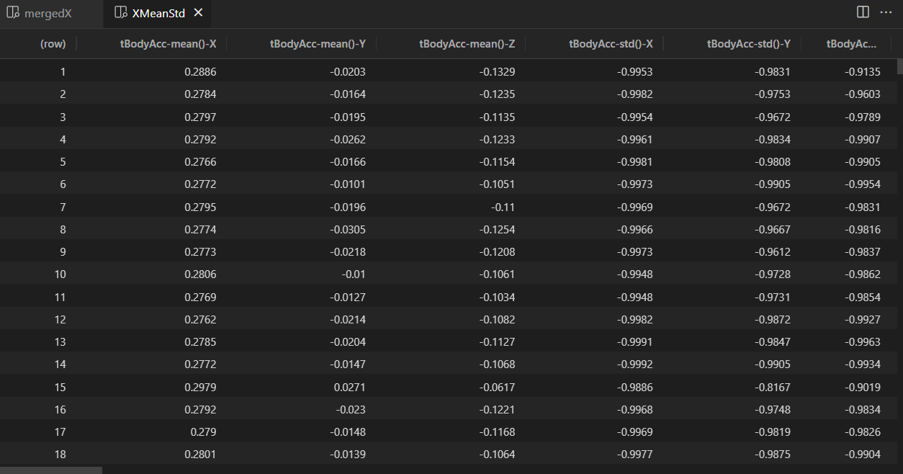

[1] "3. Uses descriptive activity names to name the activities in the data set."

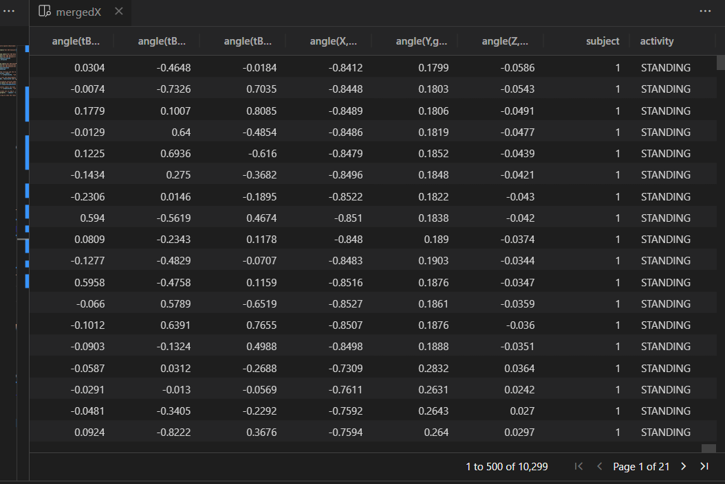

[1] "4. Appropriately labels the data set with descriptive variable names."



[1] "5. From the data set in step 4, creates a second, independent tidy data set with the average of each variable for each activity and each subject."

