Website Engagement Health Check

This report presents a data-driven check on a website’s interaction with its visitors. The objective is to assess the health of the funnel.

# My Approach

I run and combined the following:

* Dataset Merging
* Data Modelling
* Funnel Analysis
* Trend Analysis
* Comparative Analysis
* Insights & Recommendations

# My Tools

* **Excel:** For initial data exploration
* **SQL/MS SQL SERVER:** There were 4 original datasets. Each dataset contained data from a stage of the funnel and a separate dataset of the users. In order to make my life easier, I combined (unionized) all of stage files into a single dataset since they shared a common structure. Later in Tableau, I created a data model relating the unionized dataset with the users.
* **Tableau:** Used for data extraction, data modelling, data visualization, data analysis, finding insights and building recommendations.
* **AI:** Used for refining this report and correcting any spelling/syntax mistakes.

# The Deliverables

* A written report of the analysis visualizations, findings and recommendations.
* A non-interactive dashboard (preferably in Tableau) for (near) real-time decision making.

# Executive Summary

**This is not a traffic problem.** **It's a conversion efficiency problem**. Fixing it could unlock revenue gains, without spending a euro on more visitors.

## Final Recommendations

* **Investigate & Fix Checkout and Payment Page Friction**
* Audit the payment flow UX, loading times, and fields.
* Test error rates in payment success logs.
* Reduce friction with: Fewer input fields, visible trust/security indicators, mobile wallet support (especially on desktop).
* **Run a Root-Cause Analysis on the March Incident**
* Review logs, broken links, tracking errors, or A/B tests between Feb 28-Mar 3.
* Prioritize restoring any broken internal linkages or broken CTAs.
* **Implement Mobile Experience Learnings to Desktop**
* Mobile converts 4x better. Examine why.
* Port design decisions (button size, trust placement, simplified layout) to desktop.
* **Launch Segment-Specific UX Improvements**
* Run gender and device session recordings.
* A/B test product sort order, CTA language, and page layout based on segment insights.
* **Set New Conversion Targets**
* Set more aggressive targets site-wide final conversion.
* Segment retention and re-marketing efforts based on page exit points.

# Analysis #1: Conversion Rates

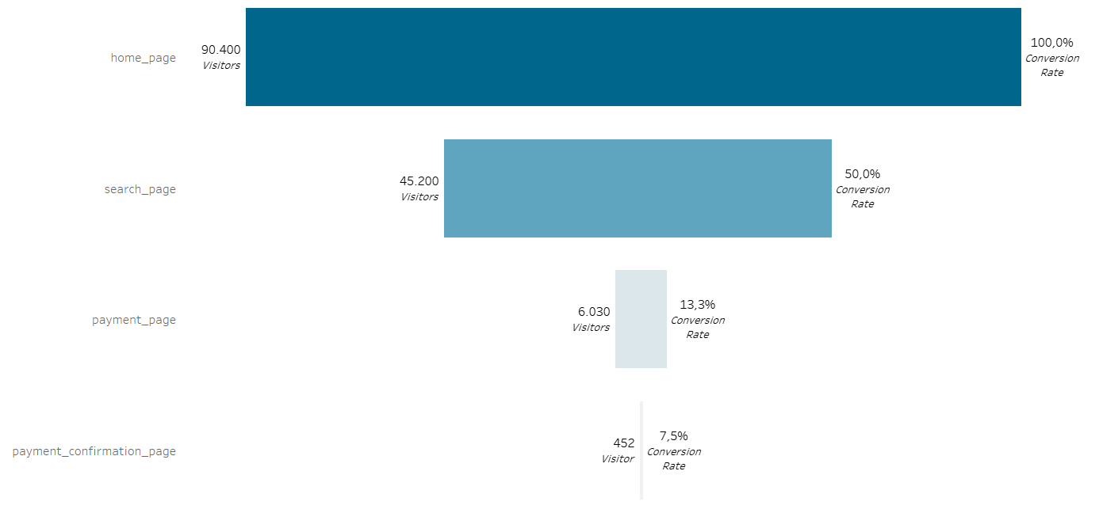

## Insights

* While the website begins with 90,400 visitors on the home_page, only 452 reach the payment_confirmation_page, indicating a final conversion rate of just 0.5%.
* Major friction begins after search_page where only 13.3% proceed to the payment page.
* Major issue in payment completion: A drastic 92.5% drop-off occurs between payment page and payment confirmation, likely during or right before checkout.

## Recommendations

* Prioritize investigating the checkout process.

# Analysis #2: Drop-off Rates

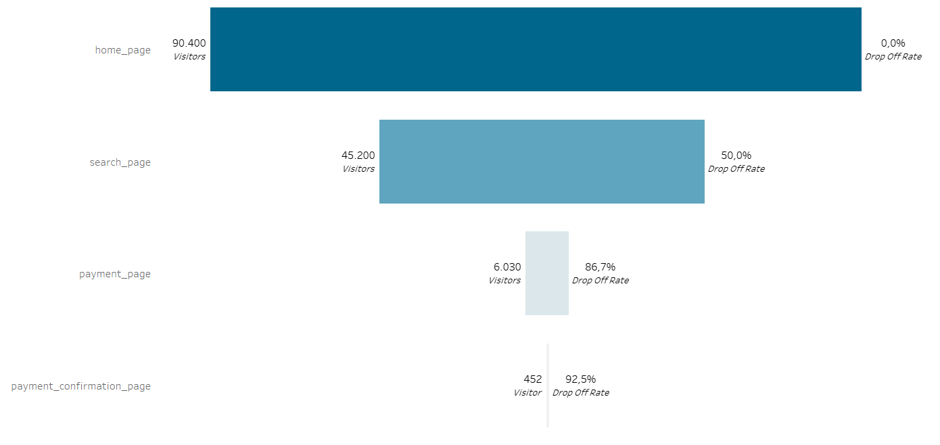

## Insights

The most severe drop-offs happen at the bottom of the funnel, particularly:

* From search to payment page: 86.7% drop suggests users are not sufficiently motivated or able to proceed to checkout.
* From payment to confirmation: 92.5% drop indicates serious friction during or right after the payment process.

## Recommendations

* Optimize Search to Payment Flow:
* Improve product clarity, calls to action, and page load speed.
* Offer promotions or urgency signals.
* Fix Payment Page Issues:
* Audit UX and loading times.
* Reduce form fields and distractions.
* Highlight security badges and guarantees.
* Test payment methods (errors? failures? abandoned carts?).
* Run Drop-off Surveys:
* Identify real user objections at the payment step.

# Analysis #3: Daily Traffic & Volatility Trends for home_page

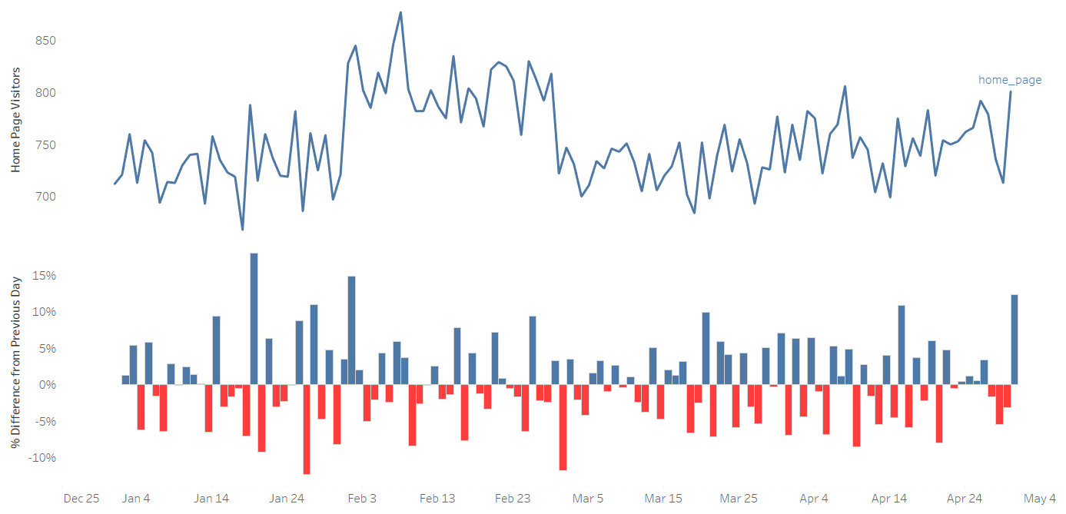

## Insights

* Overall Traffic is Stable with Periods of Volatility
* The homepage receives consistently between ~700 to 850 visitors/day.
* A visible traffic peak occurred in late January, with the highest spike above 850.
* After early March, traffic becomes more stable but slightly declines before recovering by early May.
* High Volatility in Daily % Changes
* Frequent swings of ±5–15%, especially:
* Positive spikes around Jan 23, Feb 2, and Apr 15.
* Negative drops around Jan 25, Feb 6, Mar 4, and Apr 9 (some nearing -10%).
* These patterns suggest possible external influences (e.g., campaigns, email pushes, outages, holidays).
* Recent Surge
* May 4 shows a significant positive spike (~12–15%) in homepage visits, potentially a new campaign, feature launch, or media mention.

## Recommendations

* Correlate Spikes & Drops with Campaigns or Events
* Map traffic anomalies to email, social media, SEO changes, or tech issues.
* Stabilize Traffic Drivers
* If traffic is driven by bursts (e.g., newsletters), consider a more even-paced approach.
* Investigate May 4 Surge
* If it's due to an experiment or campaign, consider replicating it.

# Analysis #4: Daily Traffic Trends for other pages

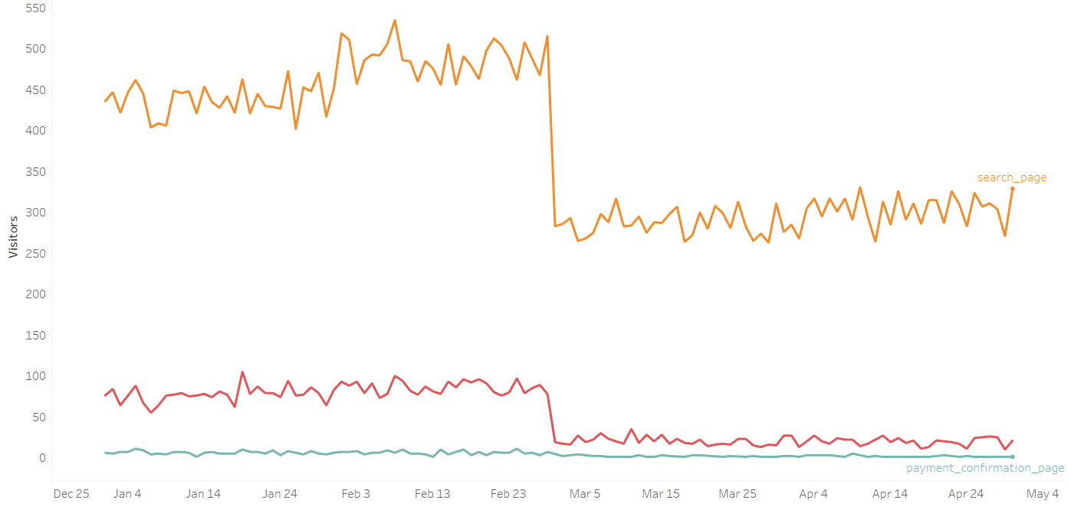

## Insights

* Sharp Drop Across All Stages Around Late February / Early March
* The search page dropped from ~500 visitors/day to ~280, a ~44% drop.
* The payment page dropped from ~90/day to ~25, a ~72% drop.
* The payment confirmation page remained consistently low, but shows a minor dip post-March as well.

## Recommendations

* Investigate Changes Around Feb 28 – Mar 2
* Logs, A/B tests.
* Internal linking from homepage to search page.
* Compare with home_page Trend
* Since home_page traffic is steady, the issue is within site navigation or functionality.
* Run Funnel Diagnostics
* Set up session recordings for early March onward.
* Check for code errors, broken CTAs, or load issues.

# Analysis #5: Comparative Funnel for Desktop Visitors

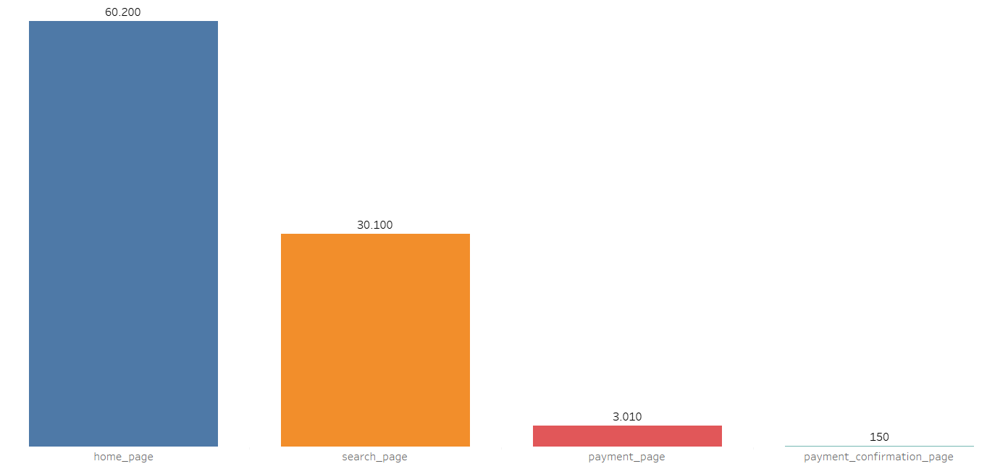

## Insights

* Only 0.25% of desktop homepage visitors (150 of 60,200) complete the payment process.
* The worst drop-offs occur at:
* Search to payment page (90% loss): Indicates major friction in product selection or purchase initiation.
* Payment to confirmation page (95% loss): Suggests critical failure at the checkout stage.

## Recommendations

* Run a UX audit for desktop checkout:
* Button placements, page responsiveness, form errors.
* Test payment functionality on desktop browsers:
* Cross-browser testing (Chrome, Firefox, Edge, Safari).
* Review analytics for exit points on payment page:
* Where exactly do users abandon?

# Analysis #6: Comparative Funnel for Mobile Visitors

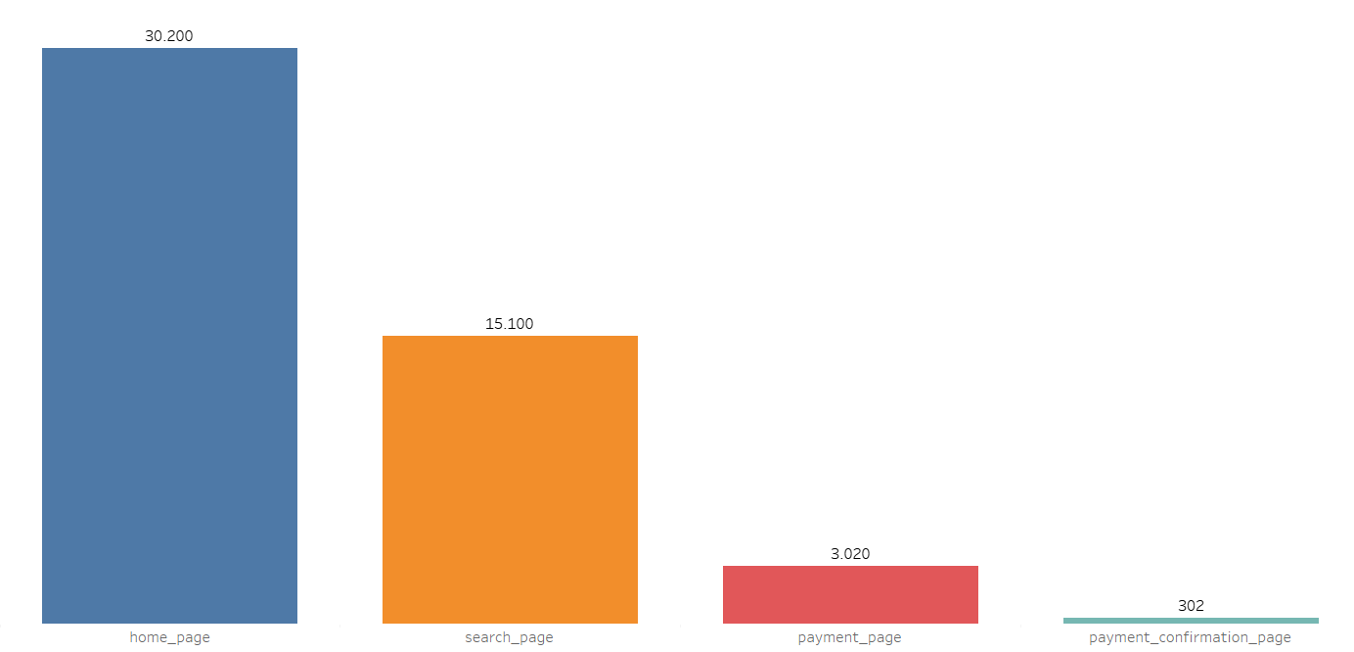

## Insights

* Despite fewer total visitors than desktop, mobile users convert more efficiently, especially at the final stage.

## Recommendations

* Investigate why mobile converts better:
* Is mobile checkout more streamlined?
* Are payment options better optimized for mobile wallets (e.g., Apple Pay, Google Pay)?
* Replicate effective mobile elements on desktop:
* Button placement, fewer distractions, intuitive navigation.
* A/B test simplified checkout flows on desktop, inspired by mobile UX.

# Analysis #7: Comparative Funnel for Male Visitors

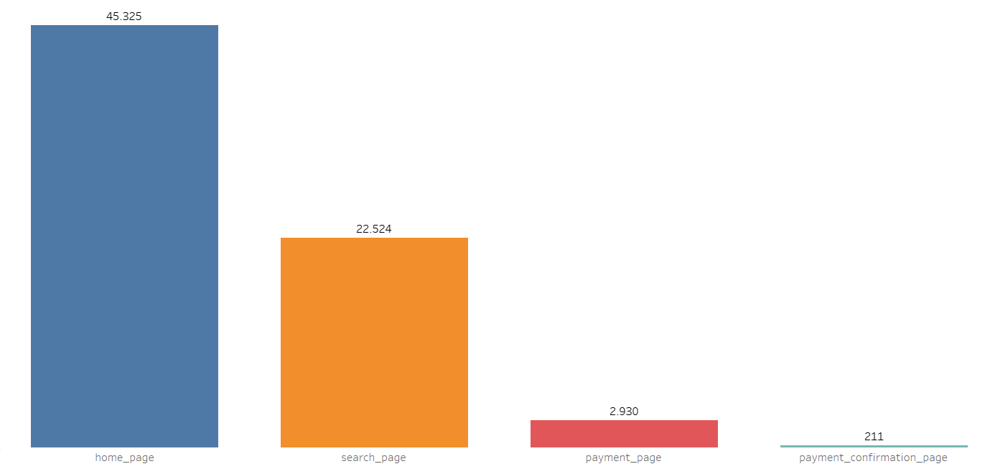

## Insights

Although males represent a substantial share of traffic (45K home page visitors), their conversion efficiency is very poor, particularly in the final stages:

* Only 0.47% of male visitors complete a purchase (211 out of 45,325).
* There is steep attrition at every step, especially:
* From search to payment page (–87%)
* From payment to confirmation (–92.8%)

## Recommendations

* Conduct UX research on male behavior:
* Use session recordings segmented by gender.
* Run male-targeted A/B tests:
* Try streamlined flows, different product defaults, or male-specific CTAs.
* Investigate mobile vs. desktop patterns for this segment.
* If male users skew toward desktop (which underperforms), optimize accordingly.

# Analysis #8: Comparative Funnel for Female Visitors

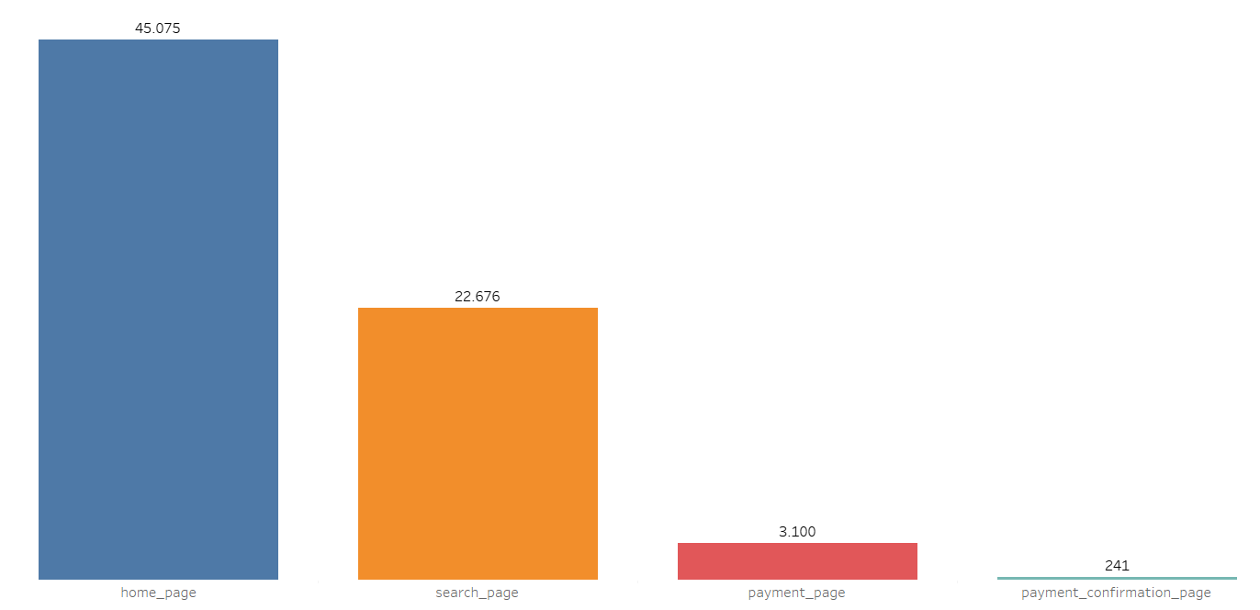

## Insights

Female visitors show slightly better conversion performance than male visitors at every step of the funnel.

* Final conversion rate (home to confirmation):
* Female: 0.53%
* Male: 0.47%
* Checkout stage (payment to confirmation):
* Female: 7.8%
* Male: 7.2%

## Recommendations

* Run qualitative research by gender:
* Why do females convert better? Could design, trust, or product relevance play a role?
* Analyze device behavior across genders:
* Female visitors may be skewed toward mobile, which converts better overall.
* Run gender A/B tests:
* Tailored messaging, layout changes, or trust-building elements.

# Conclusion

With a combination of UX optimization, technical audits, and segment-specific improvements, there’s a clear path to increase conversion rates, without increasing traffic spend.