1. **Introduction**

Problem: One of my cousins had migrated to Brisbane, Australia a few months back and he was residing in Teneriffe i.e. a suburb of Brisbane. He was thinking about starting a chain of Indian food restaurants in the suburbs which are like Teneriffe. So, I thought why not try to find some insights about the suburbs and venues in Brisbane. The following information could be of great help to him:

1. Which suburbs of Brisbane are like Teneriffe?
2. What are top 10 most common business in that neighbourhood? (His/her business might have more chances of flourishing in that region where there is no Indian Restaurant in the top 10 most common venues as there will be less competition)
3. **Data**

The following datasets will be required for this analysis:

1. List of Suburbs in Brisbane- It will be obtained from https://en.wikipedia.org/wiki/City_of_Brisbane
2. Longitudes and latitudes of the neighbourhoods- Will be extracted and joined to the neighbourhood data using geopy.geocoders library.
3. The types of Venues in each neighbourhood would be obtained through the Foursquare API.
4. **Methodology**
5. The list of Suburbs in Brisbane was taken from Wikipedia and compiled into a CSV file which was imported into a pandas dataframe.

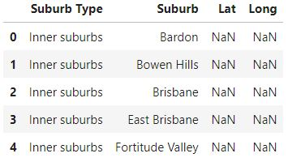

1. The Latitude and Longitude values of the Suburbs were obtained using the geopy.geocoders library and populated in the dataframe.

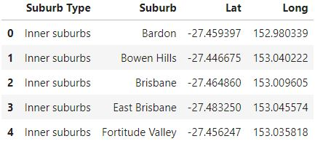

1. The Foursquare API was then used to identify around 100 venues in the 500 meters radius for each suburb.
2. The results obtained were then normalized by calculating the mean through the onehot encoding technique and top 10 most common venues were listed for each suburb.

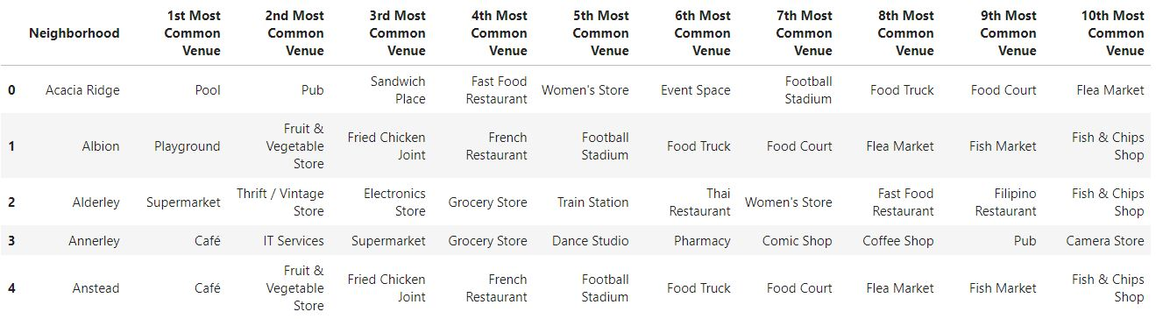

1. Using k-means clustering technique, each of the suburb were clustered and allotted a cluster number.

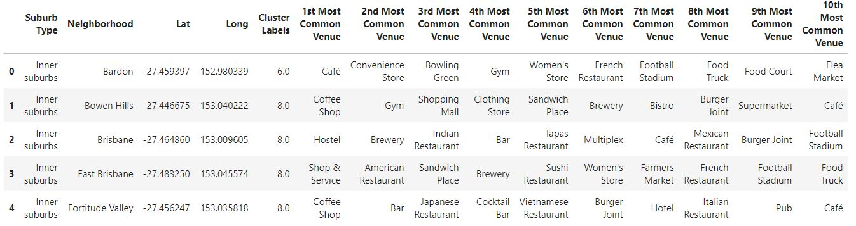

1. The clusters were then represented on the map.

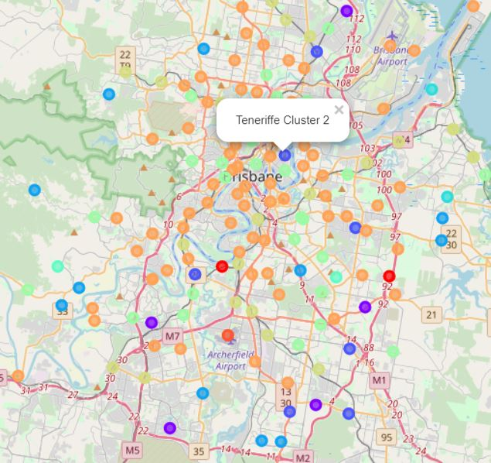

1. The cluster with suburbs like Teneriffe i.e. cluster 2 were then listed for reference regarding the top 10 venues in each of them.

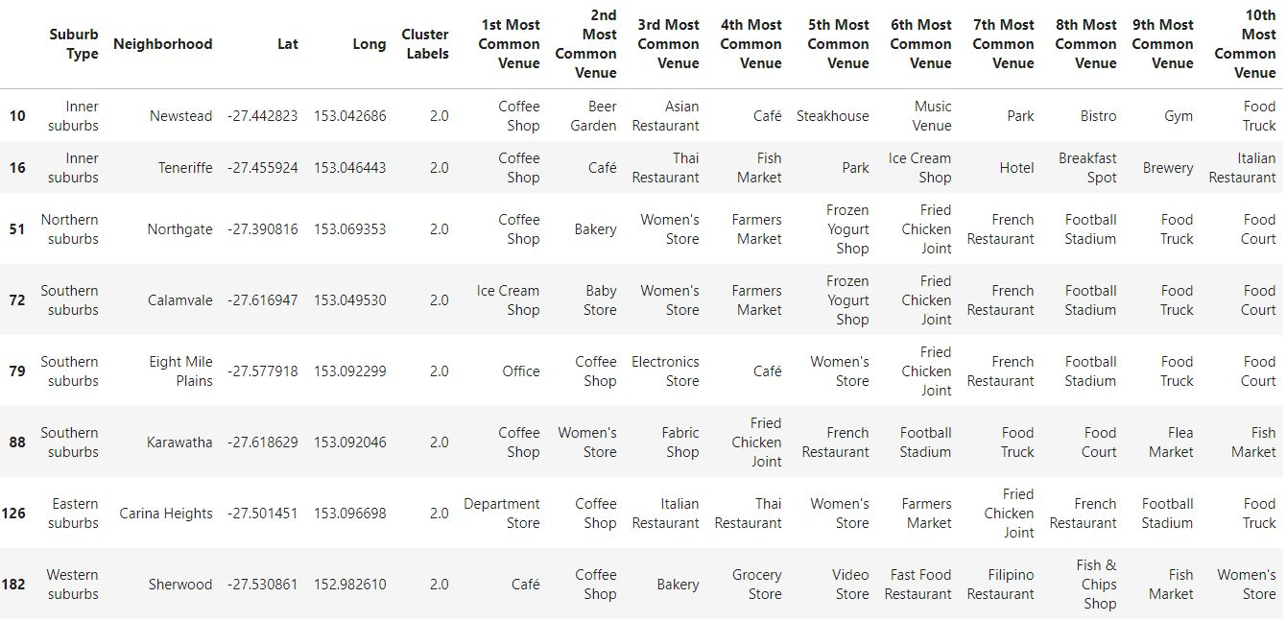

1. **Results**
2. **Clustered suburbs – The suburbs like Teneriffe have been highlighted.**



1. **Listing of suburbs belonging to the Teneriffe cluster with most common venues**

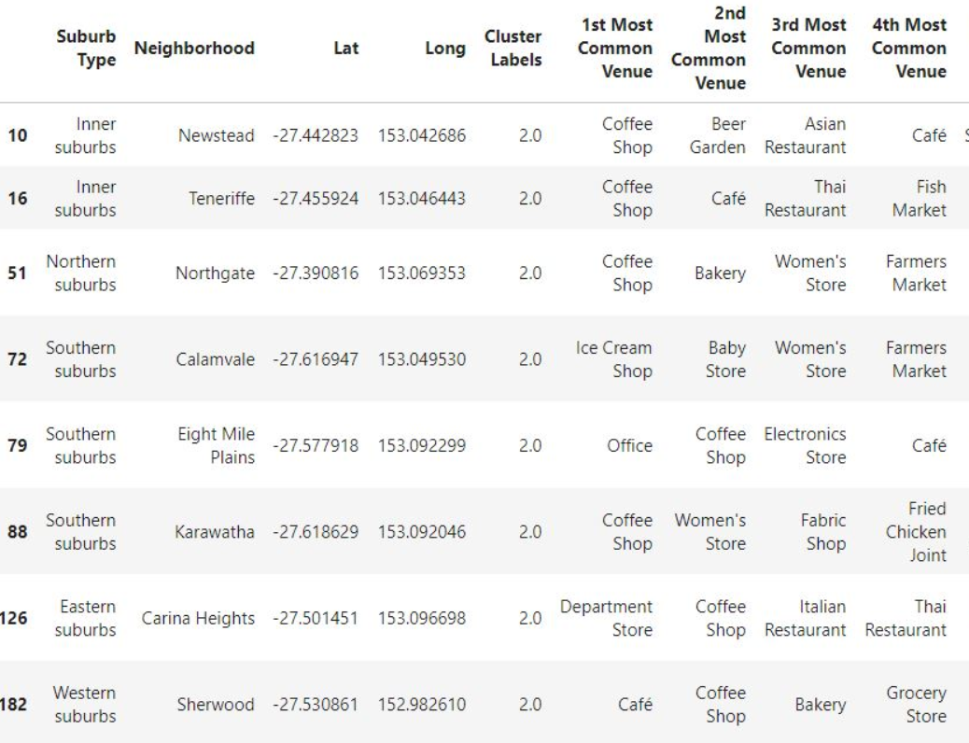

1. **Discussion**

In-case more information is available for the suburbs like population, %of immigrants/citizens etc, the clustering could be done according to them to get a richer more accurate result for this case.

1. **Conclusion**

The other suburbs like Teneriffe were plotted on the map form which they can be easily identified and locate the closer ones to Teneriffe.

None of them have an Indian restaurant in the top 10 common venues so they could be a good place to start one.