By:
Pavni Gupta

EC2 Automation with Lambda Deployment Report
This report documents the automation of EC2 instance start and stop scheduling using AWS Lambda and Amazon EventBridge Scheduler.

Project 4: EC2 Automation
Objective: Automate the starting and stopping of an EC2 instance on a schedule using AWS Lambda and Amazon EventBridge Scheduler, reducing manual effort and avoiding unnecessary running costs outside working hours.

IAM Role Configuration
Created an IAM role for the Lambda functions with Lambda selected as the trusted service, then attached the AmazonEC2FullAccess and AWSLambdaBasicExecutionRole permissions policies to allow the functions to manage EC2 instances and write logs to CloudWatch.
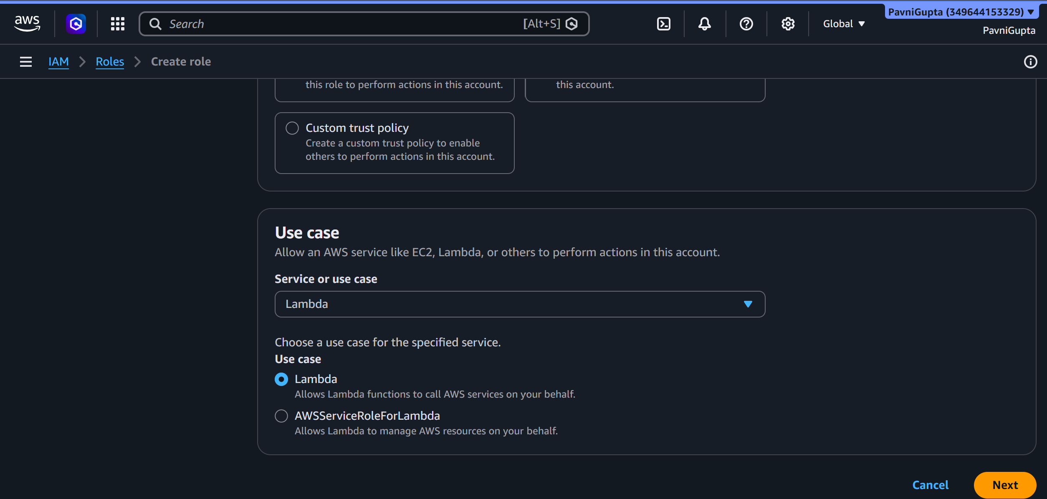
Fig 1: Creating an IAM role with Lambda selected as the use case
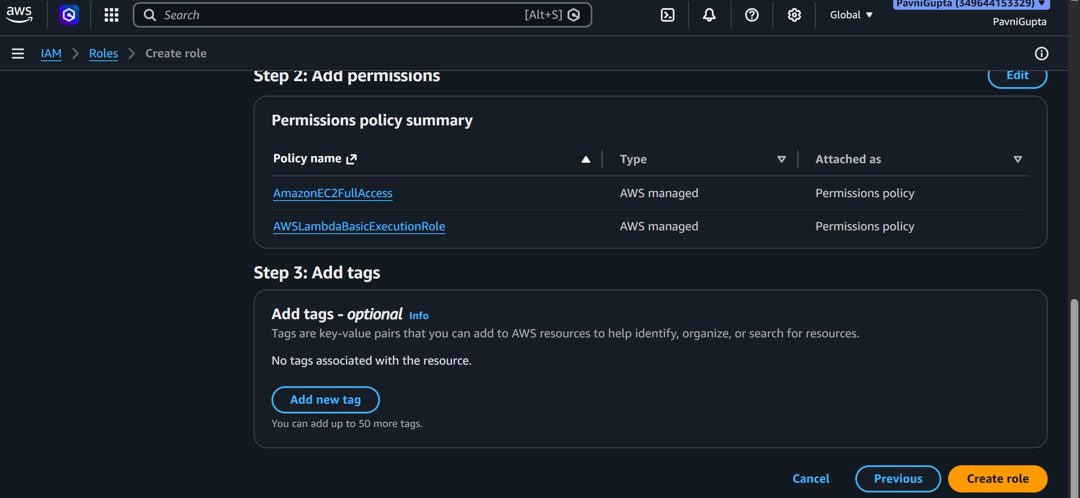
Fig 2: Permissions policy summary showing AmazonEC2FullAccess and AWSLambdaBasicExecutionRole attached to the role

Lambda Functions for Start and Stop
Created Lambda functions to start and stop the EC2 instance programmatically using the boto3 SDK, and attached the AmazonEC2FullAccess policy to the function\'s execution role.
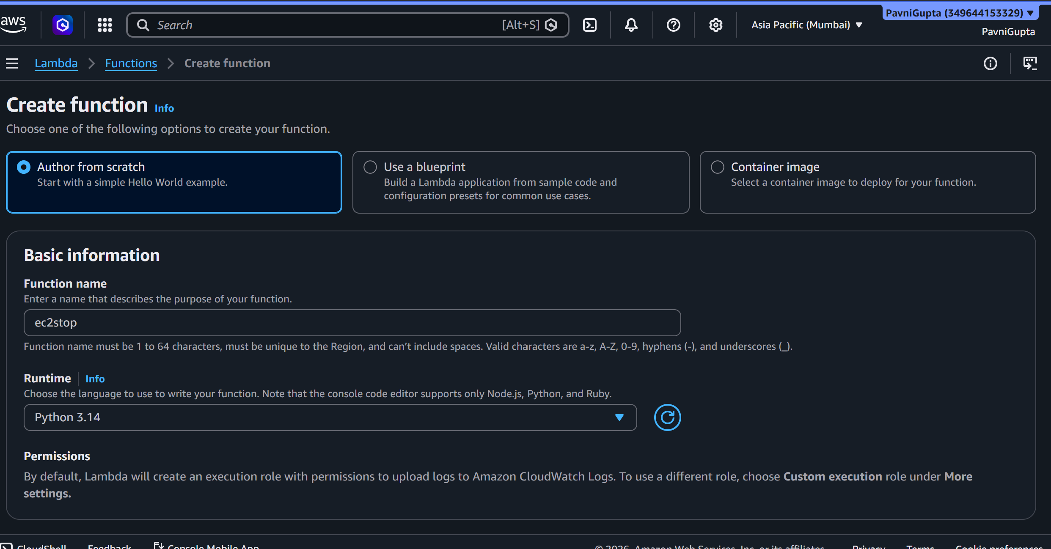
Fig 3: Creating the ec2stop Lambda function with Python runtime
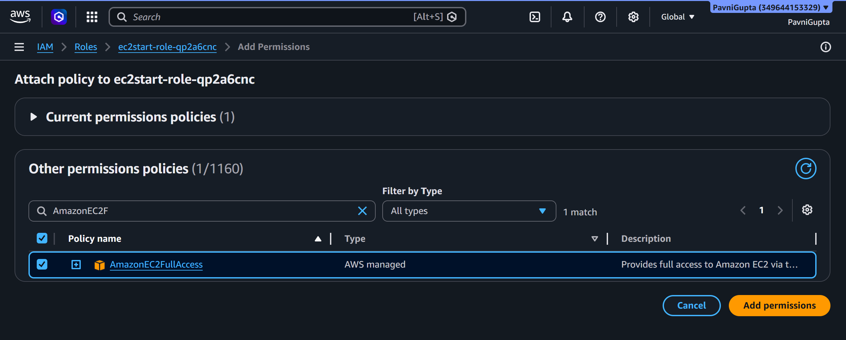
Fig 4: Attaching the AmazonEC2FullAccess policy to the ec2start function\'s execution role
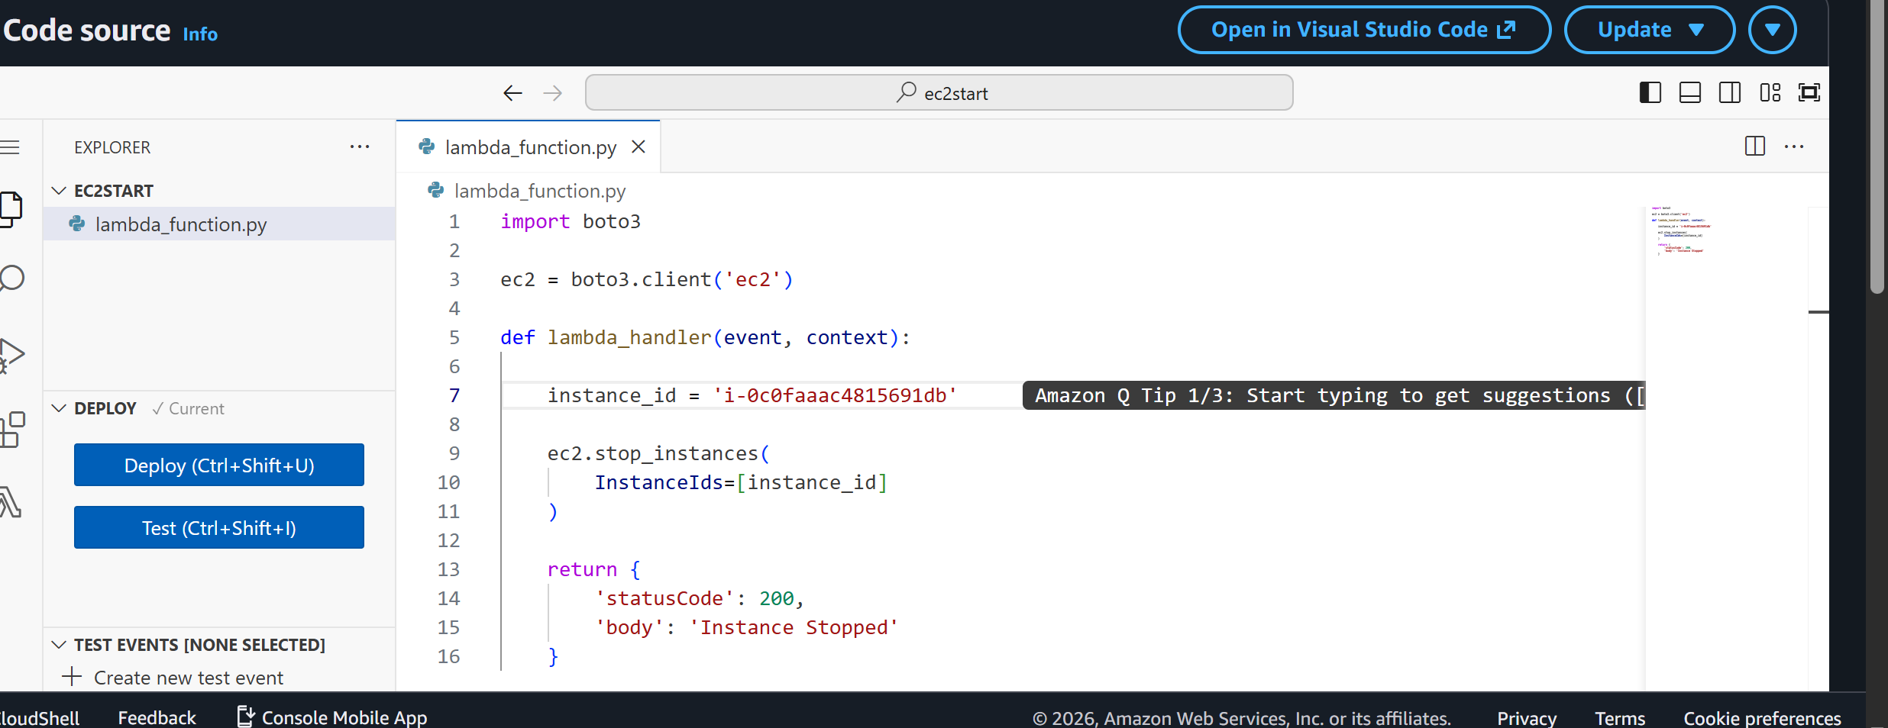
Fig 5: Lambda function code using boto3 to stop the EC2 instance
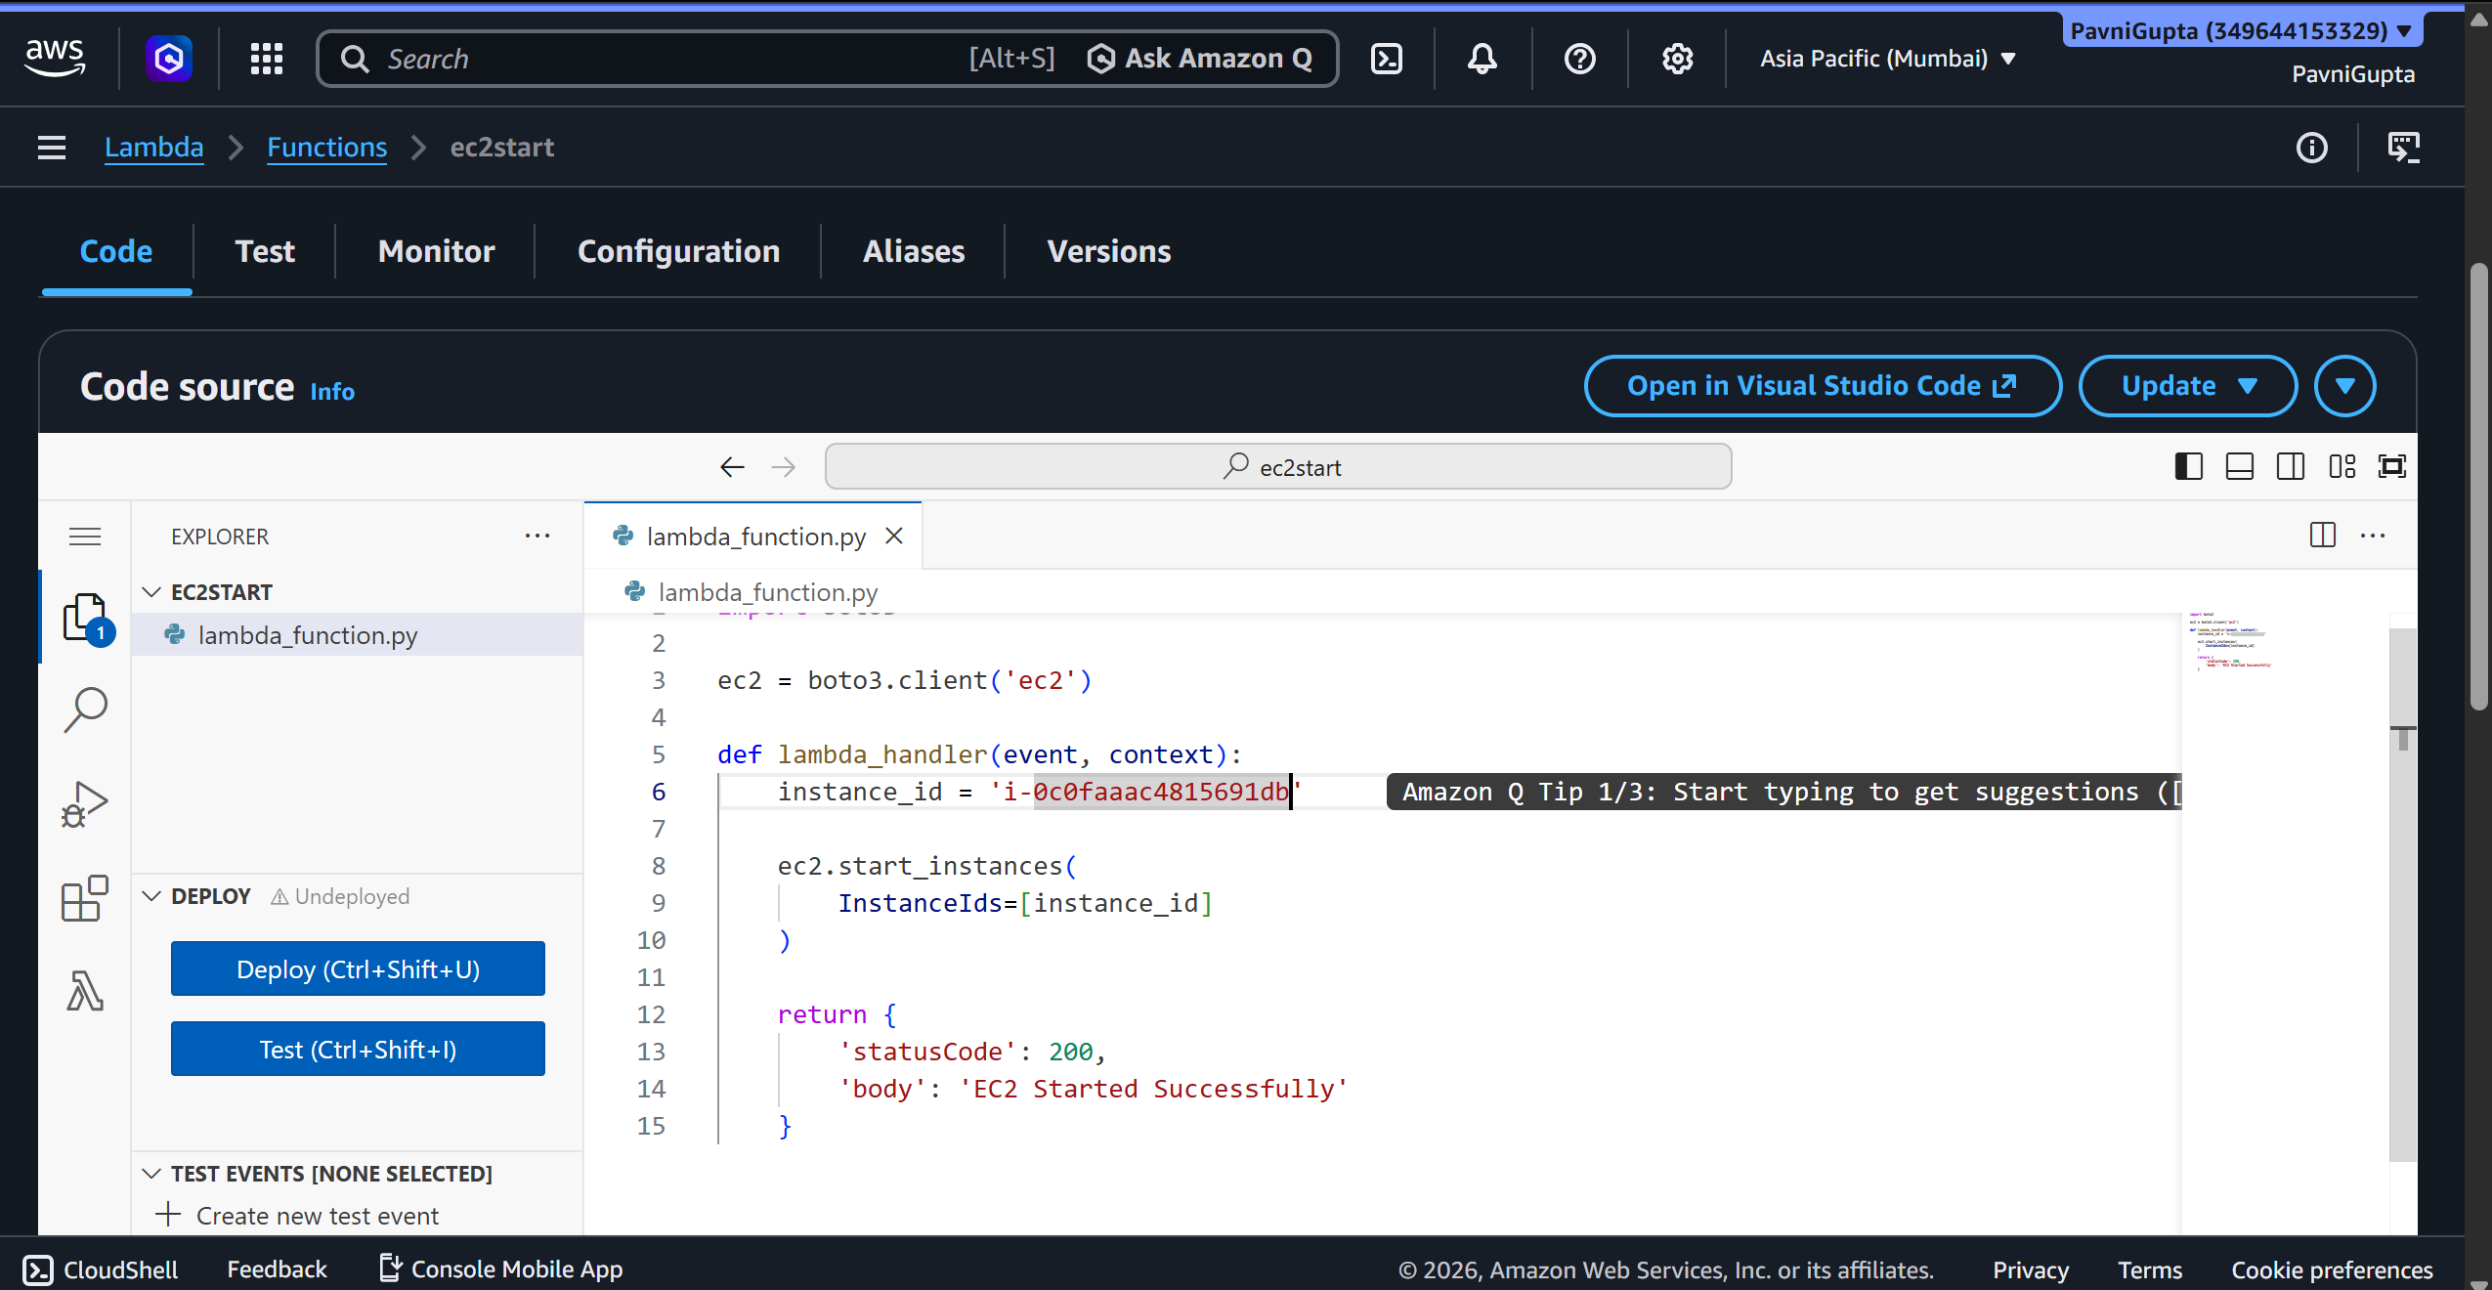
Fig 6: Lambda function code using boto3 to start the EC2 instance
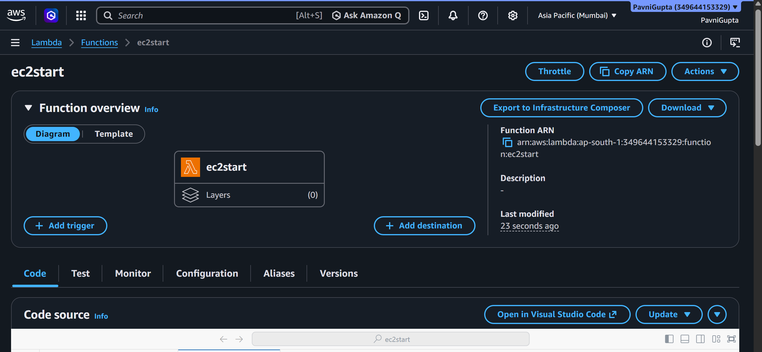
Fig 7: Function overview diagram for the ec2start Lambda function

Testing the Lambda Functions
Tested the Lambda function manually from the console and confirmed successful execution, with the EC2 instance started as expected.
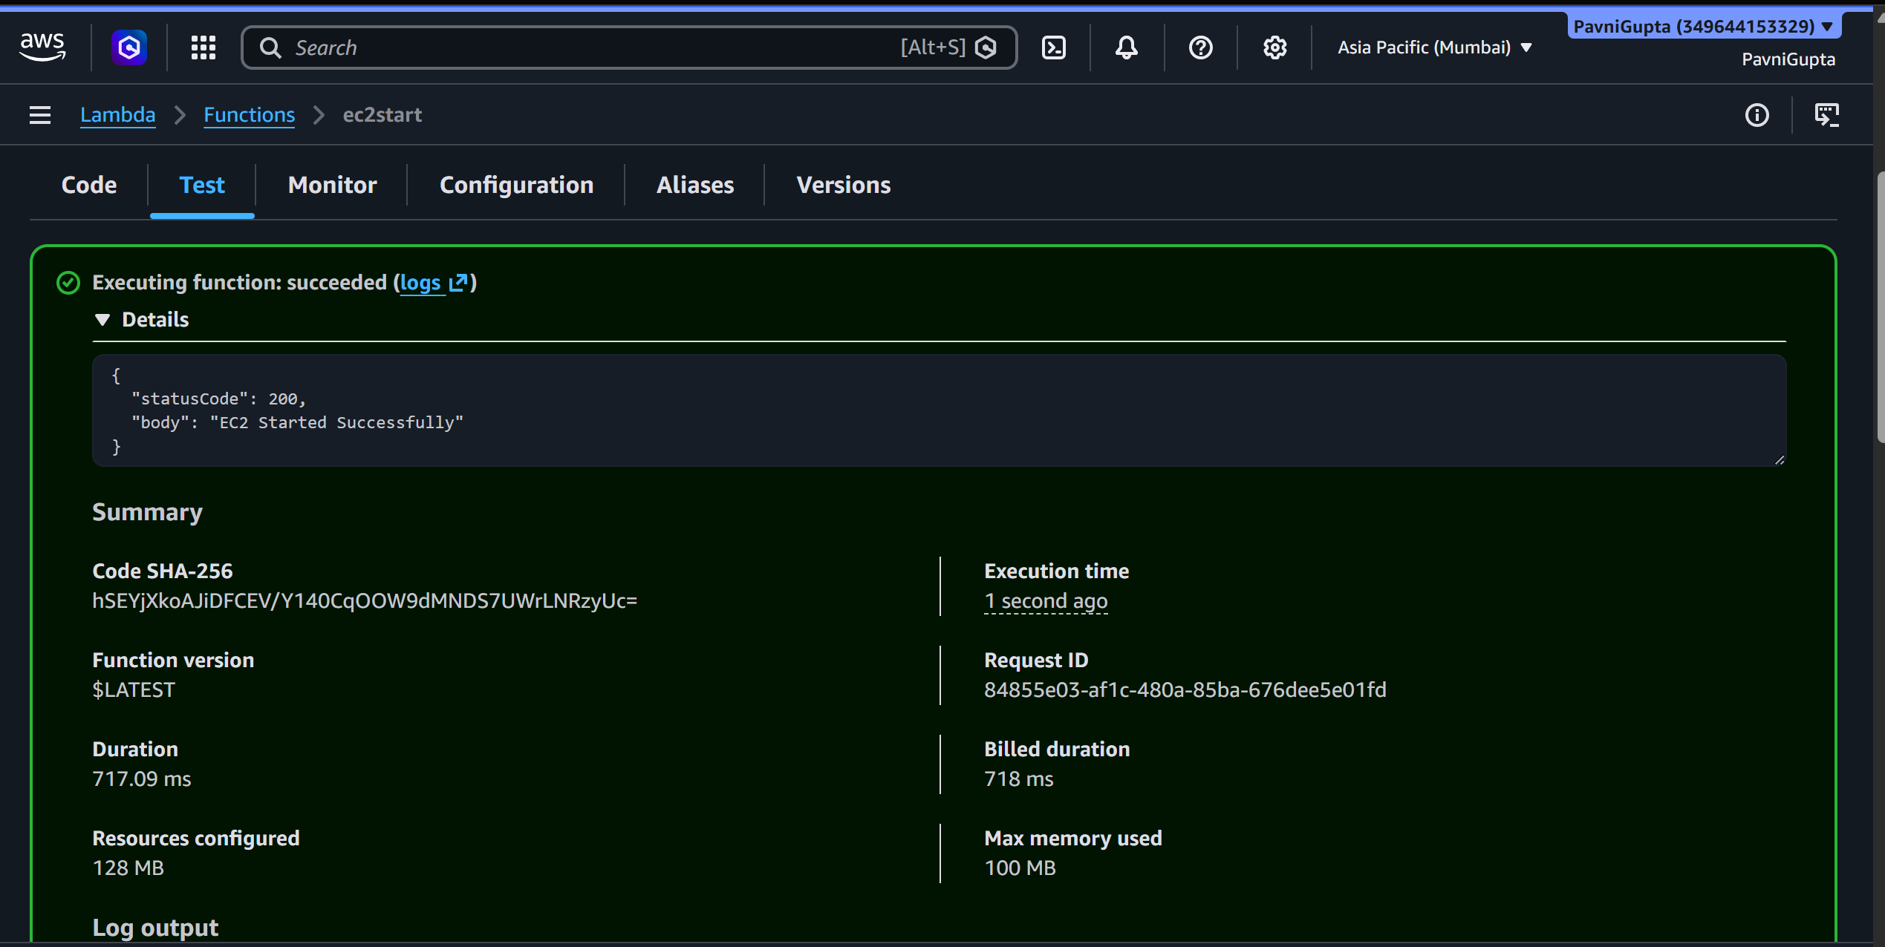
Fig 8: Lambda test execution succeeded with response confirming the EC2 instance was started

EventBridge Scheduler Configuration
Configured Amazon EventBridge Scheduler to invoke the Lambda functions automatically on a recurring basis using cron expressions, defining the target action and the schedule\'s timing.
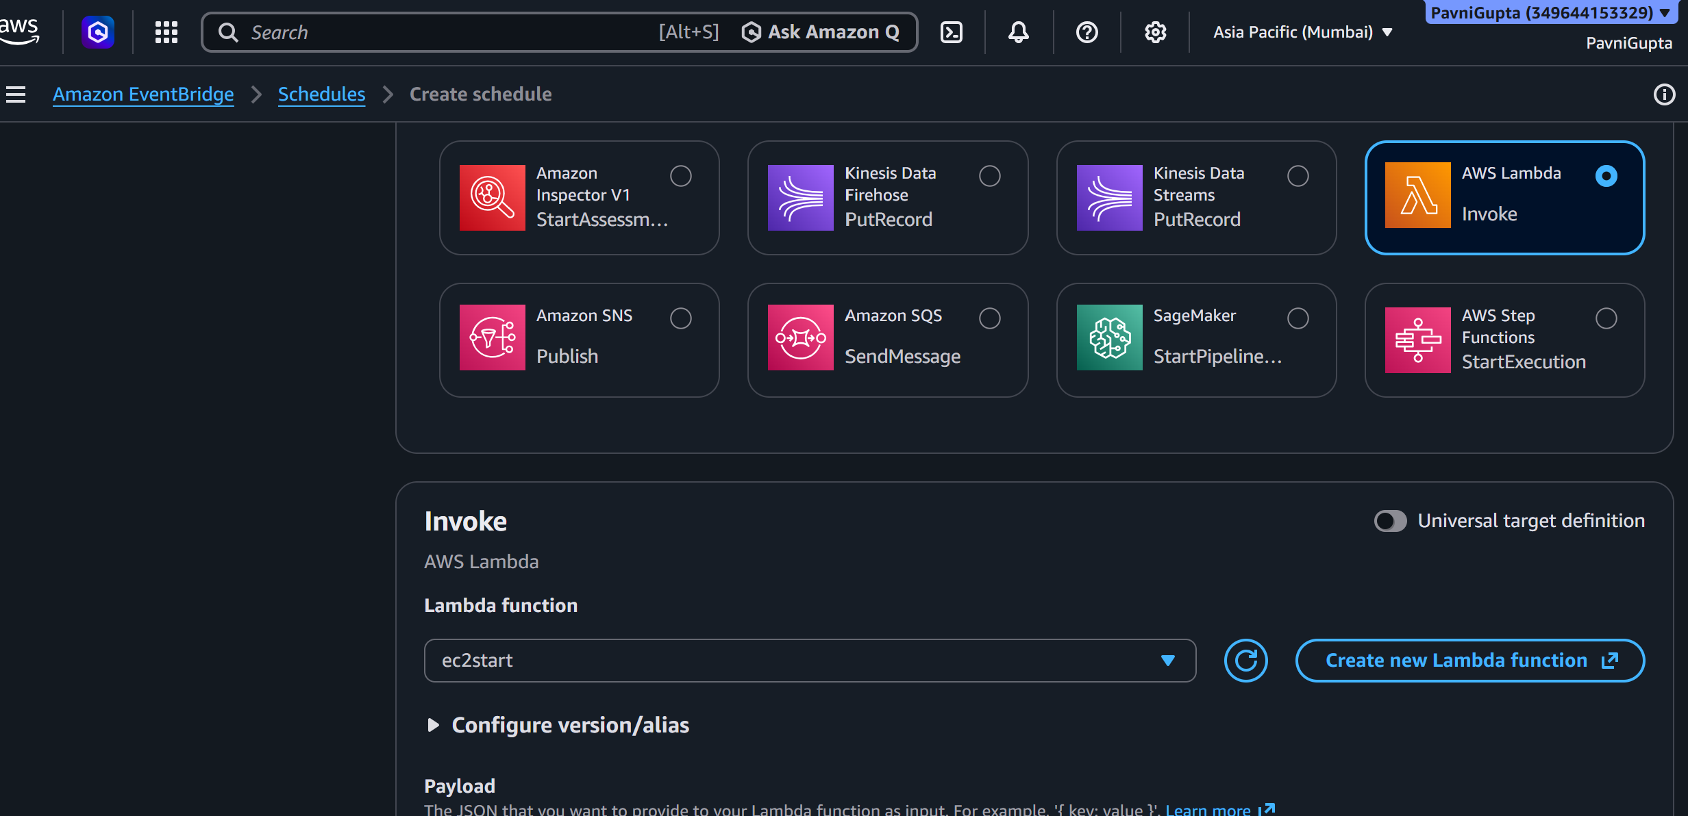
Fig 9: Creating a schedule with AWS Lambda Invoke selected as the target, pointing to the ec2start function
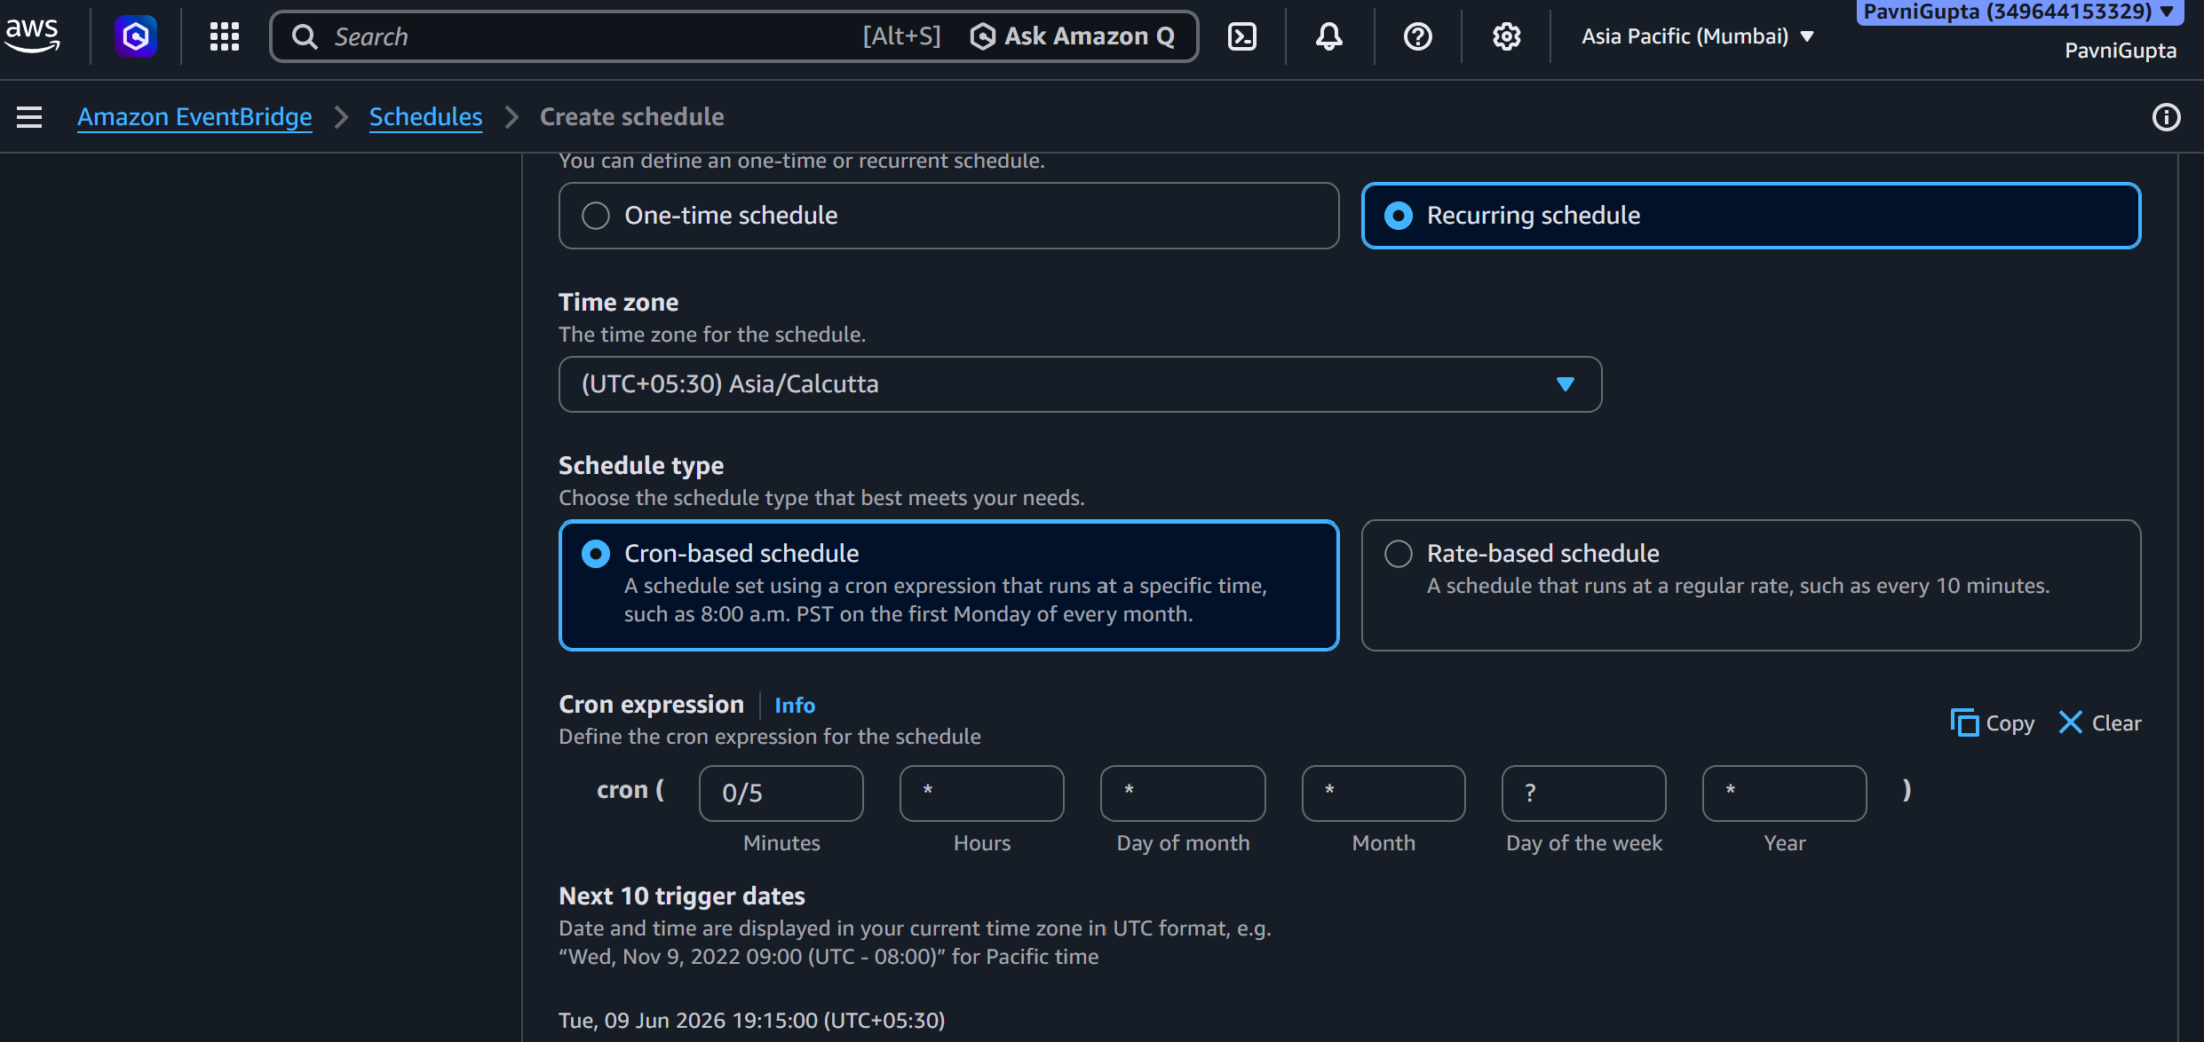
Fig 10: Configuring a recurring, cron-based schedule with the execution time zone and next trigger dates
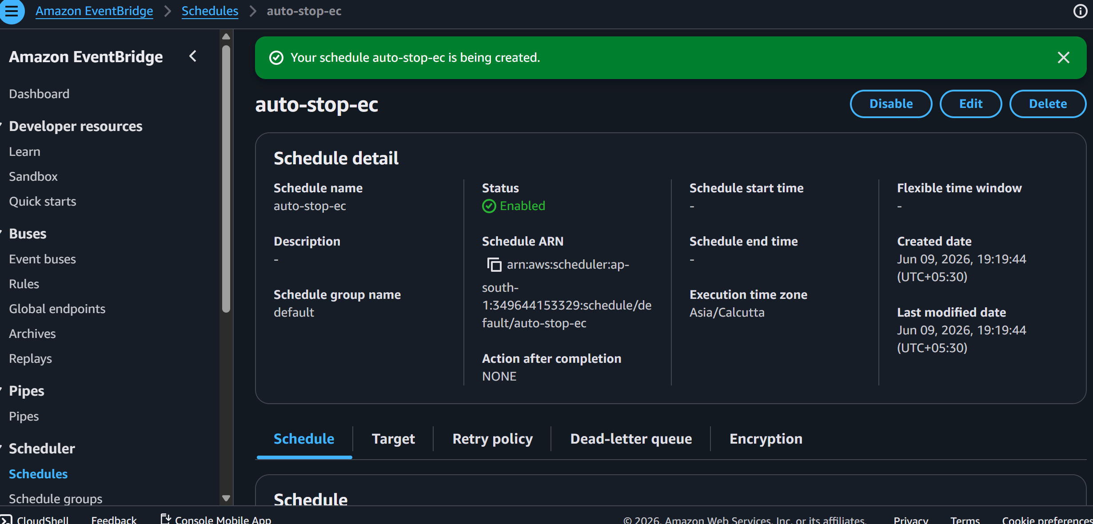
Fig 11: Schedule \'auto-stop-ec\' successfully created and enabled in EventBridge Scheduler

Verification
Verified the automation end-to-end by confirming the EC2 instance transitioned between stopped and running states in line with the configured schedules.
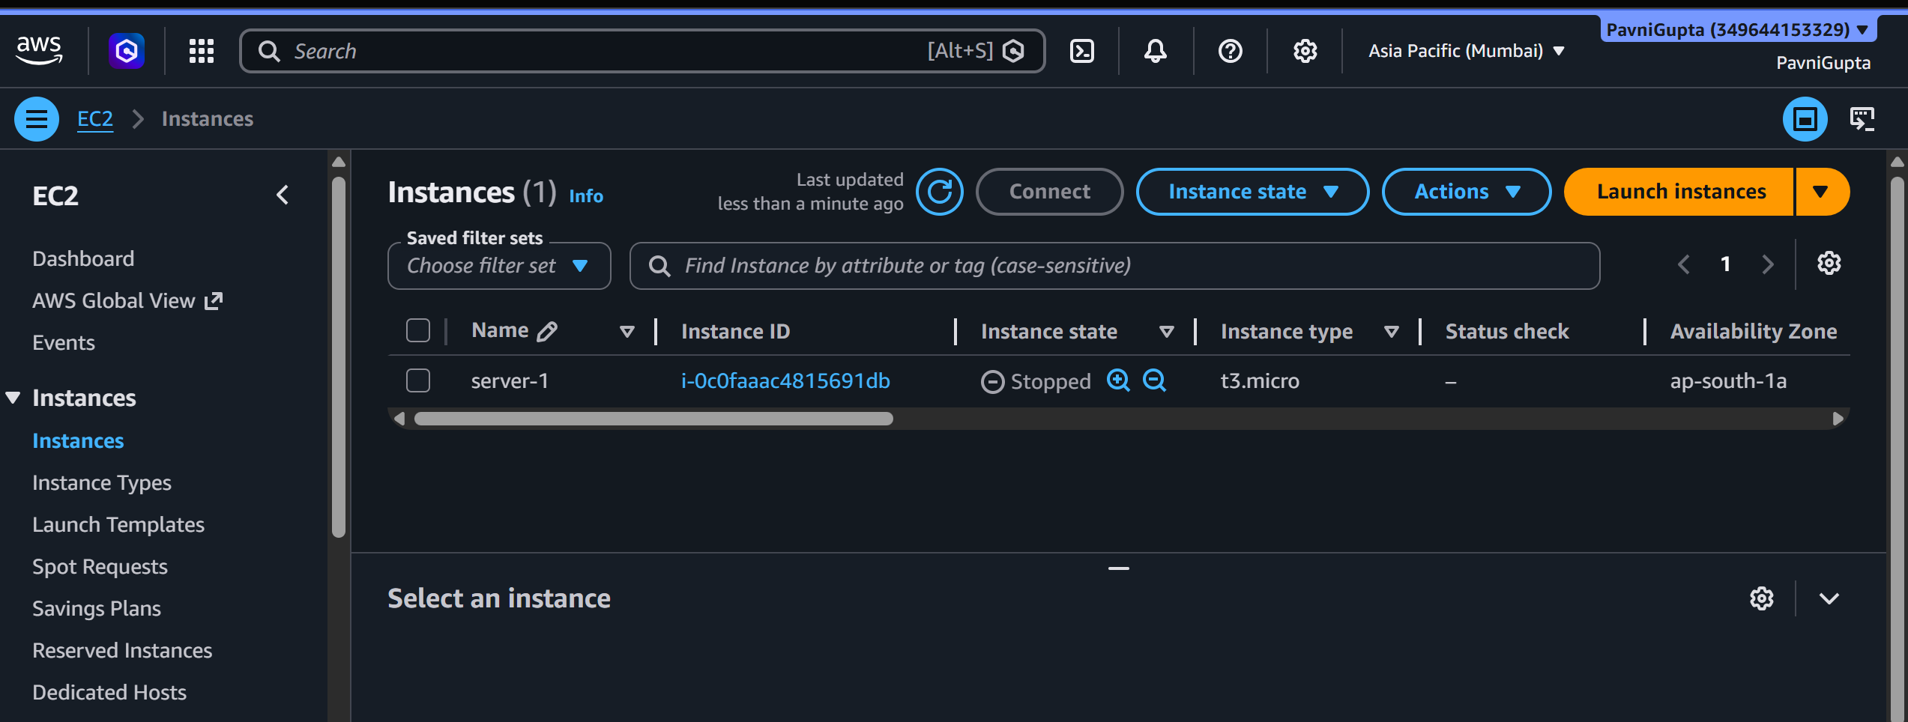
Fig 12: EC2 instance in the Stopped state after the automated stop schedule ran
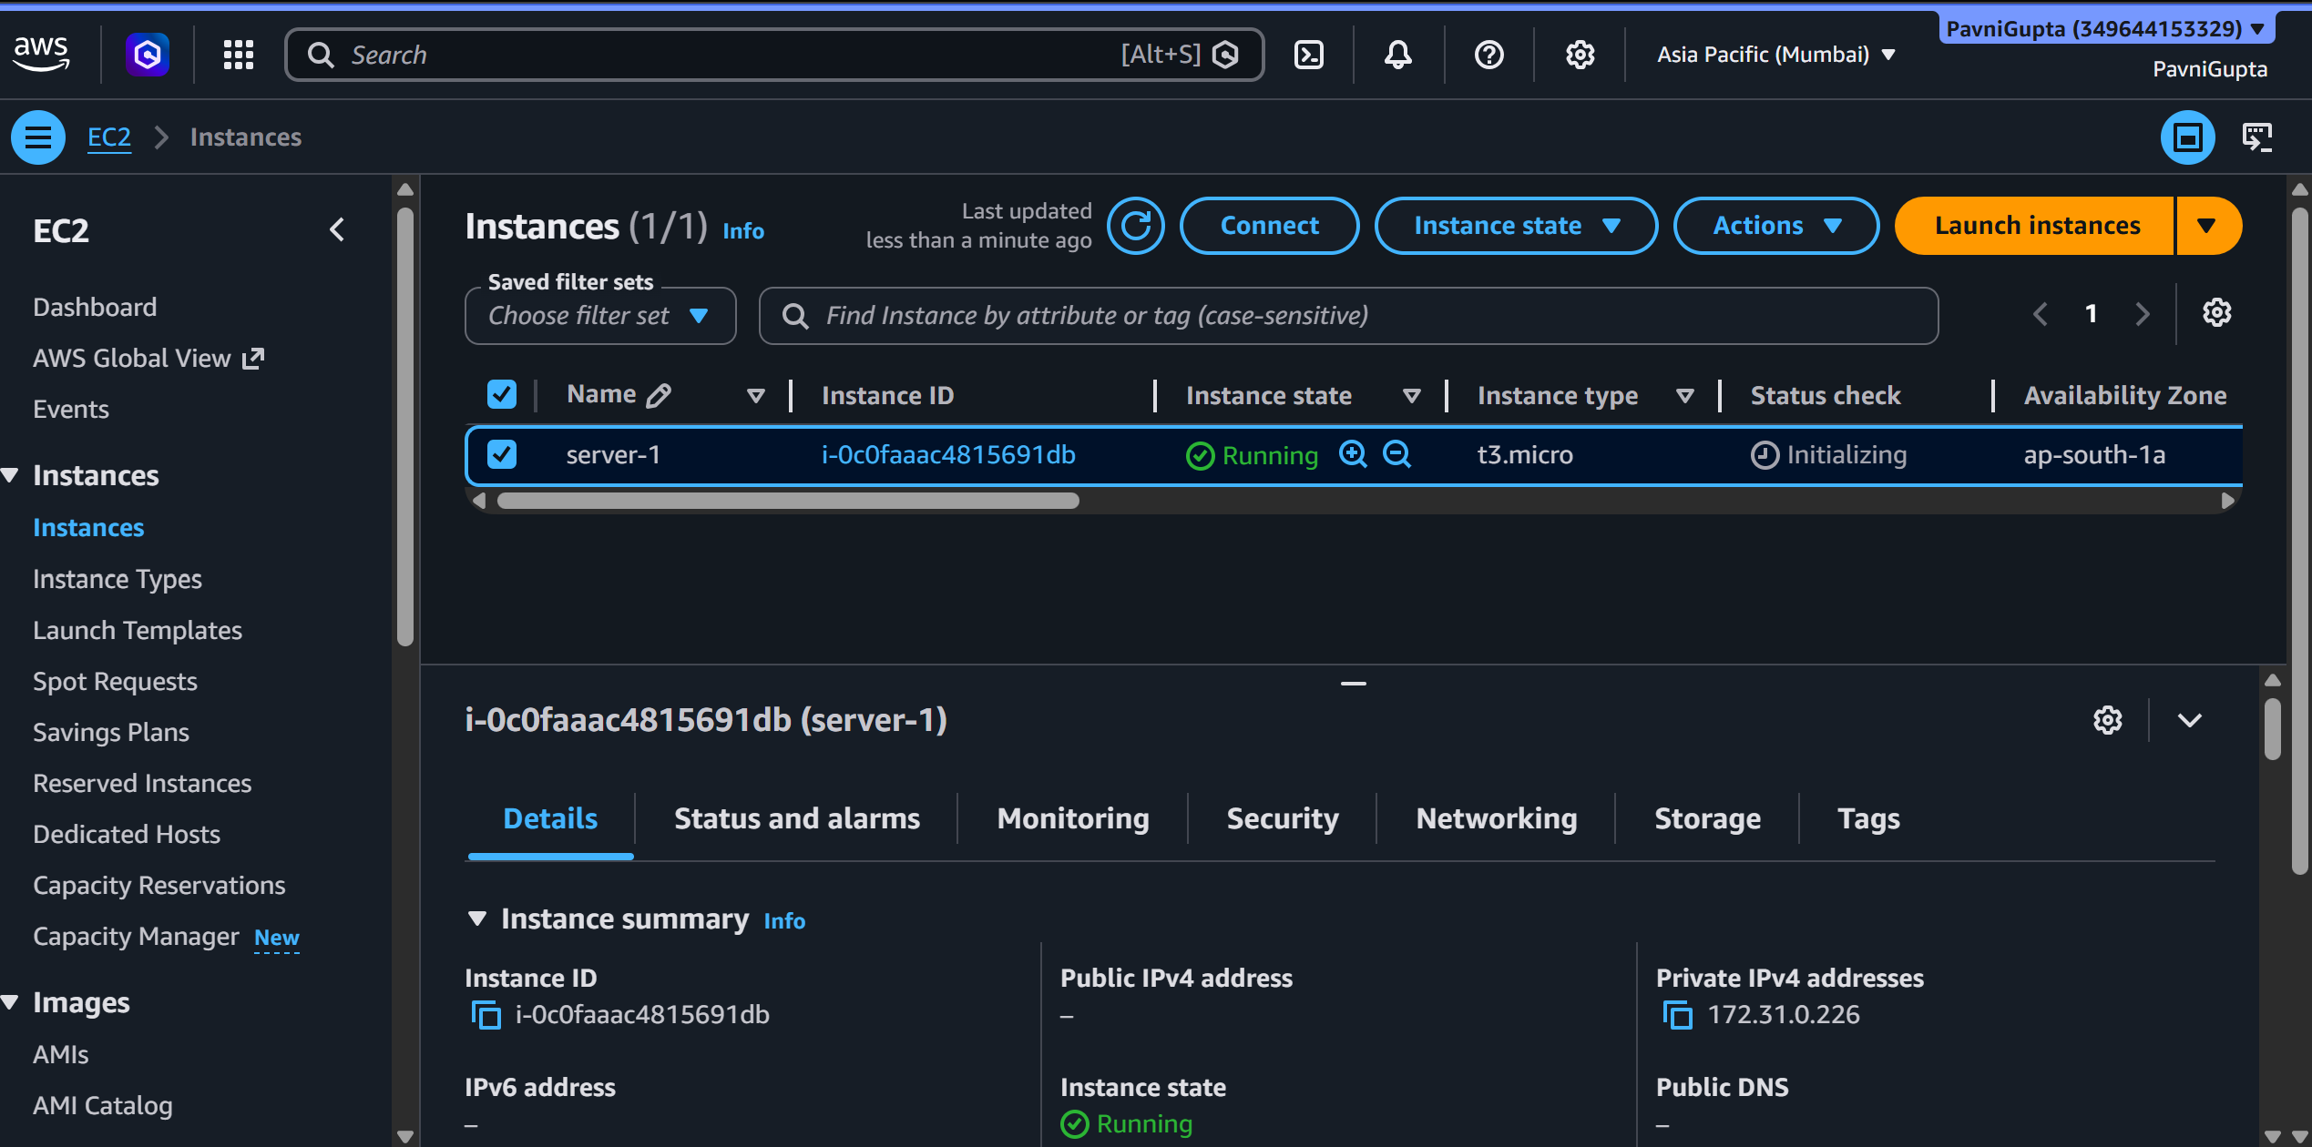
Fig 13: EC2 instance Running and initializing after the automated start schedule ran

Conclusion
A Lambda and EventBridge-based EC2 start/stop automation was implemented and verified for cost-efficient resource management, with the instance confirmed to transition correctly between running and stopped states on the configured schedule.

