By:
Pavni Gupta

S3-Based File Upload/Download Web Application Deployment Report
This report documents the development of a serverless file upload/download web application built on Amazon S3 with a Flask backend.

Project 2: S3-Based File Upload/Download Web Application
Objective: Build a web application that allows users to upload and download files using Amazon S3. The project uses a Flask backend to securely generate upload URLs and store files in the cloud, helping demonstrate cloud storage, web development, and AWS service integration.

Step 1: S3 Bucket Creation
Created an S3 bucket in the AWS console to serve as the storage backend for uploaded and downloaded files.
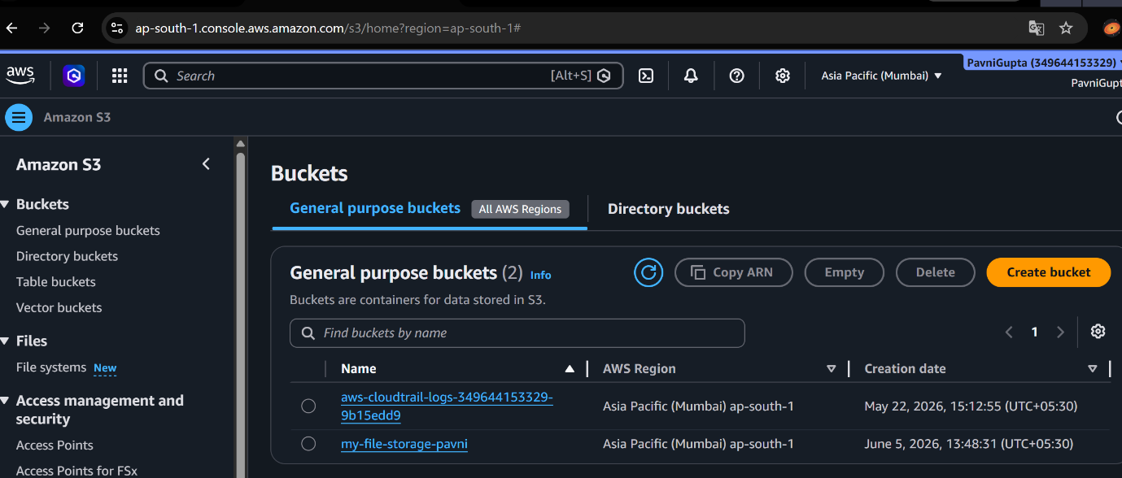
Fig 1: S3 bucket created for the upload/download application

Step 2: Frontend Development
Wrote the frontend code in VS Code to provide the user interface for uploading and downloading files.
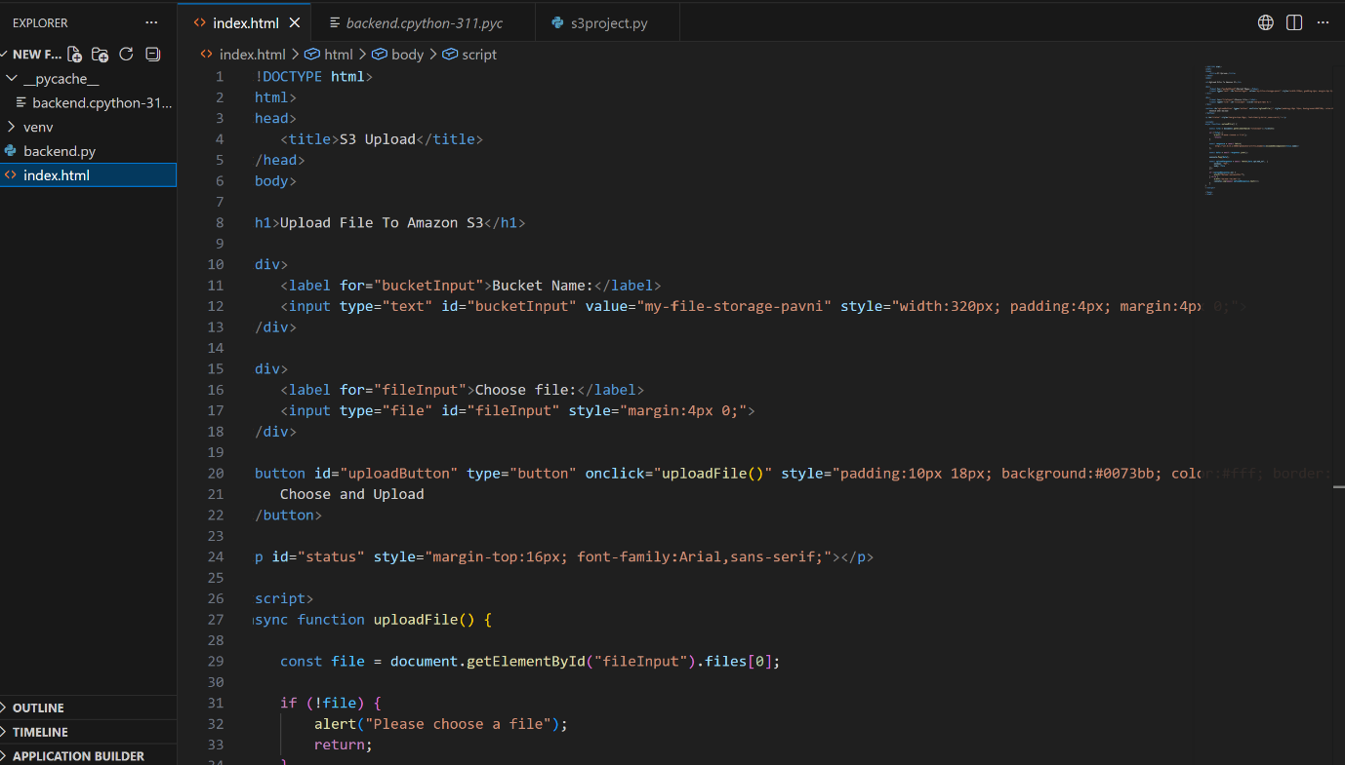
Fig 2: Frontend code written in VS Code
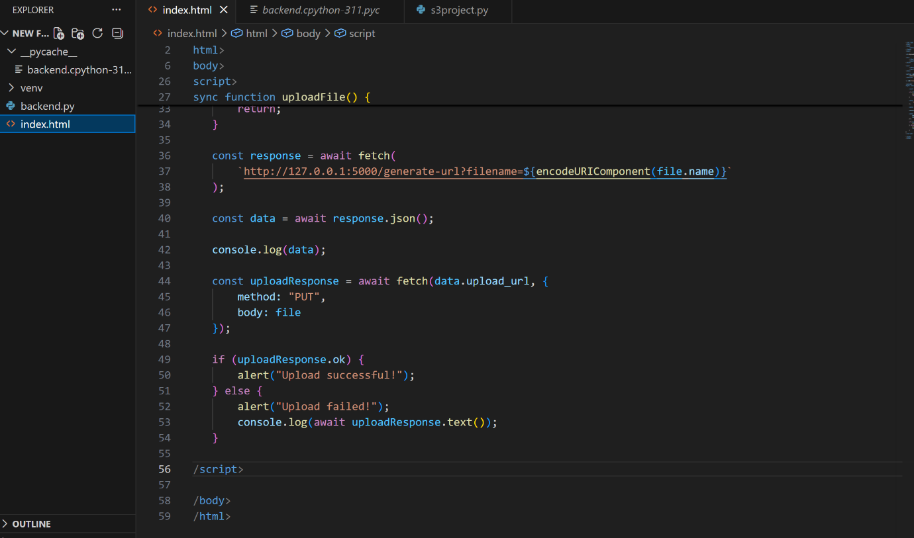
Fig 3: Frontend interface for the file upload/download application

Step 3: Backend Development
Wrote the Flask backend code to securely generate upload URLs and handle interaction between the frontend and the S3 bucket.
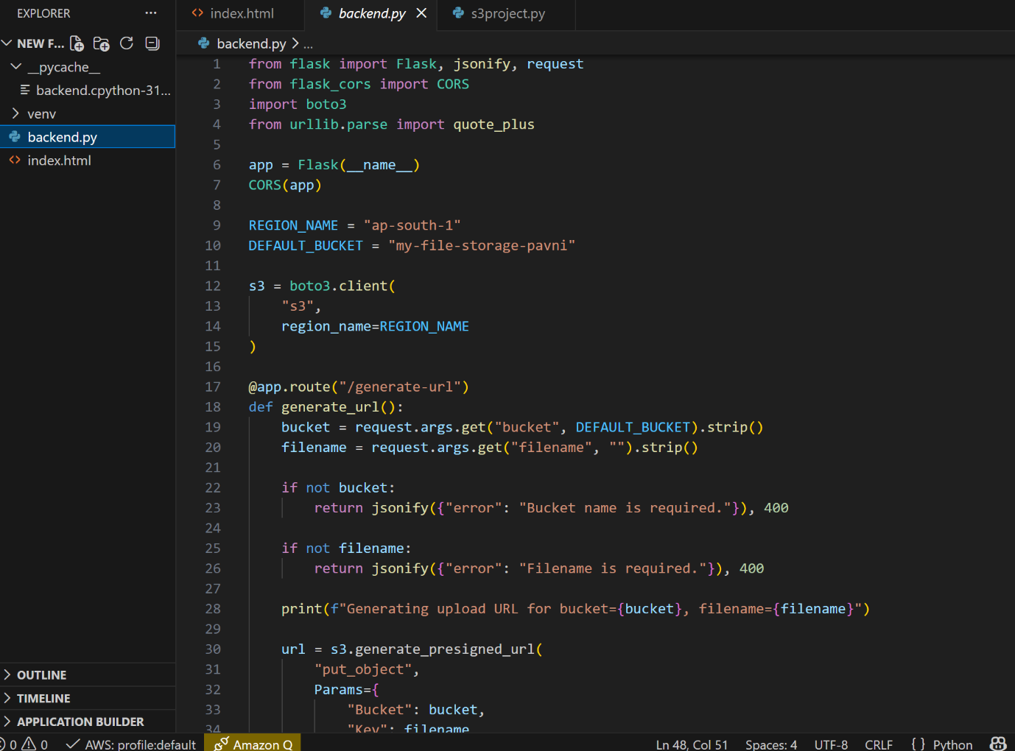
Fig 4: Backend Flask code in VS Code
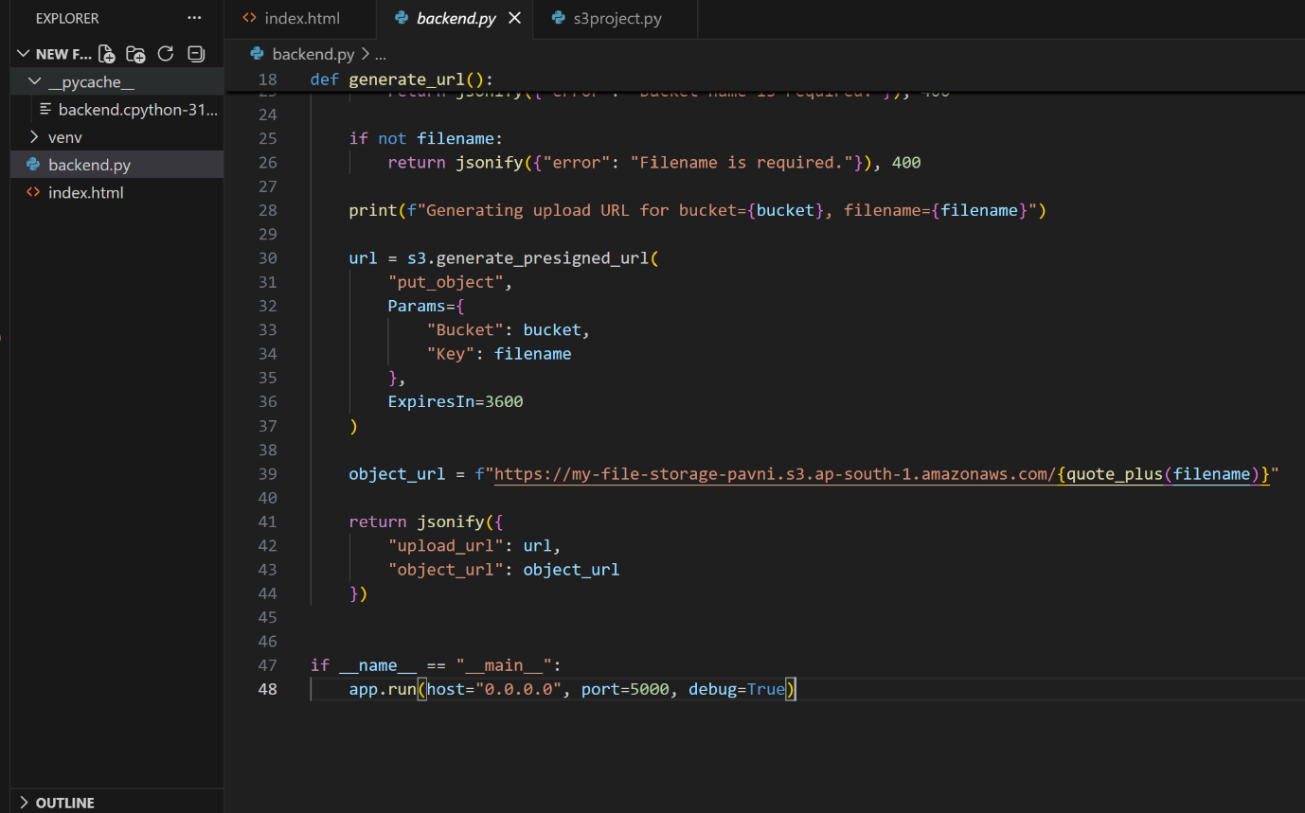
Fig 5: Backend route handling for file uploads
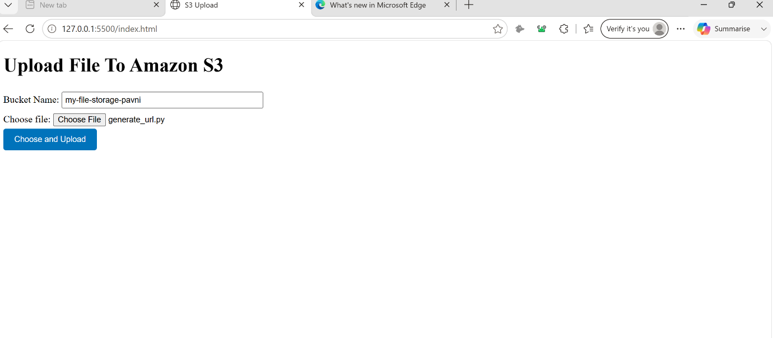
Fig 6: Application running and connected to the backend
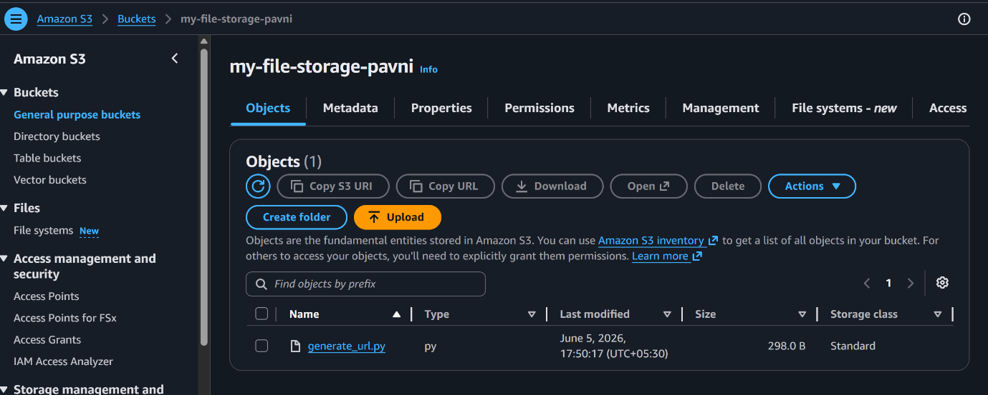
Fig 7: File successfully uploaded to and retrieved from S3

Conclusion
A serverless, S3-backed file upload/download application was built and verified end-to-end, with a Flask backend securely generating upload URLs and a working frontend interface confirmed against live file transfers.

