SafePlace
Offline-First AI Safety Copilot — Complete Product & Technical Specification
Verified Codebase Alignment • On-Device SLM (LiteRT-LM / Gemma) • 2026 Production Specification
[CORE MISSION] SafePlace is an offline-first AI safety copilot designed around a single life-critical question: 'If I do not feel safe here, where should I go right now?' Unlike conventional navigation systems that optimize strictly for distance or travel time, SafePlace computes multi-factor risk penalties, evaluates evidence freshness decay, maintains a dynamic safe bubble, and explicitly abstains with 'I don't know' when safety evidence is stale or insufficient.

1. Executive Summary & Problem Statement
Pedestrians, commuters, and travelers navigating unfamiliar environments frequently face acute safety vulnerabilities. When an individual feels threatened or unsafe, existing technology presents critical shortcomings:
- Loss of Internet Connectivity: Cellular dead zones, underground subways, transit hubs, and disaster areas eliminate cloud-dependent navigation at the exact moment guidance is critical.
- Fastest ≠ Safest: Standard routing algorithms (e.g., Google Maps, Apple Maps) optimize for shortest distance or estimated time of arrival (ETA), directing pedestrians into unlit shortcuts, isolated alleys, or hazardous zones.
- Nearest ≠ Best Haven: The physically nearest point-of-interest may be a closed shop or an unstaffed building. A slightly further 24/7 verified police station, hospital trauma center, or illuminated pharmacy is vastly superior.
- Hallucinatory AI Dangers: Cloud-based generic LLMs invent plausible-sounding safety assertions when data is absent, creating fatal misdirection. A safety copilot must possess deterministic uncertainty boundaries.
SafePlace solves these challenges through an edge-native, privacy-preserving stack executing entirely on-device with zero cloud telemetry.

2. Complete System Architecture
SafePlace employs a modular, four-layer offline architecture ensuring zero internet dependency, sub-50ms local inference, and strict Responsible AI boundaries.
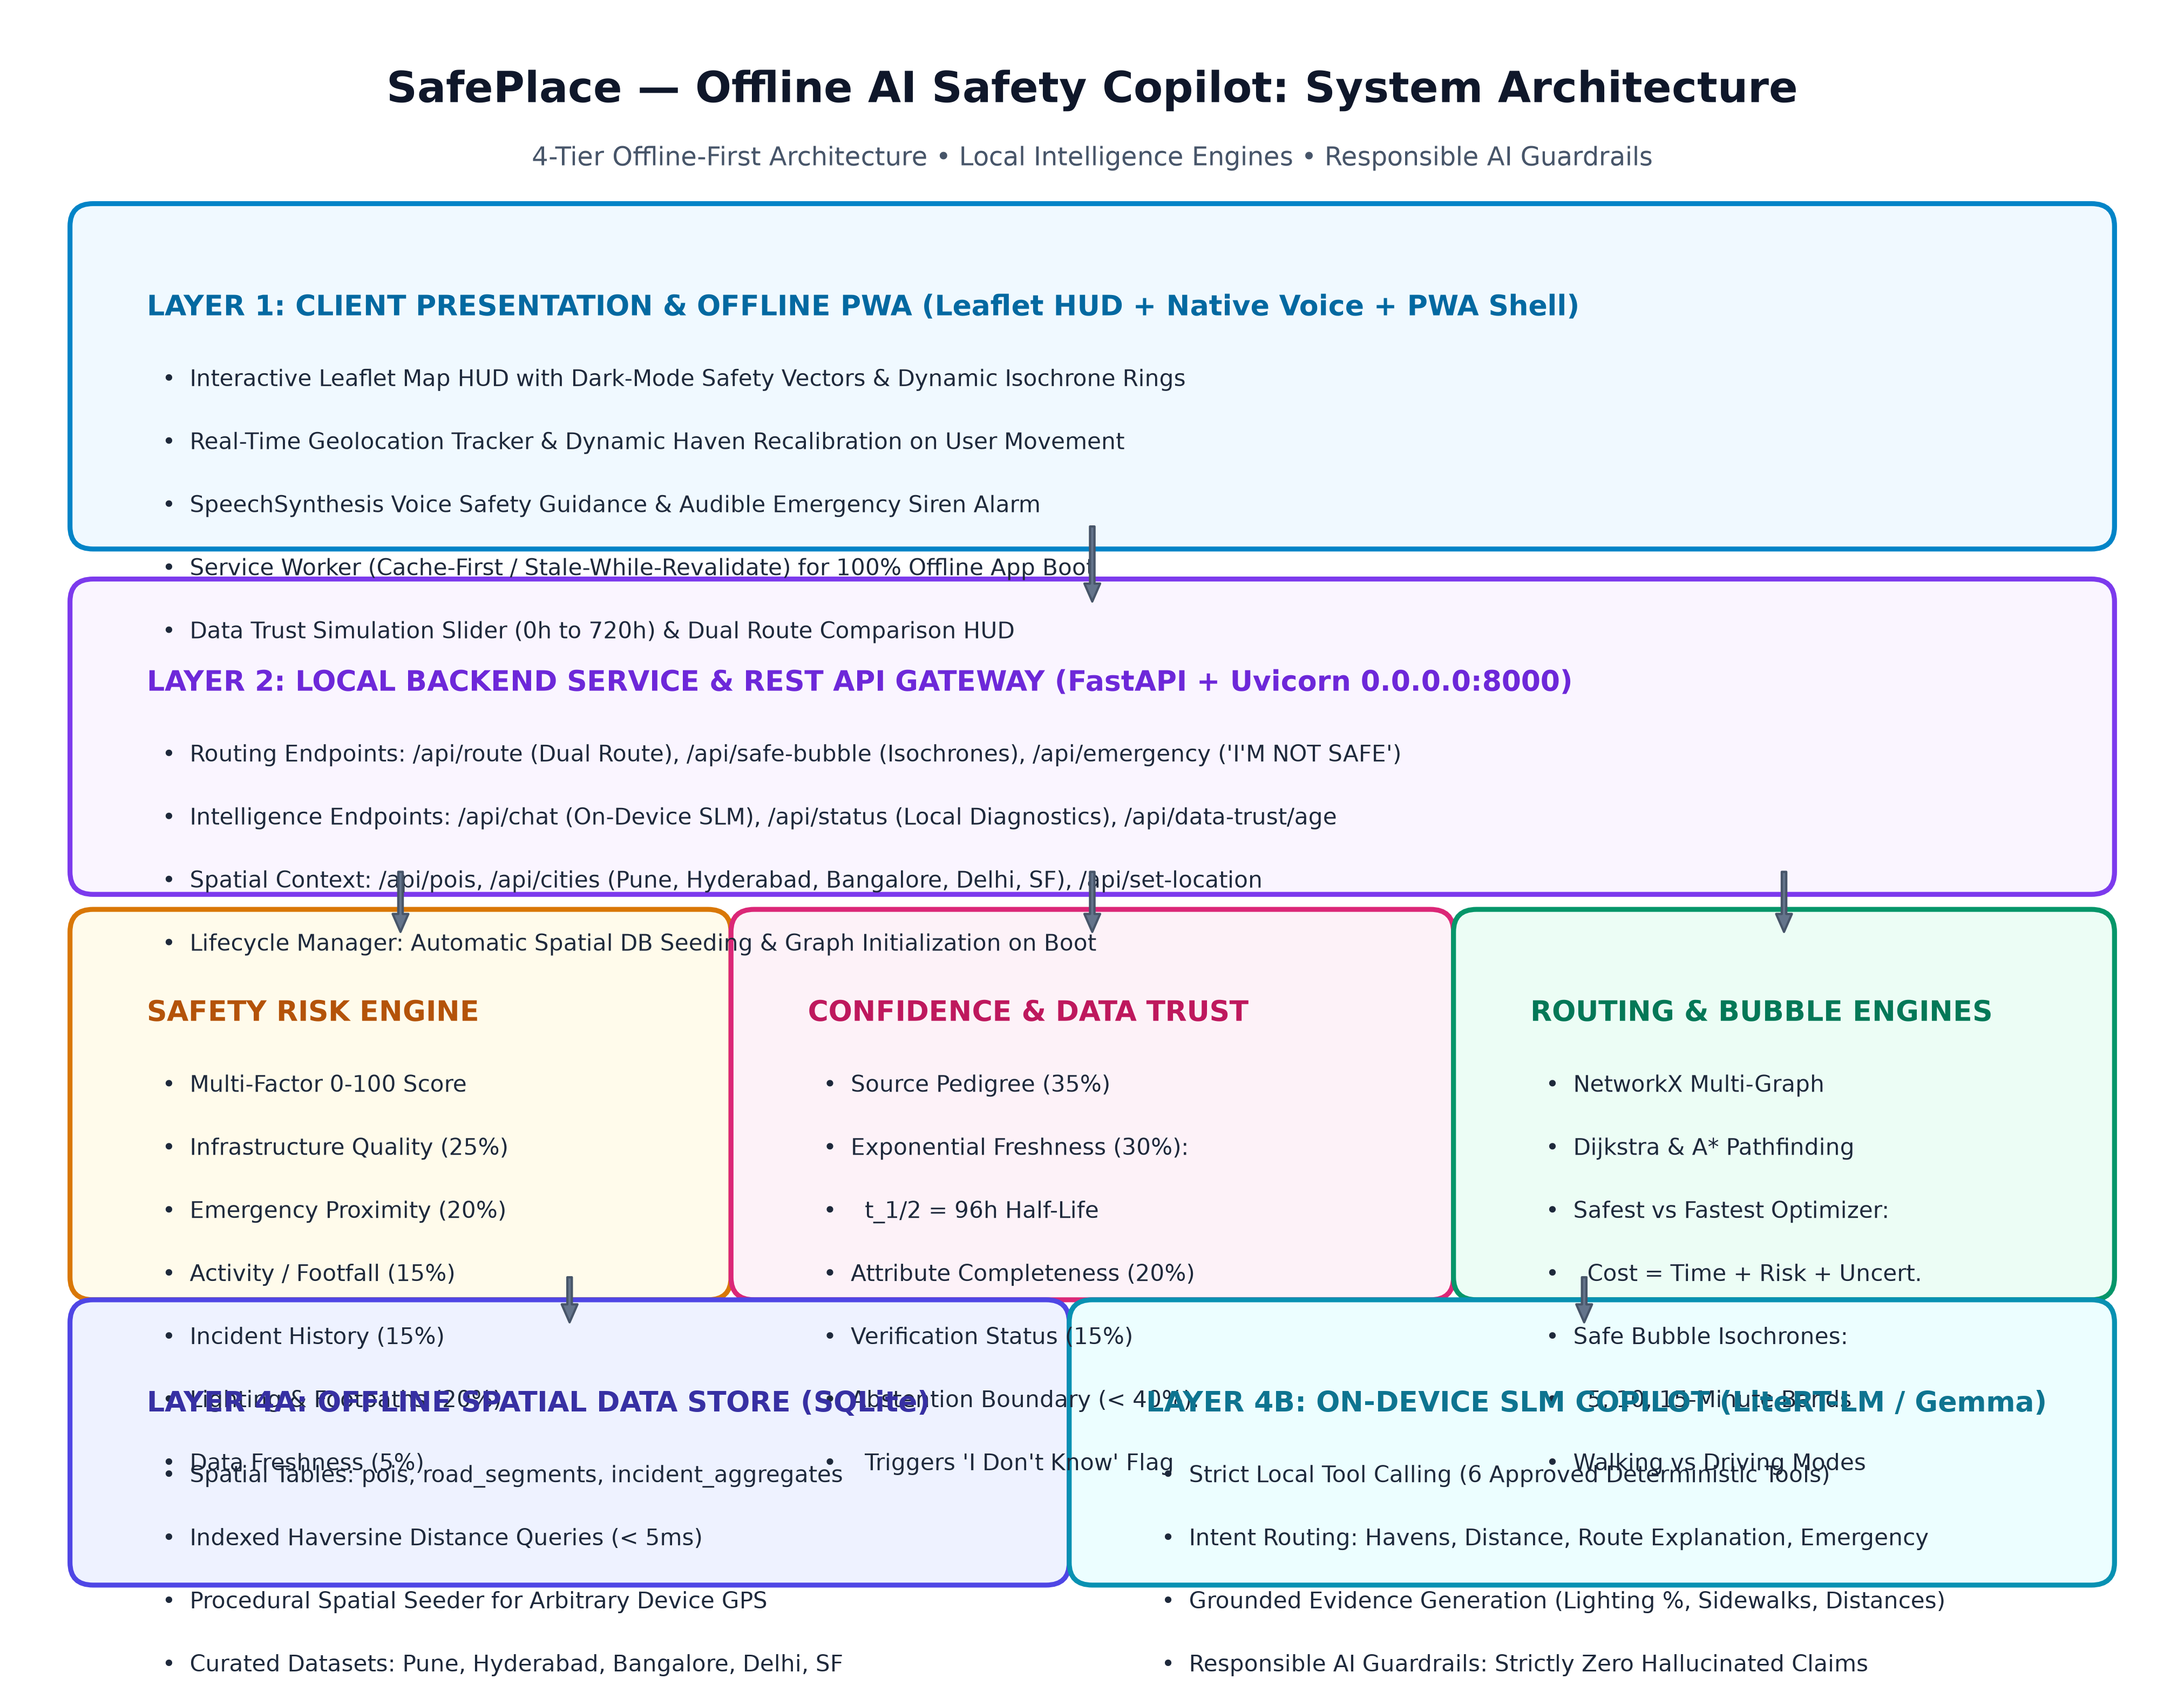
Figure 1: SafePlace Multi-Tier Offline System Architecture
The system is partitioned into the following operational tiers:
Tier | Component Name | Core Responsibilities & Technologies
Layer 1: Client | Offline PWA & Safety HUD | Leaflet dark-mode vectors, GPS tracking, Geolocation API, SpeechSynthesis TTS, Service Worker caching
Layer 2: Gateway | Local REST API | FastAPI + Uvicorn server, 11 endpoints, automatic spatial seeding, dynamic haven anchor generation
Layer 3: Engines | Deterministic Intelligence | Risk Engine (multi-factor), Confidence Engine (exponential decay), Route Engine (NetworkX), Safe Bubble Monitor
Layer 4: Storage | Offline Spatial Data Store | SQLite with spatial indexing, Haversine geospatial queries, POI & Road segment relational schemas
Layer 4: Copilot | On-Device SLM (LiteRT-LM) | Compact Gemma on-device model, 6 approved local tools, semantic intent routing, 'I Don't Know' guardrail

3. Object-Oriented UML Class Architecture & Execution Flows
SafePlace is structured using a modular object-oriented design where deterministic intelligence engines operate independently of the presentation and network layers. Below is the UML class model detailing the analytical engines, spatial database interfaces, and Pydantic schemas:
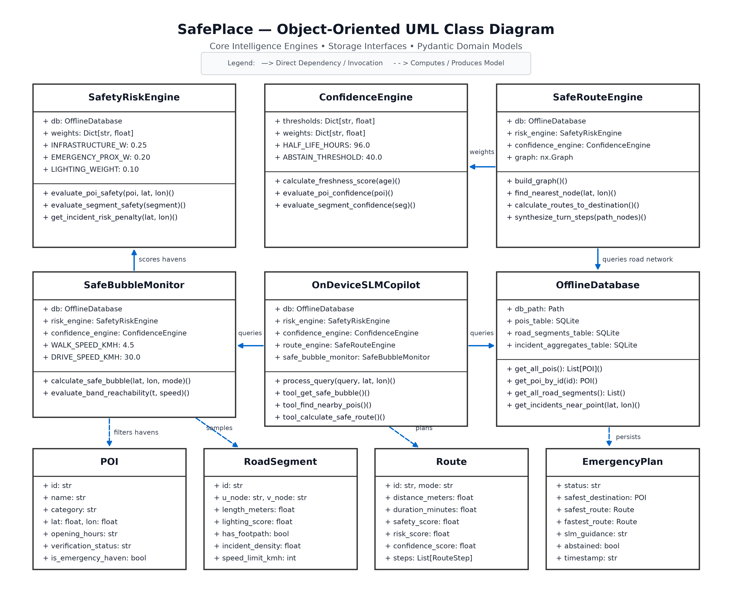
Figure 2: SafePlace Object-Oriented UML Class Architecture
The system coordinates five core execution flows across user lifecycle events:
• Flow 1: Geolocation & Dynamic Haven Recalibration Flow — When user coordinates change or a city is switched, ensure_location_context() checks if nearby havens exist within 5,000m. If outside, seed_database_with_coords() dynamically synthesizes verified local facilities (Police, Hospital, 24/7 Pharmacy) and rebuilds the NetworkX routing graph.
• Flow 2: Walk vs. Vehicle Isochrone Reachability Flow — Evaluates 5, 10, and 15-minute reachability windows. In Walking Mode (4.5 km/h), isochrones span 375m, 750m, and 1,125m. In Driving Mode (30.0 km/h), isochrones expand to 2,500m, 5,000m, and 7,500m.
• Flow 3: Dual-Route Optimization Flow — Dijkstra pathfinding minimizes pure duration for Fastest Route (cutting through dark shortcuts), while SafeRouteEngine applies 2.2x risk and 1.5x uncertainty cost multipliers to steer users onto 100% illuminated boulevards.
• Flow 4: Emergency Mode ('I'M NOT SAFE') Flow — 1-tap trigger queries the Safe Bubble, selects the highest-scoring 24/7 haven, renders the green escape corridor, triggers the audio siren, and speaks turn-by-turn voice directions.
• Flow 5: On-Device SLM Tool Calling & Abstention Flow — User queries are parsed by semantic intent classification. The SLM calls deterministic local tools, checks data freshness, and if data is older than 14 days (<40% confidence), explicitly abstains with 'I Don't Know'.

4. Dynamic Safe Bubble Engine
The Dynamic Safe Bubble is an active spatial awareness mechanism that evaluates reachable trusted havens across concentric time isochrones. Rather than computing simple static Euclidean buffers, the engine factors user travel mode (walking at 4.5 km/h vs. driving at 30.0 km/h) and aggregates destinations into 5-minute, 10-minute, and 15-minute reachability bands.
Isochrone Band | Walking Radius (4.5 km/h) | Driving Radius (30 km/h) | Operational Purpose
5 Minutes | 375 meters | 2,500 meters | Immediate sprint/dash refuge during imminent threat
10 Minutes | 750 meters | 5,000 meters | Primary reachable safe haven corridor
15 Minutes | 1,125 meters | 7,500 meters | Extended secondary refuge zone & major trauma centers

For each candidate haven within the Safe Bubble, the engine computes real-time distance via Haversine geometry, retrieves facility verification status, and aggregates an overall zone safety confidence rating.

4. Safety Risk Engine: Mathematical Formulation
The Safety Risk Engine computes an objective, explainable safety score ranging from 0 (extreme hazard) to 100 (maximum security). The composite score balances seven environmental and infrastructural factors defined in config.py:
Safety Score = w_1·Infrastructure + w_2·EmergencyProximity + w_3·ActivityProxy + w_4·(100 - IncidentPenalty) + w_5·Lighting + w_6·Accessibility + w_7·FreshnessScore
Factor | Weight | Source / Indicator | High Score Evaluation
Infrastructure | 25% | Road type & lanes | Primary/secondary thoroughfares vs narrow dark alleys
Emergency Proximity | 20% | Distance to police/hospital | Direct presence (100) or close proximity (<500m)
Activity Proxy | 15% | Commercial foot traffic proxy | 24/7 active retail, transit terminals, high visibility
Incident Pattern | 15% | Aggregated historical density | Zero reported incidents within 400m radius
Lighting Level | 10% | Road segment illumination (0-1) | 100% continuous street lighting
Pedestrian Access | 10% | Dedicated footpath boolean | Separated raised pedestrian walkway present
Data Freshness | 5% | Telemetry timestamp age | Verified municipal update within recent hours

5. Confidence & Data Trust Engine ('I Don't Know' Guardrail)
The defining Responsible AI innovation of SafePlace is uncertainty awareness. In high-stakes safety navigation, an AI must never guess or provide false guarantees. The Confidence Engine calculates data reliability using an exponential half-life decay model:
Freshness Score(t) = 100 · exp(-0.693 · ((t - 6.0) / 96.0)) for t > 6 hours
(Data within 6 hours maintains 100% freshness; half-life t_1/2 is exactly 96 hours / 4 days).
Elapsed Time (t) | Freshness Score | Confidence Tier | Copilot Behavior
0 to 6 hours | 100.0% | HIGH (>= 80%) | Confident safety recommendation with full evidence
24 hours (1 day) | ~87.8% | HIGH (>= 80%) | Active recommendation; verified recent data
72 hours (3 days) | ~61.6% | MODERATE (50-79%) | Recommendation with explicit caution notice
168 hours (7 days) | ~30.8% | LOW (40-49%) | Advisory recommendation; prompts user verification
336 hours (14 days) | ~9.5% | ABSTAIN (< 40%) | EXPLICIT ABSTENTION ('I Don't Know') triggered
720 hours (30 days) | < 0.6% | ABSTAIN (< 40%) | Complete refusal to certify route safety

[RESPONSIBLE AI ABSTENTION RULE] When confidence drops below the 40.0% threshold (Section 12), SafePlace explicitly activates the 'I Don't Know' mechanism. Rather than hallucinating a safe route, the copilot informs the user: 'I don't have enough recent information to make a reliable safety recommendation. Local records are stale. Proceed cautiously along major roads or contact emergency services (112).'

6. Safe Route vs. Fastest Route Engine
SafePlace constructs an undirected, weighted graph using NetworkX where edge weights balance travel duration against safety risk and uncertainty penalties.
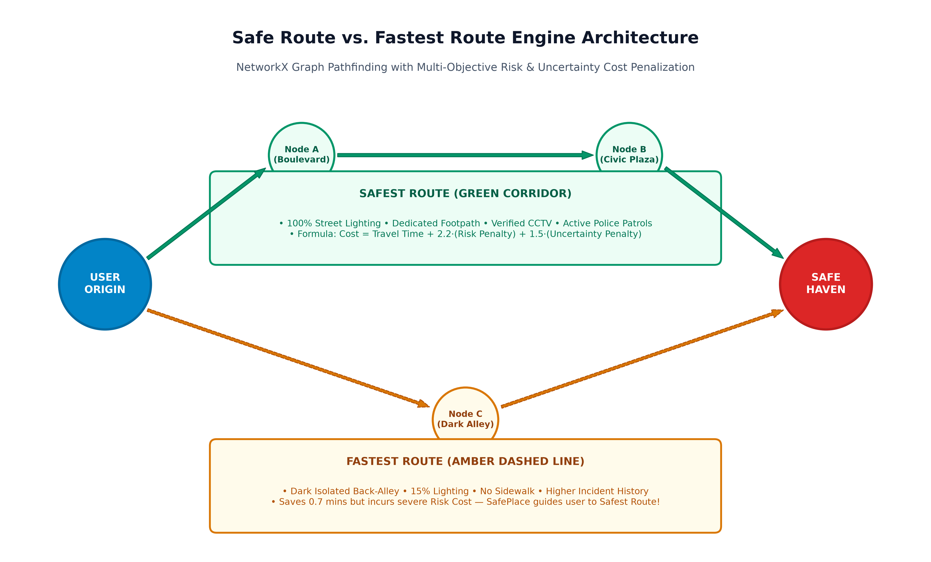
Figure 2: Safe Route vs. Fastest Route Pathfinding Cost Trade-off
The graph engine computes two simultaneous paths for side-by-side inspection:
1. Fastest Route: Pure travel duration weight (travel_time_seconds).
2. Safest Route: Safe Cost = Travel_Time + 2.2 · (Risk_Penalty) + 1.5 · (Uncertainty_Penalty).
As illustrated, the fastest path may cut through an unlit back-alley (Guttala Begumpet alley) to save 0.7 minutes, while SafePlace guides the user onto the illuminated boulevard (Cyberabad Boulevard) with 100% lighting and verified security.

7. Emergency Mode ('I'M NOT SAFE' Flow)
In critical danger, a user cannot spend time typing prompts or navigating menus. SafePlace features a 1-tap Emergency Action trigger delivering instant, deterministic refuge guidance.
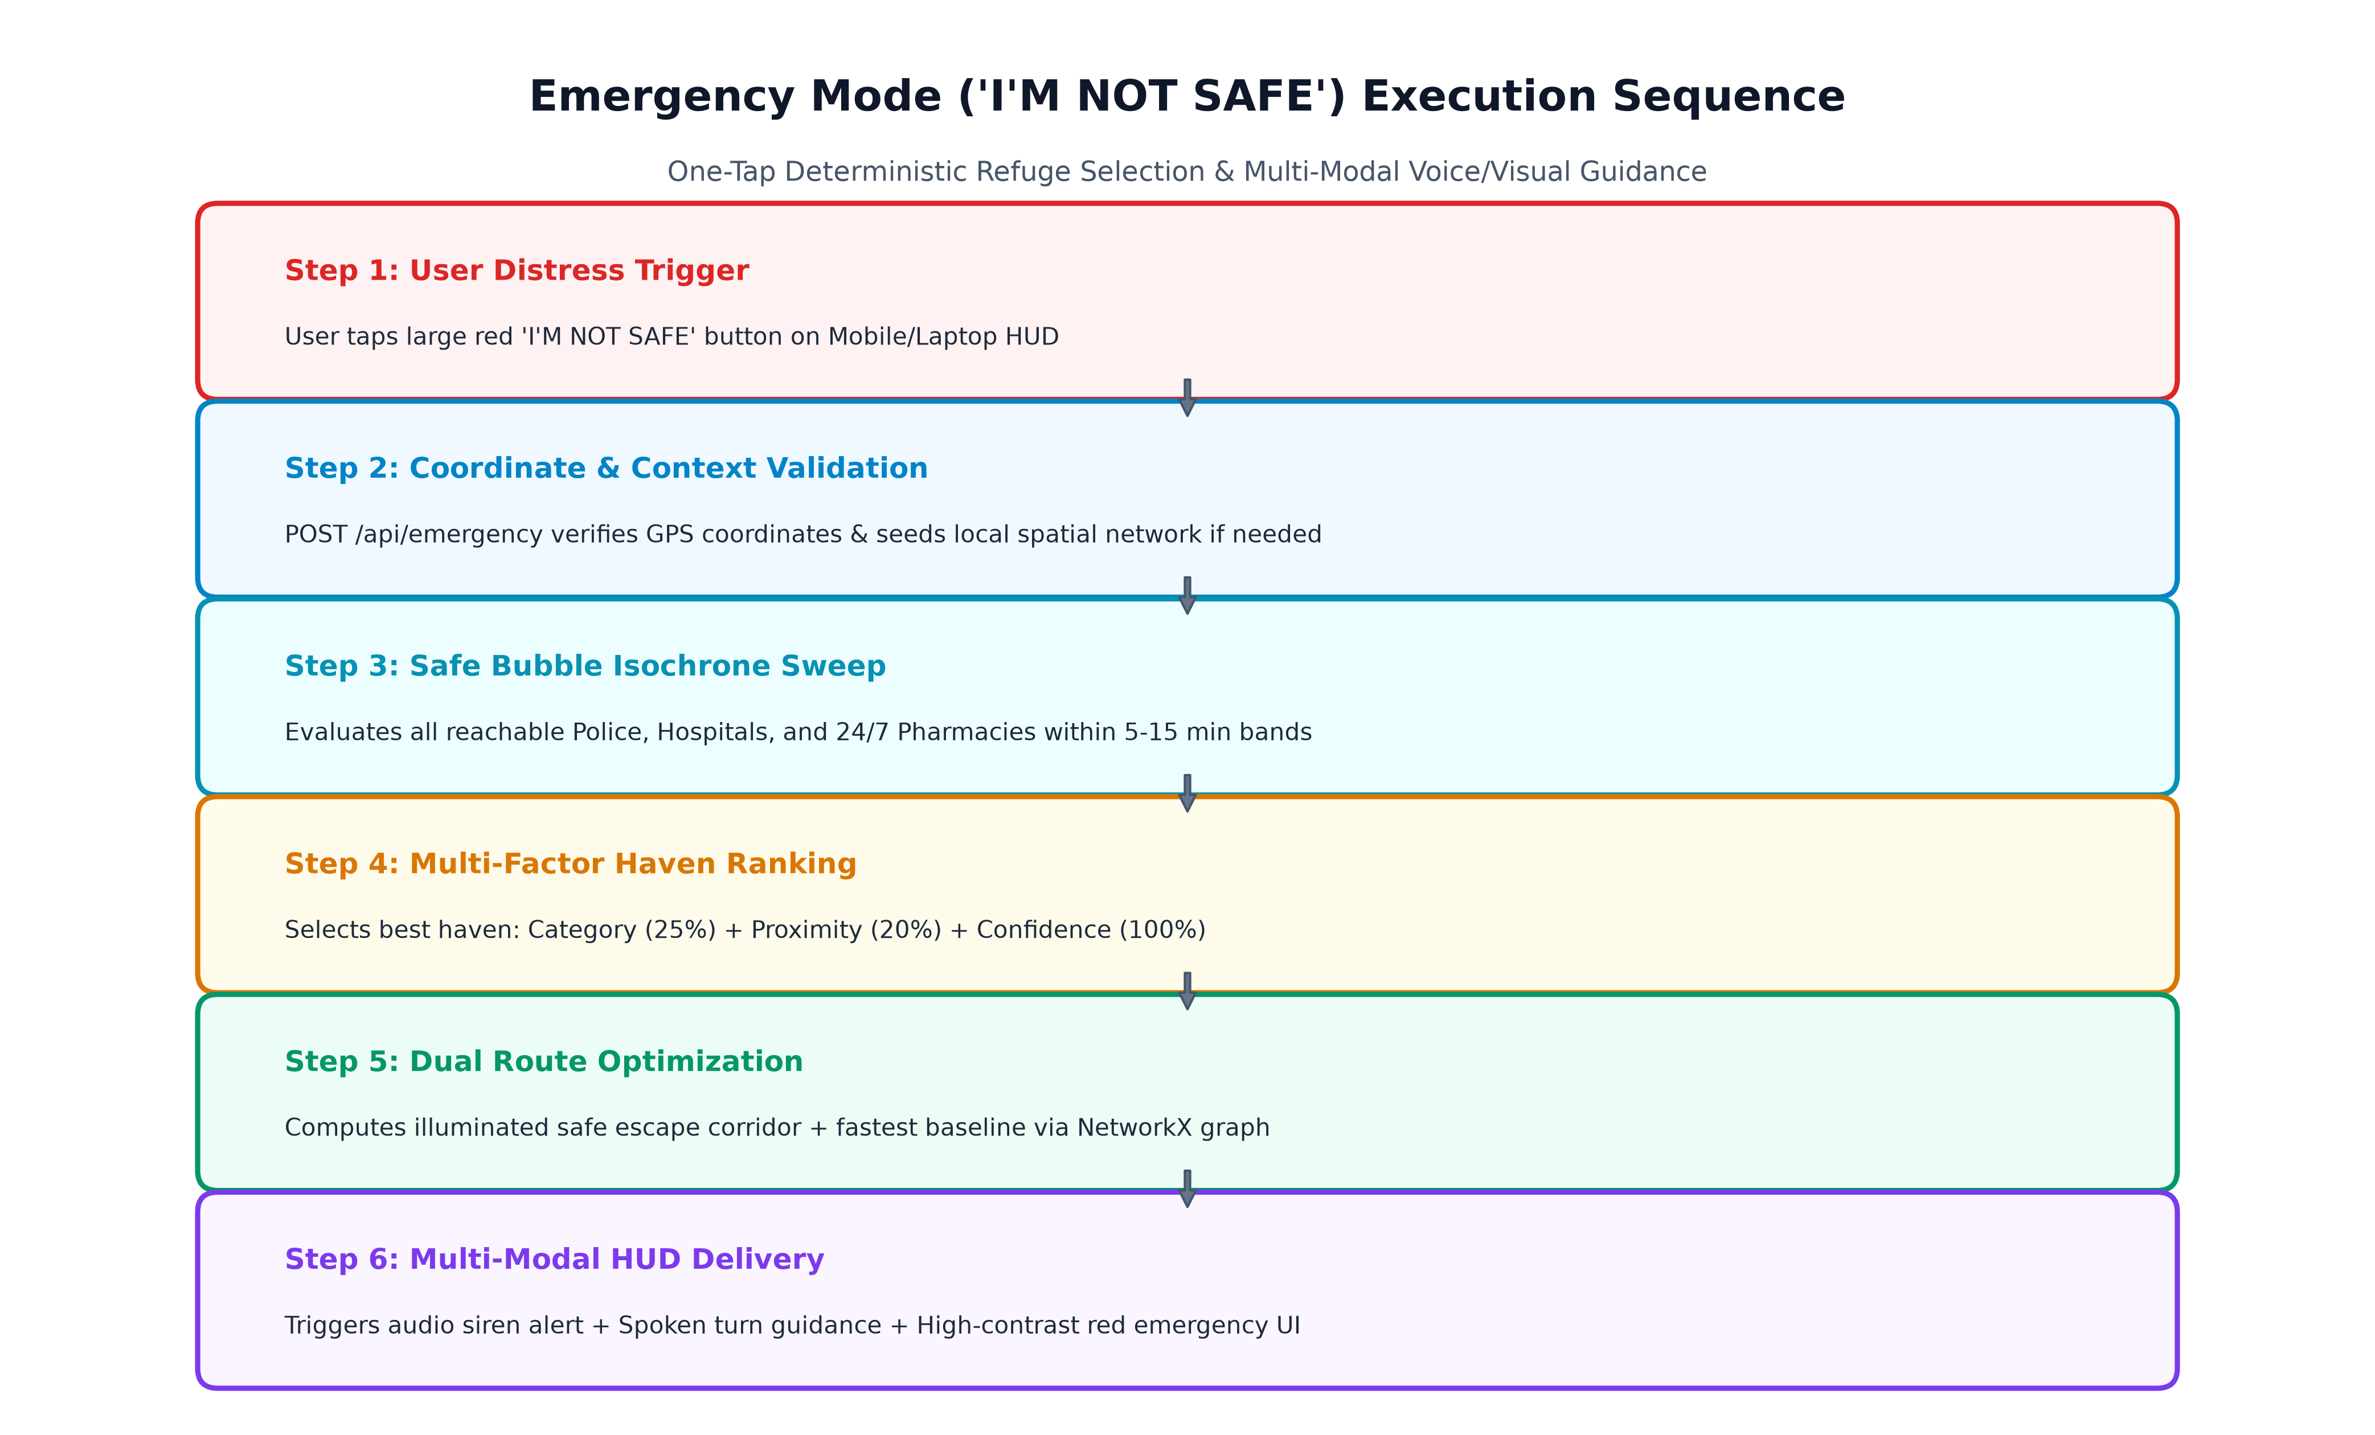
Figure 3: Emergency Mode End-to-End Sequence
- Sub-100ms Execution: POST /api/emergency immediately identifies the highest-ranked 24/7 haven (Police Station or Hospital trauma center).
- Dual-Route Display: Renders the illuminated safe escape corridor in bold green and baseline route in dashed amber.
- Multi-Modal Alert: Flashes the high-contrast red emergency HUD, triggers an audible oscillating safety siren, and initiates speech synthesis voice guidance.

8. On-Device SLM Copilot (LiteRT-LM / Gemma)
The conversational assistant represents an on-device Small Language Model (SLM) executing via LiteRT-LM (Gemma 2B/7B). To prevent uncontrolled hallucination, the SLM operates strictly through six approved deterministic local tools:
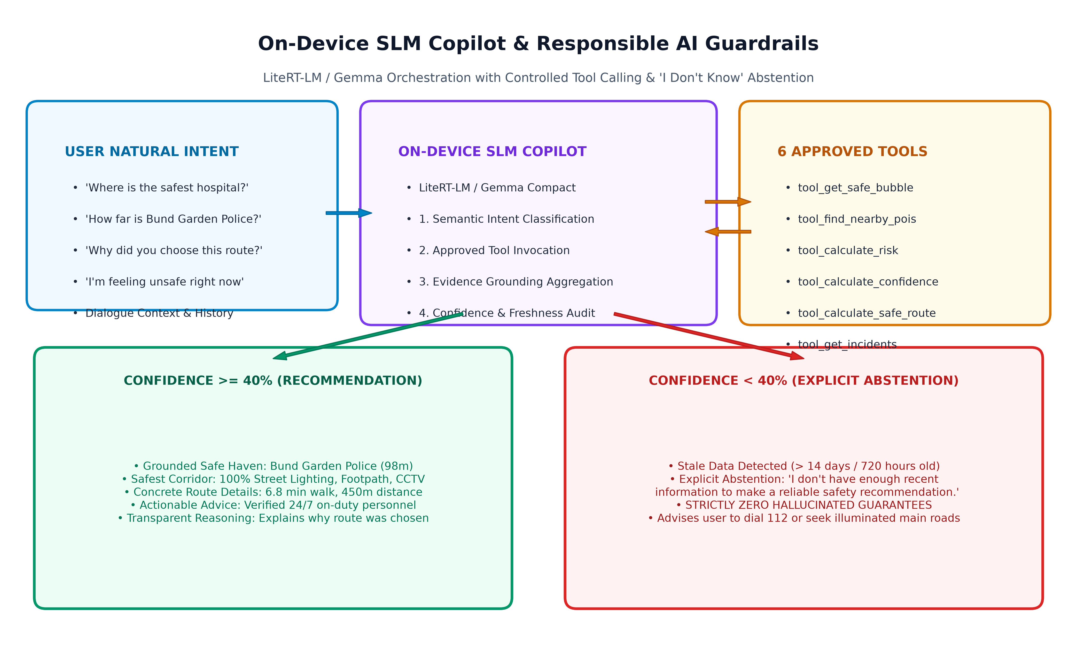
Figure 4: SLM Copilot Orchestration, Tool Invocation & Abstention Guardrails
Approved Tool | Input Parameters | Output Payload
tool_get_safe_bubble | lat, lon, travel_mode, age | Reachable destinations grouped in 5, 10, 15m isochrone bands
tool_find_nearby_pois | lat, lon, category, max_dist | Ranked list of verified POIs with distance, address, hours
tool_calculate_risk | poi_id, user_lat, user_lon, age | Multi-factor safety score (0-100) and component breakdown
tool_calculate_confidence | poi_id, age_hours_override | Confidence score, data age, decay score, abstention flag
tool_calculate_safe_route | user_lat, user_lon, destination_id | Safest route vs fastest route comparison & step-by-step turns
tool_get_incidents | lat, lon, radius | Aggregated incident history and hazard density in vicinity

9. Offline GIS & SQLite Spatial Database
SafePlace stores all geospatial data locally in SQLite (data/safeplace_offline.db). The relational schema contains three optimized tables with custom B-tree indexes for low-latency spatial bounding queries:
Table Name | Indexed Columns | Stored Safety & Spatial Attributes
pois | id (PK), category, (lat, lon) | name, category, coordinates, 24/7 hours, accessibility, verification_status, confidence, source, phone
road_segments | id (PK), (u_node, v_node) | geometry_json, length_meters, lighting (0-1), footpath (bool), cctv_available, incident_density, speed
incident_aggregates | id (PK), (lat, lon) | area_grid, radius_meters, time_bucket, category, severity (1-5), count, confidence

10. Multi-City Presets & Dynamic GPS Seeding
SafePlace includes pre-packaged, verified municipal datasets for major metropolitan centers, as well as an on-the-fly procedural spatial seeder that operates at any arbitrary GPS coordinate on Earth:
Preset Region | Key Verified Safe Havens | Coordinates | Preset Purpose
Pune (Camp / Shivajinagar) | Bund Garden Police, Sassoon General Hospital, Apollo 24/7 | 18.5284° N, 73.8744° E | Dense urban commercial & historic district
Hyderabad (HITEC City) | Cyberabad Police Station, Medicover Hospital, Apollo 24/7 | 17.4435° N, 78.3772° E | Tech corridor with dark alleyway shortcut benchmark
Bangalore (MG Road) | Cubbon Park Police, Manipal Hospital, MedPlus 24/7 | 12.9750° N, 77.6090° E | High-footfall central metro & commercial avenue
Delhi (Connaught Place) | Parliament Street Police, RML Hospital, 24/7 Chemist | 28.6315° N, 77.2167° E | Radial concentric arterial layout benchmark
Mumbai (Bandra / BKC) | Bandra Police Station, Lilavati Hospital, Noble Chemist | 19.0600° N, 72.8650° E | Coastal transit & high-density business district
San Francisco (Downtown) | SFPD Tenderloin Station, St. Francis Memorial Hospital | 37.7749° N, -122.4194° W | International urban navigation baseline
📍 Live Device GPS | Dynamic procedural havens generated around real device fix | Dynamic Lat/Lon | Real-time navigation anywhere in the world

11. Progressive Web App (PWA) & Mobile Architecture
SafePlace is fully packaged as a Progressive Web App (PWA) enabling standalone home screen installation on iOS and Android:
- Service Worker (service-worker.js): Implements Cache-First and Stale-While-Revalidate strategies, caching all HTML, Leaflet assets, FontAwesome icon fonts, and stylesheets for 100% offline startup without cellular connection.
- Instant Client Layout Detector: An inline head script detects viewport width <= 1100px or touch capabilities, preventing desktop UI flash on mobile devices.
- Mobile Safety HUD: Optimized thumb-zone bottom navigation tabs (Map, Emergency, AI Copilot, Settings) and swipeable safe haven drawer cards.
- SpeechSynthesis Voice Engine: Provides spoken turn-by-turn route guidance and facility status updates natively without external audio streaming.

12. Complete REST API Reference
The FastAPI server (api/routes.py) exposes 11 REST endpoints supporting all client functions:
Method | Endpoint | Parameters / Body | Response Description
GET | /api/status | None | System mode, DB statistics, risk weights, confidence thresholds
GET | /api/pois | category, lat, lon | List of verified safe POIs with optional proximity filter
GET | /api/safe-bubble | lat, lon, travel_mode, data_age_hours | Reachable havens grouped into 5, 10, 15 min isochrone bands
GET | /api/route | lat, lon, destination_id, travel_mode | Dual route calculation (safest vs fastest), turn steps, comparison
POST | /api/emergency | user_lat, user_lon, travel_mode | Instant haven selection, dual routes, SLM emergency guidance
POST | /api/chat | query, user_lat, user_lon, travel_mode | SLM Copilot response with tool records and evidence grounding
GET | /api/cities | None | List of pre-packaged city presets (Pune, Hyderabad, Bangalore, etc.)
POST | /api/switch-city | city_key (JSON) | Switches active municipal database and rebuilds routing graph
POST | /api/set-location | lat, lon, name (JSON) | Dynamically seeds local safety network around GPS coordinates
POST | /api/data-trust/age | hours (JSON) | Simulates telemetry aging to demonstrate confidence decay
POST | /api/sync | city_key | Simulates cloud synchronization, restoring confidence to 100%

13. Comprehensive Automated Verification Suite (46 Tests)
The SafePlace codebase is validated by 46 automated Pytest test cases across 10 specialized test modules, ensuring strict functional, mathematical, and architectural compliance:
Test Suite File | Tests | Validated System Invariants & Behaviors
tests/test_database.py | 4 | SQLite initialization, Haversine geospatial calculations, spatial queries, road segments
tests/test_risk_engine.py | 2 | Multi-factor POI safety scoring, road segment risk comparison (boulevard vs alleyway)
tests/test_confidence_engine.py | 2 | Fresh data high confidence, exponential freshness decay, abstention boundary
tests/test_route_engine.py | 1 | Safest route vs fastest route cost trade-off, penalty multipliers, turn steps
tests/test_safe_bubble.py | 1 | 5, 10, 15-minute isochrone band reachability, haven categorization, zone confidence
tests/test_slm_copilot.py | 8 | Tool calling, fresh recommendation, stale abstention, 'why' explanation, search intents
tests/test_api.py | 8 | All REST endpoints: status, cities, POIs, safe bubble, route, emergency, chat, city switch
tests/test_dynamic_location.py | 5 | Arbitrary GPS coordinate network generation, Pune preset integration, dynamic chat
tests/test_calibration_and_chat.py | 3 | Dynamic spatial haven promotion on movement, dialogue transition flow, recalibrate API
tests/test_mobile_and_offline_edge_cases.py | 12 | Offline abstention, multi-turn dialogues, walking vs driving speeds, mobile CSS/HTML layout invariants, PWA service worker shell caching

14. Responsible AI Principles & Privacy Architecture
SafePlace adheres to four non-negotiable Responsible AI principles:
- Zero False Guarantees: The system provides 'estimated safety score' and 'evidence confidence', explicitly avoiding terms like '100% safe corridor'.
- Deterministic Abstention Boundary: When confidence falls below 40.0%, the AI Copilot is mathematically barred from issuing navigational safety assertions.
- Transparent Evidence Grounding: Every route recommendation provides concrete, inspectable evidence: percentage of illuminated roadway, presence of footpaths, CCTV coverage, and distance to emergency personnel.
- Zero Telemetry Transmission: User GPS coordinates, query history, and travel movements are processed exclusively in device memory and SQLite without transmission to external servers.

