PawHome
A Pet Adoption and Boarding Management System
Project Report
CSE 3522 — Database Management Systems Laboratory
Department of Computer Science and Engineering
United International University
Submitted by Group — Faiyaj Jarif, Mir Mukararam Hossain, Nowshin Islam Tonni
Date: __________________________

Table of Contents

To refresh this list in Word: click it, then press F9 (or right-click → Update Field → Update entire table).

1. Group Details
PawHome was built by a group of three. The division below is the one actually reflected in the repository: each member owned a role end to end — its screens, its endpoints and its slice of the schema — rather than splitting the work into "front end" and "back end", so that every member had to reason about the database.
Name | Student ID | Role in the project | Branch
Faiyaj Jarif  (Team Leader) | ____________ | Database design and all 19 migrations; authentication and sign-up; the public home and browse pages; the whole Adopter role; the shared application shell. | feature/auth-adopter
Mir Mukararam Hossain | ____________ | The Staff role: shelter and room management, application review, the boarding board, daily care logging, vaccinations, daycare attendance and shelter billing. | feature/staff
Nowshin Islam Tonni | ____________ | The Admin role and the public surface: user and shelter administration, the matching quiz builder, analytics, network-wide billing and reports. | feature/admin-public
Course instructor: __________________________
Section / Lab group: __________________________

2. Link of Video Demonstration
The video walks through all three roles against a live database: an adopter taking the matching quiz and applying for a pet, a staff member reviewing that application and checking a pet into a room, and an administrator reading the analytics the two actions produced.
Item | Link
Video demonstration | ____________________________________________________
Source code repository | ____________________________________________________

3. Introduction
PawHome is a database-backed web application for animal shelters. It covers the whole life of an animal in a shelter's care rather than only the moment of adoption: a pet is registered, listed publicly, applied for, matched to an adopter, adopted — and then, as an owned pet, may come back for boarding or for a daycare subscription, each of which has its own rooms, capacity limits, daily care record and bill.
The system serves three roles. An adopter browses the catalogue, takes a matching quiz, applies for a pet, and afterwards manages the pets they own. A staff member runs one shelter: its rooms, its intake, its applications, the animals currently boarding, the daily feeding and medication log, vaccinations and the shelter's takings. An administrator runs the network: shelters, user accounts, the quiz question bank, analytics and billing across every shelter.
The implementation is a Spring Boot 3.4.1 backend on Java 17, a React 19 single-page front end built with Vite, and MySQL 8.4 running in Docker. The schema is owned by Flyway — nineteen versioned migrations, applied in order, with Hibernate set to ddl-auto: validate so that the Java entity classes are checked against the schema at start-up and can never silently change it.

3.1 The system at a glance
Measure | Value
Base tables | 32
Views | 4 (all four read by application code)
Columns in base tables | 290 (a further 61 columns are defined by the views)
Foreign key constraints | 69 — of which 4 are composite, giving 73 constrained columns
ON DELETE policies | 42 RESTRICT · 21 CASCADE · 6 SET NULL
CHECK constraints | 39
Indexes | 124 — including 19 unique indexes besides the primary keys, and 41 composite
ENUM columns | 42
Generated (computed) columns | 4, all STORED
Flyway migrations | 19, applied in order on every boot
REST endpoints | 151 across 32 controllers (66 GET · 64 POST · 11 PUT · 10 DELETE)
Hand-written SQL / JPQL statements | 149 (128 SELECT · 12 UPDATE · 5 DELETE · 4 INSERT)
Repository write calls generated by Hibernate | 90 call sites over 29 entity classes
Transactional service methods | 162
Pessimistic row locks | 7 (SELECT … FOR UPDATE)
Front-end source files / routes | 119 files · 47 routes
Every figure in that table was read from the running database or counted from the source tree for this report, not estimated.

4. Motivation
Three things pushed us towards this problem rather than a simpler CRUD application.

4.1 Shelters in Bangladesh keep their records on paper
Small rescues and shelters typically track animals in a notebook or a spreadsheet. That is workable for a list of names, and it fails exactly where it matters: when an animal has a history. Which vaccinations are due, who fed the dog in room 3 this morning, whether the family applying for a cat already has an application open on another pet, how many nights a boarding stay actually ran and therefore what it costs. Each of those questions is a join, and a notebook cannot do joins.

4.2 The interesting problems in this domain are database problems
We wanted a project where the difficulty lived in the data rather than in the interface. Shelter management is full of rules that a form cannot enforce and only the database can state honestly:
- A pet must not be booked into two overlapping boarding stays, however fast two staff members click.
- A room must not be filled past its capacity, and a room for cats must not take a dog.
- Approving one adoption application has to close every rival application for the same pet, in one statement.
- A vaccination record must outlive the staff member who gave the shot and, arguably, the pet.
- A bill, once issued, must not change when somebody later corrects a charge.
Each of those became a constraint, a transaction or a lock in the schema rather than a comment in a service class. That is the part of the project we actually wanted to learn.

4.3 One animal, several relationships to the shelter
The modelling problem that made the project worth doing is that the same pet is a different thing at different times. It arrives as shelter stock, becomes an adopted animal owned by a person, and may return as a paying guest in boarding or daycare. A design that treats "shelter pet" and "owned pet" as two tables duplicates the animal; a design that treats them as one table has to express, in constraints, that a pet with an owner cannot be listed as available and that a pet with no shelter of record cannot appear in the public catalogue. We chose the single table, and section 8 explains what that cost.

5. Similar Projects
Software for this domain already exists, and it divides cleanly into two kinds. Reading both kinds is what told us where a student project could sit without being either a toy or a pointless clone.

5.1 Listing aggregators
Petfinder is the best known. It connects adopters with screened shelters and rescues across the United States, Canada and Mexico: an adopter can search adoptable pets, save favourites, receive alerts and then apply — but the application goes to the organisation, not through Petfinder. Its own help pages are explicit that the adopter applies to the shelter or rescue directly. Petfinder therefore holds a listing, not an operational record: no boarding, no medical history, no daily care log.
PawHome's public browse page and matching quiz do roughly what an aggregator does. Everything behind the application form is the part an aggregator deliberately does not do.

5.2 Shelter management platforms
Shelterluv is the clearest comparison, used by more than 2,500 shelters and rescues. Its modules are animal records and adoptions, medical features with vaccine and treatment templates designed by shelter veterinarians, foster management with capacity and preference search, an automatic task list that updates animal records, field services with map-based case tracking, donations and payments through an integrated checkout, and microchip registration. PetPoint and ShelterBuddy occupy the same space.
These are the real comparison, and they are far larger than a semester project. The honest statement of scope is the table below.
Capability | Petfinder | Shelterluv | PawHome
Public adoptable-pet catalogue | Yes | Yes | Yes
Adopter accounts, favourites, alerts | Yes | Partly | Yes (favourites; in-app notifications)
Adoption applications handled in-system | No — sent to the shelter | Yes | Yes, with review, decline reasons and rival-application closure
Suitability questionnaire driving matching | No | No | Yes — a trait-scored quiz
Medical / vaccination records | No | Yes | Yes, with due-date reminders
Boarding with rooms and capacity | No | No | Yes
Daycare subscriptions and attendance | No | No | Yes
Daily care tasks and logs | No | Yes | Yes
Billing and itemised slips | No | Yes (donations/payments) | Yes
Foster management | No | Yes | No
Donations, microchip registry, field services | No | Yes | No
Multi-shelter network administration | Aggregates | Yes | Yes

5.3 Where PawHome is actually different
Two things in the list above are not in either commercial product we read about. The first is boarding and daycare modelled as first-class, capacity-constrained services with rooms, arrival tracking and per-stay billing — shelter platforms treat boarding as a note on an animal record, if at all. The second is the matching quiz: a questionnaire whose options carry trait weights, so that a pet is recommended on temperament fit rather than on breed and distance filters. Neither is novel research; both are the parts where our schema had to do real work.

6. Benchmark Analysis
Everything in this section was measured against the real schema on MySQL 8, loaded with 60,000 pets, 2,000 adopter accounts and 50 shelters. The numbers are EXPLAIN ANALYZE output — MySQL's own measurement of a query it actually ran — repeated three times and reported as a range. No figure here is estimated.

6.1 Does the browse index earn its place?
The public catalogue filters on status, species and size and then orders by newest. idx_pets_browse covers exactly those three columns in that order. To test whether it matters, the index was dropped and the same query re-measured, then the index was restored.
 | With idx_pets_browse | Without it
Access method | Index lookup | Full table scan
Optimiser cost | 932 | 6,084
Rows read from pets | 5,714 (only the matches) | 60,000 (every row, then filtered to 5,714)
Measured time, 3 runs | 10.9 / 13.1 / 19.8 ms | 30.5 / 30.6 / 33.3 ms
About two and a half times faster, and the ratio is the uninteresting part. The important column is rows read: without the index MySQL touches all 60,000 rows to return twelve, and that cost grows with the catalogue. With the index it touches only the 5,714 that can possibly match. A shelter network with ten times the animals would see the gap widen, which is the actual argument for the index.
The composite order matters as much as the index's existence. (status, species, size) can serve a query that filters on status alone, or status and species; it cannot serve one that filters on size alone. The column order is therefore a statement about which filters the catalogue page offers first.

6.2 Does the pessimistic lock actually prevent double-booking?
BoardingRequestRepository.lockOverlappingForPet is annotated @Lock(PESSIMISTIC_WRITE), which appends FOR UPDATE. The claim is that two staff members accepting overlapping stays for the same animal at the same instant cannot both succeed. That claim is testable, so we tested it: two database sessions, A holding its transaction open for three seconds, B starting half a second later and running the same overlap check.
Session | With FOR UPDATE | Without FOR UPDATE
A — starts at 0 ms, holds 3 s | commits at 3,011 ms | commits at 3,015 ms
B — starts at 500 ms | blocked; acquires its lock at 3,012 ms | finishes at 513 ms — never waits
That is the whole mechanism in two rows. With the lock, B cannot read the overlap set until A has committed, so B sees the stay A just wrote and refuses. Without it, B reads a snapshot taken before A wrote, sees no clash, and writes a second overlapping stay for the same animal. The isolation level is REPEATABLE READ, under which B's read would otherwise be of a consistent but stale snapshot — which is precisely the danger, because stale and consistent is still wrong when you are about to write based on it.
A blocked caller is not blocked forever: innodb_lock_wait_timeout is 50 seconds, after which the second transaction is rolled back with an error rather than left hanging.

6.3 Is a view free?
v_pet_listing exists so that the definition of a listing — the cover photo, the trait labels, the open-application count, and what "vaccinated" means — lives in one place. The question is what reading through it costs compared with writing the same projection by hand. Both forms return identical rows; this was checked, and no row differs.
 | Through v_pet_listing | Hand-written equivalent
Measured time, 3 runs | 99.2 / 99.9 / 107 ms | 12.3 / 12.4 / 14.6 ms
Plan | Materialize, then sort, then LIMIT | Index lookup, sort, LIMIT, then project
Projection subqueries evaluated | 5,714 times (loops=5714) | 12 times (loops=12)
The view is eight times slower, and the reason is worth more than the number. MySQL materialises the view into a temporary table before applying the outer ORDER BY and LIMIT, so the correlated subqueries in its SELECT list — cover photo, photo gallery, trait labels, open applications, the vaccinated test — are evaluated for all 5,714 matching rows. The hand-written query sorts and limits first and evaluates those subqueries for the twelve rows it is actually going to return. LIMIT cannot be pushed through the materialisation.
We report this against ourselves because it is the useful finding. A view is a correctness tool, not a performance tool: it stops five screens from disagreeing about what "vaccinated" means, and it costs something on a paginated hot path. The right conclusion is not "remove the view" but "know which of the two you are buying" — and, if the catalogue ever becomes slow in production, that this particular page is where the trade would have to be revisited.

6.4 What was not measured
No end-to-end response times are reported. The HTTP layer, JSON serialisation and network were not isolated from the database work, and a number that mixes them would not support any conclusion about the schema, which is what this report is about. Concurrency was tested only for the case in section 6.2; no sustained load test was run.

7. Complete Feature List
Every feature below is implemented and reachable from the user interface. The endpoint counts are exact: 151 REST endpoints across 32 controllers, each one called by at least one screen. Features are grouped by the role that performs them.

7.1 Accounts and access — 8 public endpoints, 11 administrative
- Register as an adopter, with the email address verified by a single-use token before the account can sign in.
- Sign in and out, with a JWT (HS384) carrying the role; every request re-checks the account is still active and approved, so an administrator switching an account off takes effect immediately rather than when the token expires.
- Forgot password and reset password, both by single-use emailed token. Changing a password retires every token issued before that instant, so a session left open on a shared machine actually ends.
- Staff sign-up requires administrator approval: the account exists, is verified, and still cannot act until approved.
- Administrator invites a staff member by email; the invitee chooses their own password through the invite link.
- Administrator approves, rejects (with a reason the person is told), activates, deactivates, force-verifies, re-sends verification, re-sends an invite, and reassigns a staff member's shelter.
- Every user manages their own profile, avatar, password and notification preferences — and the preferences are honoured at send time, not merely stored.

7.2 Adopter — browsing, matching and applying
- Browse the public catalogue with filters on species, size, age, sex and shelter, and full pagination.
- View a pet's public page: photo gallery, traits, vaccination status, adoption fee and shelter.
- Favourite and unfavourite a pet; the favourites list survives sign-out.
- Take the matching quiz. Each option carries weighted traits; the answers produce a trait profile for the adopter.
- See pets recommended by that trait profile, scored against each pet's own traits through the v_adopter_traits view.
- Take the eligibility quiz, which is a precondition for applying — the application stores which attempt made the applicant eligible, as a composite foreign key so the attempt cannot belong to somebody else.
- Submit an adoption application with household details, and track its status.
- Withdraw an application while it is still pending.
- Read in-app notifications and mark them read.

7.3 Adopter — the pets they own
- See every pet they have adopted, and register a household pet that never came from a shelter.
- Edit an owned pet's details and add their own photographs — while the shelter's original photographs stay protected, because every photo records who uploaded it.
- Keep an owned pet's vaccination record: schedule, mark complete, attach a certificate, and receive reminders as a shot falls due.
- Request a boarding stay at a shelter, with dates, emergency contact and care instructions.
- Follow a stay in progress: room, status and the timeline of updates staff post.
- Take out a monthly daycare subscription for a time band, see whether the pet is at the shelter right now and in which room, and cancel the subscription.
- Read their own billing slips for boarding stays and daycare months.

7.4 Staff — one shelter
- Manage the shelter profile: capacity, boarding day rate, daycare monthly price and daycare slot capacity.
- Create and edit rooms, each with a species restriction and its own capacity; retire a room rather than delete it, because stays reference it.
- See live occupancy per room — how many animals are in each, against its capacity.
- Register a pet into the shelter with photographs, traits and details; set a cover photo; remove a pet, which is refused while any application, adoption or boarding record still names it.
- Review adoption applications: read the applicant's quiz result and household answers, approve, or decline with a reason. Approving one application closes every rival application for the same pet in a single statement and marks the pet adopted.
- Accept or decline boarding requests, with five separate capacity and eligibility checks before a stay can be accepted.
- Assign a room to a stay, and move a pet to a different room mid-stay, which writes a ROOM_CHANGE entry to the stay's timeline so the owner can be told when and why.
- Check a pet in and out of boarding; check-out computes the nights actually stayed and issues the bill.
- Add charges during a stay — food, medication, grooming — rather than having to remember them until check-out.
- Post updates to a stay's timeline, which the owner sees.
- Create and complete daily care tasks, and keep a care log of feeding, medication and exercise.
- Record vaccinations for any pet in the shelter's care and see what is due.
- Run the daycare day: the arrivals board of who is expected, check pets in and out of rooms, and review any previous day's attendance.
- Read the shelter's billing slips and totals.

7.5 Administrator — the network
- Create and edit shelters, and manage any shelter's rooms through the same component staff use.
- Manage every user account across the network, with the approval and invitation flow in 7.1.
- Build the quiz question bank: questions, options, the trait weights each option carries, and the draft / active / archived lifecycle for all three quiz types.
- Read the analytics dashboard: live counts, adoptions by month, applications by status, boarding revenue, daycare revenue, nights boarded, active subscriptions and a per-shelter table — all from the v_shelter_revenue view.
- Read Recent Activity from the audit log, which is written inside the same transaction as the action it records, so an entry can never describe something that rolled back.
- Read billing slips across every shelter, with a shelter filter.
- Generate and download reports.

7.6 Features that run with nobody watching
Three scheduled jobs do work no user triggers, and they are part of the feature list because the data they write is visible to users.
Job | What it does
MonthlyBillingJob | Retires daycare subscriptions whose term has ended, then issues one billing slip per active subscription for the month. Guards against issuing twice for the same subscription and month.
HealthReminderJob | Emails the owner when a vaccination is due soon or overdue, honours their notification preferences, and records what was sent so the same reminder is not sent twice.
CareDueJob | Announces care tasks that have fallen due to the staff of the shelter concerned.

7.7 Deliberate omissions
These were considered and left out, and the reason is recorded in the code rather than discovered later:
- No hand-issued billing slip. A slip must point at a boarding stay or a subscription — ck_slip_source enforces it — so a bill with neither behind it is not a missing feature but a forbidden row.
- Pet statuses ADOPTED, BOARDING and OWNED are not user-settable. They are consequences of the flows that cause them, and letting a form set them directly would let the status disagree with the records.
- No network-wide daycare occupancy view for the administrator: occupancy is a property of one shelter's rooms, and summing it across shelters produces a number nobody can act on.
- No foster management, donations, microchip registry or field services. These are real parts of commercial platforms and out of scope here.

8. Database Design Approach
The guiding decision was to put every rule that the database is capable of enforcing into the database, and to accept the cost of that. A rule stated in a Java service is a rule that a second service, a script, or a late-night manual UPDATE can break. A rule stated as a constraint cannot be broken by any of them.

8.1 Normalisation
The schema is in third normal form, with two deliberate and documented departures.
Every table has a single surrogate primary key (BIGINT AUTO_INCREMENT), with the natural key expressed as a unique constraint where one exists — users.email, billing_slips.slip_no. Repeating groups are separate tables: a pet has many photos, many traits, many vaccinations. Many-to-many relationships have their own junction tables with composite unique keys: pet_traits, option_traits, favorites.

Departure 1 — prices are copied, on purpose
boarding_requests.daily_rate is copied from the shelter when the stay is booked, and billing_slips.unit_rate is copied again when the bill is issued. Strict 3NF would store the price only on shelters and join. That would be wrong: a shelter raising its day rate would retroactively reprice every stay already booked, and re-issuing an old bill would produce a different number from the one the customer was given. The duplication is not redundancy — the three columns answer three different questions: what the shelter charges now, what this stay was booked at, and what this customer was actually billed.

Departure 2 — four generated columns
line_total on billing_slip_items and boarding_charges is ROUND(quantity * unit_price, 2), STORED. It is derivable, so storing it is denormalisation; it is stored because the alternative is every reader multiplying two columns, and the one reader who forgets to round disagrees with the printed slip by a paisa. pending_flag on adoption_applications and cover_flag on pet_photos are generated columns of a different kind: they exist to make a partial unique index possible, since MySQL has no filtered indexes. cover_flag is IF(is_cover, 1, NULL), and a unique index on (pet_id, cover_flag) enforces at most one cover photo per pet, because NULLs do not collide.

8.2 What the database enforces, and why there
39 CHECK constraints state the rules that fit in a single row. A boarding stay must end after it starts; a pet collected before it arrived is not a row the database will accept; a quantity must be positive; a room's capacity must be between 1 and 500. A staff account must have a shelter and a non-staff account must not — ck_users_staff_shelter, which is why clearing shelter_id on a staff row is refused.
The limit of a CHECK is that it sees one row. "This room is not full" and "this pet is not already booked" are statements about other rows, and MySQL cannot express them declaratively. Those rules are enforced instead by a transaction that takes a pessimistic lock, reads the other rows, decides, and writes — seven such locks in the codebase. Section 6.2 shows that mechanism being tested.
Room feasibility is the one genuinely hard case. Fitting a set of animals into a set of rooms where some rooms only take one species is a bipartite matching problem; the service applies Hall's condition — a per-species bound and an overall bound — rather than attempting a full matching on every request.

8.3 The ON DELETE policy is the design argument
Every one of the 69 foreign keys had to answer the same question: if the parent goes, what happens to this row? The answer divides into three, and the division is not arbitrary.
Policy | Count | When it is used | Example
RESTRICT | 42 | The child is a record of something that happened and must outlive its subject. The parent simply cannot be deleted while it exists. | adoptions.pet_id — an adoption is an agreement between two parties; it cannot vanish because the pet record was tidied away.
CASCADE | 21 | The child is part of the parent and is meaningless without it. | pet_photos.pet_id — a photograph of a dog means nothing once the dog's row is gone.
SET NULL | 6 | The record must survive, but the link to a person may be cut. | billing_slips.issued_by — a staff member must not become undeletable for having issued a bill, and the bill is still valid without a name on it.
The clearest illustration is that pets uses both. Photos, traits, favourites, vaccinations, care logs and care tasks cascade — they describe the pet. Applications, adoptions, boarding requests and daycare subscriptions restrict — they are transactions involving the pet. Same parent, opposite answers, decided by what the child row actually means.
Cascades chain. Deleting a pet removes its vaccinations, and each vaccination takes the reminder rows attached to it — two levels. Deleting a quiz question removes its options and their trait weights — three levels. Both were verified by running the deletes against the real schema and counting what was left.
None of this cascading is in Java. There is no CascadeType, no orphanRemoval and no @JoinColumn anywhere in the codebase; foreign keys are mapped as plain Long columns by convention, so JPA has no object graph to walk and could not cascade even if asked. All 21 cascades are ON DELETE CASCADE clauses in the migrations, and the database performs every one of them.

8.4 Migrations, not generated schema
Flyway owns the schema. Nineteen migrations run in order on every boot, and Hibernate runs with ddl-auto: validate, which compares the entity classes to the live schema at start-up and refuses to start if they disagree. A migration that has already run is never edited — a change means a new migration — because editing one changes the checksum and breaks every machine that already applied it.
That discipline produced one rule worth stating. MySQL stores an ENUM as the index of the value, not its text, so inserting a value into the middle of an ENUM list silently renumbers every value after it and changes the meaning of existing rows. Both migrations that extended an ENUM — V13 adding SLIP_ISSUED and V18 adding ROOM_CHANGE — append at the end for that reason.

8.5 Views
Four views, each read by application code:
View | Purpose
v_adopter_traits | The trait profile a quiz attempt produces, used by the recommendation query and by the quiz service.
v_pet_listing | The public catalogue projection — cover photo, gallery, trait labels, open application count, and the definition of "vaccinated".
v_shelter_revenue | Billing by shelter and month, with boarding and daycare kept apart because billing_slips.units means nights on one and months on the other; summing them would add nights to months.
v_daycare_day | One attendance row with every name attached — pet, owner, shelter, room and both staff members — joining eight tables so that the live board and the history screen cannot disagree about what a visit is.
A view here is a way of stating a definition once. Section 6.3 measures what that costs on a paginated page, and the answer is: more than nothing.

9. Entity Relationship Diagram
The diagram below was generated directly from the running database's catalogue, so no entity, key or relationship in it was transcribed by hand and none can be out of date with respect to the schema the application actually uses. The editable draw.io source accompanies this report as pawhome-diagrams.drawio, page 1.
Line colour carries the ON DELETE rule argued in section 8.3 — green RESTRICT, red CASCADE, amber SET NULL — because that rule, rather than the existence of the relationship, is where the design decisions are. One line is drawn per pair of tables; the 69 foreign keys reduce to 63 pairs, because several tables reference users more than once (an applicant and a reviewer, a check-in and a check-out staff member).
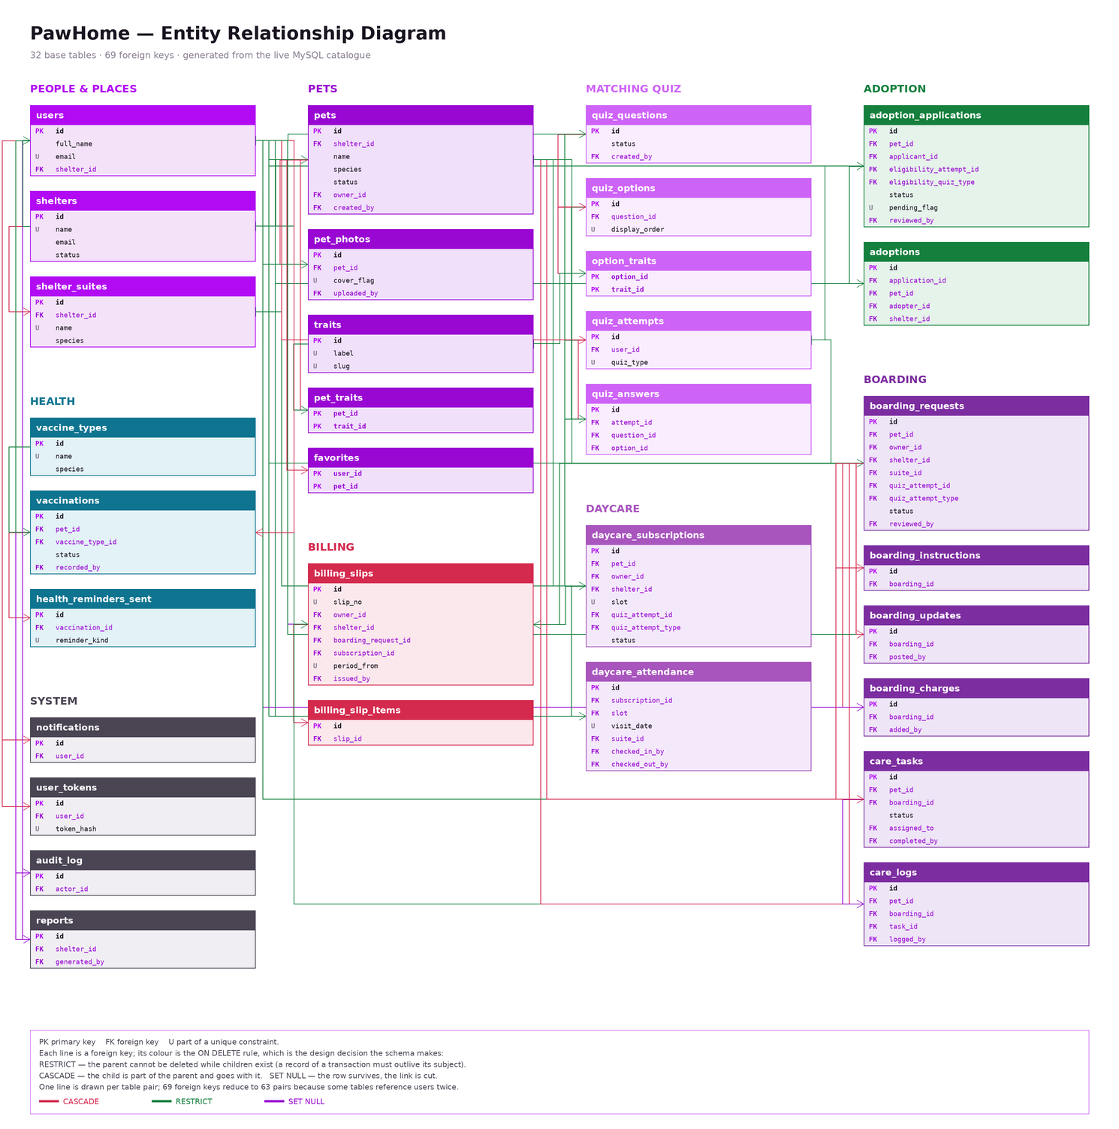
Figure 1. PawHome entity relationship diagram — 32 entities, 69 foreign keys, grouped by subject area.

10. Schema Diagram
The physical schema: every column of all 32 base tables with its declared type and nullability, exactly as MySQL reports it. Primary keys are bold, foreign keys brown, and columns participating in a unique index are marked U. This is page 2 of the accompanying draw.io file.
The four views are deliberately absent. A view stores no data of its own; all four are defined in migration V19 over the tables shown here, and their 61 columns are projections of these 290.
The schema is split across the two figures below so that the column names stay legible on the page. Together they show all 32 tables; nothing is omitted. The draw.io file has the same content on one canvas, where it can be zoomed.
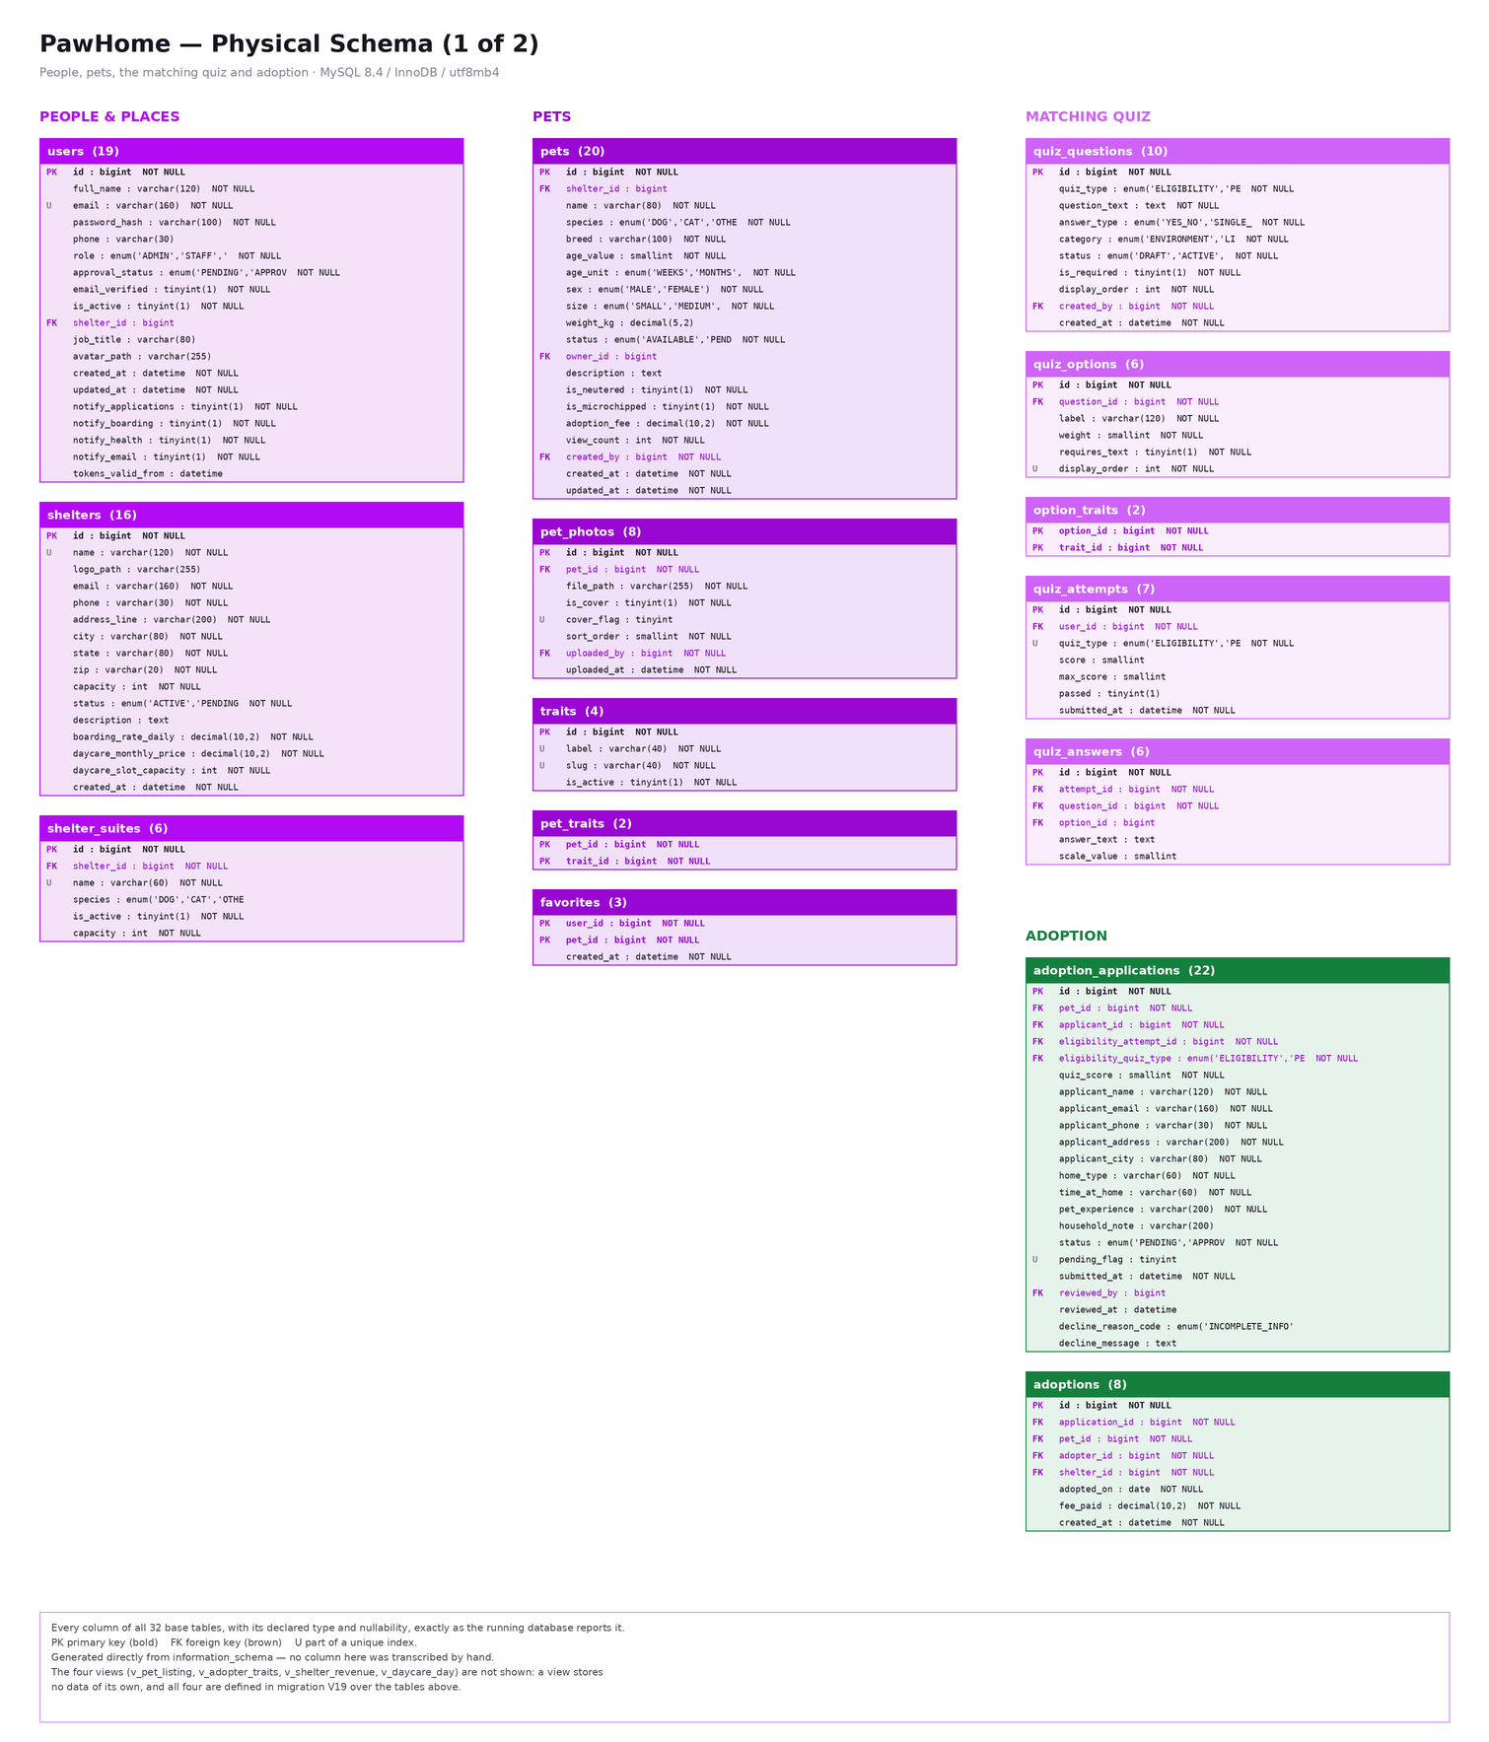
Figure 2. PawHome physical schema, part 1 of 2 — people and places, pets, the matching quiz, adoption.

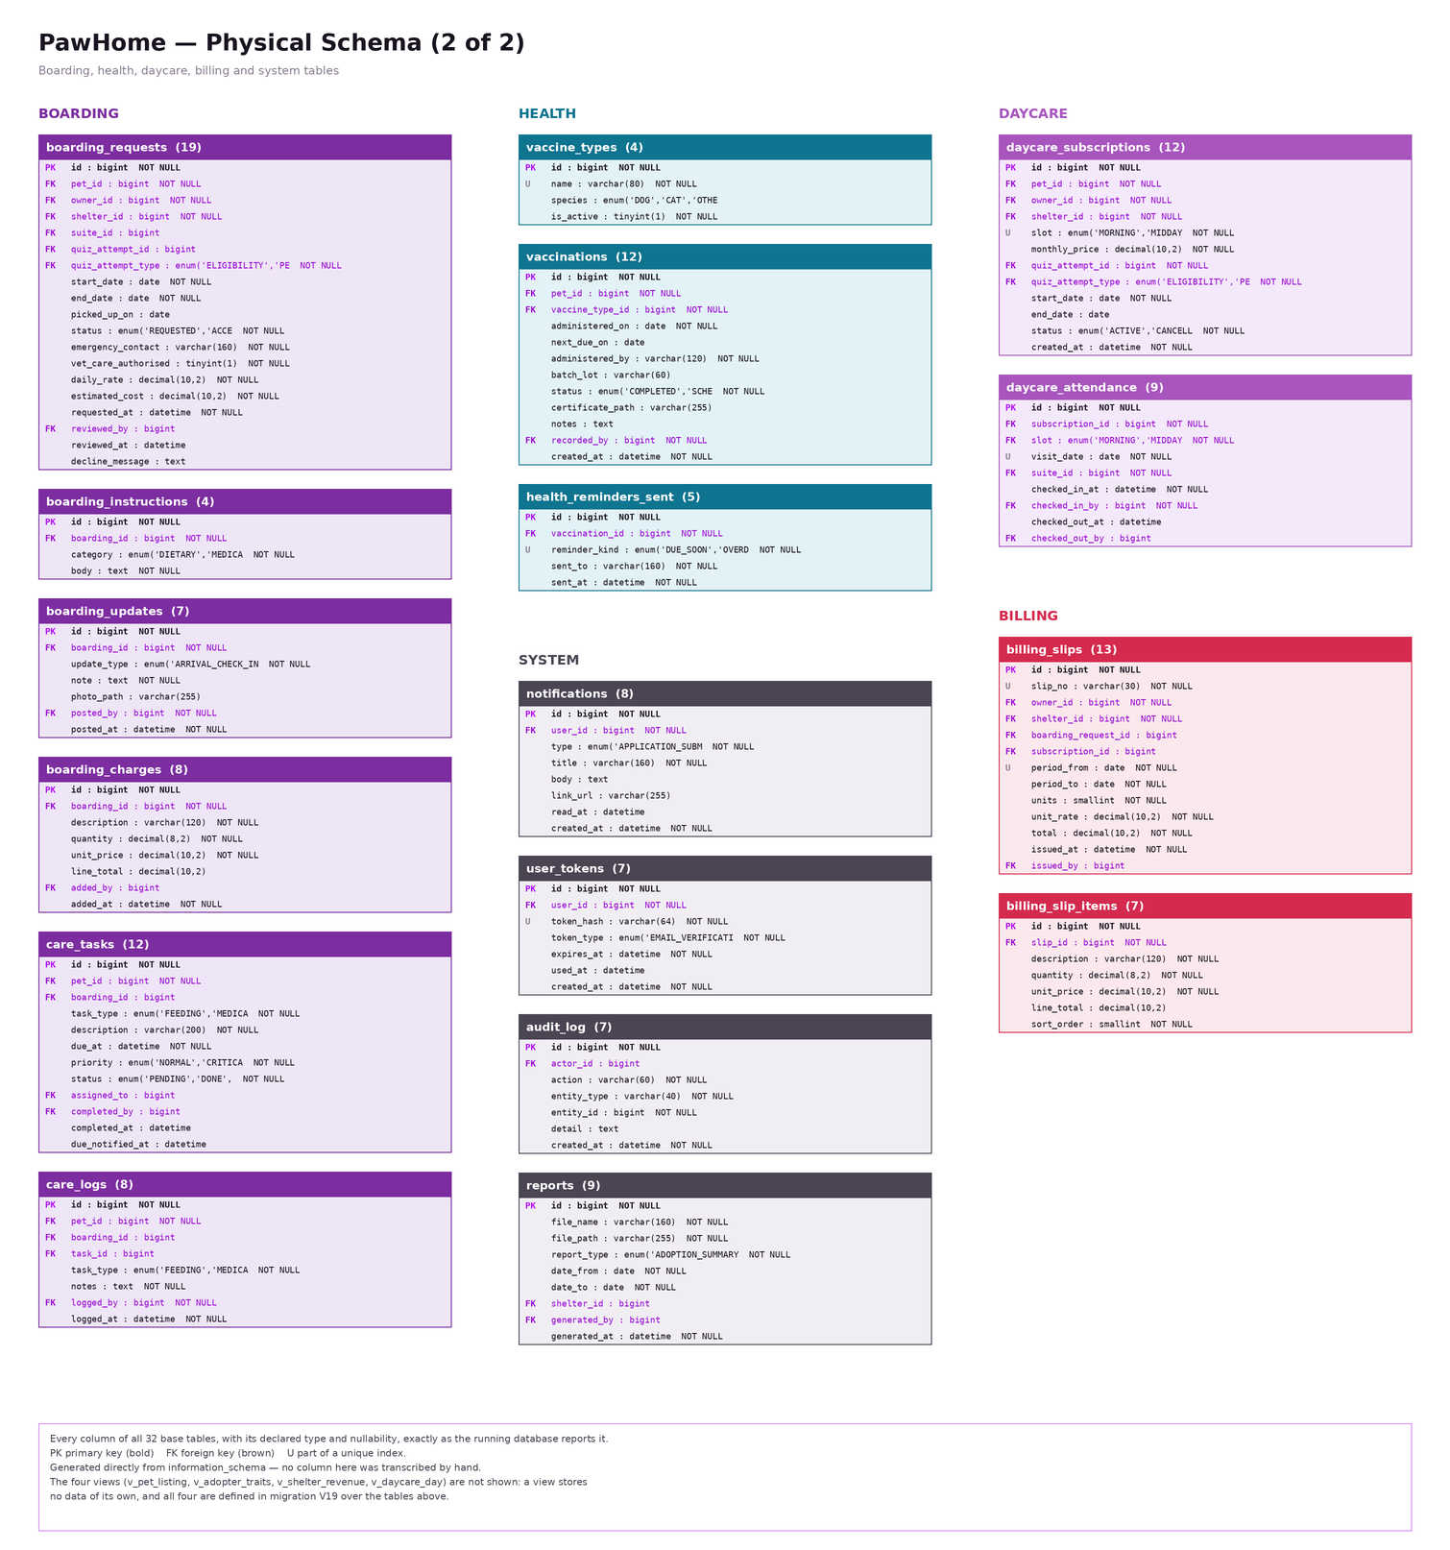
Figure 3. PawHome physical schema, part 2 of 2 — boarding, health, daycare, billing and system tables.

11. Queries to Implement Features
The application reaches the database three ways, and it is worth separating them before showing the queries, because a reader who sees only the hand-written SQL would conclude the system barely writes anything.
Mechanism | Count | What it does
Flyway migrations | 19 files | DDL only — CREATE TABLE, ALTER TABLE, CREATE VIEW. Never writes a data row.
Hibernate / JPA | 90 call sites | Single-row INSERT, UPDATE and DELETE, generated at runtime from the 29 entity classes when the code calls save() or delete(). This SQL does not appear in the source.
JdbcTemplate and @Query | 149 statements | Every read, and the writes that change many rows in one statement. These are written by hand and are the queries shown below.
Of the 149 hand-written statements, 128 are SELECT, 12 UPDATE, 5 DELETE and 4 INSERT. The writes are hand-written precisely because each changes a set of rows at once; through an ORM each would be a loop of single-row updates.
A complete listing of all 149 statements with the endpoint that runs each one accompanies this report as PawHome_Queries.pdf, and the Hibernate-generated statements as PawHome_Hibernate_Writes.pdf. What follows is one query per major feature, chosen because each shows a different technique.

11.1 Browse the catalogue — composite index and a view
Feature 7.2.1. The public catalogue reads v_pet_listing so that every screen agrees on what a listing is; the WHERE clause is served by idx_pets_browse (status, species, size).
SELECT pet_id, pet_name, species, breed, age_value, age_unit, sex, size,
adoption_fee, shelter_name, shelter_city, cover_photo_path,
trait_labels, open_application_count, is_vaccinated
FROM v_pet_listing
WHERE status = 'AVAILABLE'
AND (? IS NULL OR species = ?)
AND (? IS NULL OR size = ?)
AND (? IS NULL OR shelter_id = ?)
ORDER BY created_at DESC
LIMIT ? OFFSET ?

11.2 Prevent double-booking — a pessimistic lock
Feature 7.4.6. The single most important query in the project. @Lock(PESSIMISTIC_WRITE) appends FOR UPDATE, which is what makes two simultaneous acceptances impossible; section 6.2 measures it working.
SELECT b FROM BoardingRequest b
WHERE b.petId = :petId
AND b.status IN (BoardingStatus.ACCEPTED, BoardingStatus.ACTIVE)
AND b.startDate <= :end
AND b.endDate >= :start
ORDER BY b.startDate
The overlap test is the pair of inequalities, not BETWEEN: two closed date ranges overlap when each starts on or before the other ends. BETWEEN would miss a stay that straddles the new dates entirely. There is deliberately no "exclude myself" parameter — the row being accepted is still REQUESTED, and REQUESTED does not hold dates, so it cannot match its own query.

11.3 Approve an application — one statement, many rows
Feature 7.4.5. Approving one application must reject every rival application for the same pet. This is why the write is hand-written rather than left to the ORM: it is one statement whatever the number of rivals, where save() in a loop would be one round trip each.
UPDATE adoption_applications
SET status = 'REJECTED',
reviewed_by = :reviewerId,
reviewed_at = :decidedAt,
decline_reason_code = 'PET_ALREADY_MATCHED',
decline_message = :message
WHERE pet_id = :petId
AND id <> :keepId
AND status = 'PENDING'

11.4 Is there room in the building? — a capacity check under lock
Feature 7.4.6. Counts the places already committed for the dates requested. It runs inside the transaction that holds a lock on the shelter row, so the count cannot change between reading it and acting on it.
SELECT COUNT(*)
FROM boarding_requests
WHERE shelter_id = ?
AND status IN ('ACCEPTED','ACTIVE')
AND start_date <= ?
AND end_date >= ?

11.5 Match an adopter to pets — a view and a scored join
Feature 7.2.5. v_adopter_traits turns a quiz attempt into a weighted trait profile; the recommendation scores each available pet against it.
SELECT p.id, p.name, p.species, p.breed,
SUM(at.weight) AS match_score
FROM v_adopter_traits at
JOIN pet_traits pt ON pt.trait_id = at.trait_id
JOIN pets p ON p.id = pt.pet_id
WHERE at.attempt_id = ?
AND p.status = 'AVAILABLE'
GROUP BY p.id, p.name, p.species, p.breed
ORDER BY match_score DESC, p.created_at DESC
LIMIT ?

11.6 The daycare arrivals board — eight tables, one view
Features 7.4.13 and 7.3.6. v_daycare_day joins the attendance row to the subscription, pet, owner, shelter, room and both staff members, and computes minutes on site against NOW() so the figure keeps climbing while the animal is there.
SELECT attendance_id, visit_date, slot, pet_name, species,
owner_name, suite_name, checked_in_at, checked_out_at,
still_here, minutes_on_site,
checked_in_by_name, checked_out_by_name
FROM v_daycare_day
WHERE shelter_id = ? AND visit_date = ?
ORDER BY still_here DESC, checked_in_at
A duration is computed, never stored: a number of minutes frozen into a column is wrong one minute later. The check-out staff member is a LEFT JOIN because a visit has somebody who checked the pet in from the start, and somebody who checked it out only once that has happened — an inner join there would silently hide every pet currently on site, which is the opposite of what the board is for.

11.7 Revenue by shelter and month — aggregation that refuses to add nights to months
Feature 7.5.4. The crucial detail is that billing_slips.units means nights on a boarding slip and months on a subscription. The view keeps them in separate columns so no caller can sum them together.
SELECT s.id AS shelter_id,
s.name AS shelter_name,
DATE_FORMAT(bs.issued_at, '%Y-%m-01') AS billed_month,
COALESCE(SUM(CASE WHEN bs.boarding_request_id IS NOT NULL
THEN bs.units END), 0) AS nights_billed,
COALESCE(SUM(CASE WHEN bs.boarding_request_id IS NOT NULL
THEN bs.total END), 0.00) AS boarding_total,
COALESCE(SUM(CASE WHEN bs.subscription_id IS NOT NULL
THEN bs.units END), 0) AS months_billed,
COALESCE(SUM(CASE WHEN bs.subscription_id IS NOT NULL
THEN bs.total END), 0.00) AS daycare_total,
COUNT(*) AS slips, SUM(bs.total) AS total_billed
FROM billing_slips bs
JOIN shelters s ON s.id = bs.shelter_id
GROUP BY s.id, s.name, DATE_FORMAT(bs.issued_at, '%Y-%m-01')

11.8 Which shelters run daycare?
Feature 7.3.6. A small query with a real decision in it: capacity alone would list every shelter, because the column has a default.
SELECT id, name, city, state, daycare_monthly_price, daycare_slot_capacity
FROM shelters
WHERE status = 'ACTIVE'
AND daycare_monthly_price > 0
AND daycare_slot_capacity > 0
ORDER BY name

11.9 A write Hibernate generates
For contrast, this is what repository.save(pet) emits when the entity has no id. It appears nowhere in the source: Hibernate derives it from the @Table and @Column annotations on the Pet class at runtime.
INSERT INTO pets
(shelter_id, name, species, breed, age_value, age_unit, sex, size,
weight_kg, status, description, adoption_fee, is_neutered,
is_microchipped, owner_id, view_count, created_by, created_at, updated_at)
VALUES (?, ?, ?, ?, ?, ?, ?, ?, ?, ?, ?, ?, ?, ?, ?, ?, ?, ?, ?)

12. Screenshots of the Application
The figures below cover one screen per major feature area, across all three roles.
Sign-in and registration
Replace this box with the screenshot.
Figure 4. Sign-in page. Email verification and role-based redirect after authentication.
Public catalogue — browse
Replace this box with the screenshot.
Figure 5. The public catalogue, showing species, size and shelter filters with pagination.
Pet detail page
Replace this box with the screenshot.
Figure 6. A pet's public page: photo gallery, traits, vaccination status and adoption fee.
Matching quiz and recommendations
Replace this box with the screenshot.
Figure 7. The matching quiz, and the pets recommended from the resulting trait profile.
Adopter — my pets and vaccinations
Replace this box with the screenshot.
Figure 8. An adopter's owned pets, with the vaccination record and reminder schedule.
Staff — application review
Replace this box with the screenshot.
Figure 9. Application review: the applicant's quiz result and household answers, with approve and decline.
Staff — my shelter and room occupancy
Replace this box with the screenshot.
Figure 10. Shelter management showing each room's live occupancy against its capacity.
Staff — boarding board
Replace this box with the screenshot.
Figure 11. The boarding board: requests, accepted stays and the pets currently in care.
Staff — daycare arrivals board
Replace this box with the screenshot.
Figure 12. The daycare day: expected arrivals, check-in and check-out, and attendance history.
Staff — daily care log
Replace this box with the screenshot.
Figure 13. Care tasks and the feeding, medication and exercise log for a boarding pet.
Admin — analytics dashboard
Replace this box with the screenshot.
Figure 14. The administrator dashboard: live counts, adoptions by month and revenue, from v_shelter_revenue.
Admin — billing and users
Replace this box with the screenshot.
Figure 15. Network-wide billing slips with the shelter filter, and user administration with approvals.

13. Limitations
These are the limitations we know about, found by auditing the system against itself rather than by hoping none existed. A mechanical cross-reference of all 151 endpoints against all front-end API calls found no broken call, no role mismatch and no ungated private endpoint — but it did find the following.

13.1 Functional gaps
- There is no administrator screen for daycare subscriptions. The endpoint exists and returns the data; nothing calls it.
- Quiz questions cannot be reordered after creation. display_order is set once at creation as max + 1, and the reorder endpoint has no user interface.
- An owner whose pet is boarding sees the stay timeline and their own instructions, but not the staff care log of feeding and medication. The data exists and is staff-only.
- Fourteen repository methods are declared, compile, and are called by nothing — two of them superseded by a JdbcTemplate query doing the same job in the matching service. They are harmless, but they are claims the code makes and does not keep.

13.2 Design limitations we accepted
- Cross-row rules cannot be declarative. "This room is not full" and "this pet is not already booked" are enforced by locking and re-reading inside a transaction, not by constraints. They are therefore only as strong as the discipline of always going through the service, and a direct UPDATE against the database could still create an overlapping stay.
- Room allocation uses Hall's condition rather than a full bipartite matching. It is correct as a feasibility test and fast, but it will not suggest the best arrangement of animals among rooms.
- Reading the catalogue through v_pet_listing is roughly eight times slower than the hand-written equivalent, because MySQL materialises the view before applying LIMIT (section 6.3). We chose the single definition over the speed, knowingly.
- The audit log records seven kinds of action, not every change. It is a record of consequential decisions, not a full change history, so it cannot answer "who edited this field last".
- A deleted user leaves anonymous entries in the audit log, because audit_log.actor_id is ON DELETE SET NULL. The entry survives; the name does not.

13.3 Operational limitations
- Single database instance, no replication and no automated backup. Acceptable for a course project, not for a shelter network.
- Photographs are stored on the application server's filesystem with only their paths in the database, so the file store and the database can drift apart if one is restored without the other.
- No load testing was performed. Section 6 measures individual queries and one concurrency case; nothing was run under sustained multi-user load.
- Email delivery depends on a single SMTP account; if it is unavailable, verification and reset links are not sent, and the affected flows stall.

14. Future Work

14.1 Closing the known gaps
- Build the administrator daycare screen and the quiz reorder interface; both have working endpoints waiting.
- Give owners a read-only view of the care log for their own boarding pet.
- Either wire up or delete the fourteen uncalled repository methods — an uncalled query is a maintenance cost with no benefit.

14.2 Database work
- Measure whether a narrower listing view, or a materialised summary table refreshed on write, removes the view's cost on the catalogue page without giving up the single definition.
- Partition daycare_attendance and boarding_updates by date. Both grow without bound and are almost always queried for a recent window.
- Add a full-text index on pets.name and pets.description. Search is currently a LIKE, which no index can serve.
- Introduce an optimistic-locking version column on pets and boarding_requests so that two staff members editing the same record do not silently overwrite one another — the pessimistic locks protect bookings, not edits.
- Record the care log at a finer grain and expose it as a timeline, which would also make the audit log a genuine change history.

14.3 Features
- Foster placements — the nearest missing module to what shelters actually need, and a natural extension of the boarding model: a pet in a household that is not its owner's.
- Online payment for boarding and daycare bills; the slip model already carries everything a payment would need to reference.
- Microchip registration, so a found animal can be traced back to its adoption record.
- Improve matching beyond the summed trait score — the current model treats every trait weight as independent, which is a reasonable first approximation and not much more.
- A mobile client for staff, since check-in, check-out and care logging all happen away from a desk.

14.4 Engineering
- Automated tests around the capacity and locking rules specifically; they are the parts where a regression would be both easy to introduce and hard to notice.
- Database backups with a tested restore, and a read replica for analytics so reporting cannot slow the operational path.
- Move photograph storage to object storage with the database as the only index.

15. Conclusion
PawHome implements the full life of an animal in a shelter's care: registration, public listing, matching, application, adoption, and then boarding, daycare, daily care, health records and billing for the animal that comes back. It is a working system of 32 tables, 4 views, 151 endpoints and 47 screens, with three roles whose boundaries are enforced in the filter chain rather than assumed in the interface.
What we set out to learn was how much of a system's correctness can be pushed into the database, and the answer turned out to be: most of it, but not all, and the boundary is sharp. Thirty-nine CHECK constraints, sixty-nine foreign keys and a deliberate ON DELETE policy for every one of them carry the rules that fit inside a single row or a single relationship. The rules that span rows — this room is not full, this animal is not already booked — cannot be stated declaratively in MySQL at all, and had to become transactions holding pessimistic locks. Learning to tell those two categories apart was the most useful thing the project taught us.
The measurements in section 6 are the part we would defend most readily, including the one that went against us. A composite index turned a 60,000-row scan into a 5,714-row lookup. A FOR UPDATE lock demonstrably serialised two simultaneous bookings, where the same query without it let both through. And reading the catalogue through a view proved roughly eight times slower than the hand-written equivalent, because LIMIT cannot be pushed through a materialised view — a result we kept in the report because a benchmark that only confirms your decisions is not a benchmark.
The system is not finished, and section 13 is an honest list of where it stops. But every number in this report was read from the running database or counted from the source rather than estimated, every diagram was generated from the live catalogue rather than drawn by hand, and the limitations were found by auditing the system against itself. That, more than the feature count, is what we would want the work judged on.

Accompanying files: pawhome-diagrams.drawio (ERD and schema, editable) · PawHome_Queries.pdf (all 149 hand-written statements with the endpoint that runs each) · PawHome_Hibernate_Writes.pdf (the generated INSERT/UPDATE/DELETE) · docs/WINDOWS_SETUP.md (how to run the project).

