**Manual to the program “Period_D&P v 5.4”**

Kashko P.P.1,2, Tvardovskyi D.E.1,3

*1 Universit $\acute{e}$ de Moncton, Moncton, New Brunswik, Canada*

*2 Taras Shevchenko National University of Kyiv, Kyiv, Ukraine*

*3 Odessa National I.I. Mechnikov University, Odessa, Ukraine*

Contents

Introduction 2

Astrophysical background 2

Mathematical methods 4

Algorithm 4

Input data 4

Output 5

For users 5

References 5

Created 29 May 2019

# Introduction

***Period_D&P v5.4*** is a program which calculates parameters of flux changes for different types of periodical variable stars. It uses photometric observations from text file, plots light curve, makes fitting, then calculates value of the period, plots phase curve and cuts all points which have too large deviation between fit and observations.

# Astrophysical background

Variable star is a star or stellar system which changes or changed its brightness (or, as astronomers call it, magnitude) at least ones during all the history of observations and the precision of the observational equipment was enough to detect such changes.

There are more than 100 types and 7 main categories of variable stars according to General Catalogue of Variable Stars (GCVS). Totally in GCVS more than 50 000 variable stars are listed, each of them have the unique name (a few letters or a number + constellation) and list of parameters. In some of variable stars brightness changes are caused by the explosion-like processes. In these stellar systems changes are not periodic. In other types brightness variations are caused by eclipses of one star by another (eclipsing binary stars) or by various kinds of pulsations. Such changes are periodical and the period could remain constant for hundreds of years. Usually the period is in range between several hours and several dozens of years. Average value for eclipsing binary systems is about several days.

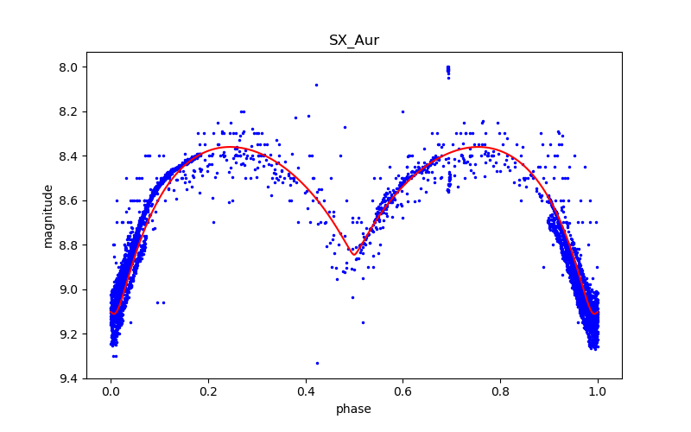

Period

Fig. 1. Typical dependence between time and brightness of the eclipsing binary star (SX Aur).

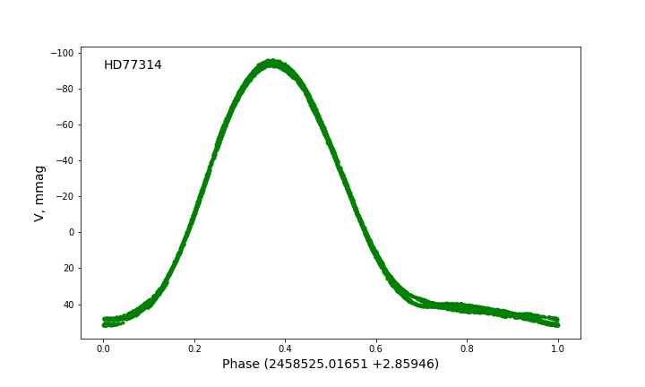

Period

Phase

Magnitude (x0.001)

Fig. 2. Typical dependence between time and brightness of the pulsating star.

GCVS is not only one catalogue of variable stars. There are many others such as Hipparcos (HIP…), AAVSO catalogue, Simbad database etc.

If scientists get value of the period, they could consider many processes caused by presence of additional components, mass transfer or matter loss because of stellar wind etc. That’s why computing period from observations is a really important task.

After several month or years of observations, astronomers get the long data series of light variations. Such plot calls light curve.

Fig 3. Light curve for SX Aur

It is useful to see the amount of observed data, however it’s not comfortable for classification and calculations. That’s why astronomers use mostly phase curves (examples are Fig.1 & Fig.2) for stars with periodic light variations.

# Mathematical methods

To transform Julian date (JD) into phase (*φ*) it is necessary to know the period (P) and the “zero-point” which is called initial epoch (T0). The calculation needs two steps. The first one is calculation of the cycle number (E):

$$E=\frac{JD-T_{0}}{P} (1)$$

E is time interval (measured in periods) between considered moment of time and initial epoch. The second step is calculating the phase:

$$φ=E-integer\left(E\right) (2)$$

For eclipsing binary stars the initial epoch frequently equals to the Julian date of one of the moments of minimal brightness. For pulsating stars it is usually considered as the moment of maximal brightness.

To describe the periodical light curve we used trigonometric polynomial (similar to Fourier series):

$$m(JD)=C+\sum_{k=1}^{n}{A_{k}∙\cos\left(\frac{2πk}{T}∙JD+φ_{k}\right)} (3)$$

Here:

* $m$– magnitude as the function of JD;
* C – a constant (equals to average value of the magnitude during one cycle – it is ususally equal to zero);
* $A_{k}$, $φ_{k}$– amplitude and horizontal shift of each component of trigonometric polynomial.

All these values are named parameters of the approximation (or shorter – fit parameters). To find the most optimal fit parameters we used least-squares method (try to find such parameters to minimize sigma):

$${σ=\left[m_{obs}\left(JD\right)-C-\sum_{k=1}^{n}{A_{k}∙\cos\left(\frac{2πk}{T}∙JD+φ_{k}\right)}\right]}^{2} (4)$$

$$σ→0 (5)$$

Exactly, we used Levenberg-Marquardt algorithm because the model is not linear. There are two methods of estimation of initial parameters and obtaining corrected values, they are described at the paragraph “Algorithm”.

# Algorithm

The program works in 2 modes: Automatic and Manual.

1. Automatic

This mode requires the value of maximum possible period.

Firstly it set the T range {T_min; $T_{max}$} with step in Presize_appr_T. For each point $T_{0}$ program approximate the curve by trigonometric polynomial (3) with $n=n_app_T and$ $T= T_{0}$ and by the method of least squared find the most suitable ${ A}_{i} and φ_{i}$. In this case as start conditions program use by default: $A_{0}=\frac{\max\left(y\right)-min⁡(y)}{2} , A_{i}=φ_{i}=1$. After it, the program calculate the sum of average square deviations of all points from the approximated line. As the result, we obtain σ as the function of the period, after plotting which we get special graph – periodogram. Having the periodogram, the program find the minimum $T_{min}$.

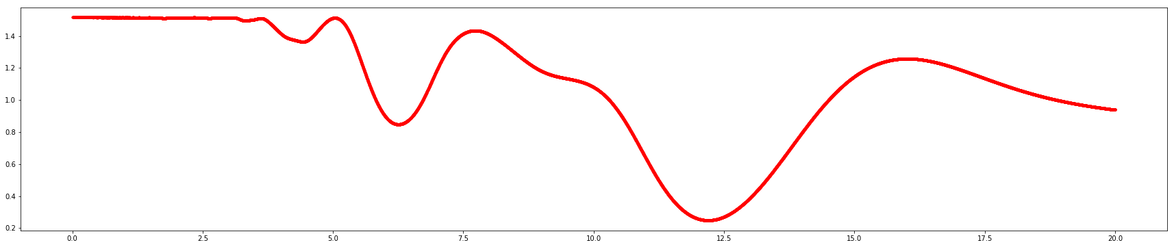

Fig. 4. Example of the periodogram

Secondly, the program try to approximate the light curve by trigonometric polynomial (n = n_becoming_perfect) with start condition of the best period from periodogram. For this approximation, we get ${ T}_{ideal}$, $A_{ideal}^{i}, { φ}_{ideal}^{i}$

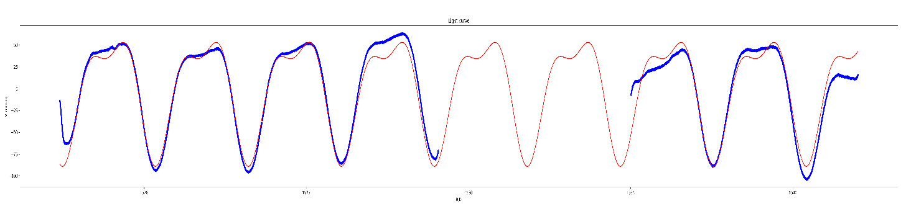

Fig. 5. Example of light curve

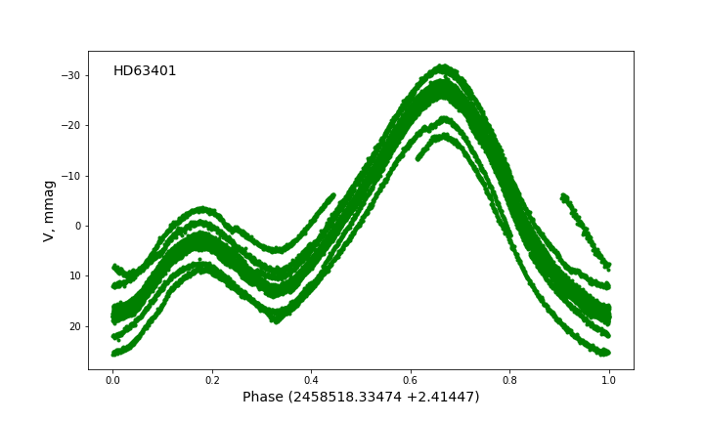

Fig. 6. Example of start phase curve

Thirdly, program plots phase curve using value ${T= T}_{ideal}$ and shift it so that it begins with the lowest value (also reverse the y-axe as the lower is magnitude – the brighter is the star). From this time program works with phase curve. As (Fig.5) shows, the light curve is not ideal as some part it (especially start and end are not in general order because of random noises). Therefore, it is better to not include them when calculating the best approximation. The program repeat N_cutting times each time time cut off dots that stands out at distance more than d (it is decreasing linearly with iterations) from max_width to Parametr

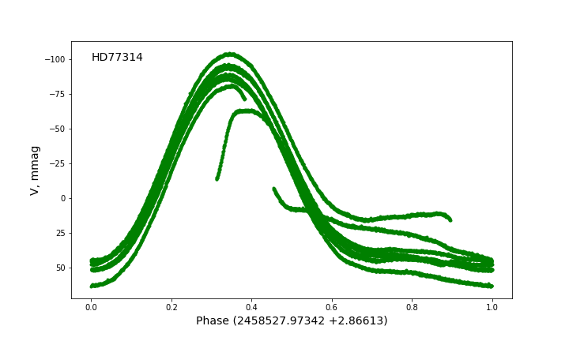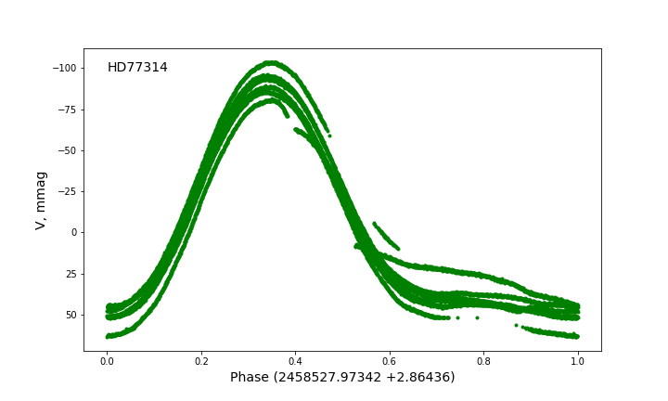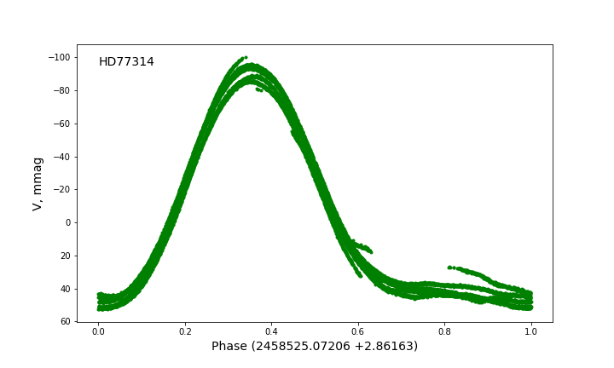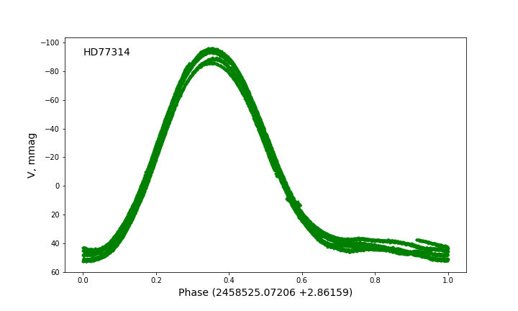

Fig. 6. Example of cutting phase curves

After all operation the user get the “clear” phase curve without noises and the value of period with high precise. The results of period are also written to file “results.dat” and pictures are saved in special directory for each star.

1. Manual

The program works almost the same. However, the first step is missed and the user input the estimated value of period and its error. The rest is the same

# Input data

At the beginning user can choose in which mode he will work

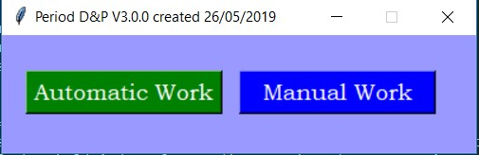

In Automatic mode user should create file “Name.txt” with task and put it in the same directory with the code. The format of data is next:

| name of star | file type | number of repeats | parameter p | n

For example:

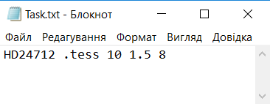

All data’s should be named “name_of_star.filetype” (for instance: HD63401.tess) and be putted in the same directory as code and task file.

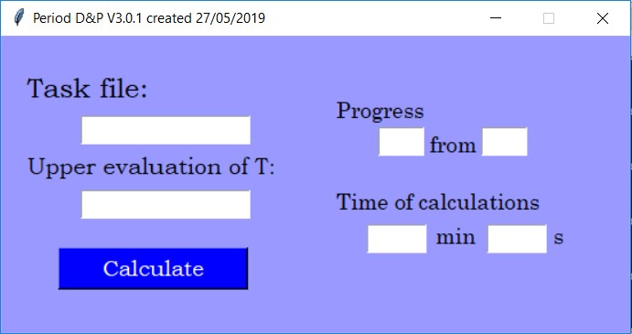

In Manual mode user can process only one star by one. All dates are inputting manually in the window

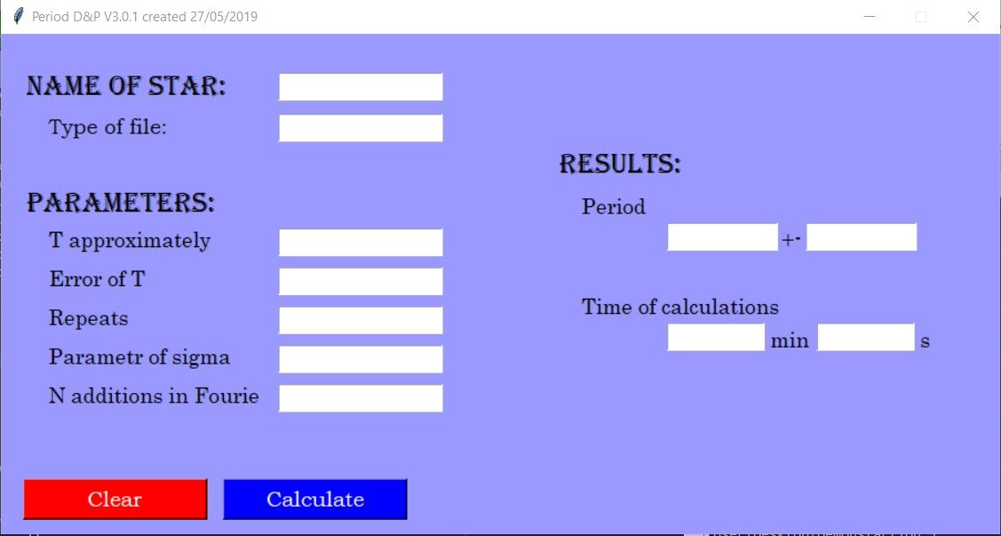

# Output

In Automatic mode, the program create for each star its own directory (or if it exists, write there). Then paste there a graph of light curve, a picture of peridogram, all graphs with cutting phase curves and the respective data of it. Therefore, user can choose which phase curve looks the best and have the data to it. Beside this, the program also create a file ‘results.dat’ (or rewrite existing) and write there the results of approximation in such format:

| name of star | period | error of period | time of calculations

For example

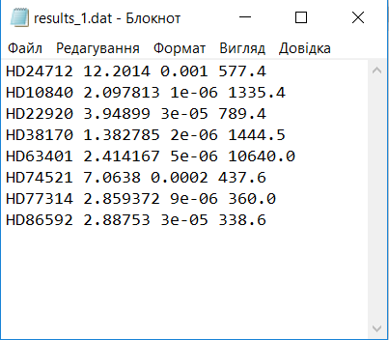

If during calculation some problem occurs, the program will miss this star and write in the “results.dat”: Problem. Check {name of star} + manually. It means that something went wrong and it is better to proceed this star manually. In the window, the program will show how many stars have succeeded and the total time of calculations.

In the manual mode, the program also creates the folder with the name of star and all graphs and datas. It does not create the file with the results. However, it shows them in the window

# For users

Do not hesitate to write authors your e-mails if something went wrong. We will be happy to help you.

E-Mails: [kashko.pavlo@gmail.com](mailto:kashko.pavlo@gmail.com), [dmytro.tvardovskyi@gmail.com](mailto:dmytro.tvardovskyi@gmail.com)

# References

Marquardt D.: 1963, SIAM Journal on Applied Mathematics. 11 (2): 431

<https://pdfs.semanticscholar.org/6b6a/a371154f9ffedea68f2f0140bc18e9a71211.pdf>