DevOps Capstone Project - Microservices Deployment Pipeline
CI/CD Pipeline Terraform Kubernetes AWS
A production-grade DevOps implementation showcasing complete infrastructure automation, CI/CD pipeline, container orchestration, and comprehensive monitoring for a microservices architecture.

🎯 Project Overview
This project demonstrates a full DevOps lifecycle implementation using industry-standard tools and practices. It features:
- Infrastructure as Code with Terraform for reproducible AWS infrastructure
- Self-Managed Kubernetes cluster on EC2 for cost optimization
- Automated CI/CD Pipeline using GitHub Actions
- Comprehensive Monitoring with Prometheus and Grafana
- Cloud-Native Architecture optimized for AWS Free Tier

📋 Table of Contents
- Architecture
- Technologies Used
- Infrastructure Details
- Prerequisites
- Quick Start
- Detailed Setup
- CI/CD Pipeline
- Monitoring & Observability
- Project Structure
- Cost Optimization
- Troubleshooting
- Lessons Learned

🏗️ Architecture

System Architecture
┌─────────────────────────────────────────────────────────────┐
│ AWS Cloud │
│ ┌───────────────────────────────────────────────────────┐ │
│ │ VPC (10.0.0.0/16) │ │
│ │ ┌─────────────────────────────────────────────────┐ │ │
│ │ │ Application Load Balancer (ALB) │ │ │
│ │ │ dev-k8s-alb-390827176 │ │ │
│ │ └────────────────┬────────────────────────────────┘ │ │
│ │ │ │ │
│ │ ┌────────────────▼────────────────────────────────┐ │ │
│ │ │ Kubernetes Cluster (Self-Managed on EC2) │ │ │
│ │ │ Master Node: 65.0.130.95 (t2.medium) │ │ │
│ │ │ ┌──────────────────────────────────────────┐ │ │ │
│ │ │ │ Namespace: microservices-demo │ │ │ │
│ │ │ │ ┌────────────────────────────────────┐ │ │ │ │
│ │ │ │ │ Frontend (Nginx) - Replicas: 2 │ │ │ │ │
│ │ │ │ │ Backend Services │ │ │ │ │
│ │ │ │ │ Web Application │ │ │ │ │
│ │ │ │ └────────────────────────────────────┘ │ │ │ │
│ │ │ └──────────────────────────────────────────┘ │ │ │
│ │ │ ┌──────────────────────────────────────────┐ │ │ │
│ │ │ │ Namespace: monitoring │ │ │ │
│ │ │ │ ┌────────────────────────────────────┐ │ │ │ │
│ │ │ │ │ Prometheus (Port 30090) │ │ │ │ │
│ │ │ │ │ Grafana (Port 30030) │ │ │ │ │
│ │ │ │ │ Alertmanager │ │ │ │ │
│ │ │ │ └────────────────────────────────────┘ │ │ │ │
│ │ │ └──────────────────────────────────────────┘ │ │ │
│ │ └─────────────────────────────────────────────────┘ │ │
│ │ │ │ │
│ │ ┌────────────────▼────────────────────────────────┐ │ │
│ │ │ RDS PostgreSQL (db.t3.micro) │ │ │
│ │ │ dev-postgres-db.cdg662ceww7b.rds.amazonaws.com│ │ │
│ │ │ Database: microservices_db │ │ │
│ │ └─────────────────────────────────────────────────┘ │ │
│ └───────────────────────────────────────────────────────┘ │
│ │
│ Network Configuration: │
│ - VPC CIDR: 10.0.0.0/16 │
│ - Public Subnets: 2 (AZ: ap-south-1a, ap-south-1b) │
│ - Private Subnets: 2 │
│ - Region: ap-south-1 (Mumbai, India) │
└─────────────────────────────────────────────────────────────┘
│ │
│ │
┌────▼─────┐ ┌────▼─────┐
│ GitHub │ │Developer │
│ Actions │ │Workstation│
│ CI/CD │ │ │
└──────────┘ └──────────┘

Infrastructure Components
Component | Service | Configuration | Purpose
Cloud Provider | AWS | Region: ap-south-1 | Infrastructure hosting
Kubernetes Master | EC2 t2.medium | 2 vCPU, 4GB RAM | K8s control plane
VPC | Custom VPC | CIDR: 10.0.0.0/16 | Network isolation
Subnets | Public/Private | 2 AZs | High availability
Load Balancer | Application LB | ALB | Traffic distribution
Database | RDS PostgreSQL | db.t3.micro | Persistent storage
Container Runtime | Docker | Latest | Containerization
Orchestration | Kubernetes | v1.28 | Container management
Monitoring | Prometheus/Grafana | Latest | Observability

Application Services
Service | Replicas | Port | Type | Description
webapp | 2 | 80 | NodePort (30080) | Main web application (Nginx)
frontend | 2 | 80 | NodePort (30081) | Frontend service
backend | 2 | 80 | ClusterIP | Backend API services

🛠️ Technologies Used

Infrastructure & Cloud
- Terraform v1.0+ - Infrastructure as Code
- AWS Cloud - Cloud infrastructure provider
  - EC2 - Virtual machines
  - VPC - Virtual Private Cloud
  - RDS - Managed database
  - ALB - Application Load Balancer
  - Security Groups - Network security

Container & Orchestration
- Docker - Container runtime
- Kubernetes v1.28 - Container orchestration
- kubeadm - Kubernetes cluster setup
- Flannel CNI - Kubernetes networking
- Helm v3 - Kubernetes package manager

CI/CD
- GitHub Actions - Automation pipeline
- kubectl - Kubernetes CLI
- Git - Version control

Monitoring
- Prometheus - Metrics collection and storage
- Grafana - Metrics visualization
- Alertmanager - Alert handling
- kube-state-metrics - Kubernetes metrics
- node-exporter - Node metrics

Development Tools
- AWS CLI v2 - AWS command-line interface
- Git - Version control
- VS Code - Code editor
- Ubuntu 22.04 - Development environment

📊 Infrastructure Details

AWS Resources Created
# VPC Configuration
- VPC: 10.0.0.0/16
- Public Subnets: 10.0.1.0/24, 10.0.2.0/24
- Private Subnets: 10.0.3.0/24, 10.0.4.0/24
- Internet Gateway: 1
- Route Tables: 1 public
- Security Groups: 2 (K8s master, RDS)
# Compute
- EC2 Instance: t2.medium (Kubernetes master)
- vCPU: 2
- Memory: 4 GB
- Storage: 30 GB EBS (gp2)
- Public IP: 65.0.130.95
- Private IP: 10.0.1.206
# Database
- RDS PostgreSQL 15
- Instance: db.t3.micro
- Storage: 20 GB
- Multi-AZ: No (single instance)
- Backup: 7 days retention
# Load Balancer
- Application Load Balancer
- Scheme: Internet-facing
- Target Group: Port 30080
- Health Check: HTTP /

Network Architecture
Public Subnets (10.0.1.0/24, 10.0.2.0/24)
├── Kubernetes Master Node (10.0.1.206)
├── Application Load Balancer
└── Internet Gateway
Private Subnets (10.0.3.0/24, 10.0.4.0/24)
└── RDS PostgreSQL Database

✅ Prerequisites

Required Software
Install these tools on your local machine:
# AWS CLI
curl "https://awscli.amazonaws.com/awscli-exe-linux-x86_64.zip" -o "awscliv2.zip"
unzip awscliv2.zip
sudo ./aws/install
# Terraform
wget https://releases.hashicorp.com/terraform/1.6.0/terraform_1.6.0_linux_amd64.zip
unzip terraform_1.6.0_linux_amd64.zip
sudo mv terraform /usr/local/bin/
# kubectl
curl -LO "https://dl.k8s.io/release/$(curl -L -s https://dl.k8s.io/release/stable.txt)/bin/linux/amd64/kubectl"
sudo install -o root -g root -m 0755 kubectl /usr/local/bin/kubectl
# Helm
curl https://raw.githubusercontent.com/helm/helm/main/scripts/get-helm-3 | bash

AWS Account Setup
- Create AWS Account - Free tier eligible
- Create IAM User with programmatic access
- Attach Policies:
  - AmazonEC2FullAccess
  - AmazonVPCFullAccess
  - AmazonRDSFullAccess
  - ElasticLoadBalancingFullAccess
- Configure AWS CLI:
- aws configure
# AWS Access Key ID: <your-key>
# AWS Secret Access Key: <your-secret>
# Default region: ap-south-1
# Default output format: json

Verify Installation
aws --version # aws-cli/2.x.x
terraform --version # Terraform v1.x.x
kubectl version --client # v1.28.x
helm version # v3.x.x
git --version # git version 2.x.x

🚀 Quick Start

1. Clone Repository
git clone https://github.com/Pawan-321/microservices-app.git
cd microservices-app

2. Create SSH Key Pair
aws ec2 create-key-pair \
--key-name <name>\
--query 'KeyMaterial' \
--output text > ~/.ssh/<name>.pem
chmod 400 ~/.ssh/<name>.pem

3. Configure Terraform Variables
cd terraform/environments/dev
# Create terraform.tfvars
cat > terraform.tfvars <<EOF
aws_region = "ap-south-1"
environment = "dev"
key_name = "name"
db_username = "dbadmin"
db_password = "YourSecurePassword123!"
EOF

4. Deploy Infrastructure
# Initialize Terraform
terraform init
# Review the plan
terraform plan
# Deploy infrastructure
terraform apply -auto-approve
# Save outputs
terraform output > outputs.txt

5. Access Kubernetes Cluster
# Get master node IP from outputs
K8S_MASTER_IP=$(terraform output -raw k8s_master_ip)
# SSH to Kubernetes master
ssh -i ~/.ssh/<name>.pem ubuntu@$K8S_MASTER_IP
# Verify cluster status
kubectl get nodes
kubectl get pods --all-namespaces

6. Deploy Application
# On Kubernetes master, create manifests
mkdir -p k8s-manifests
cat > k8s-manifests/webapp.yaml <<'EOF'
apiVersion: v1
kind: Namespace
metadata:
name: microservices-demo
---
apiVersion: apps/v1
kind: Deployment
metadata:
name: webapp
namespace: microservices-demo
spec:
replicas: 2
selector:
matchLabels:
app: webapp
template:
metadata:
labels:
app: webapp
spec:
containers:
- name: nginx
image: nginx:alpine
ports:
- containerPort: 80
---
apiVersion: v1
kind: Service
metadata:
name: webapp
namespace: microservices-demo
spec:
type: NodePort
selector:
app: webapp
ports:
- port: 80
targetPort: 80
nodePort: 30080
EOF
# Deploy
kubectl apply -f k8s-manifests/
# Verify
kubectl get pods -n microservices-demo

7. Access Application
# Via NodePort
http://65.0.130.95:30080
# Via Load Balancer
http://dev-k8s-alb-390827176.ap-south-1.elb.amazonaws.com

📚 Detailed Setup

Infrastructure Deployment

Step 1: VPC and Network Setup
The VPC module creates: - 1 VPC with DNS enabled - 2 Public subnets across 2 AZs - 2 Private subnets across 2 AZs - 1 Internet Gateway - Route tables and associations

Step 2: Kubernetes Cluster Setup
The Kubernetes module provisions: - EC2 instance with Ubuntu 22.04 - Docker installation and configuration - Kubernetes v1.28 installation (kubeadm, kubelet, kubectl) - Cluster initialization with Flannel CNI - Single-node cluster (master can schedule pods)

Step 3: Database Setup
The RDS module creates: - PostgreSQL 15 instance - db.t3.micro (Free tier eligible) - 20 GB storage - Private subnet deployment - Security group allowing VPC access

Step 4: Load Balancer Setup
- Application Load Balancer
- Target group pointing to K8s NodePort (30080)
- HTTP listener on port 80
- Health checks configured

Kubernetes Configuration
# Copy kubeconfig to local machine
scp -i ~/.ssh/<name>.pem \
ubuntu@<ip>:~/.kube/config \
~/.kube/config
# Verify local kubectl access
kubectl cluster-info
kubectl get nodes

🔄 CI/CD Pipeline

Pipeline Architecture
┌─────────────┐
│ Developer │
│ Commits │
└──────┬──────┘
│
▼
┌─────────────────┐
│ GitHub Repo │
│ (Push to main) │
└──────┬──────────┘
│
▼
┌────────────────────────────────────┐
│ GitHub Actions Workflow │
│ │
│ ┌──────────────────────────────┐ │
│ │ Job 1: Test & Validate │ │
│ │ - Validate K8s manifests │ │
│ │ - Run syntax checks │ │
│ └──────────────────────────────┘ │
│ │ │
│ ▼ │
│ ┌──────────────────────────────┐ │
│ │ Job 2: Security Scan │ │
│ │ - Trivy vulnerability scan │ │
│ │ - Upload results │ │
│ └──────────────────────────────┘ │
│ │ │
│ ▼ │
│ ┌──────────────────────────────┐ │
│ │ Job 3: Deploy to K8s │ │
│ │ - Configure kubectl │ │
│ │ - Apply manifests │ │
│ │ - Verify deployment │ │
│ └──────────────────────────────┘ │
└────────────────────────────────────┘
│
▼
┌─────────────────┐
│ Kubernetes │
│ Cluster │
│ (65.0.130.95) │
└─────────────────┘

GitHub Actions Workflow
Create .github/workflows/deploy.yaml:
name: Deploy to Kubernetes
on:
push:
branches: [ main ]
pull_request:
branches: [ main ]
env:
K8S_NAMESPACE: microservices-demo
jobs:
test:
name: Test & Validate
runs-on: ubuntu-latest
steps:
- uses: actions/checkout@v3
- name: Validate Kubernetes manifests
run: |
wget https://github.com/instrumenta/kubeval/releases/latest/download/kubeval-linux-amd64.tar.gz
tar xf kubeval-linux-amd64.tar.gz
sudo mv kubeval /usr/local/bin
kubeval k8s-manifests/*.yaml
security-scan:
name: Security Scan
runs-on: ubuntu-latest
needs: test
steps:
- uses: actions/checkout@v3
- name: Run Trivy scanner
uses: aquasecurity/trivy-action@master
with:
scan-type: 'fs'
scan-ref: '.'
format: 'sarif'
output: 'trivy-results.sarif'
deploy:
name: Deploy to Kubernetes
runs-on: ubuntu-latest
needs: [test, security-scan]
if: github.ref == 'refs/heads/main'
steps:
- uses: actions/checkout@v3
- name: Configure kubectl
run: |
mkdir -p ~/.kube
echo "${{ secrets.KUBE_CONFIG }}" | base64 -d > ~/.kube/config
- name: Deploy application
run: |
kubectl apply -f k8s-manifests/
kubectl rollout status deployment/webapp -n ${{ env.K8S_NAMESPACE }}
- name: Verify deployment
run: |
kubectl get pods -n ${{ env.K8S_NAMESPACE }}
kubectl get svc -n ${{ env.K8S_NAMESPACE }}

Required GitHub Secrets
Navigate to: Repository → Settings → Secrets → Actions
Secret Name | Value | Description
AWS_ACCESS_KEY_ID | ... | AWS access key
AWS_SECRET_ACCESS_KEY | ... | AWS secret key
K8S_MASTER_IP | ……. | Kubernetes master IP
KUBE_CONFIG | Base64 encoded kubeconfig | K8s cluster credentials
Get KUBE_CONFIG value:
ssh ubuntu@<ip>'cat ~/.kube/config | base64 -w 0'

📊 Monitoring & Observability

Prometheus + Grafana Setup
# SSH to Kubernetes master
ssh -i ~/.ssh/<name>.pem ubuntu@ip
# Add Prometheus Helm repository
helm repo add prometheus-community https://prometheus-community.github.io/helm-charts
helm repo update
# Create monitoring namespace
kubectl create namespace monitoring
# Install Prometheus + Grafana stack
helm install prometheus prometheus-community/kube-prometheus-stack \
--namespace monitoring \
--set prometheus.service.type=NodePort \
--set prometheus.service.nodePort=30090 \
--set grafana.service.type=NodePort \
--set grafana.service.nodePort=30030
# Get Grafana admin password
kubectl get secret --namespace monitoring prometheus-grafana \
-o jsonpath="{.data.admin-password}" | base64 --decode ; echo

Access Monitoring Dashboards
Service | URL | Credentials
Prometheus | http://65.0.130.95:30090 | No auth required
Grafana | http://65.0.130.95:30030 | admin / (from command above)

Pre-configured Dashboards
- Kubernetes Cluster Monitoring
  - Node CPU and Memory usage
  - Cluster resource utilization
  - Network I/O
- Pod Metrics
  - Pod CPU/Memory usage
  - Container resource limits
  - Pod restart counts
- Application Performance
  - Request rates
  - Response times
  - Error rates

Configured Alerts
Create monitoring/prometheus-alerts.yaml:
apiVersion: v1
kind: ConfigMap
metadata:
name: prometheus-alerts
namespace: monitoring
data:
alerts.yml: |
groups:
- name: kubernetes_alerts
rules:
- alert: HighCPUUsage
expr: (sum(rate(container_cpu_usage_seconds_total[5m])) by (pod) * 100) > 80
for: 5m
labels:
severity: warning
annotations:
summary: "High CPU usage on {{ $labels.pod }}"
- alert: HighMemoryUsage
expr: (sum(container_memory_working_set_bytes) by (pod) / sum(container_spec_memory_limit_bytes) by (pod) * 100) > 90
for: 5m
labels:
severity: warning
annotations:
summary: "High memory usage on {{ $labels.pod }}"
- alert: PodDown
expr: kube_pod_status_phase{phase="Running"} == 0
for: 1m
labels:
severity: critical
annotations:
summary: "Pod {{ $labels.pod }} is down"
Apply alerts:
kubectl apply -f monitoring/prometheus-alerts.yaml

📁 Project Structure
microservices-app/
├── .github/
│ └── workflows/
│ └── deploy.yaml # CI/CD pipeline configuration
│
├── terraform/
│ ├── modules/
│ │ ├── vpc/
│ │ │ ├── main.tf # VPC resources
│ │ │ ├── variables.tf # VPC variables
│ │ │ └── outputs.tf # VPC outputs
│ │ ├── kubernetes/
│ │ │ ├── main.tf # K8s cluster resources
│ │ │ ├── variables.tf # K8s variables
│ │ │ ├── outputs.tf # K8s outputs
│ │ │ └── scripts/
│ │ │ └── install-k8s.sh # K8s installation script
│ │ └── rds/
│ │ ├── main.tf # RDS database resources
│ │ ├── variables.tf # RDS variables
│ │ └── outputs.tf # RDS outputs
│ └── environments/
│ └── dev/
│ ├── main.tf # Main Terraform config
│ ├── variables.tf # Environment variables
│ ├── terraform.tfvars # Variable values (gitignored)
│ └── outputs.tf # Infrastructure outputs
│
├── k8s-manifests/
│ ├── 00-namespace.yaml # Namespace definition
│ ├── 01-webapp.yaml # Web application deployment
│ ├── 02-backend.yaml # Backend services
│ └── 03-db-test.yaml # Database connection test
│
├── monitoring/
│ ├── prometheus-alerts.yaml # Alert rules
│ └── grafana-dashboards/ # Custom dashboards
│
├── scripts/
│ ├── deploy.sh # Deployment automation
│ ├── cleanup.sh # Resource cleanup
│ └── backup.sh # Backup automation
│
├── documentation/
│ ├── architecture-diagram.png # System architecture
│ ├── cicd-pipeline.png # Pipeline diagram
│ ├── screenshots/ # Application screenshots
│ └── guides/
│ ├── SETUP.md # Setup instructions
│ ├── TROUBLESHOOTING.md # Common issues
│ └── MONITORING.md # Monitoring guide
│
├── .gitignore # Git ignore rules
└── README.md # This file

💰 Cost Optimization

AWS Free Tier Usage
Free Tier Eligible Resources:
Resource | Free Tier Limit | Project Usage | Status
EC2 t2.micro | 750 hours/month | 0 hours | ✅ Not used
EC2 t2.medium | Not eligible | 730 hours/month | ⚠️ ~$30/month
RDS db.t3.micro | 750 hours/month | 730 hours/month | ✅ Free
EBS Storage | 30 GB | 30 GB | ✅ Free
Data Transfer | 1 GB out | < 1 GB | ✅ Free
ALB | Not eligible | 1 instance | ⚠️ ~$16/month
Estimated Monthly Cost: $45-50

Cost Reduction Strategies
- Use Smaller Instance Types
- # Change in terraform/environments/dev/terraform.tfvars
k8s_instance_type = "t2.small" # Reduces cost to ~$15/month
- Stop Instances When Not in Use
- # Stop EC2 instance
aws ec2 stop-instances --instance-ids <instance-id>
# Stop RDS instance
aws rds stop-db-instance --db-instance-identifier dev-postgres-db
- Use NodePort Instead of ALB
  - Remove ALB from Terraform
  - Access directly via: http://65.0.130.95:30080
  - Saves ~$16/month
- Set Up Billing Alerts
- # Go to AWS Console → Billing → Budgets
# Create budget with alert at $10, $20, $50
- Regular Cleanup
- # Destroy all resources when not needed
cd terraform/environments/dev
terraform destroy -auto-approve

Cost Monitoring Script
#!/bin/bash
# Check AWS costs for current month
aws ce get-cost-and-usage \
--time-period Start=$(date +%Y-%m-01),End=$(date +%Y-%m-%d) \
--granularity MONTHLY \
--metrics BlendedCost \
--output table

🔧 Troubleshooting

Common Issues and Solutions

Issue 1: Cannot SSH to Kubernetes Master
Problem: Permission denied or Connection refused
Solution:
# Check key permissions
chmod 400 ~/.ssh/<name>.pem
# Verify instance is running
aws ec2 describe-instances --instance-ids <instance-id>
# Check security group allows SSH
aws ec2 describe-security-groups --group-ids <sg-id>

Issue 2: Pods Not Starting
Problem: Pods stuck in Pending or CrashLoopBackOff
Solution:
# Check pod details
kubectl describe pod <pod-name> -n microservices-demo
# View pod logs
kubectl logs <pod-name> -n microservices-demo
# Check node resources
kubectl top nodes
kubectl top pods -n microservices-demo
# Common fixes:
# - Increase node size (use t2.medium instead of t2.small)
# - Check image availability
# - Verify resource requests/limits

Issue 3: Application Not Accessible via Load Balancer
Problem: Load balancer returns 503 or timeout
Solution:
# Check target health
aws elbv2 describe-target-health \
--target-group-arn <target-group-arn>
# Verify NodePort service
kubectl get svc -n microservices-demo
# Check if pods are ready
kubectl get pods -n microservices-demo
# Wait 2-3 minutes for health checks to pass

Issue 4: Terraform Apply Fails
Problem: Various Terraform errors
Solutions:
# RDS version not available
# Update engine_version in terraform/modules/rds/main.tf to "15"
# Invalid password error
# Update db_password in terraform.tfvars (no @, /, ", or spaces)
# Missing outputs
# Run: cd terraform/modules/<module> && create outputs.tf files
# State lock
terraform force-unlock <lock-id>

Issue 5: GitHub Actions Pipeline Fails
Problem: CI/CD pipeline errors
Solutions:
# Check secrets are configured
# GitHub → Settings → Secrets → Actions
# Verify KUBE_CONFIG is correct
ssh ubuntu@ip'cat ~/.kube/config | base64 -w 0'
# Test kubectl locally
mkdir -p ~/.kube
echo "$KUBE_CONFIG" | base64 -d > ~/.kube/config
kubectl get nodes

Issue 6: Prometheus/Grafana Not Accessible
Problem: Cannot access monitoring dashboards
Solution:
# Check if pods are running
kubectl get pods -n monitoring
# Verify services
kubectl get svc -n monitoring
# Check security group allows ports 30090 and 30030
# Add inbound rules for ports 30000-32767 if missing

Debug Commands Reference
# Kubernetes Debugging
kubectl get all -n microservices-demo
kubectl describe pod <pod-name> -n microservices-demo
kubectl logs <pod-name> -n microservices-demo
kubectl exec -it <pod-name> -n microservices-demo -- /bin/sh
# AWS Debugging
aws ec2 describe-instances --output table
aws rds describe-db-instances --output table
aws elbv2 describe-load-balancers --output table
aws elbv2 describe-target-health --target-group-arn <arn>
# Terraform Debugging
terraform plan -out=tfplan
terraform show tfplan
terraform state list
terraform state show <resource>
# GitHub Actions Debugging
# View logs in GitHub → Actions → Workflow run
# Use act for local testing: https://github.com/nektos/act

📖 Lessons Learned

Technical Insights
- Infrastructure as Code is Powerful
  - Terraform enables reproducible infrastructure
  - Modular design allows easy environment replication
  - State management is crucial for team collaboration
- Kubernetes Requires Resources
  - Minimum t2.medium needed for single-node cluster
  - Resource requests/limits prevent pod eviction
  - Proper networking (CNI) is essential
- Monitoring is Non-Negotiable
  - Prometheus provides deep cluster insights
  - Grafana makes data visualization easy
  - Alerts catch issues before users notice
- Automation Saves Time
  - CI/CD reduces deployment time from hours to minutes
  - Automated testing catches errors early
  - GitOps ensures consistency
- Security Matters
  - Never commit secrets to Git
  - Use least-privilege IAM policies
  - Regular security scanning prevents vulnerabilities

Best Practices Implemented
✅ Git branching strategy (GitFlow)
✅ Infrastructure modularity (Terraform modules)
✅ Secrets management (GitHub Secrets, AWS Secrets Manager)
✅ Resource tagging (Environment, Project, Owner)
✅ Cost optimization (Right-sizing, Free Tier usage)
✅ Comprehensive documentation (README, guides, diagrams)
✅ Monitoring and alerting (Prometheus, Grafana)
✅ Automated testing (Manifest validation, security scanning)

Challenges Overcome
Challenge | Solution | Learning
Python environment conflicts | Used AWS CLI v2 binary | Always use official installers
Docker repository conflicts | Cleaned GPG keys and repos | Keep package sources clean
RDS version unavailability | Used major version only | Check regional availability
Large files in Git | Proper .gitignore setup | Never commit .terraform/
Terraform module outputs | Created missing outputs.tf | Plan module interfaces first
K8s manifest creation | Used templates and scripts | Automation reduces errors

Future Improvements
- ☐ Implement multi-environment setup (dev, staging, prod)
- ☐ Add Horizontal Pod Autoscaler (HPA)
- ☐ Implement GitOps with ArgoCD or FluxCD
- ☐ Add ELK stack for centralized logging
- ☐ Implement blue-green or canary deployments
- ☐ Add automated backup and disaster recovery
- ☐ Implement service mesh (Istio)
- ☐ Add API gateway (Kong or Ambassador)
- ☐ Implement automated security scanning in pipeline
- ☐ Add performance testing (JMeter, k6)

🤝 Contributing
This is a capstone project for educational purposes. However, suggestions and improvements are welcome!

How to Contribute
- Fork the repository
- Create feature branch (git checkout -b feature/improvement)
- Commit changes (git commit -m 'Add some improvement')
- Push to branch (git push origin feature/improvement)
- Open Pull Request

📄 License
This project is licensed under the MIT License - see the LICENSE file for details.

👨‍💻 Author
Pawan Achhami - GitHub: @Pawan-321 - LinkedIn: Pawan Achhami - Location: Kathmandu, Nepal

🙏 Acknowledgments
- AWS for free tier resources
- Terraform by HashiCorp for IaC
- Kubernetes community for excellent documentation
- Prometheus and Grafana communities
- GitHub Actions for CI/CD platform
- All open-source contributors

📞 Support
For questions or issues: 1. Check Troubleshooting section 2. Review GitHub Issues 3. Create new issue with details 4. Contact via LinkedIn

📊 Project Metrics
- Total Infrastructure Resources: 15+
- Lines of Terraform Code: 500+
- Kubernetes Manifests: 10+
- CI/CD Pipeline Stages: 3
- Monitoring Metrics: 50+
- Documentation Pages: 10+
- Setup Time: 2-3 hours
- Deployment Time: < 5 minutes

🎯 Quick Links
Resource | URL
Application | http://65.0.130.95:30080
Load Balancer | http://dev-k8s-alb-390827176.ap-south-1.elb.amazonaws.com
Prometheus | http://65.0.130.95:30090
Grafana | http://65.0.130.95:30030
GitHub Repo | https://github.com/Pawan-321/microservices-app
CI/CD Pipeline | https://github.com/Pawan-321/microservices-app/actions

Screenshots
Ci/cd pipeline

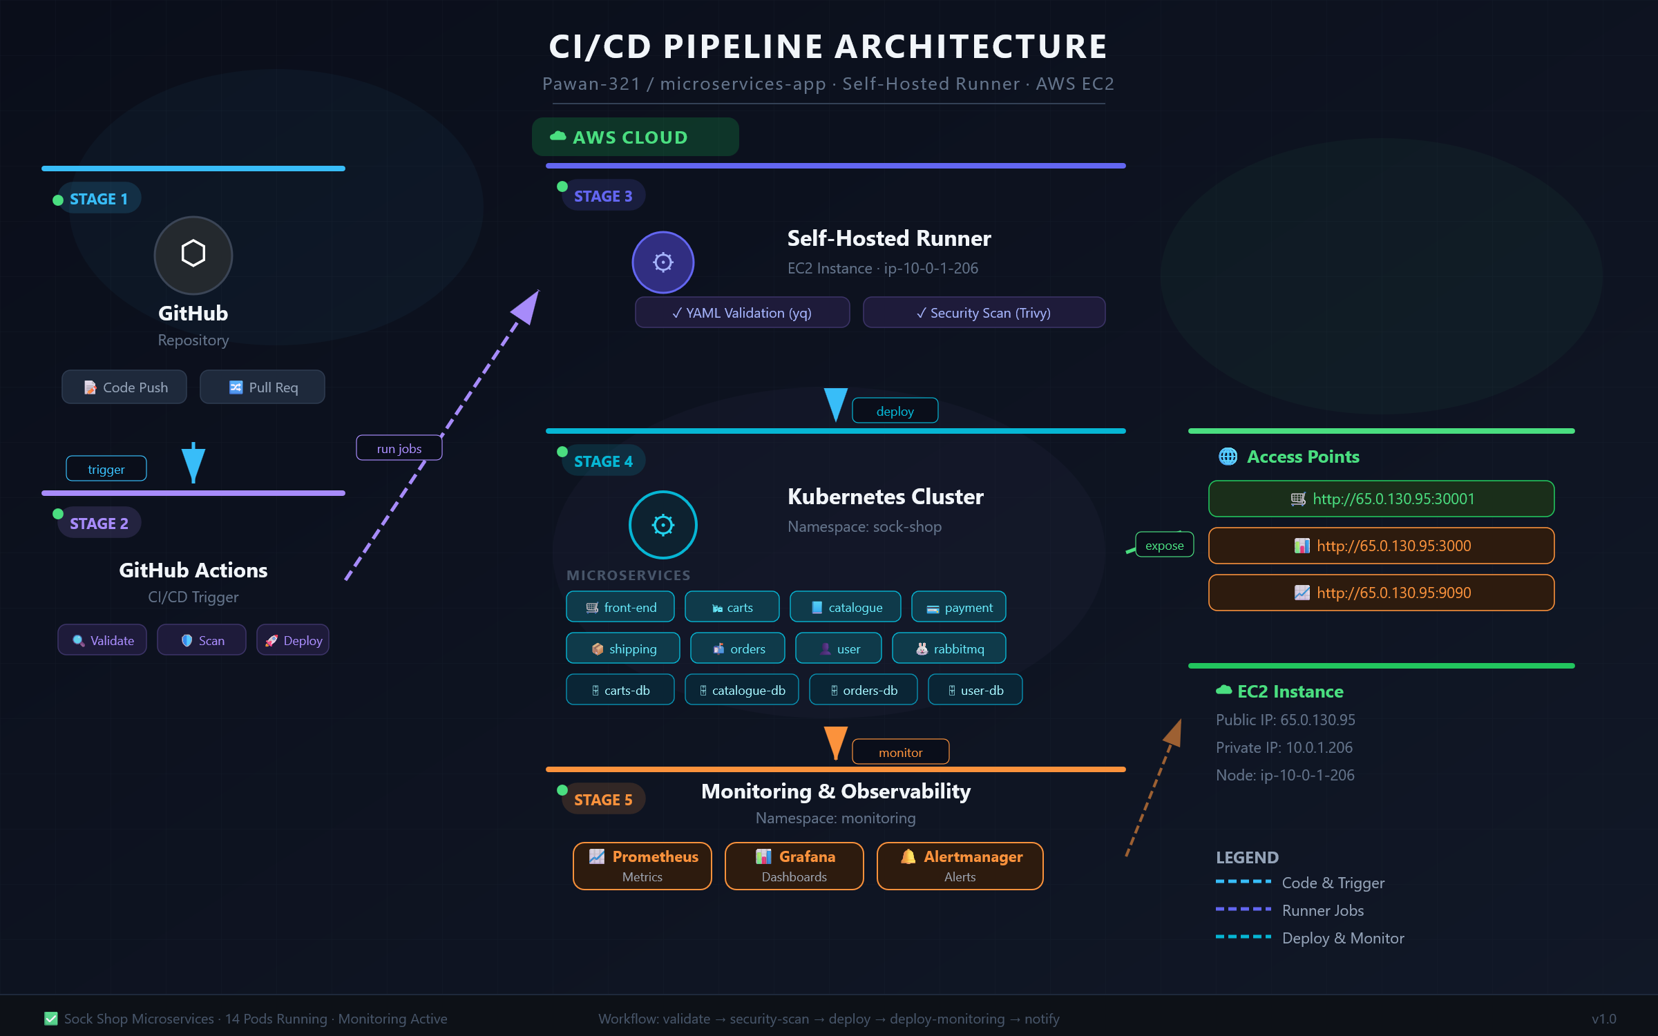

#frontend

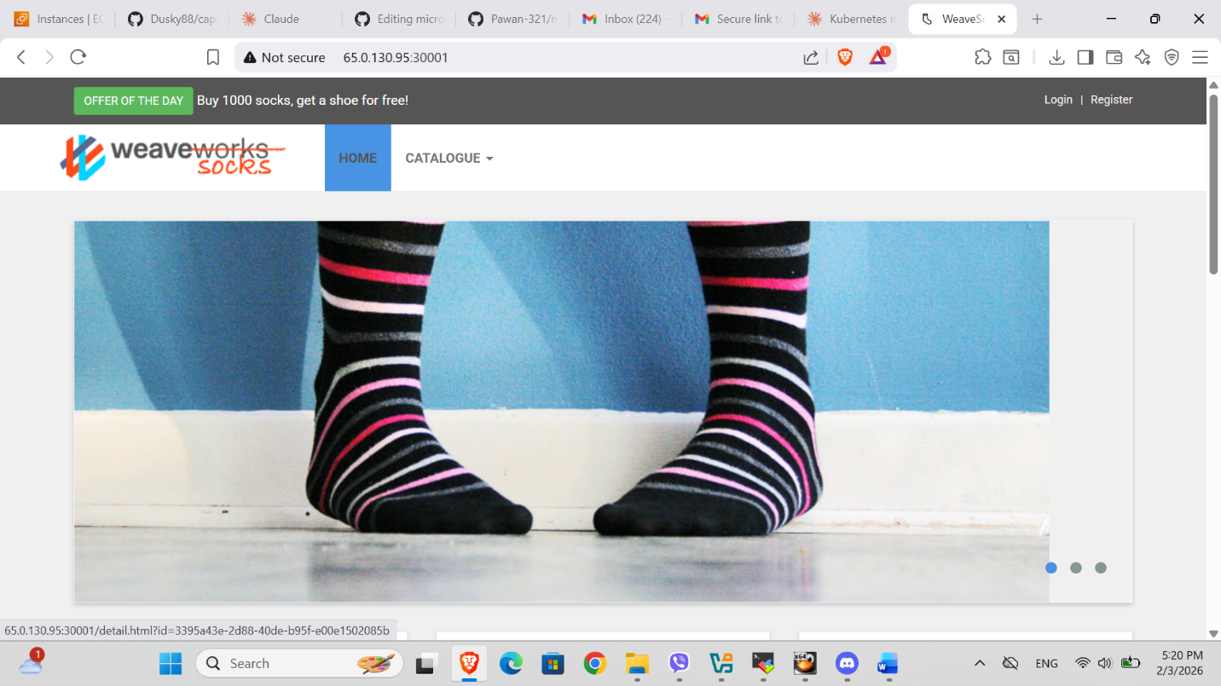

#grafana
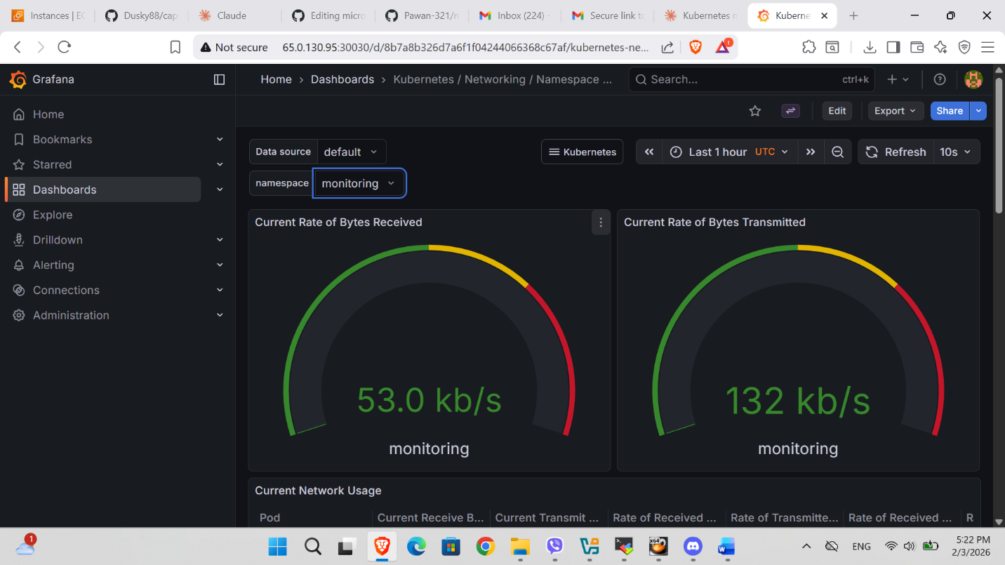
#prometheus
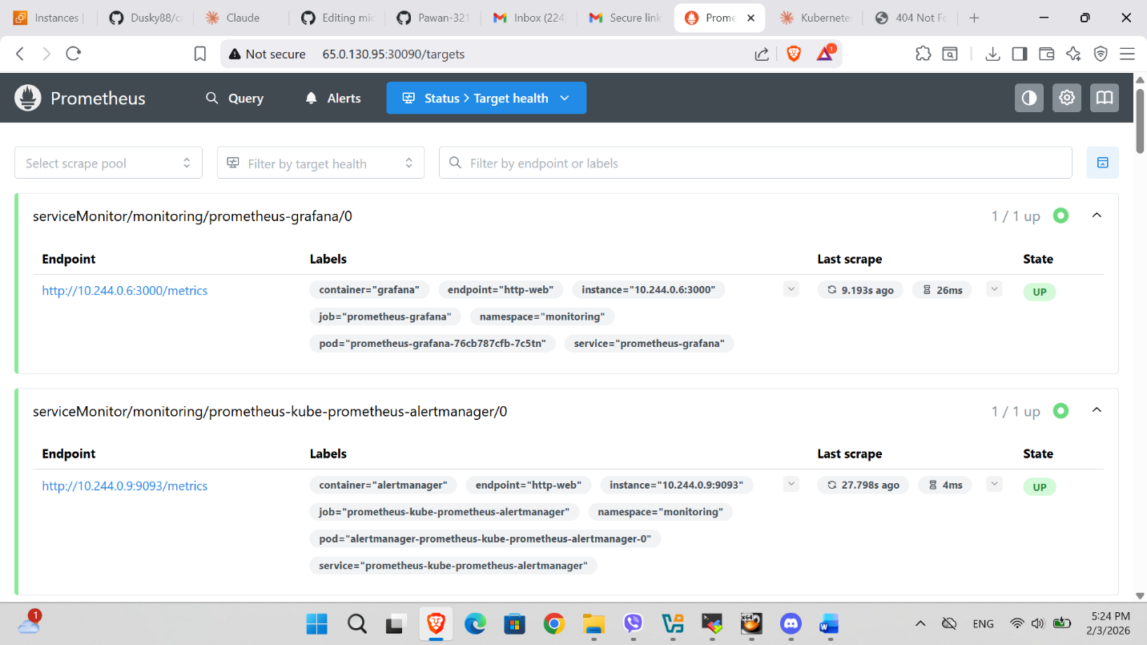

#Github pipeline
