Autoencoders:

Algorithm that learns the essential features of the input (effectively reducing/compressing the input dimension), with the purpose of reconstructing the input image using the learnt representation, as closely as possible to the original image.

Has three main components:
- Encoder
- Latent Space Representation
- Decoder

Encoder turns the higher dimensional input into lower dimension output, gradually working its way up to the latent space representation, while capturing the essential features of the input. Decoder converts the information about the image in this latent space representation to higher, human understandable dimensions. At the heart of this, lies the Latent Space.

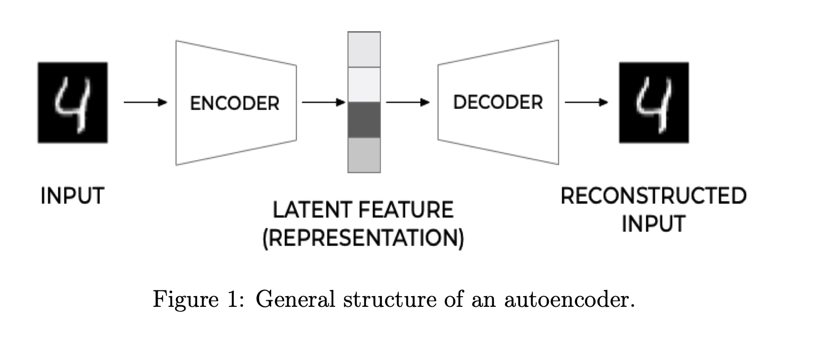
Let us take a simple example to understand this. For a digit classification task (like MNIST), the latent space would capture the essential features of digits (eg. No of lines, angles, strokes etc.) while ignoring the features like whitespace background.

The models we already know of, like CNNs, transformers etc already utilise the concept of latent space. A kernel of a CNN trained on cat dataset, capture the essence of the cat-ness by looking for things like whiskers, eyes etc. Similarly, the embedding space in a transformer represents the words in a higher dimensional space capturing the relationship between words. (Eg. King + Femaleness = Queen)

Now let’s shift back to how autoencoders work. In high level, we can represent the encoder block as a function:

hi = g(xi)

Here,
xi = Input in higher dimension n. i.e xi ∈ R^{n} ,
g : Rn →Rq ,
And hi = Latent feature representation in q dimensions. i.e. hi ∈ R^{q}

Similarly the decoder block can be represented as:

xi~ = f(hi) = f(g(xi))

Where˜xi∈Rn.
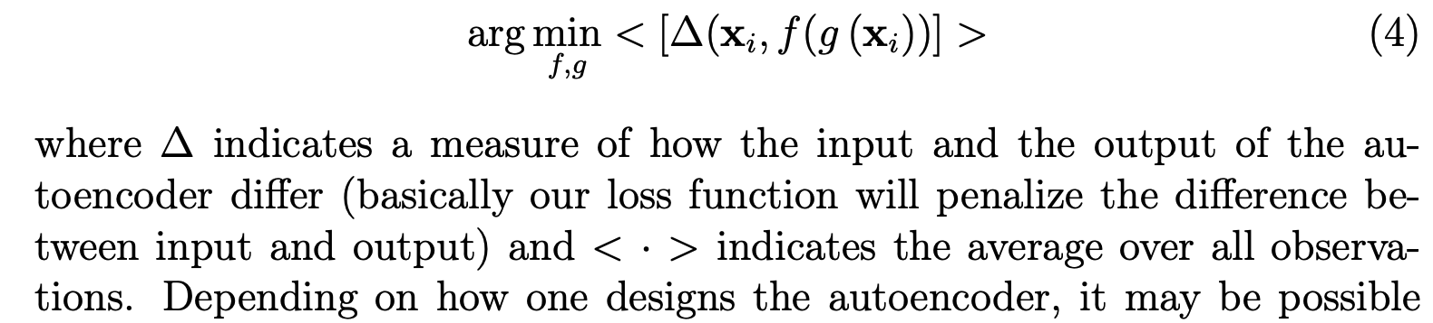
And finally we summarise the entire working by:

So the model needs to learn the functions f and g so that the reconstruction error is minimum. In doing so, the model might learn the identity functions which reconstructs the output exactly. To prevent this, we introduce the concept of “bottleneck”. Bottleneck is merely decreasing the dimensions of input (encoding). An identity function is an one-to-one mapping, but, dimension reduction is not. Thus, the model can’t learn the identity function and dimension reduction both. Also, learning the identity is a form of “overfitting”. So, the first thing that comes to our mind is “regularisation”. Therefore, here too, we can apply normalisation techniques such as L2, or L1. While there are other methods of regularization, the primary goal is to increase sparsity of the latent space feature representation.

Feed Forward Autoencoders.(FFA)
The most common type of autoencoders is FFA. It is essentially a satisfying looking symmetrical neural network as shown below. The neurons of the layers in the encoder block goes down until it reaches the bottleneck layer, then again it moves up to reach the same number of neurons (Dimensions) as the input. Typically, the number of layers (and their neurons), is kept equal in encoder and decoder block.
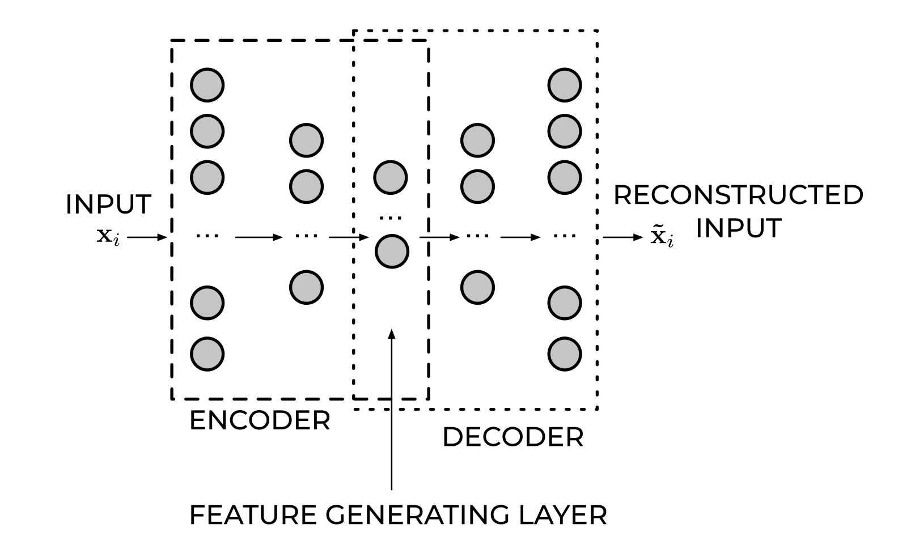
The output of the middle, bottleneck layer is known as the learned(latent) representation of the input. This output captures the most important features of the input for our given task. This learned representation in lower dimensions, is enough to reconstruct the much higher dimensional input as the model’s output.

https://arxiv.org/pdf/2201.03898

