Name: Pawan Sadashiv Bhirawandekar
Subject: Data Structure and Algorithms

Theory Question
1 What is data Structure? Explain the Classification of Data Structure in detail?
A Data Structure is a method of organizing, storing, and managing data in a computer so that it can be accessed and used efficiently.
It defines how data is arranged, how operations like insertion, deletion, searching, and sorting are performed, and how memory is managed.
Classification of Data Structures:
A. Primitive Data Structures
These are the basic data types provided by programming languages.
Examples:
- int
- float
- char
- double
- boolean
They are the building blocks for other complex data structures.
B. Non-Primitive Data Structures
These are more complex structures built using primitive data types.
Non-Primitive data structures are further divided into:
1. Linear Data Structures
In linear data structures, data elements are arranged in a sequential manner.
Each element is connected to the previous and next element.
Examples:
a) Array
- Stores elements of the same data type in contiguous memory.
- Example: int arr[5]
b) Linked List
- Collection of nodes connected using pointers.
- Types: Singly, Doubly, Circular Linked List
c) Stack
- Follows LIFO (Last In First Out) principle.
- Operations: push(), pop()
d) Queue
- Follows FIFO (First In First Out) principle.
- Types: Simple queue, Circular queue, Priority queue, Deque

C. Non-Linear Data Structures
In these structures, data is stored hierarchically or in a network form.
Examples:
a) Tree
- Represents data in hierarchical form.
- Types: Binary tree, BST, AVL, B-tree, Heap

b) Graph
- Represents relationships between nodes.
- Consists of vertices and edges.
- Types: Directed/Undirected, Weighted/Unweighted.

2. Explain the Types of an Array. Write down syntax for declaration, initialization and how to access elements from Array in C?
An array is a linear data structure that stores a fixed-size sequence of elements of the same data type in contiguous memory locations. Each element can be accessed directly using its index, which allows for efficient retrieval and modification.
Arrays are mainly classified into the following types:
1. One-Dimensional Array (1D Array)
Stores data in a single row.
Example: int marks[5];
2. Two-Dimensional Array (2D Array)
Stores data in rows and columns, like a matrix or table.
Example:
int matrix[3][3];
3. Multi-Dimensional Array (3D or more)
Arrays with more than two dimensions.
Example:
int arr[3][4][5];
- Array Declaration Syntax:
data_type array_name[size];
Example: int arr[10];

- Array Initialization Syntax:
Example: int arr[5] = {10, 20, 30, 40, 50};
int arr[] = {1, 2, 3, 4}; //Without specifying size

- Accessing Elements of an Array:
Example: printf("%d", arr[2]); // prints third element
Using Loops: for(int i=0; i<5; i++){
printf("%d ", arr[i]);
}

Printing 2D array
for(int i=0; i<3; i++){
for(int j=0; j<3; j++){
printf("%d ", mat[i][j]);
}
printf("\n");
}

3. What is stack? Explain the working of PUSH and POP operations in the stack with examples.
Stack is a linear data structure that follows LIFO (Last In First Out) Principle, the last element inserted is the first to be popped out. It means both insertion and deletion operations happen at one end only.
Basic Terminologies of Stack
- Top: The position of the most recently inserted element. Insertions (push) and deletions (pop) are always performed at the top.
- Size: Refers to the current number of elements present in the stack.
Common Operations on Stack:
In order to make manipulations in a stack, there are certain operations provided to us.
- push() to insert an element into the stack.
- pop() to remove an element from the stack.
- top() Returns the top element of the stack.
- isEmpty() returns true if stack is empty else false.
- size() returns the size of the stack.

1. PUSH Operation
PUSH operation is used to add an element to the top of the stack.
2. POP Operation
POP operation is used to remove and return the element from the top of the stack.
Example:
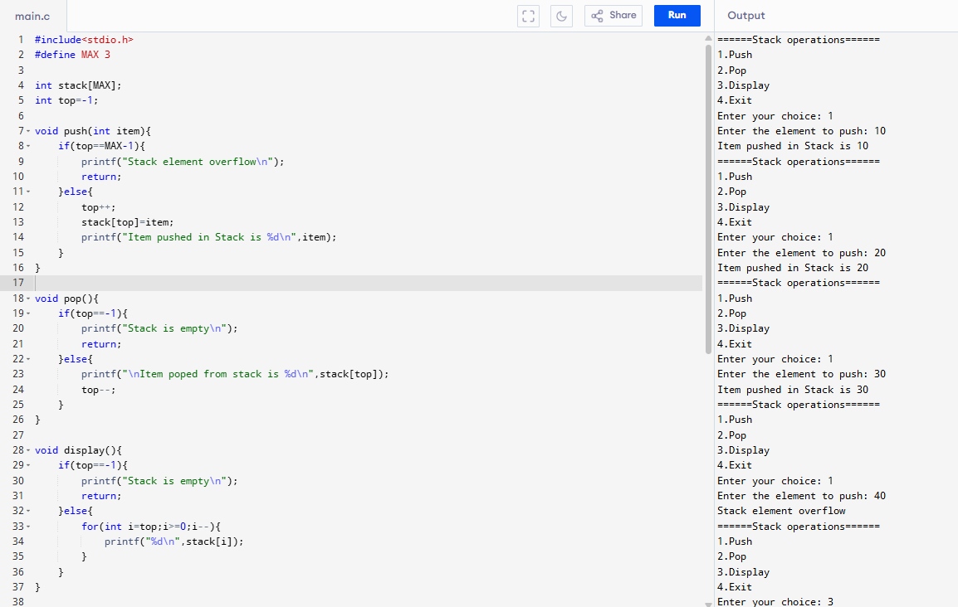
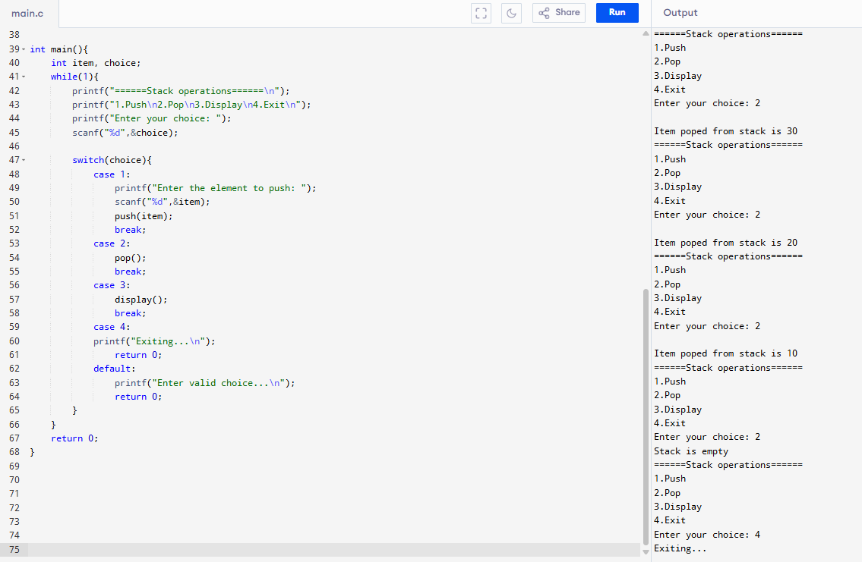
4. Give the difference between Simple Queue V/S Circular Queue?
Simple Queue | Circular Queue
Also called Linear Queue. | Also called Ring Buffer Queue.
Elements are arranged in a straight line. | Last position is connected back to the first, forming a circle.
FIFO (First In First Out) order. | Also follows FIFO.
Once the rear reaches the end, no more insertions are allowed even if space is free at the beginning. (Wastage of memory) | Space is fully utilized. After the rear reaches the end, it loops back to the front. No memory wastage.
Condition for Overflow: rear == size-1 | Condition for Overflow: (rear + 1) % size == front
Condition for Underflow: `front == -1
Front always moves forward and never returns to previous positions. | Front and rear move in a circular manner using modulo (%) operator.
Implementation is simpler. | Slightly more difficult because of circular linkage.
Example use: Basic line systems (ticket counter). | Example use: CPU scheduling, buffering, real-time systems.

5. How do singly and doubly linked list differ from each other? Explain with Proper Example?
Singly linked list : A singly linked list is a set of nodes where each node has two fields 'data' and 'link'. The 'data' field stores actual piece of information and 'link' field is used to point to next node. Basically the 'link' field stores the address of the next node.
In Singly linked list, the traversal can be done using the next node link only. Thus traversal is possible in one direction only.
Complexity of deletion with a given node is O(n), because the previous node needs to be known, and traversal takes O(n)
A singly linked list consumes less memory as compared to the doubly linked list.
Singly linked list is relatively less used in practice due to limited number of operations
Characteristics:
- Moves in one direction only (forward).
- Requires less memory (only one pointer per node).
- Traversal is simple but reverse traversal is not possible.
- Deletion of previous node is difficult (need to traverse from head).
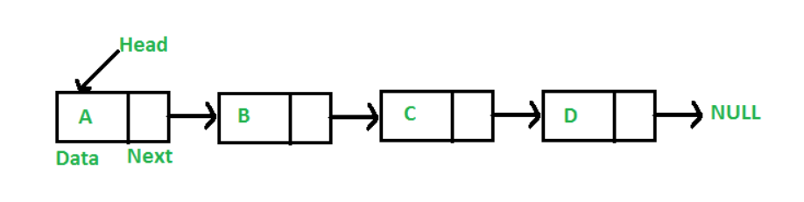
Example:
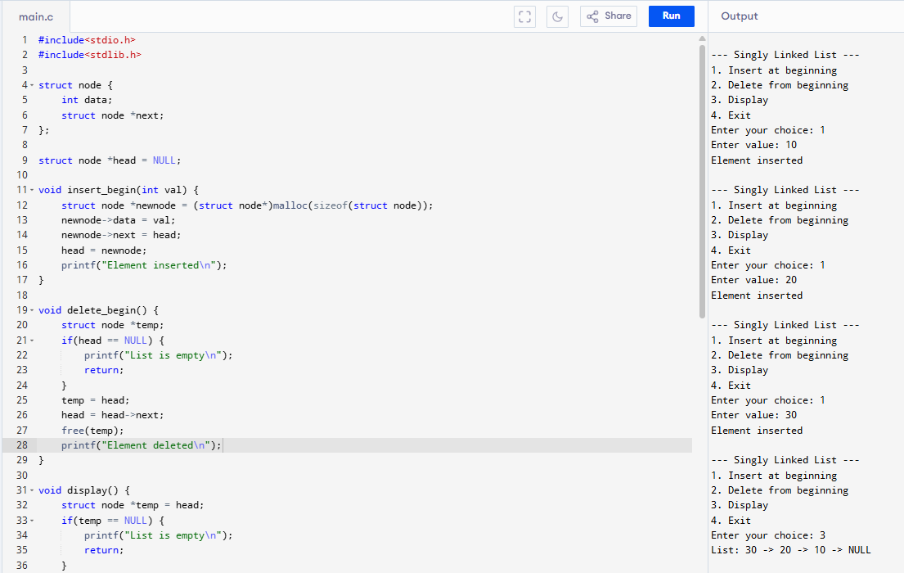
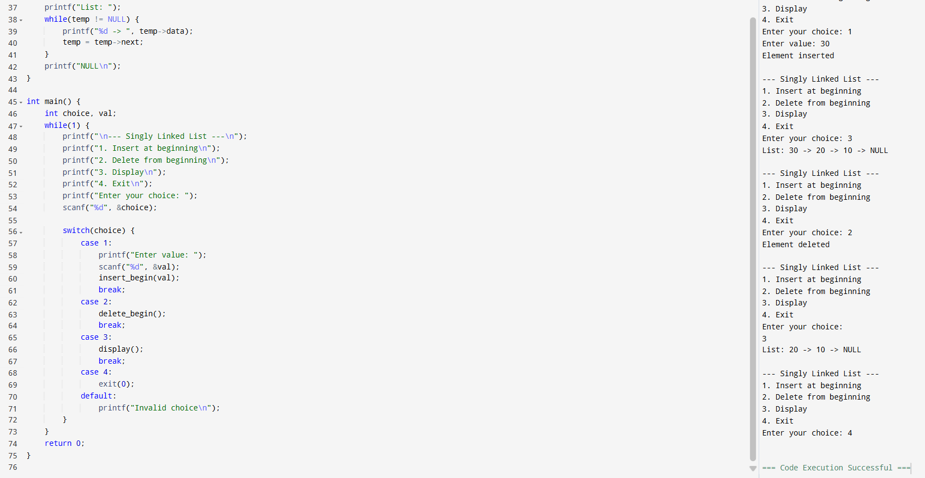
Doubly linked list : A Doubly Linked List (DLL) contains an extra pointer, typically called previous pointer, together with next pointer and data which are there in singly linked list.
In Doubly linked list, the traversal can be done using the previous node link or the next node link. Thus traversal is possible in both directions (forward and backward).
Complexity of deletion with a given node is O(1) because the previous node can be accessed easily
The doubly linked list consumes more memory as compared to the singly linked list.
Doubly linked list is implemented more in libraries due to wider number of operations.
Characteristics:
- Moves in both directions (forward and backward).
- Requires more memory (two pointers per node).
- Easy backward traversal.
- Easy deletion of any node because the previous pointer is available.

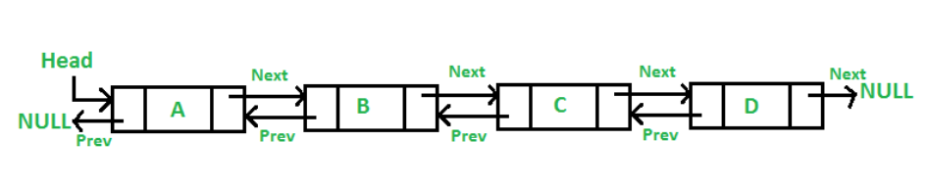
Example:
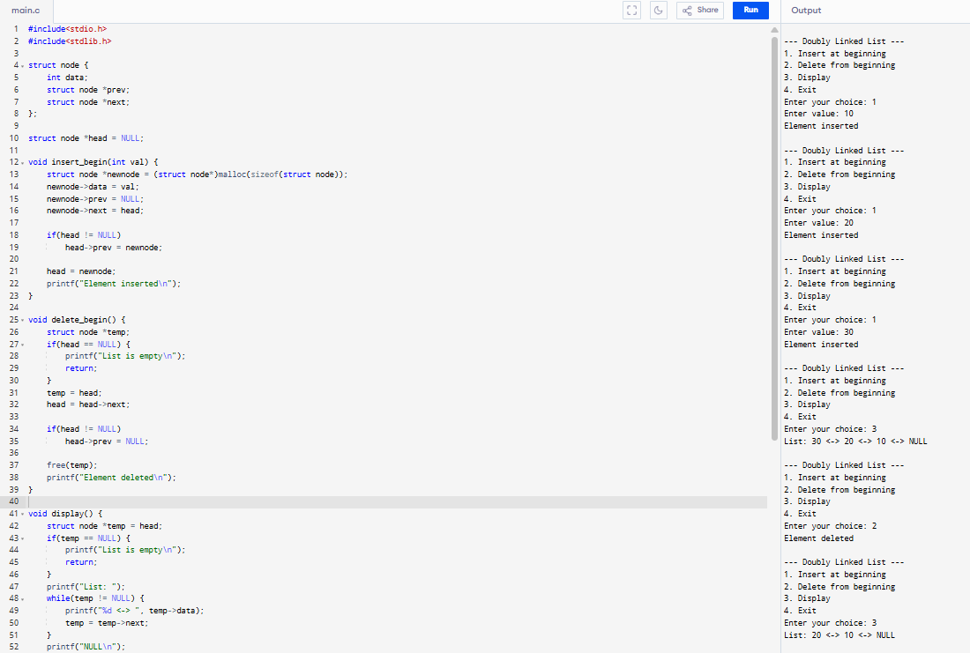
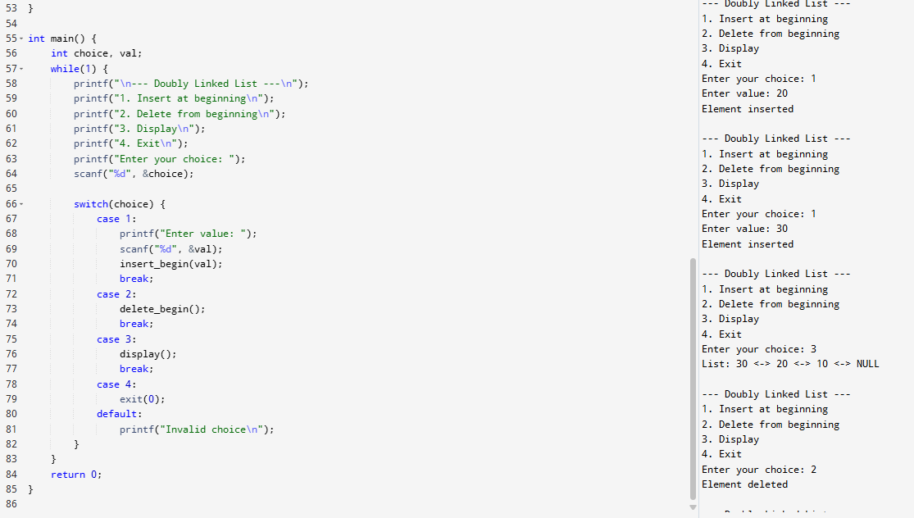
Practical Question
1. Write a Program to Perform Tower of Hanoi Problem.
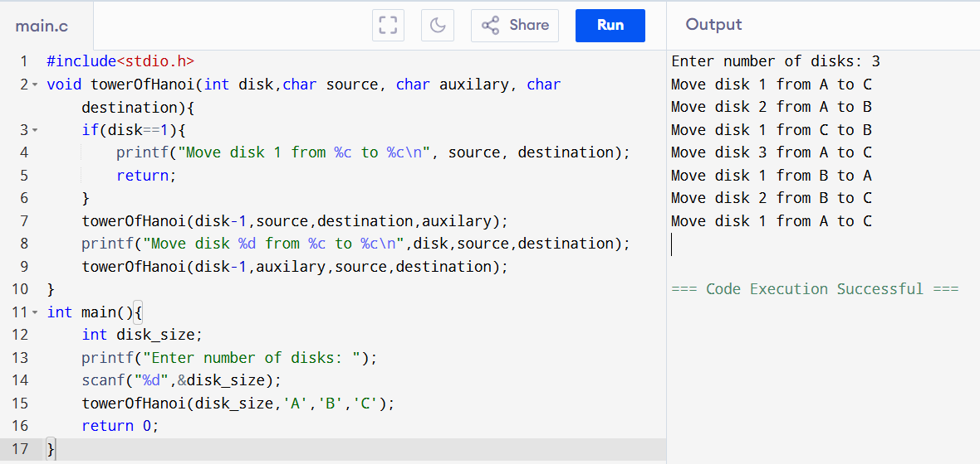
2. Write a Program to calculate the sum of the first N natural numbers using Recursive function.
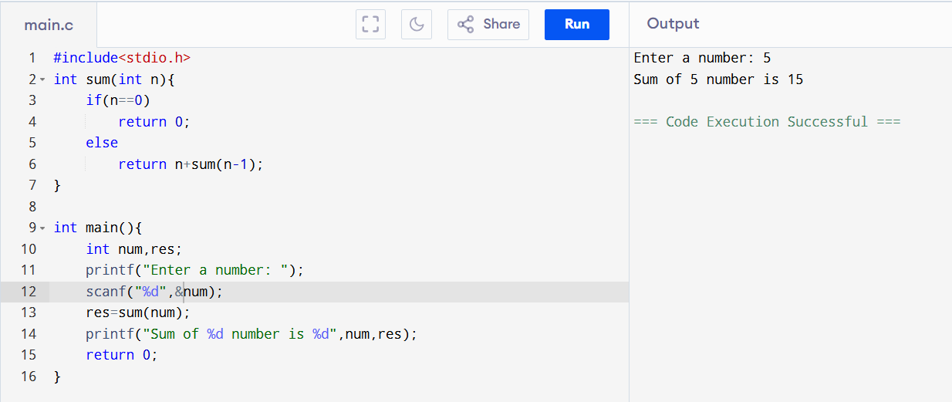

3. Write a program to implement Insertion (Push) & deletion (Pop) operation using linked list in c.
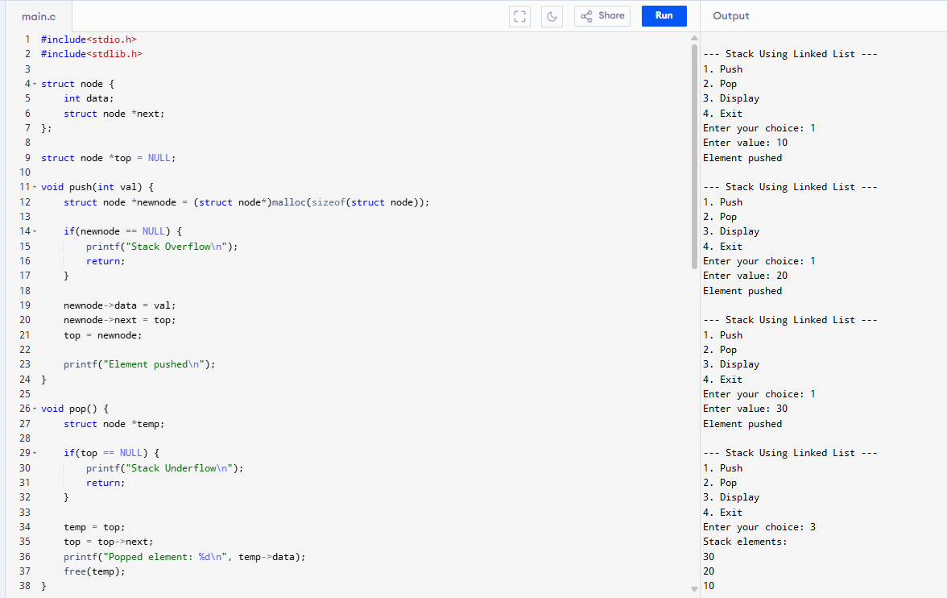
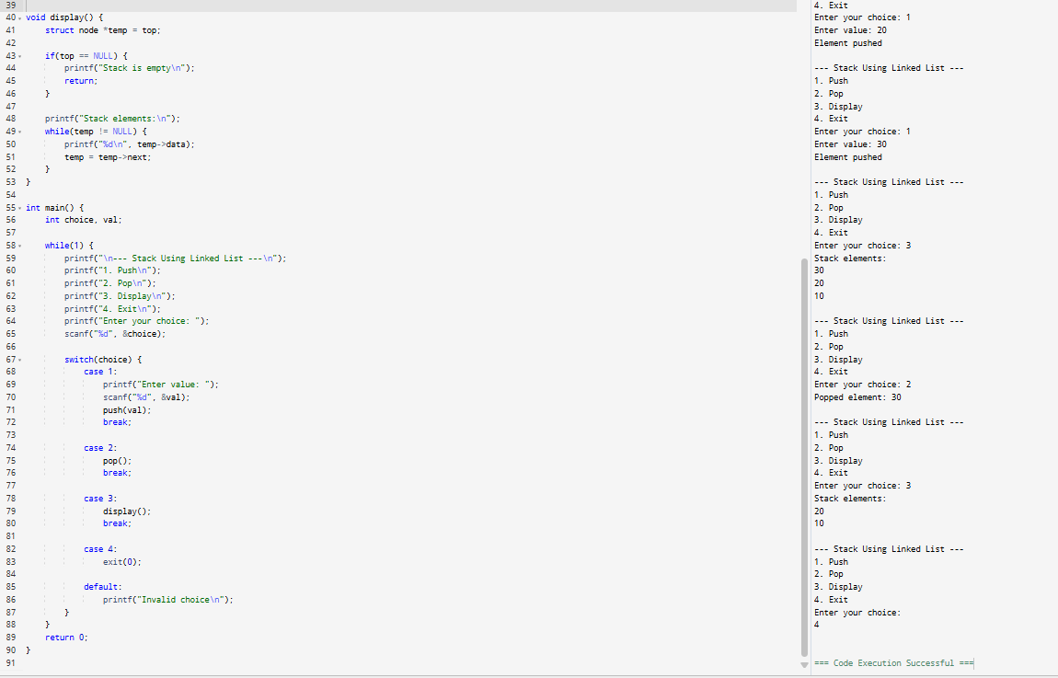
4. Write a C Program to Implement a queue using array.
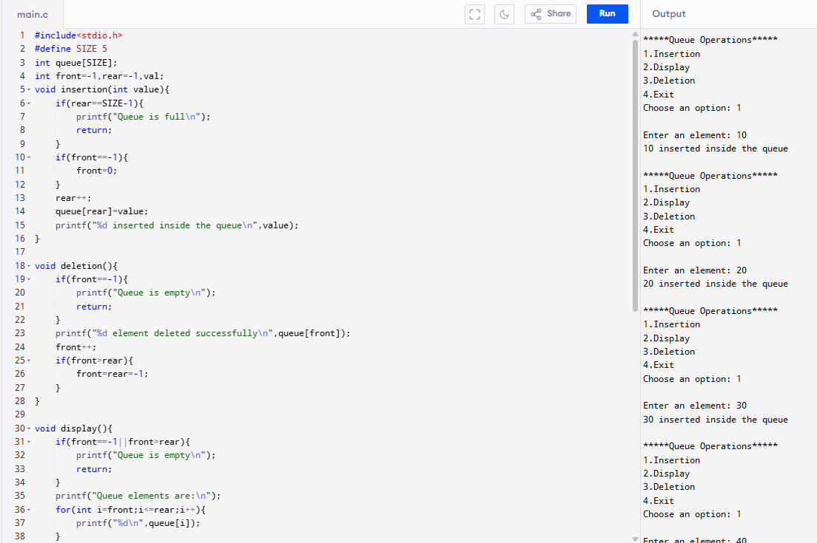
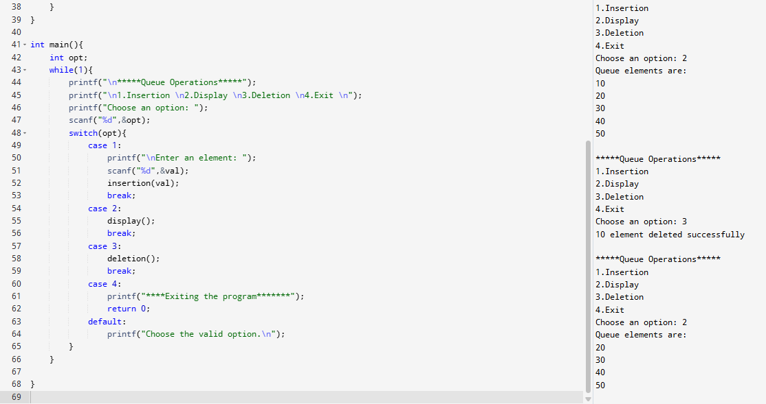

5. Write a program to implement Singly Linked List.

