**Solution’s For some Problems**

1. **MySQL - Connector Jar File**

**Problem -**

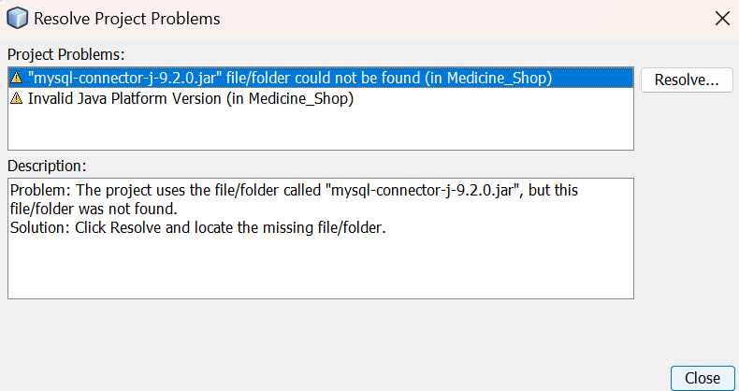

**Solution –**

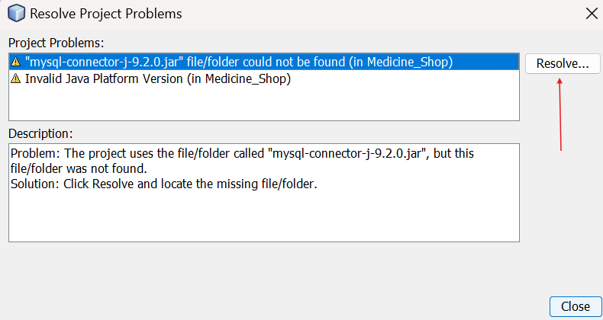

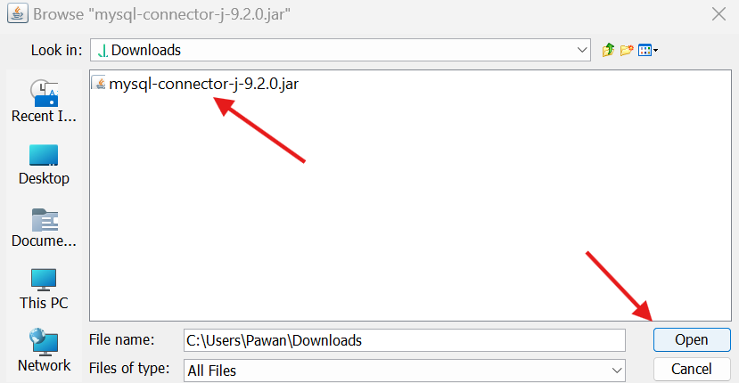

Done

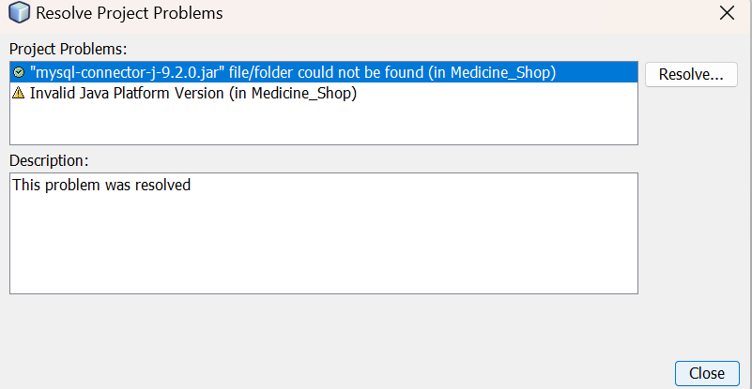

1. Invalid Java Platform Version

Problem –

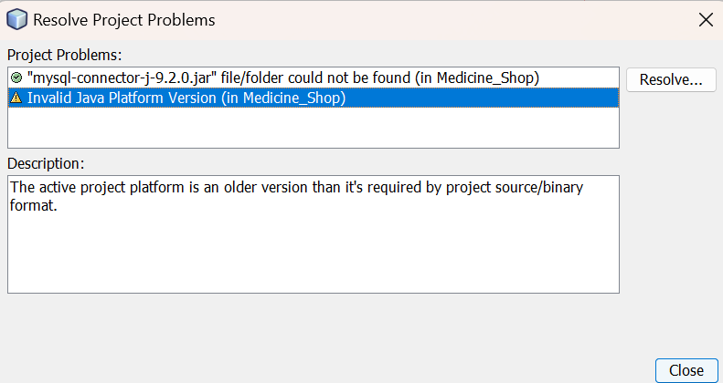

Solution –

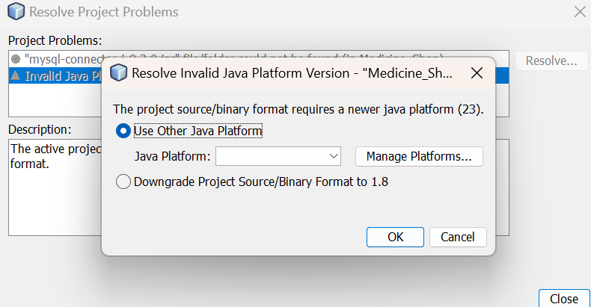

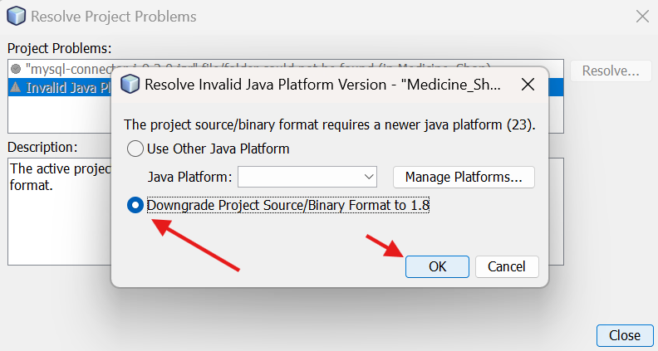

Solved –

