# # Student Marks Analyzer (GUI Version)

A Python GUI application built with Tkinter to analyze student marks, calculate grades, and visualize results.

Designed for beginners learning Python and GUI development, with features to manage multiple students, generate reports, save data to a file, and display charts.

---

#### ## Features

- Add multiple students with their marks (comma-separated)

- Calculate total marks, percentage, and grade for each student

- View a detailed report including topper and lowest scorer

- Save the student report as a text file

- Visualize student percentages with a bar chart (using matplotlib)

---

#### ## Technologies Used

- Python 3

- Tkinter (for GUI)

- Matplotlib (for charts)

## Usage

1. Enter the student’s name in the "Student Name" field.
2. Enter the student's marks separated by commas (e.g., 78, 85, 90).
3. Click **Add Student** to add the student to the list.
4. Repeat to add multiple students.
5. Click **Show Report** to see all students’ marks, grades, topper, and lowest scorer.
6. Click **Save Report to File** to save the report as a .txt file on your computer.
7. Click **Show Percentage Graph** to visualize the students’ percentages in a bar chart.

## Screenshots

**1:To add the marks of student**

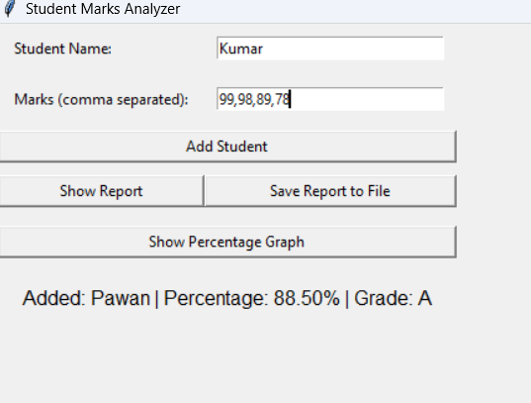

**2:The Students Report**

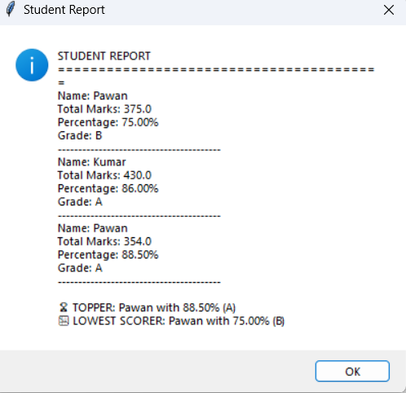

**3:The Percentage Graph of Students**

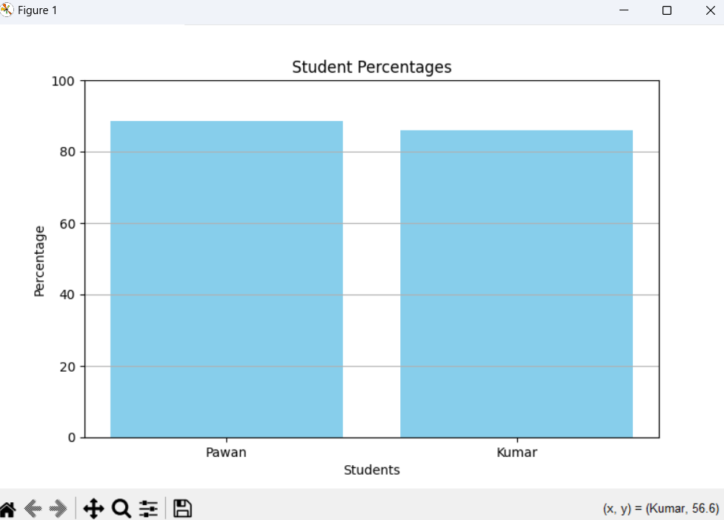

### About Me

I am Pawan Kumar, a Computer Science student passionate about Python and software development.  
Check out more of my projects on my [GitHub](https://github.com/yourusername" \t "_new) and connect with me on

Linkedin: www.linkedin.com/in/pawan-kumar-0238p