## 

***Car Sell Project..***

***Punam Ahire Wagh.***

***Overview :***

The core intention of the AutoMat project is to establish a novel and open ecosystem in the form of a cross-border Vehicle Big Data Marketplace that leverages currently unused information gathered from a large amount of vehicles from various brands. The interface to the marketplace is derived from a brand-independent Common Vehicle Information Model (CVIM) that makes aggregated vehicle data accessible to cross-sectorial service providers. AutoMat intends to reduce the costs for realizing and providing services based on vehicle data, by achieving the following

***Objective :***

* Creation of an open ecosystem for provisioning of manufacturer and service provider independent vehicle data
* Single point of data access for service providers via the Marketplace
* Definition of standardized and open interfaces for unconstrained data access
* Specification of the Common Vehicle Information Model (CVIM) data format that enables harmonized, generic vehicle data access
* Provision of a broad spectrum of collected data due to different participating OEMs

**Sytem User :**

**1.**Services Scenarios**.**

# 2. Meteorological Service.

Services Scenarios**:-**

**Service Description Road Roughness:**

HERE Technologies mission is ‘creating a digital representation of reality’. How that works now and may work in the future thanks to the use of Car Sensors and the H2020 project Automat is described here.

**Road Roughness Service**

Road Roughness is an indication of the quality of a road. A standardized measure for road roughness is the International Roughness Index (IRI), which is introduced in 1996. The HERE Road Roughness Product is a content layer that can be displayed on top of maps, indicating the respective road roughness at specific road segments (see below).

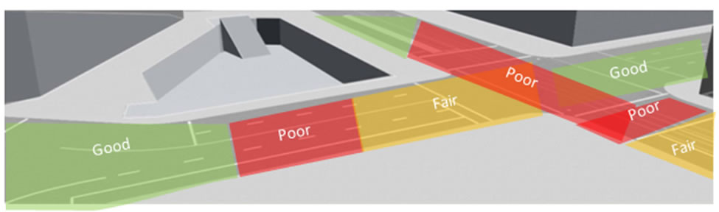

**Meteorological Service:-**

**Service Description Weather Prediction Model Development**

Weather information delivered by cars has a unique potential to improve the quality of weather prediction models. The data can be used directly to feed the models with real-time information as well as indirectly in order to improve the physical treatments in the models.

**How can meteorological data from cars be useful?**

Weather prediction models are used to calculate the weather forecast. The quality of the weather forecast depends strongly on the conditions of the atmosphere (e.g., temperature, humidity, pressure) at the start of the forecast (so called initial conditions). The information about these initial values of meteorological parameters origins mostly from the last available measurements of conventional weather stations. In the already quite dense meteorological measurement network in Germany, the distance between two stations is often more than 20km. Meteologix’ own Swiss HD Model uses a spatial resolution of 1x1km. At present, in order to define the initial conditions for such high resolution models, gaps between the weather stations are filled by making use of earlier forecasts and interpolation methods.

**Software requirements:**

I. IDE/Text Editor:

● Visual Studio Code

● Git Bash CLI

II. Front End:

● HTML5

● CSS3

III. Browser:

● Google Chrome

● Mozilla Firefox

**Use Case Diagram:-**

