

Travel Website-Bus Online Booking

14.01.2022
─

Srigowri Shrinivas Deogirikar
MI-14-MEAN

Overview

In this project we are presenting a code for online booking of the bus ticket which will be in the travel website.Here we are focusing on HTML,CSS and Bootstrap coding. Here we are writing the code for the website. This page should look like the real website and should be Responsive.

Objective
1. To make the website's interface more user-friendly.
2.To create a Responsive Website Code.
3. To use HTML,CSS,Bootstrap.

System Users
1. Technical Staff
2. Management Staffs
3. Students

Management Staff Features
To help the students to achieve their goals by monitoring the project and help them to have a good knowlege and skills.By individually montoring the student and help them achieve the requirements of the company.

Technical Staff Features
To help the students in the technical skills and to upgrade their skills to present skills and help them to persue their targets on time. To provide deep knowledge on the subject and help them to build the code .

Students Features
To write the code and execute the code on Visual Studio Code and buid the code from basic. This code will be written in HTML,CSS,Bootstrap.The students can take help from the Technical Staff.

Software requirements:

IDE/Text Editor:
● Visual Studio Code
● Terminal(Ubuntu)

Front End:
● HTML5
● CSS3

Browser:
● Google Chrome
● Mozilla Firefox

Use Case Diagram:

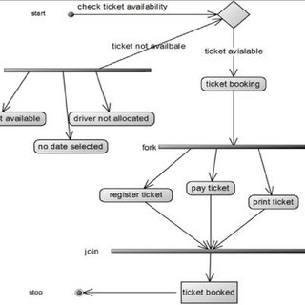

Overview of Project:

