**Abstract**

The main aim of the paper is to demonstrate the operation of LiFi (Light Fidelity). We narrow this paper down to find a substitute to WiFi which we use pass the data to a portable speaker instead of other conventional methods i.e. (bluetooth,WiFi). The high data transfer, throughput , data security makes LiFi more advantageous over WiFi.

Since mobile is a daily driver for almost everyone we take this research one step further by providing a portable charger for a mobile phone using solar panel . The mobile is charged simultaneously when we operate the speaker. We can use this concept domestically or for industrial purposes for managing devices more efficiently and with ease.

**Keywords:** LiFi: Light Fidelity, WiFi: Wireless Fidelity, Bluetooth, solar panel, portable charger.

**INTRODUCTION**

Today communication technology is grown to such an extent that communicating across the corners of the globe is very easy. The telecommunication satellites and optical communication are the two major reasons for it. But the energy resource used is electricity, which is a non-renewable source of energy. Thus providing energy source through solar energy and transmitting data via light rather than micro waves is the main concern of the paper. The Li-Fi provides highly reliable and secure data transfer. When compared to Wi-Fi the data throughput and data security is relatively high for Li-Fi. Thus using solar energy to charge the smart phones and Li-Fi to transmit the data is the main aim of this paper. Li-Fi module is connected to an audio jack output available on mobile phones. It has a led which is used to transmit audio signal as light signal. These light signals are captured by Li-Fi speaker through the solar cell array.

**LITERATURE SURVEY**

LiFi a term introduced by Herald Hass is a wireless optical networking technology which uses light emitting diodes (LED's) for data transmission. LiFi uses light bulbs similar to those which are used in energy-conscious homes and offices therefore making it readily available . The data transmitted by these light bulbs are received by photoreceptors of other devices. In earlier times the speed of the transmission was restricted to 150Mbps.

But recent studies with stronger LED's and different technology, researchers have enabled it to 10Gbps which is faster than 802.11ad.We see a potential in LiFi because of its benefits stated below:

* It prevents Piggybacking -Piggybacking is the intent of getting access of WiFi which is restricted. LiFi prevents it because the light cannot penetrate walls and hence restricting the access.
* The data being transmitted is not hindered by any radio frequencies thus making it very reliable.
* The transmission does not create interference in sensitive electronic devices thus making it better to use it in environments like hospitals and aircrafts.

**DESIGN AND IMPLEMENTATION**

A. ARCHITECTURE

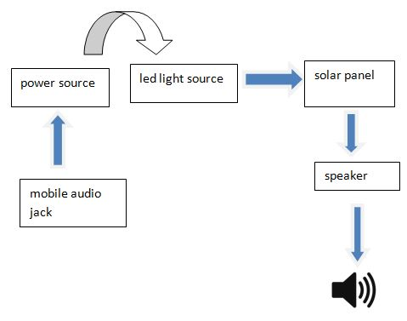

Figure 1: Architecture of the model