**Write a python program to draw a triangle shape using print statement only.**

print('     *    ')

print('   *  *   ')

print('  *    *  ')

print(' *      * ')

print('* *  * * *')

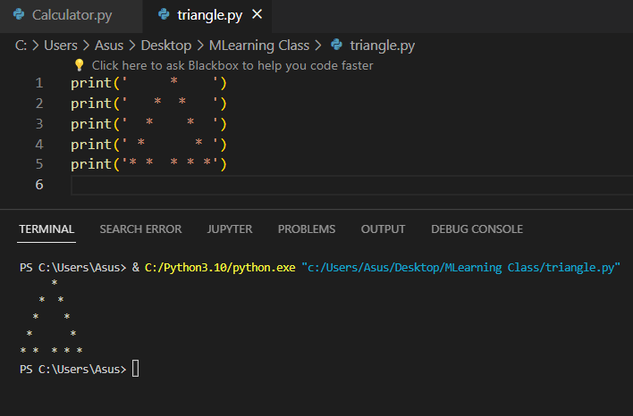

**Python Program to Make a Simple Calculator**

# Input from the user: operation, and two numbers

operation = input("Choose an operation (+, -, *, /): ")

first = float(input("Enter first number: "))

second = float(input("Enter second number: "))

# Perform the calculation based on the operation

if operation == '+':

    result = first + second

    print(f"{first} + {second} = {result}")

elif operation == '-':

    result = first - second

    print(f"{first} - {second} = {result}")

elif operation == '*':

    result = first * second

    print(f"{first} * {second} = {result}")

elif operation == '/':

    # Check to prevent division by zero

    if second != 0:

        result = first / second

        print(f"{first} / {second} = {result}")

    else:

        print("Error! Division by zero.")

else:

    print("Invalid operation selected.")

