**Topics: Descriptive Statistics and Probability**

1. Look at the data given below. Plot the data, find the outliers and find out $μ, σ, σ^{2}$

|  |  |
| --- | --- |
| **Name of company** | **Measure X** |
| Allied Signal | 24.23% |
| Bankers Trust | 25.53% |
| General Mills | 25.41% |
| ITT Industries | 24.14% |
| J.P.Morgan & Co. | 29.62% |
| Lehman Brothers | 28.25% |
| Marriott | 25.81% |
| MCI | 24.39% |
| Merrill Lynch | 40.26% |
| Microsoft | 32.95% |
| Morgan Stanley | 91.36% |
| Sun Microsystems | 25.99% |
| Travelers | 39.42% |
| US Airways | 26.71% |
| Warner-Lambert | 35.00% |

Answers:

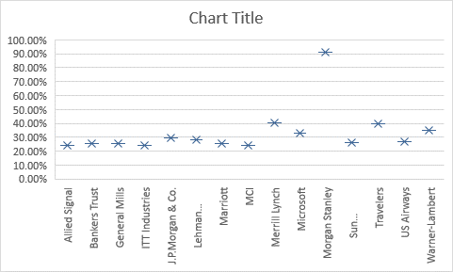

|  |  |  |
| --- | --- | --- |
| **Mean** | **m** | **33.27%** |
| **Standard Deviation** | **s** | **0.169454009** |
| **Variance** | **s²** | **0.028714661** |
| **Outliers** |  | **Morgan stanley (91.36%)** |



Answer the following three questions based on the box-plot above.

1. What is inter-quartile range of this dataset? (please approximate the numbers) In one line, explain what this value implies.
   1. Q1=5
   2. Q3=12
   3. IQR=Q1-Q3= 5-12
2. What can we say about the skewness of this dataset?
   1. Dataset has a positive skewness, that means data is skewed at right side of the mean.
3. If it was found that the data point with the value 25 is actually 2.5, how would the new box-plot be affected.
   1. There will be not outliers in the dataset.
   2. Q1, mean and Q3 will shift slightly to the right.



Answer the following three questions based on the histogram above.

1. Where would the mode of this dataset lie?
   1. Value 5 and 6
2. Comment on the skewness of the dataset.
   1. Data is skewed at right side of which shows positive skewness.
3. Suppose that the above histogram and the box-plot in question 2 are plotted for the same dataset. Explain how these graphs complement each other in providing information about any dataset.
   1. From both graphs are shows the value 25 which is outlier.
   2. Most of the data is spread in between the 5-12 the same can be seen in the histogram.
   3. Both the graphs show the positive skewness in the data.
4. AT&T was running commercials in 1990 aimed at luring back customers who had switched to one of the other long-distance phone service providers. One such commercial shows a businessman trying to reach Phoenix and mistakenly getting Fiji, where a half-naked native on a beach responds incomprehensibly in Polynesian. When asked about this advertisement, AT&T admitted that the portrayed incident did not actually take place but added that this was an enactment of something that “could happen.” Suppose that one in 200 long-distance telephone calls is misdirected. What is the probability that at least one in five attempted telephone calls reaches the wrong number? (Assume independence of attempts.)

P(Probability of at least 1 misdirected call)=1-(No call are misdirected)

= 1-(199/200)5

= 1- 97.5248753

=2.475

=**24.75%**

1. Returns on a certain business venture, to the nearest $1,000, are known to follow the following probability distribution

|  |  |
| --- | --- |
| x | P(x) |
| -2,000 | 0.1 |
| -1,000 | 0.1 |
| 0 | 0.2 |
| 1000 | 0.2 |
| 2000 | 0.3 |
| 3000 | 0.1 |

1. What is the most likely monetary outcome of the business venture?

|  |  |  |
| --- | --- | --- |
| **x** | **P(x)** | **Weighted average return** |
| -2,000 | 0.1 | -200 |
| -1,000 | 0.1 | -100 |
| 0 | 0.2 | 0 |
| 1000 | 0.2 | 200 |
| 2000 | 0.3 | 600 |
| 3000 | 0.1 | 300 |
| **Most likely return** | | **800** |

1. Is the venture likely to be successful? Explain
   1. Yes, As the return are growing at increasing rate
   2. Also the from the past result probability of positive return is high than the negative return(Loss)
2. What is the long-term average earning of business ventures of this kind? Explain.
   1. If the venture keeps up the pace the long term average earing will grow.
3. What is the good measure of the risk involved in a venture of this kind? Compute this measure
   1. Standard deviation is too high in this business.
   2. Which is 1870.8