
Final Year Project Title

EduCom

Project Proposal

Supervisor
Asim Riaz

Anmol Kumari
2212141
Pawan Mahesh
22121263

Faculty of Computing and Engineering Sciences
Shaheed Zulfiqar Ali Bhutto Institute of Science and Technology, Karachi.

- Introduction
The EduCom Platform is an academic communication and transparency system designed to connect students, teachers, and administrators within a unified digital environment. It provides a centralized space for effective communication, collaboration, and feedback across academic departments, ensuring both transparency and accountability in educational interactions. The platform features Course-Based Communities, where teachers can share announcements, post assignments, and engage with students in real time. Students can communicate within their respective course groups, submit assignments, and participate in moderated discussions. The Anonymous Feedback and Reporting System allows students to share their opinions or report issues without fear, while maintaining institutional responsibility and professionalism. EduCom also integrates AI-powered moderation, which automatically detects and filters inappropriate or non-academic content to maintain a safe and respectful communication space. Additionally, its Admin Panel provides tools to manage users, roles, and content efficiently, ensuring smooth system governance.
The project aims to enhance academic communication, promote transparency, and strengthen teacher–student engagement. It provides a platform where constructive discussions and feedback can thrive, ultimately improving the learning environment. Education today is deeply intertwined with technology. Platforms like EduCom demonstrate how digital communication systems can revolutionize academic collaboration, promote fairness, and support responsible use of online spaces. By combining structured communication, AI moderation, and data-driven transparency, EduCom serves as a model for the future of digital education systems one that empowers both learners and educators.

Objective
To design and develop a real-time academic communication and transparency platform that connects students, teachers, and administrators through course-based communities, enabling structured discussions, assignment management, and anonymous feedback with integrated AI-powered moderation to ensure a safe, transparent, and collaborative digital learning environment.

Problem Description
In most universities, communication between students, teachers, and administrators is scattered across multiple channels such as emails, WhatsApp groups, and informal messaging platforms. This lack of a unified academic communication system often leads to miscommunication, delayed responses, missing assignments, and lack of transparency in academic interactions. Students struggle to receive timely updates, while teachers face difficulties managing course communications and collecting feedback in an organized manner. The absence of an official, structured communication platform also results in limited accountability — anonymous complaints or feedback often go unheard due to the lack of a controlled system that ensures both privacy and responsibility. Additionally, manual moderation of online discussions becomes impractical in large classes, increasing the chances of irrelevant or inappropriate content being shared.
EduCom addresses these challenges by providing a centralized digital platform for real-time communication, course management, and feedback exchange within the university. It introduces AI-powered moderation to filter non-academic content, and an anonymous feedback system that allows students to share opinions safely. Through role-based access, EduCom maintains discipline, privacy, and institutional transparency. By transitioning from fragmented manual communication to a secure and intelligent system, EduCom aims to enhance collaboration, improve response times, and promote academic accountability, ensuring that communication in educational institutions becomes structured, respectful, and effective.

Target Industry
EduCom is primarily targeted toward the education industry, specifically within the EdTech(Educational Technology) domain. It is designed for universities, colleges, and other academic institutions seeking to enhance internal communication, transparency, and collaboration among students, teachers, and administrators through digital means.

Methodology
EduCom will be developed as a web-based application using a modular, client-server architecture to ensure scalability, reliability, and ease of maintenance. The frontend will be built using React.js with Tailwind CSS for a responsive and user-friendly interface, while the backend will be developed using Node.js and Express.js, connected to a PostgreSQL database for secure and efficient data management. Real-time communication features such as chat and notifications will be implemented using Socket.io, ensuring instant message delivery and live system updates. The AI-powered content moderation module, developed in Python using spaCy or TensorFlow, will automatically detect and flag inappropriate or non-academic content to maintain a safe communication environment.
The system will employ JWT (JSON Web Tokens) for authentication and bcrypt for password encryption to ensure data security. Role-Based Access Control (RBAC) will be used to manage user permissions for Admins, Teachers, and Students. All modules will communicate through RESTful APIs, following the MVC (Model-View-Controller) design pattern for clear separation of concerns. Agile development practices will be followed to allow iterative testing, integration, and user feedback throughout the project lifecycle.
Through this structured approach, EduCom ensures a secure, real-time, and transparent communication platform that effectively addresses the challenges of academic collaboration and accountability.

Project Scope
The EduCom platform will focus on developing a web-based academic communication and transparency system for students, teachers, and administrators within the university. The project will include features such as course-based communities, real-time messaging, assignment management, anonymous feedback, and AI-powered moderation to ensure responsible and structured communication.
The scope of this project is limited to the web application version only. Future extensions such as a mobile app, voice/video conferencing, or integration with external Learning Management Systems (LMS) like Moodle or Google Classroom are beyond the current development phase. Similarly, the platform will not include advanced analytics dashboards or external API automation for ZABDESK; instead, user and course data will be added manually in the initial version.
Assumptions made during development include that users will have reliable internet access, use modern browsers, and that institutional IT support will be available for system hosting and maintenance. The AI moderation feature will focus on text-based content filtering only, without multimedia moderation.
Overall, EduCom’s scope is to provide a secure, reliable, and transparent academic communication platform that serves as the foundation for future scalability and advanced integrations.

Feasibility Study
With the defined scope, the EduCom project is expected to be completed within the Final Year Project timeline. The project team will ensure that risks are properly managed and that all required resources are available to support successful development and deployment.
i. Risks Involved
Some potential risks that could impact the project schedule include:
- Technical Challenges: Integration of AI-based moderation and real-time chat features may require additional research and testing.
- Unexpected Delays: Unforeseen issues such as server downtime, software incompatibilities, or communication gaps within the team may delay progress.
- Scope Creep: Additional feature requests during development could increase workload and extend the project timeline.
- Data Reliability: Dependence on institutional data (e.g., from ZABDESK) could pose risks if access or accuracy is limited.
Risk Mitigation:
To address these risks, the project team will follow an Agile development approach, dividing work into sprints, conducting regular progress reviews, and maintaining clear communication between members. Frequent testing and early integration will help identify and resolve issues quickly. Backup and version control through GitHub will ensure code safety and recovery in case of system failures.
ii. Resource Requirement
The EduCom project will require a robust computing environment for development, testing, and deployment.
Hardware Requirements:
- High-performance laptops or PCs with internet access for the development team.
- Access to university or cloud-based servers for testing and deployment.
Software Requirements:
- Frontend: React.js, Tailwind CSS
- Backend: Node.js, Express.js
- Database: MySQL or PostgreSQL
- Real-Time Communication: Socket.io
- AI Moderation: Python with spaCy or TensorFlow
- Development Tools: Visual Studio Code, GitHub, Postman
- Deployment: Render, Vercel, or university hosting environment
With these resources and an organized workflow, the project is technically, economically, and operationally feasible within the defined academic timeframe.

Solution Application Areas
Yes, this project holds real value for students, teachers, and administrators within educational institutions. Students will benefit from a centralized and transparent communication platform where they can easily access course materials, receive announcements, submit assignments, and provide feedback. Teachers will have an efficient space to manage courses, interact with students, and monitor academic progress, while administrators can oversee activities and ensure accountability across departments. EduCom will help foster a stronger academic community by encouraging structured communication and collaboration between teachers and students. This will lead to improved learning outcomes, timely feedback, and a more connected educational environment.
By enhancing communication and introducing AI-powered moderation to ensure respectful and academic interactions, EduCom addresses the long-standing challenges of disorganized communication, lack of transparency, and limited student engagement in universities. This platform aims to provide a much-needed digital solution for modern educational institutions, promoting efficiency, fairness, and inclusivity in academic communication. With its potential to strengthen teacher-student relationships, improve academic accountability, and support digital transformation in education, EduCom will have a lasting positive impact on how universities manage communication and collaboration.
- Tools/Technology
- Frontend: React.js, HTML5, CSS3, JavaScript
- Backend: Node.js, Express.js
- Database: PostgreSQL
- Real-Time Communication: Socket.io
- AI : Python
- Version Control: Git, GitHub
- Design & Prototyping: Figma, Adobe XD

10. Expertise of the Team Members
Both team members, Anmol Kumari and Pawan Mahesh, have the necessary background in relevant courses and practical development experience to successfully complete this project. We share equal interest in the work and are committed to collaborating effectively, managing time efficiently, and ensuring the project’s successful delivery.

11. Milestones
FYP-I
• Database Setup
• Role-Based Authentication & Access Control (Frontend & Backend Integration)
• Admin Management System (Frontend & Backend Integration)
• User Profile Management
• Community Channel System (Frontend & Backend Integration
FYP-II
• Official Real-Time Messaging System (Frontend & Backend Integration)
• Anonymous Feedback & Complaint Submission (Frontend & Backend Integration)
• AI-Based Content Moderation
• Message Logs (Backend)
• Email Notification Integration (Backend)
• Marketplace Module (Frontend & Backend Integration)
• Payment Integration (Backend & Frontend)
• System Testing, QA & Optimization

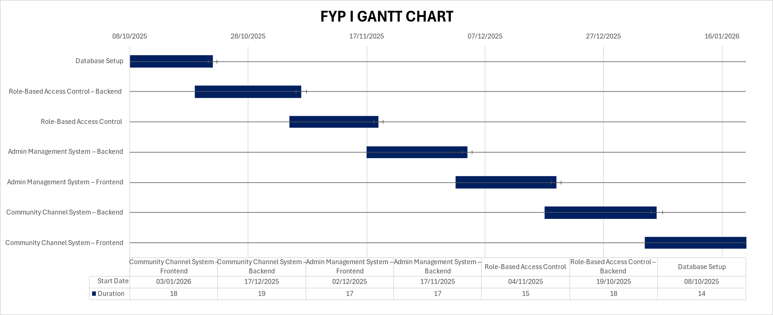
12. Project Schedule
Figure 1: FYP 1 Schedule - Gantt Chart

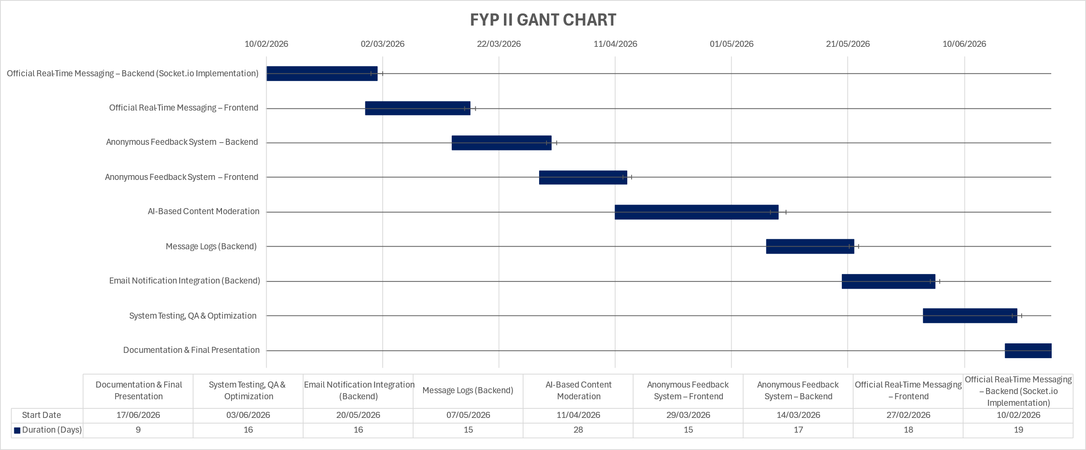
Figure 2: FYP 2 Schedule - Gantt Chart

13. Work Breakdown Structure
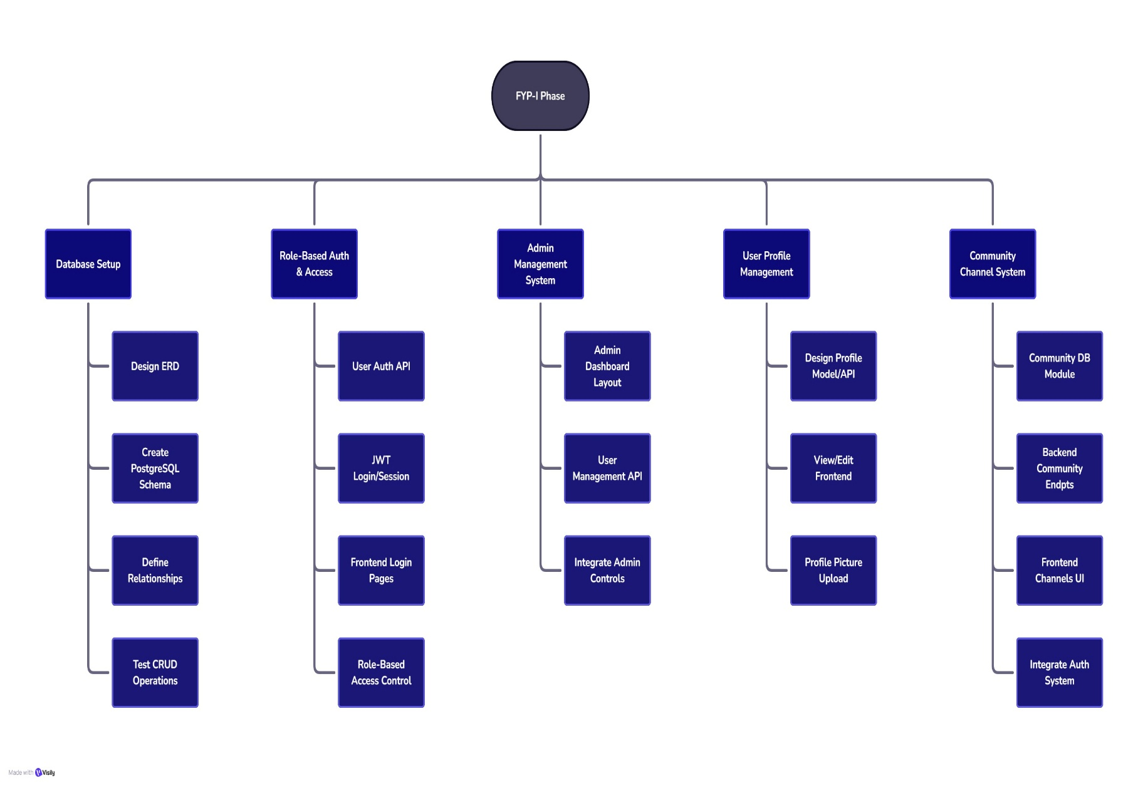
Figure 3: FYP 1 - Work Breakdown Structure

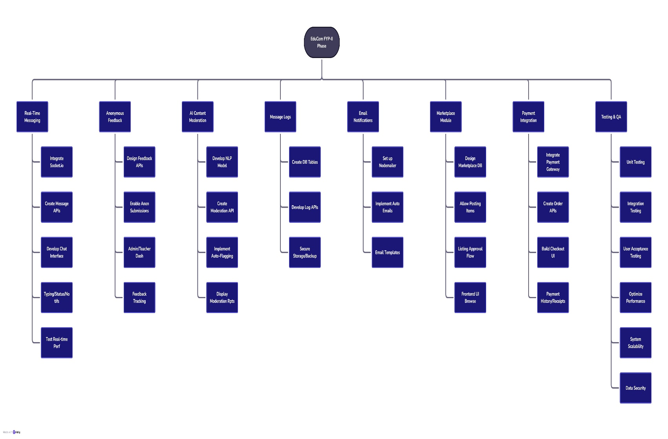
Figure 4: FYP 2 - Work Breakdown Structure

14. References
[1] M. Kaur, S. Kumar, and A. Singh, “Design and Implementation of Role-Based Access Control in Web Applications,” International Journal of Computer Applications, vol. 182, no. 27, pp. 1–6, 2021.
[2] A. Rahman, A. Alamri, and F. Ahmad, “Real-Time Communication Systems Using Node.js and Socket.IO,” Journal of Web Engineering and Technology, vol. 19, no. 3, pp. 245–260, 2022.
[3] H. Chen, J. Li, and X. Zhou, “Anonymous Feedback Collection Framework for Institutional Systems,” IEEE Access, vol. 10, pp. 95632–95645, 2022.
[4] T. Nguyen, P. Do, and K. Le, “AI-Based Content Moderation for Online Communication Platforms,” ACM Transactions on Internet Technology, vol. 23, no. 2, pp. 1–19, 2023.
[5] S. Anwar, M. J. Khan, and N. Hussain, “Developing Secure Educational Communication Platforms Using Role Hierarchies,” Education and Information Technologies, vol. 28, pp. 15213–15229, 2023.
[6] L. Torres and B. Chowdhury, “Building Smart University Systems with Integrated Chatbots and Notification Services,” IEEE Transactions on Learning Technologies, vol. 17, no. 2, pp. 120–131, 2024.
[7] A. K. Sharma and M. Patel, “Integrating Email Notifications in Modern Web-Based Communication Systems,” International Journal of Advanced Computer Science and Applications, vol. 15, no. 3, pp. 145–153, 2024.
[8] J. Wang, C. Liu, and H. Lin, “Monitoring and Logging Mechanisms in Distributed Web Platforms,” Journal of Information Systems Engineering, vol. 21, no. 4, pp. 211–225, 2023.
[9] P. O’Connor, E. B. Santos, and M. Gomez, “AI-Driven Transparency in University Communication Systems,” Computers & Education: Artificial Intelligence, vol. 5, p. 100181, 2024.
[10] OpenAI Research, “Understanding Natural Language Processing (NLP) in Educational Communication Systems,” OpenAI Blog, 2024. Available: https://openai.com/research

