**TidsReg (Time Tracker)**

Expected Project Structure:

Current Project Structure:

Currently the project is in above stage and work is in progress to reach the expected structure.

Database Structure:

BusinessLogic:

Modules:

Funtionality:

NOTE: Special characters exclude å,æ,ø,Å,Æ and Ø.

1. Login Module
   1. User Login
      1. Looks after login of user and sets session for the user.
         1. Username: Range - Alphanumeric (no spaces), with at max 8 characters, no special chars.
         2. Password: Range – Alphanumeric (no spaces), no special chars.
   2. Register User (Api)
      1. Username and Password criteria same as user login above.
2. Project Module
   1. Get Project List (Api)
      1. Gets the list of projects employee is associated to.
         1. Project Name: Alphanumeric (no spaces), no special chars.
   2. Add New Project (Api)
      1. Adds a new Project to the employee
3. Timelog Module
   1. Update TimeLog (Api)
      1. Updates daily timelog. Hours are considered positive integer in value.
   2. Fetch Log (Api)
      1. Fetches timelog with in a period or of particular date.
   3. Fetch Statistics (Api)
      1. Fetches timelog of any month or any time period of a given project.

REST Api Structure:

GUI Structure:

REST Api calls:

|  |  |  |  |  |
| --- | --- | --- | --- | --- |
| Functionality | Module | REST Api | Basic  Auth | Api type |
| User Login | Login | NA | NA | NA |
| Register User | Login | api/TidsReg | No | POST  Body =  {  "username":"123456789",  "password":"abc"  } |
| Get Project List | Project | api/TidsReg/FetchProjectList | Yes | GET |
| Add New Project | Project | api/TidsReg/AddNewProject/{projectName} | Yes | GET |
| Fetch TimeLog | TimeLog | api/TidsReg/FetchtimeLog | Yes | POST  Body =  {  "from":"01-04-2018",  "to":"10-04-2018"  } |
| Fetch Statistics | TimeLog | api/TidsReg/FetchStatistics | Yes | POST  Body =  {  **"project":"Nordea**",  "from":"01-04-2018",  "to":"10-04-2018"  } |
| Add TimeLog | TimeLog | api/TidsReg/AddTimeLog | Yes | POST  Body =  {"logs":  [{  "log":  {  "workday":"04-04-2018",  "timelogs": [{  "project": "Nordea",  "Hours": "8"  }]  }}]} |

Work in Progress:

1. Project structure needs to be changed.
2. Stored procedures needs to be implemented to make efficient use of sql server.
3. Route functionality yet to be implemented.
4. Export functionality needs to be implemented properly and functionality needs to be extended.
5. More constraints need to be added to username and password to make it more flexible.
6. React implementations are yet to be done.
7. More tests are needed.

**Current GUI layout:**

Login Page:

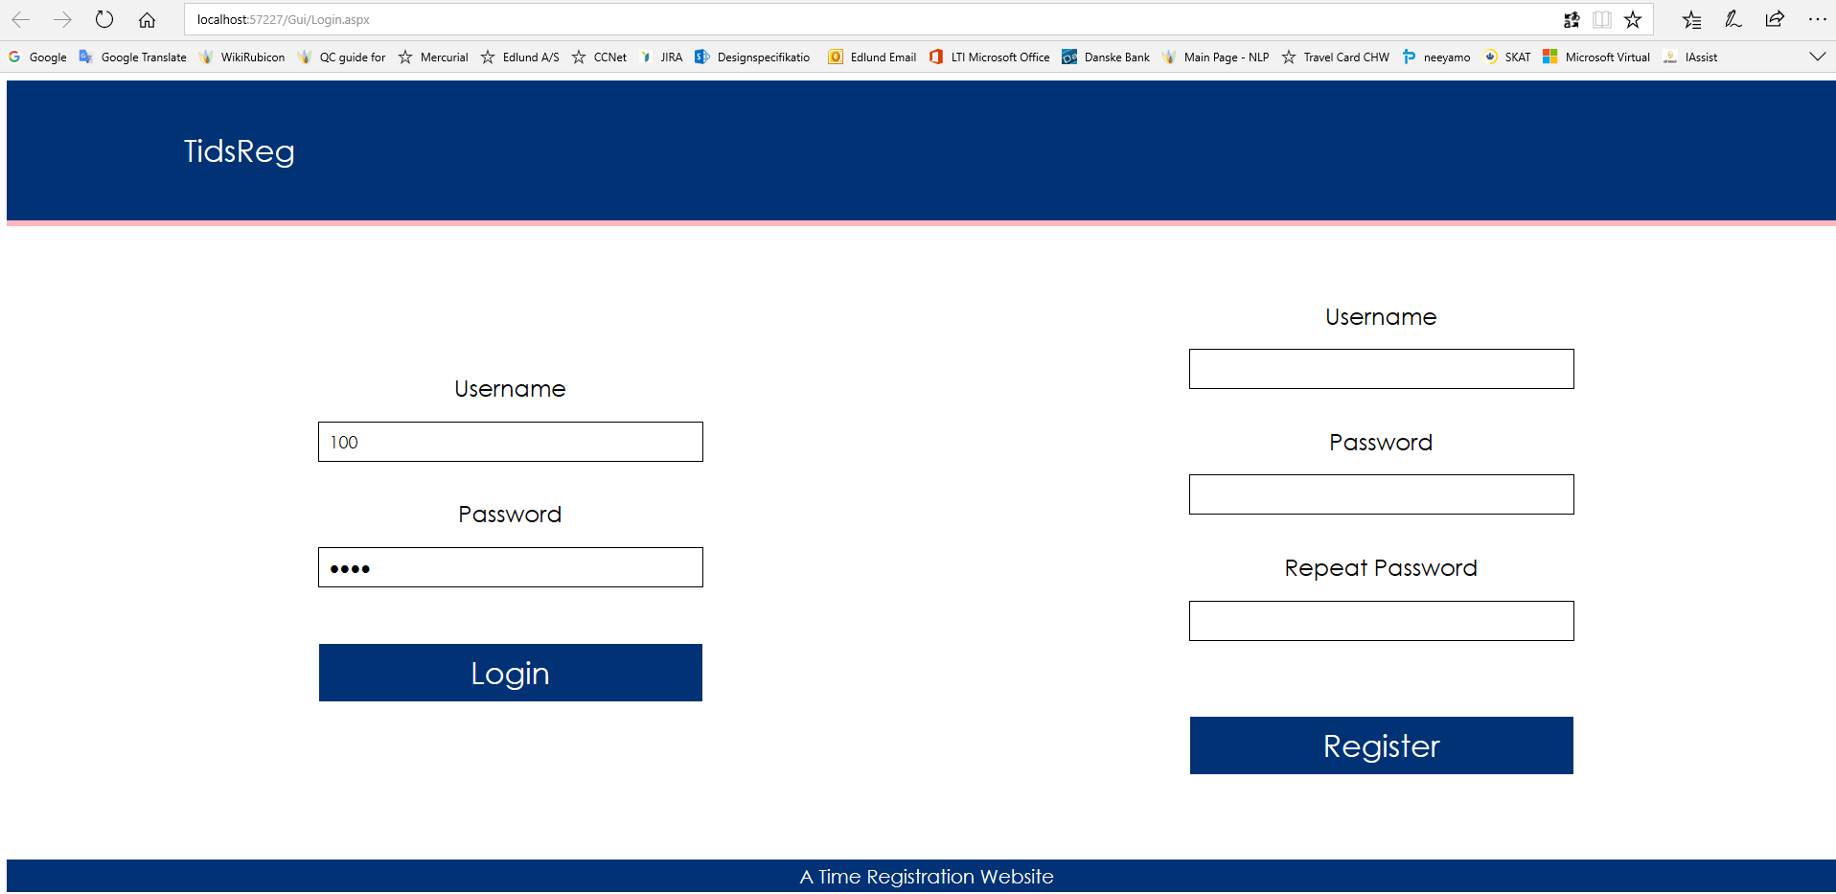

TimeTracking Page:

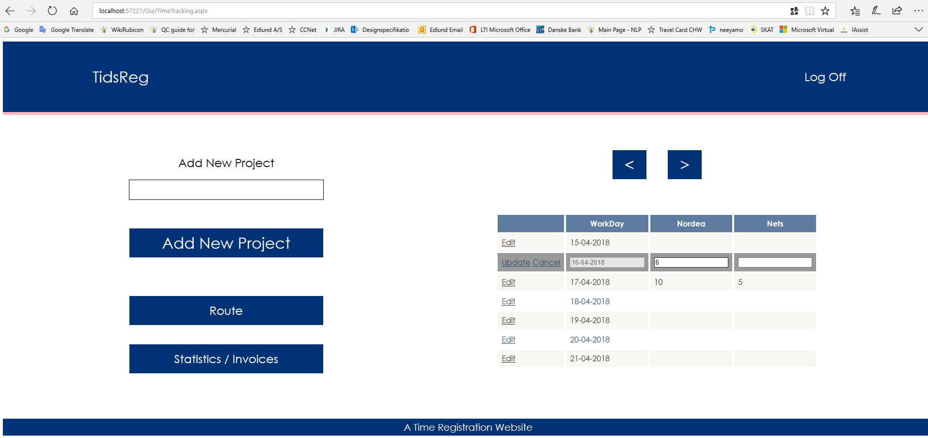

Project Overview Page:

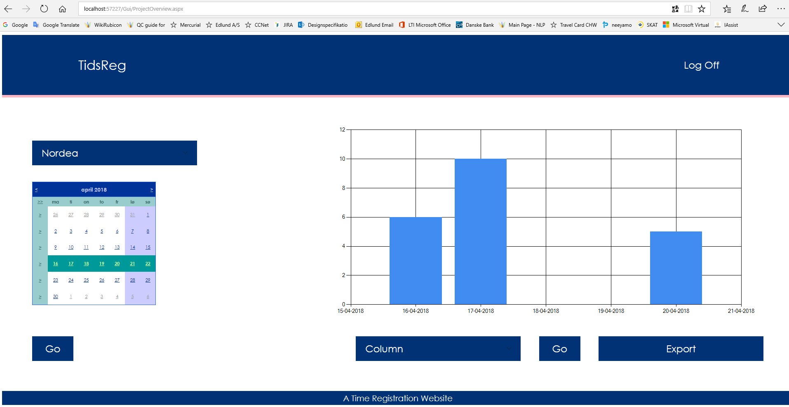

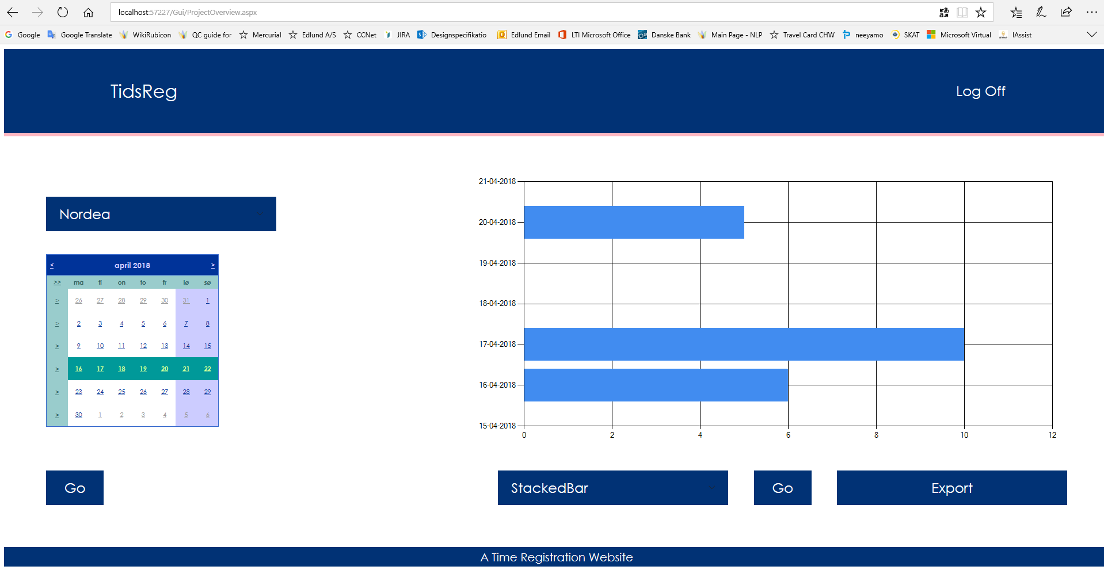

Error Page:

