1. Introduction
SNPSU: Students Feedback Collecting System is a web-based academic feedback management platform developed to simplify and modernize the process of collecting, managing, and analyzing student feedback at Sapthagiri NPS University (SNPSU). Traditional feedback methods, such as paper forms and online surveys, often involve manual processing, delayed report generation, limited participation tracking, and difficulties in maintaining data accuracy. The system addresses these challenges by providing a centralized, secure, and real-time platform for efficient feedback management.
From a Web Programming perspective, the project demonstrates the development of a full-stack MERN (MongoDB, Express.js, React.js, and Node.js) application using React 19, Vite, Express.js, MongoDB, and Mongoose. The backend exposes secure RESTful APIs for authentication, validation, and database operations, while the React-based frontend delivers a responsive and user-friendly Single Page Application (SPA). Technologies such as HTML5, CSS3, JavaScript, React Router, and Axios are used to provide a seamless user experience.
The system enables authenticated students to submit subject-wise feedback only during administrator-controlled feedback sessions, preventing duplicate submissions and ensuring accurate participation tracking. It also includes an anonymous feedback module that encourages students to share honest opinions without revealing their identity. Administrators can manage feedback sessions, monitor participation, analyze subject-wise reports, review anonymous feedback, and export reports in CSV and Word formats through a centralized dashboard.
In addition to feedback collection, the SNPSU: Students Feedback Collecting System incorporates comprehensive modules for administrator authentication, student dashboard management, session allotment control, anonymous feedback management, participation tracking, database analytics, report generation, and secure role-based access management. Security is strengthened through JWT authentication, BCrypt password hashing, Helmet security headers, CORS protection, rate limiting, CSRF mitigation, structured logging, and refresh token management. The modular architecture, RESTful API design, component-based frontend, and adherence to modern software engineering principles such as scalability, maintainability, security, and separation of concerns make the SNPSU: Students Feedback Collecting System a comprehensive Web Programming solution for intelligent academic feedback management.
2. Literature Survey and Tools & Technologies
2.1 Literature Survey
[1]. IoT and New Technologies to Improve Smart Parking Efficiency: Systematic Review
AUTHORS: Reyes Salazar, F. del R., Valdivia Ríos, J. J., Ráez Martínez, H. T., & Pachas Quispe, G. H. (2024)
This systematic literature review analyzes recent advancements in smart parking technologies by examining 32 research studies selected from Scopus-indexed publications. The authors discuss the integration of Internet of Things (IoT), Artificial Intelligence (AI), Machine Learning (ML), smart sensors, cameras, and Big Data for intelligent parking management. The study concludes that combining IoT with AI significantly improves parking space detection, occupancy monitoring, and operational efficiency while highlighting interoperability and data management as future research challenges.

[2]. Computer Vision-Based Approaches, Datasets, and Applications of Smart Parking Systems: A Review
AUTHORS: Hadi, R. A., George, L. E., & Ahmed, Z. J. (2024)
This review focuses on computer vision techniques used in modern smart parking systems. The authors examine deep learning models, object detection algorithms, image processing methods, and publicly available parking datasets for vehicle occupancy detection. The paper concludes that computer vision provides higher flexibility and accuracy than traditional sensor-based systems while emphasizing the need for robust datasets and improved real-world deployment strategies.

[3]. Smart Camera Parking System with Auto Parking Spot Detection
AUTHORS: Nguyen, T. T., & Sartipi, M. (2024)
This research introduces an intelligent camera-based parking system that automatically detects parking spaces without requiring manual annotation. The proposed PakLoc and PakSta frameworks employ computer vision techniques to identify parking locations and determine occupancy status, significantly reducing manual configuration effort. Experimental results demonstrate improved parking detection accuracy and reduced implementation cost, making the solution practical for large-scale smart parking environments.

[4]. Smart Parking Systems: A Comprehensive Review of Digitalization of Parking Services
AUTHORS: Channamallu, S. S., Kermanshachi, S., Rosenberger, J. M., & Pamidimukkala, A. (2026)
This comprehensive review examines the evolution of smart parking systems through digital technologies such as IoT, Artificial Intelligence, Machine Learning, wireless communication, and mobile applications. The authors analyze vehicle detection methods, occupancy prediction techniques, and intelligent parking management frameworks. The study concludes that smart parking platforms improve parking efficiency, reduce traffic congestion, and support smart city initiatives while identifying scalability and interoperability as important future research directions.

[5]. Implementation of IoT-Based Smart Parking with Automated Barrier and QR Code Validation
AUTHORS: Ilmananda, A. S., Djuk, J. A. L., & Sanusi, A. P. (2026)
This paper presents an IoT-enabled smart parking system that integrates automated barrier control, real-time parking monitoring, online reservation, and QR-code validation. The proposed system utilizes ESP8266 controllers, infrared sensors, and a web-based application to automate vehicle entry and exit operations. The study demonstrates that QR-code authentication combined with IoT technologies improves parking efficiency, reduces waiting time, and enhances overall user experience in modern parking facilities.

2.2 Tools and Technologies
Category | Tool & Technologies | Purpose in SNPSU: Students Feedback Collecting System
Programming Language | JavaScript (ES6+) | Implements both frontend and backend application logic.
Frontend Library | React 19 | Builds the responsive Single Page Application (SPA) using reusable components.
Build Tool | Vite 8 | Provides fast development, Hot Module Replacement (HMR), and optimized production builds.
Backend Framework | Express.js | Develops RESTful APIs, routing, middleware, and business logic.
Runtime Environment | Node.js | Executes the backend application and manages server-side operations.
Architecture | MERN Architecture | Separates the application into frontend, backend, API, and database layers.
Frontend Technologies | HTML5, CSS3 | Develops responsive and user-friendly web pages.
Database | MongoDB | Stores student accounts, feedback records, anonymous feedback, and session data.
ODM Framework | Mongoose | Maps JavaScript objects to MongoDB documents and simplifies CRUD operations.
Authentication | JSON Web Token (JWT) | Provides secure user authentication and role-based authorization.
Password Encryption | BCryptJS | Encrypts user passwords before storing them in the database.
HTTP Client | Axios | Enables communication between the React frontend and Express backend.
Security | Helmet & Express Rate Limit | Protects the application using secure HTTP headers and rate limiting.
API Documentation | Swagger (Swagger UI) | Generates interactive REST API documentation for testing and development.
Data Visualization | Recharts | Displays charts, statistics, and administrative analytics.
Testing Framework | Jest & Supertest | Performs unit testing and REST API integration testing.
Deployment & Version Control | GitHub, GitHub Actions & Vercel | Supports version control, CI/CD automation, and application deployment.

3. Methodology
3.1 Methodology Overview
The proposed methodology for SNPSU: Students Feedback Collecting System follows a structured full-stack MERN architecture for secure and efficient academic feedback management. The system integrates user authentication, session-based feedback collection, anonymous feedback submission, participation tracking, and administrative analytics within a centralized web application.
The workflow begins with user authentication using JSON Web Token (JWT) authentication and BCrypt password encryption. After successful login, students are redirected to their dashboard, where they can view active feedback sessions and submit subject-wise feedback only when the administrator has opened the corresponding feedback allotment. Simultaneously, the system provides an anonymous feedback module that enables users to submit feedback without revealing their identity. Before storing any submission, the application validates user inputs, verifies feedback session availability, and prevents duplicate submissions to maintain data consistency and reliability.
Student records, feedback data, anonymous submissions, and session allotments are securely stored in MongoDB using Mongoose. The backend, developed with Express.js, processes business logic through RESTful APIs, while the React frontend communicates using Axios. Security features such as JWT authentication, Helmet, CORS protection, rate limiting, and input validation protect the application from unauthorized access.
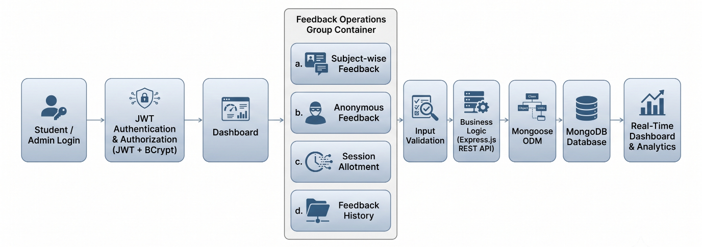
The overall methodology ensures secure communication between the frontend, backend, and database, providing a scalable and user-friendly academic feedback management solution. The complete workflow of the proposed system is illustrated in Figure 3.1.
3.2 System Architecture:
The architecture of SNPSU: Students Feedback Collecting System follows a modular MERN (MongoDB, Express.js, React.js, and Node.js) client-server architecture that separates the application into presentation, application, and data layers. This layered design improves maintainability, scalability, and security while ensuring efficient communication between the frontend, backend, and database.
The Presentation Layer is developed using React 19, HTML5, CSS3, and JavaScript, providing a responsive and interactive Single Page Application (SPA). This layer allows students to securely log in, view active feedback sessions, submit subject-wise feedback, access their feedback history, and provide anonymous feedback when required. Administrators can manage feedback allotments, monitor student participation, analyze subject-wise reports, review anonymous feedback, and generate downloadable reports through an intuitive administrative dashboard. React Router enables seamless navigation, while Axios facilitates secure communication with the backend through RESTful APIs.
The Application Layer is implemented using Node.js and Express.js, which process all incoming client requests. This layer performs user authentication, role-based authorization, session allotment verification, input validation, duplicate feedback prevention, anonymous feedback processing, and report generation. Business logic is executed through RESTful API endpoints before interacting with the database. Secure authentication is achieved using JSON Web Tokens (JWT), while BCrypt encrypts user passwords to protect account credentials.
The Data Layer utilizes MongoDB with Mongoose for efficient storage and retrieval of application data. The database maintains student accounts, administrator information, feedback records, anonymous submissions, and feedback session allotments. Mongoose simplifies database interactions through schema-based models, validation, and CRUD operations, ensuring data consistency and integrity throughout the system.
Security is integrated across every architectural layer using JWT authentication, BCrypt password encryption, Helmet security headers, CORS protection, rate limiting, server-side validation, and secure API communication. These mechanisms protect the application against unauthorized access, malicious requests, and common web vulnerabilities. The layered MERN architecture therefore provides a secure, scalable, maintainable, and efficient platform for managing academic feedback, making the SNPSU: Students Feedback Collecting System a reliable solution for modern university feedback management.
3.3 Functional Methodology:
The functional methodology of SNPSU: Students Feedback Collecting System is designed using a modular MERN architecture, where each module performs a specific function while communicating through secure RESTful APIs. This modular approach improves maintainability, scalability, and reliability by separating the system into independent functional components that work together to provide efficient academic feedback management. Each module is responsible for a specific task while interacting seamlessly with other modules, ensuring smooth data flow and real-time system operation.
The process begins with the Authentication Module, where students and administrators log in using their registered credentials. The backend verifies user information through JSON Web Token (JWT) authentication, while BCrypt encrypts passwords before storing them in the database. After successful authentication, users are redirected to their respective dashboards based on their roles. Students can access feedback-related features, whereas administrators gain access to system management, analytics, and reporting modules through secure role-based authorization.
The Feedback Management Module enables students to submit subject-wise feedback only during administrator-controlled feedback sessions. Before accepting any submission, the system validates user inputs, verifies whether the feedback session is active, and checks for duplicate submissions. Along with authenticated feedback, the system provides an Anonymous Feedback Module, allowing students to submit opinions without revealing their identity. This dual-feedback mechanism encourages honest responses while maintaining accountability and improving the overall quality of academic feedback collected by the institution.
The Administration and Analytics Module provides administrators with comprehensive control over the system. Administrators can create and manage feedback allotments, monitor student participation, analyze subject-wise feedback, review anonymous submissions, and generate reports in CSV and Word formats. Interactive dashboards display real-time statistics, participation percentages, feedback summaries, and overall system activity, enabling efficient monitoring and informed academic decision-making.
Figure 3.2 illustrates the functional workflow of the proposed system, showing how authentication, dashboard operations, feedback modules, validation, business logic, and database interaction work together to provide secure and efficient feedback management.
Figure 3.2
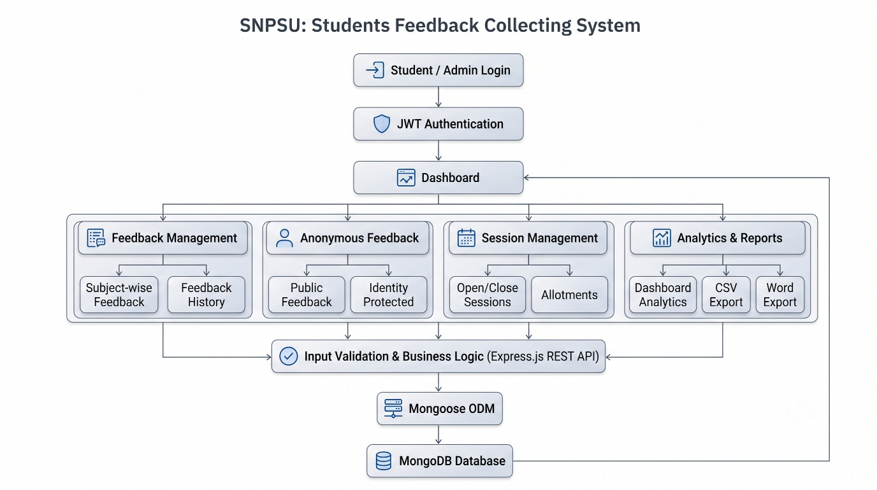
All application data, including student accounts, feedback records, anonymous submissions, and session allotments, is securely stored in MongoDB using Mongoose. The Express.js backend executes business logic and communicates with the React frontend through RESTful APIs, while Axios enables efficient data exchange between the client and server. Every request initiated by the user is validated, processed by the backend, and stored or retrieved from the database before the updated response is displayed on the user interface.
The application incorporates multiple security mechanisms, including JWT authentication, BCrypt password encryption, Helmet security headers, CORS protection, rate limiting, server-side validation, and role-based authorization. These mechanisms safeguard sensitive user information, prevent unauthorized access, and protect the application against common web vulnerabilities while ensuring secure communication between all architectural layers.
The modular architecture enables independent management of the presentation, application, and data layers, making the system easier to develop, test, maintain, and extend with future enhancements. During runtime, every user request is processed in real time, ensuring accurate feedback collection, secure data management, and continuous dashboard updates. This functional methodology provides a scalable, reliable, and user-friendly solution for modern academic feedback management.

4. System Design
4.1 System Workflow:
The System Workflow of SNPSU: Students Feedback Collecting System represents the complete sequence of operations performed during the feedback collection process, beginning with user authentication and ending with real-time dashboard updates. The workflow is designed to ensure secure access, accurate feedback collection, reliable data validation, and efficient storage of feedback records through a structured request-processing pipeline.
The workflow begins when a student or administrator logs into the application using registered credentials. The system verifies the user's identity through JWT-based authentication, and after successful authentication, redirects the user to the appropriate dashboard according to their role. Students can access active feedback sessions, while administrators can manage feedback allotments, monitor participation, and analyze reports.
Before allowing feedback submission, the application validates the student's eligibility by checking whether the corresponding feedback session is active and whether feedback has already been submitted for the selected subject. The system also validates all required inputs to prevent incomplete or duplicate submissions. Alongside authenticated feedback, users may also submit anonymous feedback through a separate module without revealing their identity.
Once validation is completed, the request is forwarded to the Express.js backend, where the business logic processes the submitted data. The application manages feedback records, session allotments, participation tracking, and administrative operations before securely storing the processed information in the MongoDB database using Mongoose. Every successful operation immediately updates the administrative dashboard with the latest participation statistics, feedback summaries, and analytical reports.
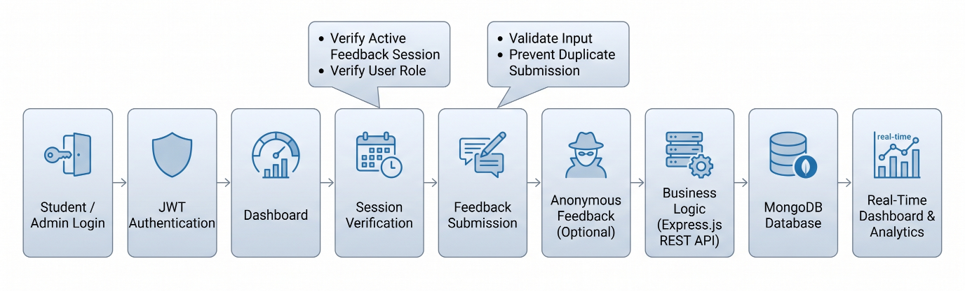
Figure 4.1
4.2 System Components
The SNPSU: Students Feedback Collecting System follows a modular MERN (MongoDB, Express.js, React.js, and Node.js) architecture, where each component performs a specific responsibility while working together to provide secure and efficient academic feedback management. The modular design ensures clear separation between the presentation, application, and data layers, improving maintainability, scalability, and future extensibility.
The Web Interface, developed using React, HTML5, CSS3, and JavaScript, provides a responsive platform for students and administrators. Students can submit subject-wise and anonymous feedback, while administrators can manage feedback sessions, monitor participation, generate reports, and access analytics through a centralized dashboard.
The Application Layer, built with Node.js and Express.js, processes RESTful API requests, performs authentication, input validation, session verification, feedback processing, and report generation. Business services coordinate communication between the frontend and database while ensuring secure and reliable application workflows.
The Data Access Layer uses Mongoose to perform CRUD operations and communicate with the MongoDB database, which securely stores student accounts, feedback records, anonymous submissions, and session allotments. Data is retrieved dynamically to update dashboards, generate reports, and display real-time statistics. Together, these components establish a secure, scalable, and reliable architecture that supports efficient academic feedback management and simplifies future system enhancements.
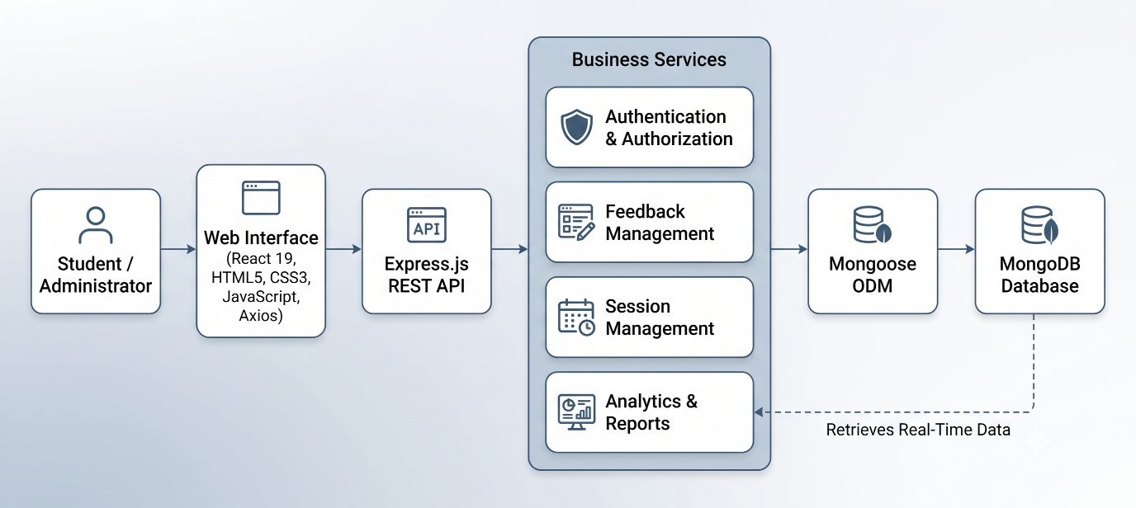
Figure 4.2
5. Implementation
5.1 Development Environment and Project Structure
The development of SNPSU: Students Feedback Collecting System was carried out using a modern MERN (MongoDB, Express.js, React.js, and Node.js) technology stack that supports secure, scalable, and maintainable web application development. The frontend is developed using React 19 with Vite, while the backend is built using Node.js and Express.js. MongoDB serves as the primary NoSQL database, with Mongoose providing object data modeling and database communication. The application was developed using Visual Studio Code and tested locally using the Vite development server and Node.js runtime.
The project follows a well-organized directory structure that separates the frontend, backend, configuration files, and project resources. The client directory contains React components, pages, contexts, services, assets, and styling files responsible for the user interface. The server directory contains API routes, controllers, models, middleware, configuration files, utilities, and authentication logic. Configuration files such as package.json, vite.config.js, and environment files manage dependencies, build settings, and application configuration.
This modular project organization improves code readability, simplifies maintenance, and enables future feature enhancements without affecting the overall architecture. The structured folder hierarchy also supports collaborative development and follows modern software engineering practices for full-stack web application development.
SNPSU: Students Feedback Collecting System
│
├── client
│ ├── Components
│ ├── Pages
│ ├── Context
│ ├── Services
│ ├── Assets
│ └── Styles
├── server
│ ├── Controllers
│ ├── Models
│ ├── Routes
│ ├── Middleware
│ ├── Configuration
│ └── Utilities
├── Public
├── Environment Files (.env)
├── package.json
└── vite.config.js
5.2 Core Module Implementation

The SNPSU: Students Feedback Collecting System is implemented using a modular MERN architecture, where each functional module performs a specific responsibility while interacting with other components through secure RESTful APIs. This modular implementation improves maintainability, scalability, and simplifies future system enhancements by separating authentication, feedback processing, administration, and data management into independent modules.
The Authentication Module verifies student and administrator credentials using JSON Web Token (JWT) authentication and BCrypt password encryption before granting access to the application. After successful authentication, users are redirected to their respective dashboards based on their roles, ensuring secure and role-based access to system resources.
The Feedback Management Module enables students to submit subject-wise feedback only during administrator-controlled feedback sessions. Before storing any submission, the system validates user inputs, verifies session availability, and prevents duplicate feedback for the same subject. An additional Anonymous Feedback Module allows users to submit feedback without revealing their identity, encouraging honest and unbiased responses.
The Administration and Analytics Module allows administrators to manage feedback sessions, monitor student participation, review anonymous submissions, analyze subject-wise feedback, and generate reports. All application data is securely stored in MongoDB using Mongoose, while the Express.js backend processes business logic and communicates with the React frontend through RESTful APIs. The dashboard dynamically displays participation statistics, feedback summaries, and system analytics in real time, providing administrators with accurate insights for academic decision-making.
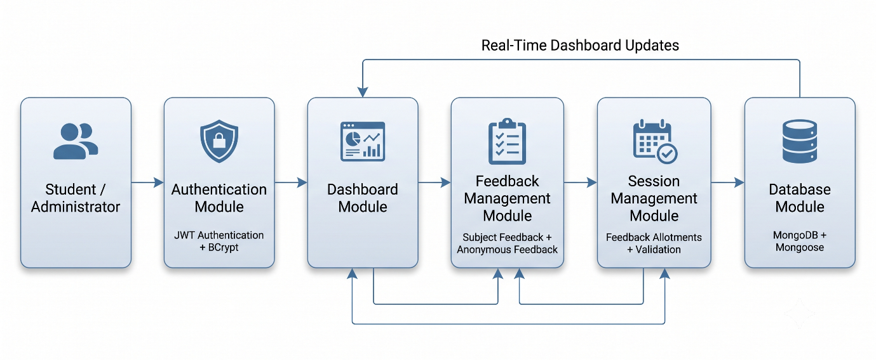
Figure 5.1
5.3 Database Implementation and Data Processing
The SNPSU: Students Feedback Collecting System uses MongoDB as its primary NoSQL database to store student accounts, administrator information, subject-wise feedback, anonymous feedback, and feedback session allotments. The database is implemented using Mongoose, which provides object data modelling (ODM) and enables efficient communication between the application and the database through schema-based document management.
Whenever a user performs an operation such as logging in, submitting feedback, or managing feedback sessions, the request is first processed by the Express.js backend. The application validates the request, executes the required business logic, and then uses Mongoose to perform the necessary CRUD operations before storing or retrieving data from MongoDB. This layered architecture reduces direct database dependencies, improves maintainability, and ensures secure and reliable data processing.
The database supports real-time retrieval of application data, enabling administrators to monitor participation statistics, feedback summaries, anonymous submissions, and subject-wise reports through the dashboard. Efficient document queries and schema validation ensure fast data access while maintaining consistency and data integrity. The centralized database architecture enables seamless synchronization between the frontend, backend, and all functional modules, providing reliable performance and supporting future scalability.
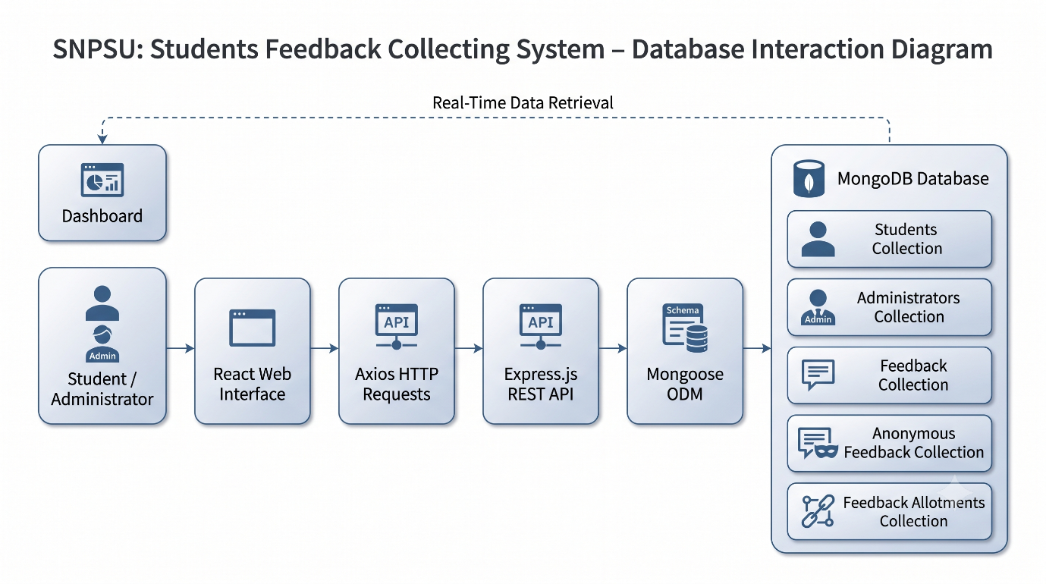
Figure 5.2

5.4 Navigation Workflow and Validation Mechanism
The QSpark application follows a structured navigation workflow that enables administrators to access different system modules through a secure and user-friendly interface. After successful authentication, the administrator is redirected to the dashboard, where features such as vehicle registration, parking slot allocation, QR code management, and parking history can be accessed. The navigation is designed to provide quick access to all core functionalities while maintaining secure user sessions.
Before processing any request, the application performs server-side validation to ensure the accuracy and consistency of the submitted data. Vehicle registration numbers, mobile numbers, and parking slot availability are verified before creating a parking booking. If invalid or duplicate information is detected, the system displays appropriate validation messages and prevents incorrect data from being stored in the database.
The application also includes exception handling mechanisms to improve reliability and user experience. Invalid login attempts, duplicate vehicle registrations, occupied parking slots, and unsuccessful QR code scans are handled gracefully by displaying meaningful error messages. Once a request is successfully validated, the information is stored in the database, and the dashboard is updated instantly to reflect the latest parking status and booking information.
This navigation and validation mechanism ensures secure request processing, minimizes operational errors, and provides a smooth user experience while maintaining the integrity and reliability of the parking management system.
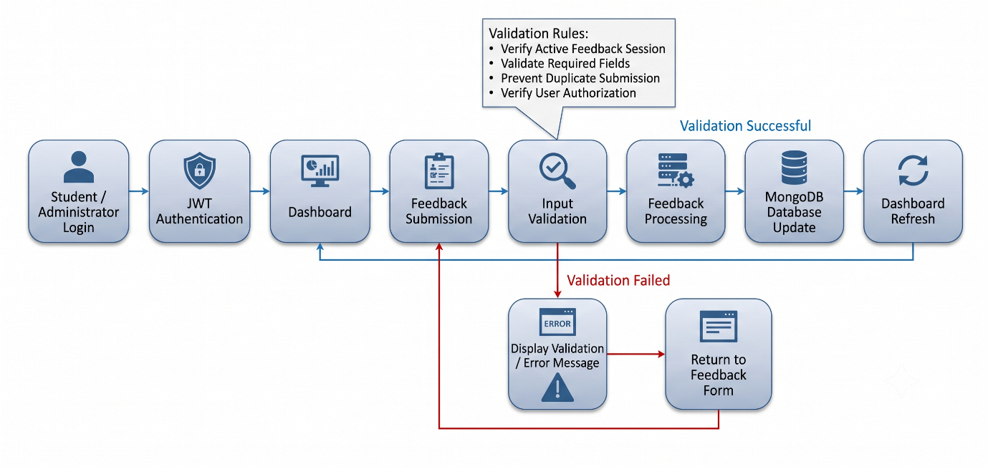
Figure 5.3
5.5 User Interface Implementation
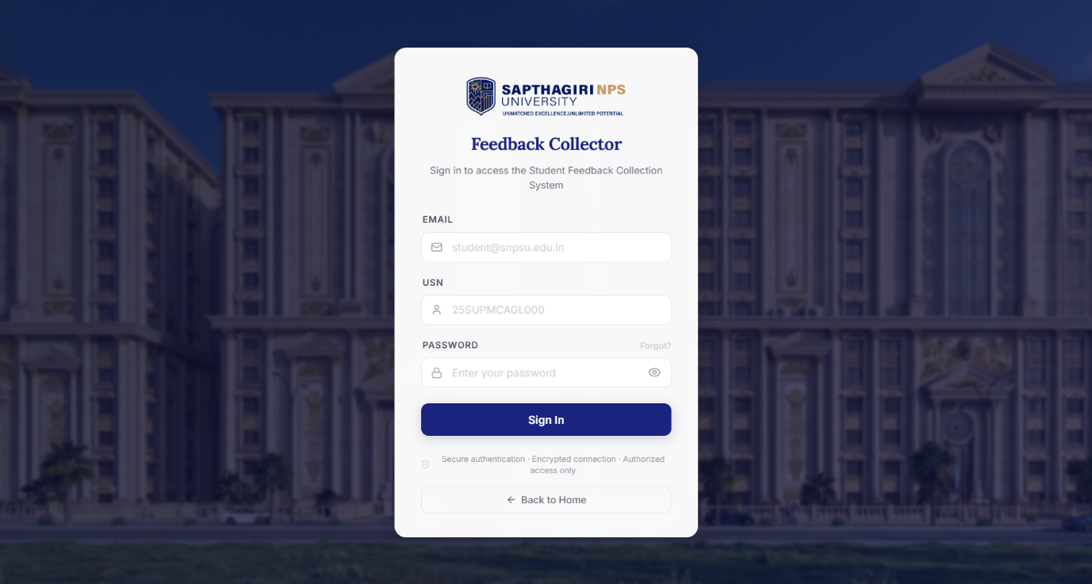
Figure 5.4 Login Page
The Login Page provides secure authentication for students and administrators using JWT-based authentication. Only authorized users can access the application after successful credential verification, ensuring secure access to system resources.
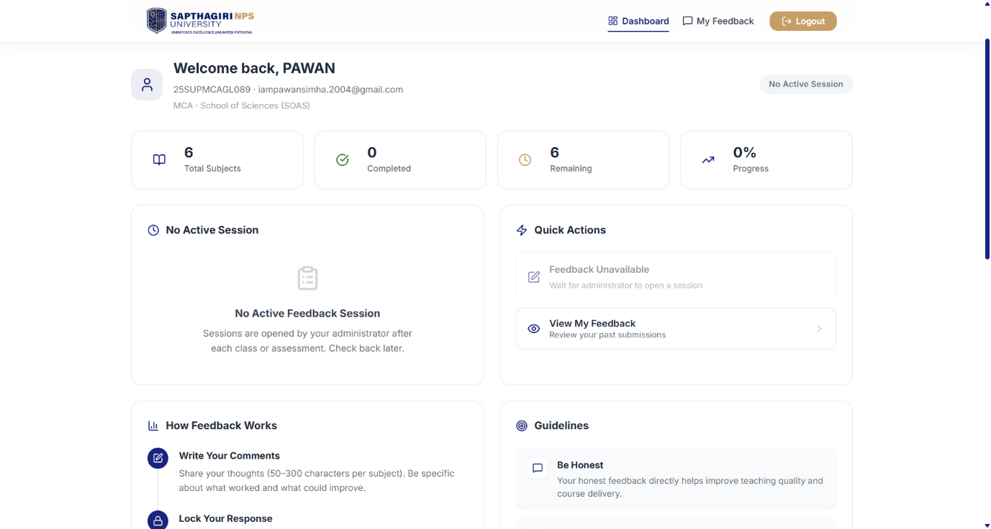
Figure 5.5 Student Dashboard
The Student Dashboard displays active feedback sessions, available subjects, feedback history, and quick navigation to feedback modules. It serves as the primary interface through which students participate in the feedback process.

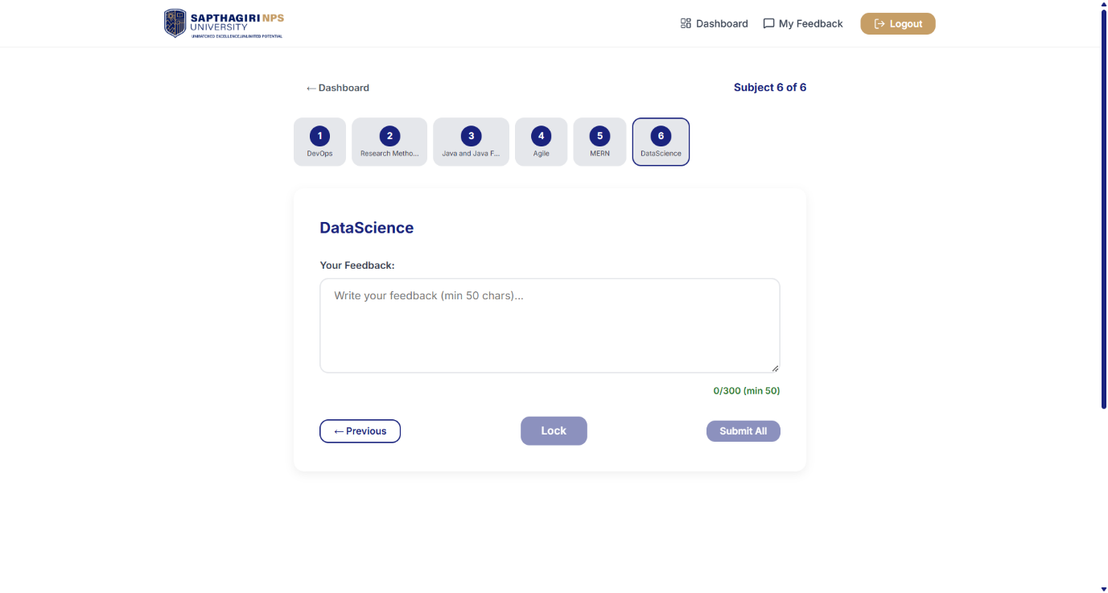
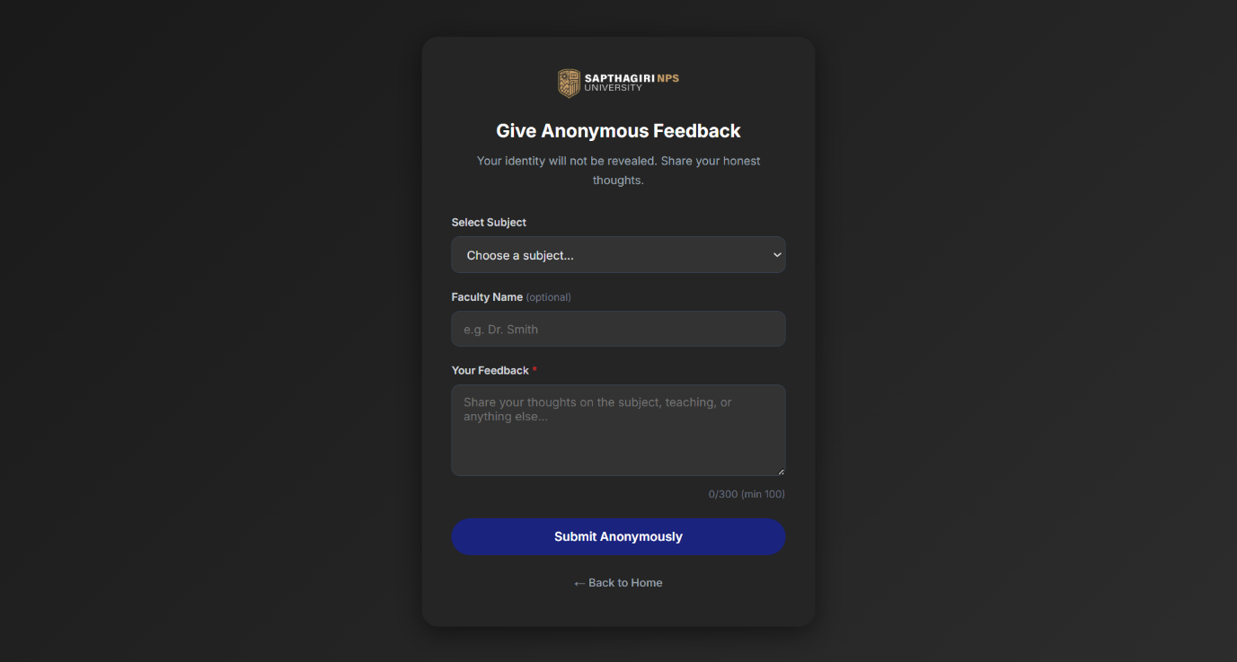

Figure 5.6 Feedback Submission & Anonymous Feedback
- The Feedback Submission interface enables students to submit subject-wise feedback during active feedback sessions. Input validation ensures accurate and complete feedback before submission.
- he Anonymous Feedback page allows users to provide feedback without revealing their identity, encouraging honest opinions while maintaining user privacy.

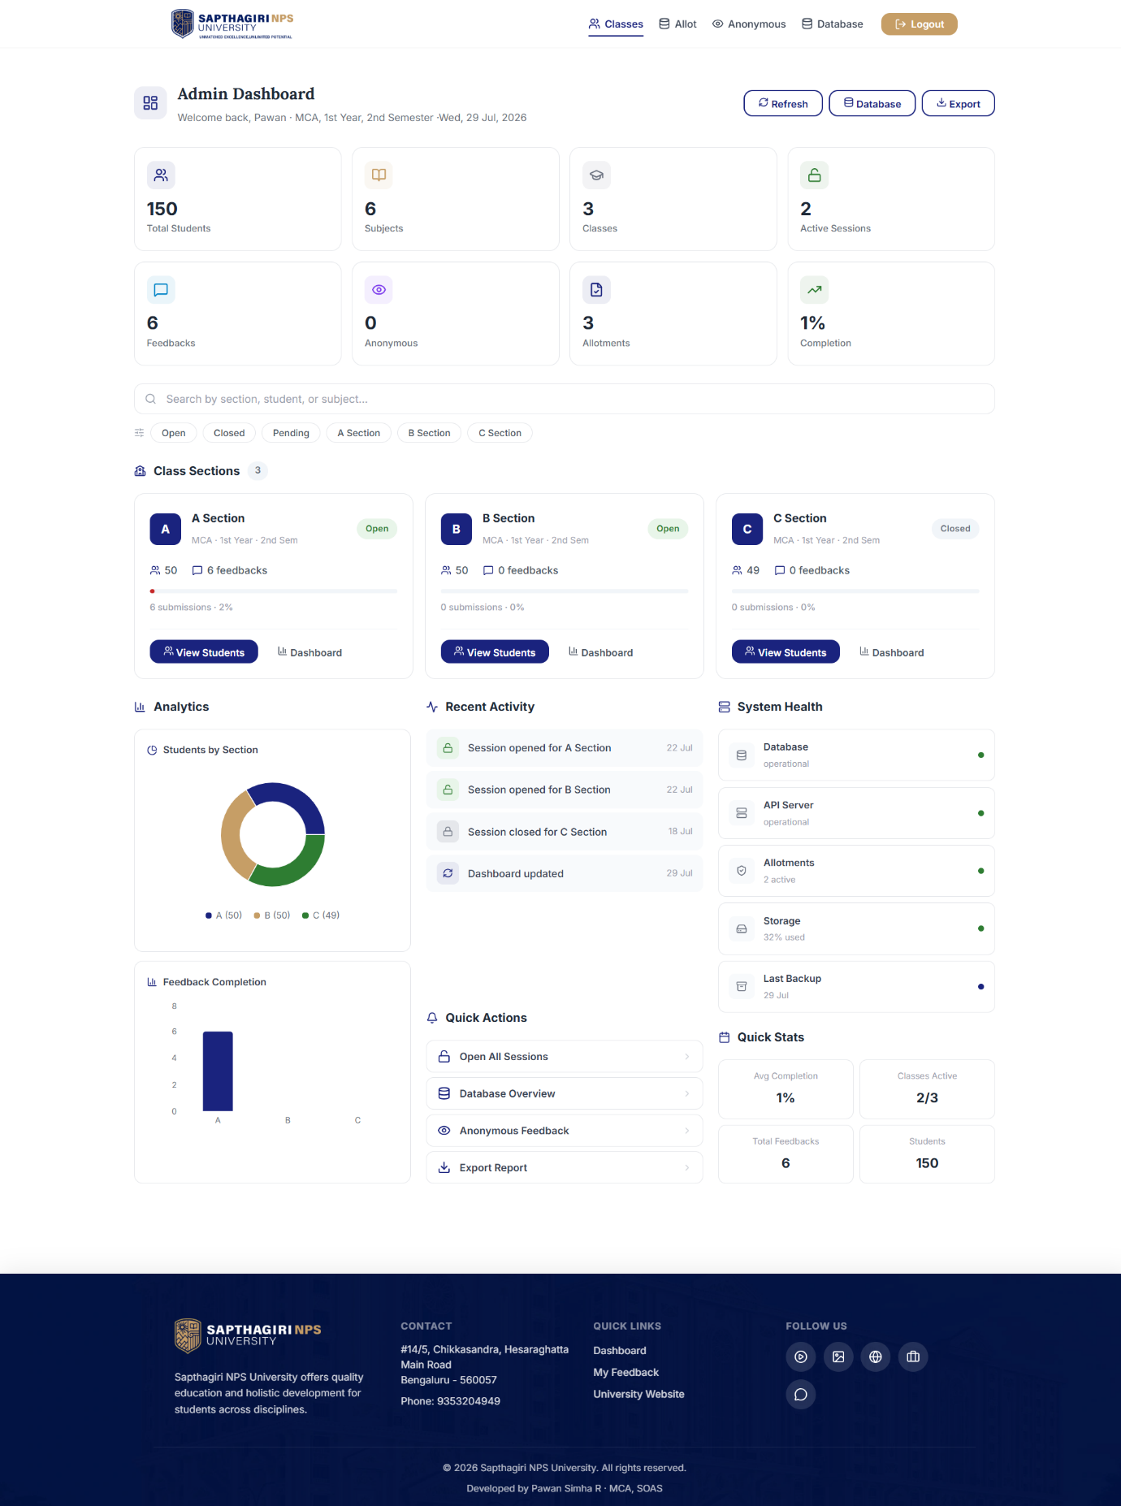Figure 5.7 Administrator Dashboard
The Administrator Dashboard provides a centralized interface for managing feedback sessions, monitoring student participation, viewing system statistics, and accessing administrative modules.
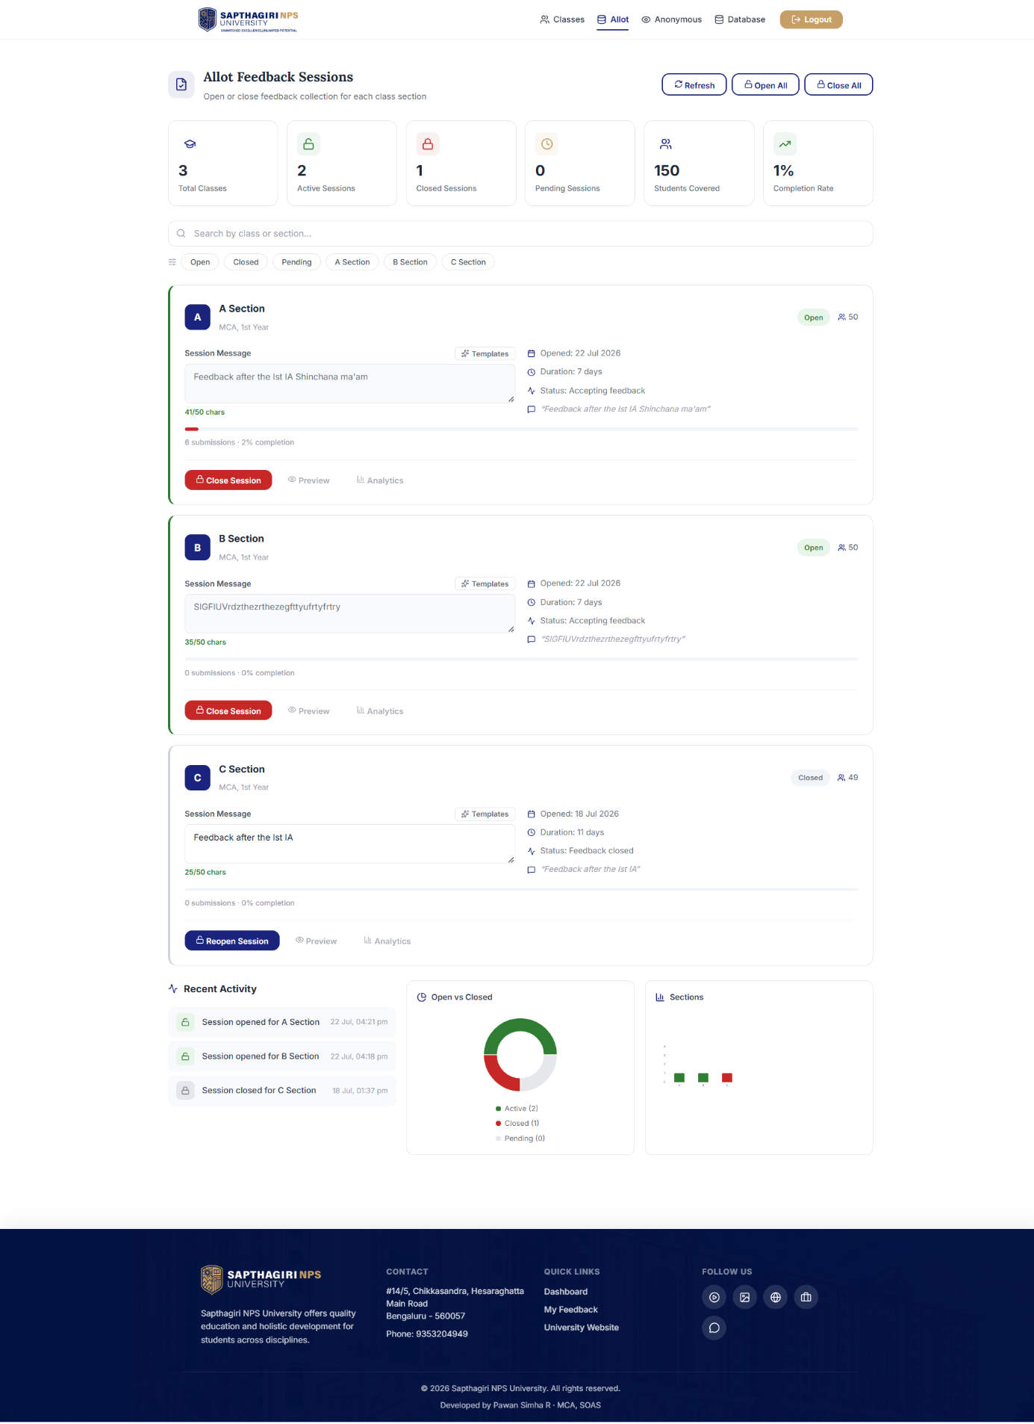
Figure 5.8 Feedback Allotment Management
This interface enables administrators to create, activate, edit, and manage feedback sessions for different subjects and classes. It ensures that students can submit feedback only during authorized feedback periods.
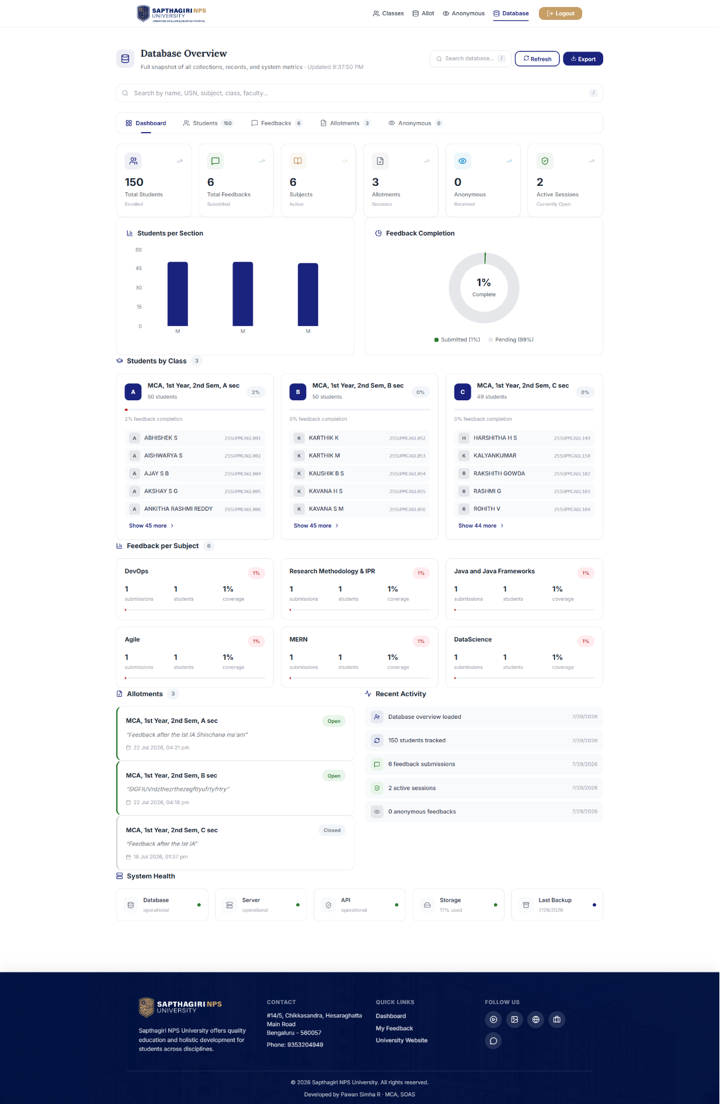
Figure 5.9 Database Overview / Student Feedback Records
This interface displays stored feedback records, anonymous submissions, and student participation details. Search and filtering options enable administrators to efficiently manage and review collected feedback.
6. Conclusion
SNPSU: Students Feedback Collecting System successfully demonstrates the design and implementation of a secure, scalable, and user-friendly web-based academic feedback management platform using the MERN (MongoDB, Express.js, React.js, and Node.js) technology stack. The project effectively addresses the limitations of traditional paper-based and manual feedback collection methods by providing a centralized system for secure user authentication, subject-wise feedback collection, anonymous feedback submission, participation tracking, and real-time administrative analytics. The modular client-server architecture ensures clear separation between the presentation, application, and data layers, making the system easier to maintain, extend, and manage.
The application is developed using React 19, Node.js, Express.js, MongoDB, and Mongoose, providing a modern and reliable full-stack development environment. Security mechanisms such as JWT authentication, BCrypt password encryption, Helmet security headers, CORS protection, rate limiting, and server-side validation protect the application from unauthorized access and common web vulnerabilities. Features including feedback session management, anonymous feedback, role-based access control, report generation, and real-time dashboard analytics improve the efficiency and transparency of the feedback collection process while ensuring data consistency and reliability.
Throughout the development process, emphasis was placed on modular architecture, structured project organization, efficient database management, RESTful API design, and responsive user interface development. The implemented modules perform according to the expected functional requirements and provide a stable, secure, and intuitive user experience for both students and administrators.
Overall, SNPSU: Students Feedback Collecting System successfully achieves its objective of providing a comprehensive digital solution for academic feedback management at Sapthagiri NPS University. The scalable architecture provides a strong foundation for future enhancements such as faculty dashboards, email notifications, AI-based sentiment analysis, predictive feedback analytics, cloud deployment, and mobile application support. These improvements can further enhance decision-making, accessibility, and institutional quality assurance, making the system a practical and reliable solution for modern higher education institutions.

7. Future Enhancements
Although the SNPSU: Students Feedback Collecting System successfully fulfills the current project objectives, several enhancements can further improve its functionality, scalability, security, and overall user experience.
7.1 AI-Based Sentiment Analysis
Integrate Artificial Intelligence and Natural Language Processing (NLP) techniques to automatically analyze anonymous comments and classify feedback as positive, negative, or neutral. This would help administrators identify trends and make data-driven academic decisions.
7.2 Email and Notification System
Implement automated email and in-app notifications to inform students about newly opened feedback sessions, submission deadlines, and successful feedback submissions. Administrators can also receive notifications regarding participation statistics and system activities.
7.3 Mobile Application
Develop dedicated Android and iOS applications that enable students and administrators to access the system, submit feedback, monitor participation, and receive real-time notifications through their smartphones.
7.4 Advanced Analytics Dashboard
Enhance the dashboard with interactive visualizations, predictive analytics, department-wise comparisons, and downloadable reports. Advanced analytical features can provide deeper insights into student feedback and academic performance.
7.5 Cloud Deployment and Scalability
Deploy the application on cloud platforms such as AWS, Microsoft Azure, or Google Cloud Platform to improve scalability, availability, performance, and disaster recovery while supporting a larger number of concurrent users.
7.6 Enhanced Security and Multi-Factor Authentication
Strengthen application security by implementing Multi-Factor Authentication (MFA), audit logging, account activity monitoring, advanced role-based access control, and encrypted backup mechanisms to further protect sensitive academic data.
Overall, these enhancements will transform the SNPSU: Students Feedback Collecting System into a more intelligent, scalable, and secure academic feedback platform capable of supporting advanced analytics, institutional quality assurance, and future digital transformation initiatives in higher education.
8. Bibliography & References
1] Sun, S., Gao, X., Rahmani, B. D., Bose, P., & Davison, C., Student Voice in Assessment and Feedback (2011–2022): A Systematic Review, Assessment & Evaluation in Higher Education, Vol. 48, No. 7, 2023.
[2] Taghizadeh Kerman, N., Banihashem, S. K., Karami, M., Er, E., & Noroozi, O., Online Peer Feedback in Higher Education: A Synthesis of the Literature, Education and Information Technologies, Vol. 29, 2024.
[3] Gaikwad, A., Jadhav, N., Jadhav, S., Jadhav, N., & Jadhav, D. K., Student Feedback Management System, International Journal of Research Publication and Reviews (IJRPR), Vol. 4, No. 12, 2023.
[4] Sommerville, I., Software Engineering, 10th Edition, Pearson Education, 2016.
[5] Fowler, M., Patterns of Enterprise Application Architecture, Addison-Wesley Professional, 2002.
[6] Gamma, E., Helm, R., Johnson, R., & Vlissides, J., Design Patterns: Elements of Reusable Object-Oriented Software, Addison-Wesley, 1994.
[7] Meta Platforms, Inc., React Documentation, 2025.
[8] Node.js Foundation, Node.js Documentation, 2025.
[9] Express.js Team, Express.js Documentation, 2025.
[10] MongoDB Inc., MongoDB Documentation, 2025.
[11] Mongoose Team, Mongoose ODM Documentation, 2025.
[12] Auth0, JSON Web Token (JWT) Documentation, 2025.
[13] Helmet.js Team, Helmet.js Documentation, 2025.
[14] World Wide Web Consortium (W3C), HTML5, CSS3 and JavaScript Web Standards, 2025.
[15] OpenJS Foundation, npm Documentation, 2025.

Appendix
The appendix provides supplementary information related to the implementation and deployment of the SNPSU: Students Feedback Collecting System. It includes additional technical details that support the project documentation and provide a better understanding of the developed web application.

Appendix A: Software and Hardware Requirements
- Operating System: Windows 10/11
- Programming Language: JavaScript (ES6+)
- Frontend: React 19, Vite, HTML5, CSS3, JavaScript
- Backend: Node.js, Express.js
- Database: MongoDB
- ODM: Mongoose
- Authentication: JWT (JSON Web Token), BCrypt
- Security: Helmet, CORS, Express Rate Limiter
- Development Tools: Visual Studio Code
- API Testing: Postman
- Package Manager: npm
- Web Browser: Google Chrome / Microsoft Edge

Appendix B: Project Structure
The project follows a modular MERN architecture, with separate directories for frontend components, backend controllers, routes, middleware, models, services, utilities, configuration files, and API modules. This structured organization improves maintainability, scalability, code reusability, and efficient project development.

Appendix C: Database Information
The MongoDB database stores student information, administrator accounts, faculty records, subjects, feedback sessions, anonymous feedback, participation records, and system logs. Mongoose ODM is used to perform secure, efficient, and structured database operations while maintaining data integrity.

Appendix D: Application Modules
- User Authentication (Student & Administrator)
- Student Dashboard
- Administrator Dashboard
- Feedback Session Management
- Subject-wise Feedback Submission
- Anonymous Feedback Module
- Feedback Reports and Analytics
- User Management
- Database Management
- Role-Based Access Control

Appendix E: Source Code Repository
The complete source code, project documentation, configuration files, API implementation, database schema, and frontend resources are maintained in the project repository for future maintenance, testing, debugging, and feature enhancements. The modular architecture facilitates continuous development and simplifies the integration of additional functionalities in future releases.

