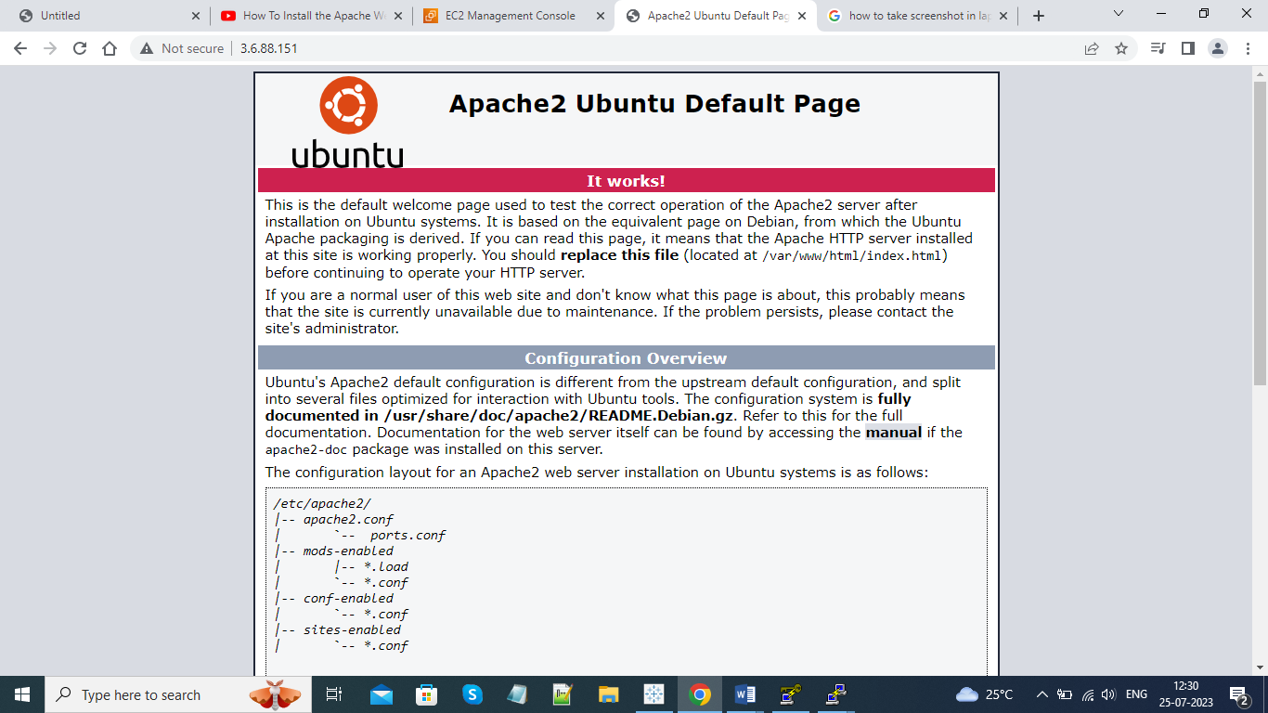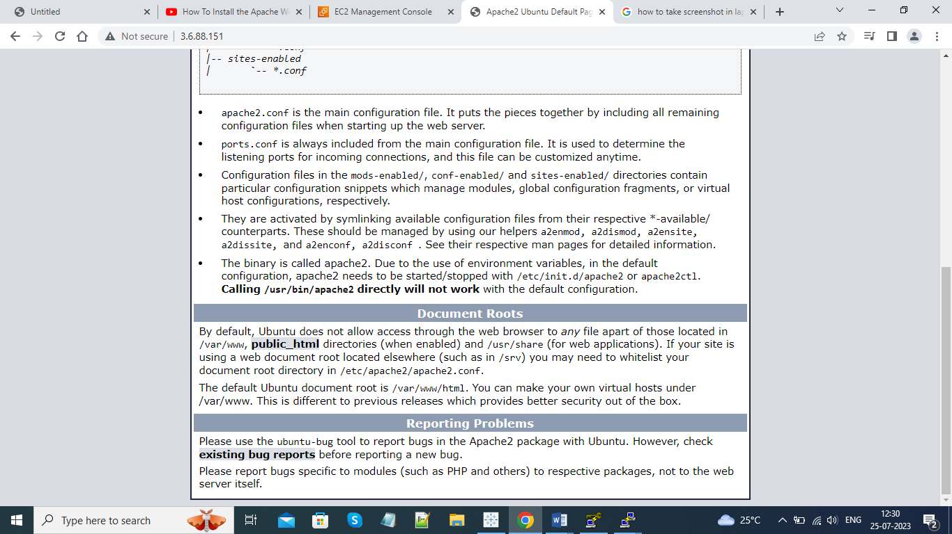login as: ubuntu
Authenticating with public key "imported-openssh-key"
Welcome to Ubuntu 20.04.6 LTS (GNU/Linux 5.15.0-1036-aws x86_64)

* Documentation: https://help.ubuntu.com
* Management: https://landscape.canonical.com
* Support: https://ubuntu.com/advantage

System information as of Tue Jul 25 06:33:23 UTC 2023

System load: 0.0 Processes: 111
Usage of /: 27.1% of 7.57GB Users logged in: 1
Memory usage: 26% IPv4 address for eth0: 172.31.39.65
Swap usage: 0%

Expanded Security Maintenance for Applications is not enabled.

7 updates can be applied immediately.
7 of these updates are standard security updates.
To see these additional updates run: apt list --upgradable

Enable ESM Apps to receive additional future security updates.
See https://ubuntu.com/esm or run: sudo pro status

New release '22.04.2 LTS' available.
Run 'do-release-upgrade' to upgrade to it.

Last login: Tue Jul 25 06:13:39 2023 from 49.43.202.121
ubuntu@ip-172-31-39-65:~$ sudo apt install apache2
Reading package lists... Done
Building dependency tree
Reading state information... Done
apache2 is already the newest version (2.4.41-4ubuntu3.14).
0 upgraded, 0 newly installed, 0 to remove and 3 not upgraded.
ubuntu@ip-172-31-39-65:~$ sudo systemctl status apache2
● apache2.service - The Apache HTTP Server
Loaded: loaded (/lib/systemd/system/apache2.service; enabled; vendor prese>
Active: active (running) since Tue 2023-07-25 06:10:20 UTC; 25min ago
Docs: https://httpd.apache.org/docs/2.4/
Main PID: 1532 (apache2)
Tasks: 55 (limit: 1141)
Memory: 4.7M
CGroup: /system.slice/apache2.service
├─1532 /usr/sbin/apache2 -k start
├─1534 /usr/sbin/apache2 -k start
└─1535 /usr/sbin/apache2 -k start

Jul 25 06:10:20 ip-172-31-39-65 systemd[1]: Starting The Apache HTTP Server...
Jul 25 06:10:20 ip-172-31-39-65 systemd[1]: Started The Apache HTTP Server.
lines 1-14/14 (END)

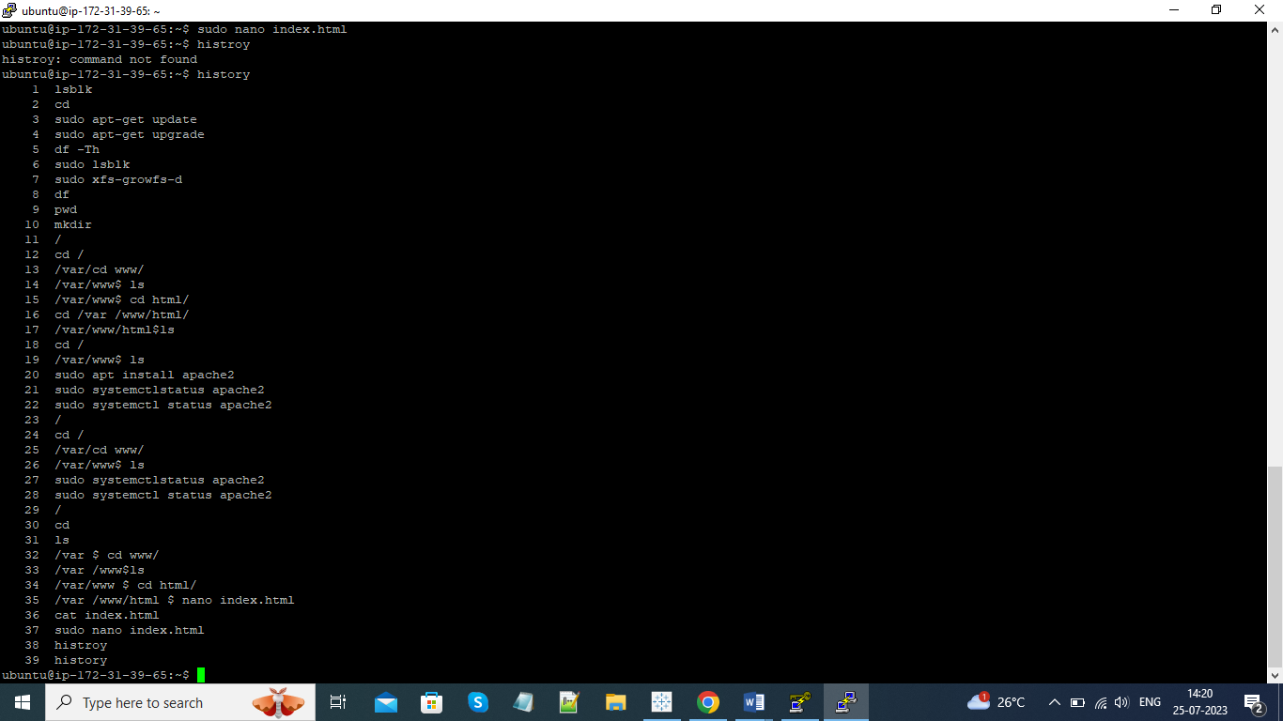 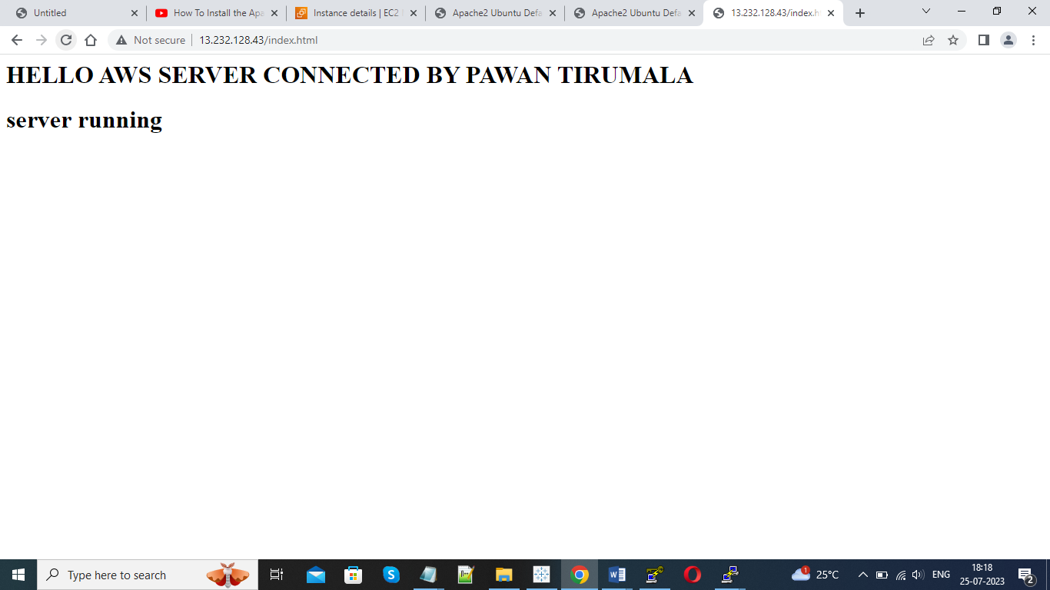 /
66 cd
67 cd /
68 /var/cd www/
69 /var/www$ ls
70 /var/www$ cd html/
71 /var/www$ cd html $ nano index.html
72 /var /www$ ls
73 /var /www $ ccd html/
74 /var /www/html $ nano index.html
75 sudo nano index.html
76 curl http://13.232.128.43/
77 curl http://13.232.128.43/index.html
78 sudo service apache2 status
79 sudo service apache2 restart
80 ls -la
81 cp index.html /var/www/html/index.html
82 sudo cp index.html /var/www/html/index.html
83 cd /var/www/html/
84 cat index.html
85 sudo service apache2 restart
86 sudo nano index.html
87 sudo service apache2 restart
88 sudo nano index.html
89 sudo service apache2 restart
90 histroy
91 history

26-07-2023(load balancer changing the html files to index. Html to web.html)

ubuntu@ip-172-31-39-65:/var/www/html$ Last login: Wed Jul 26 06:52:04 2023 from 49.43.202.121
ubuntu@ip-172-31-39-65:~$ history
1 lsblk
2 cd
3 sudo apt-get update
4 sudo apt-get upgrade
5 df -Th
6 sudo lsblk
7 sudo xfs-growfs-d
8 df
9 pwd
10 mkdir
11 /
12 cd /
13 /var/cd www/
14 /var/www$ ls
15 /var/www$ cd html/
16 cd /var /www/html/
17 /var/www/html$ls
18 cd /
19 /var/www$ ls
20 sudo apt install apache2
21 sudo systemctlstatus apache2
22 sudo systemctl status apache2
23 cd /var/
24 ls
25 cd www
26 cd html/
27 ls
28 clear
29 nano index.html
30 sudo nano index.html
31 sudo apt install apache2
32 sudo systemctl status apache2
33 /
34 cd /
35 /var/cd www/
36 /var/www$ ls
37 sudo systemctlstatus apache2
38 sudo systemctl status apache2
39 /
40 cd
41 ls
42 /var $ cd www/
43 /var /www$ls
44 /var/www $ cd html/
45 /var /www/html $ nano index.html
46 cat index.html
47 sudo nano index.html
48 histroy
49 history
50 sudo nano index.html
51 /
52 cd
53 ls
54 /var/www $ls
55 sudo systemctl launch apache2
56 cd/var/www/html $ls
57 ubuntu
58 cd/var/www/html $ls
59 /var $ cd www/
60 /var /www$ls
61 /var /www$ cd html/
62 /var /www/ html$ nano index.html
63 cat index.html
64 sudo nano index.html
65 sudo systemctl launch apache2
66 sudo systemctl start apache2
67 sudo apt install apache2
68 sudo systemctl launch apache2
69 sudo systemctl status apache2
70 cd /var/www/html/
71 ls
72 mv index.html /var/www/
73 swudo mv index.html /var/www/
74 sudo mv index.html /var/www/
75 ls
76 rm -rf index.html.save
77 sudo rm -rf index.html.save
78 cd /var/www
79 ls
80 history

