**Verification Screen Shot of Backend work**

Collections which is used in this project

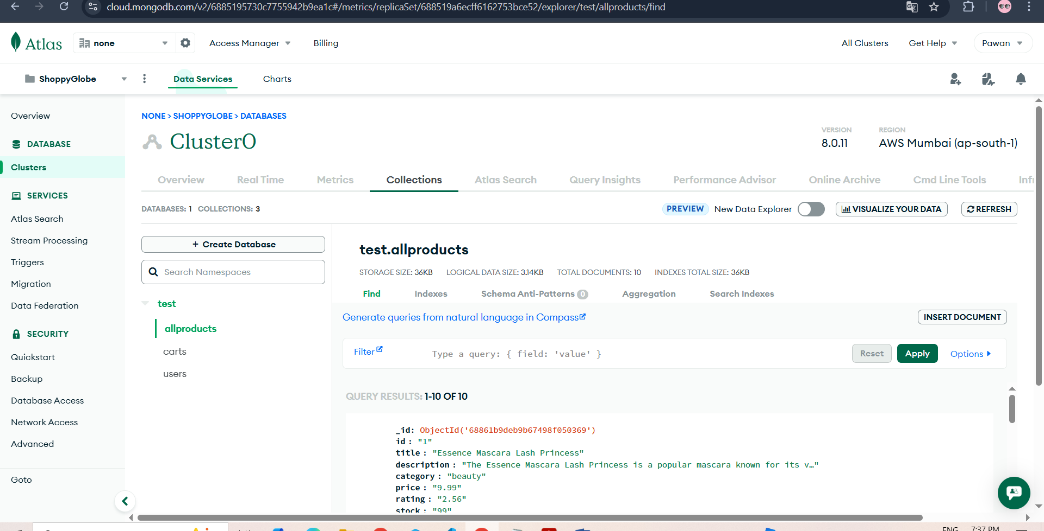

allproducts – Have all the listed product which is present for shopping

carts – User for store the product which is added by the user in it Cart

users – Store all the user data like username and password

**Below are the API calling and there working –**

**GET/products –**

API –

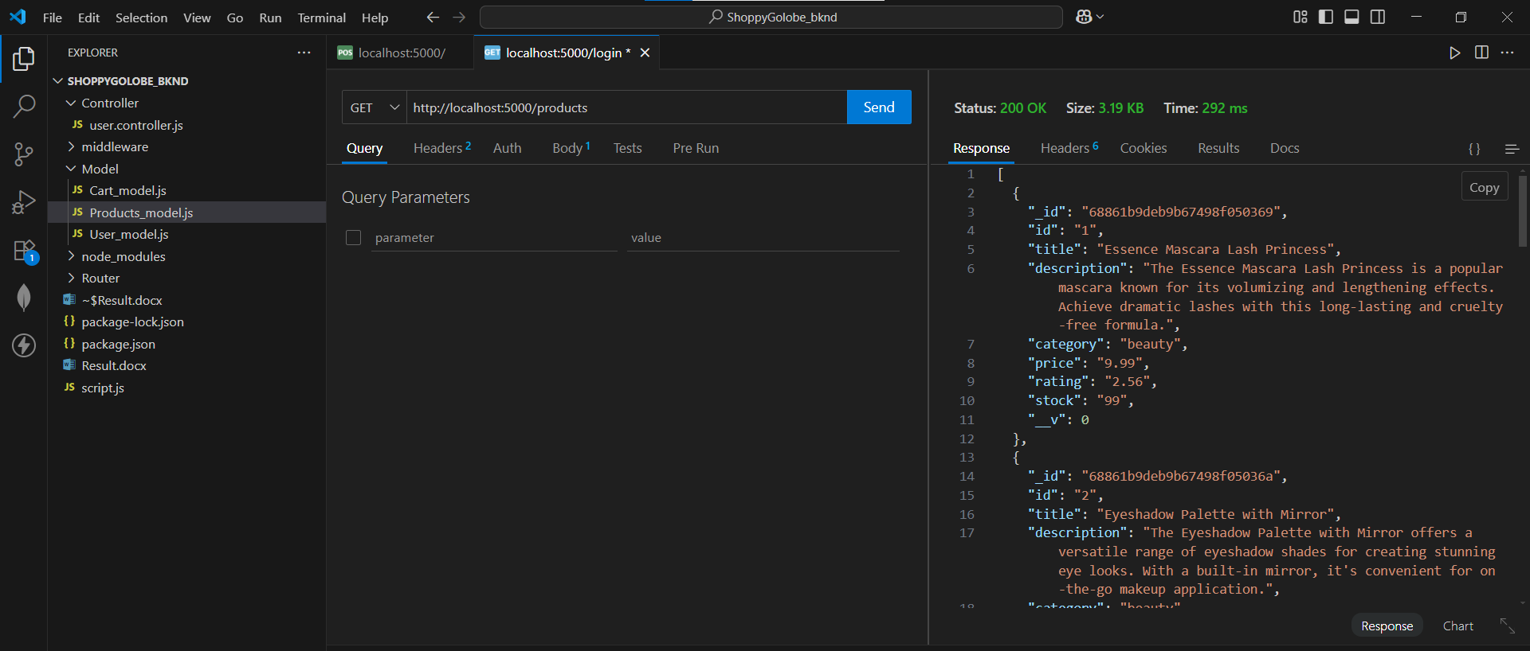

MongoDB –

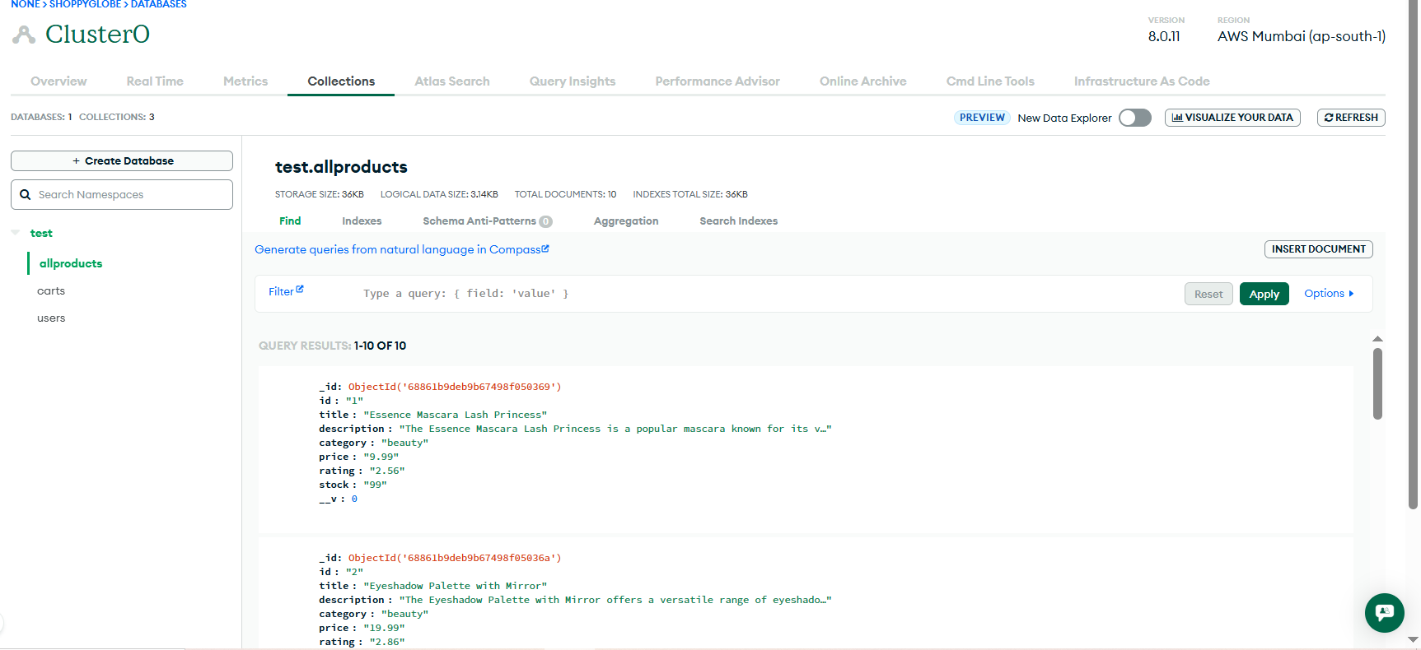

**GET/products/:id**

API –

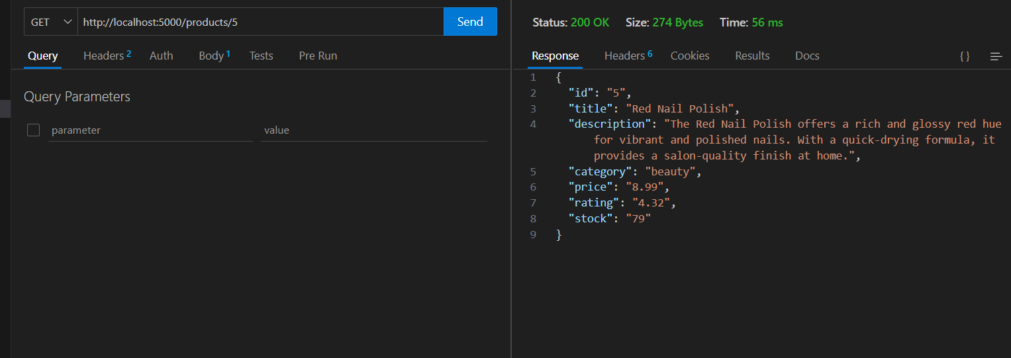

If we try to fetch the products which is not present

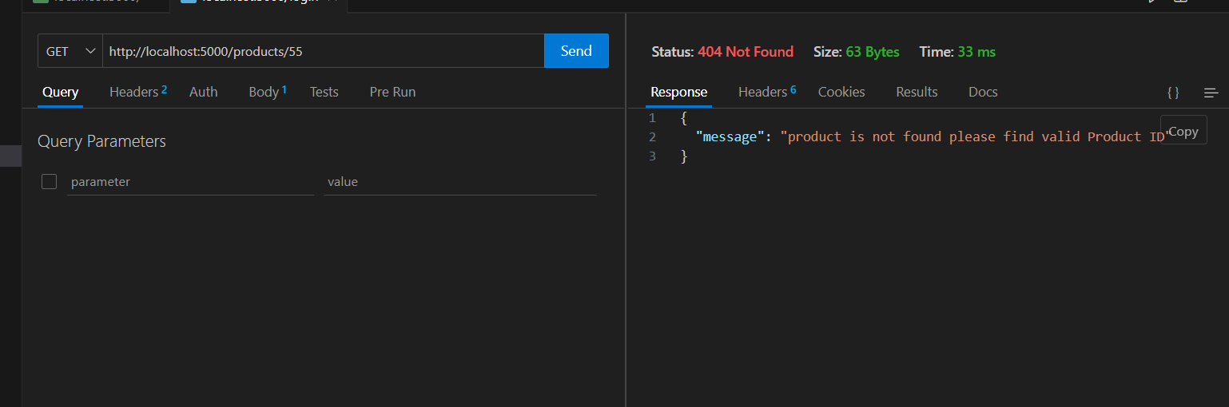

**POST/register**

Before API call MongoDB

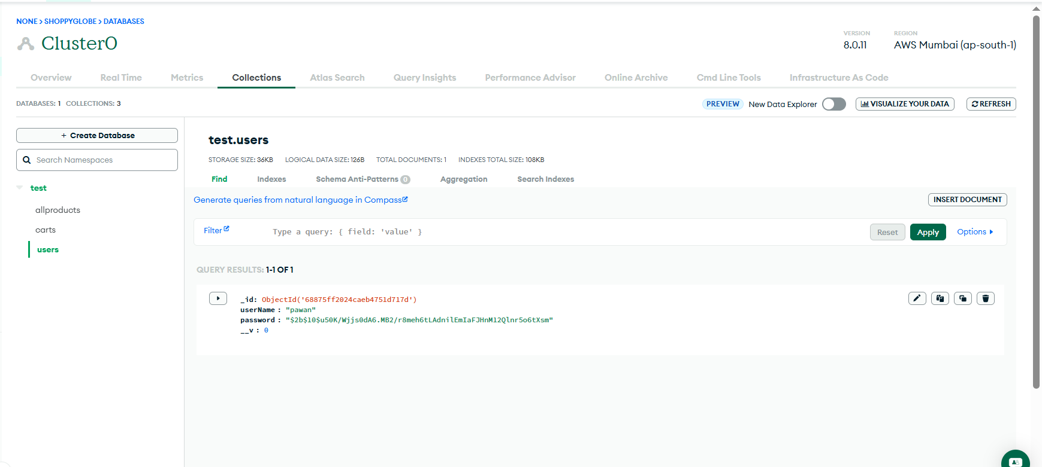

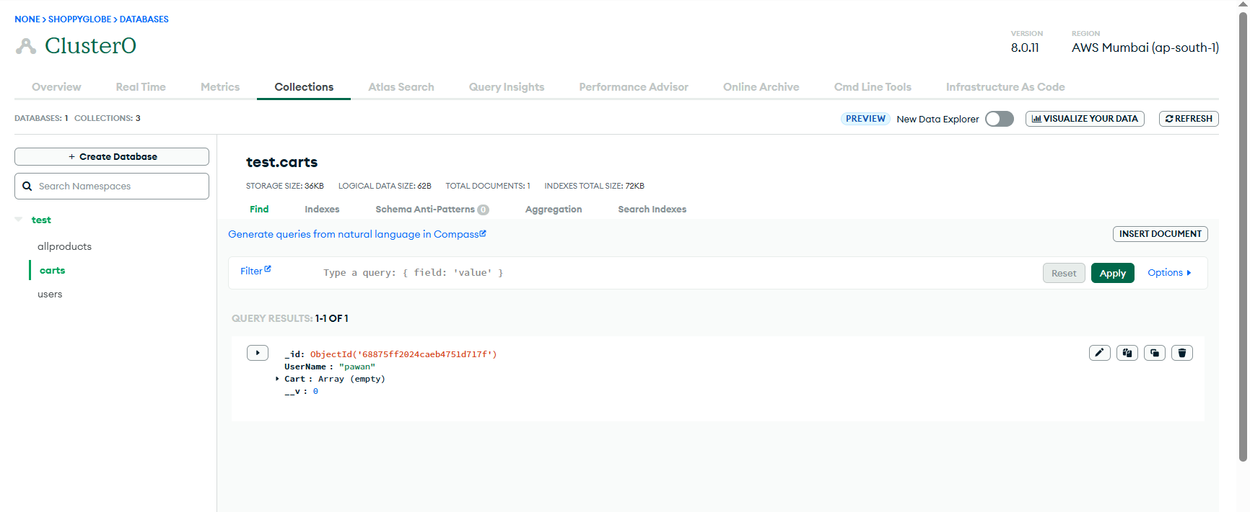

After API call MongoDB

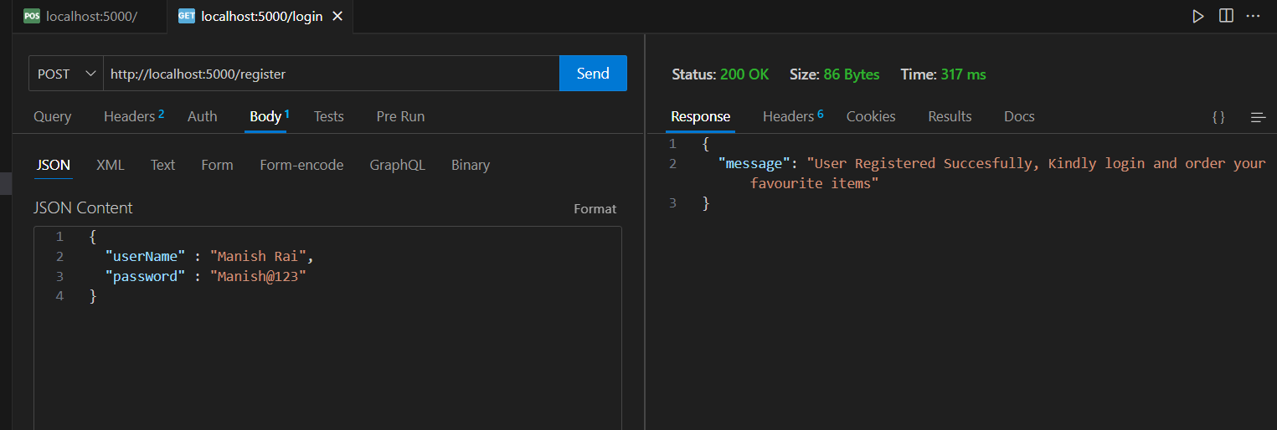

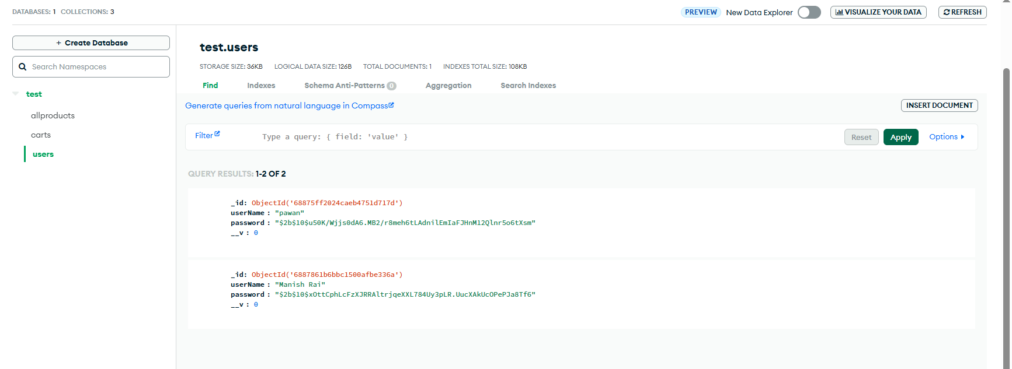

User also added in Cart after registration with empty array of Cart after we will add the product in the Cart as per the user who login

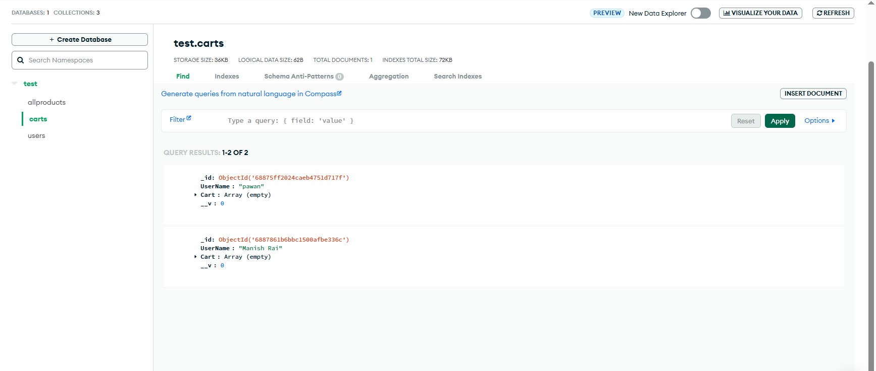

**GET/login**

I can see in the request login mention as POST request, correct me if I am wrong it need to be GET

API –

Login to get the Token –

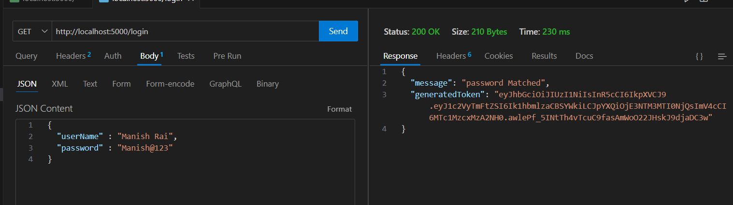

**POST/cart**

Enter the token and try to add the product in Cart

Before API all Mongo DB

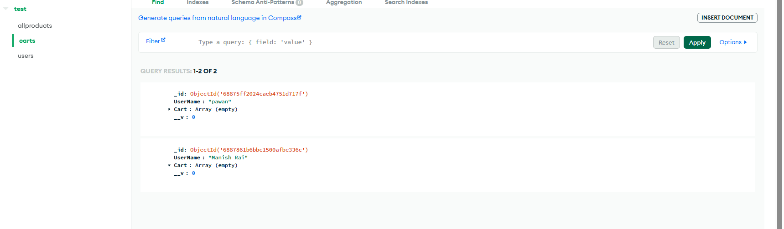

After API all Mongo DB

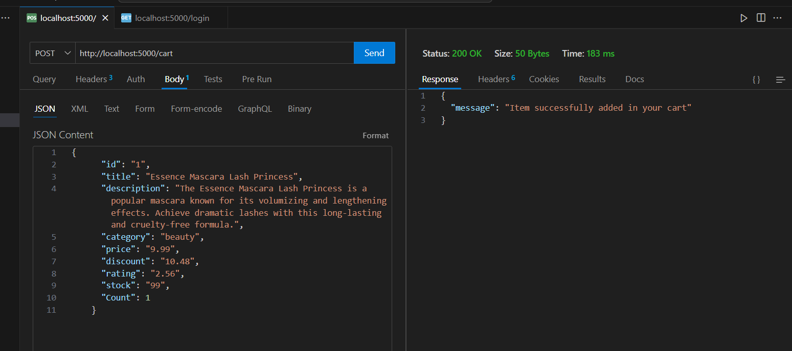

As we use Manish Rai login token, so addition of product only happens in Manish Cart, other account is not impacted

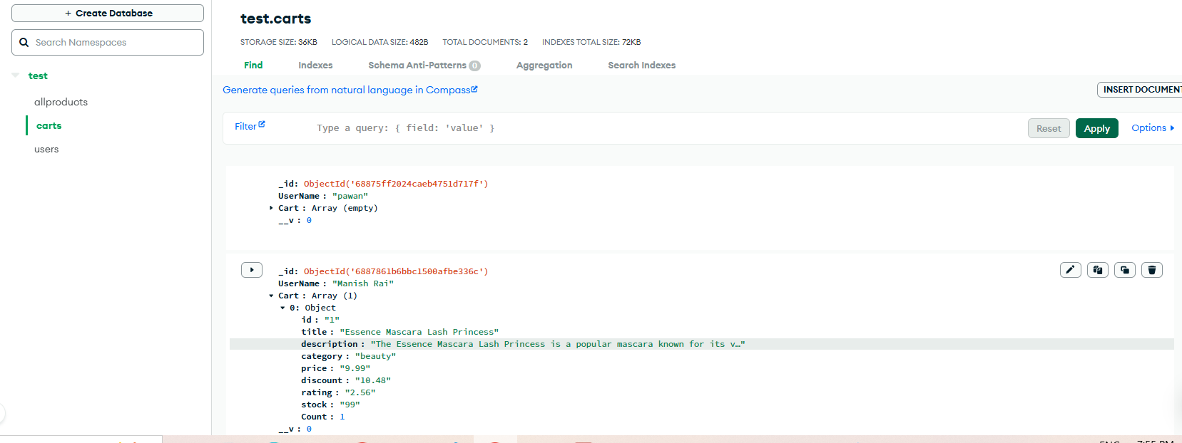

Addition of same product again

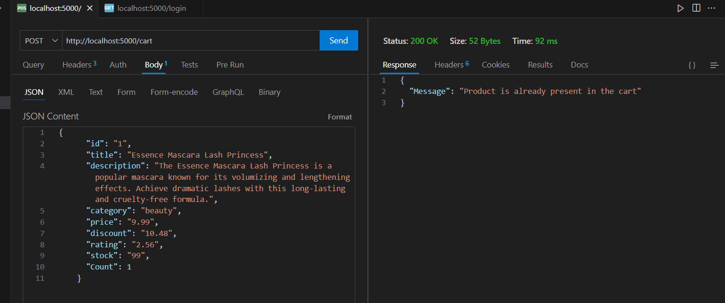

Try to add the product once token expire

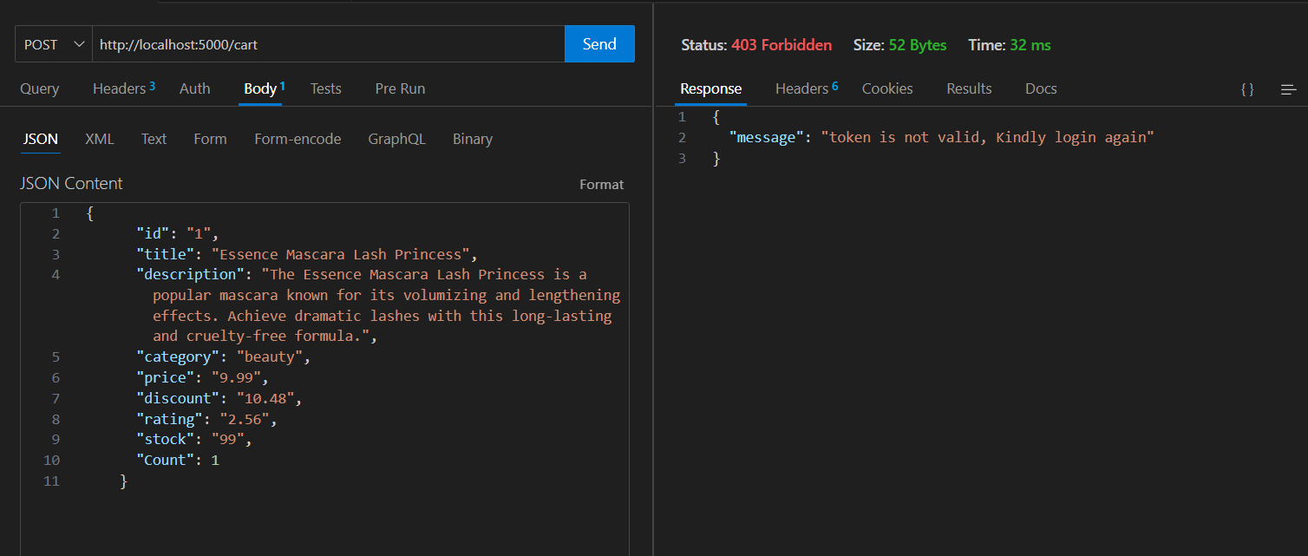

Try to add the product which is not listed in allproducts collection

I updated the ID to 76 remain all details are same

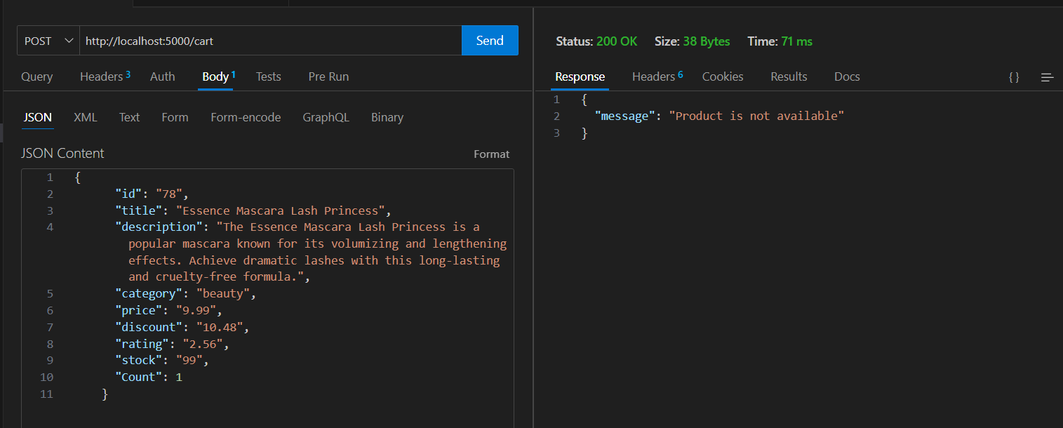

**PUT/cart/:id**

Before API call MongoDB

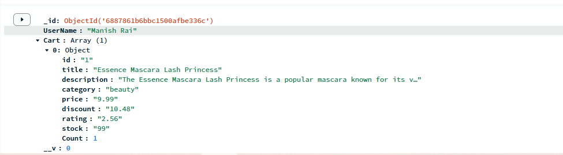

After API call MongoDB

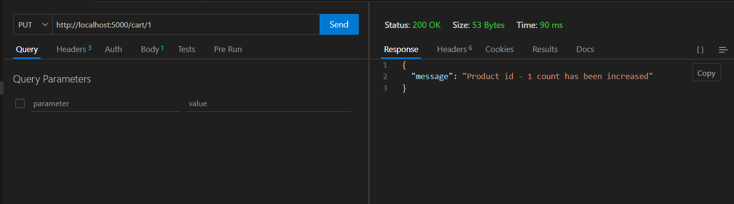

Product count increase to 2 from 1

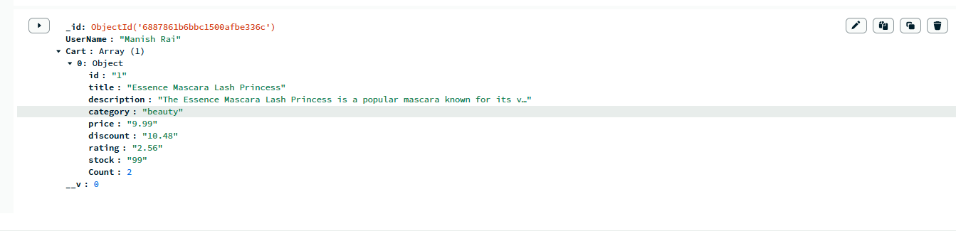

Request for the product which is not preset in the Cart

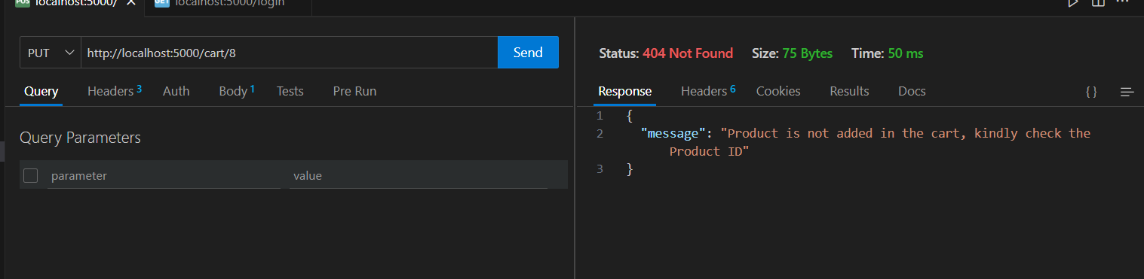

If the toke is expired

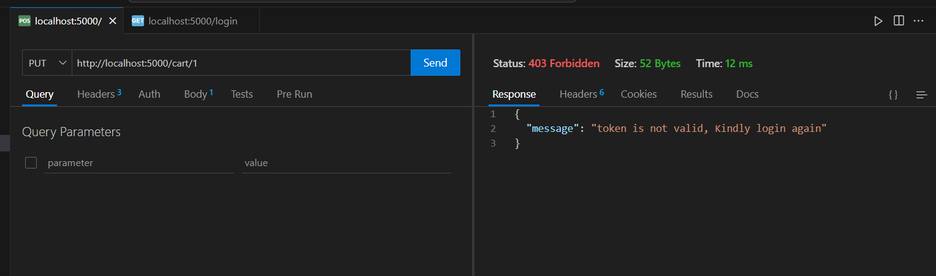

**DELETE/cart/:id**

Before API call MongoDB

Product ID – 1 is present in Manish Cart

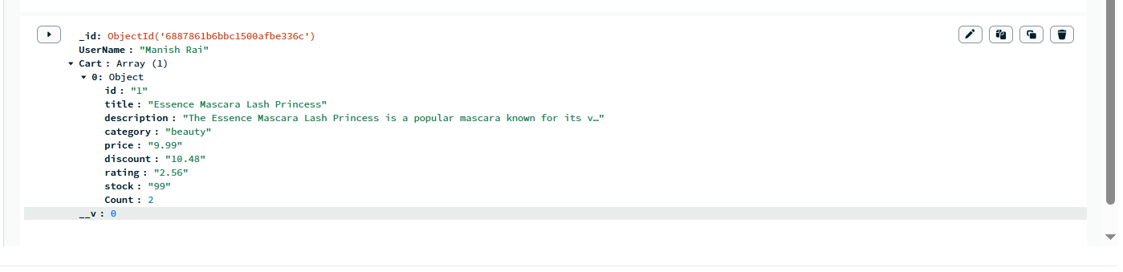

After API call MongoDB

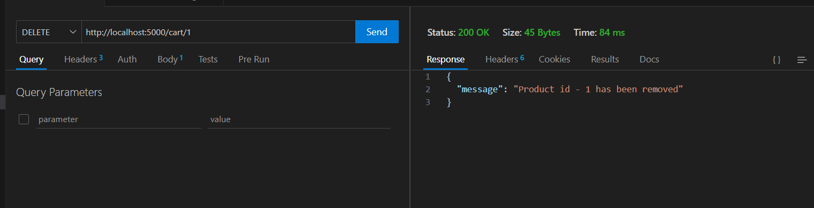

Cart is Empty now as only products has been removed

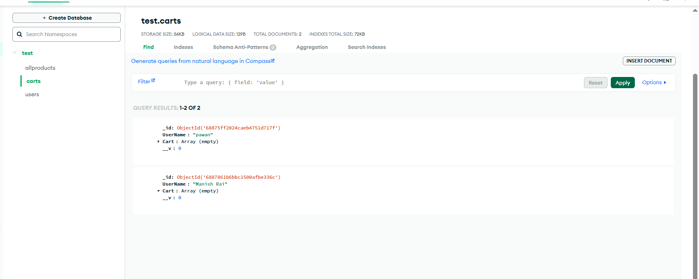

Remove the product which is not present in Cart

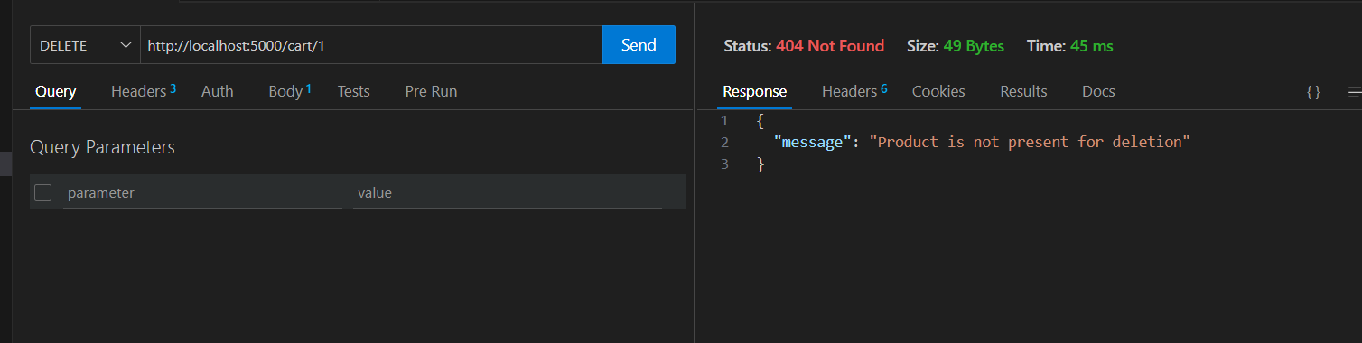

Try to remove the cart after the token expire

