


Informatics Institute of Technology

Advanced Client-Side Development
5COSC026C

Mawarala Hetti Arachchilage Pawani Nethmini Hettiarachchi
Uow Number – w2120117
IIT Number – 20240167
Tutorial Group - CS25
Web Design

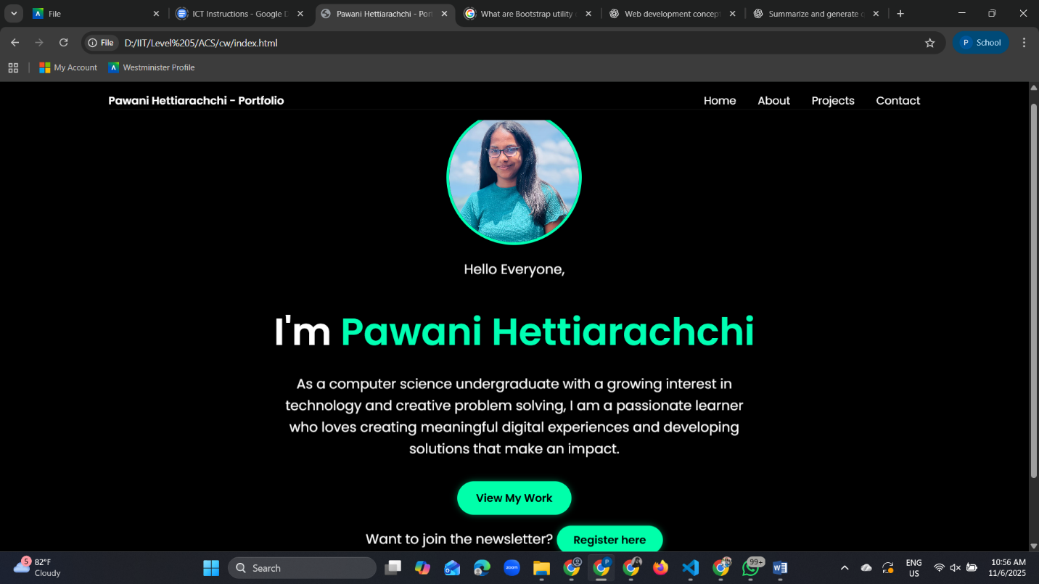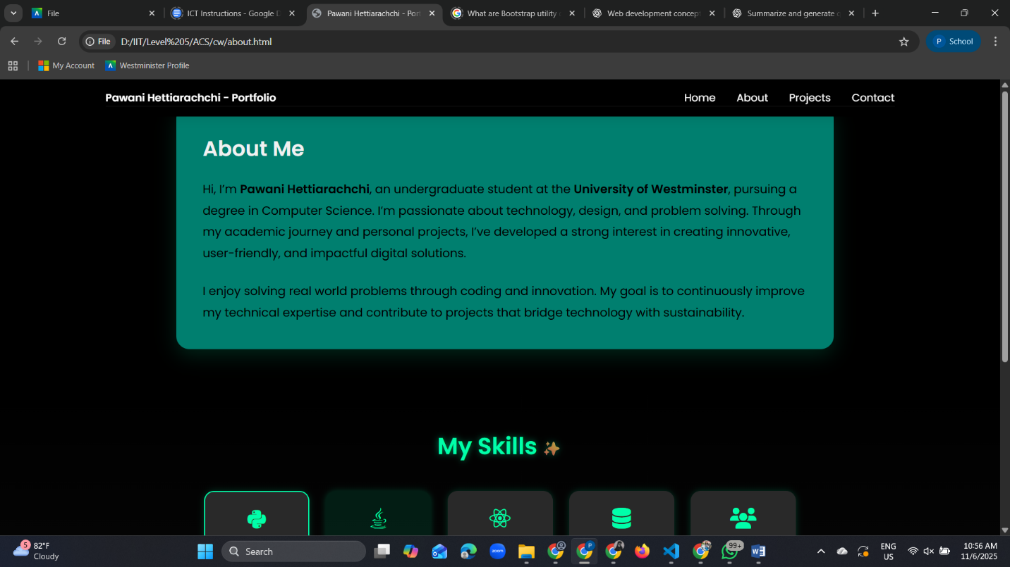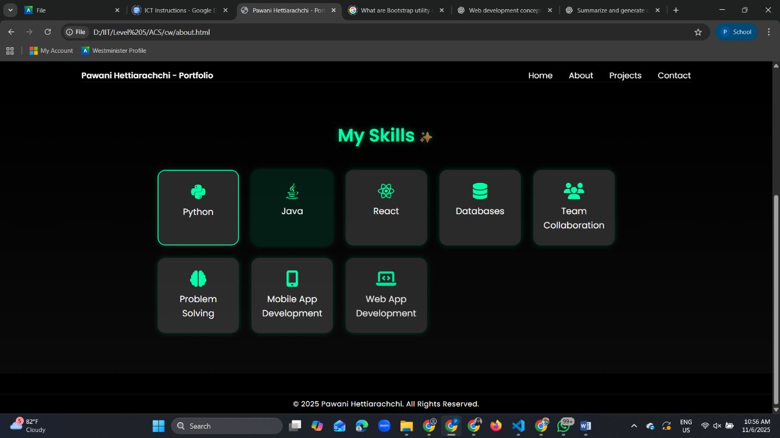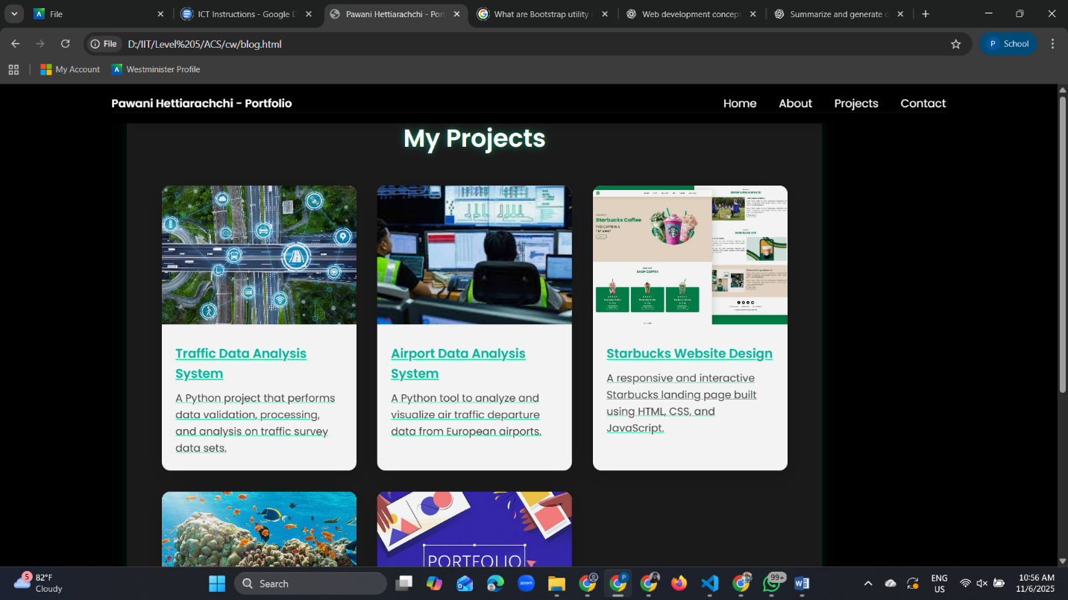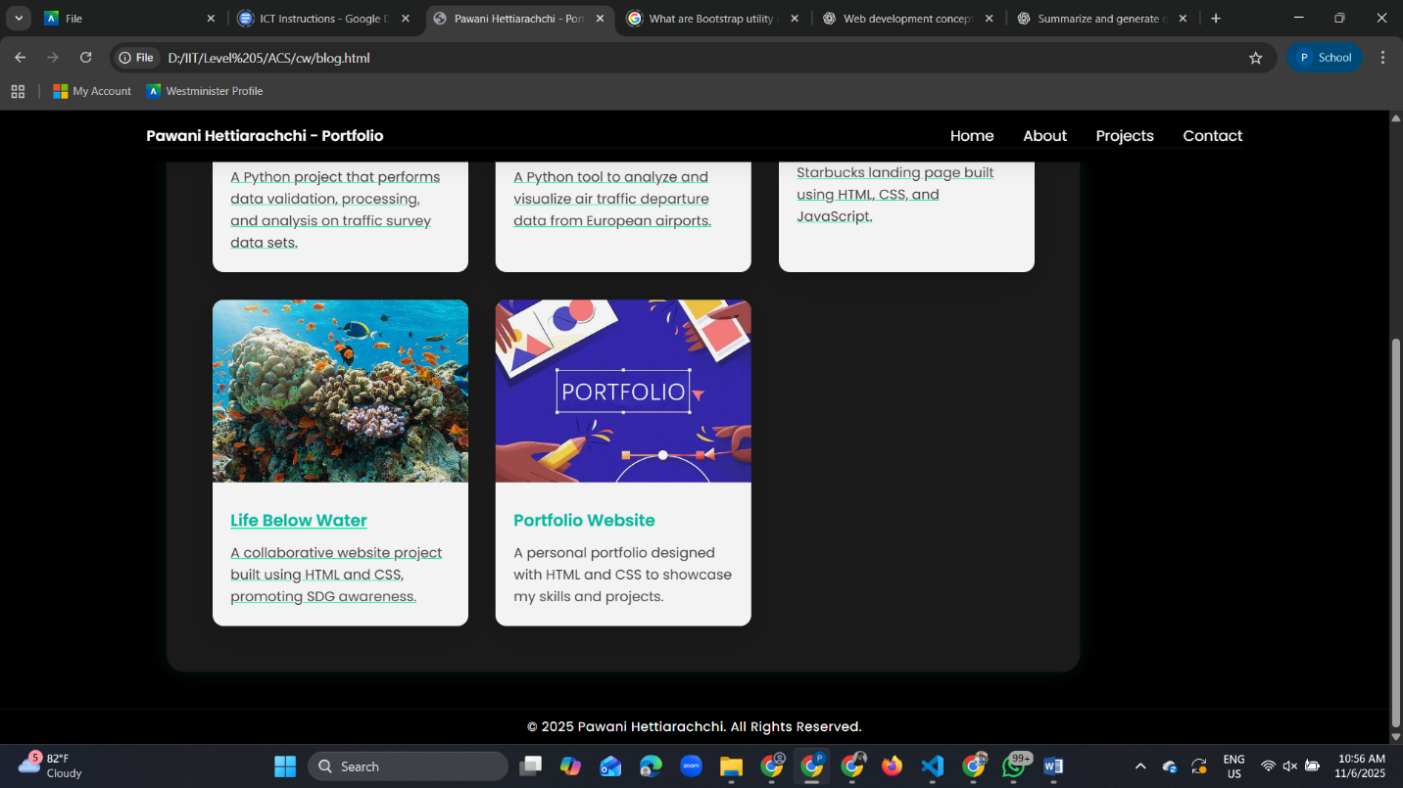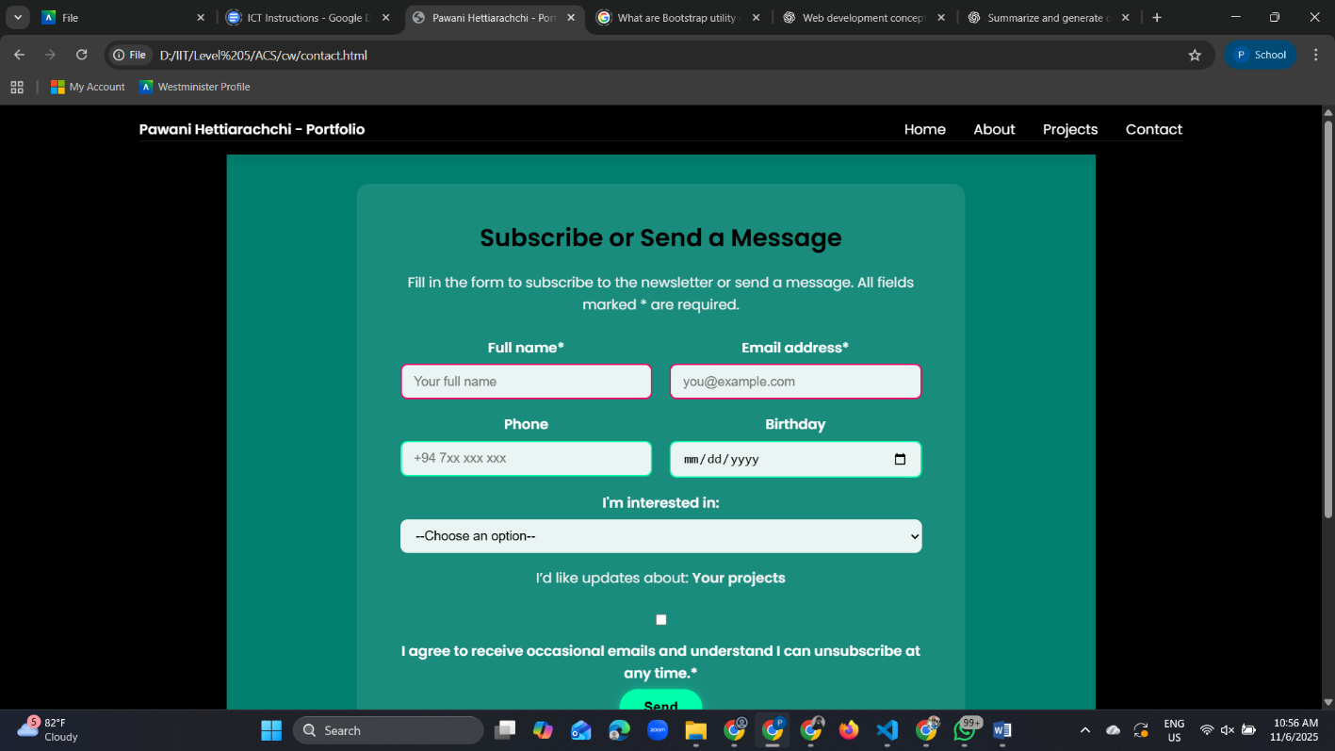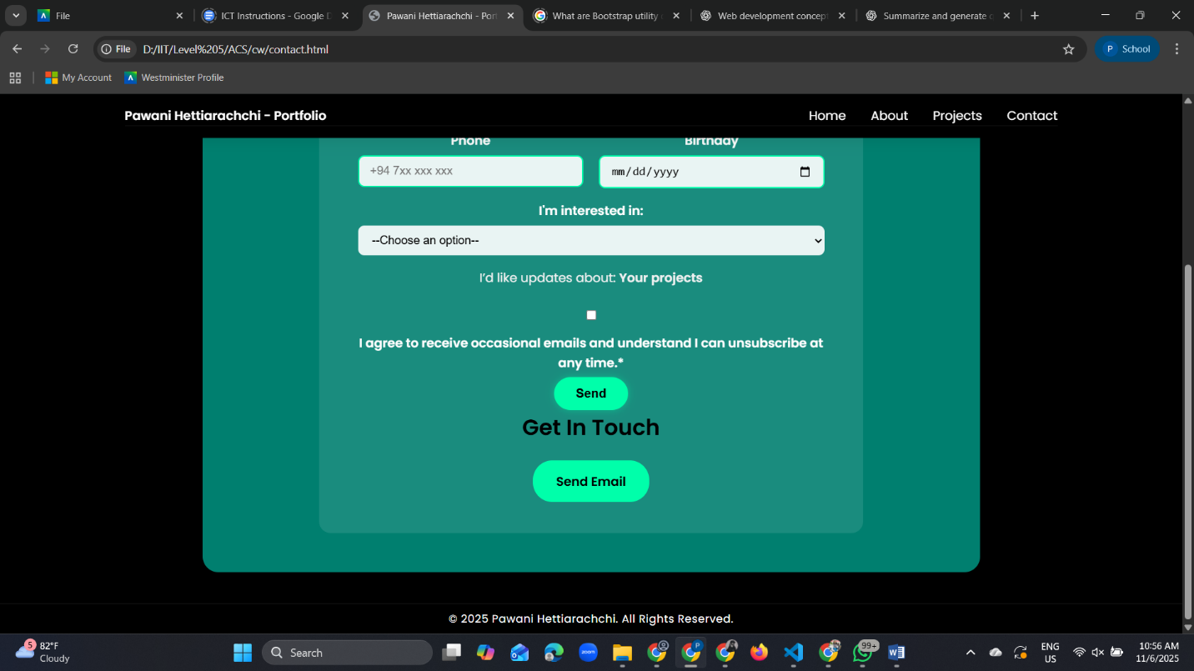

(A) html files
1) Index.html
<!DOCTYPE html>
<html lang="en">
<head>
<meta charset="UTF-8">
<meta name="viewport" content="width=device-width, initial-scale=1.0">
<title>Pawani Hettiarachchi - Portfolio</title>
<link rel="stylesheet" href="style.css">
<link rel="stylesheet" href="https://cdnjs.cloudflare.com/ajax/libs/font-awesome/6.5.0/css/all.min.css">
</head>

<body>
<!--Navigation-->
<nav class="navbar">
<div class="nav-container">
<div class="logo">Pawani Hettiarachchi - Portfolio</div>
<ul class="nav-links">
<li><a href="index.html">Home</a></li>
<li><a href="about.html">About</a></li>
<li><a href="blog.html">Projects</a></li>
<li><a href="contact.html">Contact</a></li>
</ul>
</div>
</nav>

<!--Hero Section-->
<section class="hero">
<div class="hero-content">
<div class="profile-img">
<img src="images/profile.jpg" alt="Pawani Nethmini profile image">
</div>
<p class="intro">Hello Everyone,</p>
<h1>I'm <span>Pawani Hettiarachchi</span></h1>
<p class="description">
As a computer science undergraduate with a growing interest in technology and creative problem solving,
I am a passionate learner who loves creating meaningful digital experiences and developing solutions that make an impact.
</p>
<div class="button-container">
<a href="blog.html" class="btn">View My Work</a>
<p class="newsletter-text">
Want to join the newsletter?
<a href="contact.html" class="btn secondary">Register here</a>
</p>
</div>
</div>
</section>

<!--Social Sidebar-->
<aside class="social-sidebar" aria-labelledby="socials">
<ul class="social-list">
<li><a href="https://linkedin.com/in/pawani-hettiarachchi"><i class="fab fa-linkedin-in"></i></a></li>
<li><a href="https://github.com/Pawani-Nethmini"><i class="fab fa-github"></i></a></li>
<li><a href="https://instagram.com/nethmini.hettiarachchi"><i class="fab fa-instagram"></i></a></li>
</ul>
</aside>

<!--Foote-->
<footer class="footer">
<p>&copy; 2025 Pawani Hettiarachchi. All Rights Reserved.</p>
</footer>
</body>
</html>

2) About.html
<!DOCTYPE html>
<html lang="en">
<head>
<meta charset="UTF-8">
<meta name="viewport" content="width=device-width, initial-scale=1.0">
<title>Pawani Hettiarachchi - Portfolio</title>
<link rel="stylesheet" href="style.css">
<link rel="stylesheet" href="https://cdnjs.cloudflare.com/ajax/libs/font-awesome/6.5.0/css/all.min.css">
</head>

<body>
<!--Navbar-->
<nav class="navbar">
<div class="nav-container">
<div class="logo">Pawani Hettiarachchi - Portfolio</div>
<ul class="nav-links">
<li><a href="index.html">Home</a></li>
<li><a href="about.html">About</a></li>
<li><a href="blog.html">Projects</a></li>
<li><a href="contact.html">Contact</a></li>
</ul>
</div>
</nav>

<!--About Section-->
<section id="about" class="about section">
<div class="about-content">
<div class="about-intro">
<h3>About Me</h3>
<p>
Hi, I’m <strong>Pawani Hettiarachchi</strong>, an undergraduate student at the
<strong>University of Westminster</strong>, pursuing a degree in Computer Science.
I’m passionate about technology, design, and problem solving. Through my academic
journey and personal projects, I’ve developed a strong interest in creating innovative,
user-friendly, and impactful digital solutions.
</p>
<br>
<p>
I enjoy solving real world problems through coding and innovation. My goal is to continuously
improve my technical expertise and contribute to projects that bridge technology with sustainability.
</p>
</div>
</div>
</section>

<!--Skills Section-->
<section id="skills" class="skills-section">
<h2>My Skills</h2>
<div class="skills-grid">
<div class="skill-card">
<i class="fab fa-python"></i>
<p>Python</p>
</div>
<div class="skill-card">
<i class="fab fa-java"></i>
<p>Java</p>
</div>
<div class="skill-card">
<i class="fab fa-react"></i>
<p>React</p>
</div>
<div class="skill-card">
<i class="fa-solid fa-database"></i>
<p>Databases</p>
</div>
<div class="skill-card">
<i class="fa-solid fa-users"></i>
<p>Team Collaboration</p>
</div>
<div class="skill-card">
<i class="fa-solid fa-brain"></i>
<p>Problem Solving</p>
</div>
<div class="skill-card">
<i class="fa-solid fa-mobile-screen-button"></i>
<p>Mobile App Development</p>
</div>
<div class="skill-card">
<i class="fa-solid fa-laptop-code"></i>
<p>Web App Development</p>
</div>
</div>
</section>

<!--Footer-->
<footer class="footer">
<p>&copy; 2025 Pawani Hettiarachchi. All Rights Reserved.</p>
</footer>
</body>
</html>

3) blog.html
<!DOCTYPE html>
<html lang="en">

<head>
<meta charset="UTF-8">
<meta name="viewport" content="width=device-width, initial-scale=1.0">
<title>Pawani Hettiarachchi - Portfolio</title>
<link rel="stylesheet" href="style.css">
</head>

<body>
<!--Navbar-->
<nav class="navbar">
<div class="nav-container">
<div class="logo">Pawani Hettiarachchi - Portfolio</div>
<ul class="nav-links">
<li><a href="index.html">Home</a></li>
<li><a href="about.html">About</a></li>
<li><a href="blog.html">Projects</a></li>
<li><a href="contact.html">Contact</a></li>
</ul>
</div>
</nav>

<!--Projects Section-->
<section id="projects" class="section projects">
<h2 class="section-title">My Projects</h2>

<div class="projects-grid">
<a href="https://github.com/Pawani-Nethmini/Traffic-Data-Analysis-System" class="project-card">
<img src="images/project1.jpg" alt="Traffic Data Analysis System" class="project-img">
<div class="project-info">
<h3>Traffic Data Analysis System</h3>
<p>A Python project that performs data validation, processing, and analysis on traffic survey data sets.</p>
</div>
</a>

<a href="https://github.com/Pawani-Nethmini/airport-data-analyzer" class="project-card">
<img src="images/project2.jpg" alt="Airport Data Analysis System" class="project-img">
<div class="project-info">
<h3>Airport Data Analysis System</h3>
<p>A Python tool to analyze and visualize air traffic departure data from European airports.</p>
</div>
</a>

<a href="https://github.com/Pawani-Nethmini/Starbuks-website-design" class="project-card">
<img src="images/project3.jpg" alt="Starbucks Website Design" class="project-img">
<div class="project-info">
<h3>Starbucks Website Design</h3>
<p>A responsive and interactive Starbucks landing page built using HTML, CSS, and JavaScript.</p>
</div>
</a>

<a href="https://github.com/yasiramnd/web" class="project-card">
<img src="images/project4.jpg" alt="Life Below Water Website" class="project-img">
<div class="project-info">
<h3>Life Below Water</h3>
<p>A collaborative website project built using HTML and CSS, promoting SDG awareness.</p>
</div>
</a>

<a href="#" class="project-card">
<img src="images/project5.jpg" alt="Portfolio Design" class="project-img">
<div class="project-info">
<h3>Portfolio Website</h3>
<p>A personal portfolio designed with HTML and CSS to showcase my skills and projects.</p>
</div>
</a>
</div>
</section>

<!--Footer-->
<footer class="footer">
<p>&copy; 2025 Pawani Hettiarachchi. All Rights Reserved.</p>
</footer>
</body>

</html>

4) contact.html
<!DOCTYPE html>
<html lang="en">

<head>
<meta charset="UTF-8">
<meta name="viewport" content="width=device-width, initial-scale=1.0">
<title>Pawani Hettiarachchi - Portfolio</title>
<link rel="stylesheet" href="style.css">
</head>

<body>
<!--Navigation-->
<nav class="navbar">
<div class="nav-container">
<div class="logo">Pawani Hettiarachchi - Portfolio</div>
<ul class="nav-links">
<li><a href="index.html">Home</a></li>
<li><a href="about.html">About</a></li>
<li><a href="blog.html">Projects</a></li>
<li><a href="contact.html">Contact</a></li>
</ul>
</div>
</nav>

<!--Contact Section-->
<section id="contact" class="contact section">
<div class="contact-card">
<h1 id="form-heading">Subscribe or Send a Message</h1>
<p>Fill in the form to subscribe to the newsletter or send a message. All fields marked * are required.</p>

<form class="register-form" action="#" method="post" aria-label="Newsletter and contact form">
<div class="form-row">
<div class="half">
<label for="fullname">Full name*</label>
<input id="fullname" name="fullname" type="text" placeholder="Your full name" required autocomplete="name">
</div>
<div class="half">
<label for="email">Email address*</label>
<input id="email" name="email" type="email" placeholder="you@example.com" required autocomplete="email">
</div>
</div>

<div class="form-row">
<div class="half">
<label for="phone">Phone</label>
<input id="phone" name="phone" type="tel" placeholder="+94 7xx xxx xxx" pattern="^\+?[0-9\s\-]{7,20}$" autocomplete="tel">
</div>
<div class="half">
<label for="birthday">Birthday</label>
<input id="birthday" name="birthday" type="date" max="2025-12-31" autocomplete="bday">
</div>
</div>

<div class="form-group">
<label for="interest">I'm interested in:</label>
<select id="interest" name="interest" required>
<option value="">--Choose an option--</option>
<option value="projects">Project updates</option>
<option value="volunteering">Volunteering</option>
<option value="research">Research & publications</option>
</select>
</div>

<div class="form-group checkbox-group">
<p>I’d like updates about: <strong>Your projects</strong></p>
</div>

<div class="form-group checkbox-group">
<label>
<input id="consent" name="consent" type="checkbox" required>
I agree to receive occasional emails and understand I can unsubscribe at any time.*
</label>
</div>

<button type="submit" class="submit-btn">Send</button>
</form>

<div class="contact-content">
<h3>Get In Touch</h3>
<a href="mailto:pawani.20240167@iit.ac.lk" class="contact-btn">Send Email</a>
</div>
</div>
</section>

<!--Footer-->
<footer class="footer">
<p>&copy; 2025 Pawani Hettiarachchi. All Rights Reserved.</p>
</footer>
</body>
</html>

(B & C) CSS File
@import url('https://fonts.googleapis.com/css2?family=Poppins:wght@400;600&display=swap');

* {
margin: 0;
padding: 0;
box-sizing: border-box;
}

html,
body {
height: 100%;
font-family: 'Poppins', sans-serif;
background: black;
color: #fff;
line-height: 1.6;
scroll-behavior: smooth;
}

/*Navigation*/
.navbar {
position: fixed;
top: 0;
width: 100%;
background: black;
backdrop-filter: blur(10px);
padding: 15px 40px;
z-index: 1000;
box-shadow: 0 2px 20px rgba(0, 0, 0, 0.1);
}

.nav-container {
max-width: 1200px;
margin: 0 auto;
display: flex;
justify-content: space-between;
align-items: center;
border-bottom: 1px solid rgba(255,255,255,0.1);
}

.logo {
color: white;
font-weight: bold;
font-size: 16px;
}

.nav-links {
display: flex;
list-style: none;
gap: 32px;
}

.nav-links a {
text-decoration: none;
color: white;
font-weight: 500;
transition: color 0.3s ease;
}

.nav-links a:hover {
color: #667eea;
}

.footer{
width: 100%;
background: black;
color: #fff;
text-align: center;
padding: 8px 0;
margin-top: 40px;
border-top: 1px solid rgba(255, 255, 255, 0.1);
font-size: 14px;
letter-spacing: 0.5px;
}

.footer p{
margin: 0;
color: white;
}

/*Hero Section*/
.hero {
height: 100vh;
display: flex;
flex-direction: column;
align-items: center;
justify-content: center;
text-align: center;
color: white;
padding: 0 20px;
}

.profile-img {
width: 200px;
height: 200px;
border-radius: 50%;
overflow: hidden;
border: 4px solid #00ffb3;
margin: 0 auto 20px auto;
margin-top: 110px;
}

.profile-img img {
width: 120%;
height: 120%;
object-fit: cover;
}

.intro {
color: white;
font-size: 32px;
margin-bottom: 10px;
}

.hero-content h1 {
font-size: 56px;
margin-bottom: 16px;
animation: fadeInUp 1s ease;
}

.hero-content h1 span {
color: #00ffb3;
}

.hero-content p {
font-size: 20px;
margin: 0 auto 32px;
max-width: 700px;
opacity: 0.9;
animation: fadeInUp 1s ease 0.2s both;
}

/*Buttons*/
.button-container{
margin-top: 30px;
display: flex;
flex-direction: column;
align-items: center;
gap: 20px;
}
.btn{
background-color: #00ffaa;
color: #000;
padding: 12px 28px;
border-radius: 25px;
text-decoration: none;
font-weight: bold;
font-size: 16px;
transition: 0.3s;
box-shadow: 0 0 10px rgba(0, 255, 170, 0.4);
}
.btn:hover {
background-color: #00cc88;
color: white;
transform: translateY(-3px);
box-shadow: 0 0 20px rgba(0, 255, 170, 0.7);
}

.btn.secondary {
background-color: #00ffaa;
border: none;
padding: 10px 25px;
border-radius: 25px;
color: black;
font-weight: bold;
cursor: pointer;
transition: 0.3s;
}

.btn.secondary:hover {
background-color: 00cc88;
color: white;
transform: translateY(-3px);
box-shadow: 0 0 20px rgba(0, 255, 170, 0.7);
}

.newslettet-text{
text-align: center;
margin-top: 40px;
margin-bottom: 30px;
}

/*Sidebar*/
.sidebar {
position: fixed;
top: 50%;
left: 50%;
transform: translate(-50%, -50%);
background: rgba(255, 255, 255, 0.1);
border-radius: 15px;
padding: 10px 15px;
z-index: 1000;
}

.social-list {
list-style: none;
margin: 0;
padding: 0;
display: flex;
flex-direction: row;
justify-content: center;
align-items: center;
gap: 20px;
margin-top: 30px;
}

/*links*/
.social-list a {
display: flex;
align-items: center;
gap: 8px;
color: #fff;
text-decoration: none;
font-size: 22px;
transition: color 0.3s, transform 0.3s;
}

/*hover effect*/
.social-list a:hover {
color: #00ffb3;
transform: translateY(-3px);
}

@keyframes fadeInUp {
from {
opacity: 0;
transform: translateY(30px);
}
to {
opacity: 1;
transform: translateY(0);
}
}

/*About section*/
.about {
background: #00bfa6aa;
border-radius: 20px;
margin: 40px;
box-shadow: 0 10px 30px rgba(0, 255, 170, 0.15);
max-width: 1000px;
padding: 40px;
position: relative;
left: 15%;
}

.about-content {
display: grid;
gap: 48px;
align-items: center;
}
.about-content p{
font-size: large;
}

.about h3 {
font-size: 32px;
margin-bottom: 20px;
color: #f1f1f1;
}

.about p {
font-size: 18px;
color: black;
line-height: 1.8;
}

/*Skill Section*/
.skills-section {
text-align: center;
padding: 80px 0;
background: linear-gradient(to bottom, #000, #0a0a0a);
}

.skills-section h2 {
font-size: 2.2rem;
color: #00ffaa;
margin-bottom: 40px;
font-weight: bold;
text-shadow: 0 0 10px rgba(0, 255, 170, 0.5);
}

/*Pseudo-elements with generated content*/
.skills-section h2::after {
content: " ✨";
color: #00ffaa;
font-size: 1.5rem;
animation: sparkle 1.5s infinite alternate;
}

/*small sparkle animation*/
@keyframes sparkle {
from { opacity: 0.3; transform: scale(0.9); }
to { opacity: 1; transform: scale(1.2); }
}

.skills-grid {
display: grid;
grid-template-columns: repeat(auto-fit, minmax(160px, 1fr));
gap: 25px;
max-width: 900px;
margin: 0 auto;
}

.skills-grid div:first-child {
border: 2px solid #00ffaa;
}
.skills-grid div:last-child {
opacity: 0.9;
}

.skills-grid div:nth-child(2) {
background-color: rgba(0, 255, 170, 0.1);
}

.skill-card {
background-color: rgba(255, 255, 255, 0.149);
border-radius: 15px;
padding: 25px 15px;
color: white;
transition: all 0.3s ease;
box-shadow: 0 0 10px rgba(0, 255, 170, 0.2);
}

.skill-card i {
font-size: 2rem;
margin-bottom: 10px;
color: #00ffaa;
}

.skill-card p {
font-weight: 500;
font-size: 1.1rem;
}

.skill-card:hover {
transform: translateY(-8px);
box-shadow: 0 0 25px rgba(0, 255, 170, 0.6);
background-color: #1a1a1a;
}

/*Responsive Fixes*/
@media (max-width: 768px) {
.about {
left: 0; /*keeps centered on small screens */
margin: 16px auto;
max-width: 90%;
}
}

/*Projects Section*/
.projects {
background: rgba(255, 255, 255, 0.1);
border-radius: 20px;
margin:40x;
padding: 50px;
max-width: 1000px;
position: relative;
left: 12%;
box-shadow: 0 0 20px rgba(0, 255, 170, 0.1);
}
.projects h2{
color: #fff;
text-align: center;
margin-bottom: 40px;
font-size: 2.2rem;
text-shadow: 0 0 10px rgba(0, 255, 170, 0.5);
}

.projects-grid {
display: grid;
grid-template-columns: repeat(3, 1fr);
gap: 30px;
margin: 0 auto;
}

.project-card {
background: white;
border-radius: 12px;
padding: 0;
box-shadow: 0 10px 30px rgba(0, 0, 0, 0.15);
text-decoration: none;
color: inherit;
display: block;
transition: transform 0.3s ease, box-shadow 0.3s ease;
}

.project-card:hover {
transform: translateY(-8px);
box-shadow: 0 10px 20px rgba(0, 255, 179, 0.3);
}

.project-card:not(:hover) {
opacity: 0.95;
}

.project-img {
width: 100%;
height: 200px;
object-fit: cover;
border-top-left-radius: 12px;
border-top-right-radius: 12px;
}

.project-info {
padding: 20px;
text-align: left;
}

.project-info h3 {
margin-bottom: 10px;
font-size: 18px;
color: #00bfa5;
}

.project-info p {
color: #444;
font-size: 15px;
line-height: 1.6;
}

/*Responsive Fixes*/
@media (max-width: 1024px) {
.projects {
left: 5%;
}
}

@media (max-width: 900px) {
.projects {
left: 0;
margin: 32px auto;
max-width: 90%;
}

.projects-grid {
grid-template-columns: repeat(2, 1fr);
}
}

@media (max-width: 600px) {
.projects {
left: 0;
margin: 32px auto;
max-width: 95%;
}

.projects-grid {
grid-template-columns: 1fr;
gap: 20px;
}
}

/*Contact Section*/
.contact {
display: flex;
justify-content: center;
align-items: center;
min-height: 100vh;
background: #00bfa6aa;
border-radius: 20px;
margin: 40px auto;
max-width: 1000px;
padding: 50px 40px;
box-shadow: 0 20px 40px rgba(0, 0, 0, 0.1);
text-align: center;
position: relative;
left: 0;
}

.contact-card {
background: rgba(255, 255, 255, 0.1);
backdrop-filter: blur(6px);
border-radius: 15px;
padding: 40px 50px;
max-width: 700px;
width: 100%;
text-align: center;
}

.contact-card h1 {
font-size: 28px;
margin-bottom: 16px;
color: #000;
}

.contact-card p {
font-size: 16px;
color: #f2f2f2;
margin-bottom: 24px;
}

/* Form Styling */
.register-form label {
display: block;
font-weight: bold;
margin-bottom: 6px;
}

.register-form input,
.register-form select {
width: 100%;
padding: 10px 14px;
border-radius: 8px;
border: none;
margin-bottom: 16px;
background: rgba(255, 255, 255, 0.9);
color: #000;
font-size: 15px;
outline: none;
}

/*Attribute Selectors*/
input[type="email"] {
border: 2px solid transparent;
transition: 0.3s;
}

input[type="email"]:focus {
border-color: #00ffaa;
}

a[href^="https://"] {
color: #00ffaa; /*highlight secure links*/
text-decoration: underline;
}

input:valid {
border: 2px solid #00ffaa;
}

input:invalid {
border: 2px solid #ff0066;
}

.register-form input:focus,
.register-form select:focus {
border: 2px solid #00ffaa;
}

/*Relational Selector Example*/
form:has(input:focus) {
box-shadow: 0 0 20px rgba(0, 255, 170, 0.4);
transform: scale(1.01);
transition: 0.3s ease;
}

/* Rows */
.form-row {
display: flex;
gap: 20px;
flex-wrap: wrap;
}

.half {
flex: 1;
min-width: 250px;
}

/* Checkboxes */
.checkbox-group input[type="checkbox"] {
margin-right: 8px;
}

/* Submit Button */
.submit-btn {
background-color: #00ffaa;
color: #000;
border: none;
border-radius: 25px;
padding: 12px 28px;
font-size: 16px;
font-weight: bold;
cursor: pointer;
transition: 0.3s ease;
box-shadow: 0 0 10px rgba(0, 255, 170, 0.4);
}

.submit-btn:hover {
background-color: #00cc88;
color: #fff;
transform: translateY(-3px);
box-shadow: 0 0 20px rgba(0, 255, 170, 0.7);
}

/* Contact Content */
.contact-content {
text-align: center;
align-self: center;
}

.contact-content h3 {
font-size: 28px;
color: #000;
margin-bottom: 20px;
}

.contact-btn {
display: inline-block;
padding: 14px 30px;
background: #00ffaa;
color: #000;
text-decoration: none;
border-radius: 25px;
font-weight: bold;
transition: 0.3s ease;
}

.contact-btn:hover {
background-color: #00cc88;
color: #fff;
transform: translateY(-3px);
}

/* Responsive Fixes */
@media (max-width: 900px) {
.contact-layout {
grid-template-columns: 1fr;
text-align: center;
}

.contact {
margin: 20px auto;
padding: 30px;
}
}

(D) Diary
