Portfolio Development Diary
Student Name - Pawani Hettiarachchi
Student ID - 20240167
Module - 5COSC026C Advanced Client-Side Development
Tutorial Group - CS25

Week 1-2: Initial Planning and Design
- Started with brainstorming the website’s purpose and target audience.
- Decided to create a multi-page website with pages: Home, About, Blog, and Contact.
- Created low-fidelity wireframes on paper for both desktop and mobile views.
- Planned basic layout structure using HTML5 semantic elements such as <header>, <nav>, <main>, <section>, and <footer>.
- Choose a clean, minimal look with a focus on usability and responsive design.
- Drafted color palette and basic typography ideas.
- Created the main HTML files: index.html, about.html, blog.html, and contact.html.
- Implemented navigation links and consistent header/footer sections across all pages.
- Added placeholder content and basic section divisions for each page.
- Set up folder structure with 'images' and 'css' directories.
- Validated HTML structure for semantic correctness.
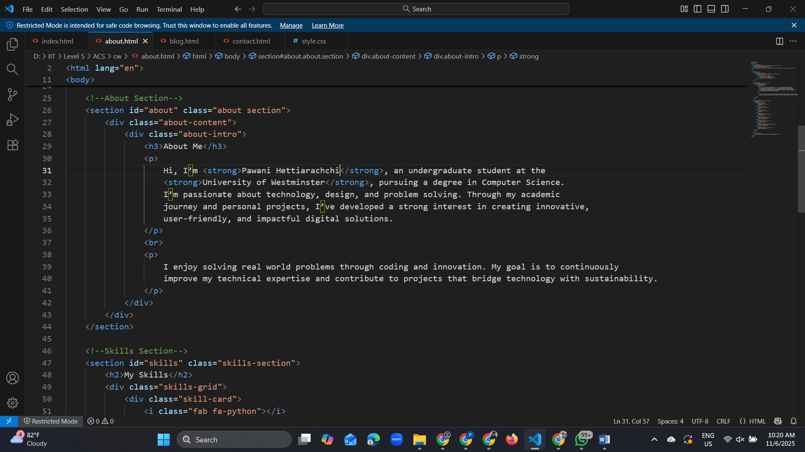

Week 3-4: Styling and Layout Development
- Developed 'style.css' and linked it to all HTML pages.
- Applied consistent color theme throughout the website.
- Used Flexbox (one-dimensional layout) and Grid (two-dimensional system for precise positioning) for layout alignment and responsiveness.
- Added hover effects for navigation links and buttons.
- Selected professional fonts using Google Fonts for headings and body text.
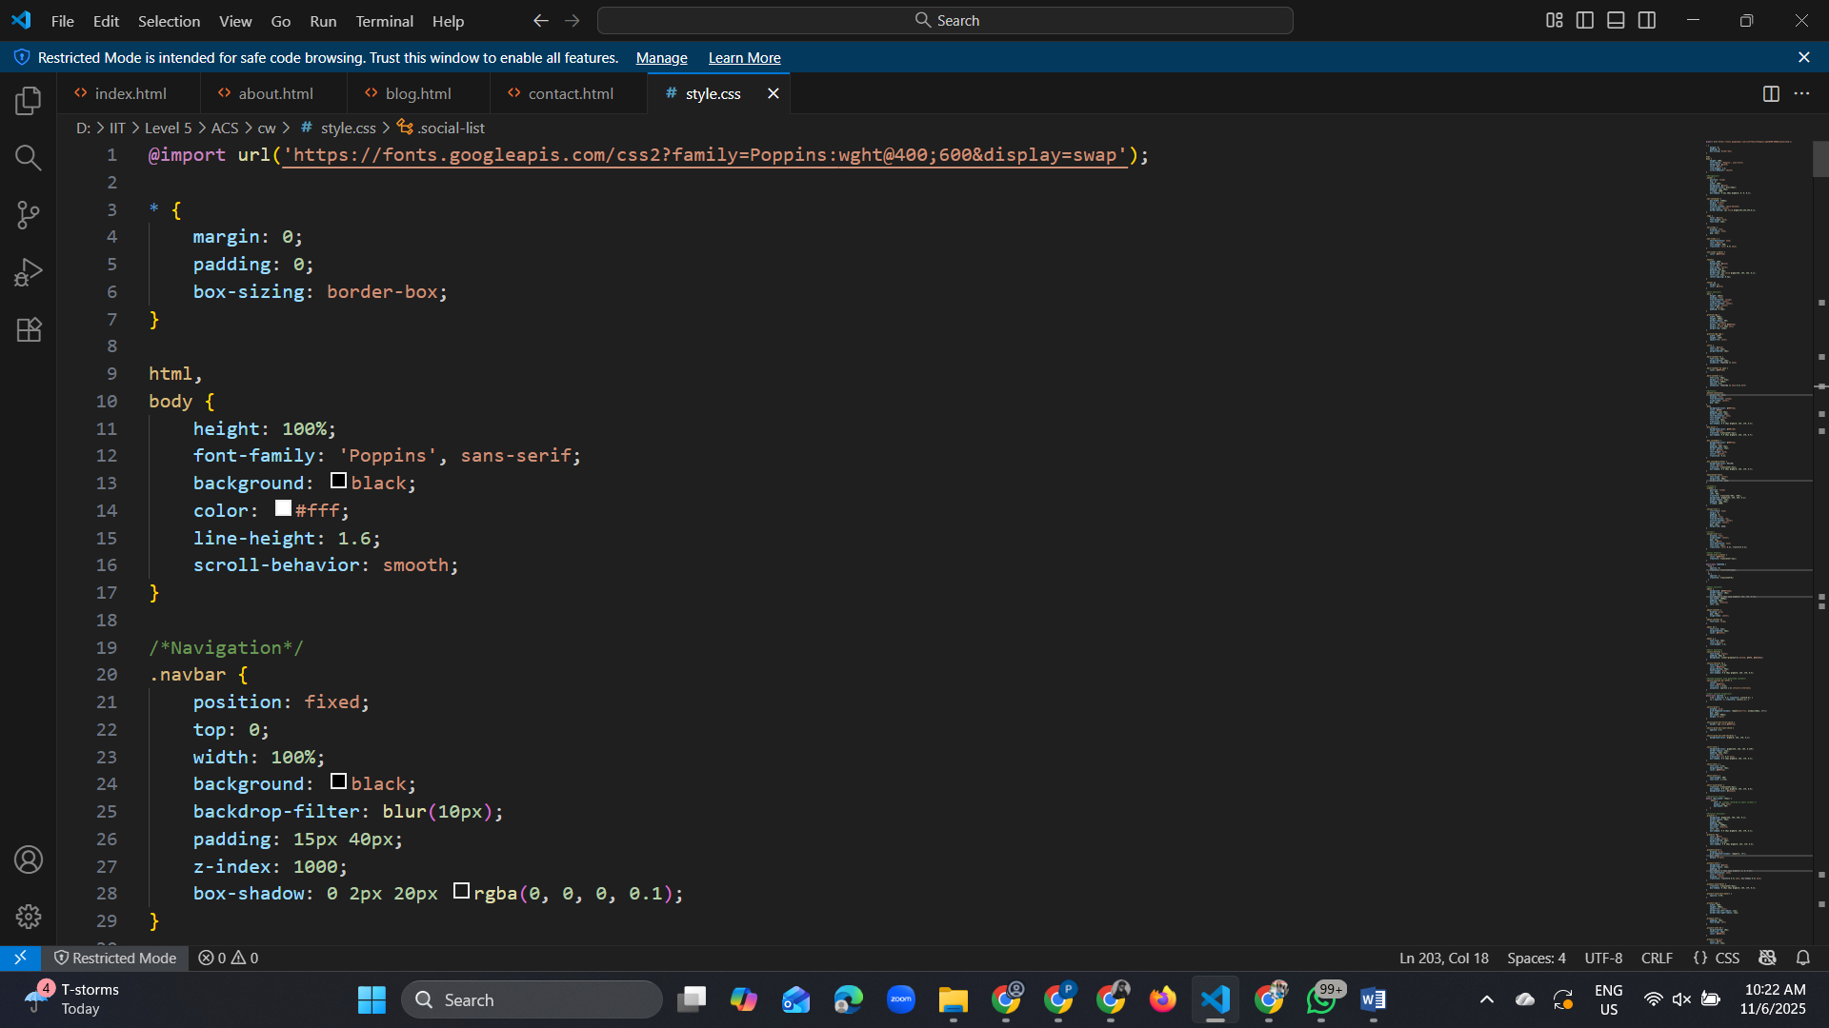

Week 5-6: Image and Media Integration and Final Touches
- Added profile and project images in the 'images' folder.
- Optimized image sizes for faster loading.
- Integrated images into home and blog pages to enhance visual appeal.
- Tested image placement on mobile and large screen layouts.
- Refined CSS styling, spacing, and color consistency.
- Conducted responsive testing on different screen sizes.
- Checked for broken links and validated HTML/CSS code.
- Updated final text content and contact information.
- Prepared the website for submission.
