- Find “application/views/admin/includes/header.php”
- This hook to show the Check-in/Checkout Icon on the Header menu when using a Mobile device
- Line 93 add new Code like the picture
Code:
<?php hooks()->do_action('admin_navbar_start'); ?>
- Line 114 add new code
Code:
<?php hooks()->do_action('admin_navbar_end'); ?>

- Image
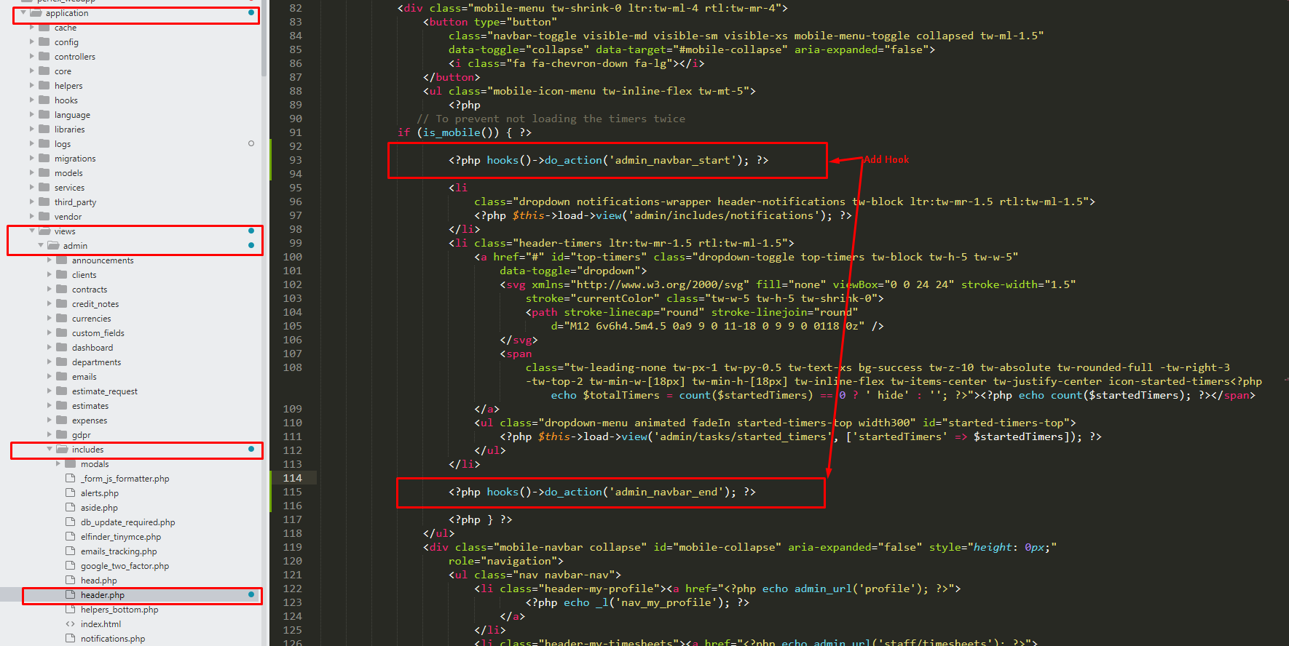

- Update date config for call API
- Find “application/config/config.php”
- Line 488 update code like below
- Code

$config['csrf_exclude_uris'] = ['forms/wtl/[0-9a-z]+', 'forms/ticket', 'forms/quote/[0-9a-z]+', 'admin/tasks/timer_tracking', 'api\/.+', 'timesheets/api\/.+'];
- Image
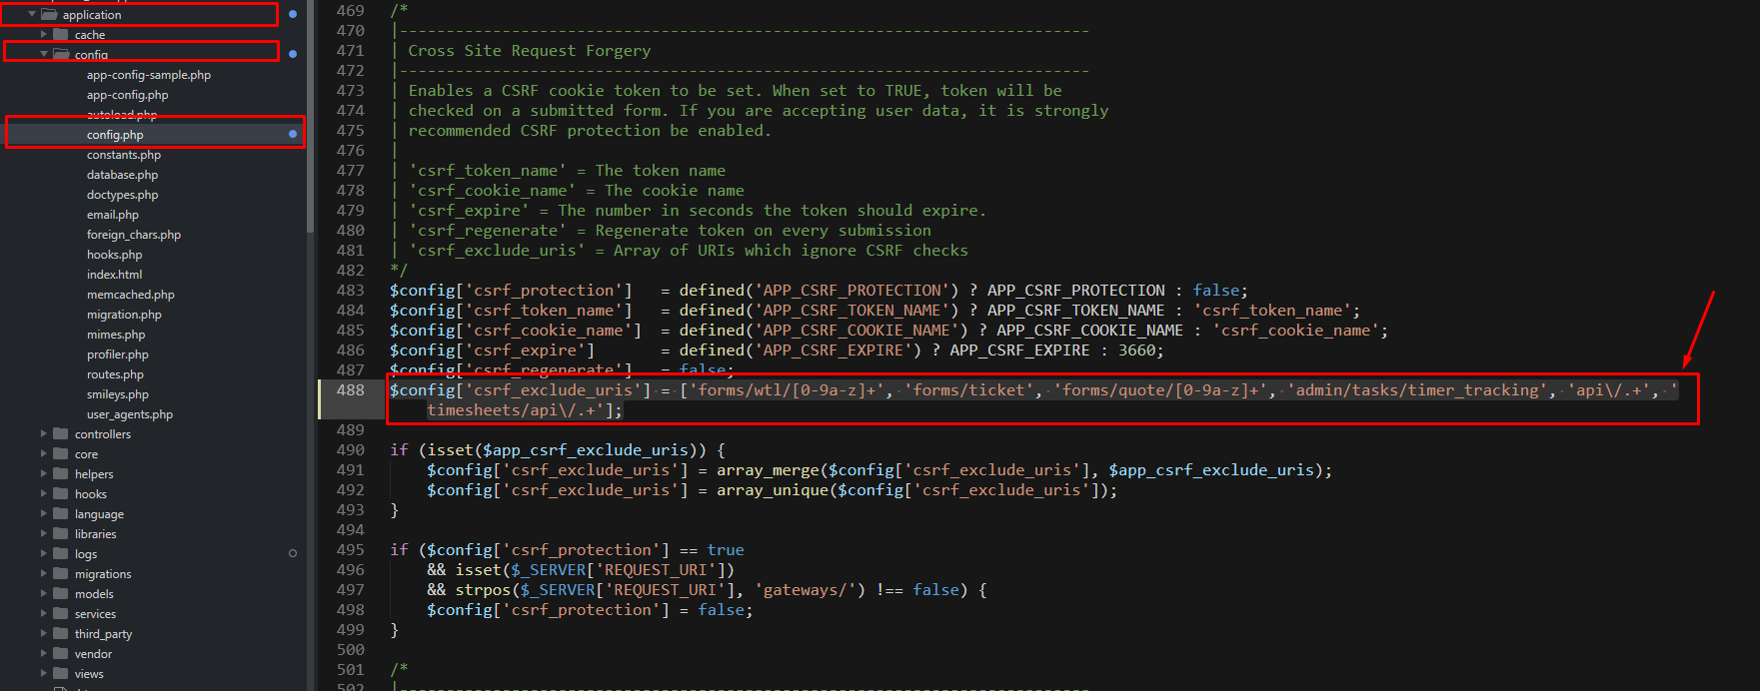

- Change file Session_driver.php
Find file “system/libraries/Session/Session_driver.php”
if your server uses PHP8.1 or later, you need to change below (because this function is not compatible with PHP 8.1 and above)

Change NULL to ‘’ ( like the image)
After Changed
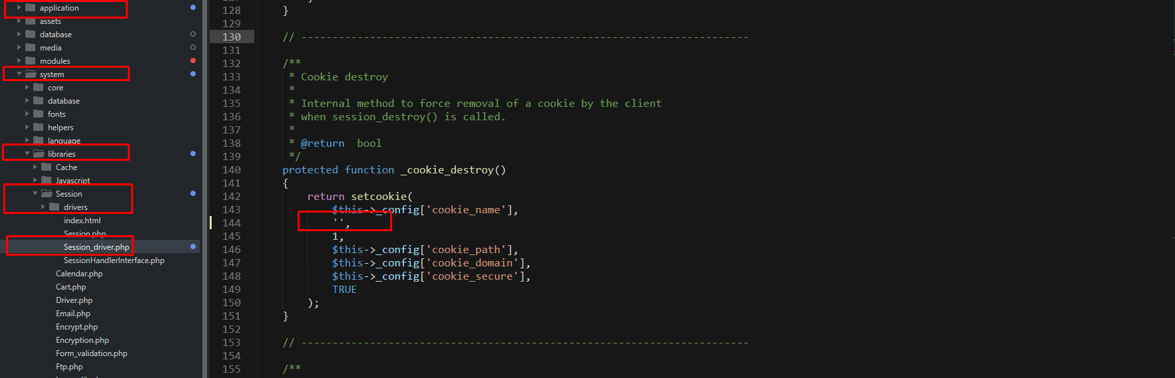

Before change
