- Display available quantity of item on Sales/Invoice
  - File “application/controllers/admin/Invoices.php”, below the line 365 add hook like this
Code

/////////////////////////////////////////////////
// add hook display Available quantity of item //
$data['items'] = hooks()->apply_filters('before_admin_view_create_invoice', $data['items']);
/////////////////////////////////////////////////

Image:
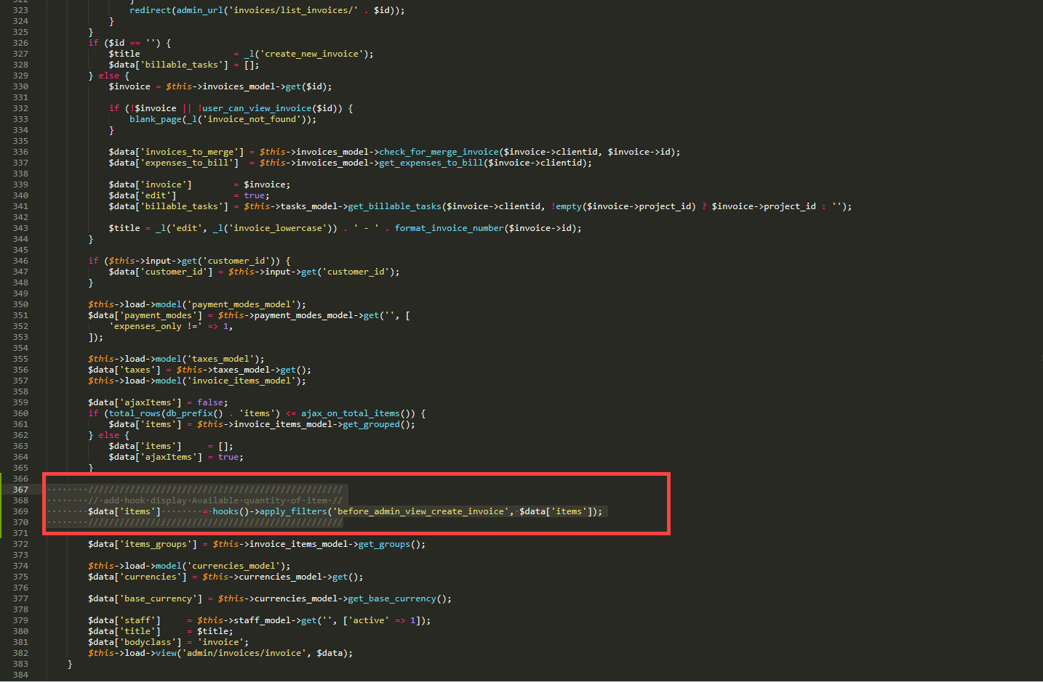

  - File “application/controllers/admin/Invoice_items.php”, find function “search” and update like the image
Code:

public function search()
{
if ($this->input->post() && $this->input->is_ajax_request()) {
$data = $this->invoice_items_model->search($this->input->post('q'));
/////////////////////////////////////////////////
// add hook display Available quantity of item //
$data = hooks()->apply_filters('admin_invoice_ajax_search_item', $data, $this->input->post('q'));
/////////////////////////////////////////////////
echo json_encode($data);
}
}

Image:
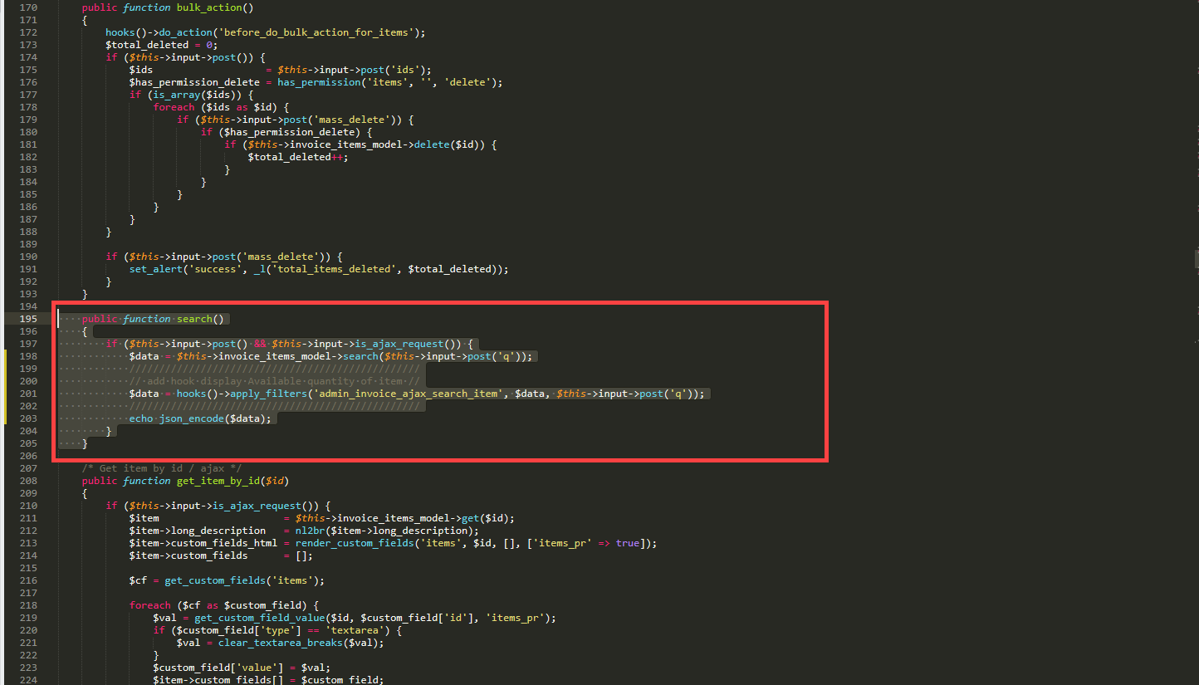
- Add Shipment in Omni sales module. ( Notes: If you use Omni sales module then add the following hooks).

  - Find “modules/omni_sales/views/order_list/cart_detailt.php”, find function “get_status_by_index” and update like the images.

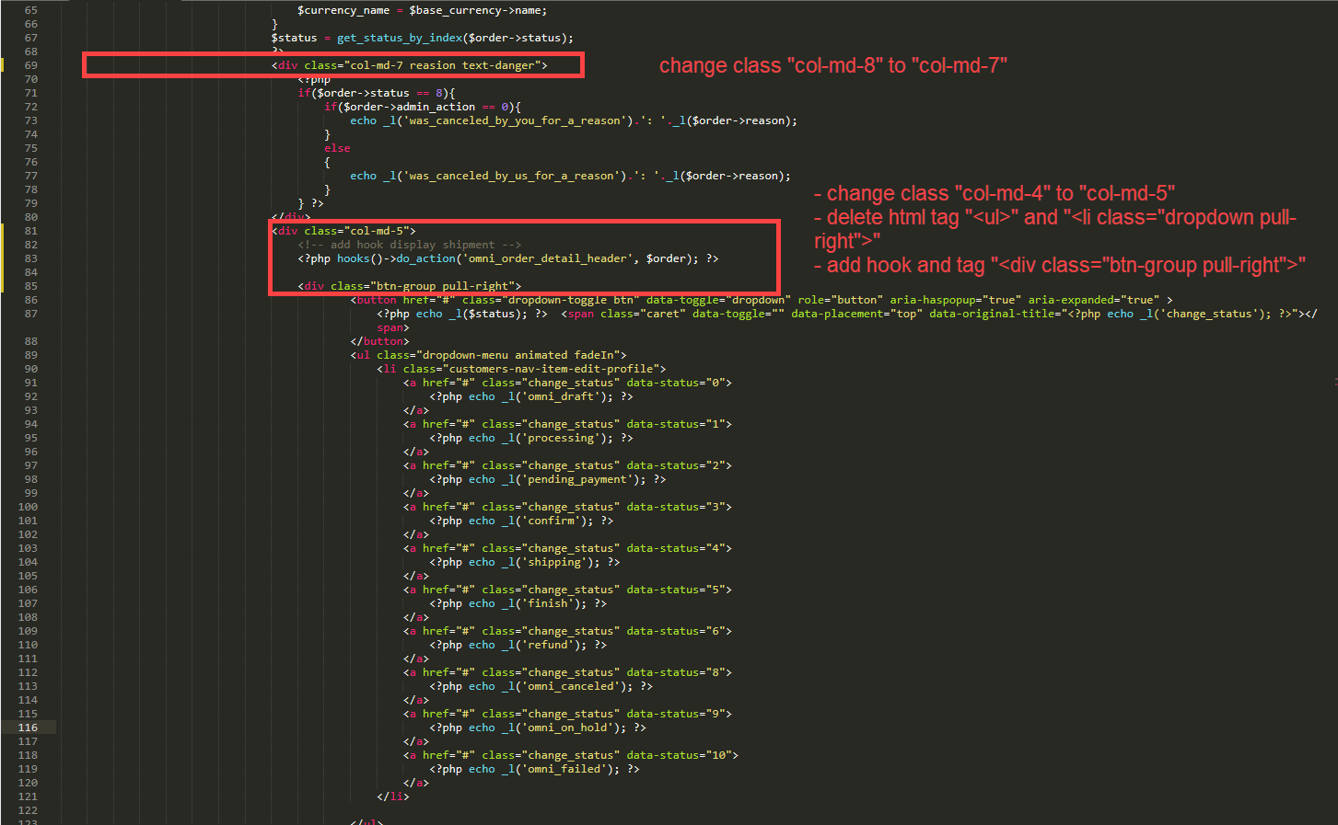

Hook and tag:

<!-- add hook display shipment -->
<?php hooks()->do_action('omni_order_detail_header', $order); ?>

<div class="btn-group pull-right">

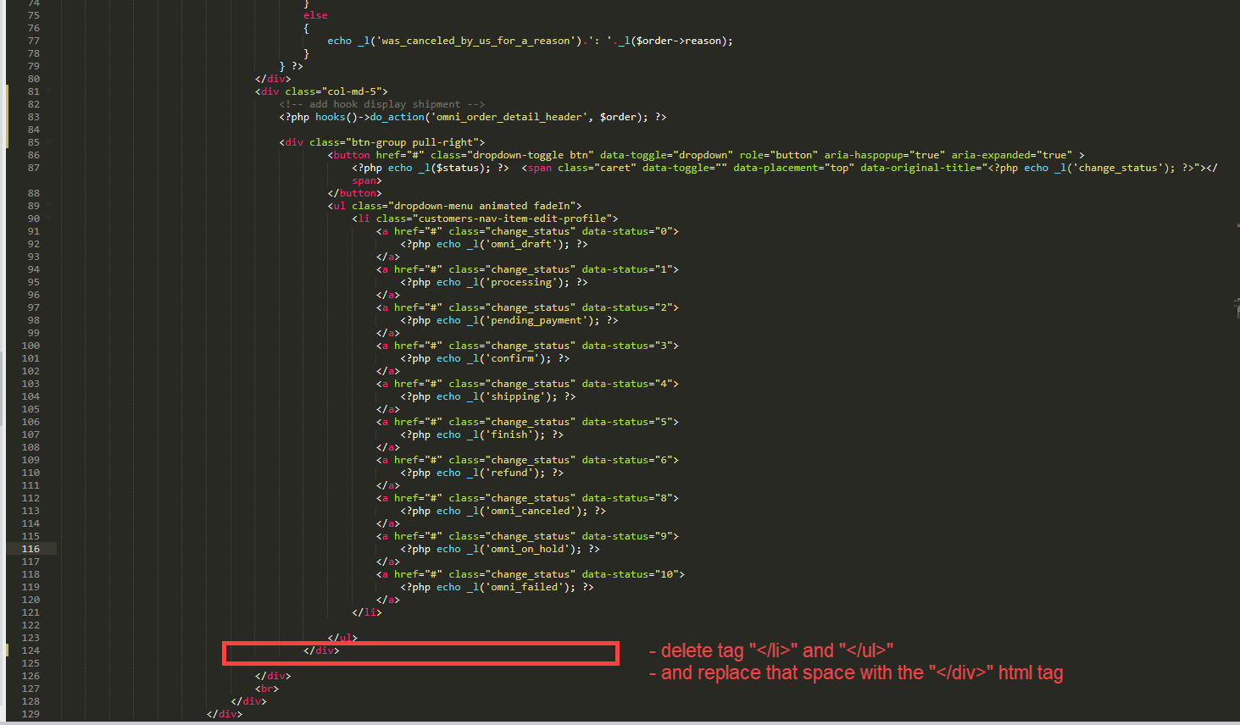
- delete tag "</li>" and "</ul>"
- and replace that space with the "</div>" html tag

  - Find “modules/omni_sales/models/Omni_sales_model.php”
- Find function “check_out”, below the line 584 add hook
Code:
//add hook after invoice add from order
hooks()->do_action('omni_sales_after_invoice_added', $insert_id);

Image:
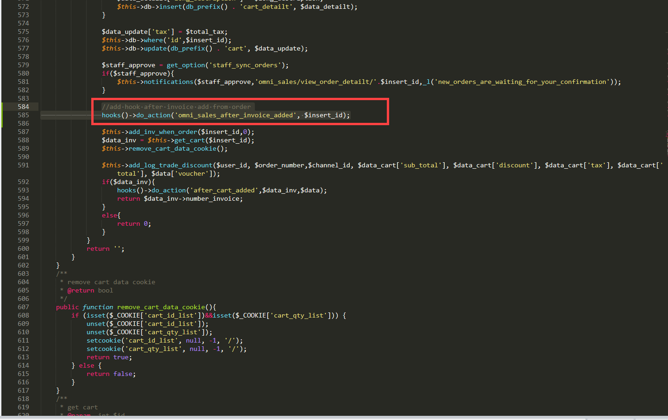

- Find function “check_out_pos”, below the line 1955 add hook
Code:

//add hook after invoice add from order
hooks()->do_action('omni_sales_after_invoice_added', $insert_id);

and below the line 1997 add hook
Code:

//add hook after delivery note add from order
hooks()->do_action('omni_sales_after_delivery_note_added', $insert_id);

Image:
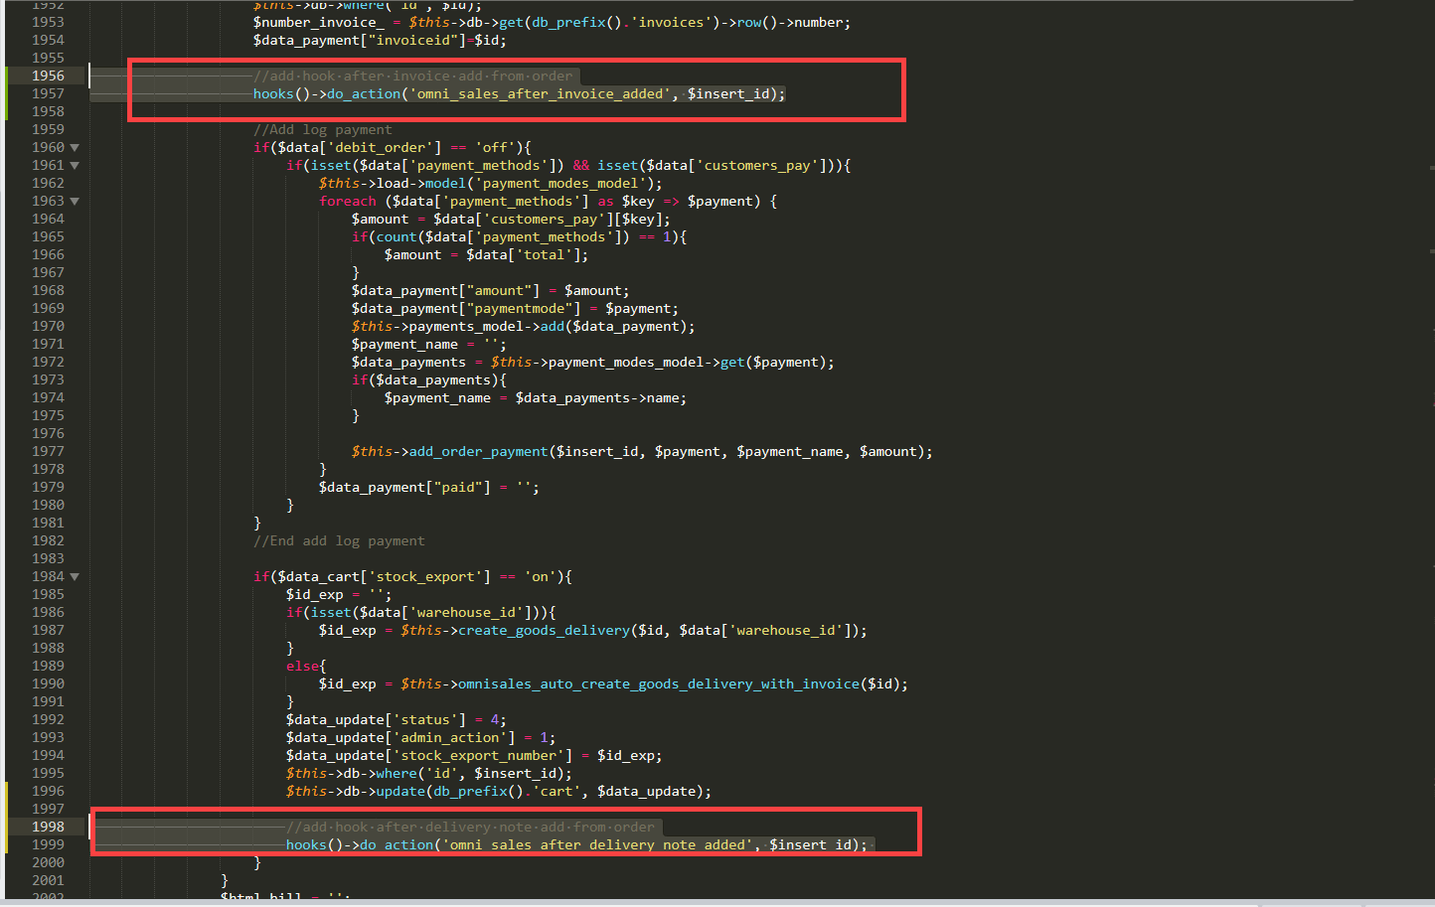

- Find function “create_export_stock”, below the line 2426 add hook
Code:
//add hook after delivery note add from order
hooks()->do_action('omni_sales_after_delivery_note_added', $orderid);

Image:
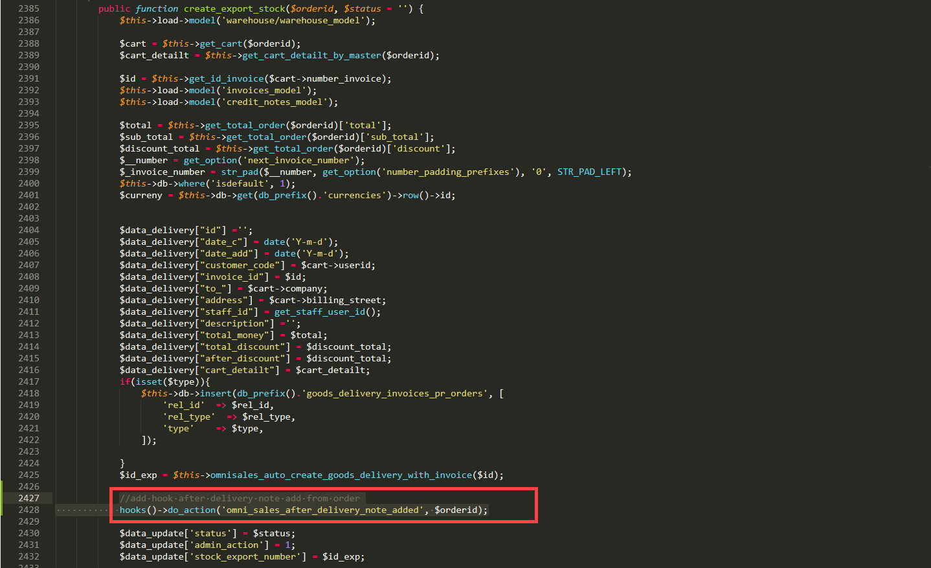

- Find function “create_invoice_detail_order”, below the line 9871 add hook
Code:
//add hook after invoice add from order
hooks()->do_action('omni_sales_after_invoice_added', $orderid);

Image:

