# ASSIGNMENT

## Aim :

To design a website login for wayanad flood donation.

## Procedure :

1. Select the frame which you use for designing your website.
2. Place the flood related images.
3. Place a link button for donation.
4. Then design the site according to your wish.
5. Place the information of causes and effect of land slide or flood.
6. Place a background image.
7. Then the website is ready.

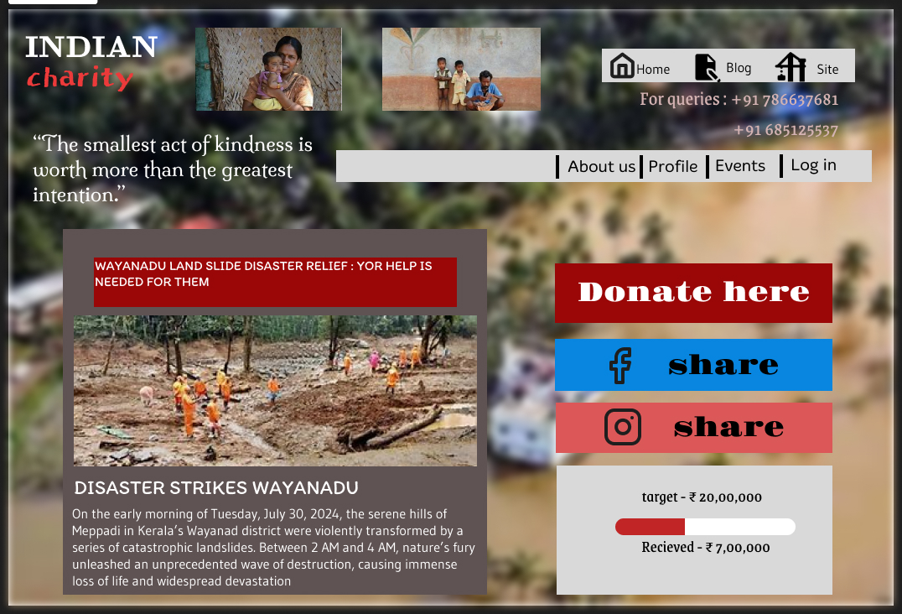

## Result :

Thus the wayanadu donation website is created.