GRX (Group Excess) Salesforce Integration
Manual Process Design Document
Package | pkg_stone_river_data_load (schema STAGE_MISREG)
Prepared by | Pawan
Date | November 11, 2026
Status | Draft v1.0 for client review

1. Purpose and scope
This document describes the changes made to the Stone River (SRM) monthly Manual process so that Group Excess (GRX) policies sourced from Salesforce (source system keys 23 and 24) flow through the existing Manual premium and claims process. It also explains the reasoning behind each design decision.
In scope: the four Manual procedures of pkg_stone_river_data_load: prc_premium_feed_load, prc_claims_feed_load, prc_premium_control_load and prc_claims_control_load; and the DataStage job changes described in Section 6.
Out of scope: the DC / CIP (Instanda) procedures and WINS. These were reviewed for impact but are not modified by this change.

2. Executive summary
- Problem: Before this change, Salesforce GRX was rejected by both selection rules. Premium admitted GRX only from the source-system names Manual and Program Connect; claims admitted only source system keys 6, 7 and 15.
- Solution: A narrowly scoped Salesforce admission rule was added to all four Manual procedures. A Salesforce row is admitted only when the source-system name is SF Admitted or SF Non-Admitted, the source system key is 23 or 24, and the policy type is GRX.
- Month basis: Salesforce claim transactions are selected on the PCS accounting month (pcs_month_acctng_ct). All other sources keep the existing accounting month (month_acctng_ct).
- DataStage: The transformer logic of the manual premium and loss data sets was updated, and the srm_instanda_premium_update and srm_instanda_error_update jobs now handle Manual (MNUL) and Salesforce (SLFS) transactions (Section 6).
- Unchanged: output record layouts, product mapping (GRX to GEX to line of business 171), orchestration order and the structure of the control totals.

3. End-to-end process flow
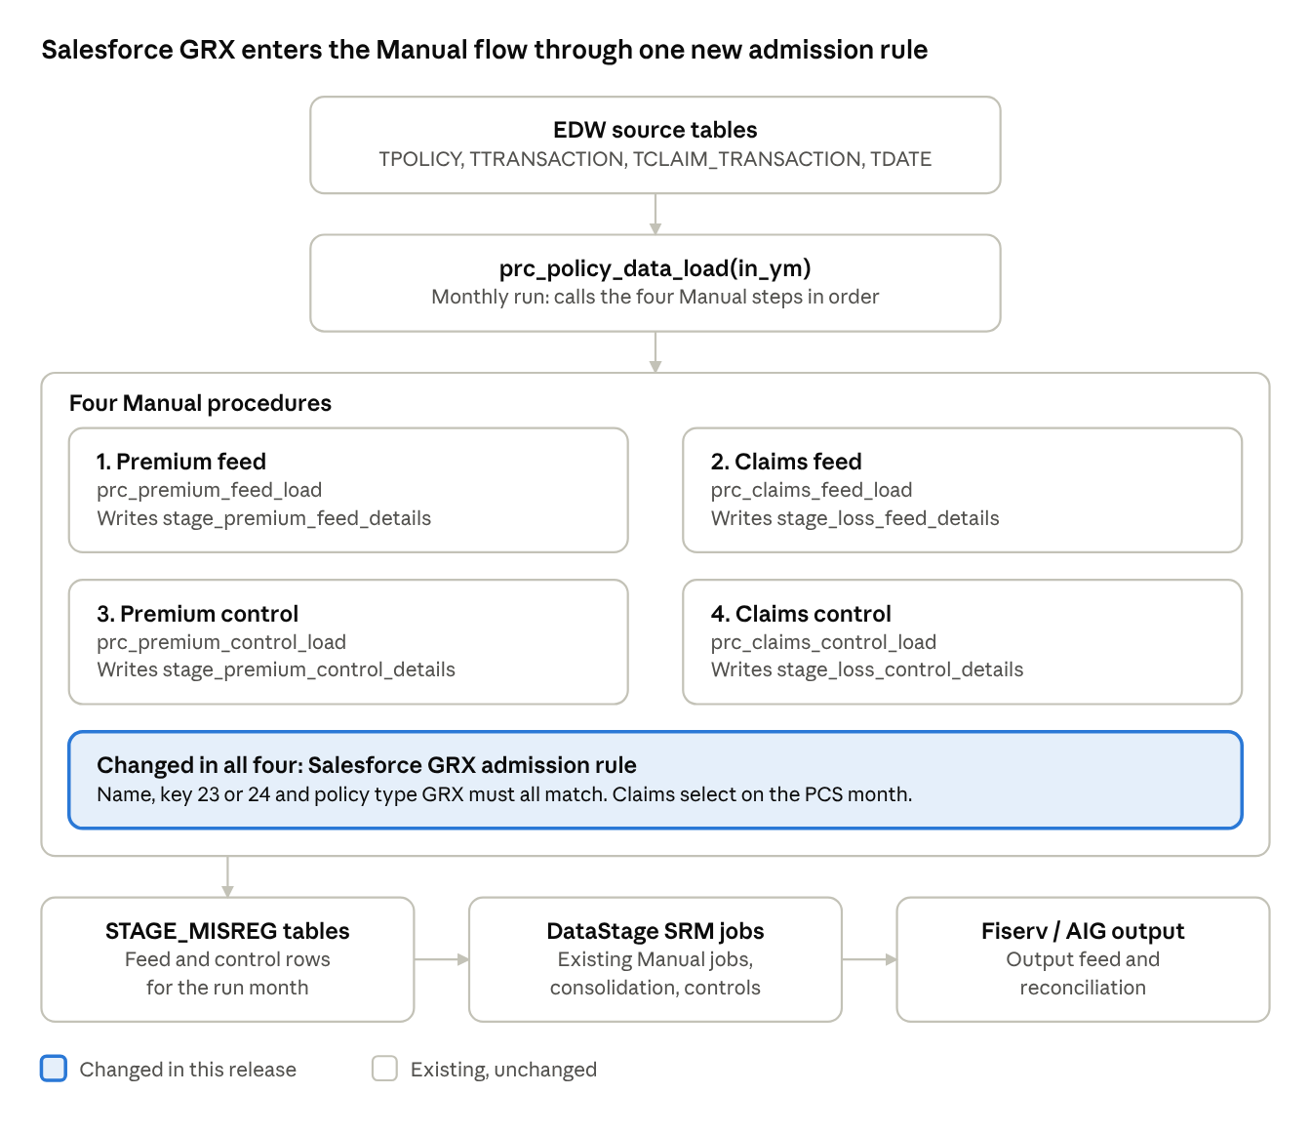
Figure 1: Manual process flow: 4 procedures, 1 change point
The Salesforce rule is applied inside the four Manual procedures (highlighted). The orchestrator and stage tables around them keep their existing design; the DataStage job changes are described in Section 6. The numbered steps below give the detail.
- Source data (EDW): TPOLICY, TTRANSACTION, TCLAIM_TRANSACTION, TCLAIM, TPOLICY_TYPE, TUW_COMPANY, TDATE and related reference tables.
- Month selection: Premium uses the accounting-date month (year_month_ct); claims use month_acctng_ct (existing sources) or pcs_month_acctng_ct (Salesforce).
- Stage tables: four feed and control tables in STAGE_MISREG.
The four Manual procedures (run in this order)
Step | Procedure / log module | What it builds | Target table (STAGE_MISREG)
1 | prc_premium_feed_load  MANUAL_PRM | Fixed-width premium records from TTRANSACTION, grouped by endorsement, policy, coverage, transaction type and dates | stage_premium_feed_details
2 | prc_claims_feed_load  MANUAL_CLAIMS | Loss records from TCLAIM_TRANSACTION in five blocks: paid loss, paid expense, salvage and subrogation, other recovery, reserves | stage_loss_feed_details
3 | prc_premium_control_load  MANUAL_CONTROL | Product-level premium control totals, using the same selection as step 1 | stage_premium_control_details
4 | prc_claims_control_load  MANUAL_CLAIMS_CONTROL | Product-level loss control totals, using the same selection | stage_loss_control_details

4. Salesforce GRX admission rule
A Salesforce row is admitted only when every check below passes.
Check | Premium (feed and control) | Claims (feed and control)
Run month | year_month_ct = in_ym on the accounting date | Salesforce: pcs_month_acctng_ct = in_ym. Other sources: month_acctng_ct = in_ym. Reserves use <= in_ym (cumulative) on the same columns
Source system key | IN (23, 24) | IN (23, 24)
Source system name | SF Admitted or SF Non-Admitted | SF Admitted or SF Non-Admitted
Policy type | GRX | GRX
Amount | premium_am <> 0 | The amount for the block (loss paid, expense paid, recovery or reserve) is non-zero
Existing exclusions kept | Unchanged | HP policy type excluded; UW company suffix 51 and 61 excluded

5. Design changes
The change is made in three places in pkg_stone_river_data_load, each shown with its screenshot: the premium admission rule, the claims admission rule and the claims month filter.

5.1 Adding ‘GRX’ in the Premium procedures
Applies to prc_premium_feed_load and prc_premium_control_load.
Premium selection (P-1 and P-2), before:
WHERE
( ( a.source_system_nm IN ( 'Manual', 'Program Connect' )
AND a.source_system_sk NOT IN ( 2, 14 )
AND TRIM(a.policy_type_cd) IN ( 'EPLI', 'EQ', 'EXFL', 'GRX', 'PC' ) )
OR ( a.source_system_nm = 'AIWCS'
AND TRIM(a.policy_type_cd) = 'WC' ) )
AND c.premium_am <> 0
After:
WHERE
( ( a.source_system_nm IN ( 'Manual', 'Program Connect' )
AND a.source_system_sk NOT IN ( 2, 14 )
AND TRIM(a.policy_type_cd) IN ( 'EPLI', 'EQ', 'EXFL', 'GRX', 'PC' ) )
OR ( TRIM(a.source_system_nm) IN ( 'SF Admitted', 'SF Non-Admitted' ) -- new
AND a.source_system_sk IN ( 23, 24 ) -- new
AND TRIM(a.policy_type_cd) = 'GRX' ) -- new
OR ( a.source_system_nm = 'AIWCS'
AND TRIM(a.policy_type_cd) = 'WC' ) )
AND c.premium_am <> 0
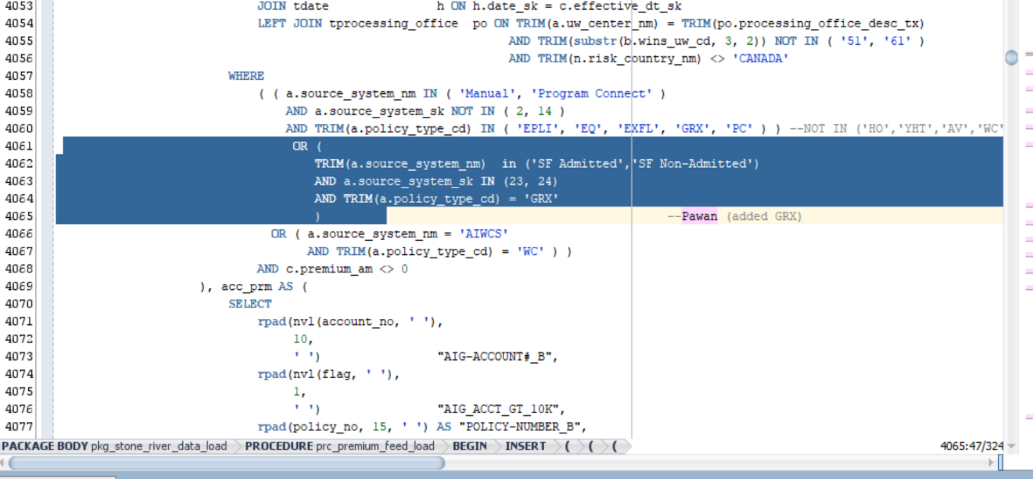
Figure 2: prc_premium_feed_load: new Salesforce GRX branch in the premium selection (highlighted)

5.2 Adding ‘GRX’ in the Claims procedures
Applies to prc_claims_feed_load and prc_claims_control_load.
Claims previously admitted only source system keys 6, 7 and 15. The highlighted block adds an OR branch that admits Salesforce rows when the source system key is 23 or 24, the source-system name is SF Admitted or SF Non-Admitted, and the policy type is GRX.
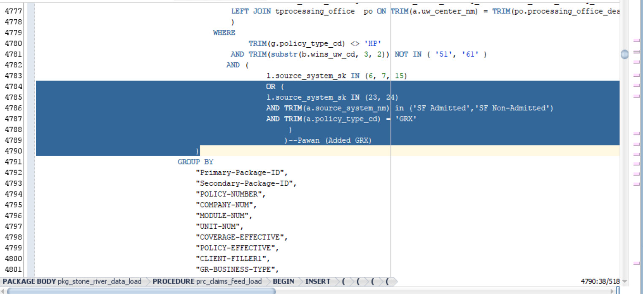
Figure 3: prc_claims_feed_load: new Salesforce GRX branch in the claims source-system filter (highlighted)

5.3 Claims month selection for Salesforce
The claims month filter was replaced with an OR condition that splits on source system: month_acctng_ct for source system keys NOT IN (23, 24), and pcs_month_acctng_ct for source system keys IN (23, 24).
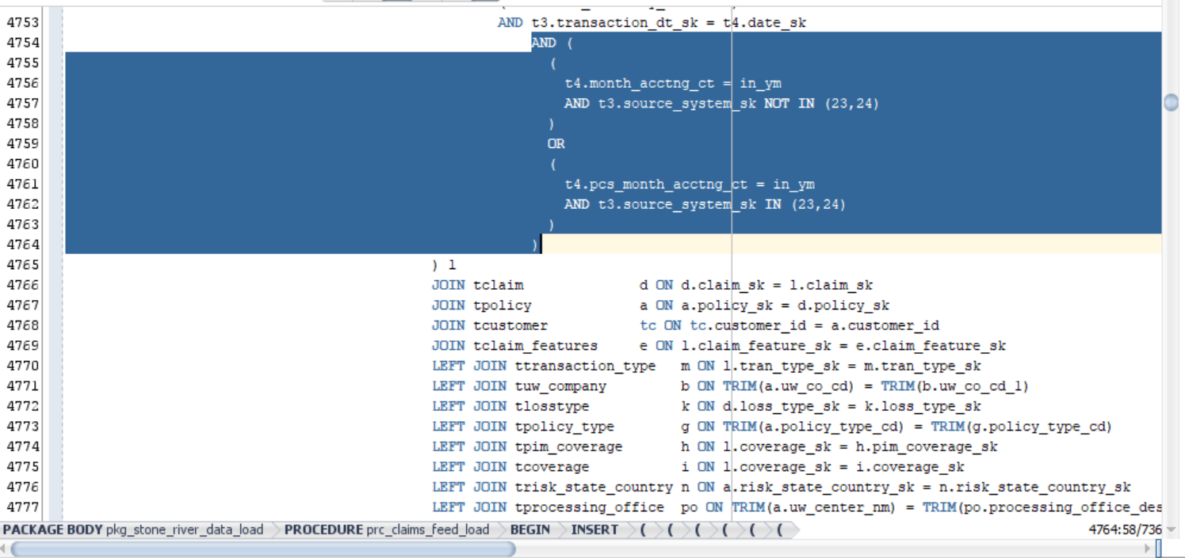
Figure 4: prc_claims_feed_load: claims month filter split between month_acctng_ct and pcs_month_acctng_ct (highlighted)

6. DataStage job modifications for GRX integration

6.1 Transformer logic updates
The following logic was implemented in the transformer stage for both the srm_manual_premium_ds and srm_manual_loss_ds data sets.
Field | Logic
Sap_Company_Cd | If NullToZero(Lkp7_out.DUMMY) <> 0 And Lkp7_out.DUMMY = 1 Then (If (NullToZero(Lkp7_out.UW_CO_CD) = 'MSIC') Then '3911' Else Lex_Sap_Company_Cd) Else Sap_Company_Cd
Issuing_Legal_Entity_Cd | IF(nulltoZero(Lkp7_out.DUMMY) <> 0 and (Lkp7_out.DUMMY)= 1) then (If (NullToZero(Lkp7_out.UW_CO_CD) = 'MSIC') Then '40' Else Lex_Issuing_Legal_Entity_Cd) else Issuing_Legal_Entity_Cd
Worldwide_Company_Cd | IF(nulltoZero(Lkp7_out.DUMMY) <> 0 and (Lkp7_out.DUMMY)= 1) then (If (NullToZero(Lkp7_out.UW_CO_CD) = 'MSIC') Then '005908' else Lex_Worldwide_Company_Cd) else Worldwide_Company_Cd
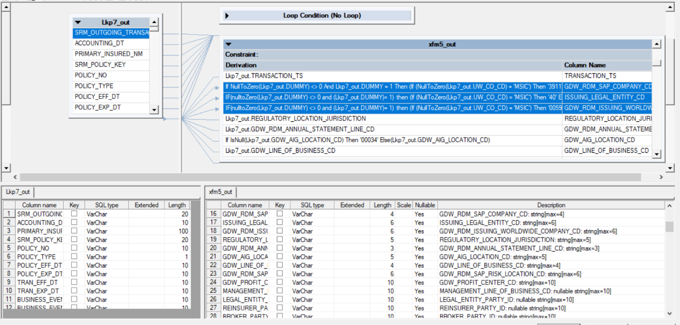
Figure 5: Transformer stage xfm5_out: the three updated derivations (highlighted)

6.2 Job: srm_instanda_premium_update

Source query updates
- Modified the WHERE clause to include ‘MNUL’ as a System_ID.
SELECT SRM_OUTGOING_TRANSACTION_ID, policy_no, POLICY_EFF_DT, system_id
FROM #PS_PCG_EDW.$PCG_EDW_Stage_Schema#.STAGE_SRM_PREMIUM_LOSS
WHERE System_ID IN ('DC','MNUL') AND accounting_month='#AccMnth#';

- Added a CASE statement to derive System_ID as ‘SLFS’ (Salesforce) when source_system_sk is 23 or 24.
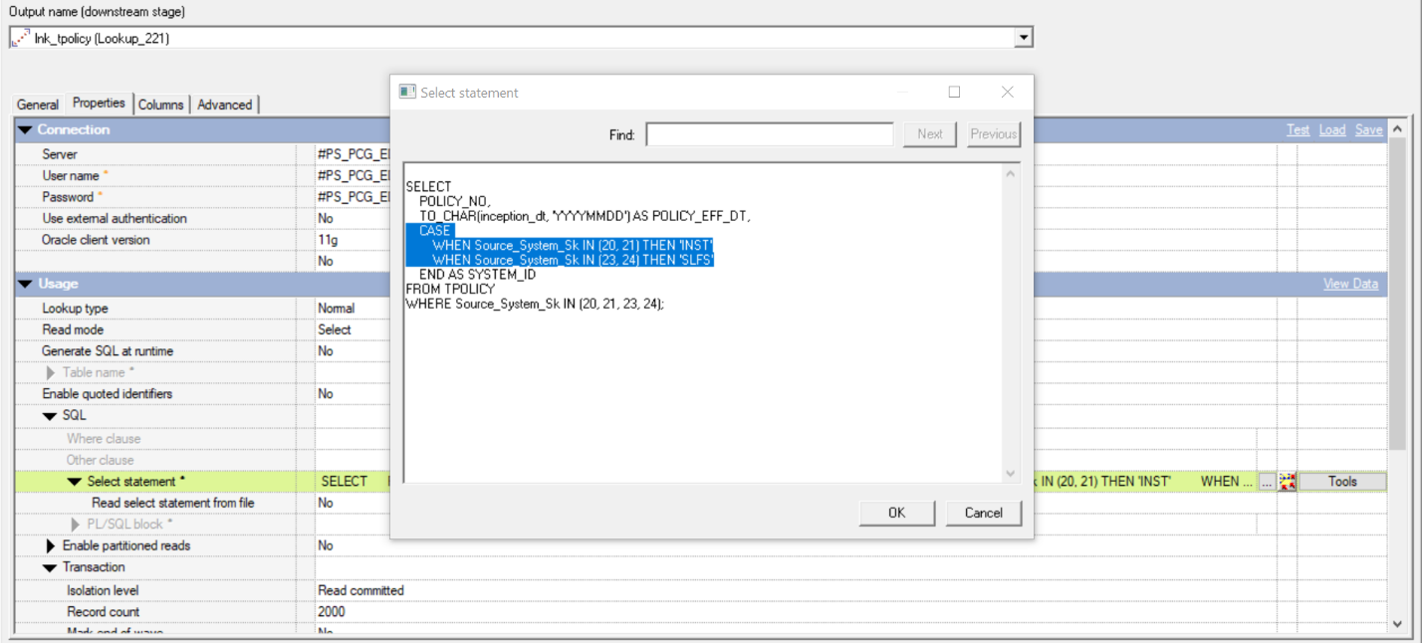
Figure 6: Lookup stage lnk_tpolicy (Lookup_221): the CASE statement that derives System_ID (highlighted); source system keys 23 and 24 return SLFS

Transformer logic updates
SRM Outgoing Transaction ID:
- MP prefix is converted to SP.
- ML prefix is converted to SL.
- For all others, D is replaced with I.

If DSLink227.SRM_OUTGOING_TRANSACTION_ID[1,2] = 'MP' Then
'SP' : DSLink227.SRM_OUTGOING_TRANSACTION_ID[3,
Len(DSLink227.SRM_OUTGOING_TRANSACTION_ID)]
Else If DSLink227.SRM_OUTGOING_TRANSACTION_ID[1,2] = 'ML' Then
'SL' : DSLink227.SRM_OUTGOING_TRANSACTION_ID[3,
Len(DSLink227.SRM_OUTGOING_TRANSACTION_ID)]
Else
Ereplace(DSLink227.SRM_OUTGOING_TRANSACTION_ID, 'D', 'I')
System ID:
- Set to ‘SLFS’ if the transaction ID prefix is MP or ML.

If DSLink227.SRM_OUTGOING_TRANSACTION_ID[1,2] = 'MP'
Or DSLink227.SRM_OUTGOING_TRANSACTION_ID[1,2] = 'ML' Then 'SLFS'
Else DSLink227.SYSTEM_ID
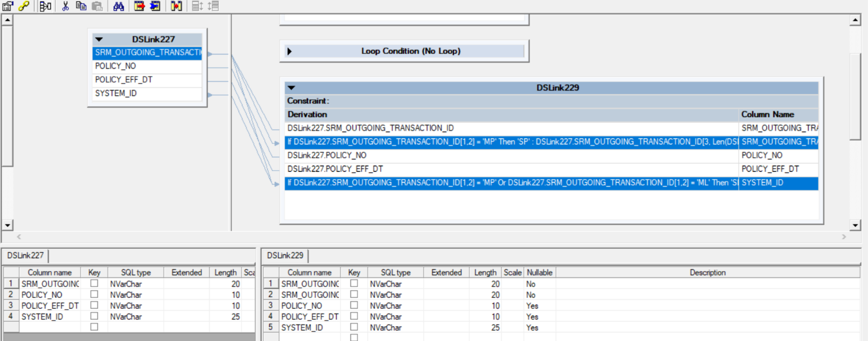
Figure 7: Transformer DSLink227 to DSLink229: derivations for SRM_OUTGOING_TRANSACTION_ID and SYSTEM_ID (highlighted)

6.3 Job: srm_instanda_error_update
The exact same changes that were applied to the srm_instanda_premium_update job were replicated in the srm_instanda_error_update job.

