GRX (Group Excess) Salesforce Integration
Manual Process Design Document
Package | pkg_stone_river_data_load
Date | November 11, 2026
Status | Design Review – SRM GRX

1. Purpose and scope
This document describes the changes made to the Stone River (SRM) monthly Manual process so that Group Excess (GRX) policies sourced from Salesforce (source_system_sk 23 and 24) flow through the existing Manual premium and claims process. It also explains the reasoning behind each design decision.
In scope: the four Manual procedures of pkg_stone_river_data_load: prc_premium_feed_load, prc_claims_feed_load, prc_premium_control_load and prc_claims_control_load, and the DataStage job changes described in Section 6.

2. Executive summary
- Problem: Before this change, Salesforce GRX was rejected by both selection rules. Premium admitted GRX only from the source-system names Manual and Program Connect; claims admitted only source system keys 6, 7 and 15.
- Solution: A narrowly scoped Salesforce admission rule was added to all four Manual procedures. A Salesforce row is admitted only when the source-system name is SF Admitted or SF Non-Admitted, the source system key is 23 or 24, and the policy type is GRX.
- Month basis: Salesforce claim transactions are selected on the PCS accounting month (pcs_month_acctng_ct). All other sources keep the existing accounting month (month_acctng_ct).
- DataStage: The transformer logic of the manual premium and loss data sets was updated, and the srm_instanda_premium_update and srm_instanda_error_update jobs now handle Manual (MNUL) and Salesforce (SLFS) transactions (Section 6).
- Unchanged: output record layouts, product mapping (GRX to GEX to line of business 171), orchestration order and the structure of the control totals.

3. End-to-end process flow
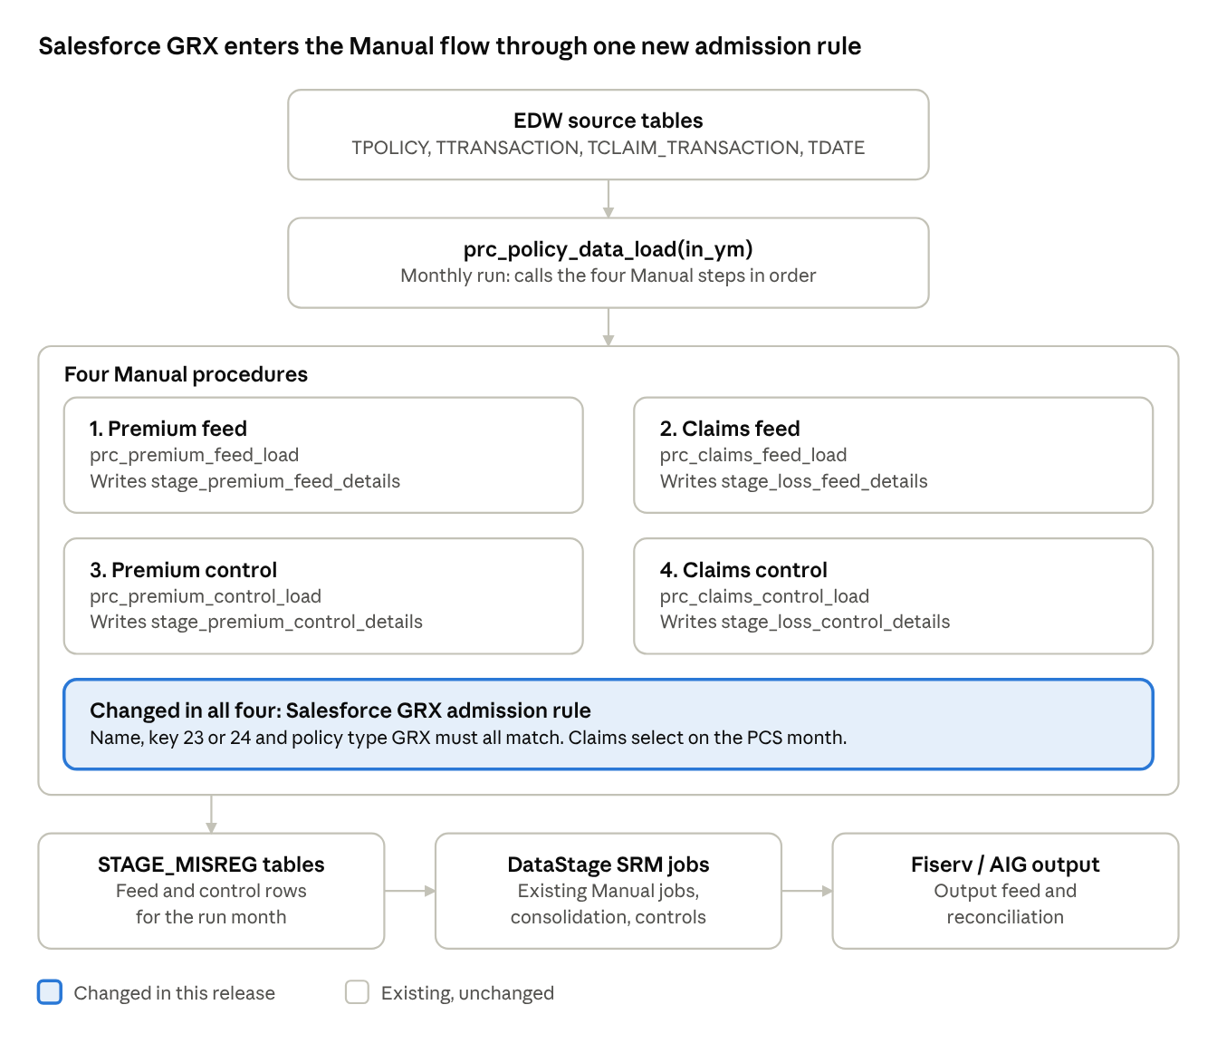
Figure 1: Manual process flow: 4 procedures, 1 change point
The Salesforce rule is applied inside the four Manual procedures (highlighted). The orchestrator and stage tables around them keep their existing design; the DataStage job changes are described in Section 6. The numbered steps below give the detail.
- Source data (EDW): TPOLICY, TTRANSACTION, TCLAIM_TRANSACTION, TCLAIM, TPOLICY_TYPE, TUW_COMPANY, TDATE and related reference tables.
- Month selection: Premium uses the accounting-date month (year_month_ct); claims use month_acctng_ct (existing sources) or pcs_month_acctng_ct (Salesforce).
- Stage tables: four feed and control tables in STAGE_MISREG.
The four Manual procedures (run in this order)
Step | Procedure / log module | What it builds | Target table (STAGE_MISREG)
1 | prc_premium_feed_load  MANUAL_PRM | Fixed-width premium records from TTRANSACTION, grouped by endorsement, policy, coverage, transaction type and dates | stage_premium_feed_details
2 | prc_claims_feed_load  MANUAL_CLAIMS | Loss records from TCLAIM_TRANSACTION in five blocks: paid loss, paid expense, salvage and subrogation, other recovery, reserves | stage_loss_feed_details
3 | prc_premium_control_load  MANUAL_CONTROL | Product-level premium control totals, using the same selection as step 1 | stage_premium_control_details
4 | prc_claims_control_load  MANUAL_CLAIMS_CONTROL | Product-level loss control totals, using the same selection | stage_loss_control_details

4. Salesforce GRX admission rule
A Salesforce row is admitted only when every check below passes.
Check | Premium (feed and control) | Claims (feed and control)
Run month | year_month_ct = in_ym on the accounting date | Salesforce: pcs_month_acctng_ct = in_ym. Other sources: month_acctng_ct = in_ym. Reserves use <= in_ym (cumulative) on the same columns
Source system key | IN (23, 24) | IN (23, 24)
Source system name | SF Admitted or SF Non-Admitted | SF Admitted or SF Non-Admitted
Policy type | GRX | GRX
Amount | premium_am <> 0 | The amount for the block (loss paid, expense paid, recovery or reserve) is non-zero
Existing exclusions kept | Unchanged | HP policy type excluded; UW company suffix 51 and 61 excluded

5. Design changes
The change is made in three places in pkg_stone_river_data_load, each shown with its screenshot: the premium admission rule, the claims admission rule and the claims month filter.

5.1 Adding ‘GRX’ in the Premium procedures
Applies to prc_premium_feed_load and prc_premium_control_load.
Premium selection (P-1 and P-2), before:
WHERE
( ( a.source_system_nm IN ( 'Manual', 'Program Connect' )
AND a.source_system_sk NOT IN ( 2, 14 )
AND TRIM(a.policy_type_cd) IN ( 'EPLI', 'EQ', 'EXFL', 'GRX', 'PC' ) )
OR ( a.source_system_nm = 'AIWCS'
AND TRIM(a.policy_type_cd) = 'WC' ) )
AND c.premium_am <> 0
After:
WHERE
( ( a.source_system_nm IN ( 'Manual', 'Program Connect' )
AND a.source_system_sk NOT IN ( 2, 14 )
AND TRIM(a.policy_type_cd) IN ( 'EPLI', 'EQ', 'EXFL', 'GRX', 'PC' ) )
OR ( TRIM(a.source_system_nm) IN ( 'SF Admitted', 'SF Non-Admitted' ) -- new
AND a.source_system_sk IN ( 23, 24 ) -- new
AND TRIM(a.policy_type_cd) = 'GRX' ) -- new
OR ( a.source_system_nm = 'AIWCS'
AND TRIM(a.policy_type_cd) = 'WC' ) )
AND c.premium_am <> 0
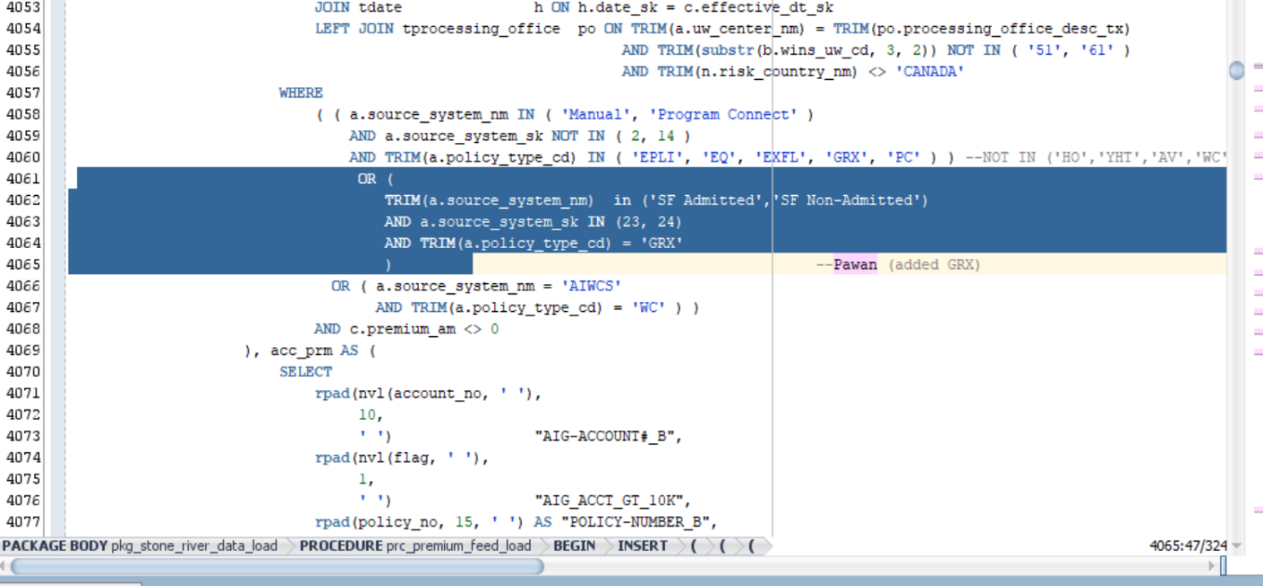
Figure 2: prc_premium_feed_load: new Salesforce GRX branch in the premium selection (highlighted)

5.2 Adding ‘GRX’ in the Claims procedures
Applies to prc_claims_feed_load and prc_claims_control_load.
Claims previously admitted only source system keys 6, 7 and 15. The highlighted block adds an OR branch that admits Salesforce rows when the source system key is 23 or 24, the source-system name is SF Admitted or SF Non-Admitted, and the policy type is GRX.
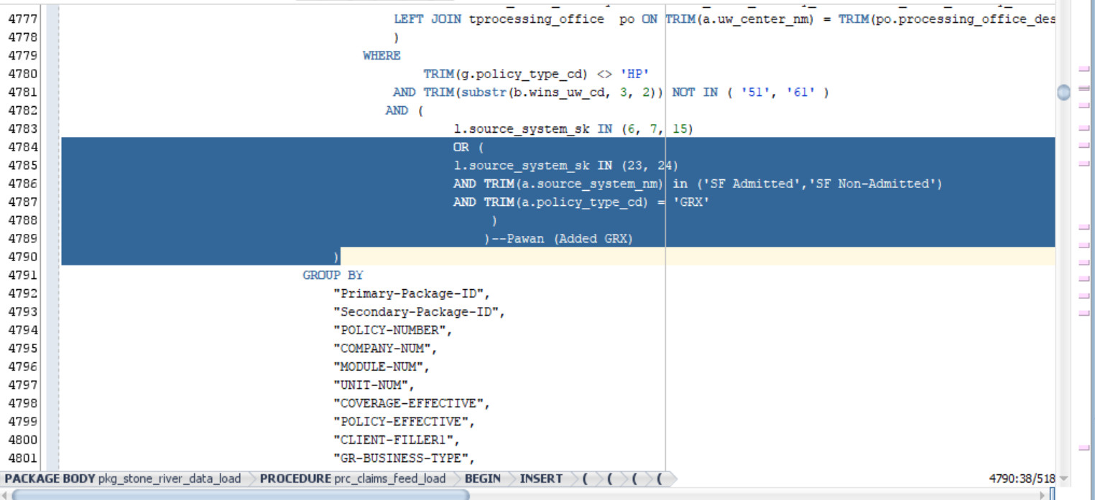
Figure 3: prc_claims_feed_load: new Salesforce GRX branch in the claims source-system filter (highlighted)

5.3 Claims month selection for Salesforce
The claims month filter was replaced with an OR condition that splits on source system: month_acctng_ct for source system keys NOT IN (23, 24), and pcs_month_acctng_ct for source system keys IN (23, 24).
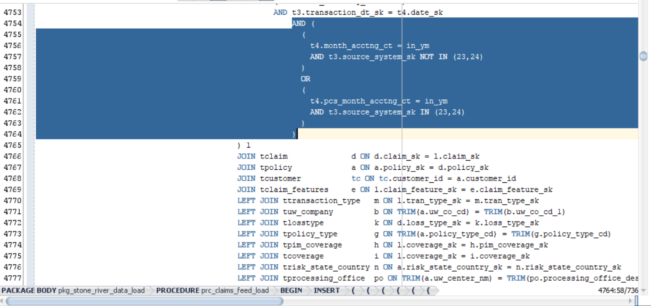
Figure 4: prc_claims_feed_load: claims month filter split between month_acctng_ct and pcs_month_acctng_ct (highlighted)

6. DataStage job modifications for GRX integration

6.1 Transformer logic updates
The following logic was implemented in the transformer stage for both the srm_manual_premium_ds and srm_manual_loss_ds data sets.
Field | Logic
Sap_Company_Cd | If NullToZero(Lkp7_out.DUMMY) <> 0 And Lkp7_out.DUMMY = 1 Then (If (NullToZero(Lkp7_out.UW_CO_CD) = 'MSIC') Then '3911' Else Lex_Sap_Company_Cd) Else Sap_Company_Cd
Issuing_Legal_Entity_Cd | IF(nulltoZero(Lkp7_out.DUMMY) <> 0 and (Lkp7_out.DUMMY)= 1) then (If (NullToZero(Lkp7_out.UW_CO_CD) = 'MSIC') Then '40' Else Lex_Issuing_Legal_Entity_Cd) else Issuing_Legal_Entity_Cd
Worldwide_Company_Cd | IF(nulltoZero(Lkp7_out.DUMMY) <> 0 and (Lkp7_out.DUMMY)= 1) then (If (NullToZero(Lkp7_out.UW_CO_CD) = 'MSIC') Then '005908' else Lex_Worldwide_Company_Cd) else Worldwide_Company_Cd
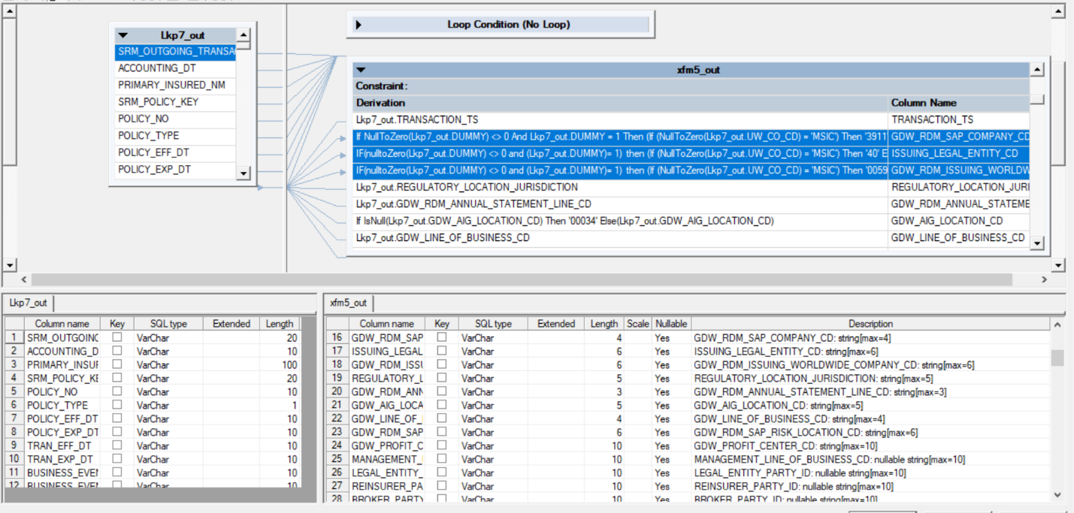
Figure 5: Transformer stage xfm5_out: the three updated derivations (highlighted)

6.2 Job: srm_instanda_premium_update

Source query updates
- Modified the WHERE clause to include ‘MNUL’ as a System_ID.
SELECT SRM_OUTGOING_TRANSACTION_ID, policy_no, POLICY_EFF_DT, system_id
FROM #PS_PCG_EDW.$PCG_EDW_Stage_Schema#.STAGE_SRM_PREMIUM_LOSS
WHERE System_ID IN ('DC','MNUL') AND accounting_month='#AccMnth#';

- Added a CASE statement to derive System_ID as ‘SLFS’ (Salesforce) when source_system_sk is 23 or 24.
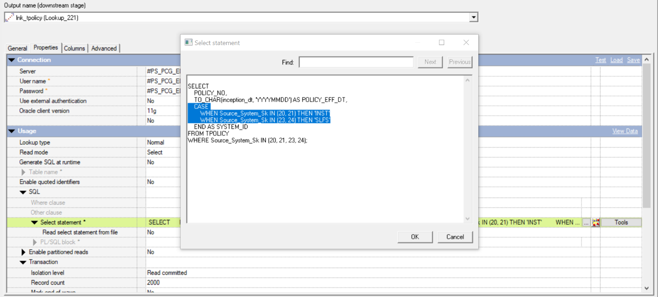
Figure 6: Lookup stage lnk_tpolicy (Lookup_221): the CASE statement that derives System_ID (highlighted); source system keys 23 and 24 return SLFS

Transformer logic updates
SRM Outgoing Transaction ID:
- MP prefix is converted to SP.
- ML prefix is converted to SL.
- For all others, D is replaced with I.

If DSLink227.SRM_OUTGOING_TRANSACTION_ID[1,2] = 'MP' Then
'SP' : DSLink227.SRM_OUTGOING_TRANSACTION_ID[3,
Len(DSLink227.SRM_OUTGOING_TRANSACTION_ID)]
Else If DSLink227.SRM_OUTGOING_TRANSACTION_ID[1,2] = 'ML' Then
'SL' : DSLink227.SRM_OUTGOING_TRANSACTION_ID[3,
Len(DSLink227.SRM_OUTGOING_TRANSACTION_ID)]
Else
Ereplace(DSLink227.SRM_OUTGOING_TRANSACTION_ID, 'D', 'I')
System ID:
- Set to ‘SLFS’ if the transaction ID prefix is MP or ML.

If DSLink227.SRM_OUTGOING_TRANSACTION_ID[1,2] = 'MP'
Or DSLink227.SRM_OUTGOING_TRANSACTION_ID[1,2] = 'ML' Then 'SLFS'
Else DSLink227.SYSTEM_ID
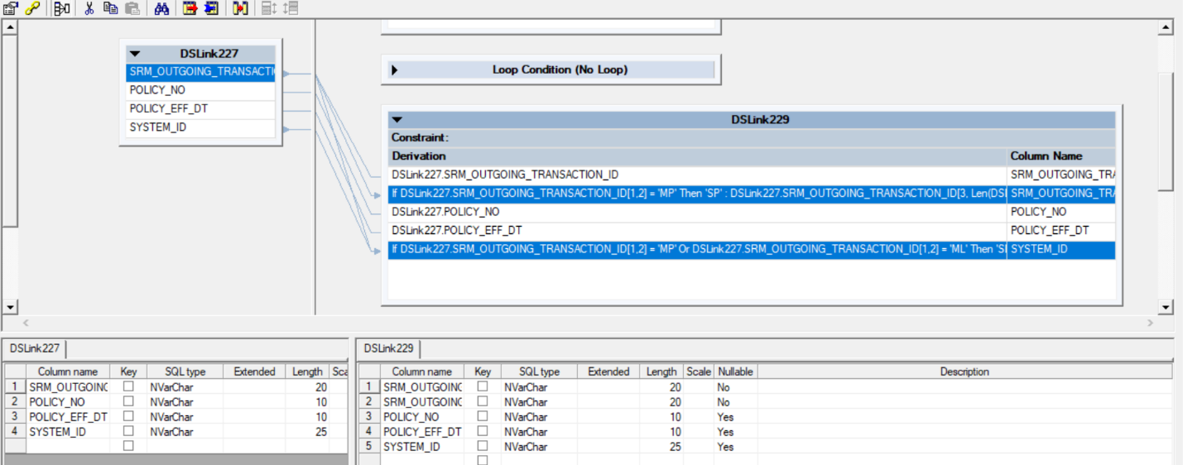
Figure 7: Transformer DSLink227 to DSLink229: derivations for SRM_OUTGOING_TRANSACTION_ID and SYSTEM_ID (highlighted)

6.3 Job: srm_instanda_error_update
The exact same changes that were applied to the srm_instanda_premium_update job were replicated in the srm_instanda_error_update job.

