

Project Marbleshore UWC – ASCO Integration Design
End-to-End Data Flow, System Architecture & Project Execution Plan
April 2026
Marbleshore Specialty Insurance Co.

Marbleshore | UWC Integration Timelines & Key Activities
Project timeline is based on high level understanding of the current scope.
Phase: Planning
- Activities: Scope Identification, Requirements gathering, impact analysis & ETL Design, Sign off for approach for design process
Phase: Design, Build & Testing
- Activities: Dev and Testing activities, Requirements gathering, impact analysis and ETL Design, Build and UT, Autosys and SFTP set up, QA / In-Sprint Testing, E2E Testing, UAT by Project team
Phase: Release
- Activities: UAT Sign-off, Prod Migration, KT to BAU team, Prod Migration and Warranty Support

Roles and Responsibilities
Team ownership across all project phases. (✓ = Responsible/Accountable, C = Consulted)
Planning & Design
**Planning & Design**
Activity / Phase | UWC/PCS | SRM | ASCO | Data (EDW)
Finalize L3 technical design for ETL jobs | C | ✓ | C
Define ASCO business requirements |  |  | ✓
Create test schedule & coordinate approvals | ✓ | ✓ | ✓
Development
Develop UWC database schema changes | ✓ | C
Develop ETL jobs (UWC → EDW → ASCO) |  | ✓ | C
Set up SFTP folders for file transfer |  |  | C
Remediate downstream applications
Testing
Coordinate & manage E2E / SIT testing | ✓ | ✓ | ✓
Conduct UAT testing for ASCO data |  |  | ✓
Conduct UAT testing for EDW & reporting
Deployment
Deploy UWC database changes to Production | ✓
Deploy ETL jobs to Production |  | ✓
Execute production data migration / cutover | ✓ | ✓ | ✓
Hypercare
Monitor production jobs & data integrity | ✓ | ✓ | ✓
Triage and resolve post-go-live defects | ✓ | ✓ | ✓

Integration Design: Data Flow Architecture
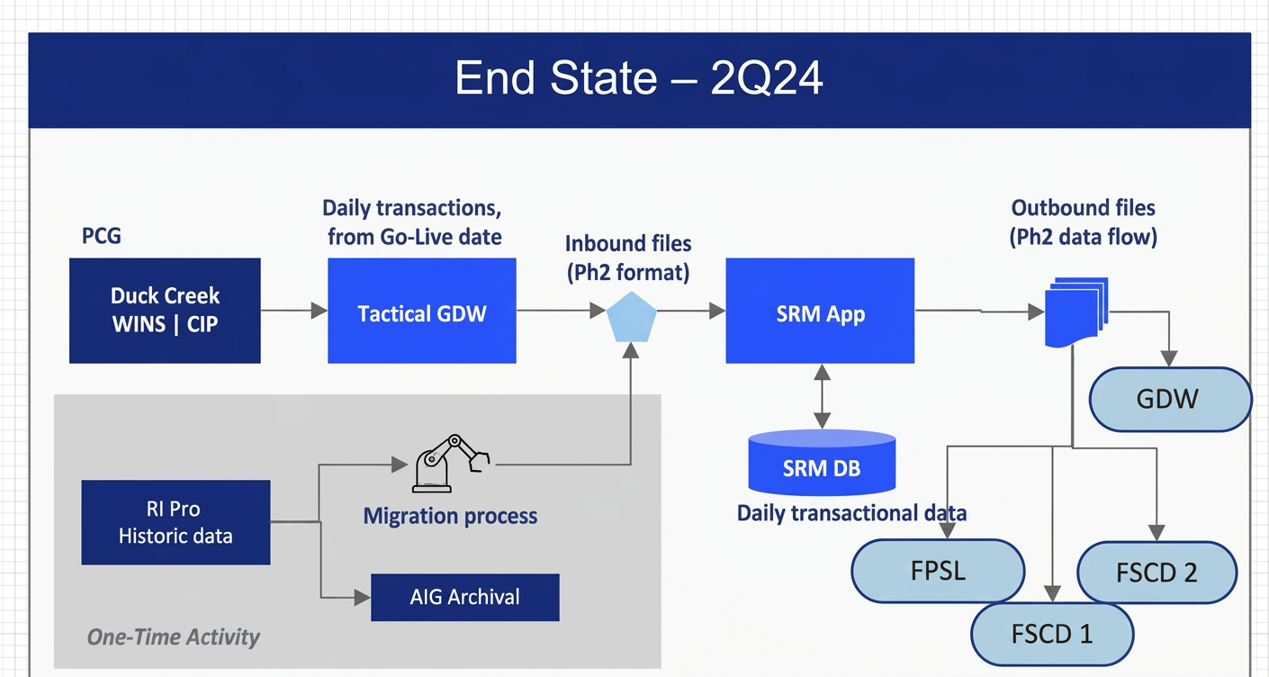
Flow:
-Data comes from Duck Creek (WINS/CIP) into Tactical GDW as daily transactions.
-Data is converted into inbound files and sent to the SRM Application.
-SRM App processes and stores data in SRM DB.
-From SRM, outbound files are generated.
-These files are sent to downstream systems like GDW, FPSL, and FSCD.

Analysis
Key improvements/Analysis delivered by the Marbleshore project.
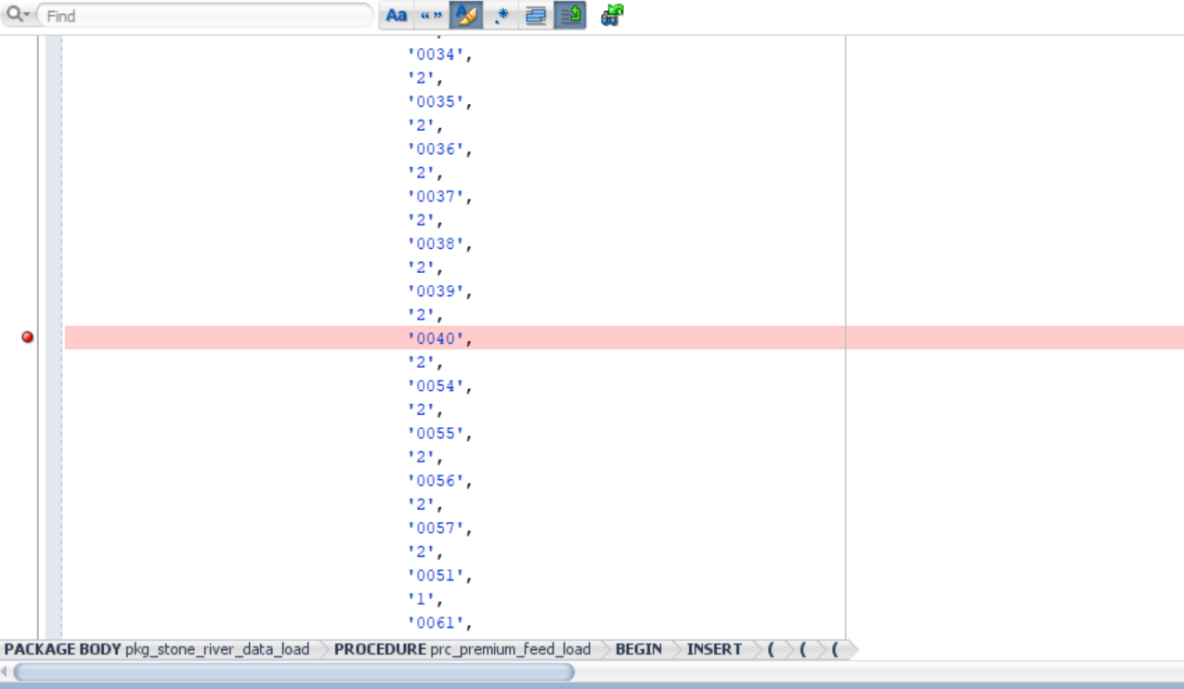
- ‘0040’ is wins_uw_cd is already present.

DataStage Job Analysis & Dependency Check

As part of the impact assessment, we need to conduct an analysis to verify the presence and active status of the following DataStage jobs in our current environment.
Once verified, we will analyze their underlying ETL logic to determine if these jobs have any dependencies on wins_uw_cd or any other Underwriter Company Code columns (such as UW_CO_CD or UW_CO_SK).

Target Jobs for Analysis:

- TQUOTE_AUTO_DRIVER_INFRCTN_PCS
- TREINSURANCE_PREMIUM_ADJ
- TQUOTE_TRANSACTION_DC
- TREINSURANCE_PREMIUM
- TREINSURANCE_CLAIMS_ADJ
- TPOLICY_LEX
- TQUOTE_AUTO_VEHICL_PREFILL_PCS
- STAGEPOLICYUK
- STAGEPOLICYUK_UKGD
- STAGEPOLICYUK14
- STAGEWCPREM_MAIN
- STAGEWCPREM_MAIN_2003
- TQUOTE_AUTOPOLCOVERAGE_PCS
- STAGING_LEXINGTON_PREMIUM_LEX
- STAGING_CLAIMSTRANS_WC_NEW

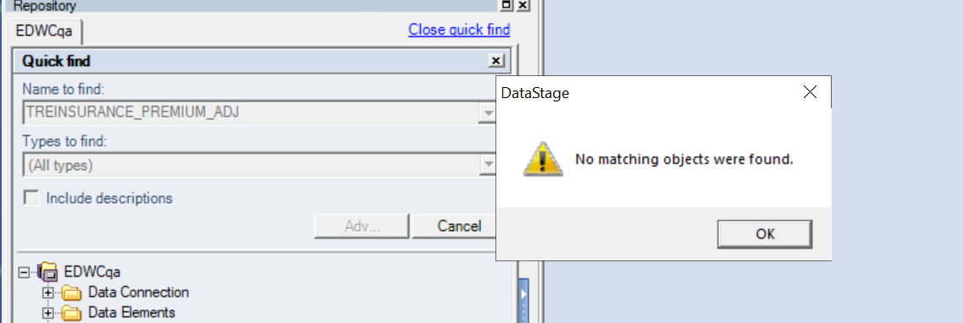

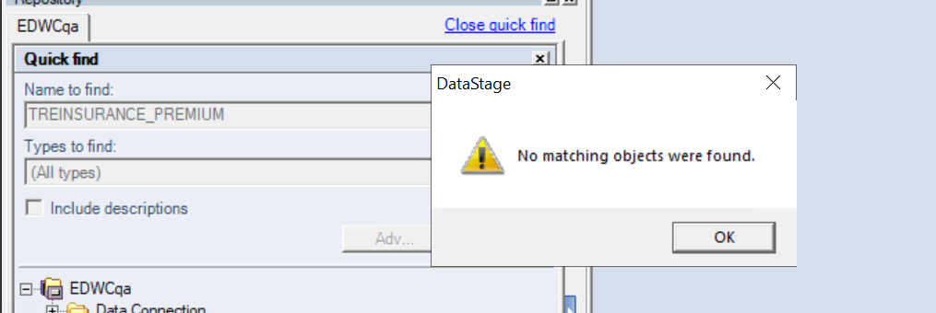
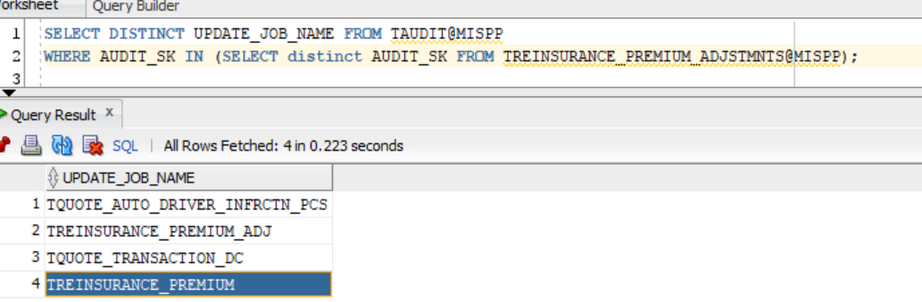
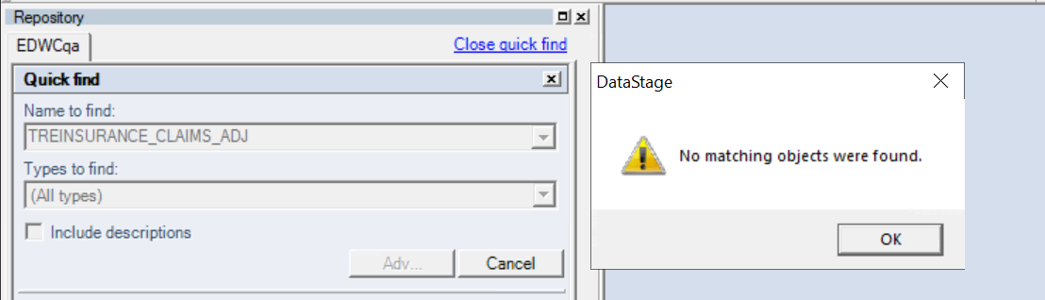



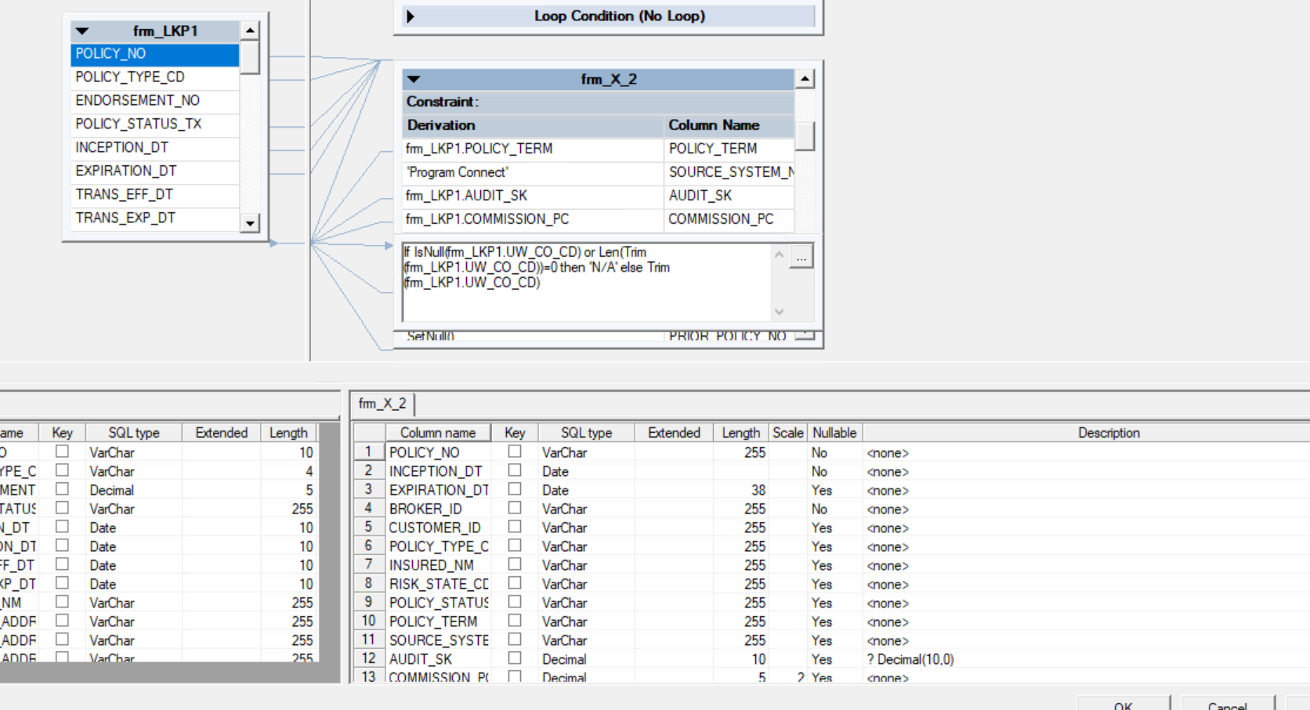
- 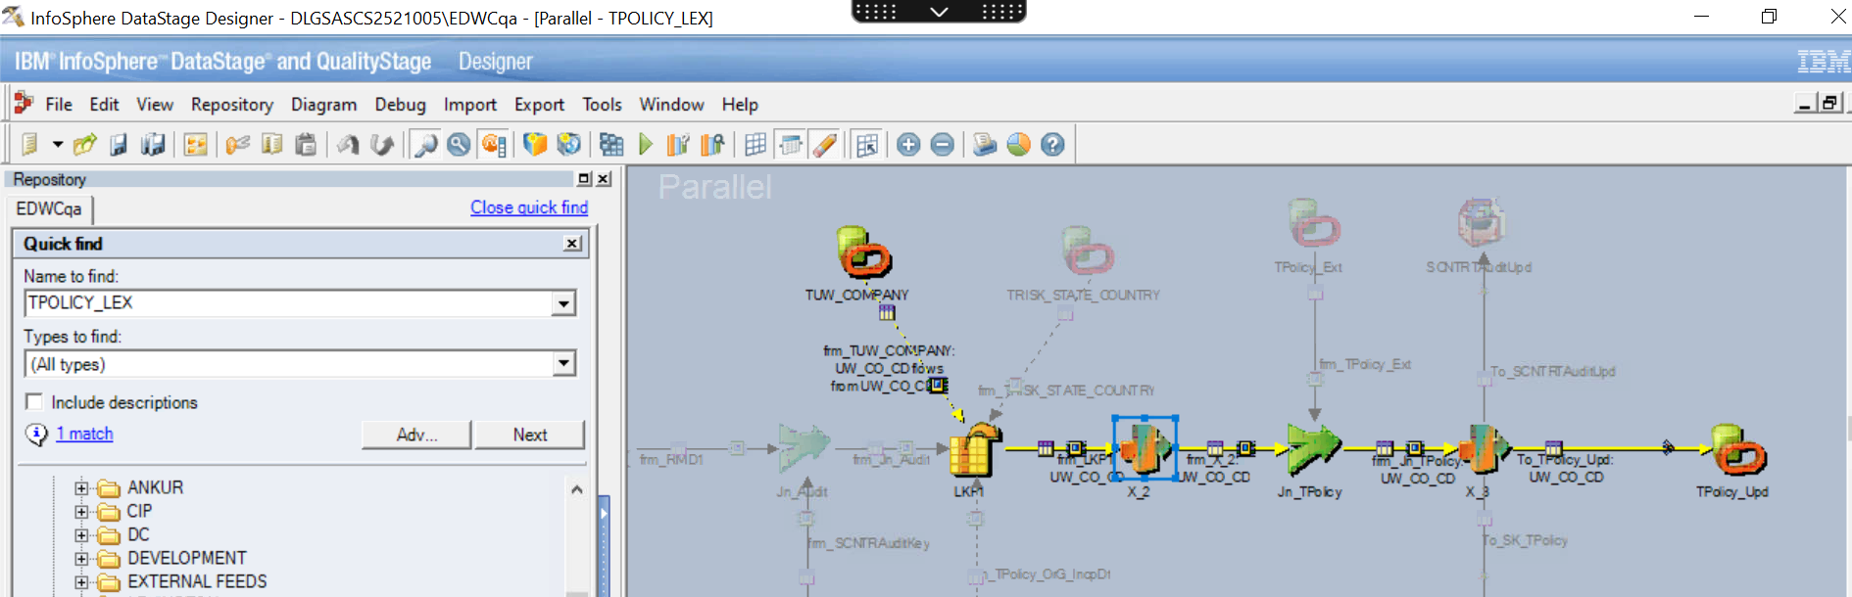

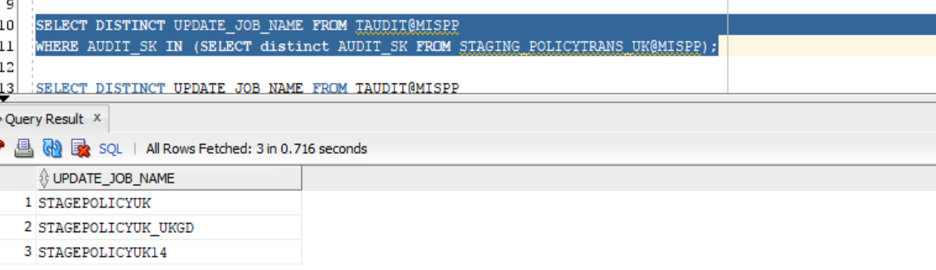
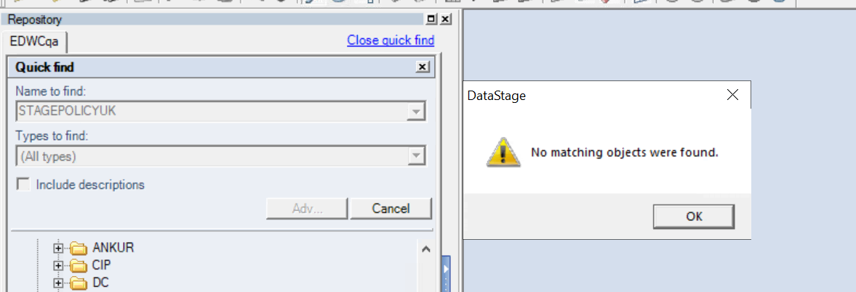
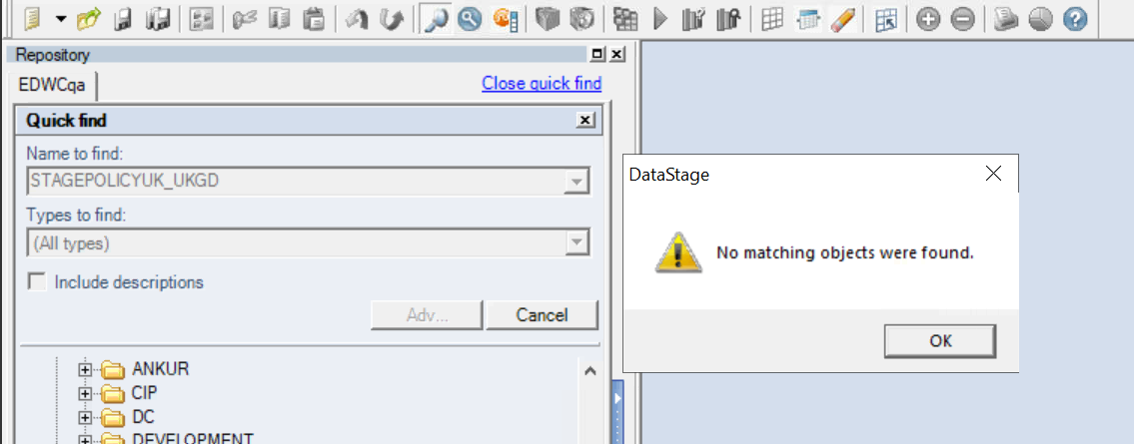
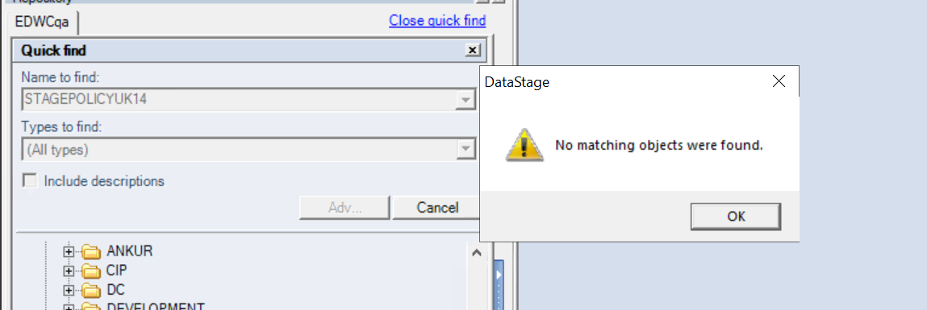
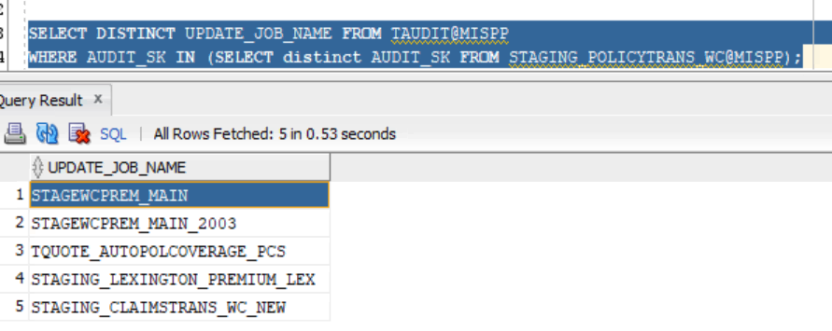
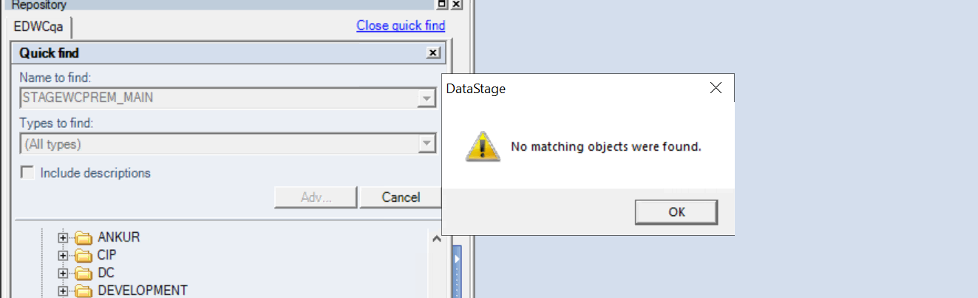
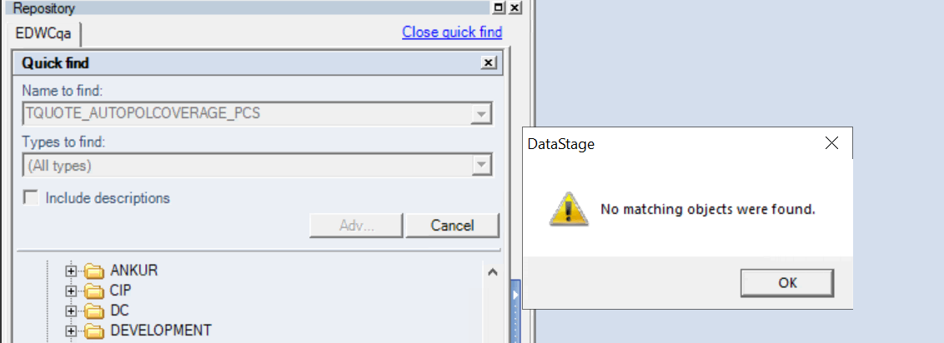
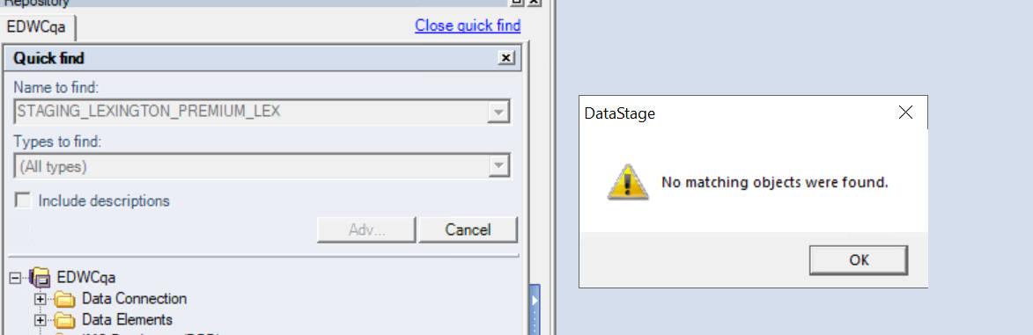
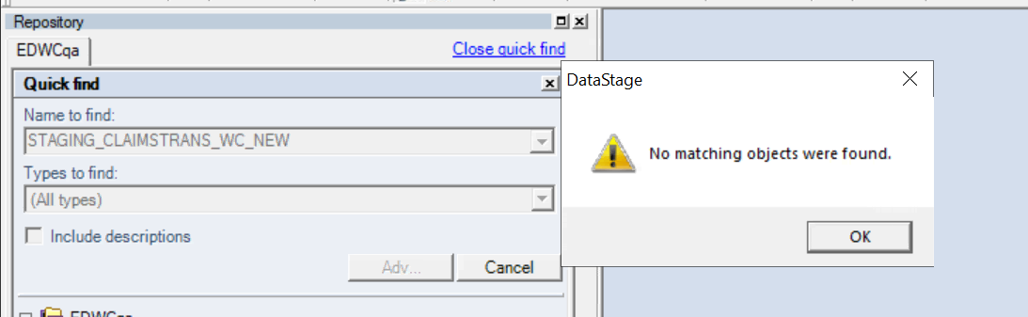

Design changes / Issues identified.
Underwriting Columns Impact Analysis
  - Marbleshore Integration Project

1. Overview & Objective
As part of the Marbleshore system integration and database consolidation effort, a comprehensive technical analysis was conducted on the Underwriting Console (UWC) database schema. The objective of this specific analysis was to identify existing underwriting entities and legacy company codes whose data columns are directly impacted by the new integration rules, specifically the routing and data mapping processes for the new data feeds.

2. Key Findings: Impacted Underwriting Entities
Our data extraction and system analysis isolated the specific Underwriting Company Codes (UW_CO_CD / UW_CO_SK) that are impacted within the current architecture.
The analysis identified the following two key entities that require specific data mapping, transformation, and regression testing during the ETL build phase:
- Company Code 34: AIG Insurance Company of Canada
- Company Code 32: Chartis Insurance Company of Canada
These entities currently reside in the impacted tables and must be properly accounted for when establishing the new routing logic to ensure no data disruption occurs for Canadian operations.

3. System Analysis & Evidence
(Please see the attached system screenshots below detailing the database query results and table impact analysis.)
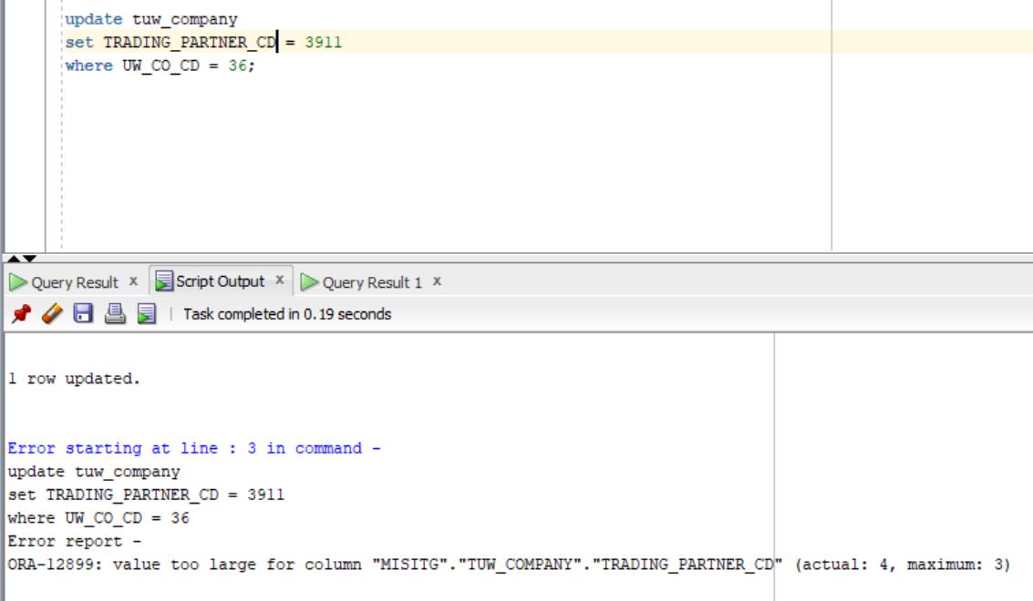
Caption: Extract from the MISP database highlighting the specific UW_CO_CD values flagged during the impact analysis.
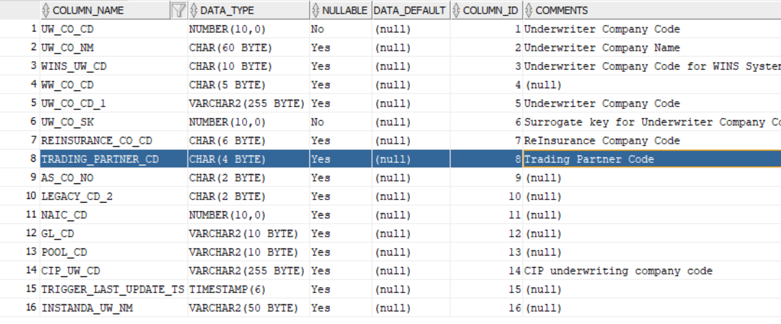
Impacted column mappings demonstrating where the legacy company codes intersect with the planned DataStage ETL enhancements.

4. Business & Technical Impact
The identification of these specific codes dictates the following technical action items for the development and QA teams:
- ETL Transformation Logic: The DataStage ETL jobs (specifically the UWC to EDW extracts) must include explicit handling/mapping for Codes 34 and 32 to ensure their policies and bordereaux data are correctly transformed and not erroneously mapped to the new Marbleshore (ASCO 40) entity.
- Targeted Regression Testing: During the System Integration Testing (SIT) phase, QA teams must inject targeted test cases for AIG Insurance Company of Canada and Chartis Insurance Company of Canada to verify that existing business workflows for these entities remain completely unimpacted by the Marbleshore code releases.
- Downstream Reporting: EDW and Reporting teams must ensure that historical data tied to these two legacy codes remains intact and queryable in the target Operational Data Store (ODS).

PCS Database Synchronization: TUW_COMPANY
To ensure data consistency across the environment, an INSERT statement was successfully executed on the PCS side to synchronize the Underwriting Company master table (TUW_COMPANY).
This update officially registers the new Marbleshore Spec Ins Company into the system's reference data, assigning it the Underwriting Company Code (UW_CO_CD) of 36, along with its corresponding ASCO Number (40) and GL Code (3911).
Insert into tuw_company (UW_CO_CD,UW_CO_NM,WINS_UW_CD,WW_CO_CD,UW_CO_CD_1,UW_CO_SK,REINSURANCE_CO_CD,TRADING_PARTNER_CD,AS_CO_NO,LEGACY_CD_2,GL_CD,POOL_CD,NAIC_CD,CIP_UW_CD,TRIGGER_LAST_UPDATE_TS,INSTANDA_UW_NM) values (36,'Marbleshore Spec Ins Company ','0040 ','00613','MSIC',36,'3911 ','3911','40','40','3911',null,13551,'0040',to_timestamp('07-APR-26 02.10.35.108092000 PM','DD-MON-RR HH.MI.SSXFF AM'),'Marbleshore Spec Ins Company');

