NITTE MEENAKSHI INSTITUTE OF TECHNOLOGY
(AN AUTONOMOUS INSTITUTION)
AFFILIATED TO VISVESVARYA TECHNOLOGICAL UNIVERSITY, BELGAUM
APPROVED BY AICTE & GOVT. OF KARNAKATA
YELAHANKA, BANGALORE - 560064


“ROBOTICS ENGINEERING – LEGO MINDSTORMS & TETRIX”

A Report on Mini – Project [Challenge Program]
Trash Collector
Submitted by
ANANYA KESARWANI | ECE | 1NT16EC011
SUMEDHA RAGHU | CSE | 1NT16CS117
PAWAN R TANKSALI | CSE | 1NT16CS070
PRAJWAL GOWDA R S | EEE | 1NT16EE057

COURSE CO-ORDINATOR
Dr. Jharna Majumdar
Robotics Engg., Course Co-ordinator
Dean R&D, Prof & Head M.Tech CSE
Head – Centre for Robotics Research
Nitte Meenakshi Institute of Technology
Bangalore – 64

FACULTY CO-ORDINATORS
Mr. Prashanth N  Assistant Professor, Dept. of Mechanical  Nitte Meenakshi Institute of Technology  Bangalore – 64 | Mr. Santhosh Kumar K L  Assistant Professor, Dept. of CSE (PG)  Nitte Meenakshi Institute of Technology  Bangalore – 64
Mrs. Sowmya Raman  Assistant Professor, Dept. of EEE  Nitte Meenakshi Institute of Technology  Bangalore – 64 | Mrs. Raji P  Assistant Professor, Dept. of ECE  Nitte Meenakshi Institute of Technology  Bangalore – 64

CENTRE FOR ROBOTICS RESEARCH, NMIT

NITTE MEENAKSHI INSTITUTE OF TECHNOLOGY
(AN AUTONOMOUS INSTITUTION)
AFFILIATED TO VISVESVARYA TECHNOLOGICAL UNIVERSITY, BELGAUM
APPROVED BY AICTE & GOVT. OF KARNAKATA
YELAHANKA, BANGALORE - 560064

Certificate

This is to Certify that the Mini-Project entitled “GARBAGE COLLECTOR” is the bonafied work of ANANYA KESARWANI (1NT16EC011), SUMEDHA RAGHU (1NT16CS117), PAWAN R TANKSALI (1NT16CSO70), PRAJWAL GOWDA R S(1NT16EE057) for the Open-Elective Course on “ROBOTICS ENGINEERING – LEGO MINDSTORMS & TETRIX” during the Academic Year 2017-18.

SIGNATURE OF THE COURSE CO-ORDINATOR

………………………………………………………………..
Dr. Jharna Majumdar
Robotics Engg., Course Co-ordinator
Dean R&D, Prof & Head M.Tech CSE
Head – Centre for Robotics Research
Nitte Meenakshi Institute of Technology
Bangalore – 64

ACKNOWLEDGEMENT

Nothing is envisaged without the help guidance of an experienced person respect in the field of concert subject. Through the benefits achieved from them can never be adequately valued, we would like to express hearty gratitude towards them.

Firstly we express our sincere gratitude to Dr. N R SHETTY, Advisor, NMIT and Dr. H C NAGARAJ, Principal, NMIT, Bangalore for providing the good infrastructure and support at NMIT

We would like to take this opportunity to thank DR. JHARNA MAJUMDAR, Dean R&D, Prof & Head M.Tech CSE for her valuable suggestions and support throughout the course of Robotics Engineering – LEGO Mindstorms & TETRIX

We extend our special thanks to Mr. PRASHANTH N (Asst. Prof., Dept of Mechanical), Mr. SANTHOSH KUMAR K L (Asst. Prof., Dept of CSE(PG)), Mrs. SOWMYA RAMAN (Asst. Prof., Dept of EEE), Mrs. RAJI P (Asst. Prof., Dept of ECE), for their effort and endurance to bring out the best in all of us.

ABSTRACT

The challenge is 1) to go in a straight path and 2) to collect the garbage using a suitably designed robot. The robot is designed in such way that it has a clamper mechanism which picks up the garbage and drops it into container which is used as collector. The robot has a sonar/ultrasonic sensor attached to it, to sense the garbage. The task is that the robot moves in a straight path sensing and once it senses the garbage, it picks up the garbage and moves forward.

TABLE OF CONTENTS
- AIM OF THE PROJECT
- HARDWARE DESCRIPTION
- DESIGN OF ROBOT
- SOFTWARE DESCRIPTION
- INDIVIDUAL ROLE
- CONCLUSION
- BIBLIOGRAPHY

1. AIM OF THE PROJECT
The challenge was to design, build and program a robot (trash collector) which is capable of sensing the trash in its path and then collecting it in a tray with the help of clamping mechanism. The robot uses ultrasonic sensor to sense the trash lying in its path.

2. HARDWARE DESCRIPTION

  - HARDWARE REQUIREMENTS:
- Speed : 1.1Ghz
- RAM : 256MB(min)
- Hard Disk : More than 500 MB
- Key Board, Mouse, Monitor
- Lego Mindstorm kit
- Tetrix kit

  - SENSORS USED:
- Ultrasonic sensor

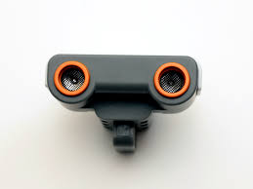
Fig 2.1 Ultrasonic Sensor
The ultrasonic sensor is one of the two sensors that give your robot vision. The Ultrasonic sensors enable the robot to see and detect the objects. You can also use it to make your robot to avoid obstacles, sense and measure distance, and detect movement. The ultrasonic sensor measures distance in centimeters and in inches. It’s able to measure distance from 0 to 255 centimeters with the precision of +/- 3 inches.

The ultrasonic sensors uses the same scientific principle as bats: it measure distance by calculating the time it takes for sound waves to hit an object and return- just like an echo. Large sized objects with hard surface return the best readings. Objects made of soft fabric or those are curved or very thin or small can be difficult for the sensors to detect.

  - MOTORS USED:
Servo motors are used in robot (NXT)
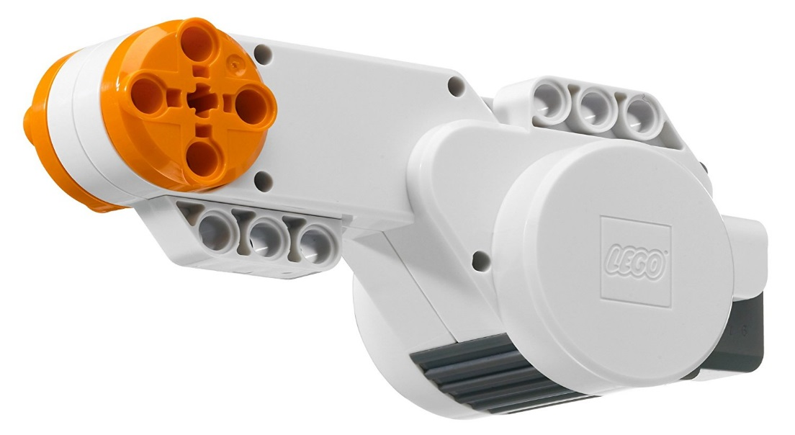
Fig 2.2 Servo motors (NXT)
Each motor has a built in rotation sensor. This lets you to control your robots movement precisely. The rotation sensor measures motor rotations in degrees or full rotation (accuracy of +/- one degree). One rotation is equal to 360 degrees, its output shaft will make half a turn.
DC motors and Servo motors are used in robot (Tetrix)
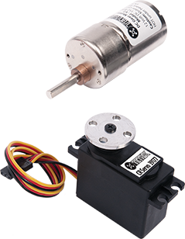
Fig 2.3 DC motor and Servo motor used in Tetrix robot

DC motor provides power for bigger and faster robots and features a head steel alloy to prevent gear stripping. The 180 degree servo is one of the best choices for rugged robotic applications. Their performance and durability are a combination of carbonite gears, high performance circuitry, and a ball bearing- supported output shaft. Standard rotation range is 90 degrees, but it can be operated to 180 degrees.

3. DESIGN OF ROBOT
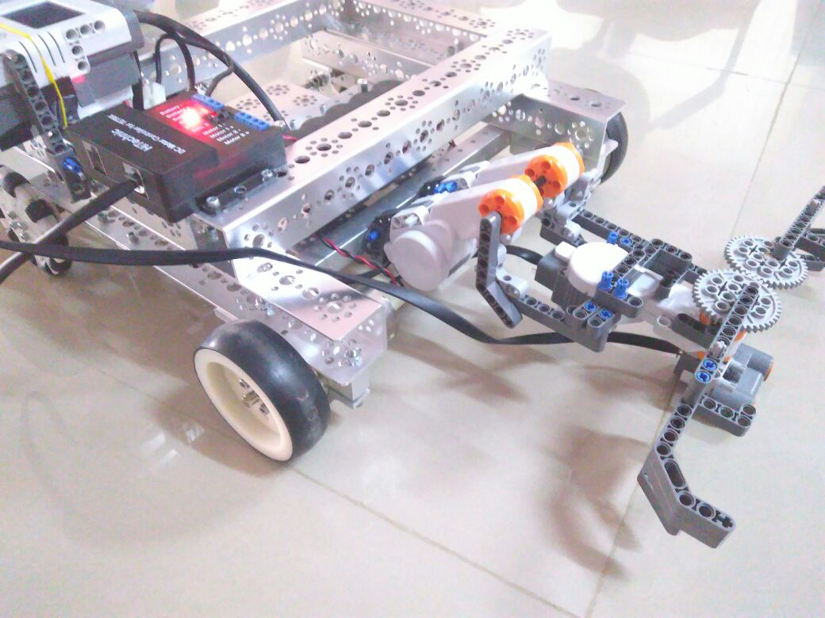

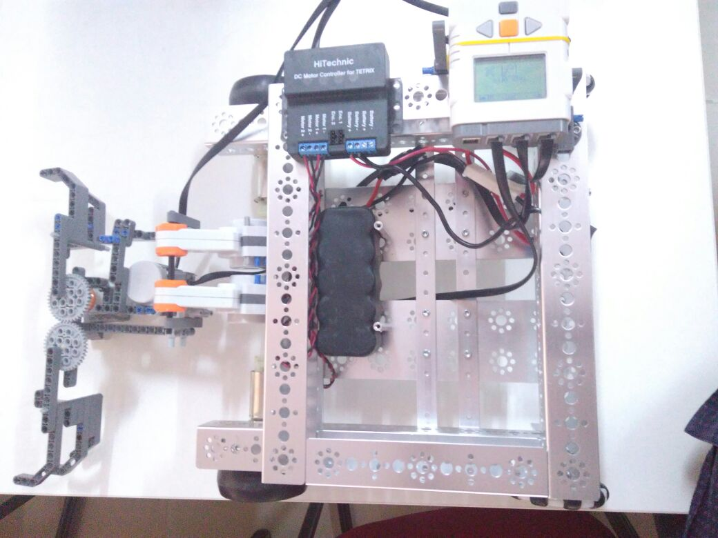

WORKING
STEP1:-The robot senses paper waste in its path using ultrasonic sensor.
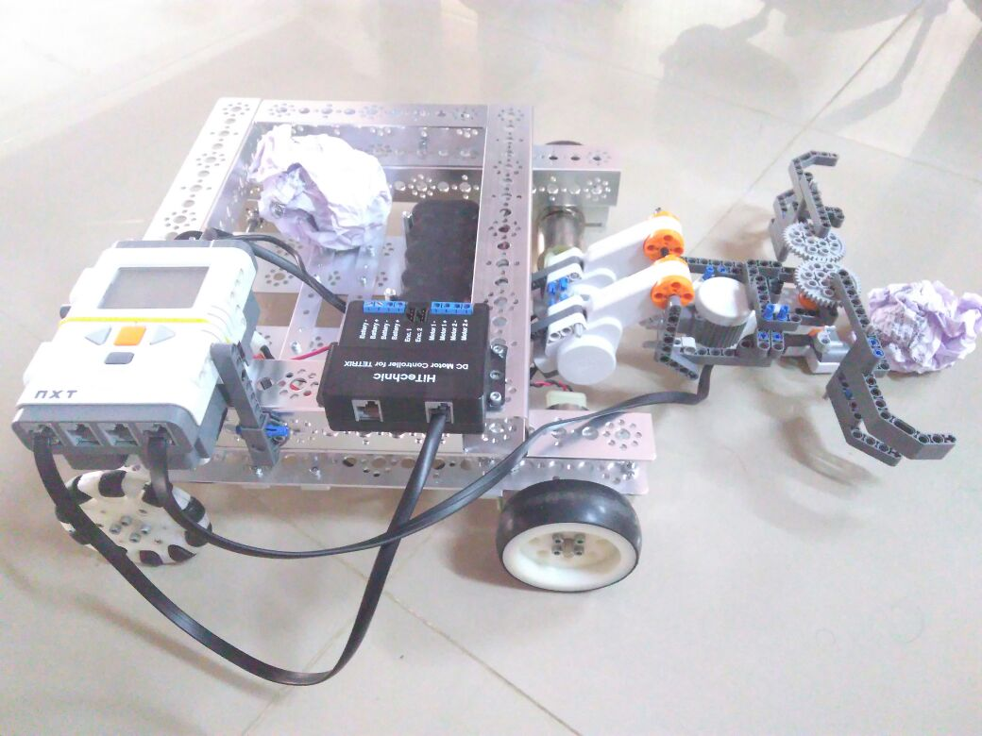

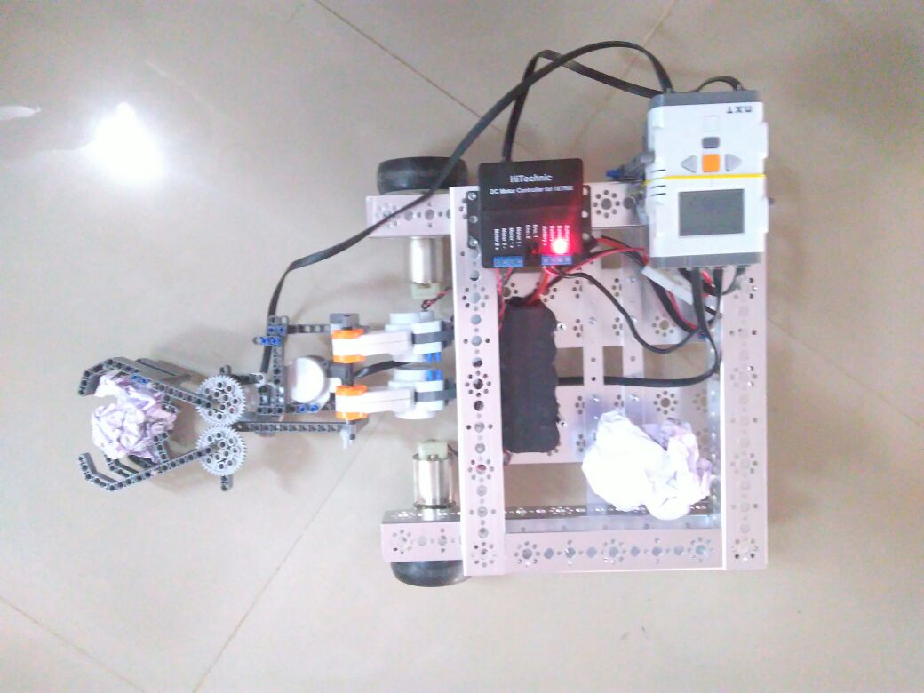
STEP2:- It clamps the garbage in its clamper.

STEP3:-It collects it in the tray behind.
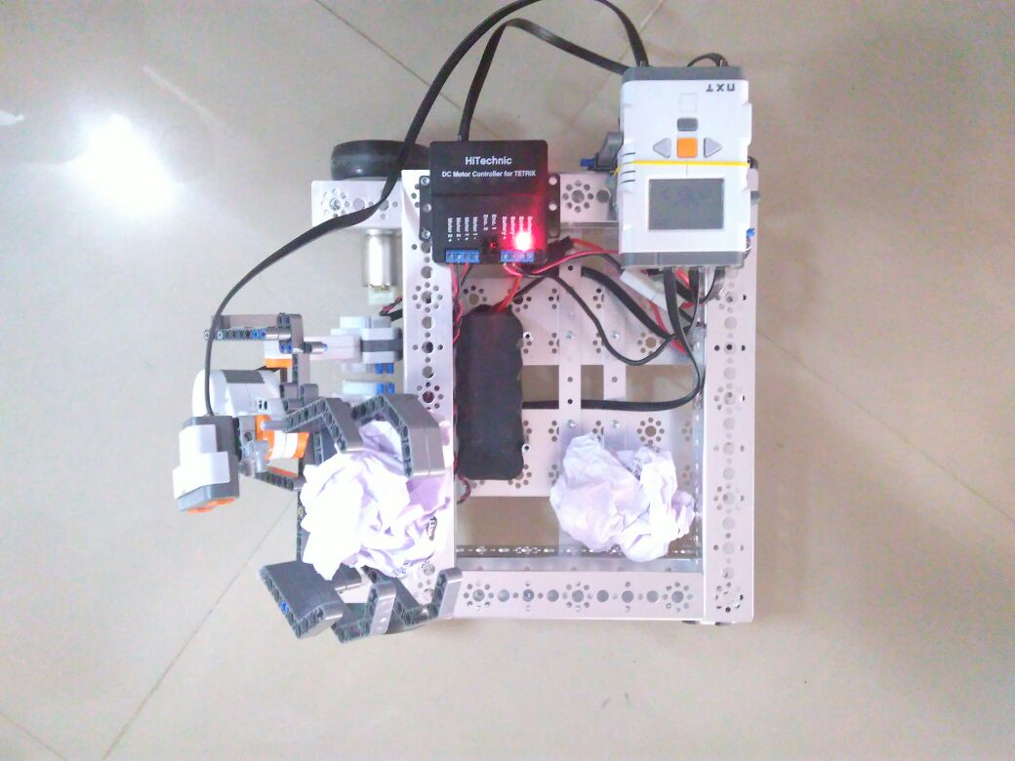

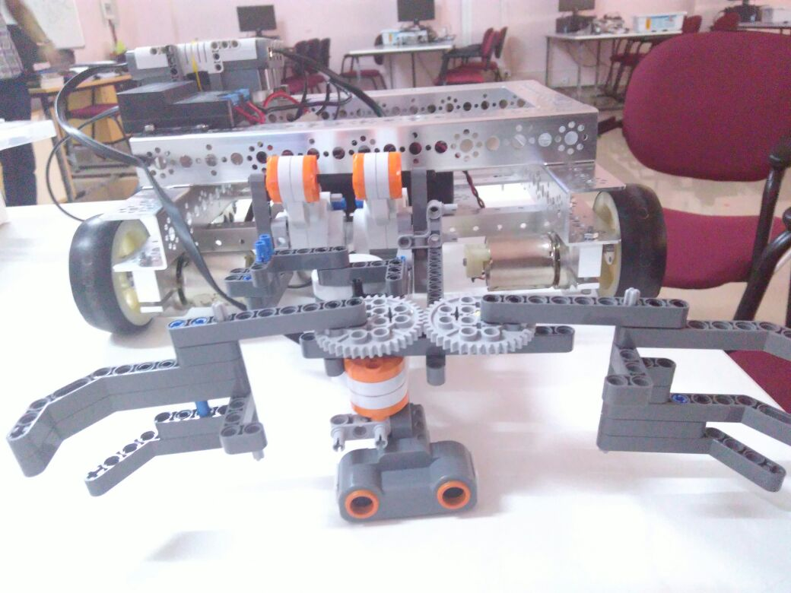
The Clamper

4. SOFTWARE DESCRIPTION

4.1 SOFTWARE REQUIREMENTS:
- Operating System : Windows
- Software : ROBOTC

Extent of ROBOTC function used
- nMotorEncoderfunction is used for making the robot to move particular degrees of rotation of wheel in linear motion.
- When an obstacle is detected ultrasonic sensor will sense and helps the robot to move in a safe path.
- Sensor values function is used for taking the reading from the sensors.
- Wait1Msec function is used for executing a group of commands for a particular period of time.

ALGORITHM:
Step1:START
Step2:[clamp function]
Initialize the names of the motors A and C
Motor A as the master and motor C as its slave
nSyncedMotors=synchAC
nSynchedturnsratio=100
Step3:[Set encoders pulses value to turn clamp and declamp using encoder function]

[for clamping]

nMotorEncoder[B]=0
nMotorEncoderTarget[B]=100
motor[B]=-25

[set time for how long the process should be carried out]
wait1Msec(2000)

[for lifting the motor]

nMotorEncoder[A]=0

nMotorEncoderTarget[A]=155

motor[A]=25

[ whole process of clamping to be carried out changing the values of respective encoders accordingly]

Step4:close clamp function

Step 5: [main function]

Initialise int ;

Step6:for(i=0;I greater than 10; i=i+1)
{

Step7:[while the sensor value detected is greater than 20]
while(SensorValue(sonar)>20)
{
[Power the dc motors]
motor[rightMotor]=5;
motor[leftMotor]=5;
}

motor[rightMotor]=0;
motor[leftMotor]=0;
Step8: clamp function is to be called
Step9: STOP

CODE IMPLEMENTATION

Top of Form
Bottom of Form

#pragma config(Hubs, S1, HTMotor, HTServo, none, none)
#pragma config(Sensor, S1, , sensorI2CMuxController)
#pragma config(Sensor, S4, sonar, sensorSONAR)
#pragma config(Motor, motorA, A, tmotorNXT, PIDControl, encoder)
#pragma config(Motor, motorB, B, tmotorNXT, PIDControl, reversed, encoder)
#pragma config(Motor, motorC, C, tmotorNXT, PIDControl, encoder)
#pragma config(Motor, mtr_S1_C1_1, rightMotor, tmotorTetrix, openLoop, reversed, driveRight, encoder)
#pragma config(Motor, mtr_S1_C1_2, leftMotor, tmotorTetrix, openLoop, driveLeft, encoder)
#pragma config(Servo, srvo_S1_C2_1, servo1, tServoNone)
#pragma config(Servo, srvo_S1_C2_2, servo2, tServoNone)
#pragma config(Servo, srvo_S1_C2_3, servo3, tServoNone)
#pragma config(Servo, srvo_S1_C2_4, servo4, tServoNone)
#pragma config(Servo, srvo_S1_C2_5, servo5, tServoNone)
#pragma config(Servo, srvo_S1_C2_6, servo6, tServoNone)
//*!!Code automatically generated by 'ROBOTC' configuration wizard !!*//
void clamp()
{
nSyncedMotors=synchAC;
nSyncedTurnRatio=100;

nMotorEncoder[B]=0;
nMotorEncoderTarget[B]=100;
motor[B]=-25;
wait1Msec(2000);

nMotorEncoder[A]=0;
nMotorEncoderTarget[A]=155;
motor[A]=25;

wait1Msec(2000);
nMotorEncoder[B]=0;
nMotorEncoderTarget[B]=50;
motor[B]=25;
wait1Msec(1000);

nMotorEncoder[A]=0;
nMotorEncoderTarget[A]=160;
motor[A]=-15;
wait1Msec(2000);

nMotorEncoder[B]=0;
nMotorEncoderTarget[B]=50;
motor[B]=25;
wait1Msec(1000);
}

task main()

{
int i;
for(i=0;i<10;i++)
{

while(SensorValue(sonar)>20)
{
motor[rightMotor]=5;
motor[leftMotor]=5;
}
motor[rightMotor]=0;
motor[leftMotor]=0;
clamp();
}

}

5. INDIVIDUAL ROLE
ANANYA KESARWANI (1NT16EC011)
- making clamping mechanism that picks the trash and puts it in a tray
- connecting the electrical components
SUMEDHA RAGHU (1NT16CS117)
- Programming the robot for the assigned task
- Designing the robot
PAWAN R TANKSALI (1NT16CS070)
- Constructing and coding
- Made the project report
PRAJWAL GOWDA R S (INT16EE057)
- Arranging components
- Helped in alteration of motor speeds

6. CONCLUSION
The robot is designed using Lego’s kit and Tetrix kit and sonar/ultrasonic sensor is attached to it. It is programmed using “ROBOT C” software. The task has been successfully completed by the help of each team member. The implemented code in RobotC for the given problem statements will satisfactorily work. All the features mentioned in the problem statement are included and tested for its execution. The output produced is examined and found to be required output. The program has its own restrictions but it can be easily modified as per changing requirements.

7. BIBLIOGRAPHY

- https://www.google.co.in/
- www.wikipedia.com
- Training Manual Robotics Engineering-Lego Mindstorm and Tetrix.
- www.legomindstorms.com
- www.tetrixrobotics.com

