Data Cleaning and Preprocessing Pipeline for Cosmetic Safety Complaints
Author: Pawan Singh Kapkoti | Programme: Data Science with Python Analyst Internship, YuvaIntern
Sector: Beauty and Wellness | Week 3 | Date: 22 October 2026
Repository: https://github.com/Pawansingh3889/yuvaintern

1. Summary
The pipeline prepares beauty reviews for safety complaint analysis, removing exact copies from the same reviewer while retaining uncertain evidence for inspection. Text transformations, numeric normalisation and sampled language agreement produce documented analysis inputs.
Key measure | Result
Input reviews | 23,911,390
Retained reviews | 23,663,832 (98.96% of input)
Same-reviewer copies removed | 247,558 (1.04% of input)
Short retained bodies | 1,672,732 (7.07%)
Retained rows missing catalogue fields | 1,929,004 (8.15%)
Brief bodies and missing catalogue context remain substantial evidence gaps after cleaning.

2. Potential data quality issues in public beauty and wellness data
Public reviews combine consumer experiences with web formatting, brief opinions, repeated wording and incomplete product descriptions. Cleaning separates representation problems from unusual accounts before annotation. The annotation guideline asks whether the product as received or used caused a physical reaction, spoilage, contamination or a hazardous defect. Delivery, value and efficacy complaints alone are outside that definition.
Retained-row measurements identify 44,736 (0.19%) empty bodies, 2,810,872 (11.88%) bodies repeated across products and 1,929,004 (8.15%) reviews lacking at least one catalogue field. These issues overlap. Counts describe reviews carrying flags, rather than distinct consumers or confirmed complaints. Examples below are constructed, and percentages use the retained population.
Issue | Constructed pattern | Retained measurement
Empty body | No words after formatting removal | 44,736 (0.19%)
Brief body | Works well | 1,672,732 (7.07%)
Repeated wording | Same body under different products | 2,810,872 (11.88%)
Missing product context | Absent store, title or category | 1,929,004 (8.15%)
Schema validation precedes cleaning: required columns must exist, ratings must be integers from 1 to 5, helpful votes non-negative integers, and timestamps parseable epoch milliseconds. Required reviewer and product identifiers must be non-empty strings. Null review titles and bodies are permitted; other non-string text values raise ValueError with field counts. This distinguishes allowed absence from invalid input instead of silently discarding inconvenient records.
The issue table consistently uses retained reviews. The source snapshot is the Beauty and Personal Care category of Amazon Reviews 2023, including its matching product catalogue. This scope supports within-release comparisons; product context comes from the released catalogue rather than from guesses based on review wording. Dataset reference: McAuley Lab, Amazon Reviews 2023, https://amazon-reviews-2023.github.io/.

3. Pipeline flowchart and rationale
Figure 1 shows the logical order. The numbered text underneath preserves the same schematic for readers using text extraction. File-wide grouping makes duplicate and activity decisions independent of chunk boundaries; every step records rows entering, leaving and affected. Only duplicate removal changes the population.
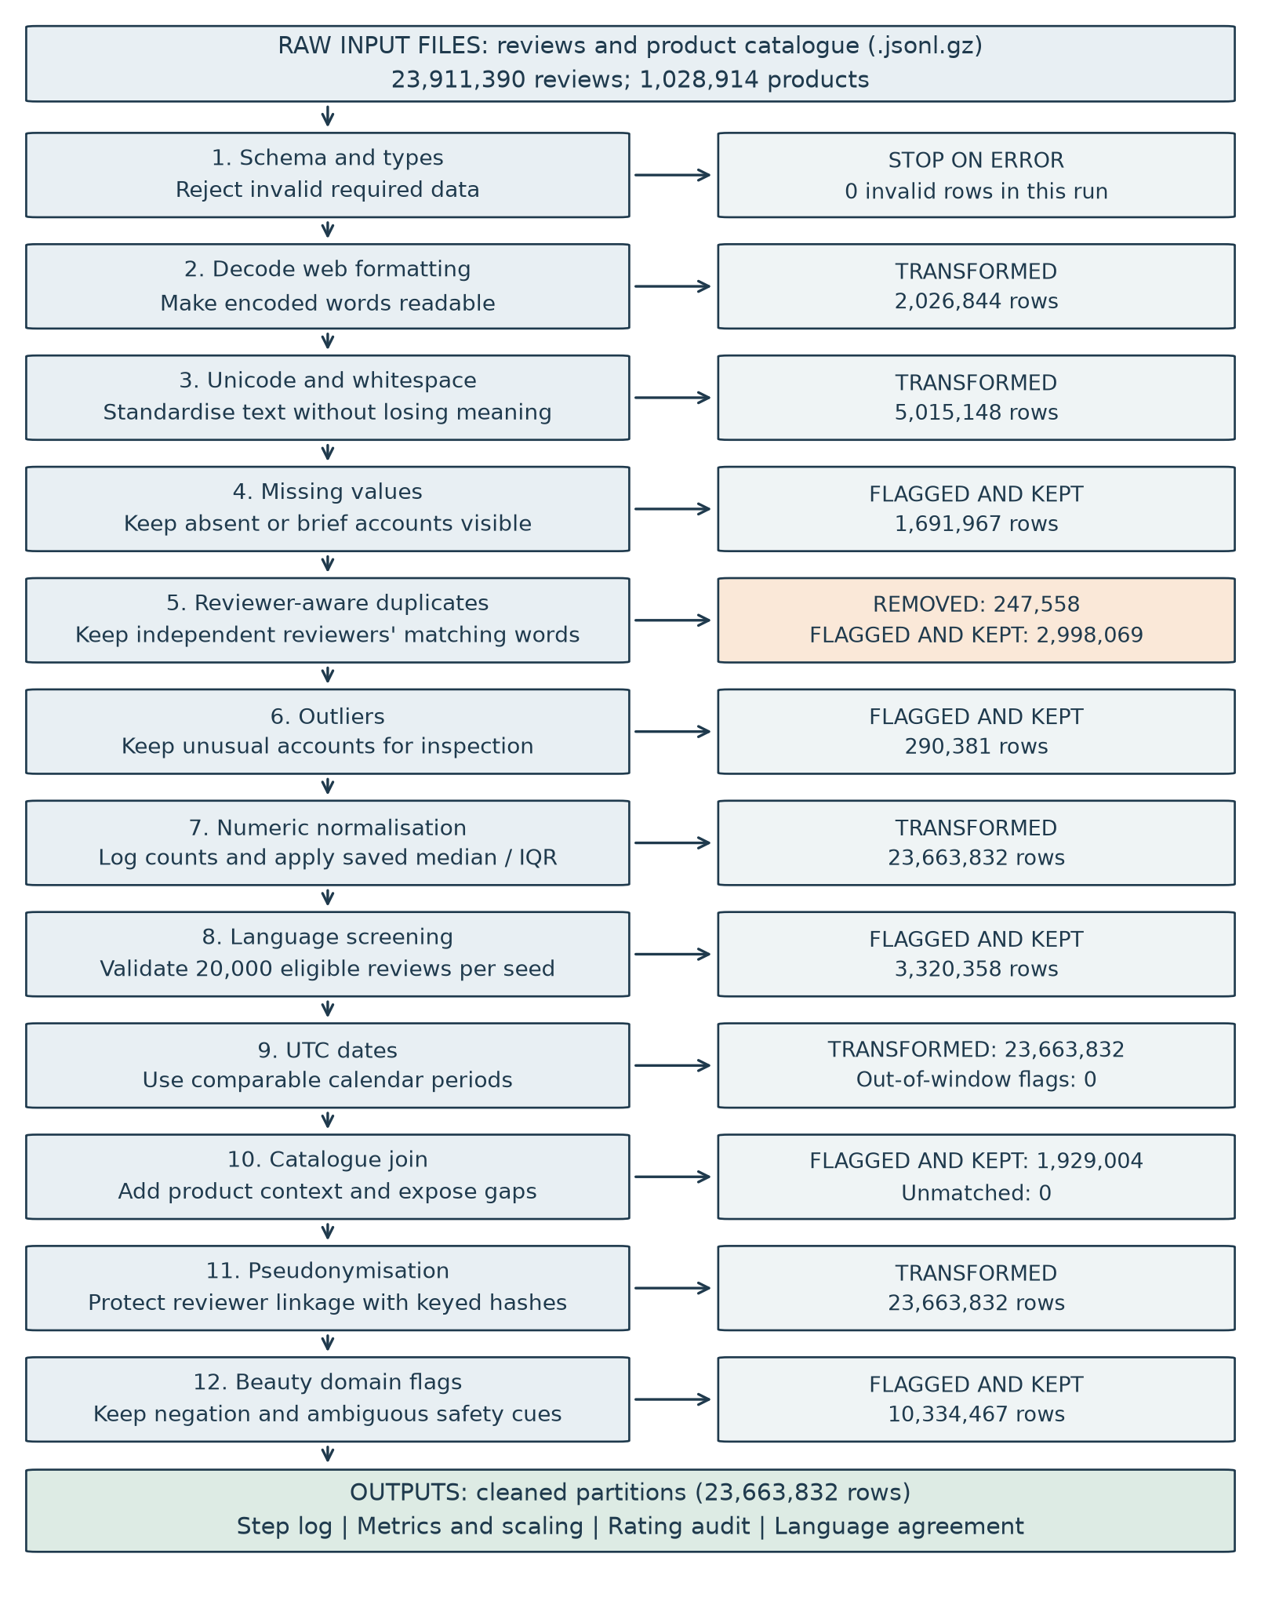
Figure 1. Preprocessing steps, outcomes and rationale. Changed rows and flagged rows are kept unless the exact-copy rule applies.
1. Schema -> validate required fields -> accepted (23,911,390), invalid (0) -> stop on malformed data.
2. HTML -> decode entities and remove interface markers -> changed (2,026,844) -> restore readable wording.
3. Unicode -> NFC and whitespace normalisation -> changed (5,015,148) -> standardise equivalent text.
4. Missing -> mark absent titles and brief bodies -> flagged (1,691,967) -> expose missing evidence.
5. Duplicates -> keep first reviewer/product/title/body tuple -> removed (247,558), retained (23,663,832) -> protect independent opinions.
6. Outliers -> inspect length, votes, activity and dates -> flagged (290,381) -> retain unusual accounts.
7. Numeric -> log counts and robust-scale -> transformed (23,663,832) -> create comparable model features.
8. Language -> screen and validate a stratified sample -> uncertain or likely non-English (3,320,358) -> measure proxy agreement.
9. UTC dates -> derive date, year and quarter -> transformed (23,663,832), outside window (0) -> align calendar periods.
10. Catalogue -> join product context and derive attributes -> missing fields (1,929,004), unmatched (0) -> expose coverage.
11. Pseudonymise -> replace raw reviewer identifiers -> transformed (23,663,832) -> protect linkage.
12. Beauty flags -> preserve negation and mark ambiguous cues -> flagged (10,334,467) -> support contextual interpretation.

4. Handling missing values
Problem: Absent text and brief opinions offer different amounts of evidence. Filling them with invented language would manufacture consumer experiences. Product metadata gaps also need a rule before grouping by store or product category.
Method: Decode null text and titles as empty strings, preserving missing_title. After normalisation, count whitespace-separated words; is_empty means no words and is_short means fewer than three, including empty bodies. Keep all rows. Missing catalogue title, store and category remain null, with catalogue_missing_fields marking any absence. The excerpt assumes missing_title was created during decoding.
df['missing_title'] |= df['title'].eq('')
df['word_count'] = df['text'].str.count(r'\S+').astype('int64')
df['is_empty'] = df['word_count'].eq(0)
df['is_short'] = df['word_count'].lt(3)
Result: 44,736 (0.19%) retained bodies are empty; 1,672,732 (7.07%) are short. Missing review titles number 0. Catalogue gaps affect 1,929,004 (8.15%) retained reviews, even though every product key matches.
In plain terms: An empty space stays marked as empty, and a missing store stays blank. A title-only review remains inspectable. These separate indicators let an analyst select the evidence needed for a particular question without replacing absence with an invented answer.

5. Detecting and treating outliers
Problem: Review length and helpful votes have long tails. Unusual dates or concentrated reviewer activity may also distort comparisons, while automatic deletion could discard detailed descriptions of harm.
Method: Flag log-word counts outside Q1 minus 1.5 IQR to Q3 plus 1.5 IQR, helpful votes above the global 99.9th percentile (95), and at least 10 reviews per reviewer per UTC day. Flag dates outside May 1996 inclusive to October 2023 exclusive. For numeric normalisation, create helpful_log1p and word_count_log1p, then subtract each full-retained median and divide by its IQR. Log1p reduces skew while accepting zero counts. Median/IQR scaling resists extreme tails better than min-max scaling, whose range depends on the largest observation. Save exact fitted parameters in cleaning_metrics.json; a zero IQR uses scale 1 to avoid division by zero without discarding variation.
for source, name in [('helpful_vote', 'helpful'), ('word_count', 'word_count')]:
values = np.log1p(df[source])
df[f'{name}_log1p'] = values
df[f'{name}_robust'] = (values - params[name]['median']) / params[name]['scale']
Result: Log-length bounds are -0.148739 and 6.107163. Length flags affect 23,333 (0.10%), vote flags 23,586 (0.10%), activity flags 245,167 (1.04%), and date flags 0 (0.00%); their union is 290,381. Helpful log median/IQR/scale: 0.000000/0.693147/0.693147. Word-count log median/IQR/scale: 3.044522/1.563976/1.563976. All 23,663,832 retained rows receive both robust features.
In plain terms: A scaled value of zero marks the fitted median. The saved parameters put future counts on the same scale; raw counts remain available for interpretation. Outlier flags bookmark unusual records for inspection, and a strict vote cutoff leaves tied boundary values unflagged. With the fitted helpful parameters, synthetic counts of one and three votes become 1.000000 and 2.000000. The word-count median corresponds to 20 words. Its lower and upper quartiles correspond to 8 and 42 words; the saved IQR is measured after the log transform, not in raw words.

6. Standardising formats and resolving inconsistencies
Problem: Formatting differences conceal copies, while identical wording alone does not establish reviewer identity. Calendar and language representations also need explicit definitions before records can be compared.
Method: Decode entities, replace break tags and video placeholders, apply NFC and collapse whitespace while preserving case and punctuation. Remove only repeated user_id/parent_asin/title/text tuples globally; flag matching product/title/body wording across reviewers and non-empty bodies shared across products. Audit repeated reviewer/variant/timestamp keys separately. Derive UTC periods and validate a many-to-one catalogue join. Language uses ASCII letters divided by Unicode letters and cue counts; letterless text stays unknown. Final likely_non_en requires letters and either ratio below 0.7 or at least 2 other-language cues with fewer than 3 English cues; likely_en requires ratio at least 0.9, at least 2 English cues and no non-English flag. Uniform-priority sampling draws 20,000 retained reviews of at least three words: at least 2,000 per class where available, then proportional allocation. Inverse inclusion weights recover overall precision and recall. DetectorFactory.seed is 0. Poor agreement means likely_en English share below 90%, likely_non_en non-English share below 80%, or weighted recall below 80%.
identity = ['user_id', 'parent_asin', 'title', 'text']
df = df.drop_duplicates(identity, keep='first')
nonempty = letters.gt(0)
nonenglish = nonempty & (
df["ascii_letter_ratio"].lt(thresholds["non_ascii_ratio"])
| (other.ge(thresholds["other_min"]) & english.lt(thresholds["english_max"])))
Result: Decoding changes 2,026,844 input rows; normalisation changes 5,015,148. The old product/title/text rule would remove 328,279 rows, including 82,193 from reviewers other than the first in their group; requiring reviewer identity removes 247,558 and preserves 80,721 independent representatives. Cross-reviewer wording flags 130,416 (0.55%); cross-product wording flags 2,810,872 (11.88%). Repeated keys form 207,189 groups, 2 with different content. Final language flags: 148,280 (0.63%) likely non-English; 3,172,078 (13.40%) unknown. Seed 42, English/non-English shares: likely_en 97.74%/2.26% (n=15,601); likely_non_en 0.10%/99.71% (n=2,078); unknown 55.67%/44.33% (n=2,321). Weighted likely_non_en precision 99.90%, recall 14.98%; 4 undetected. Seed 43, English/non-English shares: likely_en 98.74%/1.26% (n=14,808); likely_non_en 0.29%/99.67% (n=2,093); unknown 75.09%/24.91% (n=3,099). Weighted likely_non_en precision 99.71%, recall 17.77%; 2 undetected. Both samples represent 21,991,100 eligible reviews; undetected reference outputs are excluded from precision and recall.
In plain terms: Removal requires the same reviewer, product, title and text, so a genuine repeat purchase review with any changed word is kept; an identical re-post by the same person on the same product is treated as a double post, and comparing raw versus cleaned 1-to-5-star shares (11.881%/5.332%/7.176%/10.942%/64.669% versus 11.863%/5.333%/7.181%/10.948%/64.675%) shows each rating share changes by less than 0.02 percentage points. The likely_non_en flag is precise (99.71%) but misses most non-English text (recall 17.77%), so it is used only to exclude confidently non-English rows from an analysis subset; any language-sensitive analysis must run langdetect on its own subset, and a 200-review bilingual human check of the unknown class would confirm the error rates.

7. Beauty-specific innovations
Problem: A safety word may describe reassurance, memory or a return deadline. Size and shade variations can also obscure product matching. Cleaning these distinctions away would change what consumers appear to report.
Method: Preserve no, not, never, without and contracted negation. The synthetic encoding &#34;no irritation&#34; becomes readable quotation marks with no retained. Apply these case-insensitive patterns to the combined title and body without rewriting either; adjacent raw strings below form one regex.
RECALL_FRIEND = (
r"(?i)\b(?:(?:i|we|can|cannot|can't|don't|not)\s+"
r"(?:can\s+|quite\s+|really\s+)?recall|recall(?:ed)?"
r"\s+(?:using|buying|having|when|the last))\b")
RECALL_FRIEND marks memory contexts, including I recall, cannot recall and recalled buying; it flags ambiguity rather than proving the absence of a product recall.
EXPIRED_FRIEND = (
r"(?i)\b(?:return|refund|returning)\b.{0,50}\bexpir(?:ed|es|y)\b"
r"|\bexpir(?:ed|es|y)\b.{0,50}\b(?:return|refund|returning)\b")
EXPIRED_FRIEND marks expired, expires or expiry within 50 intervening non-newline characters of return, refund or returning, in either order.
text = df['title'] + ' ' + df['text']
df['has_negation'] = text.str.contains(NEGATION, regex=True)
df['recall_false_friend'] = text.str.contains(RECALL_FRIEND, regex=True)
df['expired_return_window'] = text.str.contains(EXPIRED_FRIEND, regex=True)
size = titles.str.extract(
r"(?i)\b(\d+(?:\.\d+)?)\s*"
r"(ml|millilit(?:er|re)s?|fl\.?\s*oz\.?|fluid ounces?|g|grams?)\b")
The quantity regex keeps only the first supported number/unit match from left to right, even in bundles or titles containing both mass and volume; later matches are ignored. US fluid ounce = 29.5735295625 ml; only explicit fl oz or fluid ounce(s) matches are converted. Plain oz without fl denotes weight but is not matched, converted or stored as grams; a later supported quantity can therefore be selected. Millilitres populate quantity_ml directly, and grams populate quantity_g separately, without a mass-to-volume conversion.
df["shade"] = titles.str.extract(
r"(?i)\bshade\s*[:#-]?\s*([\w]+(?:\s+[\w]+)?)",
expand=False).str.casefold()
The shade rule finds the first shade marker with an optional colon, hash or hyphen, captures up to two following word tokens and casefolds those tokens; implicit colour names are not inferred. Quantity and shade extraction use decoded, NFC-normalised, whitespace-collapsed catalogue titles, with original titles retained for inspection.
Result: Negation cues occur in 10,333,674 (43.67%); recall false friends in 2,776 (0.01%); return-window expiry cues in 2,424 (0.01%). Size information is available for 3,888,747 (16.43%) retained review rows and explicit shades for 92,555 (0.39%). These availability counts are review-weighted, rather than distinct products.
In plain terms: Keep the meaning of a reassurance and distinguish remembering a purchase from announcing a recall. Product attributes support candidate matching: explicit volume can be compared after unit conversion, while a gram quantity stays a mass. Original titles remain available to inspect the extracted value in context. For the synthetic title Serum 1 fl oz / 50 ml, quantity_ml is 29.5735295625, not 50. Cream 2 oz / 50 g yields quantity_g of 50 because plain oz is skipped. Cream 2 oz alone leaves both quantity fields missing. These examples expose the first-match limit without inferring package totals, density or equivalence between products.

8. Python libraries and why they are suitable
Vectorised DataFrame functions keep the workflow local and inspectable. SQLite supports grouping across chunks on disk; matplotlib renders aggregate figures. CSV gzip provides an output fallback when pyarrow is unavailable.
Library | Why suitable
pandas 3.0.3 | Chunk iteration, tabular checks, joins and dates
NumPy 2.4.6 | Vectorised transforms and global quantiles
html, unicodedata, regex | Standard decoding and explicit text rules
hashlib, hmac | Fingerprints and protected identifier linkage
pytest, pyarrow | Offline verification and typed output
langdetect 1.0.9 | Seeded reference inference on the validation samples
The excerpt shows the streaming interface and initial transformations, not the complete pipeline. Chunk-local grouping would miss distant repetitions, so global rules are fitted before final partitions are written. Exact integer frequency histograms recover quantiles without retaining all numeric values in RAM.
chunks = pd.read_json(path, lines=True, chunksize=100000)
for chunk in chunks:
chunk = flag_missing(normalise_text(decode_html(validate_schema(chunk))))
Library references: pandas read_json, https://pandas.pydata.org/docs/reference/api/pandas.read_json.html; NumPy log1p, https://numpy.org/doc/stable/reference/generated/numpy.log1p.html; Python hmac, https://docs.python.org/3/library/hmac.html; langdetect seed guidance, https://github.com/Mimino666/langdetect. Scaling rationale: scikit-learn RobustScaler documentation, https://scikit-learn.org/stable/modules/generated/sklearn.preprocessing.RobustScaler.html.

9. Documentation and reproducibility
src/cleaning.py implements the steps; tests/test_cleaning.py checks them. The completed normal module run uses chunks of 100,000 and writes parquet partitions under data/processed/cleaned/. cleaning_log.csv supplies the table below. cleaning_metrics.json saves scaling, thresholds, versions, input fingerprints and validation summaries; cleaning_flag_by_rating.csv records removal and retained-flag denominators. language_validation.csv contains aggregate reference outcomes without sampled wording.
Step | Rows in | Rows out | Affected
schema | 23,911,390 | 23,911,390 | 0
decode_html | 23,911,390 | 23,911,390 | 2,026,844
normalise | 23,911,390 | 23,911,390 | 5,015,148
missing | 23,911,390 | 23,911,390 | 1,691,967
duplicates | 23,911,390 | 23,663,832 | 3,245,627
outliers | 23,663,832 | 23,663,832 | 290,381
numeric_normalisation | 23,663,832 | 23,663,832 | 23,663,832
language | 23,663,832 | 23,663,832 | 3,320,358
utc_dates | 23,663,832 | 23,663,832 | 0
catalogue | 23,663,832 | 23,663,832 | 1,929,004
pseudonymise | 23,663,832 | 23,663,832 | 23,663,832
domain_flags | 23,663,832 | 23,663,832 | 10,334,467
Affected counts changed text at decoding and normalisation, issue unions at flagging stages, and every transformed row at numeric scaling and pseudonymisation. Duplicates includes removed copies plus retained repetition flags. UTC counts out-of-window flags although all retained rows gain dates. Input-stage counts include rows later removed; final flag totals use retained rows.
The synthetic suite checks every cleaning step, including independent reviewers sharing wording, same-reviewer copies, robust scaling and constant features, weighted stratified sampling, detector failures and the one-adjustment path. Integration checks compare three chunk sizes and both output formats, verifying global medians, identity audits and final language flags. The completed check reports 20 passed; Ruff reports all checks passed. Commands from the repository root:
/opt/anaconda3/bin/python -m pytest tests/
/opt/anaconda3/bin/ruff check src tests
A fresh salt is generated per run in CLEANING_SALT and is not stored, so pseudonyms are deliberately not reproducible across runs, preventing linkage of published outputs to accounts; all counts and aggregates are reproducible because they do not depend on it.
Before the module command, set CLEANING_SALT to a fresh private secret of at least 32 characters. Preserve input order, fingerprints and pinned requirements.txt to reproduce aggregates. Sampling uses seeds 42 and 43, with reference detector seed 0. Original gzip files remain untouched, and existing cleaned output causes an error rather than an overwrite.
/opt/anaconda3/bin/python -m src.cleaning \
data/raw/amazon_reviews_2023/Beauty_and_Personal_Care.jsonl.gz \
data/processed_repeat --chunksize 100000
The Week 3 notebook reads saved evidence, displays validation and scaling parameters, and draws Figure 2 from aggregates without accessing individual review wording.
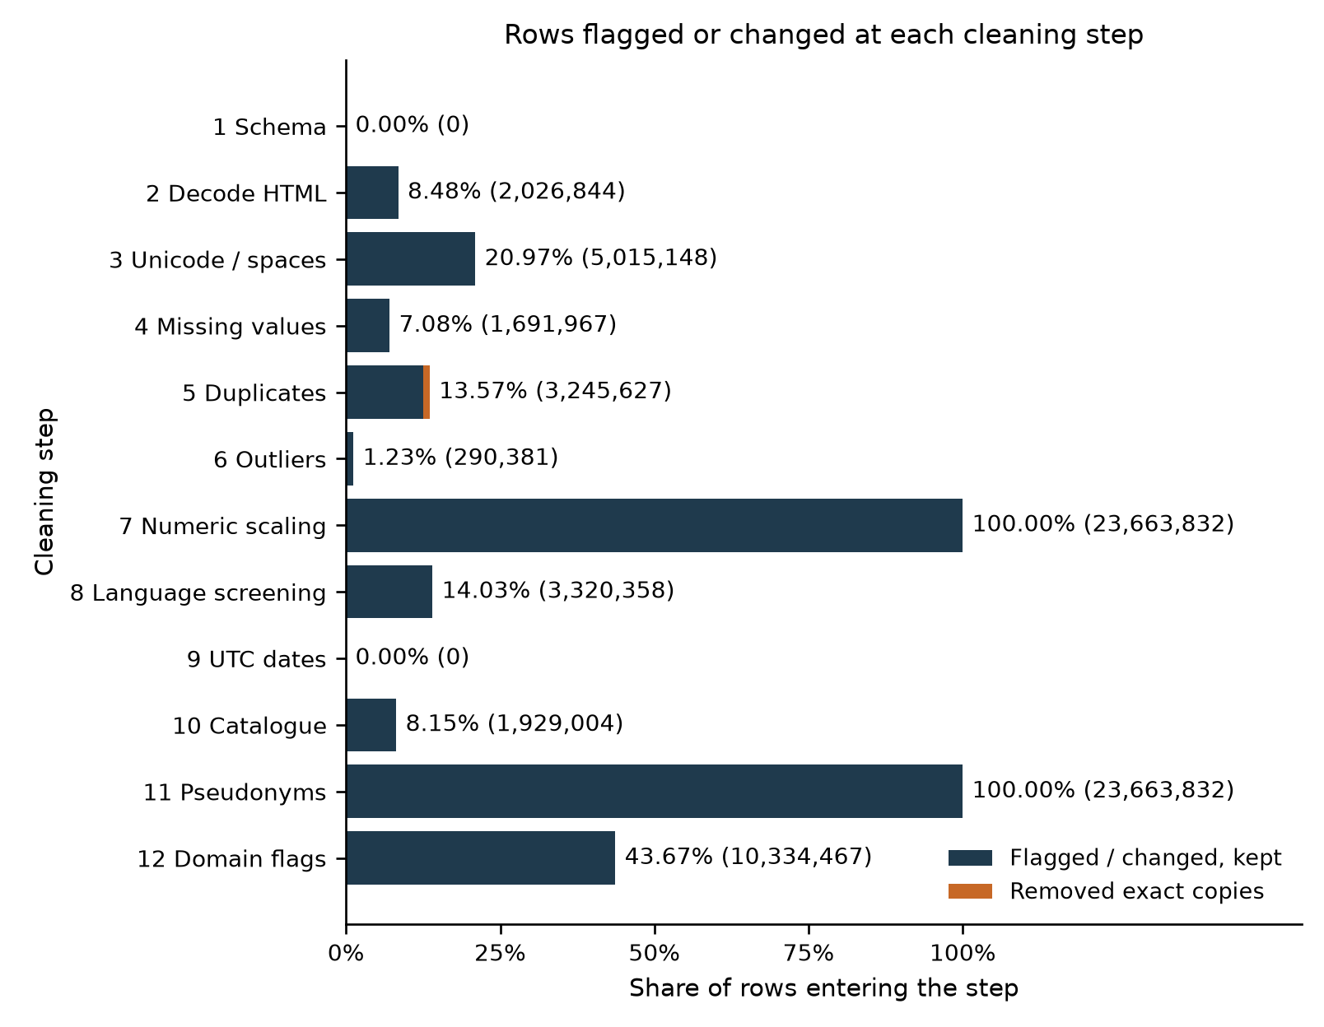
Figure 2. Affected share of each step's input. Orange shows removed exact copies; blue shows changed or flagged rows kept. Percentages describe overlapping operations, not complaint prevalence.

10. How the cleaned data enhances analysis and modelling
The cleaned fields make the original hypotheses testable; no hypothesis test or model performance is claimed here.
H1: Readable text, negation and missingness flags support annotator agreement checks without confusing formatting errors with label disagreements.
H2: Normalised text and scaled numeric features support classifier versus keyword comparisons; product keys and repeated-wording flags support split audits.
H3: Negation and false-friend flags make weak-rule coverage and errors measurable against independent human labels.
H4: UTC dates, product keys and retained review denominators support pre-recall complaint-rate comparisons with Wilson intervals.
H5: Catalogue title, store, quantity_ml, quantity_g and shade support proposed product links and explicit failure strata.
Week 4 will inspect rating-wise flags, numeric distributions, language agreement and catalogue coverage, then compare labelled outcomes for H1 to H5. Each chart will state its denominator and show sensitivity slices alongside the full retained population.

11. Ethics and limitations
- Privacy -> Replace user_id with secret-key HMAC-SHA256 and remove the raw identifier from output. Plain hashes permit candidate-ID guessing; pseudonyms still permit linkage. Restrict local access, keep the salt outside source control and publish only synthetic examples and aggregates.
- Selection bias -> Retain brief and language-uncertain accounts rather than excluding less represented voices. One-star/five-star shares are 3.13%/8.84% for short text and 0.70%/0.64% for likely_non_en. Same-reviewer removal shares are 1.18%/1.03% before deduplication. Use the complete rating audit for sensitivity checks.
- Fairness -> A quality flag is not a verdict about a brand or reviewer. Require contextual human labels, verified product links and uncertainty before product-level claims; self-reported reactions do not establish clinical causation.
- Licence and consent -> Maintainers assign no blanket licence and describe research use. Redistribute no consumer wording; minimise fields, avoid contacting reviewers and share code and aggregates. Public posting is not consent to every secondary use. Source: McAuley Lab licence clarification, https://huggingface.co/datasets/McAuley-Lab/Amazon-Reviews-2023/discussions/1.
- Leakage -> Keep human evaluation independent of rule-made labels, hide rating and product identity during annotation, and audit shared wording across product splits. Full-retained scaling serves this descriptive release; refit parameters on training data before prospective model evaluation.
Limitations
- Language: langdetect is a reference detector, not ground truth. The sample excludes bodies under three words; mixed-language and dialect errors require human validation before exclusions.
- Identity: the same account can genuinely repeat wording after another purchase; the key ignores purchase time, so compare raw and cleaned results.
- Attributes: bundles, implicit shades and cross-market equivalence require manual checking beyond the narrow title patterns.
- Labels: scarce independent human decisions constrain confidence in modelling comparisons; weak labels cannot supply that missing evidence.

12. Conclusion
Reviewer-aware grouping preserves independent accounts, and numeric features use saved parameters. Language-sensitive analysis requires subset detection and human validation alongside contextual text flags, UTC dates and catalogue attributes. Source code, tests and aggregate records keep the process reviewable and its limits explicit.

