Exploratory Data Analysis and Feature Engineering for Cosmetic Safety Complaints
Pawan Singh Kapkoti | Data Science with Python Analyst Internship | YuvaIntern
Beauty and Wellness | Week 4 | 23 October 2026

1. Summary
The analysis covers 23,663,832 preprocessed beauty and personal care reviews.
Safety-word matches, including standalone burn wording, support contextual triage while complaint status requires human assessment.
Eight feature families connect wording, ratings, earlier behavior and product context to investigation questions.
Chronological histories preserve earlier context; undated catalogue attributes remain descriptive.
Sections 11 and 12 address ethics and a concrete decision scenario for a brand safety team.

2. EDA workflow: basic and advanced techniques for multi-dimensional data
Step 1: data quality check. Missing means null or blank after trimming. Rating has 0 missing values (0.00%), title 0 (0.00%), text 44,736 (0.19%) and timestamp 0 (0.00%). Empty bodies remain in rating denominators but supply no body wording. Category has 582,382 missing values (2.46%), exact snapshot price 7,093,166 (29.97%) and store 1,351,299 (5.71%). Category and store comparisons keep missing groups; price-tier comparisons exclude unavailable prices and starting-price strings. Across partitions, 0 excess exact copies remain on reviewer, parent product, normalized title and normalized text, so repeated copies do not inflate rates. Ratings outside one to five number 0, timestamps outside May 1996 inclusive to October 2023 exclusive number 0, and negative helpful votes number 0; these checks support valid rating, time and vote comparisons. Catalogue coverage is 100.00%: every parent product matches a catalogue row, although individual attributes can still be absent.
The objective is to uncover interpretable patterns in beauty feedback and propose variables that could improve complaint modeling. The unit of analysis is a retained review, not a person, purchase or adverse event. The source is the Amazon Reviews 2023 Beauty and Personal Care snapshot with its released catalogue. The analytical question is whether wording, rating and available context together can help people find accounts that deserve investigation.
Step 2: distributions and denominators: how are rating, length, votes, missingness and cue presence distributed? Stream counts across all 240 cleaned partitions with explicit denominators to identify skew and coverage gaps.
Step 3: within-group associations: do rating and polarity associations hold within length groups and product cohorts? Plan stratified counts and effect sizes before retaining these associations as candidate signals.
Step 4: category changes over time: does changing product mix explain category-year cue shifts? Use the measured category-year counts to plan comparisons of continuing and newly observed products, separating mix from within-cohort change.
Step 5: price differences: do cue shares differ within category and rating? Plan matched comparisons using exact snapshot prices only, reporting excluded missing and starting-price coverage.
Step 6: candidate selection: which findings suggest useful features? Select candidates from these comparisons and test their contribution through the Section 9 ablations.
Pairwise calculations use a uniform random-priority reservoir of 40,000 reviews with seed 42. Text projection independently samples 20,000 cue reviews with seed 43; this enriched sample cannot estimate population prevalence. Saved aggregates omit source text and reviewer identifiers.

3. Statistical methods
A chi-square test asks whether cue presence and star rating are independent in the population contingency table. It suits categorical counts and avoids treating the stars as a continuous clinical scale. The result is chi-square 190786.7 with 4 degrees of freedom, p below 1e-300; the smallest expected cell count is 43586.4. Cramer's V is 0.090, indicating a small relationship despite the extremely small p-value.
Mann-Whitney U compares length ranks because bodies have a long tail. In the uniform sample, 1,377 cue reviews have median 50 words, versus 38,623 other reviews with median 20. U is 39,674,637, p 4.69e-212; rank-biserial correlation is 0.492, supporting length as context. Repeated products and reviewers break independence, so this inference and the Wilson intervals below are nominal; a product-clustered sensitivity check is next.
Wilson intervals describe binomial uncertainty in cue proportions, including sparse periods; empty months have no estimated rate. Pool calendar months across years for seasonality and retain category-year cells to inspect changing product mix.
Spearman correlation compares numeric feature ranks and exposes monotonic dependence without assuming normal data. TruncatedSVD reduces sparse TF-IDF text to a planar view; it is appropriate for a vocabulary much larger than the number of plotted coordinates. Point-biserial correlation compares each numeric or Boolean feature with a binary proxy.

4. Visualization plan and findings
Matplotlib supplies labeled bars, weighted histograms, line charts, interval shading and scatter plots. Seaborn renders the annotated correlation heatmap, with a Matplotlib fallback when unavailable; SciPy supplies uncertainty bounds and statistical results. Figures read saved aggregates, so their populations and denominators match the text. Length and helpful-vote histograms use log1p-transformed counts, so zero values remain visible.
Figure 1. Basic review distributions
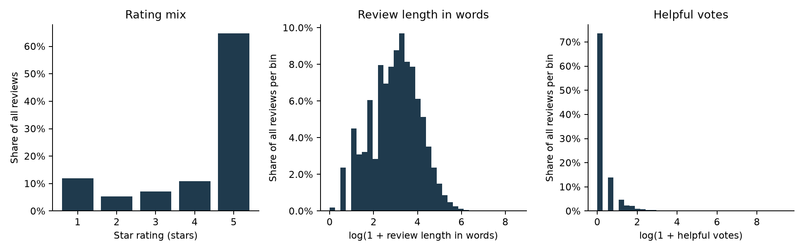
Five-star ratings account for 64.67% of reviews; median body length is 20 words and its ninety-fifth percentile is 108 words. Helpful votes are zero for 73.51% of reviews. The skewed distributions support log scaling, but cannot establish complaint severity.
Figure 2. Rating and negation context
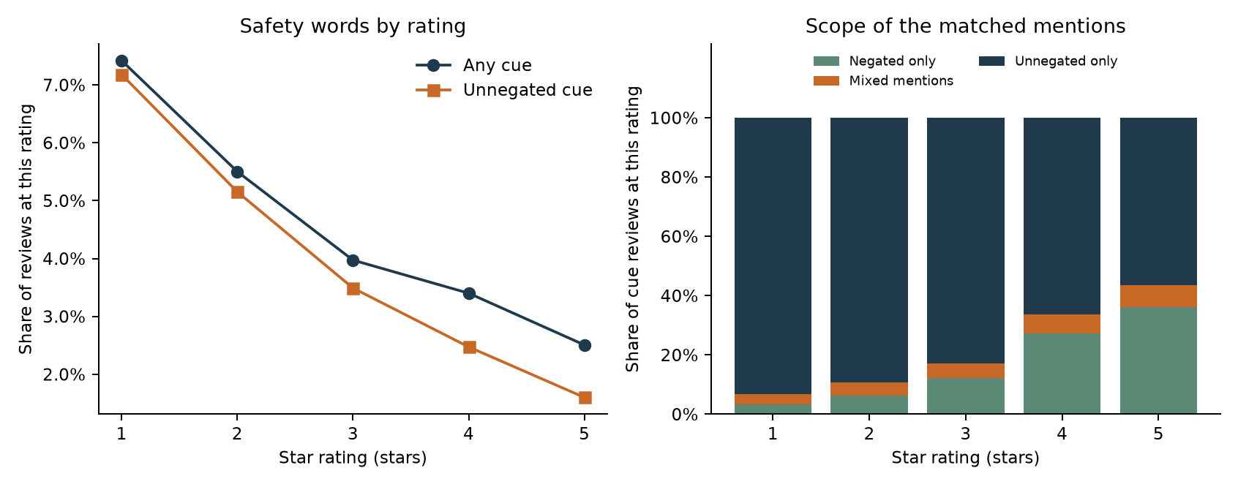
Any-cue rates are 7.42% for one-star reviews and 2.51% for five-star reviews; negated-only wording comprises 36.14% of five-star cue reviews. The raw and scoped bars support retaining polarity and rating context, but cannot identify genuine complaints.
Figure 3. Safety-word group rates
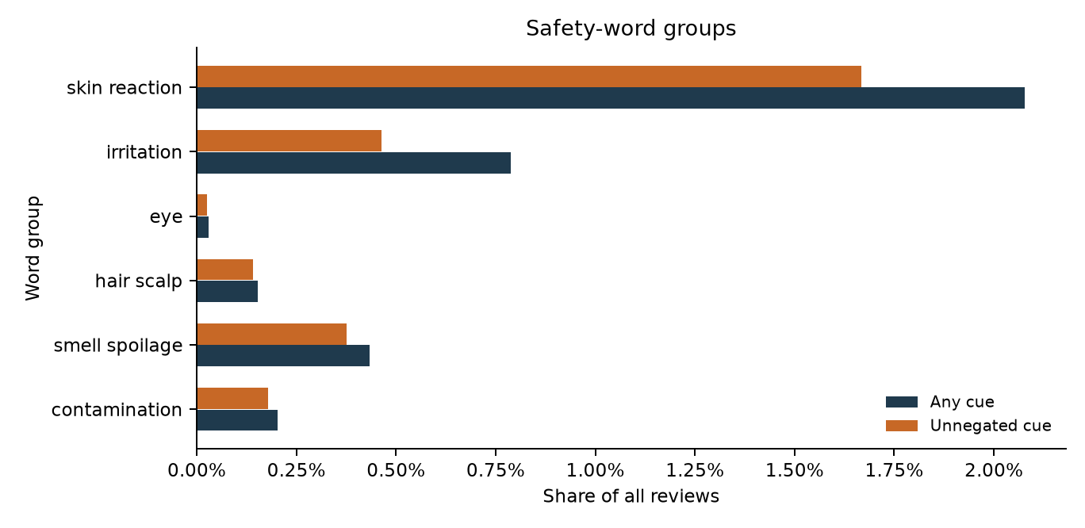
The largest raw-cue bars are skin reaction at 2.08%, irritation at 0.79% and smell or spoilage at 0.43% of all reviews; groups overlap and must not be added. Their differing shares support topic-specific review routing, but cannot establish defect types without adjudication.
Figure 4. Main-category context
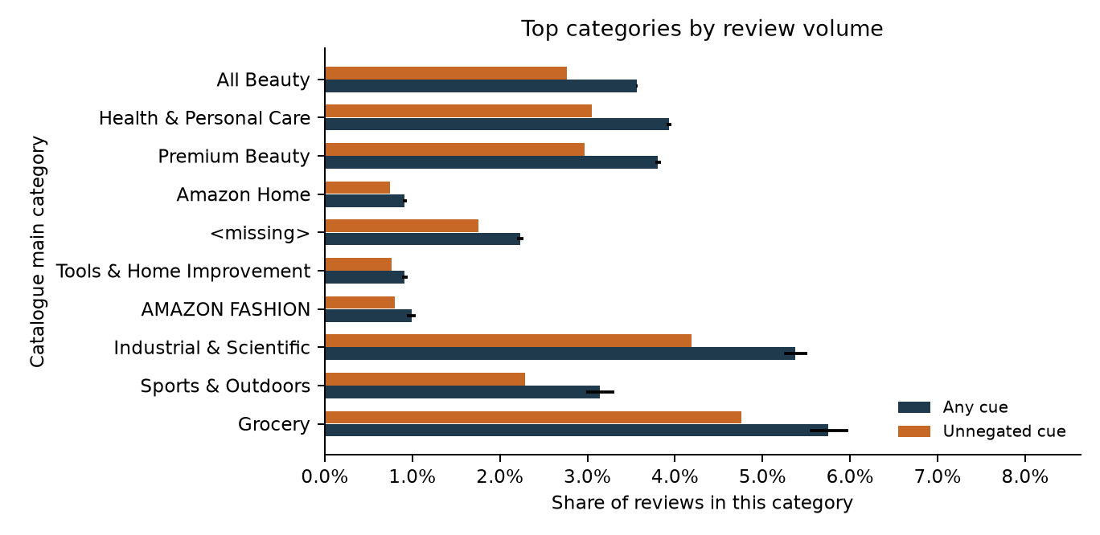
For the largest categories by volume, raw-cue bars show All Beauty 3.56%, Health & Personal Care 3.93%, Premium Beauty 3.81%; paired bars show unnegated shares with Wilson intervals on raw rates. Category variation supports composition checks before routing, but cannot establish relative product safety.
Figure 5. Monthly volume and uncertainty
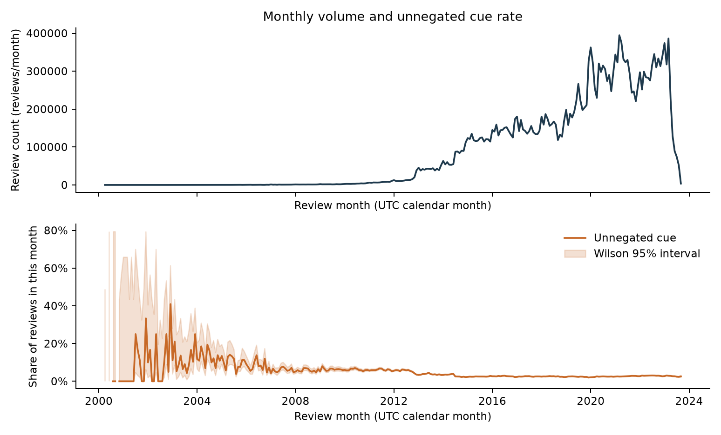
Review volume peaks in 2021-03 at 394,608 reviews. In 2023-09, the unnegated-cue rate is 2.56% with a Wilson interval of 2.09% to 3.13%; observation ends on 2023-09-13, making that month incomplete. The volume and rate panels support historical workload planning, but cannot establish a trend from the partial final month.
Figure 6. Numeric feature relationships
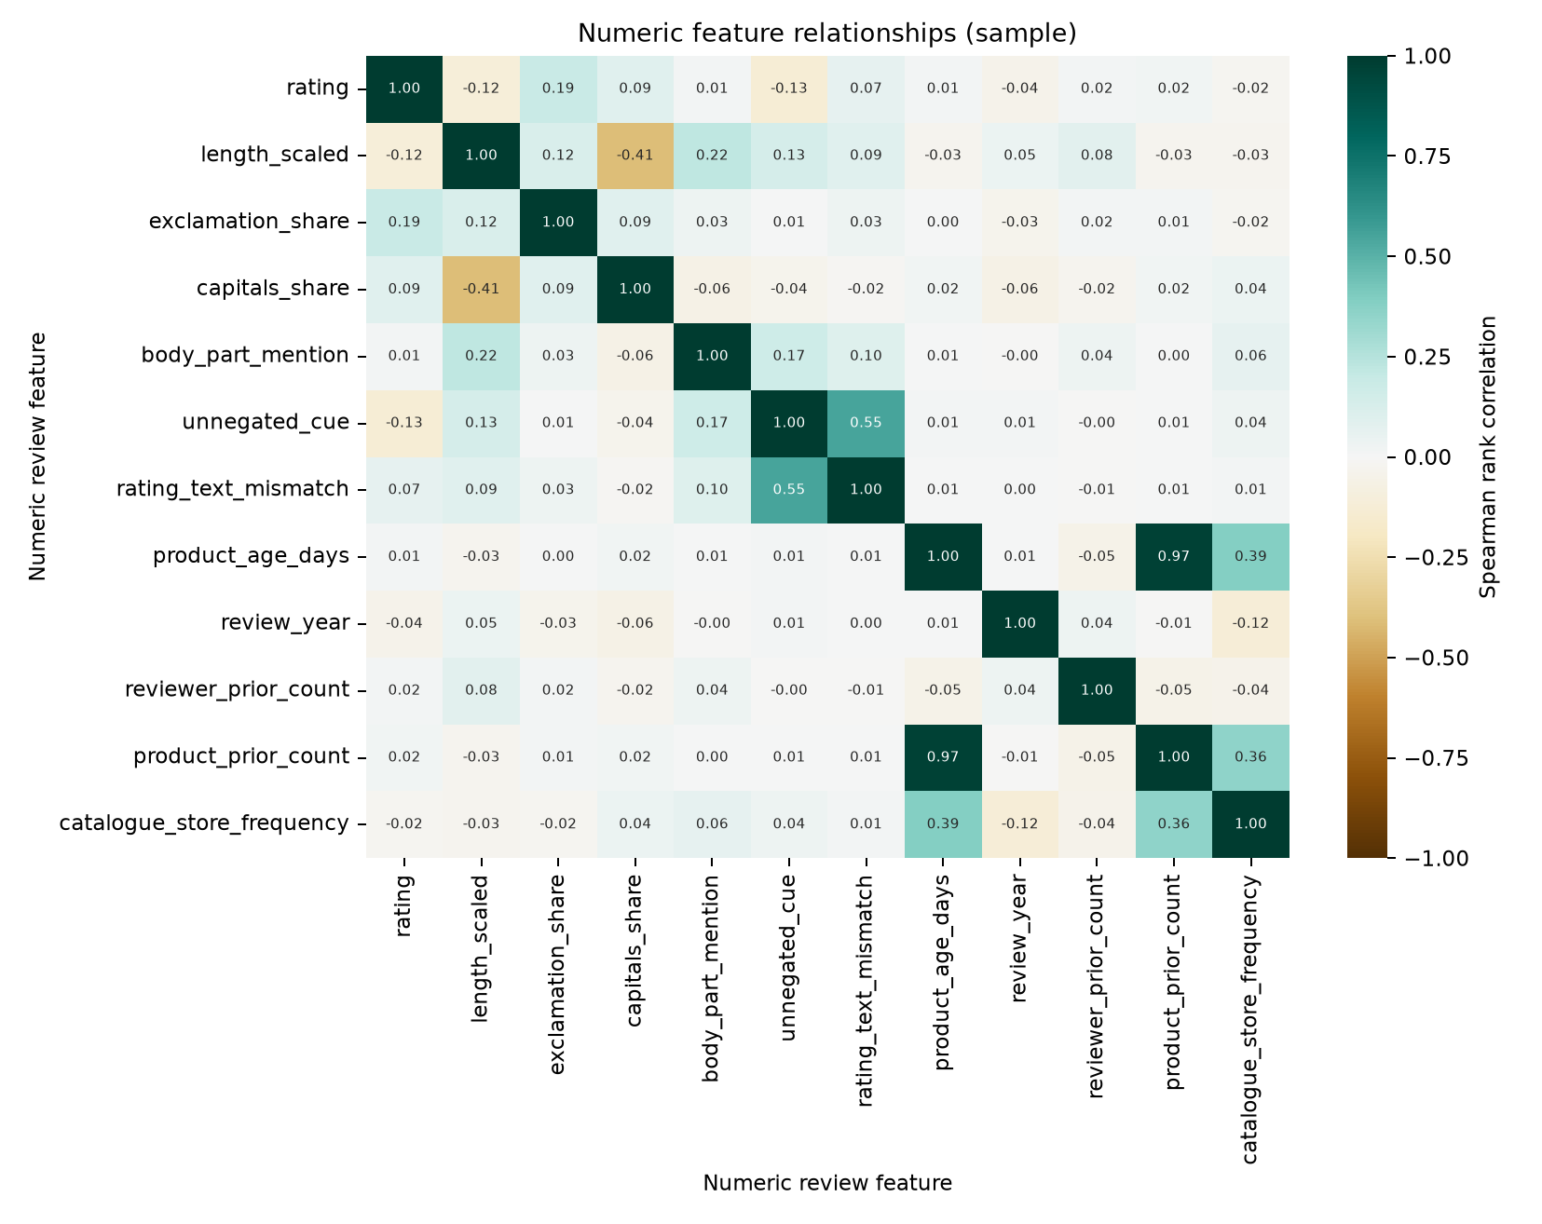
The strongest absolute off-diagonal Spearman relationship is between product_age_days and product_prior_count, with coefficient 0.972. This redundancy supports avoiding repeated evidence in explanations, but cannot establish which features improve predictions.
Figure 7. Multi-dimensional text projection
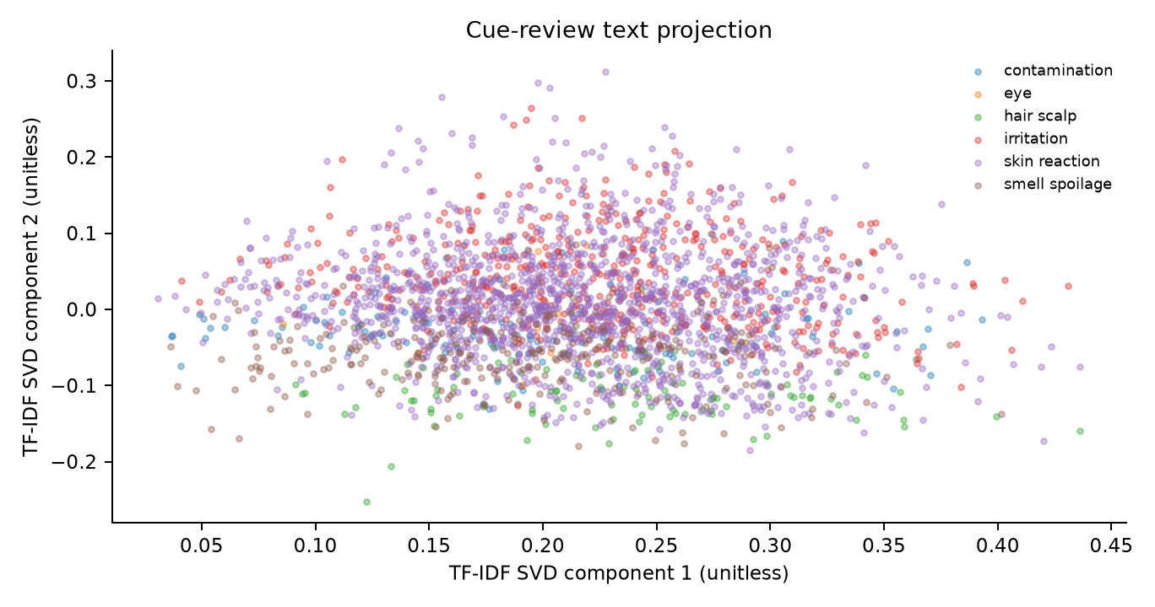
The two-component TF-IDF projection retains 1.12% of variance, with overlapping word groups and no distinct segments shown. Euclidean silhouette is -0.1227; each review receives its largest raw-match-count group, with ties resolved by code order. This overlap supports keeping interpretable word-group features as candidates, but cannot establish customer segments or predictive accuracy.
Figure 8. Engineered feature associations
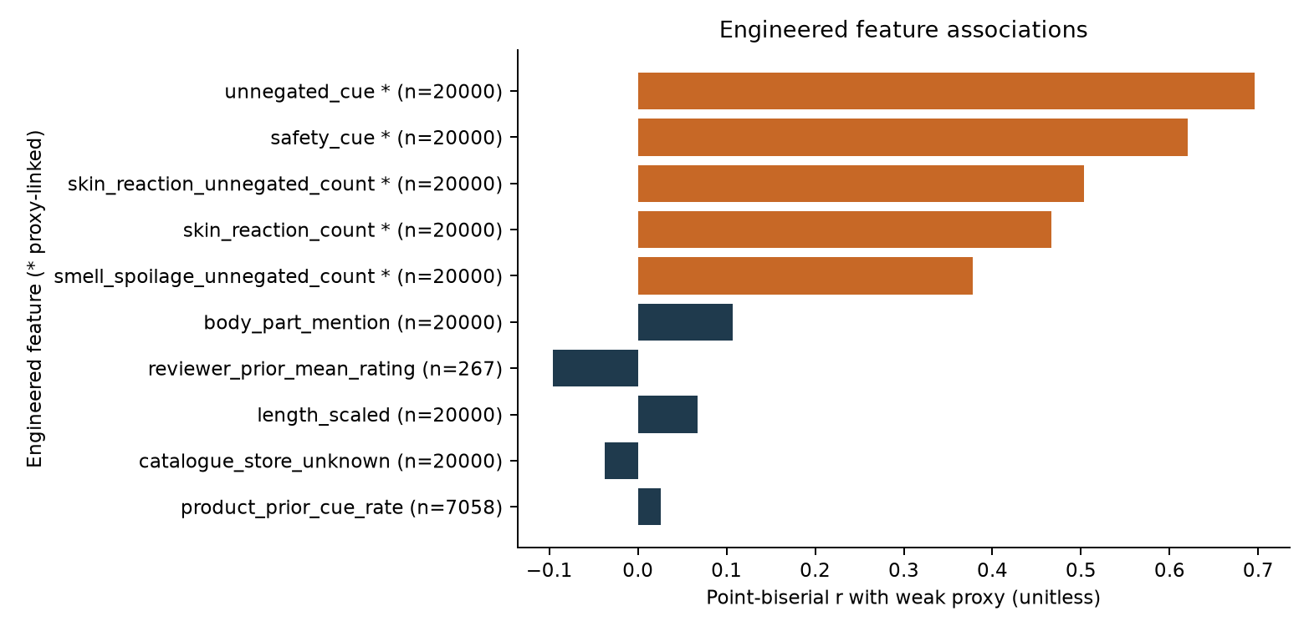
Proxy-ingredient features lead: unnegated cue presence (r 0.696), any safety-word cue (r 0.620), unnegated skin-reaction count (r 0.503); among other features, personal body-part mentions lead at r 0.107. Associations use the later-period half of the uniform sample, including 273 proxy positives. This alignment supports feature ablation, but cannot establish accuracy against human labels.

5. Patterns, trends and insights for the beauty and wellness market
Four measured comparisons connect findings to feature decisions. A higher cue-share segment warrants investigation; it does not establish higher product risk. Rates use reviews within each segment.
Finding (measured) | Feature decision | What it does not show
One-star unnegated-cue share is 7.18% versus 1.60% at five stars, a 5.58 percentage-point gap. | Rating stays a context feature; five-star affirmative accounts remain eligible. | Low ratings alone do not identify complaints.
22.29% of raw matches have no unnegated cue. | A polarity feature separates denials from affirmative wording. | Reviews with no unnegated cue are not proven false alerts.
Seasonal Cramer's V is 0.0062. | Month remains a candidate pending within-category checks. | This small association does not justify staffing or guidance changes.
Raw-cue share is 4.09% in USD 25 to <50 versus 2.58% in USD <10. | Price tier remains descriptive context for matched-category audits. | Snapshot prices are not purchase-time prices; this cannot show affordability or price-driven trends.
- Seasonality: June has the highest pooled cue rate, 3.60%, and December the lowest, 3.20%. Compare the same categories across months before interpreting seasonality.
- Category mix: the highest cue shares are Grocery 5.75% (Wilson interval 5.54% to 5.98%, 43,567 reviews) and Industrial & Scientific 5.38% (Wilson interval 5.24% to 5.52%, 105,860 reviews). Their appearance warrants checking how snapshot membership relates to catalogue category labels before interpreting these comparisons. Route verified listings to relevant specialists.
- Price mix: the leading tier has a Wilson interval of 4.07% to 4.12% across 3,272,850 reviews. Compare formulations and packaging within matched categories before recommending extra product guidance. Bands use exact USD values; missing prices and starting-price strings form a separate group.
- Yearly change: from 2021 to 2022, cue rates change by All Beauty +0.395; Health & Personal Care +0.612; Premium Beauty +0.308; Amazon Home +0.299; Tools & Home Improvement -0.061 percentage points. These are the five largest known categories by total review volume. A retailer should prioritize the largest increase for a product-level drill-down, compare continuing products with new listings, and test whether the shift persists after holding the category and rating mix constant.
Figure 9. Seasonality, price mix and category trends
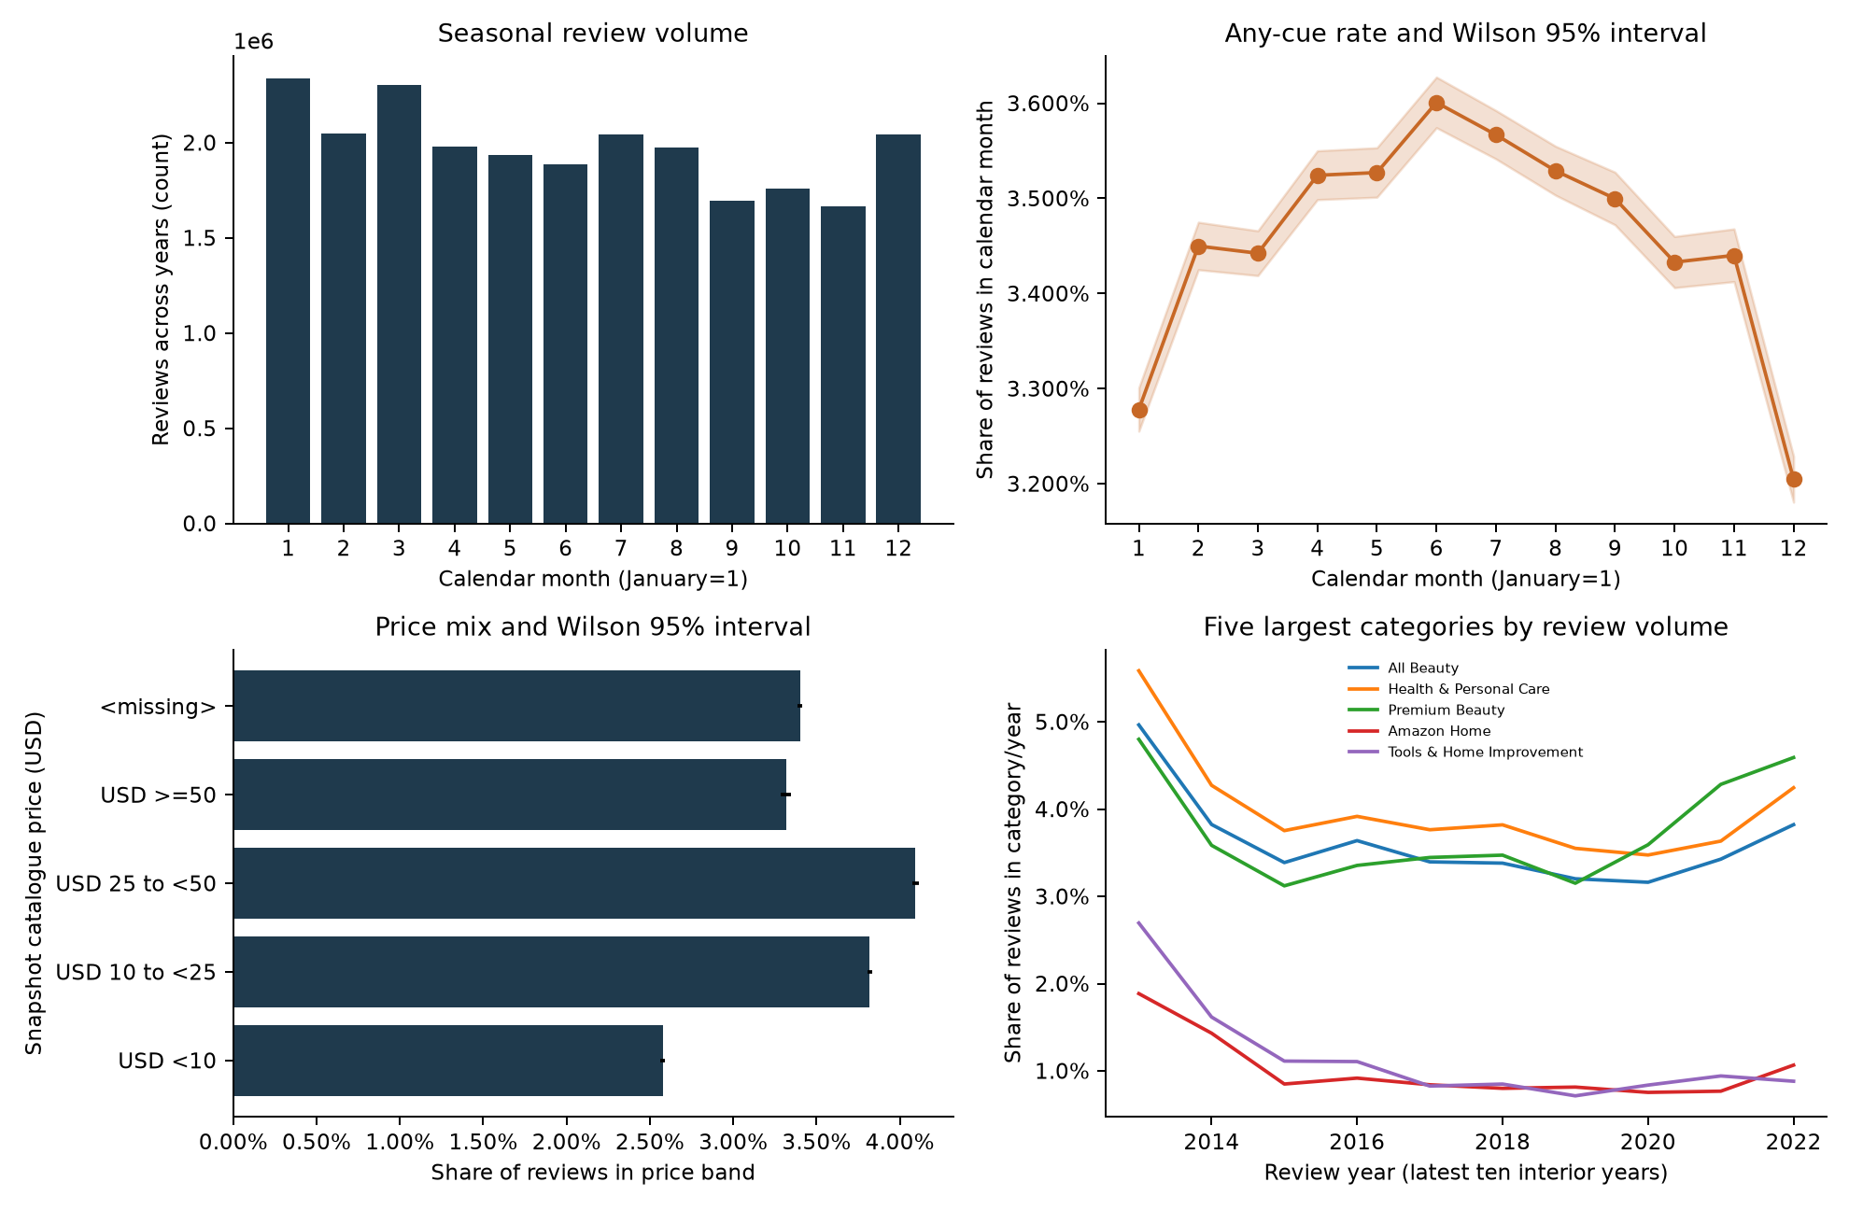
Seasonal volume bars show 2,338,973 January and 2,050,416 February reviews; the cue-rate panel shows January 3.28% and February 3.45%. Unavailable exact prices have cue share 3.40%; the All Beauty line runs from 4.97% in 2013 to 3.82% in its final plotted year. These differences support product-cohort drill-downs, but cannot attribute changes to formulation or demand.
Rank category-year changes, trace contributing product cohorts, and standardize calendar comparisons to a fixed category distribution. Obtain dated product and sales records before translating review patterns into stocking decisions.

6. Feature engineering plan: new variables
Feature | Construction and hidden insight | H2 / H3 test | Status
Scoped cues preserve polarity. | Raw, negated and unnegated matches distinguish denials. | H2 tests false alerts; H3 supplies contextual votes. | Implemented candidate; eligible prediction input.
Group counts retain topics. | Raw and unnegated counts preserve overlapping symptoms. | H2 tests topics; H3 checks rule conflicts. | Implemented candidate; eligible prediction input.
Rating mismatch flags contradiction. | Five stars with an unnegated cue retain satisfied complainants. | H2 tests misses; H3 checks rating-rule errors. | Implemented candidate; eligible prediction input.
Text shape records expression. | Scaled length, capitals, exclamations and body context describe expression. | H2 tests context; H3 audits writing styles. | Implemented candidate; eligible with training-only scaling.
Reviewer history describes observed activity. | Strictly earlier sampled reviews, not full customer activity; 99.17% cold starts, about 0.83% with prior history. | H2 tests added value beyond wording and rating; H3 checks activity bias. | Implemented candidate; retain missing-history indicator.
Product context describes cohorts. | Prior count, cue rate and cold starts describe cohorts; encodings describe retail mix. | H2 tests generalization; H3 checks product dominance. | Implemented candidate; histories eligible; undated catalogue attributes descriptive only.
Time variables locate change. | Year, quarter and time since first observed review distinguish cohorts; product age is not launch age. | H2 tests stability; H3 checks rule drift. | Implemented candidate; eligible with chronological history.
Interactions combine evidence. | Rating times cue and body context with cue expose conditional meaning. | H2 tests combinations; H3 finds conflicting votes. | Implemented candidate; eligible prediction input.
Prior count: numerator is strictly earlier reviews for the same reviewer or product; no denominator, because this is a count.
Prior mean rating: sum of strictly earlier ratings for that reviewer divided by their prior review count.
Prior cue rate: strictly earlier unnegated-cue reviews for that product divided by its prior review count.
All eight families are implemented candidates, not validated predictors. Current-review wording, rating, time and strictly prior histories are eligible prediction inputs; undated catalogue attributes remain descriptive only. Training folds must refit scaling and encodings. Validation against human outcomes is planned.
The negation window covers the preceding four tokens, with at most three intervening words; punctuation and contrast words reset it, and title and body are separated. Groups cover skin reaction, irritation, eye, hair and scalp, smell and spoilage, and contamination. Standalone burn wording includes short reaction accounts. The verified-purchase interaction is unavailable because the cleaned schema lacks that field.

7. Transformations: normalization, encoding and interaction variables
Log normalization compresses long bodies while retaining empty accounts. The saved median is 3.044522 and interquartile range of log1p(word_count) is 1.563976 across the retained population; center and scale below name these parameters. Population aggregates use src/eda.py; expressions come from src/features.py, with synthetic checks in tests/test_features.py.
out["length_scaled"] = (np.log1p(out["word_count"]) - center) / scale
Low-cardinality context uses a stable one-hot vocabulary; high-cardinality stores use training-reference frequencies. The encoder rejects rows before its cutoff. Unknown flags distinguish unseen stores from rare observed stores.
out[f"{name}_frequency"] = values.map(specification["frequency"]).fillna(0.0)
out[f"{name}_unknown"] = ~values.isin(specification["frequency"])
Interactions expose conditional meaning to a linear classifier. Preserve column order and missing indicators at prediction time.
out["rating_x_cue"] = out["rating"] * out["unnegated_cue"]
out["body_x_cue"] = out["body_part_mention"] & out["unnegated_cue"]
Constructed examples, not actual reviews: five-star "It burned my scalp" gives unnegated_cue=1, body_part_mention=1, rating_text_mismatch=1, rating_x_cue=5 and body_x_cue=1. For a five-star "No irritation at all", irritation_count=1 and irritation_unnegated_count=0 under the scope rule; unnegated_cue=0, body_part_mention=0, rating_text_mismatch=0, rating_x_cue=0 and body_x_cue=0.
A constructed 50-word review gives length_scaled=0.567338 using the saved parameters.
A constructed store observed 20 times in 100 training rows gives catalogue_store_frequency=0.20 and catalogue_store_unknown=0.
An unseen store gives catalogue_store_frequency=0 and catalogue_store_unknown=1.
Missing catalogue_store metadata becomes its own <missing> token, with its training frequency if observed and the unknown flag otherwise.

8. Features that capture hidden customer behaviour and market trends
Customer behavior can be mixed within one account. The synthetic example it burned my scalp while the smell was pleasant combines approval with a specific bodily effect. An analyst should retain both dimensions and check the claimed experience against product instructions, instead of interpreting overall enthusiasm as absence of a problem. Earlier observed ratings offer limited context for the history-covered minority; stable personal rating habits are not established. The history ablation tests added value beyond wording and rating.
Market trends require comparisons among similar products. A rising cue share across established listings suggests a different investigation from a rise concentrated in newly observed products. Hold category and rating mix constant, compare continuing cohorts, and use earlier product counts to judge the stability of a rate. This turns the seasonal and annual findings into questions about formulation, storage or assortment changes that a retailer can investigate with dated records.

9. How the features improve analytical insight and model accuracy
Hypothesis (Week 1) | Evidence available now | Planned test | Missing prerequisite
H1: Two annotators reach substantial agreement on the binary label. | Of 817,313 raw-cue reviews, 182,168 have no unnegated cue under the scope rule: a hard annotation stratum, not measured disagreement. | Compare agreement across affirmative, negated-only and ambiguous accounts on independent labels; measure kappa on 200 double-labelled reviews, requiring at least 0.70. | Independent labels and adjudication remain unavailable.
H2: A supervised classifier has higher average precision than the tuned keyword baseline (Section 8.6) on held-out labelled reviews. | The uniform sample has 402 five-star unnegated-cue reviews; mismatch is a candidate. | Compare average precision with a paired product-bootstrap interval above zero. | A tuned baseline, fitted models and frozen human test labels are needed.
H3: A model trained on weak labels reaches an average precision within 0.05 of a model trained on the hand-labelled set. | Weak-rule quality remains unmeasured. | Measure each weak rule's coverage, precision, conflicts and abstentions against development labels; compare weak-label and hand-label training on the same independent test set with uncertainty. | Development labels, weak labels and hand labels are needed.
H4: Week 1 hypothesizes a higher complaint share for Bioderma Sensibio H2O in the 12 months before recall than in the line's own earlier 12 months; no such rise is expected for a benzene recall line (Dove dry shampoo). | Health Canada recalled only the 850 ml format, lot 22414H, sold from December 2021 to February 2022. The US announcement of 18 October 2022 covered selected lots of aerosol dry shampoos produced before October 2021. | A line-level review comparison is exploratory context only and cannot stand for the recalled batch. | H4 is untestable with this snapshot unless reviews can be linked to the affected format and period, with independently labeled complaints.
H5: Matching on brand and package size links products to the right recall notice more often than matching on name alone. | Catalogue join coverage is 100.00%; no recall-match accuracy is measured. | Compare the share of reviewed pairs with the correct notice ranked first. | Reviewed product-notice pairs with brand and package size are needed.
Health Canada recall notice: https://recalls-rappels.canada.ca/en/alert-recall/bioderma-sensibio-h2o-micellar-water-makeup-remover-recalled-due-microbial
Unilever US announcement on FDA: https://www.fda.gov/safety/recalls-market-withdrawals-safety-alerts/unilever-issues-voluntary-us-recall-select-dry-shampoos-due-potential-presence-benzene
Define the training cutoff and later test window before fitting. Use product-separated folds; earlier reviews of held-out products may supply only unlabeled chronological history. Compare a tuned keyword baseline, text-only model and text plus engineered features on the same human-labeled test set. Report average precision and precision at top 50, matching reading capacity; ablate one feature family at a time.
Current EDA is descriptive and does not confirm any hypothesis yet.

10. Leakage, validation and the human check for proxy measures
No feature may use a complaint label or information after its review timestamp. Exclude current and tied events; freeze encoders on earlier training folds. A model handles a missing prior mean with a missing indicator plus fold median imputation. Exclude undated catalogue attributes and accumulated helpful votes from prospective models.
The weak proxy is unnegated cue AND rating at most two, not ground truth. Cue-presence and group-count features share its ingredients, inflating associations; wording can describe relief, another product or missed negation.
The annotation rule is yes for an affirmative physical reaction experienced by the writer or someone they describe after using this product; spoilage, contamination or expiry as received or used; a broken seal showing use; or injury caused by packaging or an applicator. No covers negated or hypothetical harm, relief, another product, dislike, and delivery, price, size or efficacy complaints. Use unclear when an effect is not connected to the product or text is too short or garbled to tell.
Draw a fifty-review pilot equally from proxy-positive, negated-only, high-rating unnegated, other-cue and no-cue strata. Record population sizes and inclusion probabilities. Two annotators independently apply the rule, hiding ratings, product names and feature outputs; record complaint type, stated severity and experiencer. A third reviewer adjudicates disagreements, preserving original labels. Report agreement, confusion counts and prevalence-weighted proxy precision and recall with uncertainty; keep unclear cases separate.
Repair the guideline, then check two hundred double-labeled reviews before freezing an independent test set. Fit all predictive preprocessing within folds, retain an audit trail of abstentions, and record reviewer workload alongside ranking quality.

11. Ethics and limitations
Privacy risk -> Health experiences and linked details can identify customers. Keep text in a controlled annotation workspace, restrict linkage keys, publish aggregates and synthetic examples, and delete histories when their investigation purpose ends. Pseudonyms still require access controls. Give annotators a route to skip distressing material without copying it into discussion channels.
Language bias -> English rules miss multilingual and indirect accounts. Deliver an internal audit table with sample size, false positives, false negatives and unclear outcomes by language, text length and reviewer cold-start status. Mark small counts "insufficient evidence"; assign an owner and review date to each open failure, with human review for affected cases meanwhile. Obtain bilingual annotation where needed; sample unflagged accounts too.
Reputational harm -> Internal rankings can wrongly implicate a supplier. Keep unreviewed brand comparisons private, verify product identity and variant before escalation, and require an accountable investigator to authorize external action. Preserve the reason for closure or referral. A complaint establishes an allegation, not laboratory confirmation of a defect.
Selection and exposure bias -> Reviewers differ from all buyers. Obtain sales or usage denominators before estimating incidence and compare like-for-like cohorts. This historical marketplace snapshot cannot establish current demand, regional applicability or causation. Document which populations the snapshot omits before extending any operational recommendation to them.
Fairness and accountability -> Emotion and frequent reviewing do not establish deception. Use behavior only as context, inspect decisions affecting new reviewers, and provide correction routes. Exclude demographic inference and personal customer risk scoring. Domain staff should review severe accounts, distinguish stated medical attention from inferred severity, and audit missed cases alongside alerts with an owner for corrective action.

12. Hypothetical scenario: how a brand safety team uses these features to decide
Assume a brand team receives 10,000 reviews in a week. Measured shares project about 345.4 raw-cue candidates and 268.4 unnegated-cue candidates: 112.7 at 1 to 2 stars and 155.7 at 3 to 5 stars. The latter account for 368,558 of 635,145 unnegated-cue reviews (58.03%). This projection assumes incoming rating and product mix matches the measured population; candidates are not confirmed complaints. Rating orders the unnegated-cue queue, never gates eligibility. Fill the 50-review capacity in priority order, giving serious-effect wording human review at any rating. At an assumed 5 minutes each, capacity requires 4.17 reader hours; the lower-rating subset alone takes about 9.4 hours, and the whole queue 22.4 hours. About 218 candidates remain queued or need another reader.
Illustrative assumption, not measured: with the same 50 alerts and the same 4.17 hours, keyword ordering yields 20 adjudicated complaints and contextual ordering 30, increasing yield from 40% to 60%, or 10 more complaints at fixed capacity. The Section 9 evaluation decides whether such an improvement exists; this example shows why a team would change ordering rather than increase staffing.
The analyst uses rating, bodily context and word group to order the queue, then opens selected accounts in the protected workspace. They check product and body area, distinguish a denied reaction from an affirmative one, and record yes, no or unclear. A separate random audit covers unreached candidates and excluded reviews, including negated-only and no-cue accounts.
Suppose a synthetic scalp-burning account remains affirmative after reading while another merely describes relief from itching. The first is referred for product and batch verification; the second is closed as a lexical false alert. Multiple adjudicated complaints about the same verified variant prompt a quality-team investigation of batch, storage and formulation records. The investigation owner documents identity checks, supplier response and evidence needed for a formal safety decision.
After adjudication, the team measures confirmed yield, missed complaints in a random no-cue audit, queue age and reading time. If workload exceeds capacity, it adjusts routing on development labels and documents the resulting recall tradeoff. The decision changes because contextual features organize evidence for human review, with measured queue outcomes informing the following investigation cycle and its allocation of staff time.

13. Conclusion
The EDA identifies rating, seasonal and product-mix differences that can guide beauty-market investigation. Local wording and contextual variables provide testable ways to rank accounts for limited reading capacity. Undated catalogue comparisons remain descriptive. Adoption depends on improved average precision and useful reviewer yield against independently adjudicated outcomes.

