YUVAINTERN | WEEK 1 | PROBLEM DEFINITION IN BEAUTY AND WELLNESS
Early Detection of Cosmetic Safety Complaints in Online Customer Reviews
A research proposal for AI-driven cosmetic product safety intelligence
Author Pawan Singh Kapkoti
Programme Data Science with Python Analyst Internship, YuvaIntern
Sector Beauty and Wellness
Document Week 1 report, second revision
Date 14 October 2026
Repository https://github.com/Pawansingh3889/yuvaintern

Executive summary
Beauty buyers now tell retailers, in public and in writing, when a product burned their skin, arrived with mould in the jar or smelled rancid. Star ratings and sentiment scores do not separate those sentences from praise: 46.1% of the reviews examined here that use a safety-related word are five-star (Section 7). Platforms screen reviews for authenticity and regulators collect formal reports, but none of the monitoring routes reviewed in Section 1.7 sorts public beauty reviews for safety complaints. This proposal defines one business problem: finding safety complaints in customer reviews early enough for a person to investigate them.
The problem is timely. Online beauty sales are growing about six times faster than store sales (NielsenIQ, 2026). The United States now requires companies to report serious cosmetic adverse events within 15 business days (U.S. Food and Drug Administration [FDA], 2026). Cosmetics were the most notified product category in the European Union's 2025 safety alerts (European Commission, n.d.). In one 2025 Canadian recall, the company had already received 48 reports of foul odour before the notice was published (Health Canada, 2025).
The study asks five connected research questions. Three form the core: whether people can label safety complaints consistently, whether a classifier finds them better than a keyword search, and whether cheap automatic labels can stand in for scarce human ones. Two are exploratory: whether complaint rates rise before a recall, and whether a flagged product can be traced to the right official record.
Week 1 is definition and planning only. No model was trained and no review was labelled. To check that the plan is realistic, I counted what the candidate data contains. The Amazon Reviews 2023 beauty file holds 23.9 million dated reviews. About 2.6% contain a safety-related word, and in an informal read of 60 of those, roughly one in five described a real complaint about the product. That points to a rare target class, which shapes every later choice: stratified sampling for annotation, precision and recall instead of accuracy, and a human reviewer between any alert and any action.
Table A. The evidence behind this proposal at a glance
Measured fact | Value
Dated beauty reviews available for the study | 23,911,390
Reviews containing a safety-related word | 614,203 (2.57%)
Share of those reviews that are five-star | 46.1%
Safety-word rate in one-star against five-star reviews | 5.8% against 1.8%
Safety-word reviews in which the word is negated ("no irritation") | 23.2% overall; 37.2% of five-star ones
Products with at least one safety-word review | 138,833 of 1,028,914 (13.5%)
Genuine complaints in an informal read of 60 safety-word reviews | 13 (22%)
Recalled product lines with 20 or more reviews in the year before recall | 8 of 40
Official cosmetic adverse event reports that name a cancer term | 71% of 85,511
Sources cited (peer-reviewed, preprint and official) | 35
Public data sources assessed, with official links | 11
Charts and tables in this report | 14 figures; 32 tables (28 numbered, 4 unnumbered)
The main deliverable of the later weeks is a labelled set of 500 to 1,000 reviews with measured agreement, a tested classifier, and an honest error audit. Section 8 sets out the method step by step and Section 12 gives the week-by-week plan, decision rules and extensions beyond the internship. The project does not certify any product as safe or unsafe, and it does not claim that a review proves a product caused a reaction.

Contents
No. | Section | Covers
1 | Industry trends and relevance to beauty and wellness | Why this problem, why now, existing practice
2 | Problem statement and business problem | Statement, users, objectives, rationale
3 | Related research and the gap | Five strands with appraisal and lessons; the search behind the gap
4 | Research questions and hypotheses | Five questions, five tests
5 | Variables and possible data | What is measured and how
6 | Expected datasets | Sources with official links
7 | Feasibility observations | Measured facts and 11 charts from the data
8 | Step-by-step approach and methodology | Eight steps in detail, with tools and checks
9 | Human annotation strategy | Labels, sampling, quality control
10 | Ethics and responsible use | Privacy, harm, licences
11 | Limitations and risks | Batch data, imbalance, false alerts
12 | Plan for the next steps | Weekly plan, decision rules, beyond six weeks
13 | Summary of findings and conclusion | Numbered findings, answer, next step
 | References and Appendix A | APA 7 list and label guide

1. Industry trends and relevance to beauty and wellness
Four developments between 2023 and 2026 make early complaint detection a current problem in beauty and wellness, not a hypothetical one.

1.1 Beauty is moving online, and so is the customer's voice
NielsenIQ's State of Beauty 2026 reports that global beauty sales grew 10% year over year and that e-commerce is growing six times faster than in-store sales, across retail data from 52 markets. The same release reports that 53% of surveyed consumers buy through social platforms and 22% buy directly through TikTok Shop (NielsenIQ, 2026). When the purchase happens online, the feedback does too. A shopper who would once have returned a jar to a counter now writes a dated, public review. For a brand, that is a free and continuous stream of post-market feedback.

1.2 Regulators now expect companies to notice problems quickly
In the United States, the Modernization of Cosmetics Regulation Act of 2022 (MoCRA) requires the responsible person for a cosmetic to report serious adverse events to the FDA within 15 business days. The definition includes serious and persistent rashes, second or third degree burns, significant hair loss and infections. The Act also gives the FDA authority to order a recall (FDA, 2026). In September 2025 the FDA opened a public dashboard of cosmetic adverse event reports, updated daily, and stated that the reports are unverified and do not show that a product caused an event (FDA, 2025). A company that learns of a pattern late now carries a legal deadline as well as a reputational cost.

1.3 Cosmetics lead safety alerts, but most alerts are invisible to shoppers
The European Commission's Safety Gate system validated 4,671 alerts in 2025, and cosmetics were the most notified category at 36%. Of the cosmetic alerts for chemical risk, 77% involved one banned fragrance ingredient, BMHCA (European Commission, n.d.). In the United Kingdom, the Product Safety Database recorded 833 notified products in cosmetics, personal care and grooming for 2025 to 2026, about 25% of all notified products (Office for Product Safety and Standards, 2026). These figures count regulatory alerts. They do not measure how many products on sale are unsafe. They also carry a warning for this project: a banned ingredient on a label cannot be smelled or felt, so a reviewer will never report it. Review monitoring can only help with defects a customer can perceive, such as irritation, spoilage, contamination or a damaged pack.
Figure 1. EU Safety Gate 2025: most frequent risk types across all product categories (European Commission, n.d.). Cosmetics were 36% of alerts.
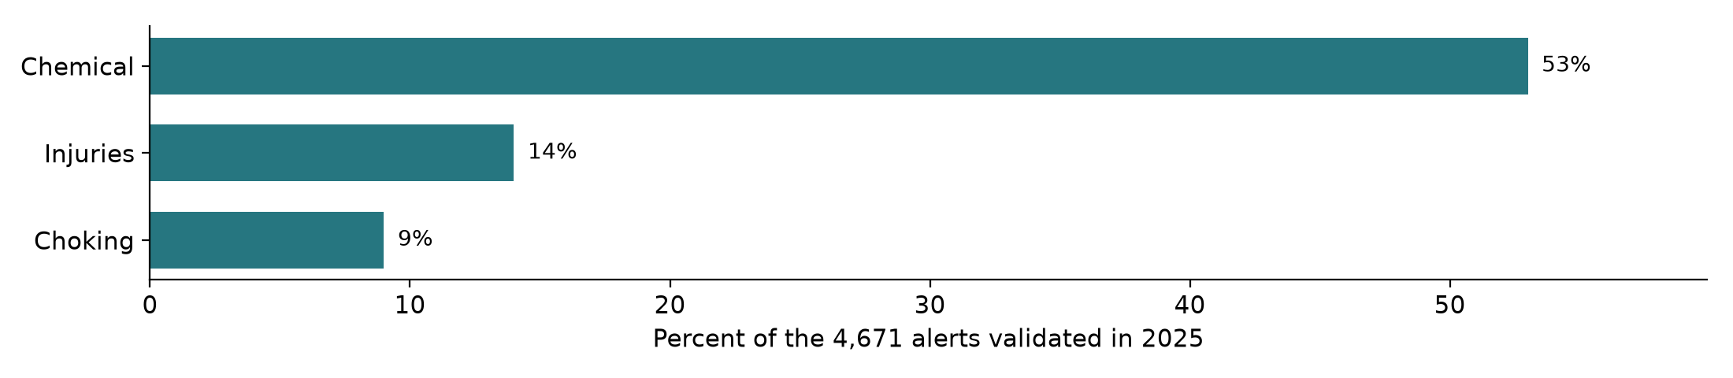

1.4 Complaints do appear before recalls, and reviews are getting noisier
Health Canada's February 2025 recall of amika Mirrorball shampoo for bacterial contamination covered about 95,000 units sold in Canada between May 2023 and November 2024. By late January 2025 the company had received 48 reports of foul odour and two reports of irritation or allergic reaction (Health Canada, 2025). The signal existed before the notice. At the same time, the review stream is degrading. A consumer investigation judged 23 of 34 cosmetics bought from online marketplaces to be likely counterfeit (Walsh, 2025), and an analysis by Pangram Labs estimated that 5% of Amazon beauty reviews were written by AI, most of them five-star (Jones, 2025). Any method that reads reviews has to cope with fakes on both sides: fake products that generate real complaints, and fake reviews that bury them.

1.5 A concrete case: one recall, read backwards
The amika recall shows what the project is trying to catch. Table 1a lays out the dates published by Health Canada (2025).
Table 1a. Timeline of the amika Mirrorball shampoo recall
Date | What happened
May 2023 | The affected product goes on sale in Canada
May 2023 to November 2024 | About 95,000 units are sold
By 27 January 2025 | The company has received 48 reports of foul odour and 2 reports of irritation or allergic reaction
7 February 2025 | Health Canada publishes the recall for bacterial contamination
Fifty customers had already described the defect in plain words before the notice. This project asks whether a method could have surfaced complaints like these from public reviews while the product was still on sale. The amika reviews themselves cannot be tested, because the open review data ends in September 2023, so the question is studied on earlier products.
Table 1. Industry trends and what each means for this project
Trend | Evidence, 2023 to 2026 | Implication for the project
Online and social commerce growth | E-commerce growing six times faster than in-store; 53% buy through social platforms (NielsenIQ, 2026) | Reviews are now the main place customers describe problems
Mandatory adverse event reporting | 15 business days under MoCRA; FDA public dashboard since September 2025 (FDA, 2025, 2026) | Brands need earlier internal signals than formal reports provide
Cosmetics lead safety alerts | 36% of 4,671 EU alerts in 2025; 833 UK notified products (European Commission, n.d.; OPSS, 2026) | Safety is a live sector issue, but most alerts concern ingredients shoppers cannot perceive
Complaints precede some recalls | 48 odour reports before one 2025 recall (Health Canada, 2025) | A detectable signal can exist before a notice
Counterfeits and AI-written reviews | 23 of 34 marketplace purchases likely fake; 5% of beauty reviews AI-written (Walsh, 2025; Jones, 2025) | Review data is noisy; results need verification and sensitivity checks

1.6 Background: why cosmetic safety monitoring lags behind
Drug safety has a mature monitoring system. Cosmetic safety does not. Toklu et al. (2019) describe cosmetovigilance, the monitoring of adverse effects of cosmetics, as fragmented and dependent on voluntary reporting. The numbers show the gap: a study of the FDA's adverse event system found only 5,144 cosmetic adverse events reported in the 13 years from 2004 to 2016, an average of 396 a year for one of the largest cosmetics markets in the world, and the authors read this as heavy under-reporting (Kwa et al., 2017). Hair care, skin care and tattoo products led the reports, and a single brand's products drove a sharp rise in 2016, which shows how a handful of products can dominate sparse official data.
Three features of beauty products make the gap matter. They are applied to skin, scalp, lips and eyes, often daily. Many are water-based and can support microbial growth once opened. And most reactions are mild enough that customers stop using the product without reporting anything to a regulator, while many still write a review. That is the gap this project targets: the reaction that is described in public but never reported.

1.7 Existing approaches in practice and why they fall short
Several routes already watch for product harm. Table 1b sets out what each does and why none of them is built to pick safety complaints out of public beauty reviews.
Table 1b. Existing monitoring routes and their limits for this problem
Route | What it does | Why it falls short here
Official adverse event reporting | The FDA collects cosmetic adverse event reports and, since September 2025, publishes them on a dashboard updated daily (FDA, 2025) | Reports arrive only when someone chooses to file one, and the FDA states that they are unverified and do not show that a product caused an event (FDA, 2025)
Company complaint handling | Companies receive complaints directly; amika had 48 odour reports and 2 irritation reports before its recall notice (Health Canada, 2025) | Covers only complaints sent to the company, not those written on retail sites
Platform review screening | Amazon runs checks before publication for signs of fake or AI-generated reviews (Jones, 2025) | Asks whether a review is genuine, not whether it reports harm
Research systems for review mining | Classifiers flag hazards in Amazon reviews of consumer products (Bhat & Culotta, 2017) and foodborne illness in Yelp reviews for the New York City health department, with every flag checked by a person (Effland et al., 2018). In cosmetics, a dictionary of skin-complaint terms has been used to extract and map Japanese dissatisfaction posts (Iwano et al., 2025) | The classifiers were built for other product types; the cosmetics study describes complaint themes but does not label, evaluate or rank individual posts (Section 3.6)
Commercial social listening and review analytics tools were not assessed, because their methods are not published. Whether any of them triages safety complaints is left as a question for the brand pilot in Table 15.
The common gap is triage. Each route either waits for a formal report, checks authenticity, or was built for a different product type. None of the routes assessed here turns public beauty reviews into a short list of probable safety complaints with a reason for each.

2. Problem statement and business problem

2.1 Problem statement
Beauty brands and retailers receive early warnings of product defects inside customer reviews, but have no reliable way to separate the small number of genuine safety complaints from millions of ordinary comments. As a result, a contaminated or irritating batch can keep selling until formal complaints accumulate or a regulator steps in.
A keyword search does not solve this. The word irritation appears far more often in praise ("no irritation at all") than in complaint. Star ratings do not solve it either, because a customer can give five stars to a product they liked before it gave them a rash, and one star to a late delivery.

2.2 Who has the problem and what they would decide
Table 2. Intended users and the decision the work supports
User | Decision supported | What they need from the output
Brand quality and safety team | Which products to investigate this week, and whether a complaint may be reportable | A short ranked list of flagged reviews with the reason for each flag
Retailer or marketplace trust team | Which listings to check for spoilage, counterfeits or mislabelling | Product-level complaint rates with volumes and dates
Marketing and customer care | When to respond to a complaint and when a product page needs a usage warning | Complaint themes in plain language, separated from general dislike
From a marketing point of view, the value is trust. A brand that spots and handles a bad batch before it trends protects repeat purchase and avoids a public recall narrative written by others. The measure of success is therefore correct and timely detection, not engagement or sentiment.
Link to brand sentiment and customer trends. Sentiment analysis, one of the standard beauty analytics tasks, averages opinion. Safety complaints are exactly what an average hides: 64.7% of all beauty reviews are five-star, so a product can look healthy on a sentiment dashboard while a small number of customers report burns or mould. Complaint detection is the sharp end of brand sentiment. It also feeds the other standard tasks: a recommendation engine can hold back a product with a rising complaint rate, and the share of reviews using safety-related words is itself a customer trend (2.3% in 2019 and 2020, 2.5% in 2021, 2.8% in 2022).

2.3 Scope and what the project will not claim
- In scope: English-language reviews of beauty and personal care products; a binary safety-complaint label with a complaint type; product-level complaint rates over time.
- Out of scope: medical diagnosis, proof that a product caused a reaction, live monitoring, and any statement that a product is safe or unsafe.
- Human in the loop: every flag is a prompt for a trained person to look. No automatic action follows from a model output.

2.4 A worked example of the problem
Bioderma Sensibio H2O micellar water was recalled in Canada on 4 March 2022 for microbial contamination. In the Amazon data, products whose titles match that line have 3,465 reviews, 3,016 of them before the recall date and 368 in the preceding 12 months. A quality analyst wanting to know whether customers had noticed anything in that year would face three poor options:
Table 2a. Three ways to read the 368 reviews from the year before the recall
Approach | Reviews to read | What goes wrong
Read everything | 368 | About four hours for one product line; a brand has hundreds of lines
Read only one and two star reviews | 56 | Only 12 of the 42 reviews that use a safety word are in this group, so 30 are never seen
Search for safety-related words | 42 | 20 of the 42 are five-star reviews, mostly praise such as "no irritation"
What the analyst needs is a short list: the handful of reviews most likely to describe a real reaction or spoilage, with the reason each was flagged. That list is the product this project works towards. Figure 9 in Section 7 shows this product line quarter by quarter. The title match is unreviewed and the Canadian recall covered specific lots, so this example illustrates the workload, not a finding about the product.

2.5 Objectives
Table 2b. Project objectives with a measure and a date
No. | Objective | Measure of success | Answers | Due
O1 | Assess the public data and decide whether the study can proceed | Register of 11 sources; feasibility checkpoint decided in writing | Gate for RQ1 to RQ5 | Week 2
O2 | Build a labelled set of beauty reviews marked for safety complaints | 1,000 labels (500 minimum); Cohen's kappa of at least 0.70 on 200 double-labelled reviews | RQ1; labels for RQ2 and RQ3 | Week 4
O3 | Find out whether a classifier beats a keyword search | Tuned keyword baseline, two classifiers and a weak-label model compared on identical folds | RQ2, RQ3 | Week 5
O4 | Report honest performance and where the method fails | Precision, recall and average precision with 95% intervals, at the population base rate; every test error categorised | RQ2, RQ3 | Week 6
O5 | Describe complaint rates before recalls and traceability to official records | Descriptive comparison for the qualifying recalled lines; one case study | RQ4, RQ5 | Week 6
Read the other way: RQ1 is answered by O2, RQ2 and RQ3 by O3 and O4, and RQ4 and RQ5 by O5. O1 decides whether any of them can proceed.

2.6 Rationale for the approach
- Start from what the data can support. 23.9 million dated reviews are in hand; recalled products with enough earlier reviews are scarce (8 of 40). So detection is the core and recall prediction is not attempted.
- Labels before models. No openly labelled set for this task was found in the search described in Section 3.6, and the keyword count shows that words and stars cannot stand in for labels.
- Simple and transparent first. A quality team has to trust a flag enough to act on it. A readable model with a reason for each flag is preferred over a larger one unless the larger one is measurably better.
- A person stays in the loop. At a base rate near 0.5%, false alerts are unavoidable, so the output is a reading list for an analyst, never an automatic verdict.

3. Related research and the gap
This review covers five strands of research that the project builds on: safety signals in social media, safety signals in product reviews, the trustworthiness of review data, methods for scarce labels and rare classes, and product identity matching. Each strand ends with an appraisal of the evidence and the lesson it gives this project. Section 3.6 records the search behind the gap.

3.1 Safety signals in social media
Pharmacovigilance researchers were the first to treat public posts as safety data. Sarker et al. (2015) reviewed this work and found recurring obstacles: informal and misspelled language, a very small share of relevant posts and little annotated data. Nikfarjam et al. (2015) labelled adverse reaction mentions in health forum and Twitter posts and showed that a sequence model with word-embedding cluster features outperformed dictionary lookups. Freifeld et al. (2014) compared adverse events found in Twitter posts with the FDA's official reports and found a strong correspondence at the level of body system, which suggests that public text and official reports describe the same harms. Appraisal. These studies are strong on scale and on comparing public text with an official reference, but the comparison is loose. Freifeld et al. compared aggregated product and event counts by organ class with FDA reports, so the agreement holds in aggregate and says nothing about whether a single post is reliable. Sarker et al. found that only six of the 22 studies they reviewed shared their annotations, which made systems hard to compare; this project therefore fixes its test set and metrics before modelling. Nikfarjam et al. extract reaction phrases, which needs span-level annotation; the review-level label planned here is cheaper but cannot say which words carry the complaint. Transfer to beauty reviews is plausible but untested, because these studies used social media posts in which the product had to be found in the text, whereas a review is already attached to its product. Lesson: hand-labelled data is the bottleneck, and word lists alone underperform.

3.2 Safety signals in product and service reviews
Abrahams et al. (2012) analysed posts on Honda, Toyota and Chevrolet owner forums and found that safety and performance defects were strongly predicted by a list of domain marker words they called smoke words; Abrahams et al. (2015) generalised this into a framework for product defect discovery and found, for automotive and consumer electronics products, that distinctive terms and product features indicated defects while sentiment features did not. Winkler et al. (2016) built smoke word lists from injury and recall narratives, scored over one million Amazon toy reviews and found that sentiment analysis had low specificity compared with danger words, partly because hazards are often mentioned in positive reviews. The New York City health department reads Yelp reviews for signs of foodborne illness with a system in which every flagged review is checked by a person (Effland et al., 2018). Bhat and Culotta (2017) trained a classifier on consumer complaints to the U.S. Consumer Product Safety Commission and found hazard reports in Amazon reviews before 45% of the recalls they examined. Maharana et al. (2019) linked about 1.3 million Amazon food reviews to FDA recalls, found that only 0.4% belonged to recalled products, had 6,000 reviews labelled by crowd workers and reached an F1 score of 0.74 with their best model. Appraisal. The strongest evidence comes from a system in real use (Effland et al.) and from studies with a recall reference (Bhat & Culotta; Maharana et al.), but each has a weakness that matters here. Effland et al. trained on 13,526 reviews that their own classifier had selected for epidemiologists to label, and needed a bias-adjusted training scheme to correct for that selection; this project's keyword-enriched sample has the same problem, which is why every sampled review carries its inclusion probability (Section 9.2). Bhat and Culotta's 45% is the share of recalled products with at least one flagged review before the recall; their abstract reports no false-alarm rate on products that were never recalled, so it shows sensitivity, not a usable early-warning precision. Maharana et al. tie their labels to recalled products, and their own finding that recall-related terms appear in more than 20,000 reviews, mostly of products never recalled, shows how loosely a product's recall status tracks what a review says; this project labels the review text instead. Winkler et al. derived their smoke words from toy injury and recall narratives, and their abstract reports statistical significance rather than precision at a working threshold, so their list cannot be reused and this project's six word groups are a sampling device, not a validated detector. Lesson: reviews do carry early safety signals, hazards hide in positive reviews, and a person must check every flag.

3.3 How far review data can be trusted
Mudambi and Schuff (2010) found that longer, more detailed Amazon reviews are judged more helpful, which makes length and helpful votes useful descriptors. He et al. (2022) documented a large market for fake Amazon reviews bought through social media groups, so unverified reviews and bursts of praise need care. Chapman et al. (2001) showed in clinical notes that a simple search for negation phrases near a finding removes a large share of false mentions, which matters here because many beauty reviews say "no irritation". Appraisal. NegEx was tested on 1,235 findings in discharge summaries, where it raised positive predictive value from 68.4% to 84.5% but lowered sensitivity from 88.3% to 77.8% (Chapman et al., 2001). Review language is far less formal than clinical notes, so the same kind of rule may remove real complaints as well as denials; the negation rule is therefore scored against development labels before it enters the tuned baseline (Section 8.6). The estimate that 5% of beauty reviews are AI-written comes from nearly 30,000 reviews of 500 top-selling Amazon products across several categories (Jones, 2025), so it is not a measured rate for the beauty category as a whole. Lesson: handle negation explicitly, measure what the negation rule costs, and check results with and without unverified reviews.

3.4 Scarce labels and rare classes
Ratner et al. (2017) show that many imperfect rules, called labelling functions, can be combined into training labels when hand labelling is slow; this is the basis of RQ3. Cohen (1960) and Landis and Koch (1977) provide the agreement statistic and its conventional reading. Saito and Rehmsmeier (2015) show that precision and recall are more informative than ROC curves when positives are rare.
Appraisal. Snorkel's reported results, models within an average of 3.6% of those trained on large hand-labelled sets, come from tasks with labelling functions written and refined by their users (Ratner et al., 2017); the rules in Table 9b are untested, so H3 is a genuine question, not an expected result. The kappa bands of Landis and Koch (1977) are conventions, which is why the 0.70 target is labelled a planning value. Saito and Rehmsmeier's argument has a corollary that matters here: precision depends on how common positives are, so precision measured on an enriched sample does not carry over to deployment without correction (Section 8.7).
Recent work on language models changes the cost of labelling but not the need to check it. Gilardi et al. (2023) found ChatGPT more accurate than crowd workers across four annotation datasets of tweets and news articles, and Ziems et al. (2024) found that across 25 benchmarks zero-shot language models reached fair agreement with humans but did not beat the best fine-tuned classifiers. Against this, Reiss (2023) found that repeating an input or changing a prompt slightly altered ChatGPT's labels, and Pangakis et al. (2023) found that performance across 27 annotation tasks depended on the dataset and the task, and argue that every automated annotation must be validated against human labels. Taken together, a language model can be one more labelling function in Step 6 but not a gold label, and a fine-tuned or prompted language model is considered as a Week 5 comparison only if the simpler models leave a clear gap.
Lesson: measure agreement before trusting labels, evaluate precision at the deployment base rate, and validate any automatic labeller against human labels.

3.5 Product identity
Linking a flagged review to an official recall is an entity matching task. Li et al. (2020) and Yin et al. (2025) study it with pretrained language models and show that the way product attributes are presented affects results. Appraisal. Li et al. report their gains on benchmark datasets and on matching two company files of 789,000 and 412,000 records; RQ5 has 17 usable product identities, far too few to fine-tune such a model, which is why semantic retrieval stays a future extension (Table 4). Lesson: keep brand, name and size as separate fields in the traceability work.

3.6 The gap
Table 2c. What earlier studies covered and what this project adds
Study | Domain | Data | Relevance to this project
Abrahams et al. (2012, 2015) | Vehicles | Owner forums | Smoke words: domain word lists as a sampling tool
Winkler et al. (2016) | Toys | Amazon reviews | Hazards in positive reviews; sentiment is not enough
Bhat and Culotta (2017) | Consumer products | Amazon reviews, CPSC | Signals before recalls
Effland et al. (2018) | Restaurants | Yelp reviews | Person checks every flag
Maharana et al. (2019) | Food | Amazon reviews, FDA recalls | Crowd labels; F1 0.74; 0.4% recalled
Sarker et al. (2015); Nikfarjam et al. (2015) | Drugs | Social media | Annotation is the bottleneck
Kwa et al. (2017); Toklu et al. (2019) | Cosmetics | FDA reports; literature | Official cosmetic data is sparse
Qi et al. (2025) | Electronics and skincare | Online reviews | Perceived-risk prediction; skin safety the key skincare feature
Iwano et al. (2025) | Cosmetics (Japan) | Dissatisfaction posts, 2015 to 2017 | Skin-complaint dictionary; themes only, no labels or accuracy
This project | Cosmetics | Amazon beauty reviews | A labelled set and a test of complaint detection for beauty reviews; none was found (see below)
How the gap was checked. On 14 October 2026 I searched PubMed titles and abstracts for cosmetic, personal care, skincare or beauty products combined with online, customer, consumer or product reviews and with adverse, safety, complaint or reaction terms; ran three combinations of the same terms on arXiv; and read the 20 most relevant Crossref records for the same terms. The search returned four PubMed records and one arXiv record, and no openly labelled set of beauty reviews marked for safety complaints. The closest study the search returned, Qi et al. (2025), predicts shoppers' perceived risk from 262,752 online reviews and reports skin safety as the most important feature for skincare products; perceived risk measures how risky shoppers judge a purchase, not whether a reviewer reports a reaction. Scopus and Web of Science were not available, and a Semantic Scholar query was refused by its rate limit, so the claim holds only for the search described here.
The closest prior work. One further study was found outside that search, through an earlier search summary, and read in full on 14 October 2026. Iwano et al. (2025) built a dictionary of 289 Japanese skin-complaint terms (such as itchy, red and stinging) from 1,500 sentences, used it to extract 13,159 posts from the 52,237 cosmetics entries of a Japanese dissatisfaction survey dataset collected in 2015 to 2017, and mapped word co-occurrence by each poster's stated purchase intention. It shows that skin reactions are described in cosmetics complaints and that a dictionary can collect them. It differs from this project in four ways. The posts were submitted as expressions of dissatisfaction, so the hard problem here, separating complaints from praise that uses the same words, hardly arises. The paper reports no hand labels and no precision or recall for the dictionary. The analysis describes themes rather than ranking individual posts for a person to check. And the text is Japanese. The authors note that positive content was mixed into the dissatisfaction posts, and they name a technique for early detection of these problems as future work. That the database search missed this paper is itself a limit of the search.
Taken together, one study analyses skin complaints in cosmetics text (Iwano et al., 2025), but no study found evaluates the detection of safety complaints in cosmetics reviews against human labels, and no openly labelled set of beauty reviews marked for safety complaints was found. A small, carefully labelled set with reported agreement would be a useful contribution even if no model beats the baseline.
What would make us doubt the approach. Three results would weaken the case built in this section. If two annotators cannot reach a kappa of 0.60 after one guideline revision, the target is not a stable concept and the labelled set loses its value (H1). If the tuned keyword baseline in Section 8.6 performs as well as the classifiers, the lesson that word lists underperform does not carry over to beauty reviews (H2). And if fewer than one safety-word review in ten is a genuine complaint in the pilot, the signal is weaker than the toy and food studies suggest and the feasibility checkpoint fails (Section 12.1).

4. Research questions and hypotheses
The five questions build on each other. Labels come first (RQ1), then detection (RQ2), then a cheaper way to get more labels (RQ3). Only then can complaint rates be compared over time (RQ4) and tied to official records (RQ5).
Table 3. Research questions, hypotheses and decision rules
RQ | Question | Testable hypothesis | Measure and decision rule
RQ1 | Can people label safety complaints in beauty reviews consistently? | H1: Two annotators reach substantial agreement on the binary label. | Cohen's kappa of at least 0.70 on 200 double-labelled reviews. Below 0.60, the guideline is revised and the overlap repeated.
RQ2 | Does a text classifier detect safety complaints better than a keyword search? | H2: A supervised classifier has higher average precision than the tuned keyword baseline (Section 8.6) on held-out labelled reviews. | Difference in average precision with a bootstrap 95% interval. Supported if the interval lies above zero; not supported if the difference is zero or below; inconclusive if it is positive but the interval includes zero (Section 8.7).
RQ3 | Can weak supervision reduce the hand labelling needed? | H3: A model trained on weak labels reaches an average precision within 0.05 of a model trained on the hand-labelled set. | Difference in average precision on the same frozen test set, with a bootstrap interval; F1, precision and recall reported at the one threshold fixed for all models. 0.05 is a planning margin. If not met, hand labels remain the training source.
RQ4 | Do complaint rates rise before a recall? (exploratory) | H4: For the one microbial recall line with volume (Bioderma Sensibio H2O), the complaint share in the 12 months before recall is higher than in the line's own earlier 12 months; no such rise is expected for a benzene recall line (Dove dry shampoo). | Complaint share per period, estimated with the selected Week 5 model and checked against the recalled-line hand labels (Table 11), with Wilson 95% intervals. Descriptive only: no significance test, because one microbial line qualifies (Section 7.3).
RQ5 | Can a flagged product be traced to the correct official record? (exploratory) | H5: Matching on brand and package size links products to the right recall notice more often than matching on name alone. | Share of reviewed cases where the correct notice ranks first. Batch-level tracing is not testable with review data.
The thresholds are planning values chosen before any labelling, not results. Kappa between 0.61 and 0.80 is conventionally read as substantial agreement (Landis & Koch, 1977).

4.1 The five research areas and their status
The wider project has five research areas. This report makes one of them the business problem and keeps the other four as exploratory work or future extensions, so that the six weeks stay achievable.
Table 4. Research areas, priority and link to the research questions
Research area | Status | Linked RQ | Reason for the status
Early safety-complaint detection | Primary | RQ1 to RQ4 | Large open data; clear user; feasible to label and test in six weeks
Product identity matching | Exploratory | RQ5 | Earlier scoping on 296 French notices found only 17 usable product identities
Variant attributes (size, formulation) | Exploratory | RQ5 | One documented wrong-size match; too few cases for a firm test
Semantic retrieval with language models | Future extension | RQ5 | Needs more reviewed pairs than six weeks will produce
Batch traceability and explanation | Future extension | RQ5 | Reviews carry no batch or lot number

5. Variables and possible data
One row in the main analysis is one review. Product-level and time-level measures are built from review rows and kept in separate tables so that denominators stay clear.
Table 5. Variables, source and handling
Variable | Type | Source and meaning | Handling rule
Review text and title | Text | Amazon Reviews 2023; what the customer wrote | Keep original; add a cleaned copy; never edit meaning
Rating | Ordinal, 1 to 5 | Amazon Reviews 2023 | Used as a feature and a stratum, never as the label
Timestamp | Date and time | Amazon Reviews 2023; when the review was posted | Convert to UTC; it is posting time, not time of use
Verified purchase | Binary | Amazon Reviews 2023 | Report results with and without unverified reviews
Helpful votes | Count | Amazon Reviews 2023 | Descriptive only; heavily skewed
Product id, title, brand, category | Categorical, text | Amazon Reviews 2023 item metadata | Group all splits by product so one product is never in both training and test
Safety complaint | Binary label | Human annotation (Section 9) | Target variable; unclear cases kept as a separate value
Complaint type | Categorical label | Human annotation | Skin reaction, eye, hair and scalp, spoilage or contamination, packaging injury, other
Severity cue | Ordinal label | Human annotation | None, discomfort, or medical attention mentioned; as written by the reviewer
Keyword flags | Binary, several | Derived from text | Baseline and sampling strata; known to include negations
Weak label | Probability | Combination of labelling functions | Training signal only; never used for evaluation
Complaint rate | Proportion | Complaint reviews divided by all reviews, per product and period | Always shown with the review count
Recall date and hazard type | Date, categorical | Health Canada and FDA recall records | Used for RQ4 only; a recall of one lot is not a recall of every unit
Reaction terms | Categorical | FDA cosmetic adverse event reports | Vocabulary source for labelling functions; not ground truth

6. Expected datasets
All sources are public and free. Sizes are as observed between 2 and 13 October 2026. Full access details, licences and limits are in `dataset_sources.md` in the repository.
Table 6. Expected datasets with official links
Dataset and official URL | Owner | Role in the project | Size and main limit
Amazon Reviews 2023, Beauty and Personal Care  https://amazon-reviews-2023.github.io/ | McAuley Lab, UC San Diego (Hou et al., 2024) | Primary review text for RQ1 to RQ4 | 23.9 million reviews, 1.03 million products, to September 2023. No licence stated. US marketplace.
openFDA cosmetic adverse event reports  https://open.fda.gov/apis/cosmetic/event/ | U.S. FDA | Reaction vocabulary for labelling functions | 85,511 reports; last updated August 2025. Unverified reports; dominated by litigation-related cancer reports.
FDA cosmetics adverse event dashboard  https://www.fda.gov/news-events/press-announcements/fda-launches-real-time-adverse-event-reporting-dashboard-cosmetic-products | U.S. FDA | Current official reports for context | Updated daily. Not yet downloaded. Unverified reports.
Health Canada recalls and safety alerts  https://open.canada.ca/data/en/dataset/d38de914-c94c-429b-8ab1-8776c31643e3 | Health Canada | Recall dates and hazards for RQ4 | 34,212 records; 201 beauty and personal care. Canadian market; lot-specific.
openFDA drug recall enforcement reports  https://open.fda.gov/apis/drug/enforcement/ | U.S. FDA | Recalls of sunscreen, antiperspirant and sanitiser for RQ4 | 18,010 records; 74 benzene recalls from 2020 to September 2023.
RappelConso V2 product recalls  https://www.data.gouv.fr/datasets/rappelconso-v2-rappels-de-produits | French economy ministries (DGCCRF) | Official notices for RQ5 | 296 cosmetic notices retained. French market; no brand overlap with US reviews.
Open Beauty Facts  https://www.data.gouv.fr/datasets/open-beauty-facts | Open Food Facts | Independent product catalogue for RQ5 | 64,237 records. Volunteer-entered; ODbL share-alike licence.
EU Safety Gate 2025 report  https://op.europa.eu/webpub/just/safety-gate-2025-report/en/ | European Commission | Sector context only | Aggregate statistics; no product-level join.
UK Product Safety Database report  https://www.gov.uk/government/statistics/product-safety-database-annual-reports | Office for Product Safety and Standards | Sector context only | Aggregate tables; definitions differ from EU and French counts.
A Kaggle set of Sephora reviews was checked and set aside: none of the 173 brand names in the French notices appears in it.

7. Feasibility observations
Before committing to this problem I checked whether the data could support it. The figures below are simple counts made while examining the sources. They are not model results, and nothing was trained or tuned. The counts are produced by the project notebook in the repository, so they can be rerun and checked. The one exception is the informal read of 60 reviews in Section 7.2, which was a separate one-off check.

7.1 How much review data there is
Table 7. Amazon Reviews 2023, Beauty and Personal Care: what the file contains
Measure | Count | Share of all reviews
Reviews | 23,911,390 | 100%
Verified purchase | 21,785,369 | 91.1%
Five-star reviews | 15,463,216 | 64.7%
One-star reviews | 2,840,878 | 11.9%
Reviews with no text | 36,594 | 0.2%
Reviews containing at least one safety-related word | 614,203 | 2.6%
of which skin reaction words (rash, hives, itch, blister, swelling) | 264,803 | 1.1%
of which irritation words | 188,371 | 0.8%
of which smell and spoilage words (rancid, mould, smells bad) | 104,162 | 0.4%
of which contamination words (bacteria, infection, expired, recall or recalled) | 48,399 | 0.2%
of which hair and scalp words (hair fell out, bald spots) | 36,581 | 0.2%
of which eye words (eye infection, eyes burning) | 7,405 | 0.03%
Groups overlap, so they sum to more than 614,203. The average review is about 38 words long.
Figure 2. Beauty and personal care reviews by year posted (millions). 2023 covers January to September.
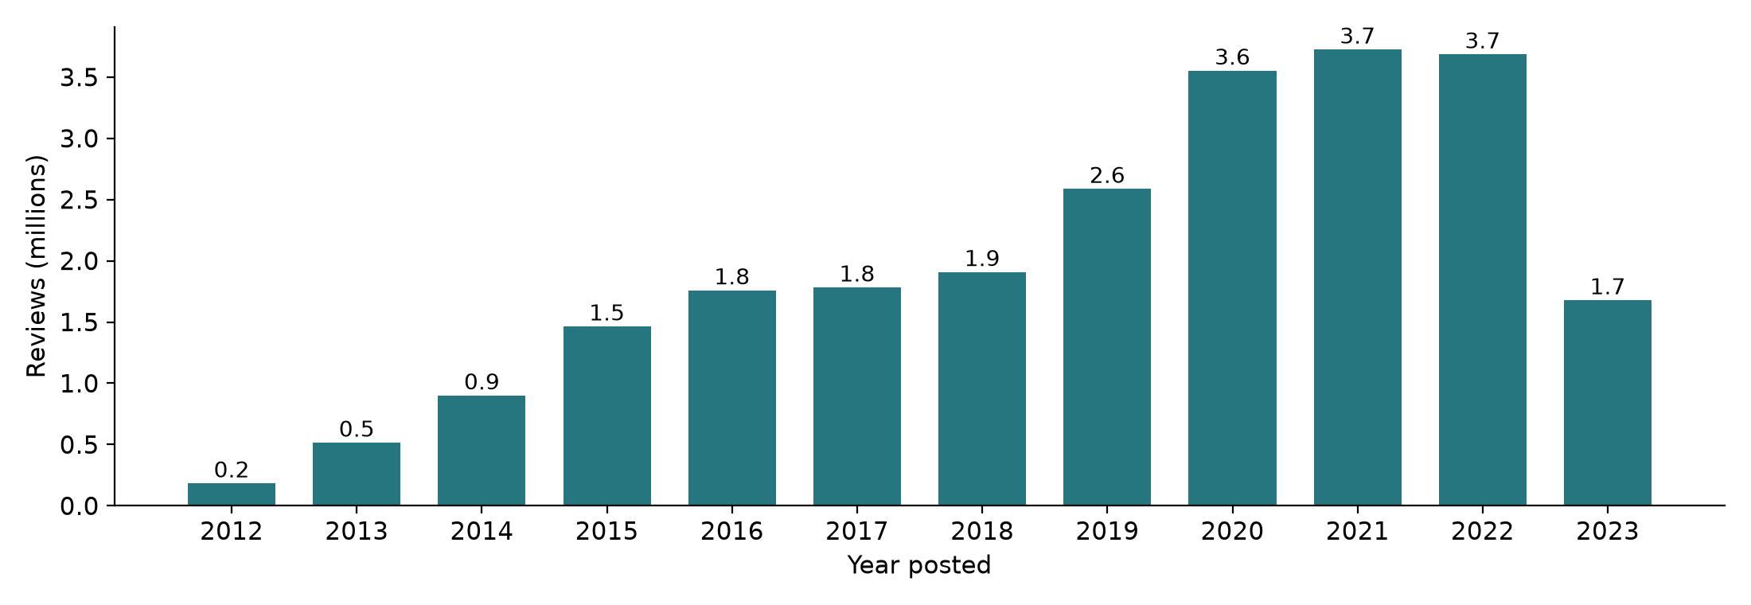
Figure 3. Reviews containing a safety-related word, by word group.
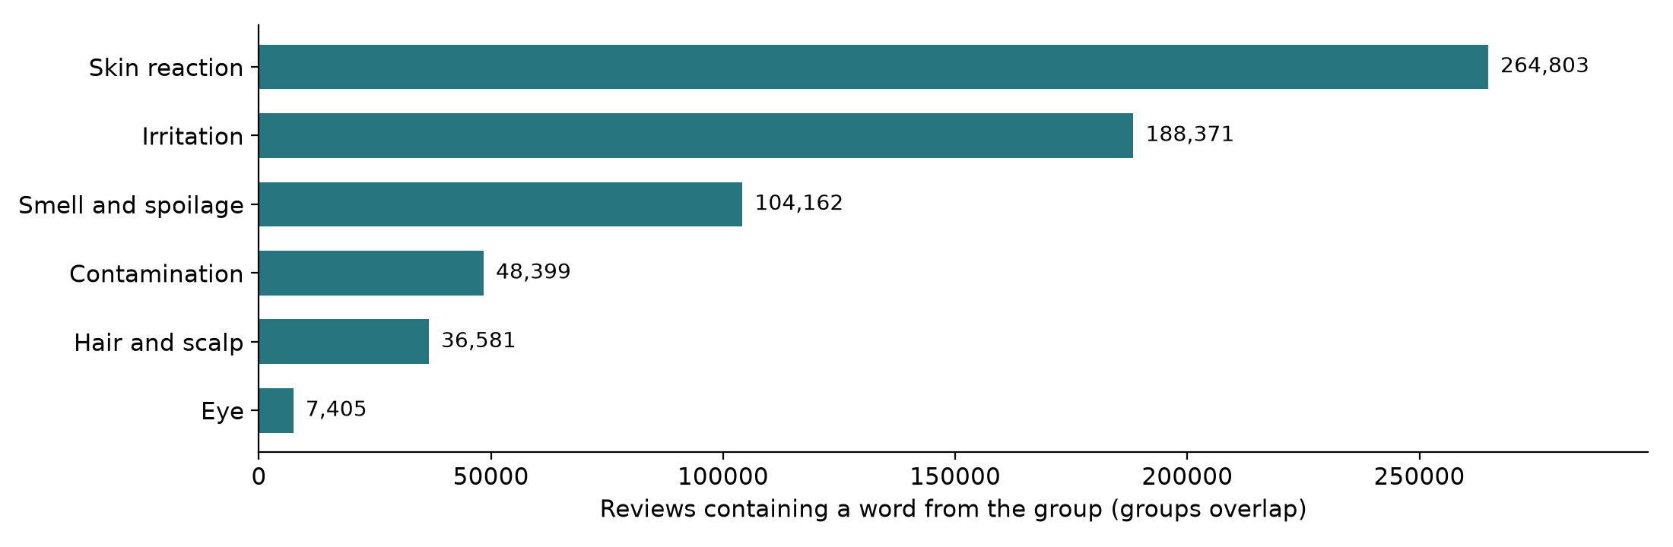
The safety-word reviews are spread across 138,833 products, 13.5% of the catalogue. They are concentrated: 4,627 products have 20 or more such reviews and 595 have 100 or more. These are the products where a rate over time can be measured at all.

7.2 Why keywords are not enough
Keyword hits appear in 5.8% of one-star reviews and 1.8% of five-star reviews. But because five-star reviews are so numerous, 46% of all keyword hits sit in five-star reviews. Reading them shows why: "no irritation", "finally stopped the itch", "gentle on my sensitive skin".
Figure 4. Safety-word reviews by star rating. Left: share of each star level. Right: share of all safety-word reviews.
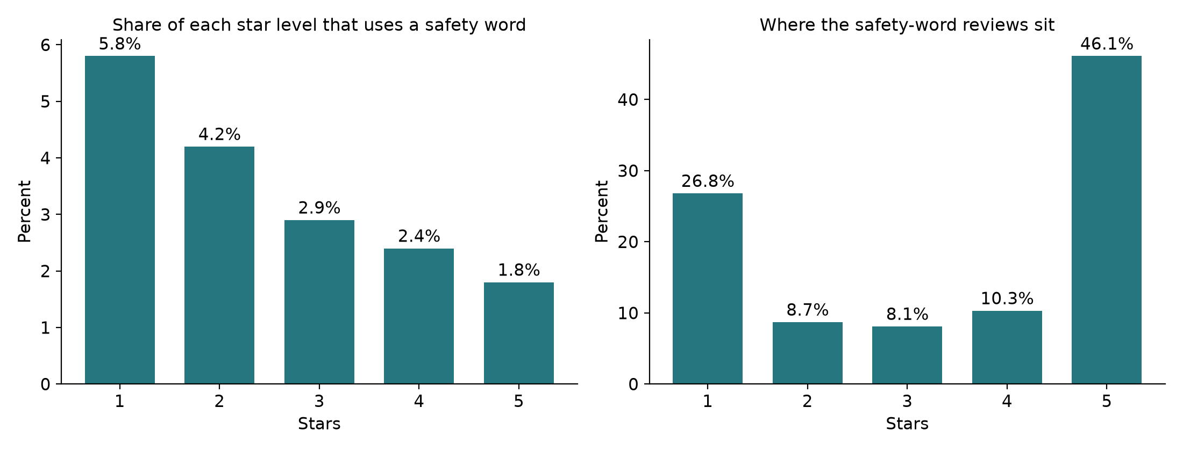
The word groups behave very differently. Irritation words appear mostly in praise: 58.9% of reviews using them are five-star and only 13.4% are one-star. Smell and spoilage words are the reverse: 19.5% five-star and 48.1% one-star. A single rule cannot treat the groups alike.
Figure 5. Share of each word group's reviews that are five-star.
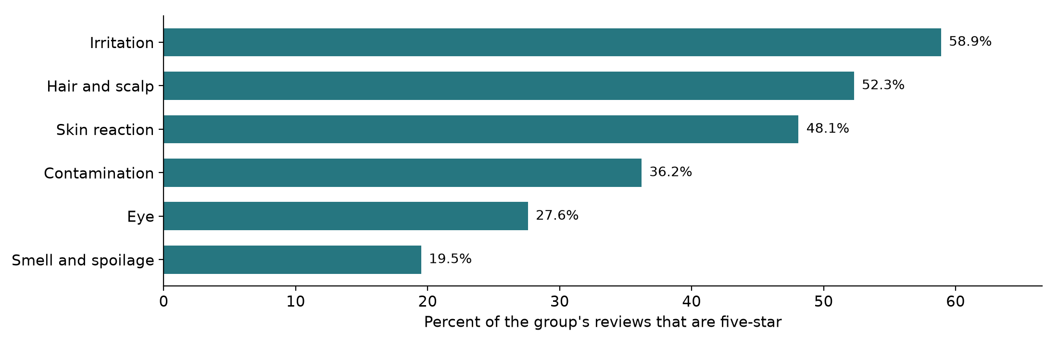
Negation explains much of this. A simple check for a negation cue (no, not, never, without, didn't and similar) within three words before a safety word finds one in 142,572 of the 614,203 safety-word reviews, or 23.2%. The share is 37.2% among five-star reviews and 5.1% among one-star reviews. The check is approximate, but the direction is clear: the higher the rating, the more likely the safety word is being denied, not reported.
Figure 6. Share of safety-word reviews with a negation cue just before the safety word, by star rating.
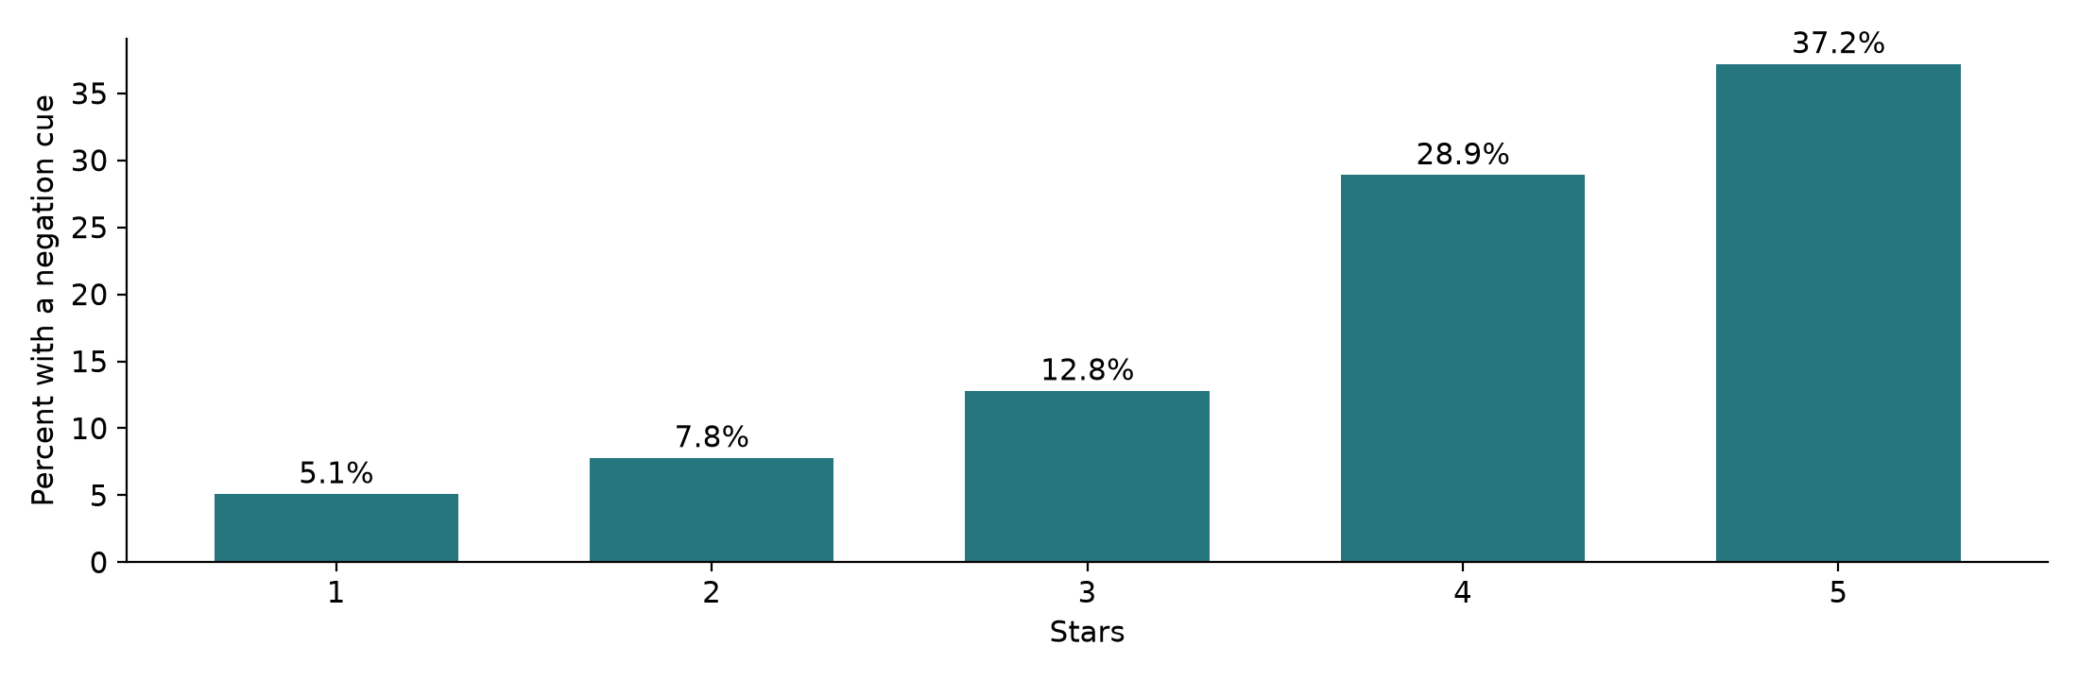
Safety-word reviews also look different from ordinary ones. Compared with a random sample of 20,000 reviews that use no safety word, they are longer (median 52 words against 20), more often voted helpful by other shoppers (43.9% against 25.8%) and less often from a verified purchase (83.0% against 90.9%). Length and helpful votes are therefore candidate features, and the verified flag needs a sensitivity check.
Figure 7. Safety-word reviews compared with a random sample of 20,000 reviews that use no safety word.
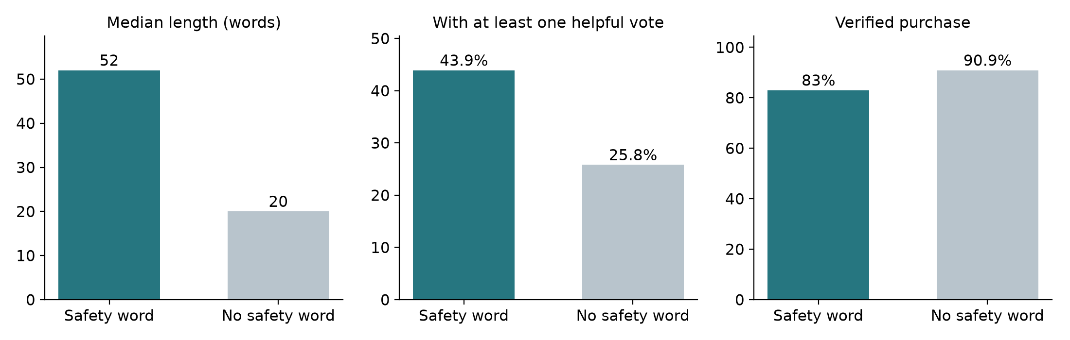
In an informal, single-reader check of 60 randomly sampled keyword-hit reviews, 13 (22%) clearly described an adverse reaction, spoilage or contamination involving the reviewed product. Five more complained only that the product smelled bad, which may be a preference and not a defect. The other 42 were negations, descriptions of a condition the product relieved, or unrelated uses of the word. This check is too small and too informal to be a result. It is enough to plan with: if about one keyword hit in five is genuine, genuine complaints are roughly 0.5% of all reviews, before counting complaints that use none of the listed words.
The contamination group is the noisiest. Of its 48,399 reviews, 41,290 match no other group. Within those, 18,320 contain "expired", 11,452 "bacteria" or "bacterial", 4,605 "recall" or "recalled" and 4,526 "infection". A short read of each word in context found the same harmless uses repeatedly: a return window that had expired, praise for antibacterial products, an infection the product cleared, and "recall" meaning remember. Genuine complaints also occur, such as an expired item received. The broad group stays in use for drawing the annotation sample, where catching more is the aim, while the baseline in Section 8.6 uses a tightened version; Week 3 records both versions so that the sampling pool and the comparison never change silently.

7.3 How many recalled products have earlier reviews
For RQ4, I listed 40 recalled product lines by hand from the Health Canada and FDA records and searched for them by title in the Amazon catalogue. Matches are by title only and have not been reviewed for variant, lot or country.
Table 8. Recalled product lines with dated reviews before the recall (40 lines examined)
Measure | Product lines
At least one title match in the Amazon catalogue | 27
At least 1 review dated before the recall | 23
At least 20 reviews dated before the recall | 14
At least 20 reviews in the 12 months before the recall | 8
At least 100 reviews in the 12 months before the recall | 3
Figure 8. Recalled product lines that have dated reviews (40 lines examined).
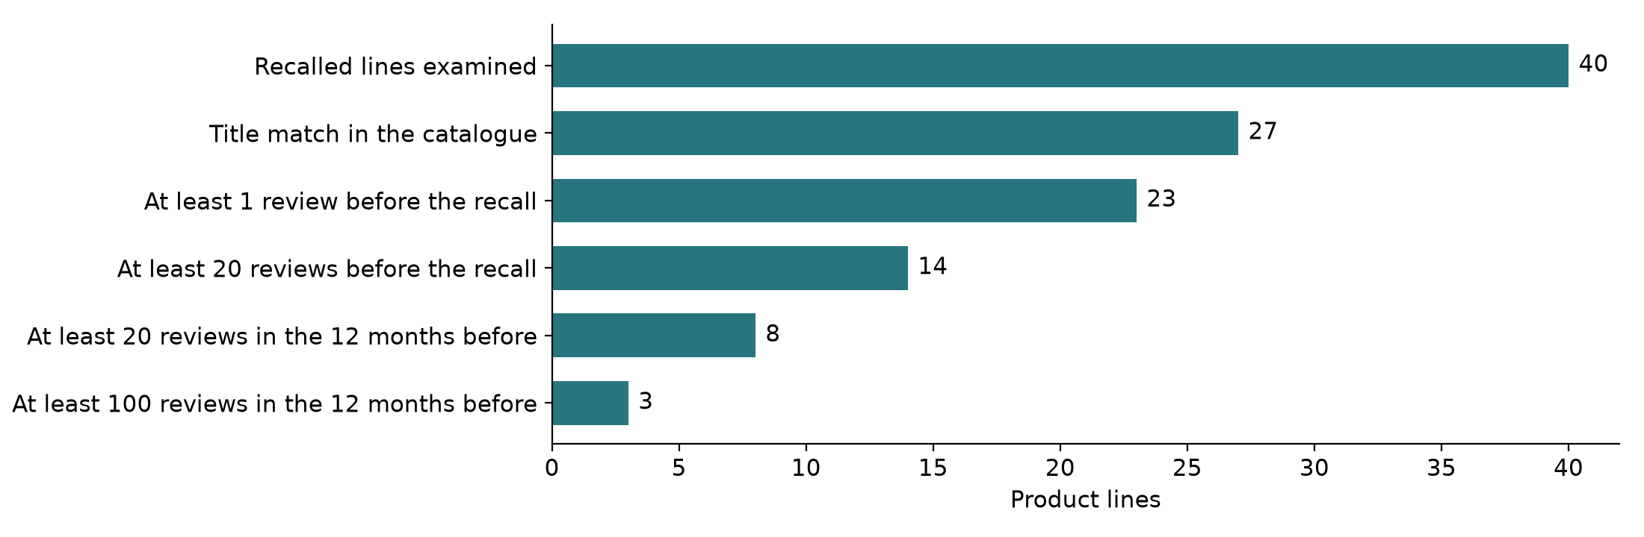
Table 8a. The eight recalled lines with 20 or more reviews in the 12 months before recall
Product line (title match) | Recall source and date | Hazard | Reviews before | In the 12 months before
Bioderma Sensibio H2O | Health Canada, 4 Mar 2022 | Microbial | 3,016 | 368
Dove dry shampoo | Health Canada, 18 Oct 2022 | Benzene | 2,062 | 241
Neutrogena Beach Defense spray | FDA, 14 Jul 2021 | Benzene | 695 | 193
Matrix Vavoom freezing spray | Health Canada, 12 Jun 2019 | Labelling | 78 | 47
Coppertone Sport Mineral spray | FDA, 30 Sep 2021 | Benzene | 79 | 44
Secret dry spray | FDA, 23 Nov 2021 | Benzene | 37 | 35
Banana Boat Hair and Scalp spray | FDA, 29 Jul 2022 | Benzene | 295 | 21
KeraCare detangling shampoo | Health Canada, 16 Jan 2018 | Other | 170 | 21
Figure 9. Case line: reviews of products matching "Bioderma Sensibio H2O", by quarter, 2018 to September 2023.
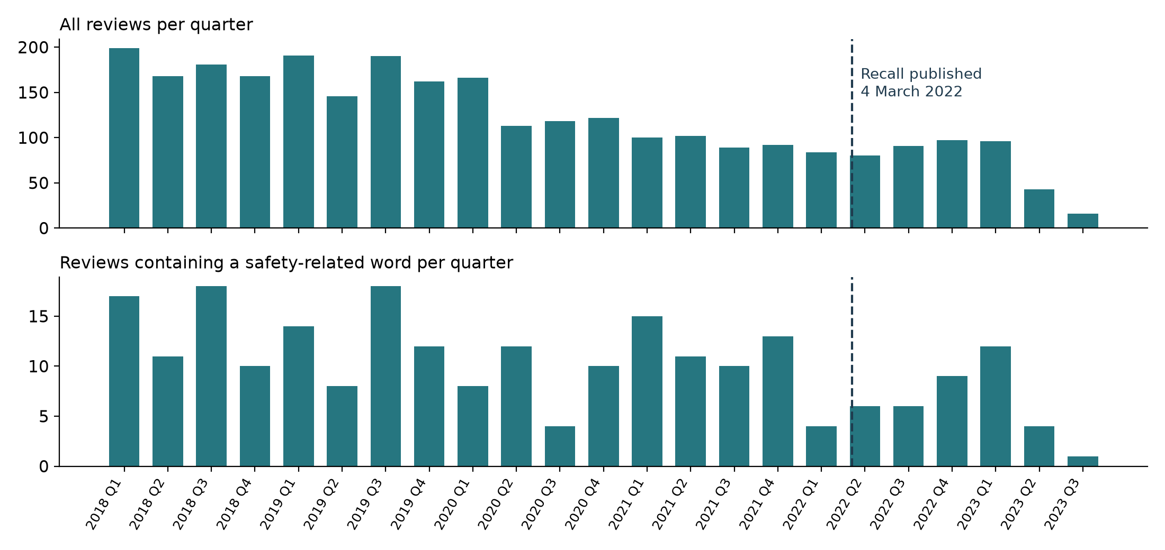
Figure 9 is the worked example from Section 2.4 over time. Of the 3,016 reviews before the recall, 242 use a safety word. The quarterly count of safety-word reviews shows no visible rise before March 2022. That is an honest null from a crude measure: the count includes praise for a product sold for sensitive skin, covers US buyers of a Canadian lot recall, and cannot see batches. It shows why RQ4 needs labelled complaints, and why it is treated as exploratory. The share view is less flat: safety-word reviews were 10.8% to 15.0% of each quarter's reviews in 2021 against 3.4% to 10.6% in 2020. Each quarter in those two years holds only 89 to 166 reviews, so a few reviews move the share by several points, and the words include praise. Neither view is evidence either way until the reviews are labelled.
Only eight lines have enough recent reviews to compare rates. Of the 12 microbial or mould recalls on the list, where a customer could plausibly notice a problem, only one product has substantial volume (3,016 earlier reviews). RQ4 is therefore exploratory and will be reported as a descriptive comparison and a case study, not a predictive model.

7.4 What the official sources contain
Opening each official file showed what it can and cannot be used for.
Table 8b. Findings from inspecting the official recall and complaint files
Source | What was measured | Consequence for the project
Health Canada recalls (34,212 records) | 201 beauty and personal care records; stated hazards are labelling 39, microbial 35, chemical 32; 81 state no hazard | Good source of perceivable defects, but 40% of beauty records need the hazard read from the title
openFDA drug recalls (18,010 records) | 114 give benzene as the reason, 74 of them from 2020 to September 2023; three firms account for 57 of the 74 | Useful comparison group; benzene cannot be noticed by a user
openFDA cosmetic adverse event reports (85,511) | 71% name a cancer term and 12% name a skin, hair or irritation term; latest report August 2025 | Not a picture of everyday reactions; used only as a word list for labelling rules
French recall notices (296 cosmetic) | 5 notices have no consumer instruction; all have a brand | Kept for the exploratory traceability question
Figure 10. openFDA cosmetic adverse event reports: the ten most frequent reaction terms.
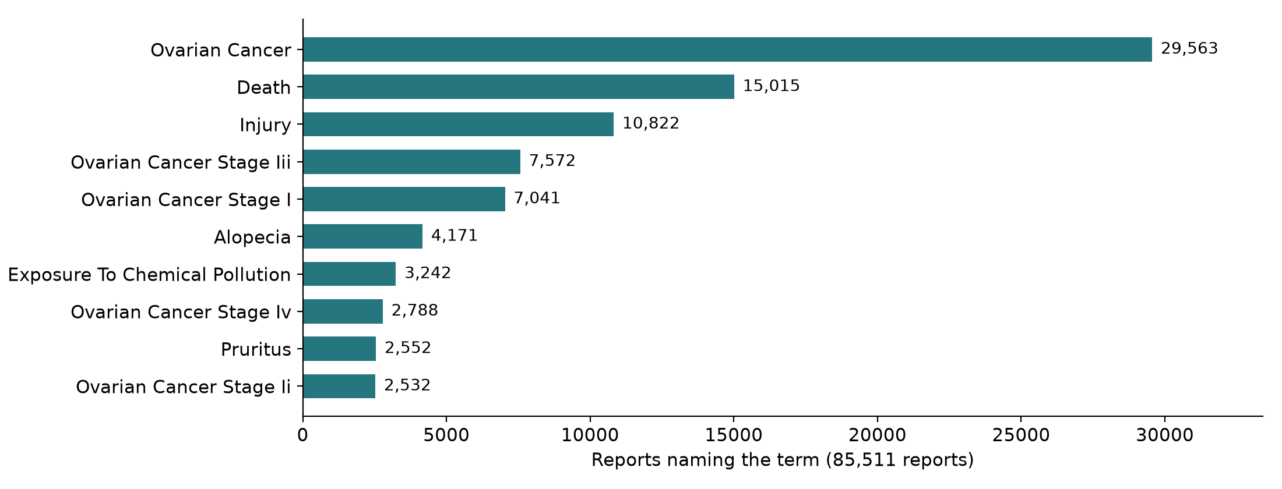
Figure 11. Health Canada beauty and personal care recalls by first hazard stated.
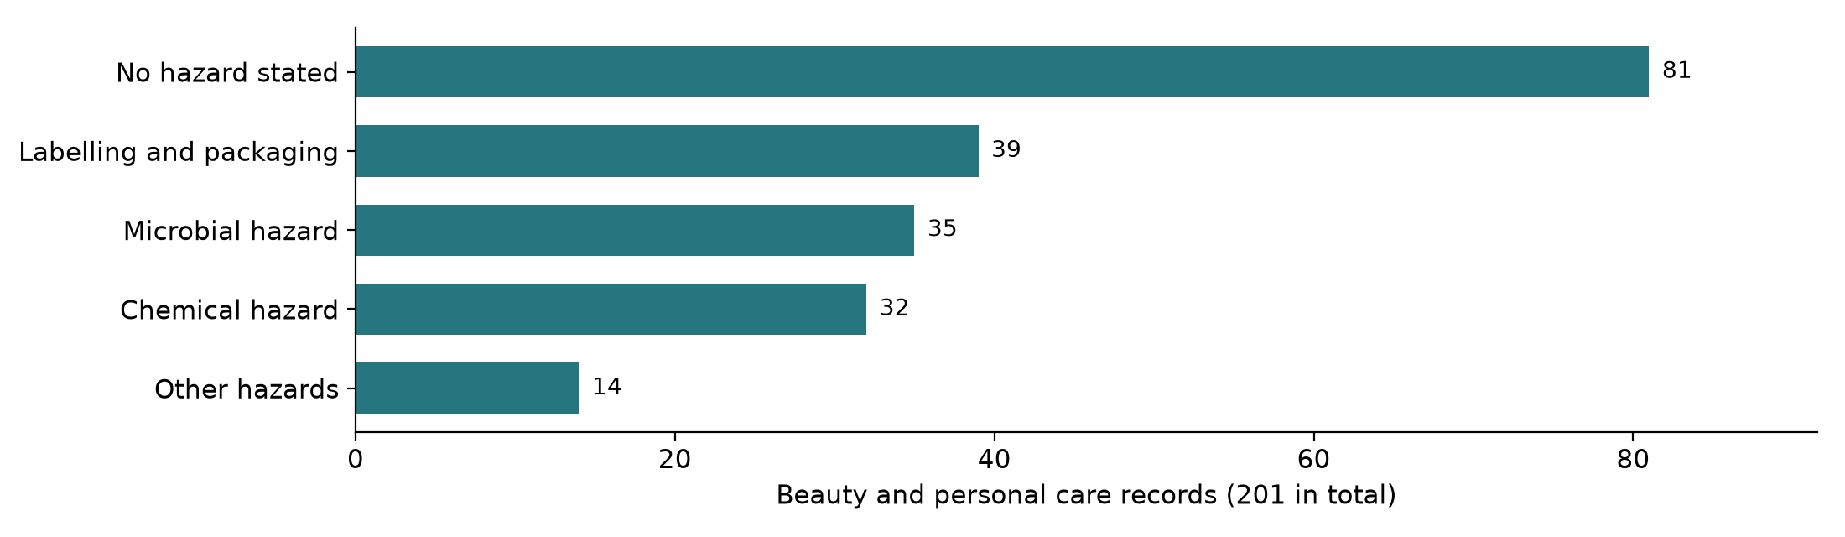

7.5 Data quality issues already counted
Table 8c. Cleaning issues measured in the 23,911,390 reviews
Issue | Reviews affected | Planned rule
No review text | 36,594 (0.15%) | Exclude from labelling; report the count
Line-break tags left in the text | 1,680,889 (7.0%) | Replace with a space in a cleaned copy
HTML character codes left in the text | 217,524 (0.9%) | Decode to plain characters
Video placeholders | 200,283 (0.8%) | Remove the placeholder, keep the review
Characters outside plain ASCII | 4,035,847 (16.9%) | Keep; measure the non-English share
Text under three words | 1,649,925 (6.9%) | Keep; too short to describe a reaction
Same product, title and text repeated | 6,260 of the 614,203 safety-word reviews | Keep one copy
Figure 12. Share of reviews affected by each cleaning issue.
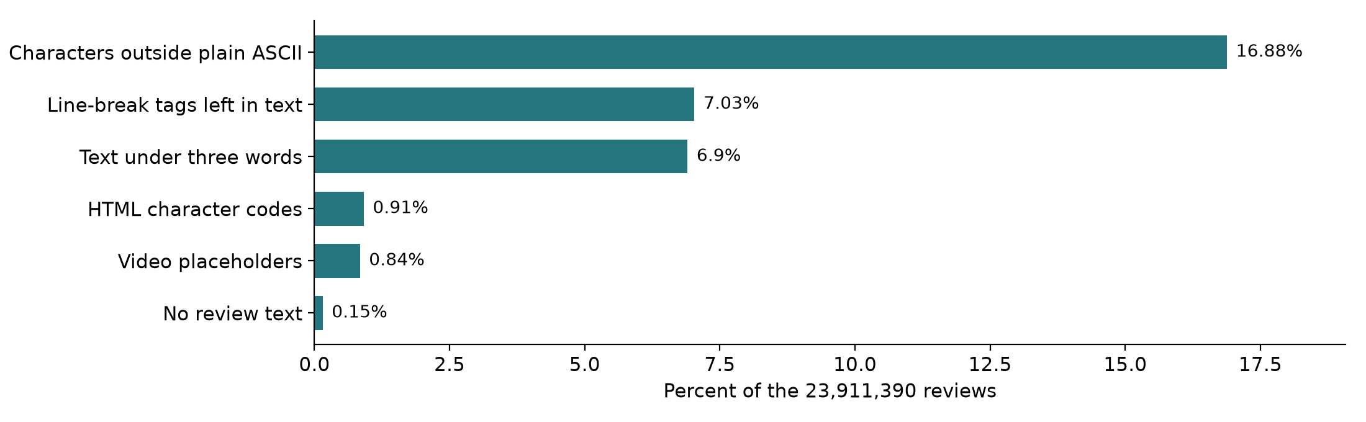

7.6 Feasibility verdict
- RQ1 to RQ3 are feasible. The review pool is large, complaints are present, and a keyword-enriched sample will contain enough positive cases to label.
- RQ4 is feasible only as a descriptive study. Too few recalled lines have enough earlier reviews.
- RQ5 is limited. Earlier scoping on French recall notices found 30 barcode-linked products, 17 with usable names, and one clear wrong-size match. Reviews contain no batch numbers, so batch-level tracing cannot be tested.

8. Step-by-step approach and methodology
The approach is eight steps. Labelling and weak supervision come before any modelling, because a model is only as trustworthy as the labels it is tested on. Table 9 gives the overview. Sections 8.1 to 8.8 then describe each step: what goes in, what is done, which tool does it, what comes out and how the step is checked.
Figure 13. The eight steps in order.
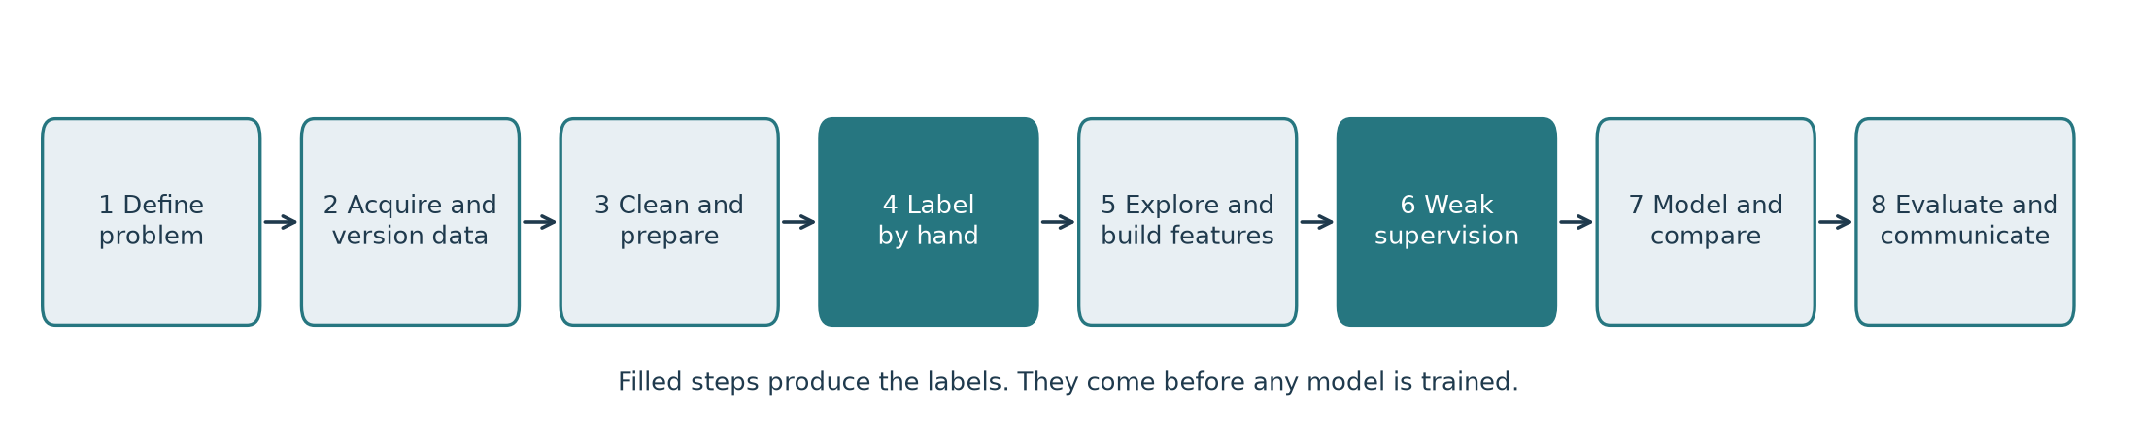
Table 9. The eight steps at a glance
Step | What is done | Output | Tools | Week
1 | Fix the problem and scope | This report | Word | 1
2 | Acquire and version the data | Fingerprinted files and a source register | hashlib, pandas | 2
3 | Clean and prepare | Analysis table and sampling frame | pandas, re, html | 3
4 | Label by hand | 500 to 1,000 labelled reviews with agreement figures | Spreadsheet, scikit-learn | 2 to 4
5 | Explore and build features | Charts, tests and a feature table | matplotlib, seaborn, SciPy | 4
6 | Weak supervision | Rule-made labels scored against hand labels | pandas, scikit-learn | 4
7 | Model and compare | Baseline and at least two models on the same folds | scikit-learn | 5
8 | Evaluate and communicate | Final metrics, error audit, dashboard | scikit-learn, SciPy, Streamlit | 6

8.1 Step 2: acquire and version the data
- Input. The eleven sources assessed: the nine in Table 6, the FDA recall dashboard and the rejected Sephora set.
- Procedure. Download each file once into a raw folder that is never edited. Record the link, the file time, the size and a SHA-256 hash. Check that compressed files open fully. Build a register with owner, licence, update frequency, what one row represents, strengths and weaknesses.
- Output. A download record and a source register. Eight files are fingerprinted so far, the largest being the 2.96 GB review file.
- Check. A later run recomputes each hash; a changed hash means the publisher changed the file and results must be re-derived.

8.2 Step 3: clean and prepare
- Input. 23,911,390 reviews and 1,028,914 product records.
- Procedure. Apply the rules in Table 8c in a fixed order, keeping the original text beside the cleaned text. Replace reviewer identifiers with a pseudo-identifier, a shortened SHA-1 of the reviewer, product and time fields. The key is deterministic, so anyone holding the source dataset can recompute it and find the review: it is pseudonymisation, not anonymisation, which is why only labels and never review text are published. Convert posting times to UTC. Join each review to its product so that every later split can be grouped by product.
- Output. One analysis table and a sampling frame in which each review carries its stratum and its chance of being sampled.
- Check. Row counts in and out of every stage are logged; unit tests cover each rule on real strings.
for each review in raw_reviews:
if text is empty: count and skip
clean = decode_html_codes(text)
clean = replace_line_break_tags(clean, with=' ')
clean = remove_video_placeholders(clean)
clean = collapse_spaces(clean)
key = sha1(reviewer_id + product_id + timestamp) # reviewer_id is then dropped
flags = match_word_groups(title + ' ' + clean) # six groups, Table 7
write(key, product_id, rating, utc_time, verified, text, clean, flags)
drop exact repeats of (product_id, title, text), keeping the first

8.3 Step 4: label by hand
Section 9 gives the full annotation design. In brief: a stratified sample of 1,000 reviews (500 minimum), a written guideline, a 50-review pilot, 200 reviews labelled by two people, Cohen's kappa of at least 0.70 as the target, and a frozen split of about 60% development and 40% test grouped by product.
Why 1,000. At the informal rate of about one genuine complaint in five safety-word reviews, 1,000 labels should hold roughly 130 positives, so the test portion would hold about 52. If a model's recall on those 52 is measured at 0.75, the 95% interval runs from about 0.62 to 0.85 (Wilson method). With 500 labels the interval would be roughly 0.56 to 0.88, too wide to compare models. This is the reason the target is 1,000 and 500 is only a floor.

8.4 Step 5: explore and build features
Table 9a. Planned exploratory analyses
Question | Statistic or test | Chart
How common are complaints overall? | Weighted prevalence with a 95% interval | Single figure with interval
Does the complaint rate differ by star rating? | Proportion per star with Wilson intervals | Bar chart with interval marks
Does it differ by product category? | Chi-square test of independence | Sorted horizontal bars
Are complaint reviews longer? | Mann-Whitney U test on word counts | Box plot
Which words separate complaints from praise? | Log-odds ratio of word counts | Ranked word table
How often is a safety word negated? | Share with a negation cue, by label | Stacked bar
Do verified and unverified reviews differ? | Fisher's exact test | Paired bars
Which complaint types and severity cues occur in each word group? | Cross-tabulation of complaint type by word group; share with a medical-attention cue by stratum, with Wilson intervals | Stacked bars
Features. Word TF-IDF on one and two word phrases and character TF-IDF on three to five character fragments (to survive misspellings such as "alergic"); a negation cue (a safety word within three words after no, not, never, without or didn't); star rating; review length; and the verified-purchase flag.

8.5 Step 6: weak supervision
A labelling function is a small rule that votes Yes, No or abstains on a review. No single rule is reliable, but several combined can label thousands of reviews that nobody has time to read (Ratner et al., 2017). Each rule is first scored against the hand-labelled development set, never the test set.
Table 9b. Planned labelling functions
Rule | Fires when | Vote
First-person reaction | A phrase such as "gave me a rash", "broke me out", "burned my" appears | Yes
Spoilage on arrival | A spoilage word appears near "arrived", "opened" or "smells" | Yes
Low star with safety word | One or two stars and any safety-related word | Yes
FDA reaction vocabulary | An everyday form of an FDA reaction term appears (itching, hair loss, redness, hives) | Yes, low weight
Negated safety word | A negation cue sits within three words before the safety word | No
Condition relieved | "Stopped", "cured", "helped" or "relieved" sits near the condition | No
Other product | "My old", "other brands" or "used to use" sits near the safety word | No
Five star, no safety word | Five stars and no safety-related word | No
For each rule the notebook reports coverage (how many reviews it votes on), precision against development labels, and how often it conflicts with other rules. Votes are combined first by simple majority and then by a vote weighted by each rule's measured precision. Hypothesis H3 compares a model trained on these rule-made labels with one trained on hand labels.

8.6 Step 7: model and compare
Table 9c. Models, settings and the reason for each
Model | Planned settings | Why it is included
Naive keyword baseline | Any match to the six word groups in Table 7, scored by the number of groups matched; no fitting | Shows how far the sampling net alone gets
Tuned keyword baseline | Tightened patterns ("recall" as remember, expired return windows and antibacterial praise removed), the negation rule from Section 8.4 and a rating rule (lower stars ranked higher); each rule kept only if it raises average precision on development folds | The baseline H2 is tested against, so beating it means more than beating a naive word list
Logistic regression on TF-IDF | Balanced class weights; regularisation strength chosen from 0.1, 1 and 10 | Fast, readable coefficients, strong on short text
Gradient boosting on engineered features | Shallow trees, early stopping, balanced weights | Tests whether negation, rating and length add value
Logistic regression on weak labels | Same settings, trained on rule-made labels only | Tests H3
Pretrained sentence encoder with a linear head | No fine-tuning of the encoder | Optional; run only if a clear gap remains
Both keyword baselines are scored on the same development folds as the models, and H2 is claimed only against the tuned one. The tightened patterns are a second, versioned copy of the word list: the broad list keeps drawing the annotation sample, and Week 3 records which version produced each output.
- Validation. Five-fold cross-validation on the development set, stratified by label and grouped by product, so no product appears on both sides of a split.
- Selection. Settings are chosen by mean average precision across folds. The test set is not opened during this step.
- Overfitting checks. Training and validation scores are reported side by side, with learning curves. The vocabulary is capped so that features do not vastly outnumber labelled reviews.

8.7 Step 8: evaluate
Each model is run once on the frozen test set. The headline measures are precision (of the reviews flagged, how many are genuine), recall (of the genuine complaints, how many were flagged) and average precision. Accuracy is not a headline measure, for the reason the worked example below makes concrete.
Table 9d. Worked illustration on 10,000 reviews (planning figures on the full-population basis, not results)
Method | Reviews flagged | Genuine among them | Precision | Reviewer time at 40 s each
Flag nothing | 0 | 0 | Undefined | 0 (and 99.4% accurate)
Keyword search | 257 | about 57 | 22% | 2.9 hours
Target for a classifier | 100 | about 46 | 46% | 1.1 hours
Both rows are on the full-population basis, in which about 0.5% of reviews are genuine complaints. The keyword row applies the measured 2.57% hit rate and the informal 22% genuine share. The classifier row is a target: keep four in five of the complaints the keywords find while cutting the reading load by 60%. Reaching 46% precision in deployment would need roughly 96% precision on the enriched test set by the conversion below, so the target is ambitious and test results are converted before they are compared with it.
Evaluation protocol: two bases, never mixed. The labelled test set is enriched: about 52 of its roughly 400 reviews (13%) are expected to be complaints, against roughly 0.5% of all reviews (Section 7.2). Because precision depends on how common positives are, every test-set figure is reported as an enriched-sample metric and used only to compare models with each other. What a brand would experience is reported separately, at the population base rate. The main estimate weights each test review by the inverse of its inclusion probability, which Section 9.2 records for every sampled review. As a hand check, enriched precision is converted with the prior-correction formula below, which assumes the model's recall and false-alarm rate are the same in the sample as in deployment.
P_pop = P_s * (p_pop / p_s) / ( P_s * (p_pop / p_s) + (1 - P_s) * ((1 - p_pop) / (1 - p_s)) )

P_s = precision on the enriched test set p_s = complaint share in the test set
p_pop = complaint share among all reviews

worked example: P_s = 0.46, p_s = 52 / 400 = 0.13, p_pop = 0.005
numerator = 0.46 * 0.005 / 0.13 = 0.0177
denominator = 0.0177 + 0.54 * 0.995 / 0.87 = 0.0177 + 0.6176 = 0.6353
P_pop = 0.0177 / 0.6353 = 0.028
A precision of 0.46 on the enriched test set therefore means about 2.8% in deployment, roughly one genuine complaint in 36 flags. The sample over-represents keyword hits, which are the hardest negatives, so the false-alarm rate measured on it is probably higher than in deployment and the formula probably understates deployment precision. That is why the weighted estimate is the headline and the formula only a check. The workload implied by the chosen threshold, in flags per 10,000 reviews and reviewer hours, is always reported at the population base rate.
What size of improvement the test can detect. With about 52 positives in the test set, small gains in average precision cannot be separated from chance. A simulation of the H2 rule (paired bootstrap of the difference in average precision, 300 simulated test sets of 400 reviews with 52 positives, baseline average precision about 0.37) found that the classifier must beat the baseline by roughly 0.13 to 0.19 in average precision to be detected four times in five, depending on how closely the two models' scores agree (correlation 0.8 to 0.5). Smaller true gains will usually give an interval that includes zero. Such a result is recorded as inconclusive, not as evidence that the classifier does not help (Table 14). The simulation resampled reviews; resampling whole products, as planned, widens the interval, so the real detectable gain is somewhat larger.
- Uncertainty. Every figure carries a bootstrap 95% interval, resampling whole products.
- Paired comparison. Model against baseline on the same test reviews, using an exact McNemar test.
- Error audit. Every false alert and every miss is read and filed under negation, relieved condition, other product, preference, unusual wording or label doubt.
- Threshold. One alert threshold is fixed on development data from a stated reviewer workload (for example, 100 flags a week), before the test run, and the same threshold is applied to every model, including the weak-label model for H3. F1, precision and recall are reported at that threshold; average precision, which needs no threshold, is the headline comparison for H2 and H3.

8.8 Tools and why they were chosen
Tool | Used for | Why it suits this project
pandas, NumPy | Tables, joins, counts | Standard, well documented, handles the 614,203-row candidate table in memory
gzip, json, hashlib | Streaming the 2.96 GB file; fingerprints | Built into Python; reads the file without unpacking it to disk
re, html | Word groups and text cleaning | Transparent rules that can be unit tested
scikit-learn | TF-IDF, models, grouped folds, kappa, metrics | One consistent interface for every model compared
SciPy | Fisher, chi-square, Mann-Whitney tests | Exact tests suited to small counts
matplotlib, seaborn | Charts | Reproducible figures from code
Streamlit | Review dashboard | A single file turns results into a tool a non-technical reader can use
Jupyter, Git, pytest | Reproducibility | Narrative, history and automated checks in one repository

9. Human annotation strategy
The labelled set is the core asset of the project. The target is 1,000 reviews, with 500 as the minimum that still allows a held-out test.

9.1 Label scheme
Table 10. Labels assigned to each review
Label | Values | Rule of thumb
Safety complaint | Yes, No, Unclear | Yes when the reviewer says this product, as received or used, caused a physical reaction or showed spoilage, contamination or a hazardous defect
Complaint type | Skin reaction; eye; hair and scalp; spoilage or contamination; packaging injury; other | Only when the first label is Yes; choose the main one
Severity cue | None stated; discomfort; medical attention mentioned | Record what the reviewer wrote; do not infer
Experienced by | Reviewer; someone else; not stated | Second-hand reports are kept but marked
The guideline's hardest rules concern what is not a complaint: a negated mention ("no rash"), a condition the product treated, a problem with a different product, simple dislike of a scent, and delivery or price issues. Appendix A gives constructed examples. Complaint type and severity cue feed the Week 4 exploration (Table 9a) and the Week 6 error audit; experienced-by is used to rerun the main results without second-hand reports.

9.2 Sampling design
A random sample of 1,000 reviews would contain about five complaints. The sample is therefore stratified to enrich for positives while keeping enough ordinary reviews to estimate how many complaints the keywords miss.
Table 11. Annotation sample by stratum
Stratum | Target of 1,000 | Minimum of 500 | Purpose
Keyword-hit reviews, equal numbers from the six word groups | 480 | 240 | Supply positive cases across complaint types
Random reviews with no keyword | 220 | 110 | Estimate complaints the keywords miss
One and two star reviews with no keyword | 150 | 75 | Find complaints phrased in unexpected ways
Reviews of recalled product lines, 12 months before recall | 150 | 75 | Support the RQ4 case study
Total | 1,000 | 500
Each sampled review carries its stratum and sampling probability, so prevalence can be estimated for the whole file by weighting. At the informal rate seen in Section 7, the 1,000 sample should yield roughly 120 to 160 positive reviews; the 500 sample about half that, which is thin for a test set. Sampling is grouped so that no product contributes more than three reviews.

9.3 Process and quality control
- Guideline draft. Write definitions, decision rules and examples before seeing the sample.
- Pilot. Two annotators label the same 50 reviews, compare disagreements and revise the guideline.
- Main round. The first annotator labels the full sample in batches of 100, with stratum and star rating hidden to avoid anchoring.
- Double labelling. A second annotator independently labels 200 reviews (20%), drawn across all strata.
- Agreement. Report Cohen's kappa for the binary label and for complaint type, with the confusion table. Target at least 0.70.
- Adjudication. Disagreements are discussed and resolved; the reason is recorded and the guideline updated.
- Consistency check. Thirty already-labelled reviews are reinserted unmarked in later batches to detect drift.
- Freeze. The final labels are split by product into development and test portions (about 60 and 40%), hashed and committed.
If no second annotator is available, the fallback is a test-retest check: the same annotator relabels 150 reviews after at least seven days. This is weaker evidence than two people agreeing and will be reported as such. A language model may be used as one more labelling function in Step 6, but never as a gold label.
Effort. At about 40 seconds a review, 1,000 reviews take about 11 hours, the 200 double labels a little over two hours, and the pilot, adjudication and guideline work about five more. This fits inside Weeks 3 and 4 alongside cleaning and exploration.

10. Ethics and responsible use
- Privacy. Reviews are public, but they were written to help shoppers, not to be studied for health information. Labels are stored against a deterministic pseudo-identifier built from the reviewer, product and time fields. Anyone holding the source dataset can recompute it, so it is not anonymous; therefore only labels, never review text, are published, and labels are never joined to other information about a reviewer. No reviewer is contacted or profiled.
- No verbatim quotation. Reports and the dashboard use paraphrased or constructed examples, so that a sentence cannot be searched to find its author.
- Health information. Self-disclosed conditions are treated as sensitive. They are labelled only as far as the scheme requires and are never linked across a reviewer's other reviews.
- Harm to brands. A complaint rate is not a finding of fault. Product-level results are prompts for investigation and are shown with volumes and uncertainty. No public ranking of unsafe products will be produced.
- No medical or safety advice. Outputs do not tell consumers whether to use a product. Official notices remain the authority.
- Licences. Amazon Reviews 2023 states no licence, so review text is not redistributed; only aggregate counts and labels keyed to review identifiers are shared. Open Beauty Facts is under ODbL and French recall data under the French Open Licence; both are attributed.
- Fairness. English-only reviews from one US marketplace under-represent many users. Reactions on darker skin tones or in other languages may be described differently and missed. This is stated with every result.
- Annotators. Labelling is voluntary, time-boxed, and limited to text. Annotators can skip any review.

11. Limitations and risks
Table 12. Main limitations, their effect and the planned response
Limitation | Effect | Response
Missing batch data | Reviews carry no lot number or purchase location, so a complaint cannot be tied to the recalled batch | Work at product-line level; state that a signal may reflect other lots; keep batch tracing as a future extension
Class imbalance | Genuine complaints are perhaps 0.5% of reviews; accuracy is meaningless and positives are scarce | Stratified sampling; precision, recall and average precision; class weights; intervals on every figure
Enriched test set | About 13% of test reviews are expected to be complaints against about 0.5% in deployment, so test-set precision overstates what a brand would see (0.46 becomes about 0.03) | Label test figures as enriched-sample metrics; report deployment precision and workload with inclusion-probability weights, and the prior-correction formula as a check (Section 8.7)
Small test set | About 52 test positives; gains below roughly 0.13 to 0.19 in average precision cannot be reliably detected | Record such results as inconclusive, not as failures; extend labelling if time allows
False alerts | Even a good classifier produces many false flags at this base rate, which wastes reviewer time and could unfairly mark a product | Human review of every flag; threshold set by workload; report precision at the top of the list; never auto-publish
Negation and context | "No irritation" and "cured my rash" contain complaint words | Explicit guideline rules; negation features; error audit by category
Invisible hazards | Banned ingredients and benzene cannot be perceived, so reviews cannot reveal them | Limit claims to perceivable defects; use benzene recalls as a comparison group
Fake and AI-written reviews | Inflated praise dilutes complaint rates; verified-purchase flags are imperfect | Sensitivity analysis with and without unverified reviews; state as a limit
Counterfeit products | A complaint may concern a fake, not the brand's product | Add a note field for suspected counterfeits; do not attribute fault
Coverage and age | US marketplace, English, ending September 2023 | Describe results as historical; no claim for other markets or for India
Self-selection | Reviewers are not a sample of users; an unhappy minority writes more | No incidence estimates; compare products with each other, not with the population
Single annotator risk | Labels may reflect one person's reading | Double labelling of 20%, or the stated test-retest fallback
Small recall overlap | Only eight recalled lines have enough earlier reviews | RQ4 reported descriptively with a case study
User needs assumed | That a ranked reading list is what a quality team wants is inferred from published recall cases and regulation, not from interviews | Stated as an assumption; tested in the brand pilot extension (Table 15)

12. Plan for the next steps

12.1 Week-by-week plan with decision gates
Table 13. Tasks, measurable outputs and decision gates for each week
Week | Main tasks | Measurable output | Decision gate
1 | Research; problem, questions, hypotheses; data check; annotation design | This report | Problem and plan fixed
2 | Source register; fingerprints; quality assessment; guideline draft; 50-review pilot by two annotators | Register of 11 sources; pilot kappa; share of pilot reviews that are genuine | Feasibility checkpoint: kappa at least 0.60 and at least 10% genuine among safety-word reviews, else revise and repeat once
3 | Cleaning pipeline with tests; sampling frame; first 300 labels | Row counts per stage; tests passing; 300 labels | Pipeline rebuilds from raw files with one command
4 | Labels to 1,000 (500 minimum); 200 double-labelled; exploration; features; labelling functions | Kappa with confusion table; frozen, hashed label set; rule coverage and precision | Annotation milestone: kappa at least 0.70, or the shortfall documented
5 | Keyword baseline; logistic regression; gradient boosting; weak-label model | Cross-validated precision, recall and average precision per model | Threshold fixed on development data before the test set is opened
6 | Single test run; intervals; error audit; dashboard; recommendations | Final metric table; error taxonomy; working dashboard | Each hypothesis recorded as supported, not supported, inconclusive or not testable
Figure 14. Six-week schedule with the three checkpoints.
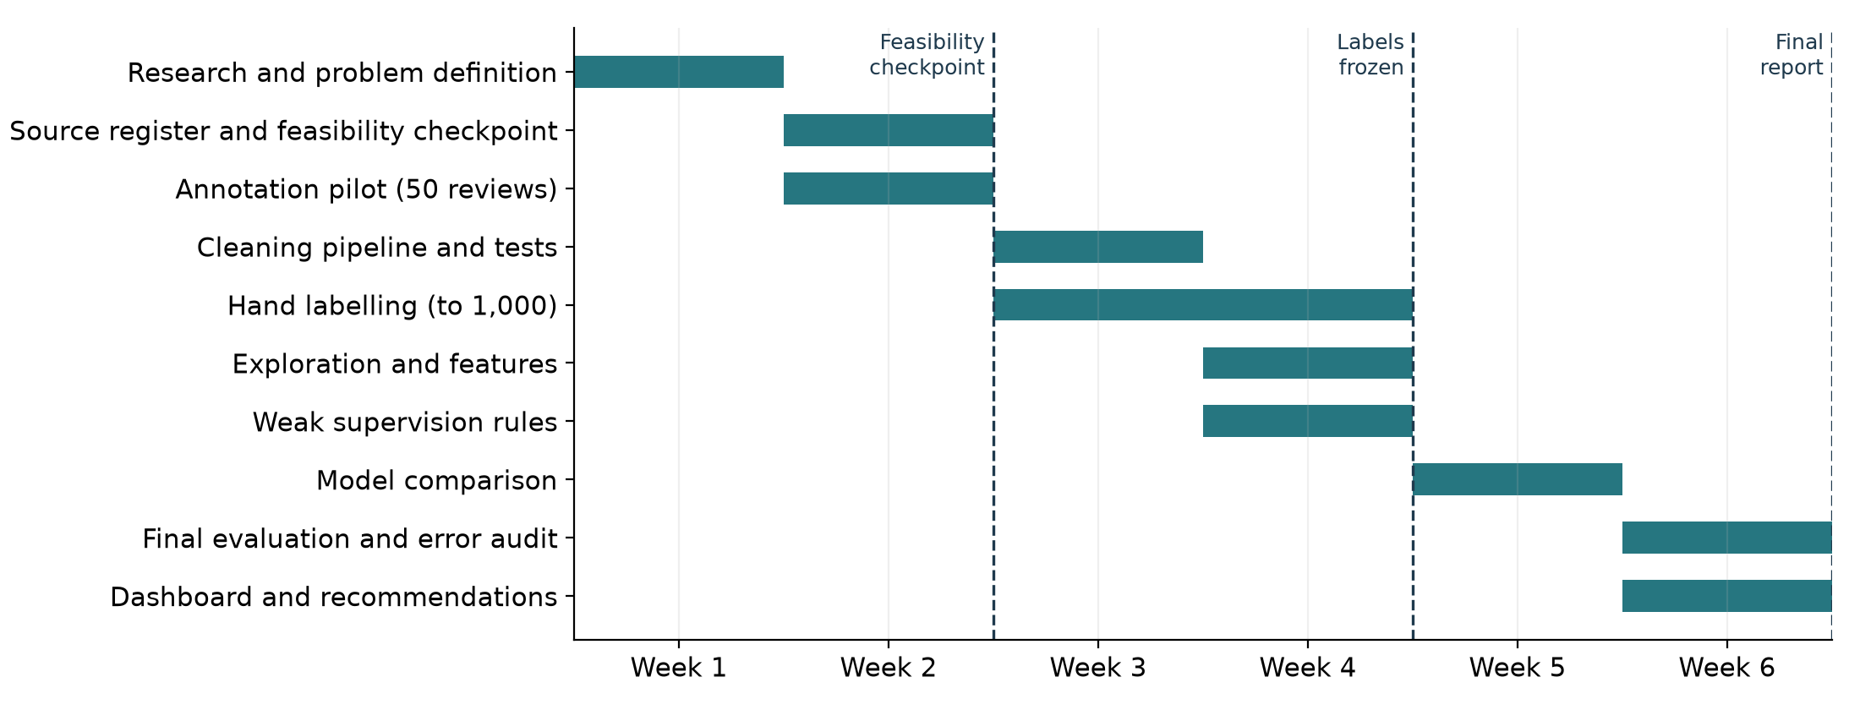

12.2 Immediate next actions
These are the first seven actions of Week 2, in order. As of 14 October 2026 the source files are downloaded and fingerprinted and the 50 pilot reviews have been drawn (30 safety-word reviews, 10 random, 10 low-star). No review has been labelled yet.
- Finalise the source register and the per-source quality table.
- Give the guideline and the pilot sheet to both annotators; each labels the same 50 reviews independently.
- Compute Cohen's kappa and the confusion table; list every disagreement.
- Revise the guideline where disagreements cluster, and tighten the word list (for example, "recall" also means "remember").
- Record the feasibility checkpoint decision in writing.
- Map each hypothesis to its dataset, variable and test in the Week 2 report.
- Begin the cleaning pipeline with the rules in Table 8c.

12.3 Decision rules agreed in advance
Table 14. What happens if a step does not go to plan
If | Then
Pilot kappa is below 0.60 | Revise the guideline, repeat the pilot once on 50 new reviews
Fewer than 60 positives after 500 labels | Continue to 1,000, drawing the extra reviews from the safety-word strata
No second annotator is available | Relabel 150 reviews after seven days and report test-retest agreement as weaker evidence
No model beats the tuned keyword baseline | Report the baseline, the labelled set and the error audit as the contribution
The classifier's gain is positive but its interval includes zero | Record H2 as inconclusive, not as failed, and report the gain against the detectable range in Section 8.7
Weak-label average precision falls more than 0.05 short | Keep hand labels as the training source; report which rules failed
Time runs short | Drop the optional sentence encoder, then dashboard extras; never the agreement check or error audit

12.4 Beyond the six weeks
Table 15. Extensions after the internship
Horizon | Extension | What it needs
1 to 3 months | Link flagged products to FDA adverse event reports and recall notices; add brand and size matching (RQ5) | Reviewed product pairs; the FDA dashboard export
1 to 3 months | Pilot with one brand quality team; measure reviewer time saved and complaints surfaced | A partner willing to share recent reviews
3 to 6 months | Current reviews in place of the 2023 snapshot; reviews in other languages | A licensed or partner review feed; multilingual labels
3 to 6 months | Batch-level tracing using order and lot records | Retailer or brand purchase data, which public reviews lack
6 to 12 months | Monitored service with drift checks and periodic relabelling | Governance for alerts, privacy review, an owner for each flag

12.5 What Week 1 includes and what it leaves for later
Done in Week 1 | Left for later weeks
Industry and academic research | Full source register and quality scoring (Week 2)
One business problem, five research questions and hypotheses | Testing any hypothesis (Weeks 4 to 6)
Variables and expected datasets named | Cleaning pipeline (Week 3)
Counts confirming the data can support the plan | Annotation (Weeks 2 to 4)
Method, annotation strategy, ethics and limitations on paper | Weak supervision and features (Week 4); models (Week 5)
No model trained and no review labelled | Evaluation, dashboard and recommendations (Week 6)
The counts in Section 7 come from the project notebook complaint_detection.ipynb in the repository, which reads the source files and saves its results. Earlier scoping work on French recall notices (cosmetic_recall_analysis.ipynb) informs RQ5 and involved no trained model.

13. Summary of findings and conclusion

13.1 Summary of findings
- The problem is real and current. Official cosmetic reporting is sparse (5,144 FDA reports in 13 years), cosmetics led EU safety alerts in 2025, and US companies must now report serious events within 15 business days.
- The literature supports the idea but has a gap. Reviews have carried early safety signals for vehicles, toys, food and restaurants; in cosmetics, the one close study maps skin complaints with a dictionary but reports no labels or detection accuracy, and no openly labelled set was found (Section 3.6).
- The data exists. 23.9 million dated beauty reviews are available, 614,203 (2.57%) of them using a safety-related word.
- Simple shortcuts fail. 46.1% of safety-word reviews are five-star and 23.2% contain a negation cue, so neither stars nor keywords can replace human labels.
- A recall study is possible only on a small scale. 8 of 40 recalled lines have enough earlier reviews; the one microbial case shows no rise in the quarterly count, and its share view is too noisy to read without labels. RQ4 is exploratory.
- The evaluation is planned for a rare class. Test figures are labelled as enriched-sample metrics and converted to the 0.5% deployment rate (a precision of 0.46 becomes about 0.03), and gains in average precision below roughly 0.13 to 0.19 will be reported as inconclusive.
- The plan is testable. Five research questions have hypotheses, measures and decision rules fixed in advance.

13.2 Conclusion
For the defects a customer can perceive, such as reactions, spoilage and contamination, public reviews are a large source of early safety information that none of the monitoring routes assessed in Section 1.7 screens for safety. The business problem defined here is narrow and testable: separate genuine safety complaints from ordinary comments reliably enough that a person can act on a short list. Industry trends make it timely, regulation makes it valuable, the literature shows the approach works in other product types, and the data check shows it is feasible within six weeks.
The plan is deliberately conservative. Labels come before models, a keyword baseline must be beaten before anything more complex is used, and the two questions the data supports weakly are marked exploratory. If the classifier does not beat the baseline, the labelled set, the agreement figures and the error audit still stand as a contribution. The next step, in Week 2, is the source register, the dataset feasibility checkpoint and the 50-review annotation pilot.

References
Abrahams, A. S., Fan, W., Wang, G. A., Zhang, Z., & Jiao, J. (2015). An integrated text analytic framework for product defect discovery. Production and Operations Management, 24(6), 975-990. https://doi.org/10.1111/poms.12303
Abrahams, A. S., Jiao, J., Wang, G. A., & Fan, W. (2012). Vehicle defect discovery from social media. Decision Support Systems, 54(1), 87-97. https://doi.org/10.1016/j.dss.2012.04.005
Bhat, S. K., & Culotta, A. (2017). Identifying leading indicators of product recalls from online reviews using positive unlabeled learning and domain adaptation. arXiv. https://doi.org/10.48550/arXiv.1703.00518
Chapman, W. W., Bridewell, W., Hanbury, P., Cooper, G. F., & Buchanan, B. G. (2001). A simple algorithm for identifying negated findings and diseases in discharge summaries. Journal of Biomedical Informatics, 34(5), 301-310. https://doi.org/10.1006/jbin.2001.1029
Cohen, J. (1960). A coefficient of agreement for nominal scales. Educational and Psychological Measurement, 20(1), 37-46. https://doi.org/10.1177/001316446002000104
Effland, T., Lawson, A., Balter, S., Devinney, K., Reddy, V., Waechter, H., Gravano, L., & Hsu, D. (2018). Discovering foodborne illness in online restaurant reviews. Journal of the American Medical Informatics Association, 25(12), 1586-1592. https://doi.org/10.1093/jamia/ocx093
European Commission. (n.d.). 2025 Safety Gate rapid alert system. Directorate-General for Justice and Consumers. Retrieved October 11, 2026, from https://op.europa.eu/webpub/just/safety-gate-2025-report/en/
Freifeld, C. C., Brownstein, J. S., Menone, C. M., Bao, W., Filice, R., Kass-Hout, T., & Dasgupta, N. (2014). Digital drug safety surveillance: Monitoring pharmaceutical products in Twitter. Drug Safety, 37(5), 343-350. https://doi.org/10.1007/s40264-014-0155-x
Gilardi, F., Alizadeh, M., & Kubli, M. (2023). ChatGPT outperforms crowd workers for text-annotation tasks. Proceedings of the National Academy of Sciences, 120(30), Article e2305016120. https://doi.org/10.1073/pnas.2305016120
He, S., Hollenbeck, B., & Proserpio, D. (2022). The market for fake reviews. Marketing Science, 41(5), 896-921. https://doi.org/10.1287/mksc.2022.1353
Health Canada. (2025, February 7). amika Mirrorball High Shine + Protect Antioxidant Shampoo recalled due to microbial contamination. Government of Canada. https://recalls-rappels.canada.ca/en/alert-recall/amika-mirrorball-high-shine-protect-antioxidant-shampoo-recalled-due-microbial
Hou, Y., Li, J., Fu, X., He, Z., Yan, A., Chen, X., & McAuley, J. (2024). Bridging language and items for retrieval and recommendation: Benchmarking LLMs as semantic encoders. arXiv. https://doi.org/10.48550/arXiv.2403.03952
Iwano, M., Kobayashi, Y., Ota, K., & Tsuda, K. (2025). Method for analysing information on psychosomatic issues based on service recipient dissatisfaction. EAI Endorsed Transactions on Scalable Information Systems, 12(5). https://doi.org/10.4108/eetsis.10574
Jones, F. (2025, July 27). AI-generated content raises concerns over authenticity of Amazon beauty reviews. BeautyMatter. https://beautymatter.com/articles/ai-generated-content-raises-concerns-over-authenticity-of-amazon-beauty-reviews
Kwa, M., Welty, L. J., & Xu, S. (2017). Adverse events reported to the US Food and Drug Administration for cosmetics and personal care products. JAMA Internal Medicine, 177(8), 1202-1204. https://doi.org/10.1001/jamainternmed.2017.2762
Landis, J. R., & Koch, G. G. (1977). The measurement of observer agreement for categorical data. Biometrics, 33(1), 159-174. https://doi.org/10.2307/2529310
Li, Y., Li, J., Suhara, Y., Doan, A., & Tan, W.-C. (2020). Deep entity matching with pre-trained language models. Proceedings of the VLDB Endowment, 14(1), 50-60. https://doi.org/10.14778/3421424.3421431
Maharana, A., Cai, K., Hellerstein, J., Hswen, Y., Munsell, M., Staneva, V., Verma, M., Vint, C., Wijaya, D., & Nsoesie, E. O. (2019). Detecting reports of unsafe foods in consumer product reviews. JAMIA Open, 2(3), 330-338. https://doi.org/10.1093/jamiaopen/ooz030
Mudambi, S. M., & Schuff, D. (2010). What makes a helpful online review? A study of customer reviews on Amazon.com. MIS Quarterly, 34(1), 185-200. https://doi.org/10.2307/20721420
Nikfarjam, A., Sarker, A., O'Connor, K., Ginn, R., & Gonzalez, G. (2015). Pharmacovigilance from social media: Mining adverse drug reaction mentions using sequence labeling with word embedding cluster features. Journal of the American Medical Informatics Association, 22(3), 671-681. https://doi.org/10.1093/jamia/ocu041
NielsenIQ. (2026, March 31). Global beauty market grows 10% as AI and e-commerce reshape consumer buying [Press release]. https://nielseniq.com/global/en/news-center/2026/online-sales-outpace-in-store-by-6x-as-digital-first-and-ai-influenced-commerce-accelerates-globally/
Office for Product Safety and Standards. (2026). Product Safety Database report 2025 to 2026. GOV.UK. https://www.gov.uk/government/statistics/product-safety-database-annual-reports/product-safety-database-report-2025-to-2026
Pangakis, N., Wolken, S., & Fasching, N. (2023). Automated annotation with generative AI requires validation. arXiv. https://doi.org/10.48550/arXiv.2306.00176
Qi, L., Xie, Y., Zhang, Q., Zhang, J., & Ma, Y. (2025). Multi-feature fusion-based consumer perceived risk prediction and its interpretability study. PLOS ONE, 20(1), Article e0316277. https://doi.org/10.1371/journal.pone.0316277
Ratner, A., Bach, S. H., Ehrenberg, H., Fries, J., Wu, S., & Ré, C. (2017). Snorkel: Rapid training data creation with weak supervision. Proceedings of the VLDB Endowment, 11(3), 269-282. https://doi.org/10.14778/3157794.3157797
Reiss, M. V. (2023). Testing the reliability of ChatGPT for text annotation and classification: A cautionary remark. arXiv. https://doi.org/10.48550/arXiv.2304.11085
Saito, T., & Rehmsmeier, M. (2015). The precision-recall plot is more informative than the ROC plot when evaluating binary classifiers on imbalanced datasets. PLOS ONE, 10(3), Article e0118432. https://doi.org/10.1371/journal.pone.0118432
Sarker, A., Ginn, R., Nikfarjam, A., O'Connor, K., Smith, K., Jayaraman, S., Upadhaya, T., & Gonzalez, G. (2015). Utilizing social media data for pharmacovigilance: A review. Journal of Biomedical Informatics, 54, 202-212. https://doi.org/10.1016/j.jbi.2015.02.004
Toklu, H. Z., Antigua, A., Lewis, V., Reynolds, M., & Jones, J. (2019). Cosmetovigilance: A review of the current literature. Journal of Family Medicine and Primary Care, 8(5), 1540. https://doi.org/10.4103/jfmpc.jfmpc_447_18
U.S. Food and Drug Administration. (2025, September 12). FDA launches real-time adverse event reporting dashboard for cosmetic products [Press release]. https://www.fda.gov/news-events/press-announcements/fda-launches-real-time-adverse-event-reporting-dashboard-cosmetic-products
U.S. Food and Drug Administration. (2026, August 10). Modernization of Cosmetics Regulation Act of 2022 (MoCRA). https://www.fda.gov/cosmetics/cosmetics-laws-regulations/modernization-cosmetics-regulation-act-2022-mocra
Walsh, H. (2025, July 24). At least two thirds of cosmetics we bought from online marketplaces are likely counterfeits. Which? https://www.which.co.uk/news/article/at-least-two-thirds-of-cosmetics-we-bought-from-online-marketplaces-are-likely-counterfeits-a6DmA3P3BjhV
Winkler, M., Abrahams, A. S., Gruss, R., & Ehsani, J. P. (2016). Toy safety surveillance from online reviews. Decision Support Systems, 90, 23-32. https://doi.org/10.1016/j.dss.2016.06.016
Yin, H., Kim, J., Mathur, P., Sarker, K., & Bansal, V. (2025). How to talk to language models: Serialization strategies for structured entity matching. In Findings of the Association for Computational Linguistics: NAACL 2025 (pp. 7851-7865). Association for Computational Linguistics. https://doi.org/10.18653/v1/2025.findings-naacl.437
Ziems, C., Held, W., Shaikh, O., Chen, J., Zhang, Z., & Yang, D. (2024). Can large language models transform computational social science? Computational Linguistics, 50(1), 237-291. https://doi.org/10.1162/coli_a_00502
Data set landing pages are listed with their official links in Table 6 and in dataset_sources.md. Page ranges use a hyphen in place of the en dash.

Appendix A. Draft label guide with constructed examples
The examples below were written for this guide. They are not quotations from any review.
Constructed example | Label | Why
"Two days after I started using this cream my cheeks came up in a red, itchy rash." | Yes | Physical reaction attributed to this product
"Opened the jar and there were dark spots growing on the surface." | Yes | Visible spoilage or contamination
"It stung my eyes badly and they were swollen the next morning." | Yes | Eye reaction attributed to this product
"Smelled sour and nothing like my last bottle, I think it had gone off." | Yes | Spoilage suspected by the reviewer, compared with normal
"Gentle formula, no irritation even on my sensitive skin." | No | Negated mention
"My scalp used to itch constantly and this shampoo fixed it." | No | Condition relieved by the product
"My old deodorant gave me a rash so I switched to this one." | No | Complaint is about a different product
"I just don't like the scent, far too sweet for me." | No | Preference, not a defect
"Arrived a week late and the box was crushed." | No | Delivery issue with no safety effect
"My skin felt a bit odd afterwards but that might be the weather." | Unclear | Reviewer does not attribute the effect

