YUVAINTERN | WEEK 2 | DATA IDENTIFICATION, SOURCING STRATEGY AND INITIAL ANALYSIS PLANNING
Data Sourcing Strategy for Early Detection of Cosmetic Safety Complaints
Source register, data quality assessment and exploratory analysis plan
Author Pawan Singh Kapkoti
Programme Data Science with Python Analyst Internship, YuvaIntern
Sector Beauty and Wellness
Document Week 2 report
Date 14 October 2026
Repository https://github.com/Pawansingh3889/yuvaintern
Notebook complaint_detection.ipynb (every number in this report is produced there)

Executive summary
Week 1 defined the business problem: shoppers describe rashes, burns, mould and contamination in public product reviews, and none of the monitoring routes Week 1 assessed screens those sentences for safety. The project will build and test a way to find genuine safety complaints among millions of ordinary reviews early enough for a person to investigate. This Week 2 report answers the next question: is there public data that can support that study, how will it be collected, how good is it, and how will it first be explored?
The answer rests on three kinds of evidence. First, a review of published research shows which data sources earlier safety-signal studies used and what went wrong with them (Section 2). Second, 14 public sources were assessed, covering government databases, review and social media data, and public APIs; seven were downloaded and fingerprinted, four were rejected with reasons (Sections 3 to 5). Third, the downloaded data was profiled in a reproducible Jupyter notebook, so every claim in this report is a measured number, not an estimate (Section 6).
Table A. Summary of findings
No. | Finding | Evidence
F1 | One public source is large enough to study complaint detection: Amazon Reviews 2023, Beauty and Personal Care. | 23,911,390 dated reviews of 1,028,914 products
F2 | Safety language is rare, so the target class will be rare. | 614,203 reviews (2.57%) use a safety-related word
F3 | Star ratings cannot stand in for labels. | 46.1% of safety-word reviews are five-star
F4 | Much safety language is denial, not complaint. | 23.2% have a negation cue before the word; 37.2% of five-star ones
F5 | Word groups behave differently, so one rule will not fit all. | Irritation words: 58.9% five-star. Smell and spoilage: 48.1% one-star
F6 | Safety-word reviews differ from ordinary ones in measurable ways. | Median 52 words against 20; helpful vote 43.9% against 25.8%
F7 | Official complaint data is unsuitable as ground truth for this task. | 71% of 85,511 FDA cosmetic reports name a cancer term
F8 | Few recalled products have enough earlier reviews for a recall study. | 8 of 40 recalled lines have 20 or more reviews in the year before
F9 | The text needs cleaning before labelling, and the scale of each issue is known. | 7.03% carry line-break tags; 16.88% carry non-ASCII characters
F10 | Social media sources were assessed and rejected for this study. | No product identifier; API terms restrict storing and modelling text
The sourcing strategy that follows from these findings is simple: one primary review source for detection, official recall and adverse event files as supporting context and as vocabulary for automatic labelling rules, and no social media data in the six-week study. The feasibility checkpoint stands at provisional go: the two data volume criteria are met, the recall-based question stays exploratory, and the three criteria that depend on human labels are decided by the 50-review annotation pilot drawn this week.

Contents
No. | Section | Covers
1 | Background | The problem, why data is the hard part, where Week 2 sits
2 | Literature review: data for safety signals | What earlier studies used and learned
3 | Data sourcing strategy | Principles, search process, selection criteria, collection plan
4 | Data sources: register, pros and cons | 14 sources with links, access, frequency, reliability
5 | Data quality and relevance assessment | Six dimensions, measured per source
6 | Initial profile of the data | Measured facts and charts from the notebook
7 | Key variables | Data dictionary and derived variables
8 | Exploratory analysis plan | Descriptive statistics, tests and chart list
9 | How the data tests the Week 1 hypotheses | Hypothesis to data map
10 | Data cleaning and preprocessing plan | Measured issues, ordered steps, checks
11 | Annotation pilot and feasibility checkpoint | Pilot design and the go decision
12 | Ethics, licences and limitations | What the data allows and does not
13 | Summary of findings and conclusion | What Week 2 established and what comes next
 | References and appendices | APA 7 list, reproducibility, source details

1. Background

1.1 The problem in brief
Cosmetic safety monitoring, sometimes called cosmetovigilance, is far less developed than drug safety monitoring (Toklu et al., 2019). In the United States, a study of the FDA adverse event reporting system found only 5,144 cosmetic adverse events reported between 2004 and 2016, an average of 396 a year for one of the largest cosmetics markets in the world, and the authors read this as heavy under-reporting (Kwa et al., 2017). Since the Modernization of Cosmetics Regulation Act, companies must report serious adverse events within 15 business days (U.S. Food and Drug Administration [FDA], 2026), but a company can only report what it notices.
Customers, meanwhile, write about reactions in public. A review that says a cream burned someone's face is an unsolicited, dated, product-specific safety report. The difficulty is volume: the Amazon beauty category alone holds almost 24 million reviews. Week 1 framed the business problem as turning that volume into a short, trustworthy reading list for a quality analyst.

1.2 Why the data is the hard part
In this problem, data is harder than modelling, for four reasons that recur in the literature reviewed in Section 2:
- No labelled data exists. No public dataset marks beauty reviews as safety complaints, so labels must be created by hand, and the source must allow that.
- The target is rare. If only a few per cent of reviews mention a safety word, and only a fraction of those are genuine complaints, the source has to be very large to yield enough positive examples.
- Official records and reviews do not join easily. Recalls name lots and batches; reviews name neither. Any link between them is approximate.
- Licences and privacy limit what can be shared. Review text written by members of the public cannot be republished freely, which shapes how the work is stored and reported.

1.3 What Week 2 had to deliver
The Week 2 brief asks for a data sourcing strategy, a list of public data sources with links, an assessment of their quality and relevance, a plan for initial exploratory analysis with statistical methods and visualisations, an explanation of how the data tests the Week 1 hypotheses, and the cleaning that will be needed. Table 1 maps each requirement to the section that answers it.
Table 1. Week 2 requirements and where they are answered
Requirement from the brief | Section | Main evidence
Review diverse public resources: government databases, social media, public APIs | 3.2, 4 | Table 4, Figure 1
List of sources with links to public datasets or APIs | 4 | Tables 3 and 4
Pros and cons: accessibility, frequency, reliability | 4 | Table 5, Figure 1
Structured plan for data collection | 3 | Table 2, Figure 2
Assessment of data quality and relevance | 5 | Tables 6 and 7
Descriptive statistics and key variables | 6, 7 | Figures 3 to 15, Table 9
Exploratory analysis plan with statistics and charts | 8 | Tables 10 and 11
How the data tests the hypotheses | 9 | Table 12
Initial cleaning and preprocessing | 10 | Table 13, Figure 16

2. Literature review: data for safety signals
This section reviews published work in four groups: studies that found safety signals in consumer text, the special case of cosmetics, research on how trustworthy review data is, and the theory of data quality used to assess sources in Section 5. The aim is practical: to learn which data choices helped earlier studies and which caused trouble.

2.1 Safety signals in consumer text
Drug safety on social media. Pharmacovigilance researchers were the first to treat public posts as safety data. Sarker et al. (2015) reviewed this work and identified recurring obstacles: informal and misspelled language, a very small share of relevant posts, and a lack of annotated data. Nikfarjam et al. (2015) addressed the language problem by labelling adverse reaction mentions in health forum and Twitter posts and training a sequence model with word-embedding cluster features, which outperformed dictionary lookups. Freifeld et al. (2014) compared adverse events found in Twitter posts with the FDA's official reporting system and found a strong correspondence at the level of body system, which suggests that public text and official reports describe the same underlying harms. Lesson for this project: hand-labelled data is the bottleneck, and dictionary matching alone underperforms.
Food safety in restaurant reviews. The New York City health department, working with Columbia University, built a system that reads Yelp reviews for signs of foodborne illness and passes likely cases to epidemiologists (Effland et al., 2018). The system relies on human review of every flagged case, and its value comes from finding outbreaks that were never reported through official channels. Lesson: reviews can surface unreported harms, and a person stays between the algorithm and any action, which is the design adopted in Week 1.
Product defects and recalls in reviews. Abrahams et al. (2012) analysed thousands of posts on Honda, Toyota and Chevrolet owner forums and found that the presence of safety and performance defects was strongly predicted by a list of domain marker words they called smoke words. Abrahams et al. (2015) extended this into a general framework for product defect discovery that combines distinctive terms, product features and other text cues. Winkler et al. (2016) built smoke word lists from injury and recall narratives, scored over one million Amazon toy reviews, and found that sentiment analysis had low specificity compared with danger word lists, partly because hazards are often mentioned in positive reviews. Bhat and Culotta (2017) trained a classifier on consumer complaints to the U.S. Consumer Product Safety Commission and found hazard reports in Amazon reviews before 45% of the recalls they examined. Maharana et al. (2019) linked about 1.3 million Amazon food reviews to FDA recalls, found that only 0.4% belonged to recalled products, had 6,000 reviews labelled by crowd workers, and reached an F1 score of 0.74 with their best model.
Lesson: the Winkler et al. finding that hazards hide in positive reviews is exactly what this project measured in Week 1: 46.1% of beauty reviews that use a safety word are five-star. It confirms that star rating cannot replace labels and that a domain word list is the right sampling tool, but not a detector.

2.2 The cosmetics gap
Toklu et al. (2019) describe cosmetovigilance as fragmented, dependent on voluntary reports and under-researched. Kwa et al. (2017) found that hair care, skin care and tattoo products led the FDA cosmetic reports, and that a single brand's products drove a sharp rise in reports in 2016, which shows how a few products can dominate official data. None of the review-mining studies above covers cosmetics. The closest cosmetics study, Iwano et al. (2025), used a 289-term skin-complaint dictionary to extract and map 13,159 Japanese cosmetics dissatisfaction posts, but reports no hand labels and no detection accuracy. No openly labelled set of beauty reviews marked for safety complaints was found in the search documented in the Week 1 report.

2.3 How far review data can be trusted
Three strands of research shape how the primary source is treated. Mudambi and Schuff (2010) studied Amazon reviews and found that review depth, measured by length, increases perceived helpfulness, which is one reason review length and helpful votes are profiled in Section 6. He et al. (2022) documented a large market for fake Amazon reviews bought through social media groups and showed that products buying them get a short-lived rise in ratings, so unverified reviews and bursts of praise must be treated with care. Hou et al. (2024) describe the Amazon Reviews 2023 release itself: its scale, its fields and its time span, which is the basis of the source description in Section 4.
For the language itself, Chapman et al. (2001) showed in clinical notes that a simple algorithm looking for negation phrases near a finding (NegEx) removes a large share of false mentions. The negation check in Section 6.3 follows the same idea, and its size is the reason negation becomes an explicit rule in the annotation guideline.

2.4 Data quality and documentation
Wang and Strong (1996) asked data users what quality means to them and grouped their answers into four categories: intrinsic quality (accuracy, objectivity, reputation), contextual quality (relevance, timeliness, completeness, appropriate amount), representational quality (interpretability, consistency) and accessibility. Pipino et al. (2002) turned such dimensions into measurable ratios, such as the share of records with a required field filled. Gebru et al. (2021) proposed datasheets that record why a dataset was made, how it was collected and what it should not be used for, and Wilkinson et al. (2016) set out the FAIR principles: data should be findable, accessible, interoperable and reusable. Section 5 applies Wang and Strong's categories with Pipino et al.'s ratio measures, and the source register in Section 4 follows the datasheet idea.

2.5 What the literature means for the sourcing strategy
Table 1a. Design choices taken from the literature
Finding in the literature | Source | Choice in this project
Hazards are often mentioned in positive reviews | Winkler et al. (2016) | Sample across all star levels; never filter by rating
Domain word lists beat sentiment, but are not detectors | Abrahams et al. (2012); Winkler et al. (2016) | Use six safety word groups to enrich the sample, then label by hand
Labelled data is the main bottleneck | Sarker et al. (2015); Maharana et al. (2019) | Annotation pilot in Week 2; 1,000 labels by Week 4; weak supervision
Only a tiny share of reviews belong to recalled products | Maharana et al. (2019) | Recall question kept exploratory; detection is the core
Negation creates false mentions | Chapman et al. (2001) | Negation measured now; explicit rule in the guideline
Fake reviews distort ratings | He et al. (2022) | Verified purchase flag profiled; sensitivity check planned
Official cosmetic reports are sparse and skewed | Kwa et al. (2017) | FDA reports used as vocabulary, not ground truth
Quality has several dimensions, not just accuracy | Wang and Strong (1996); Pipino et al. (2002) | Six-dimension, ratio-based assessment per source

3. Data sourcing strategy

3.1 Principles
- Start from the question, not the data. Each source must serve a named research question (RQ1 to RQ5 from Week 1), or it is context only.
- Official over unofficial, open over closed. Prefer government and academic sources with a stated licence and a stable download link.
- Keep the raw data untouched. Every downloaded file is stored unchanged with its link, size, time and SHA-256 fingerprint, so any result can be traced to the exact bytes it came from.
- Measure, do not assume. A source's quality is judged on counts computed in the notebook, not on its description.
- Record rejections. A rejected source stays in the register with its reason, so the search is auditable and nobody repeats it.
- Protect people. No review text and no reviewer identifier appears in any published file, notebook output or report.

3.2 How sources were found
The search covered the three kinds of public resource the brief names, plus academic datasets:
- Government databases: recall and adverse event portals of the United States (FDA, CPSC), Canada (Health Canada), France (RappelConso), the European Union (Safety Gate) and the United Kingdom (Product Safety Database).
- Review and social media data: academic review collections (Amazon Reviews 2023), community datasets on Kaggle (Sephora), and social platforms with public APIs (Reddit, YouTube).
- Public APIs: openFDA (cosmetic events and drug enforcement), the Reddit Data API, the YouTube Data API and the SaferProducts.gov API.
- Academic literature: the datasets used in the studies of Section 2 were checked for availability.

3.3 Selection criteria
Each source was rated on five criteria. The ratings in Figure 1 are my assessment, made from the documentation and, for downloaded sources, from measured counts.
Table 2. Selection criteria
Criterion | Question asked | Why it matters here
Ease of access | Can the full data be downloaded without a manual export or an approval? | Reproducibility; a six-week schedule
Update frequency | How current is it and how often does it change? | Timeliness of any signal
Reliability | Is it official, verified, or volunteer-entered? | Trust in each record
Relevance to RQ1 to RQ3 | Does it contain customer wording about beauty products? | The core study needs text
Links to a product | Does each record identify a product? | Complaint rates per product; traceability
Figure 1. Source scorecard: 14 sources rated on the five selection criteria
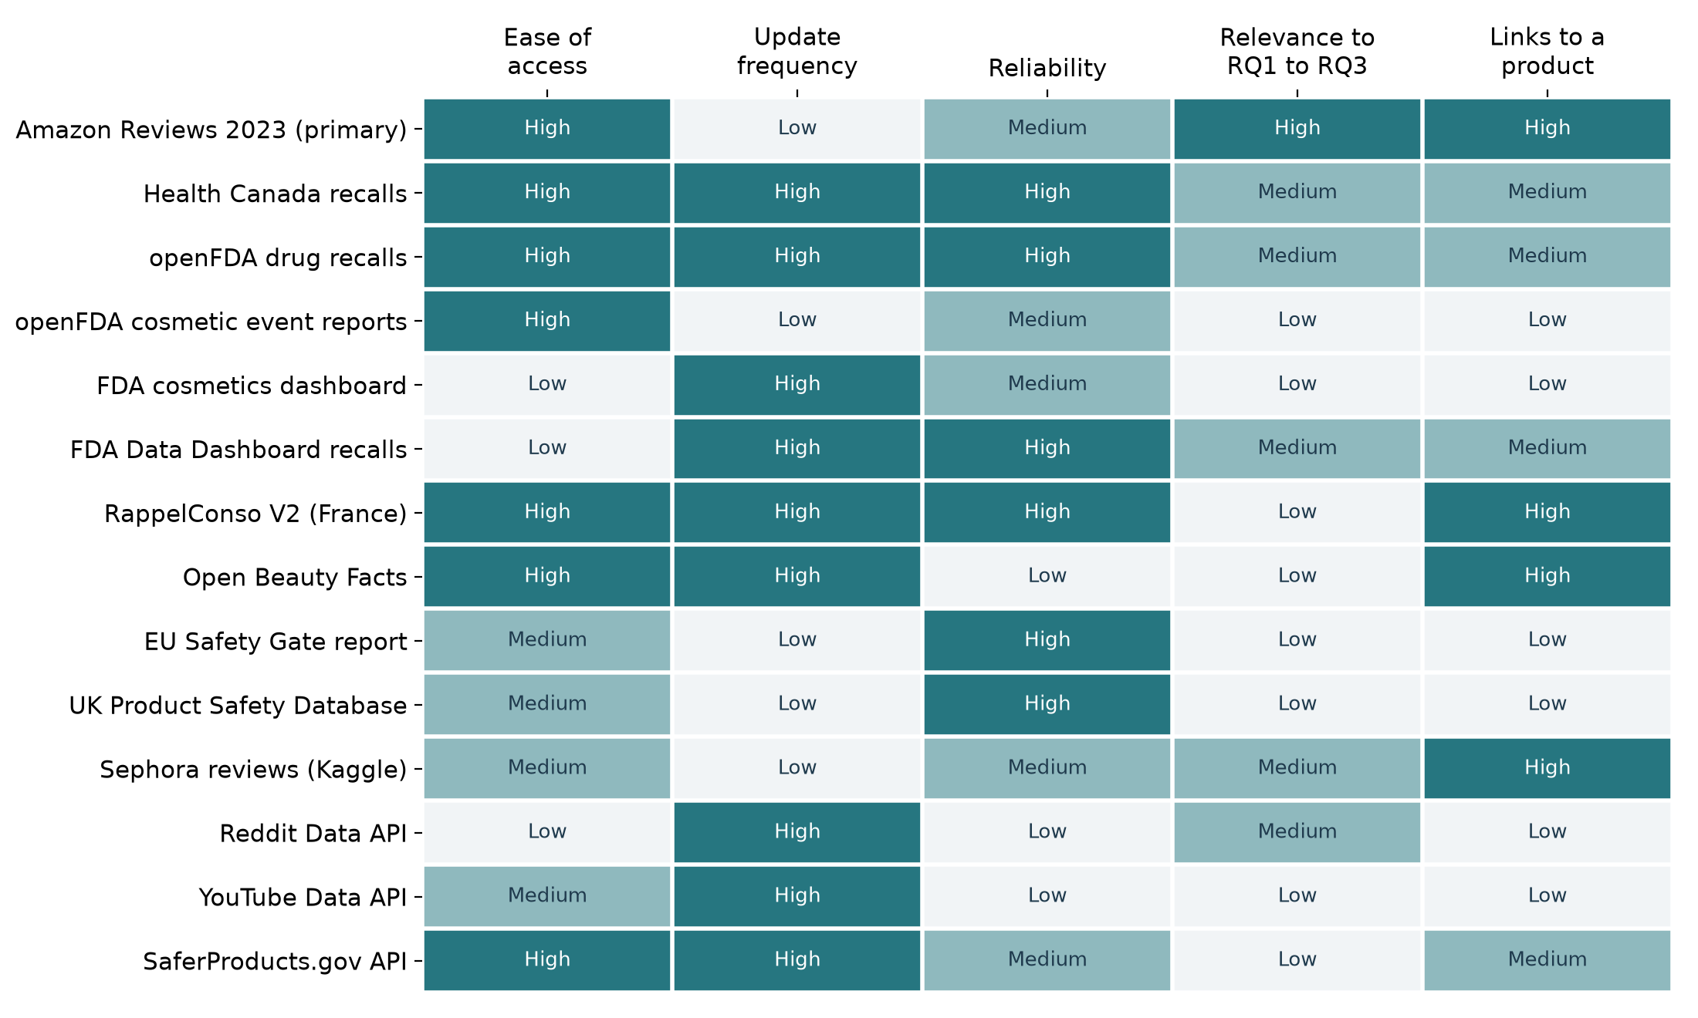
Ratings are the author's assessment. Amazon Reviews 2023 is the only source rated high on both relevance and links to a product, which is why it is the primary source.

3.4 Collection plan
Figure 2 shows how data moves from an official page to the annotation sample. Each step is a cell in the notebook and can be repeated.
Figure 2. Data collection pipeline
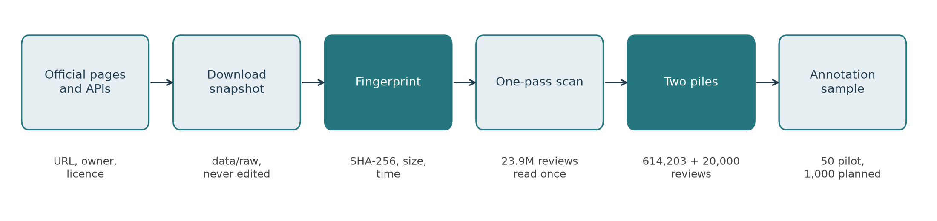
Table 2a. Collection steps, tools and outputs
Step | What happens | Tool | Output
1. Register | Record URL, owner, licence, access route, update frequency, unit of one row, strengths and weaknesses | pandas | source_register.csv
2. Snapshot | Download each open file once into data/raw; a cell only downloads when the file is missing | urllib, shutil | Files in data/raw
3. Fingerprint | Compute SHA-256, size and modification time of every file | hashlib | download_records.json
4. Profile | Open each file and count rows, fields, missing values and date range | pandas, zipfile, json | Tables in Sections 5 and 6
5. Scan | Read all 23.9 million reviews once; count by year, rating and word group; keep safety-word reviews and a random 20,000 without | gzip, re | Two compressed piles; scan summary
6. Sample | Draw the 50-review pilot and, later, the 1,000-review stratified sample | random with a fixed seed | Annotation sheets
Storage and versioning. Raw and processed data live in `data/raw` and `data/processed`, which are excluded from Git. Only code, the annotation guideline and, later, review keys with labels are published. The scan results are cached and keyed to the fingerprint of the review file and of the word list, so changing either forces a fresh scan.
Refresh schedule. Amazon Reviews 2023 is a static release. Health Canada and openFDA files are refreshed only at a checkpoint, never silently, and each refresh gets a new fingerprint. The FDA dashboards, which have no bulk link, are exported by hand only if Week 4 needs them.

4. Data sources: register, pros and cons
Table 3. Source register: links and access
Source | Official link | Access | Decision
1. Amazon Reviews 2023, Beauty and Personal Care | https://amazon-reviews-2023.github.io/ | Direct download | Primary
2. openFDA cosmetic adverse event reports | https://open.fda.gov/apis/cosmetic/event/ | Open API, bulk file | Supporting
3. FDA cosmetics adverse event dashboard | https://www.fda.gov/news-events/press-announcements/fda-launches-real-time-adverse-event-reporting-dashboard-cosmetic-products | Dashboard export | Context
4. Health Canada recalls and safety alerts | https://open.canada.ca/data/en/dataset/d38de914-c94c-429b-8ab1-8776c31643e3 | Open JSON | Supporting
5. openFDA drug recall enforcement reports | https://open.fda.gov/apis/drug/enforcement/ | Open API, bulk file | Supporting
6. FDA Data Dashboard recalls | https://datadashboard.fda.gov/oii/cd/recalls.htm | Filtered export | To obtain by hand
7. RappelConso V2 (France) | https://www.data.gouv.fr/datasets/rappelconso-v2-rappels-de-produits | Open CSV | Exploratory
8. Open Beauty Facts | https://www.data.gouv.fr/datasets/open-beauty-facts | Open TSV | Exploratory
9. EU Safety Gate 2025 report | https://op.europa.eu/webpub/just/safety-gate-2025-report/en/ | Web report | Context
10. UK Product Safety Database reports | https://www.gov.uk/government/statistics/product-safety-database-annual-reports | Open tables | Context
11. Sephora Products and Skincare Reviews | https://www.kaggle.com/datasets/nadyinky/sephora-products-and-skincare-reviews | Kaggle account | Rejected
12. Reddit Data API | https://www.reddit.com/dev/api/ | OAuth account | Rejected
13. YouTube Data API v3 | https://developers.google.com/youtube/v3/docs/commentThreads/list | API key, daily quota | Rejected
14. SaferProducts.gov API | https://catalog.data.gov/dataset/saferproducts-api | Open API | Rejected
Table 4. Sources by type, owner and update frequency
Source | Type | Owner | Update frequency
Amazon Reviews 2023 | Review data (academic) | McAuley Lab, UC San Diego | Static, to September 2023
openFDA cosmetic events | Government API | U.S. FDA | Frozen at August 2025
FDA cosmetics dashboard | Government database | U.S. FDA | Daily
Health Canada recalls | Government database | Health Canada | Continual
openFDA drug enforcement | Government API | U.S. FDA | Weekly
FDA Data Dashboard recalls | Government database | U.S. FDA | Weekly
RappelConso V2 | Government database | French economy ministries | Continuous
Open Beauty Facts | Open community database | Open Food Facts | Continuous
EU Safety Gate report | Government statistics | European Commission | Yearly
UK Product Safety Database | Government statistics | Office for Product Safety and Standards | Yearly
Sephora reviews | Review data (community) | Kaggle contributor | Static, to March 2023
Reddit Data API | Social media API | Reddit, Inc. | Live
YouTube Data API | Social media API | Google | Live
SaferProducts.gov API | Government API | U.S. CPSC | Continual
Table 5. Pros and cons of each source: accessibility, frequency and reliability
Source | Pros | Cons
Amazon Reviews 2023 | Very large (23.9M reviews); dated; star rating, verified flag and helpful votes; product identifier; no account needed | Static, ends September 2023; US only; no batch number; no licence stated, so text cannot be republished; some fake reviews
openFDA cosmetic events | Official; coded reaction terms (MedDRA); bulk file; 85,511 reports | Unverified; no causation; 71% name a cancer term, reflecting litigation; product names are free text
FDA cosmetics dashboard | Current; includes mandatory serious event reports since MoCRA | No stable bulk link; manual export only; unverified
Health Canada recalls | Open licence; beauty category; plain-language hazard; 34,212 records | Canadian market; lot-specific; 40% of beauty records state no hazard; date is last update
openFDA drug enforcement | Same market as the reviews; covers sunscreen, antiperspirant and sanitiser; weekly | Not cosmetics in law; long free-text descriptions; benzene hazards cannot be perceived by users
FDA Data Dashboard recalls | Only source found with a US cosmetics product type | Manual filtered export; not reproducible by script
RappelConso V2 | Barcodes, batch text and instructions; open licence | French market; no brand overlap with US reviews in a first probe
Open Beauty Facts | Barcodes, sizes, brands; open | Volunteer-entered; incomplete; share-alike licence
EU Safety Gate report | Authoritative sector statistics; cosmetics 36% of 2025 alerts | Aggregates only; no product-level join
UK Product Safety Database | Official category counts | Aggregates only; definitions differ from EU counts
Sephora reviews | Dated skincare reviews with product details | Smaller than source 1 for the same market; no overlap with recall brands; Kaggle terms
Reddit Data API | Detailed first-person accounts of reactions; current | Needs an account; no product identifier or rating; terms limit storing and modelling text
YouTube Data API | Very large and current | Comments respond to videos, not purchases; no product identifier; daily quota of 10,000 units
SaferProducts.gov API | Official dated harm reports with product and maker | Cosmetics fall under the FDA, not the CPSC, so creams and shampoos are out of scope
Why social media was rejected. Social media posts are rich in first-person language and have been used successfully in drug safety research (Sarker et al., 2015). For this study they fail on two counts. A post rarely names a single, identifiable product, so complaint rates per product cannot be computed, and the API terms restrict storing and modelling the text. They remain a natural extension once a classifier trained on reviews exists, as a source to apply it to rather than to train it on.

5. Data quality and relevance assessment
Quality was assessed on six dimensions drawn from Wang and Strong (1996), each measured as a simple ratio where possible (Pipino et al., 2002).
Table 6. Quality dimensions and how each was measured
Dimension | Wang and Strong category | Measure used here
Completeness | Contextual | Share of records with the field the study needs (text, hazard, reaction term)
Uniqueness | Intrinsic | Repeated identifiers or repeated texts
Timeliness | Contextual | Date range and date of the latest record
Validity | Intrinsic | Official or volunteer source; verified flag; known biases
Consistency | Representational | Markup, encodings and formats that need cleaning
Relevance | Contextual | Fit to RQ1 to RQ5
Table 7. Measured quality of the seven downloaded sources
Source | Rows | Completeness | Uniqueness | Timeliness | Relevance
Amazon reviews | 23,911,390 | 99.85% have text | 6,260 repeated texts among 614,203 candidates (1.02%) | 2000 to September 2023, static | High: the only large source of customer wording
Amazon catalogue | 1,028,914 | 95.1% have a brand field | One row per parent product | Static, to September 2023 | High: groups reviews by product
Health Canada recalls | 34,212 | 60% of 201 beauty records state a hazard | 0 repeated ids | Latest beauty record 21 September 2026 | Medium: right hazards, other country
openFDA drug recalls | 18,010 | 100% have a product description | 0 repeated recall numbers | Latest record 23 September 2026 | Medium: same market, imperceptible hazards
openFDA cosmetic reports | 85,511 | 100% have a reaction term | One row per report | Latest 29 August 2025, frozen | Low to medium: vocabulary only
French recall notices | 296 | 98% have consumer instructions | Distinct after removing exact repeats | Latest 25 September 2026 | Low; kept for RQ5
Open Beauty Facts | 64,237 | Names missing for many products | One row per barcode | Snapshot 2 October 2026 | Low; kept for RQ5
Validity issues worth naming. The primary source has three known validity risks. Verified purchases are 91.1% of all reviews but only 83.0% of safety-word reviews, so unverified reviews are over-represented exactly where the study looks (Section 6.4). Fake reviews exist on the platform (He et al., 2022). And a review records when it was posted, not when the product was used. Each is handled in the plan: a sensitivity analysis without unverified reviews, no use of bursts of praise as evidence, and timestamps treated as posting time.
Relevance verdict. Only the Amazon reviews and catalogue are highly relevant to the core questions. The official files are relevant in a supporting role: recall dates for RQ4, hazard words for labelling rules, and product records for RQ5.

6. Initial profile of the data
All figures in this section come from `complaint_detection.ipynb`, which reads the full review file once (about 14 minutes) and caches the counts. No review text is shown.

6.1 Volume and time span
The file holds 23,911,390 reviews of 1,028,914 products. 91.1% are verified purchases, 64.7% are five-star and 11.9% one-star. The average review has about 38 words, and 36,594 have no text. Volume grew steadily to a peak of 3.72 million reviews in 2021; 2023 covers January to September only.
Figure 3. Beauty and personal care reviews by year posted (millions)
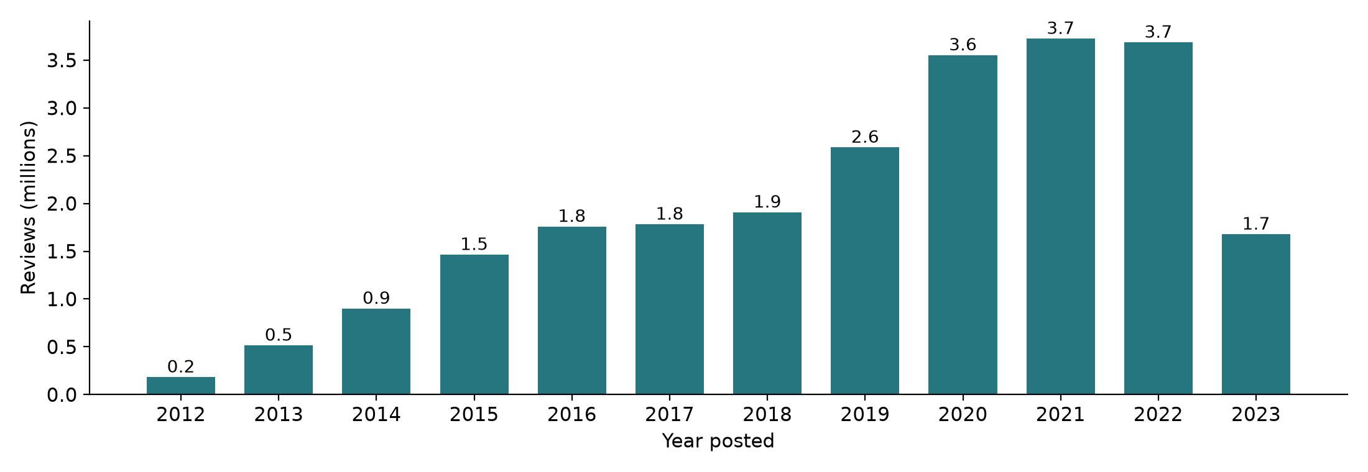

6.2 How often safety words appear
614,203 reviews (2.57%) contain a word from one of six safety word groups. Skin reaction words are the most common (264,803 reviews) and eye words the rarest (7,405). The yearly share has stayed between 2.27% (2019) and 2.82% (2022) since 2014. That stability is a property of the keyword share only; whether the features and labels a model learns from are stable over time can be tested only after labelling.
Figure 4. Reviews containing a safety-related word, by word group
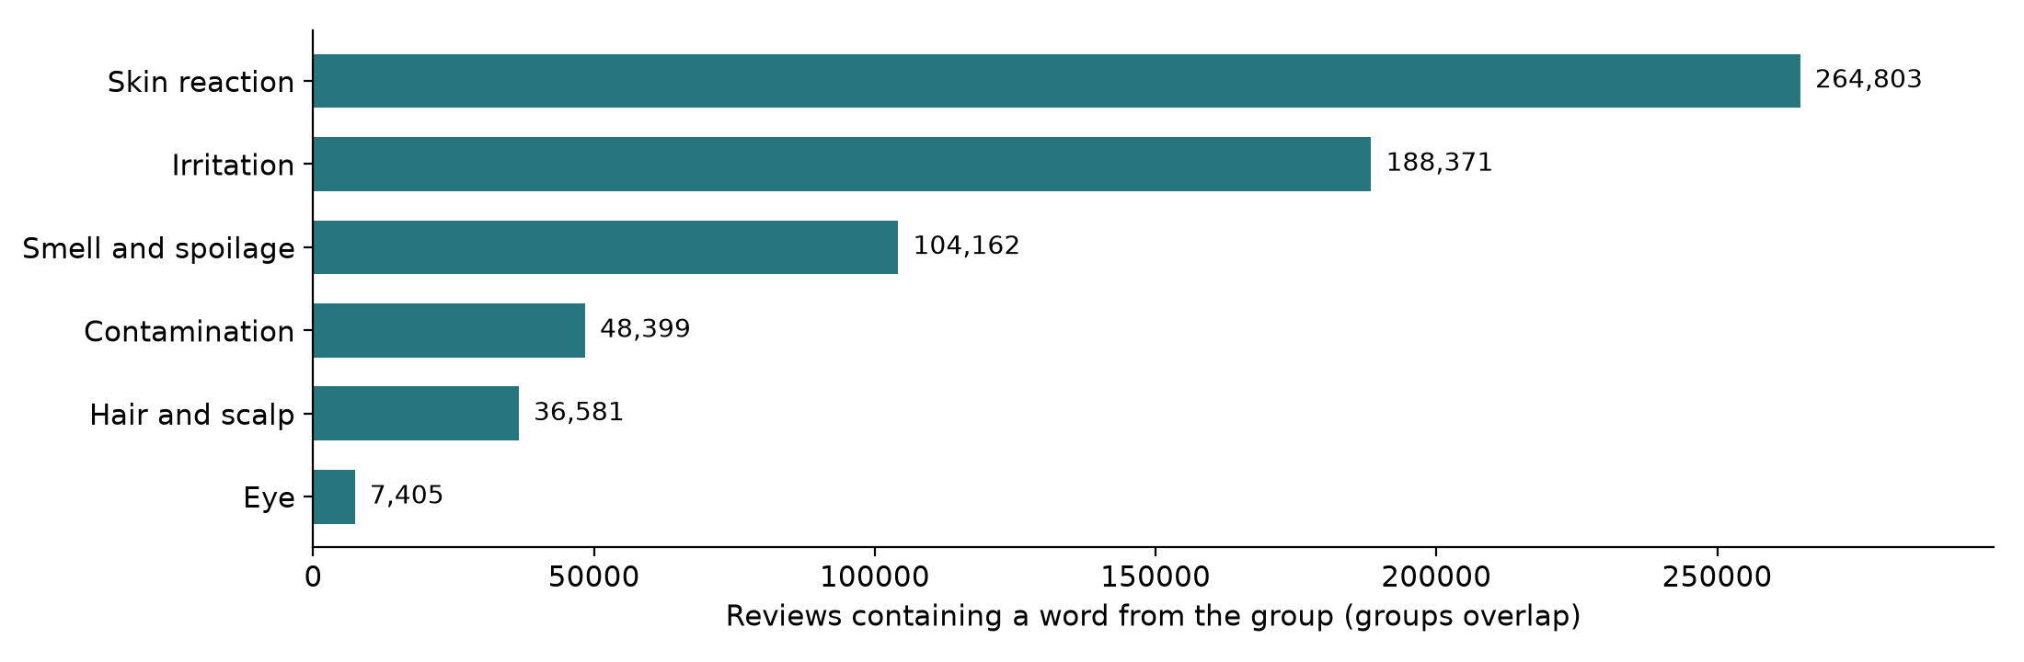
Figure 5. Share of reviews using a safety-related word, by year
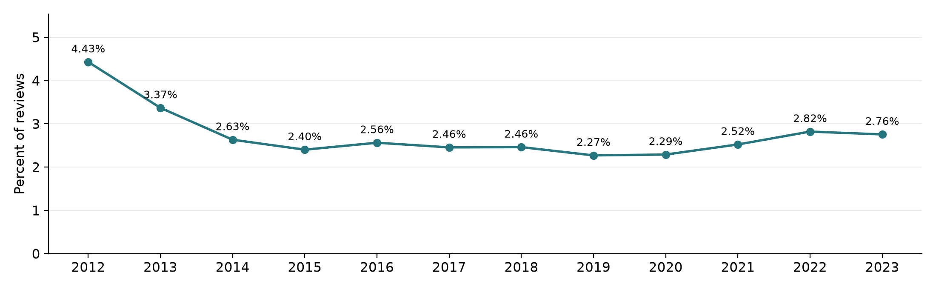

6.3 Star ratings, word groups and negation
One-star reviews use safety words more than three times as often as five-star reviews (5.8% against 1.8%). Yet because five-star reviews are so numerous, they hold 46.1% of all safety-word reviews. This is the pattern Winkler et al. (2016) found for toys.
Figure 6. Safety-word reviews by star rating. Left: share of each star level. Right: share of all safety-word reviews.
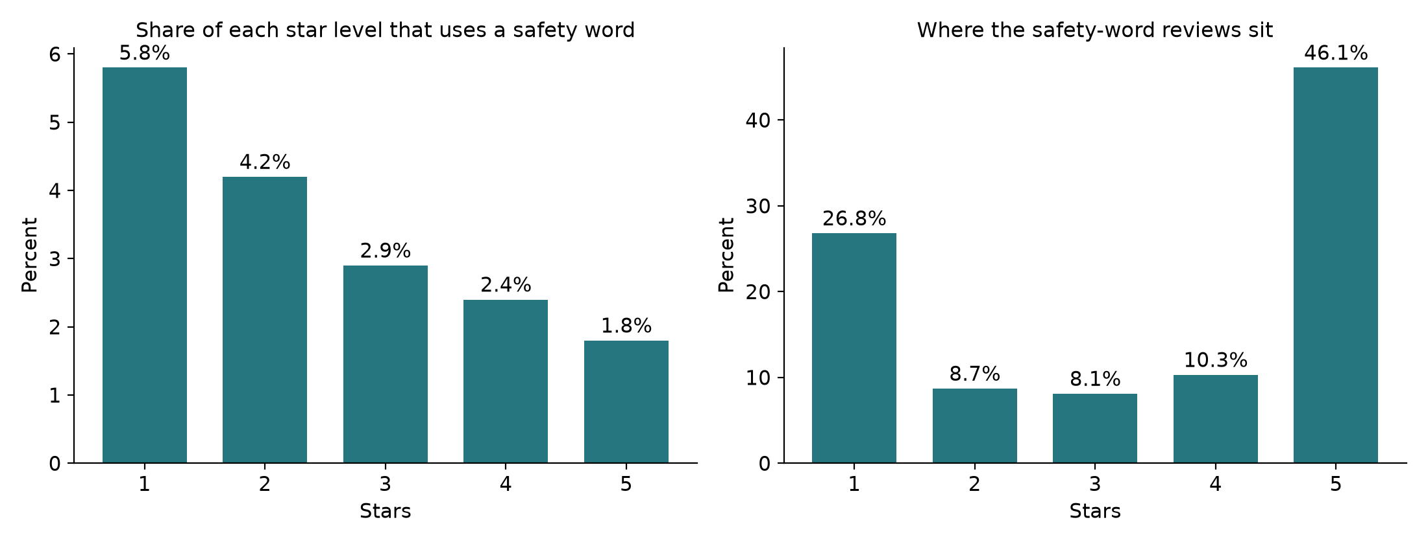
The six groups behave differently. Irritation words appear mostly in praise (58.9% five-star, 13.4% one-star), typically "no irritation". Smell and spoilage words are the reverse (19.5% five-star, 48.1% one-star). Eye and contamination words sit in between.
Figure 7. Star rating of the reviews in each word group
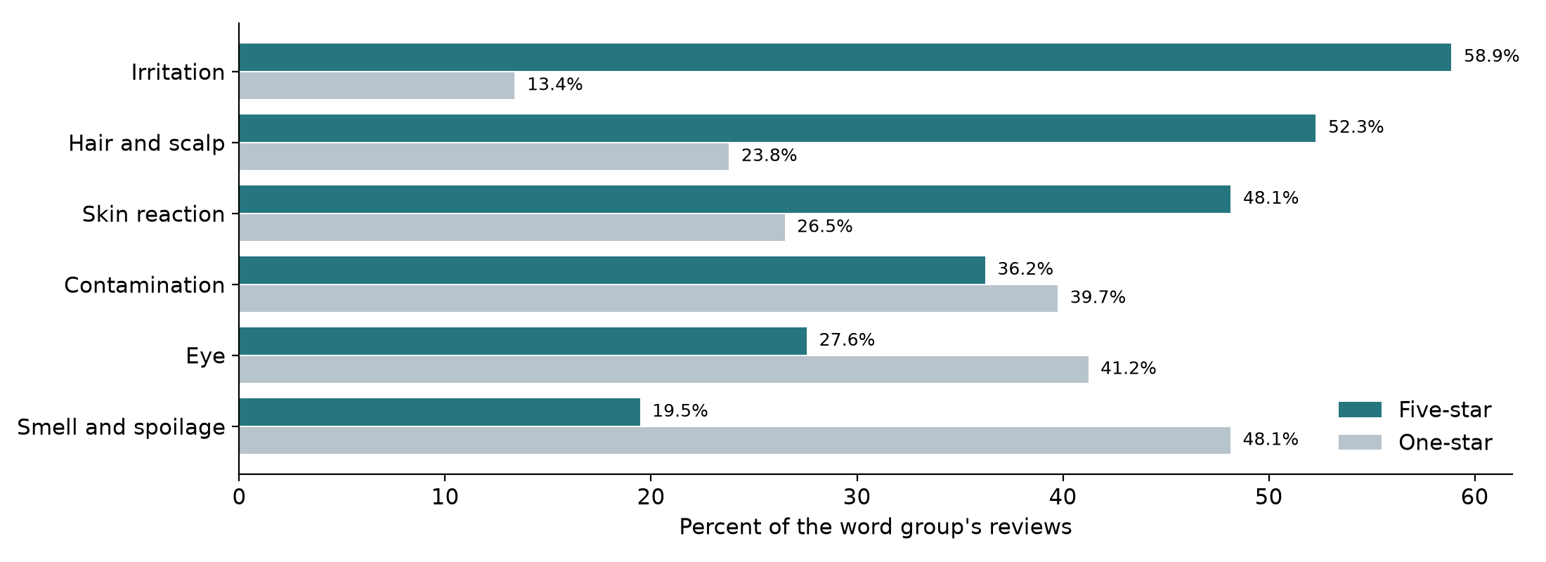
A negation check, following the idea of Chapman et al. (2001), looks for a word such as no, not, never or without up to three words before a safety word. It finds one in 142,572 safety-word reviews (23.2%): 37.2% of five-star ones and 5.1% of one-star ones. The check is approximate, but it shows that a large share of safety language is denial, which the guideline must handle explicitly.
Figure 8. Safety-word reviews with a negation cue just before the safety word, by star rating
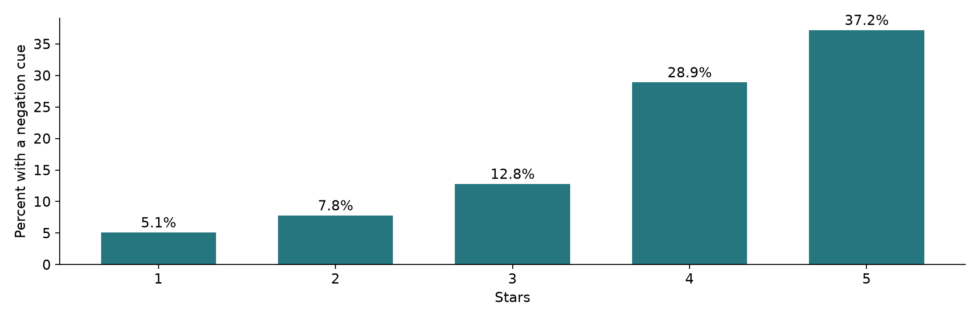

6.4 How safety-word reviews differ from ordinary reviews
Compared with a random sample of 20,000 reviews that use no safety word, safety-word reviews are much longer (median 52 words against 20; interquartile range 27 to 97 against 8 to 41), more often voted helpful (43.9% against 25.8%) and less often from a verified purchase (83.0% against 90.9%). Their mean rating is 3.40 against 4.14. Length matches Mudambi and Schuff's (2010) finding that detailed reviews attract helpful votes.
Figure 9. Review length: safety-word reviews against random reviews with no safety word
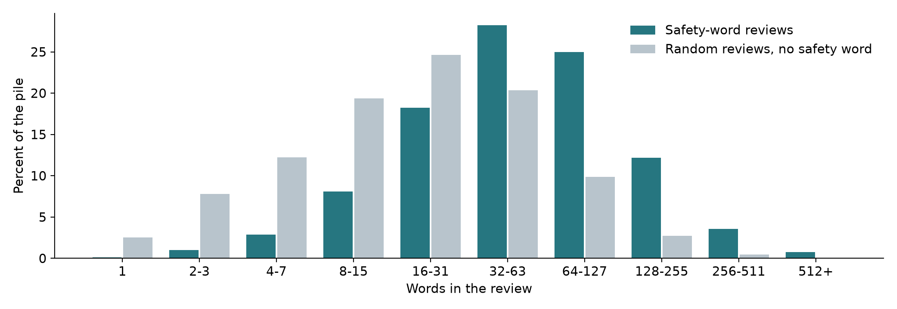
Figure 10. Three further differences between the two piles
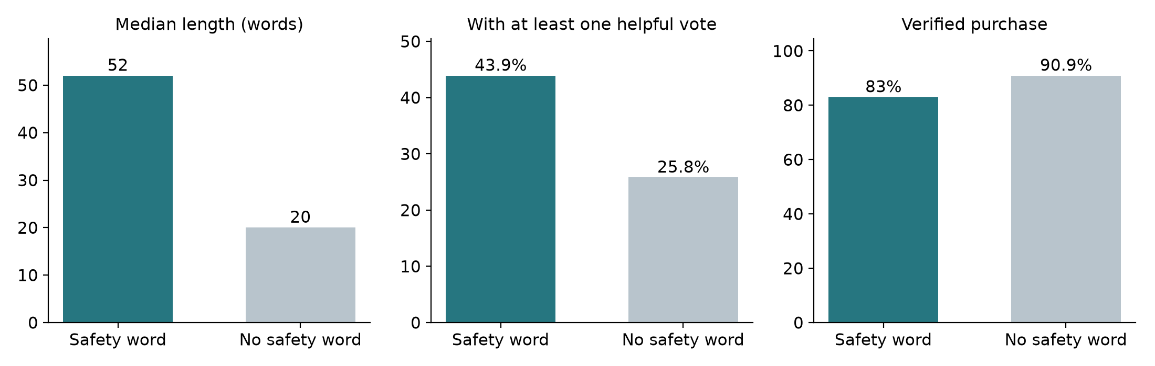
Table 8. Descriptive statistics of the two piles
Statistic | Safety-word reviews | Random, no safety word
Reviews | 614,203 | 20,000
Words: lower quartile, median, upper quartile | 27, 52, 97 | 8, 20, 41
Mean star rating | 3.40 | 4.14
One-star share | 26.8% | 11.1%
Five-star share | 46.1% | 65.4%
At least one helpful vote | 43.9% | 25.8%
Verified purchase | 83.0% | 90.9%

6.5 Spread across products
Safety-word reviews touch 138,833 products (13.5% of the catalogue), but most products have only one or two. 4,627 products have 20 or more and hold 46.6% of all safety-word reviews; 595 have 100 or more and hold 21.7%. Product-level complaint rates over time can only be measured for that smaller group.
Figure 11. Products by number of safety-word reviews, and the share of those reviews they hold
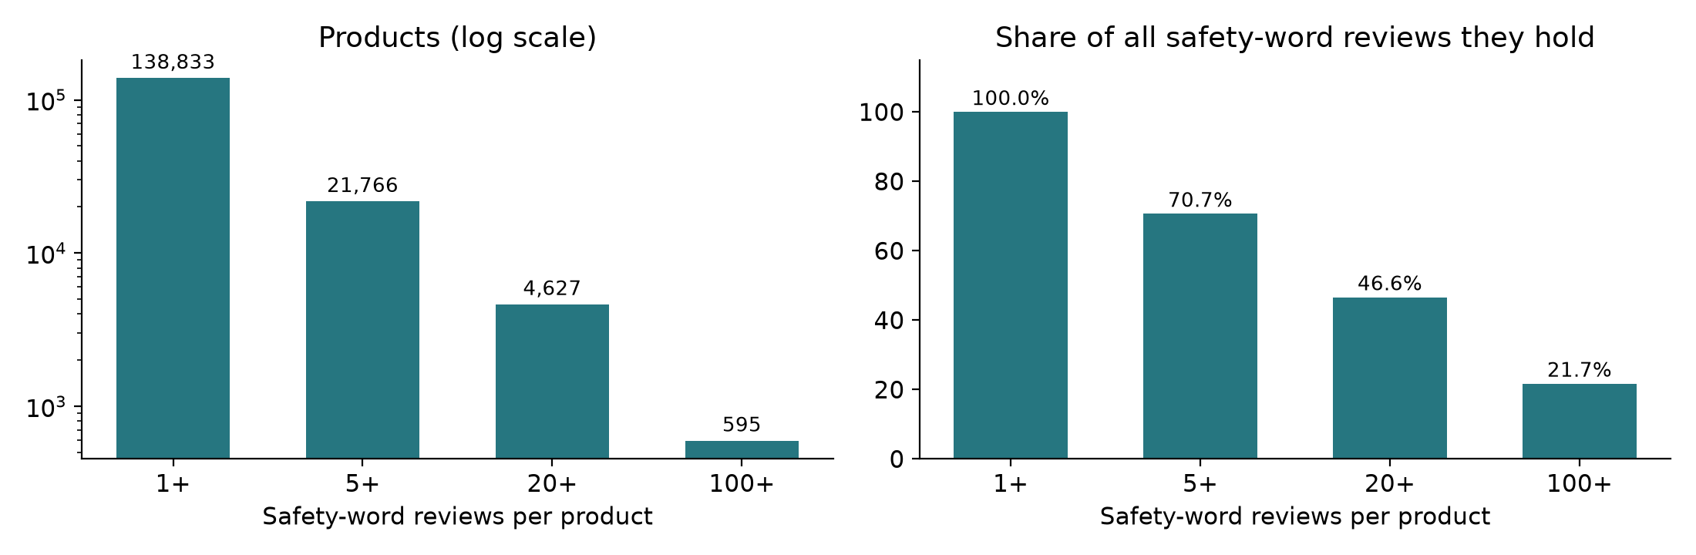

6.6 Recalled products and one case line
Of 40 recalled beauty product lines checked by title in the catalogue, 27 had a title match, 23 had at least one review before the recall, 14 had 20 or more, and only 8 had 20 or more in the 12 months before the recall. Most of those were benzene recalls, a hazard no customer can see or smell.
Figure 12. Recalled product lines that have dated reviews (40 lines examined)
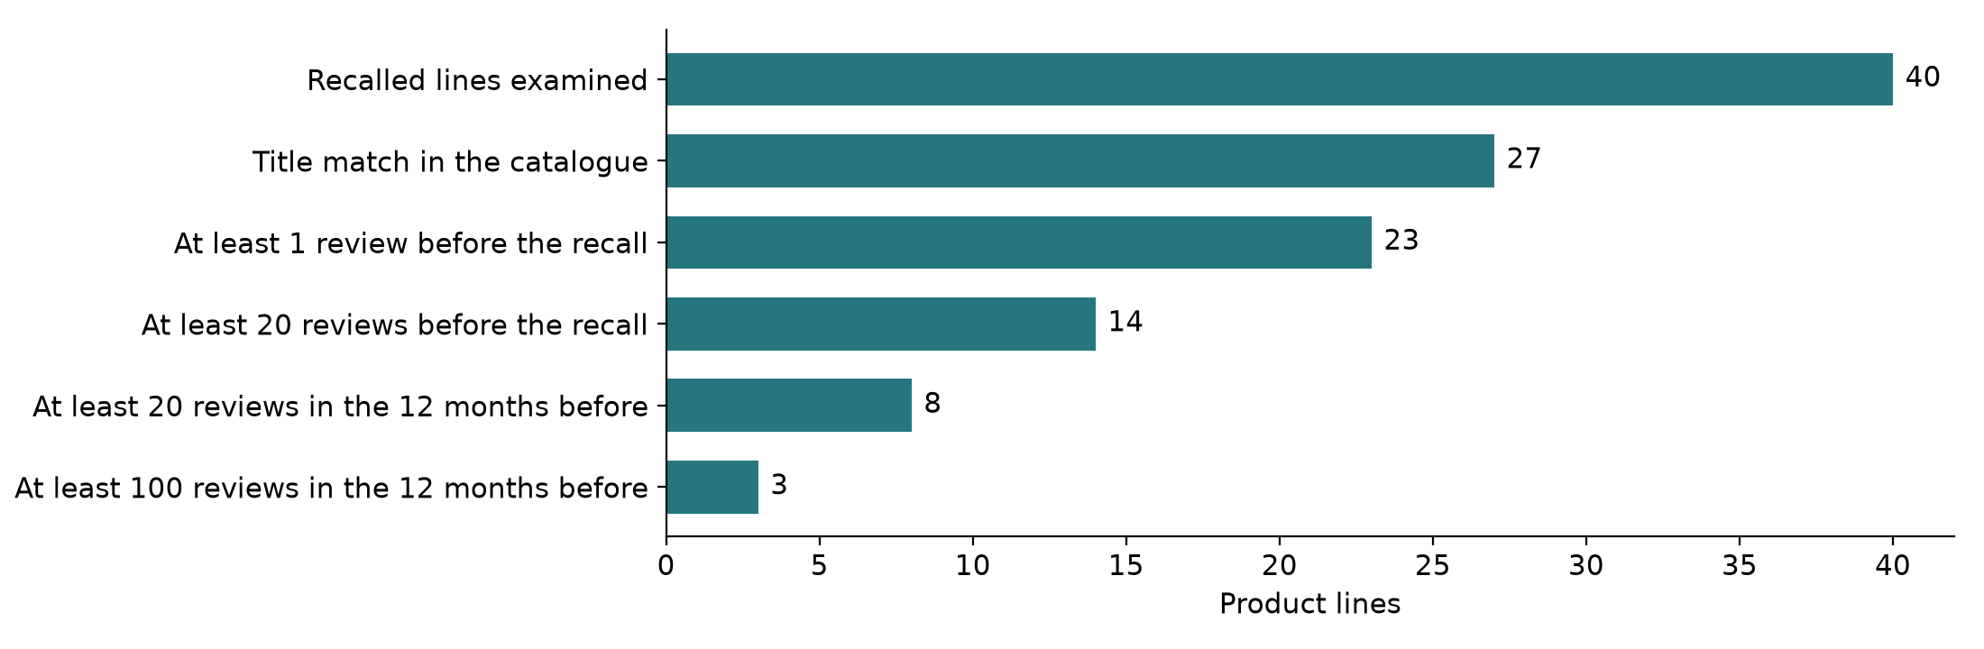
The one microbial recall with real volume is Bioderma Sensibio H2O micellar water, recalled in Canada on 4 March 2022. Its matched products have 3,465 reviews, 3,016 before the recall and 368 in the year before. Of those 368, 42 use a safety word, 20 of them five-star; 56 are one or two star, and only 12 of those 56 use a safety word. The quarterly count shows no rise before the recall. This null result is reported as found: the title match is unreviewed, the recall covered Canadian lots, and the count includes praise.
Figure 13. Case line: reviews of products matching "Bioderma Sensibio H2O", by quarter
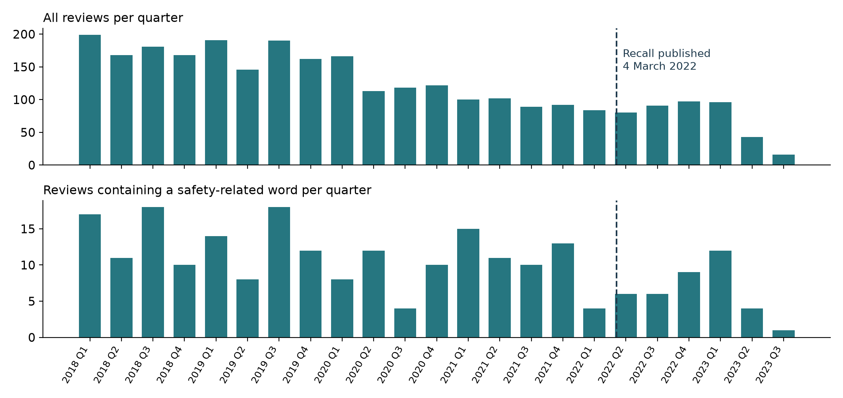

6.7 What the official files contain
The openFDA cosmetic event file is dominated by litigation-related cancer reports: ovarian cancer is named in 29,563 reports. Reactions relevant to everyday products are far rarer: alopecia 4,171, pruritus 2,552, rash 1,933 and burning sensation 1,484. These terms are useful as vocabulary for labelling rules, not as a picture of everyday harm. In Health Canada's 201 beauty records, the most frequently stated hazards are labelling and packaging (39 records), microbial (35) and chemical (32); 81 records state none.
Figure 14. openFDA cosmetic adverse event reports: the ten most frequent reaction terms
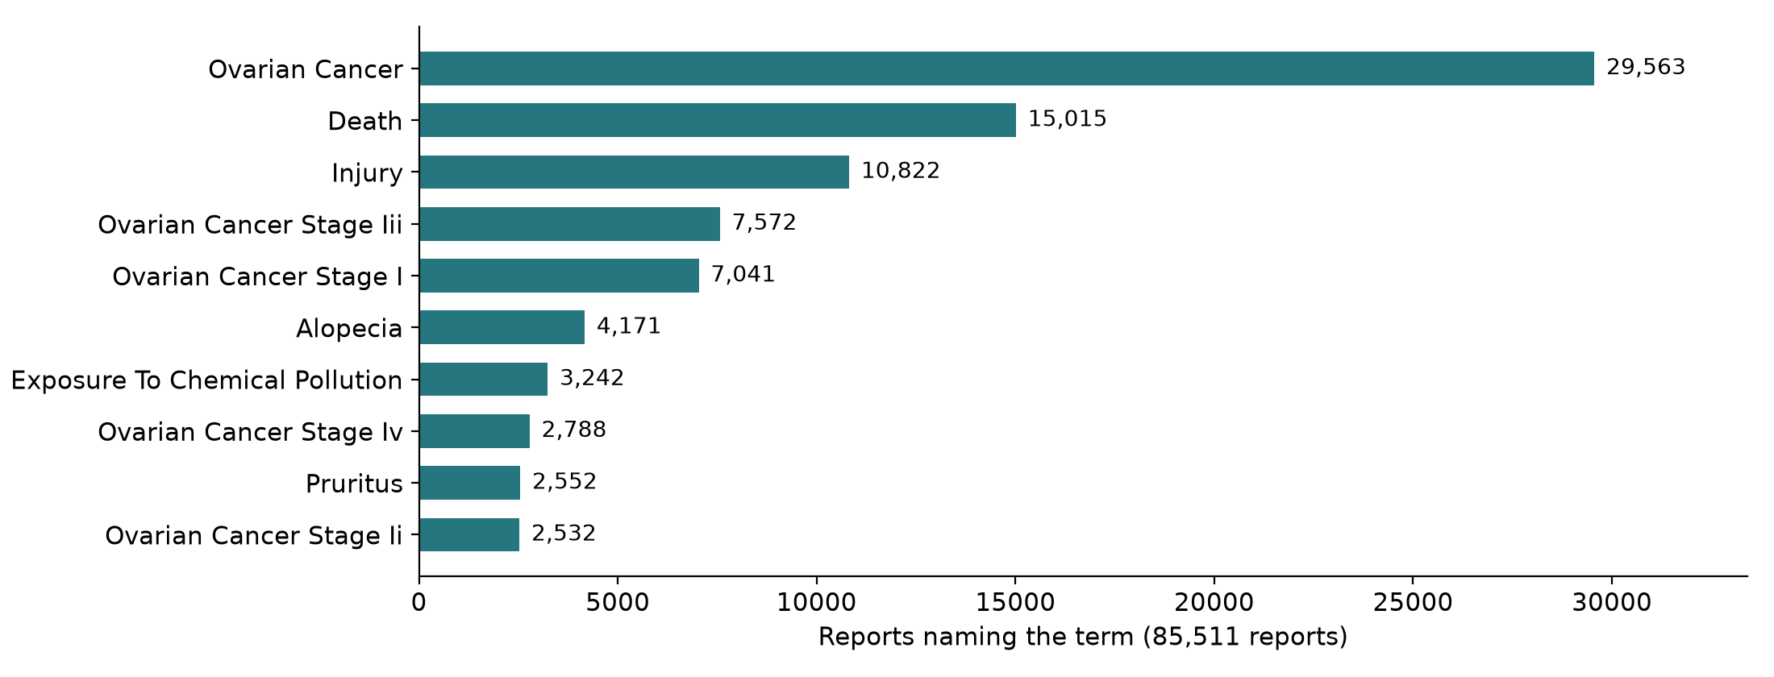
Figure 15. Health Canada beauty and personal care recalls by first hazard stated
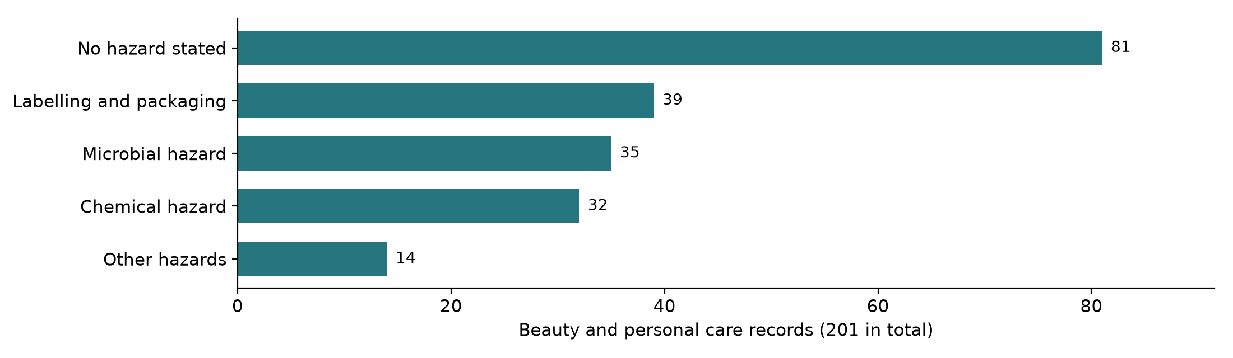

7. Key variables
One row in the main analysis is one review. Product and time measures are built from review rows in separate tables so that denominators stay clear.
Table 9. Data dictionary of key variables
Variable | Type | Source | Role and handling
safety_complaint | Label: yes, no, unclear | Human annotation | Target variable for RQ1 to RQ3; never inferred from stars
text, title | Text | Amazon reviews | Model input; original kept, cleaned copy added
rating | Ordinal 1 to 5 | Amazon reviews | Stratum and feature; hidden from annotators
timestamp | Date and time (UTC) | Amazon reviews | Posting time; used for time series and splits
verified_purchase | Binary | Amazon reviews | Sensitivity analysis
helpful_vote | Count | Amazon reviews | Feature; heavily skewed, used as at least one vote
parent_asin | Identifier | Amazon reviews and catalogue | Groups reviews by product; key for grouped cross-validation
review_key | Identifier | Derived: SHA-1 of reviewer, item and time | Replaces reviewer identifiers; never the raw id
word_groups | Set of six flags | Derived from the six word lists | Sampling strata and labelling rules
negation_cue | Binary | Derived from the negation pattern | Labelling rule and EDA variable
word_count | Count | Derived | Feature and EDA variable
store, categories | Text | Amazon catalogue | Brand and category for complaint rates by category
recall_date, hazard | Date, category | Health Canada, openFDA | RQ4 windows; microbial against benzene comparison
reaction terms | Text list | openFDA cosmetic events | Vocabulary for labelling rules

8. Exploratory analysis plan
Exploration happens in two passes. Pass 1 has already been run on the unlabelled data (Section 6). Pass 2 runs in Week 4 on the hand-labelled sample, where the label is known and differences can be tested.

8.1 Statistical methods
Table 10. Statistical methods and why each was chosen
Method | Used for | Why this method
Counts, shares, median and quartiles | Volume, length, ratings, helpful votes | Length and votes are skewed, so medians, not means
Wilson score interval (Wilson, 1927) | Complaint rate with a 95% interval, per star level or category | Accurate for small and rare proportions
Chi-square test of independence | Complaint rate across product categories | Categorical against categorical
Mann-Whitney U test (Mann & Whitney, 1947) | Length of complaints against non-complaints | No normality assumption
Fisher's exact test | Verified against unverified reviews | Small counts in some cells
Log-odds ratio with an informative prior (Monroe et al., 2008) | Words that separate complaints from praise | Stable for rare words
Cohen's kappa (Cohen, 1960) | Agreement between annotators | Corrects for chance agreement
The two key formulas are written out so that results can be checked by hand. For a complaint rate p from n reviews and z = 1.96, the Wilson interval is (p + z²/2n ± z√(p(1 - p)/n + z²/4n²)) / (1 + z²/n). Cohen's kappa is κ = (p_o - p_e) / (1 - p_e), where p_o is the observed agreement and p_e the agreement expected by chance. For example, if two annotators agree on 46 of 50 reviews (p_o = 0.92) and chance agreement is 0.70, then κ = 0.22 / 0.30 = 0.73, which passes the 0.70 target.

8.2 Visualisations
Table 11. Planned charts
Question | Chart | Reason for the choice
How many reviews, when? | Bar chart by year | Few categories, exact values labelled (Figure 3)
Where are safety words by star level? | Paired bars | Two denominators shown side by side (Figure 6)
Which groups are praise, which complaint? | Grouped horizontal bars | Long category names (Figure 7)
Are complaints longer? | Binned length bars; box plot after labelling | Skewed variable (Figure 9)
Is the complaint rate higher in some categories? | Sorted bars with Wilson intervals | Uncertainty visible
Which words mark complaints? | Ranked word table with log-odds | Readable, no word clouds
Does the rate rise before a recall? | Quarterly bars with the recall date marked | Time with an event (Figure 13)
How well do labelling rules agree? | Coverage and overlap table | Standard in weak supervision (Ratner et al., 2017)
All charts use one colour for one series, a second muted colour only for comparison, labelled values, and no dual axes. Charts never show review text.

9. How the data tests the Week 1 hypotheses
Table 12. Hypothesis to data map
H | Claim | Data | Test | Decision rule
H1 | Two annotators agree on what a safety complaint is | Pilot of 50, then 200 double-labelled reviews | Cohen's kappa with confusion table | Kappa at least 0.70
H2 | A classifier beats the tuned keyword search | Frozen labelled test set | Average precision; bootstrap interval of the difference | Interval above zero; inconclusive if it includes zero with a positive gain
H3 | Rule-made labels can replace most hand labels | Both piles; FDA reaction terms; hand labels to check | Average precision on the same test set; F1 at the shared threshold | Within 0.05 average precision of the hand-label model (planning margin)
H4 | Complaint rates rise before a recall (exploratory) | Bioderma line and one benzene line (Dove dry shampoo); recall dates | Complaint share per period with Wilson intervals; no significance test | Described, not generalised
H5 | Brand and size matching traces products correctly (exploratory) | French notices and Open Beauty Facts | Share with the right notice first | Summary of earlier scoping
The profile already informs each hypothesis. For H1, negation and relieved conditions are the expected sources of disagreement, so the guideline addresses them by name. For H2, the naive keyword search is known to be weak (most hits are not complaints), which is why Week 1 tests H2 against a tuned keyword baseline instead. For H3, star rating, negation and word group behave differently enough to serve as separate labelling rules. For H4, only 8 lines qualify and only one microbial line has volume, so the result can only be descriptive.

10. Data cleaning and preprocessing plan
Every issue below was counted in the notebook on the full file. Cleaning produces a new copy; the raw text is never edited.
Table 13. Measured cleaning issues and planned handling
Issue | Reviews affected | Planned handling
Review has no text | 36,594 (0.15%) | Exclude from labelling; keep the count
Text under three words | 1,649,925 (6.90%) | Keep; too short to describe a reaction
HTML character codes such as &#34; | 217,524 (0.91%) | Decode to plain characters
Line break tags (<br />) | 1,680,889 (7.03%) | Replace with a space
Video placeholders | 200,283 (0.84%) | Remove the placeholder; keep the review
Characters outside plain ASCII | 4,035,847 (16.88%) | Keep; measure non-English share in Week 3
Same product, title and text repeated (candidates) | 6,260 (1.02%) | Keep one copy for labelling
Repeated review key (candidates) | 6,066 (0.99%) | Investigate before using the key as an identifier
Matched only on "recall" meaning remember (candidates) | 4,401 (0.72%) | Tighten or drop the pattern
Figure 16. Share of reviews affected by each cleaning issue
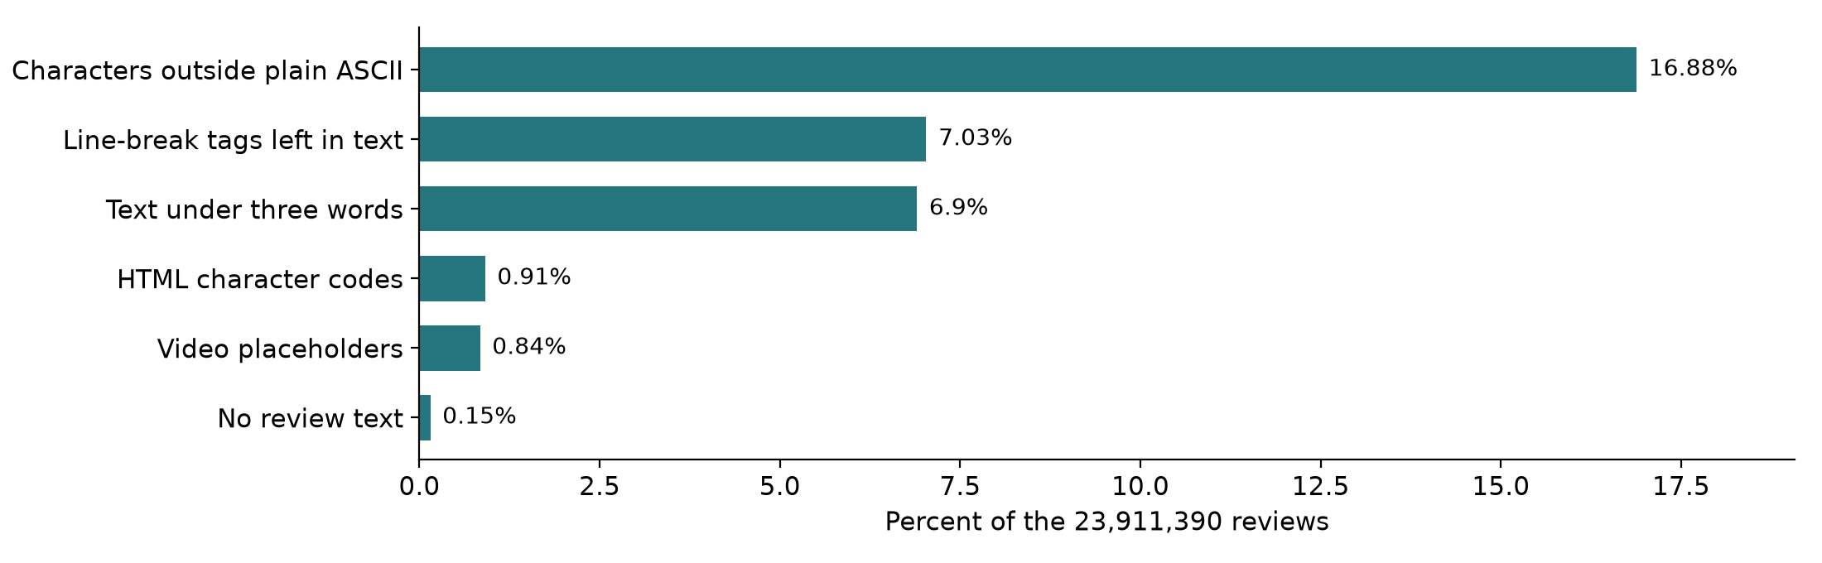

10.1 Order of operations
- Decode HTML codes, replace line-break tags, remove video placeholders.
- Normalise whitespace and Unicode form; keep case and punctuation, which carry negation and emphasis.
- Mark, do not drop, empty and very short reviews.
- Remove exact repeats within a product.
- Convert timestamps to UTC dates; derive year, quarter and days to recall.
- Join catalogue fields on parent_asin; check every review finds a product.
- Split by product, never by review, so the same product is never in training and test sets.
Each step will have a unit test in Week 3 (for example, "&#34;no irritation&#34;" must become "\"no irritation\"" and keep its negation). Row counts are logged before and after every step.

11. Annotation pilot and feasibility checkpoint
The annotation sample planned for Weeks 3 and 4 has 1,000 reviews drawn from four strata (Figure 17). Safety-word reviews are over-sampled so that enough positives appear; random and low-star reviews show what the word list misses; reviews of recalled lines serve the exploratory RQ4.
Figure 17. Design of the 1,000-review annotation sample
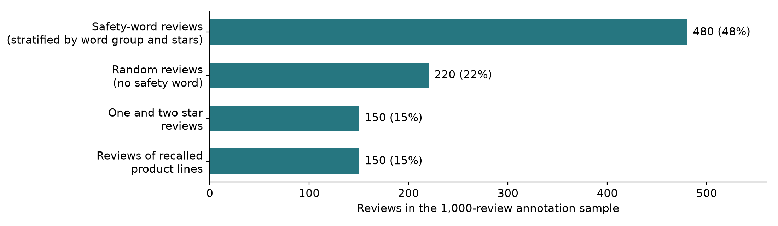
This week the notebook drew a pilot of 50 reviews into two identical sheets, one per annotator, with star rating and product hidden, and wrote the guideline to `data/labels/annotation_guideline.md`. Agreement is computed automatically once both sheets are filled.
Table 14. Dataset feasibility checkpoint
ID | Criterion | Threshold | Observed | Status
F1 | Dated beauty reviews with text held locally | At least 500,000 | 23,874,796 | Met
F2 | Keyword-enriched pool to sample from | At least 5,000 | 614,203 | Met
F3 | Genuine complaints among keyword reviews | At least 10% | About 22% in an informal read of 60 | Provisional
F4 | Annotator agreement in the pilot | Kappa at least 0.60 | Pilot drawn, labels pending | Pending
F5 | Expected complaints in the 1,000 sample | At least 100 | 120 to 160 if F3 holds | Provisional
F6 | Recalled lines with 20+ reviews in the prior year | At least 20 | 8 of 40 | Not met
Decision: provisional go. F1 and F2 are met, so the core study proceeds. F6 is not met, so RQ4 stays a descriptive comparison and no recall prediction model will be built. F3 to F5 are confirmed or revised by the pilot; if F3 or F4 fails, the guideline and word lists are revised and the pilot repeated once before the main round.

12. Ethics, licences and limitations

12.1 Ethics and licences
- Privacy. Reviewer identifiers are replaced by a one-way SHA-1 key. No review text appears in this report, the notebook outputs or the repository.
- Licences. Amazon Reviews 2023 states no licence, so the text is used for research and never redistributed. Health Canada data is under the Open Government Licence, Canada; RappelConso under the French Open Licence 2.0; Open Beauty Facts under the ODbL, which requires attribution and share-alike if its data is republished.
- Harm. A flag is a prompt for a person to read a review, never a verdict on a product. The project will not name any product as unsafe.
- Annotators. Annotators may skip any review they would rather not read.

12.2 Limitations
- The primary source is one US marketplace, in English, ending in September 2023.
- Reviews carry no batch or lot number, so no review can be tied to a recalled lot.
- Recall matches are title matches on a hand-picked list of 40 lines, not confirmed products.
- The word lists are a sampling net, not a detector; complaints phrased in other words are missed and estimated through the random stratum.
- The negation check uses a fixed three-word window and is approximate.
- The FDA dashboards were not downloaded because no stable bulk link was found.
- The source ratings in Figure 1 are judgement; the measured counts in Sections 5 and 6 are not.

13. Summary of findings and conclusion

13.1 Summary of findings
- There is enough data, from one source. Amazon Reviews 2023 provides 23.9 million dated beauty reviews with product identifiers. No other public source is both relevant and large.
- The target is rare and hidden in praise. 2.57% of reviews use a safety word, 46.1% of those are five-star, and 23.2% contain a negation cue. Labels must come from people, not stars or keywords.
- The signal has structure. Word groups differ sharply in star profile, and safety-word reviews are longer and more often voted helpful. These are usable features and labelling rules.
- Official data plays a supporting role. Recall files give dates and hazards; FDA reports give vocabulary; neither gives labels for reviews.
- The recall question is limited by data. Only 8 of 40 recalled lines have enough reviews, and the one microbial case shows no visible rise. RQ4 stays exploratory.
- The cleaning work is known and measured. Nine issues are counted with planned handling, in a fixed order.
- Social media is not suitable for the core study. No product identifier and restrictive terms; kept as a future application.

13.2 Conclusion
The Week 2 question was whether public data can support early detection of cosmetic safety complaints. It can, with one primary source and clear limits. The strategy is to collect once, fingerprint everything, measure quality on the full file, and let measured numbers, not descriptions, decide what each source is used for. Published research supports each of the main choices: sampling across all star levels because hazards hide in positive reviews (Winkler et al., 2016), labelling by hand because labelled data is the bottleneck in every comparable study (Maharana et al., 2019; Sarker et al., 2015), handling negation explicitly (Chapman et al., 2001), and assessing quality on several dimensions (Wang & Strong, 1996).
The project is therefore at a provisional go. The data volume criteria are met, the cleaning plan is costed in rows, and the exploratory analysis plan names a method and a chart for every question. What remains uncertain, and what Week 3 must settle first, is whether two people can label safety complaints consistently.

13.3 Next steps
Table 15. Next steps with outputs
When | Action | Output
Week 3, first | Two annotators label the 50-review pilot; compute kappa; revise the guideline | F3, F4, F5 decided; guideline version 1.0
Week 3 | Build the cleaning pipeline in the order of Section 10.1, with a unit test per step | pipeline.py, test_pipeline.py, row-count log
Week 3 | Draw the 1,000-review stratified sample and label the first 500 | Labelled set, round 1
Week 4 | Complete labels; run Pass 2 of the exploration with the tests of Table 10 | EDA with intervals and tests
Week 4 | Write labelling rules from star rating, negation, word groups and FDA terms | Weak labels and rule coverage table
Week 5 and 6 | Compare keyword baseline, classifiers and weak-label model; evaluate and report | Model comparison, error audit, dashboard

References
Abrahams, A. S., Fan, W., Wang, G. A., Zhang, Z., & Jiao, J. (2015). An integrated text analytic framework for product defect discovery. Production and Operations Management, 24(6), 975-990. https://doi.org/10.1111/poms.12303
Abrahams, A. S., Jiao, J., Wang, G. A., & Fan, W. (2012). Vehicle defect discovery from social media. Decision Support Systems, 54(1), 87-97. https://doi.org/10.1016/j.dss.2012.04.005
Bhat, S. K., & Culotta, A. (2017). Identifying leading indicators of product recalls from online reviews using positive unlabeled learning and domain adaptation. arXiv. https://doi.org/10.48550/arXiv.1703.00518
Chapman, W. W., Bridewell, W., Hanbury, P., Cooper, G. F., & Buchanan, B. G. (2001). A simple algorithm for identifying negated findings and diseases in discharge summaries. Journal of Biomedical Informatics, 34(5), 301-310. https://doi.org/10.1006/jbin.2001.1029
Cohen, J. (1960). A coefficient of agreement for nominal scales. Educational and Psychological Measurement, 20(1), 37-46. https://doi.org/10.1177/001316446002000104
Effland, T., Lawson, A., Balter, S., Devinney, K., Reddy, V., Waechter, H., Gravano, L., & Hsu, D. (2018). Discovering foodborne illness in online restaurant reviews. Journal of the American Medical Informatics Association, 25(12), 1586-1592. https://doi.org/10.1093/jamia/ocx093
European Commission. (n.d.). 2025 Safety Gate rapid alert system. Directorate-General for Justice and Consumers. Retrieved October 11, 2026, from https://op.europa.eu/webpub/just/safety-gate-2025-report/en/
Freifeld, C. C., Brownstein, J. S., Menone, C. M., Bao, W., Filice, R., Kass-Hout, T., & Dasgupta, N. (2014). Digital drug safety surveillance: Monitoring pharmaceutical products in Twitter. Drug Safety, 37(5), 343-350. https://doi.org/10.1007/s40264-014-0155-x
Gebru, T., Morgenstern, J., Vecchione, B., Vaughan, J. W., Wallach, H., Daumé III, H., & Crawford, K. (2021). Datasheets for datasets. Communications of the ACM, 64(12), 86-92. https://doi.org/10.1145/3458723
He, S., Hollenbeck, B., & Proserpio, D. (2022). The market for fake reviews. Marketing Science, 41(5), 896-921. https://doi.org/10.1287/mksc.2022.1353
Hou, Y., Li, J., Fu, X., He, Z., Yan, A., Chen, X., & McAuley, J. (2024). Bridging language and items for retrieval and recommendation: Benchmarking LLMs as semantic encoders. arXiv. https://doi.org/10.48550/arXiv.2403.03952
Iwano, M., Kobayashi, Y., Ota, K., & Tsuda, K. (2025). Method for analysing information on psychosomatic issues based on service recipient dissatisfaction. EAI Endorsed Transactions on Scalable Information Systems, 12(5). https://doi.org/10.4108/eetsis.10574
Kwa, M., Welty, L. J., & Xu, S. (2017). Adverse events reported to the US Food and Drug Administration for cosmetics and personal care products. JAMA Internal Medicine, 177(8), 1202-1204. https://doi.org/10.1001/jamainternmed.2017.2762
Maharana, A., Cai, K., Hellerstein, J., Hswen, Y., Munsell, M., Staneva, V., Verma, M., Vint, C., Wijaya, D., & Nsoesie, E. O. (2019). Detecting reports of unsafe foods in consumer product reviews. JAMIA Open, 2(3), 330-338. https://doi.org/10.1093/jamiaopen/ooz030
Mann, H. B., & Whitney, D. R. (1947). On a test of whether one of two random variables is stochastically larger than the other. The Annals of Mathematical Statistics, 18(1), 50-60. https://doi.org/10.1214/aoms/1177730491
Monroe, B. L., Colaresi, M. P., & Quinn, K. M. (2008). Fightin' words: Lexical feature selection and evaluation for identifying the content of political conflict. Political Analysis, 16(4), 372-403. https://doi.org/10.1093/pan/mpn018
Mudambi, S. M., & Schuff, D. (2010). What makes a helpful online review? A study of customer reviews on Amazon.com. MIS Quarterly, 34(1), 185-200. https://doi.org/10.2307/20721420
Nikfarjam, A., Sarker, A., O'Connor, K., Ginn, R., & Gonzalez, G. (2015). Pharmacovigilance from social media: Mining adverse drug reaction mentions using sequence labeling with word embedding cluster features. Journal of the American Medical Informatics Association, 22(3), 671-681. https://doi.org/10.1093/jamia/ocu041
Pipino, L. L., Lee, Y. W., & Wang, R. Y. (2002). Data quality assessment. Communications of the ACM, 45(4), 211-218. https://doi.org/10.1145/505248.506010
Ratner, A., Bach, S. H., Ehrenberg, H., Fries, J., Wu, S., & Ré, C. (2017). Snorkel: Rapid training data creation with weak supervision. Proceedings of the VLDB Endowment, 11(3), 269-282. https://doi.org/10.14778/3157794.3157797
Sarker, A., Ginn, R., Nikfarjam, A., O'Connor, K., Smith, K., Jayaraman, S., Upadhaya, T., & Gonzalez, G. (2015). Utilizing social media data for pharmacovigilance: A review. Journal of Biomedical Informatics, 54, 202-212. https://doi.org/10.1016/j.jbi.2015.02.004
Toklu, H. Z., Antigua, A., Lewis, V., Reynolds, M., & Jones, J. (2019). Cosmetovigilance: A review of the current literature. Journal of Family Medicine and Primary Care, 8(5), 1540. https://doi.org/10.4103/jfmpc.jfmpc_447_18
U.S. Food and Drug Administration. (2026, August 10). Modernization of Cosmetics Regulation Act of 2022 (MoCRA). https://www.fda.gov/cosmetics/cosmetics-laws-regulations/modernization-cosmetics-regulation-act-2022-mocra
Wang, R. Y., & Strong, D. M. (1996). Beyond accuracy: What data quality means to data consumers. Journal of Management Information Systems, 12(4), 5-33. https://doi.org/10.1080/07421222.1996.11518099
Wilkinson, M. D., Dumontier, M., Aalbersberg, I. J., Appleton, G., Axton, M., Baak, A., Blomberg, N., Boiten, J.-W., da Silva Santos, L. B., Bourne, P. E., Bouwman, J., Brookes, A. J., Clark, T., Crosas, M., Dillo, I., Dumon, O., Edmunds, S., Evelo, C. T., Finkers, R., ... Mons, B. (2016). The FAIR guiding principles for scientific data management and stewardship. Scientific Data, 3, Article 160018. https://doi.org/10.1038/sdata.2016.18
Wilson, E. B. (1927). Probable inference, the law of succession, and statistical inference. Journal of the American Statistical Association, 22(158), 209-212. https://doi.org/10.1080/01621459.1927.10502953
Winkler, M., Abrahams, A. S., Gruss, R., & Ehsani, J. P. (2016). Toy safety surveillance from online reviews. Decision Support Systems, 90, 23-32. https://doi.org/10.1016/j.dss.2016.06.016
Data set links are listed in Table 3 and in dataset_sources.md in the repository. Page ranges use a hyphen in place of the en dash.

Appendix A. Reproducibility
Every number in this report can be regenerated from the repository. The notebook downloads any missing open file, checks fingerprints and caches the long scan.
Table A1. Files produced by the notebook
File | Contents
data/processed/source_register.csv | The 14 sources with all register fields
data/raw/download_records.json | Link, size, time and SHA-256 of each downloaded file
data/processed/amazon_review_scan.json | Counts by year, rating and word group; cleaning tallies
data/processed/complaint_candidates.jsonl.gz | The 614,203 safety-word reviews (not published)
data/processed/random_no_keyword_sample.jsonl.gz | 20,000 random reviews with no safety word (not published)
data/processed/recall_review_overlap.csv | Review counts before and after each of the 40 recall dates
data/processed/case_line_reviews.csv | Date, rating and safety-word flag for the case line
data/processed/data_quality_matrix.csv | Table 7
data/processed/feasibility_checkpoint.csv | Table 14
data/labels/annotation_guideline.md | Guideline version 0.1 (published)
Table A2. The six safety word groups
Group | Words and phrases matched (case-insensitive)
Skin reaction | rash, hives, itchy or itching, blisters, swelling or swollen, allergic reaction, chemical burn, burned my skin, face, scalp, eyes or lips
Irritation | irritated, irritation, irritating, irritates
Eye | eye infection, pink eye, stye, eyes burning, stinging or swollen
Hair and scalp | hair fell out or falling out, hair loss, bald spots, scalp burning or sores
Smell and spoilage | rancid, mould or mold, mouldy, spoiled, rotten, smells bad, off, sour or like chemicals, foul odour
Contamination | contaminated, contamination, bacteria, infection, expired, recall or recalled
The lists were written before any review was read and were not tuned, so the counts in this report are not optimised in favour of the method.

