Predicting CYP450 Substrate Liability
Challenge 35 | Technical Research Report

Executive summary
This project evaluates binary substrate/non-substrate classification for CYP1A2, CYP2C19, CYP2C9, CYP2D6 and CYP3A4 using Deep-PK CYP substrate data and Morgan fingerprints. It compares independent Logistic Regression and Random Forest models with shared multi-task neural networks under global cold-compound and Bemis–Murcko scaffold-disjoint splits. Missing isoform measurements are treated as unobserved labels and masked in the multi-task loss, rather than being converted to negatives.
On the cold-compound test split, Random Forest has the highest macro ROC-AUC (0.7799) and PR-AUC (0.7400), while Logistic Regression has the highest macro MCC (0.4023) and F1 (0.6352). On the scaffold split, Random Forest leads ROC-AUC (0.7637) and PR-AUC (0.7360), while Logistic Regression leads MCC (0.3664) and F1 (0.6515). The shared MTL model does not provide a consistent macro improvement. No external dataset or experimental CYP assay validation is documented; results are research benchmarks, not clinical evidence.

1. Problem definition and objectives
The target is substrate/non-substrate status for five major CYP isoforms. The project objectives are to curate the data; compare single-task and shared multi-task models; evaluate cold-compound and scaffold generalization; report per-isoform and macro metrics; interpret structural patterns; and determine whether multi-task learning transfers information usefully across isoforms.
- Curate and canonicalize valid SMILES while retaining a raw-data audit trail.
- Train independent single-task models and a shared five-output MTL model.
- Evaluate under global compound-disjoint and scaffold-disjoint partitions.
- Report ROC-AUC, PR-AUC, MCC and F1 per isoform and macro averages.
- Analyze misclassifications, fingerprint patterns and structural applicability domain.
- Document reproducibility, limitations, provenance and responsible use.

2. Data source, schema and curation
Source: Deep-PK CYP substrate datasets (https://biosig.lab.uq.edu.au/deeppk/data/). The 15 supplied CSV files represent train/validation/test data for five isoforms. Their source schema uses `smiles_standarized` (source spelling) and `label`, plus a `group` field, rather than exactly the abstract schema shown in the problem statement. The pipeline normalizes available columns; it must not invent activity values or identifiers that are absent.
Isoform | Source records | Valid cleaned records
CYP1A2 | 366 | 366
CYP2C19 | 261 | 261
CYP2C9 | 1,034 | 1,033
CYP2D6 | 917 | 916
CYP3A4 | 1,551 | 1,551
Total | 4,129 | 4,127

RDKit identified two invalid SMILES records, both label 0: cyp2c9_train.csv row 248 and cyp2d6_test.csv row 16. They were excluded from the cleaned modeling data, not silently repaired. The cleaned data contain 4,127 compound–isoform records and 2,141 unique canonical SMILES. These are observation counts; one compound may have measurements for multiple isoforms. Missing isoform labels are not negative labels.

3. Features and models
The main molecular representation is a 2,048-bit Morgan fingerprint with radius 2. Logistic Regression is a linear baseline; Random Forest captures nonlinear interactions among fingerprint bits. The original MTL MLP uses a 2,048-input layer followed by 512 and 256 hidden units, ReLU and dropout (0.3 and 0.2), five output heads and masked binary cross-entropy. It uses Adam (learning rate 1e-3, weight decay 1e-4) and early stopping based on validation macro ROC-AUC. The task-balanced ablation uses 256/128 hidden units, dropout 0.4/0.3, AdamW (learning rate 5e-4, weight decay 1e-3), and normalizes loss per observed task.
Single-task models are fitted separately per isoform. Decision thresholds for MCC are selected on validation data; held-out test data are used for final evaluation. ROC-AUC and PR-AUC assess ranking; MCC and F1 depend on the selected threshold.

4. Split design and leakage checks

4.1 Global cold-compound split
All records with the same canonical SMILES are assigned to one partition across all isoforms. There are 2,141 unique compounds: 1,498 train (~69.97%), 321 validation (~14.99%) and 322 test (~15.04%). Exact canonical-SMILES overlap across partitions is zero. This tests unseen compounds, but does not guarantee unseen scaffolds.

4.2 Scaffold split
Bemis–Murcko scaffold groups are kept disjoint across train, validation and test. Acyclic molecules are assigned unique pseudo-groups based on canonical SMILES. The 2,141 compounds form 1,363 scaffold groups; 1,584 compounds are in train (73.98%), 274 in validation (12.80%) and 283 in test (13.22%). The recorded check shows no shared scaffold groups across partitions. The source-provided partitions had no exact overlap within an isoform, but compound identities can recur across different isoforms, motivating a global cold split.

5. Metrics and aggregation
Metric | Meaning | Caveat
ROC-AUC | Ranking positive examples above negatives | Does not describe a chosen operating threshold
PR-AUC | Precision-recall ranking quality | Baseline depends on positive prevalence
MCC | Correlation of binary predictions and labels | Threshold-dependent
F1 | Harmonic mean of precision and recall | Threshold-dependent; omits true negatives
Macro ROC-AUC | Equal-weight average of per-isoform ROC-AUC | Report each isoform too; do not confuse with pooled AUC

Macro values below are arithmetic means of the five isoform-level values, rather than pooled metrics over all compound–isoform records.

6. Results: cold-compound split
Model | Macro ROC-AUC | Macro PR-AUC | Macro MCC | Macro F1 | Macro accuracy
Logistic Regression | 0.764 | 0.709 | 0.402 | 0.635 | 0.701
Random Forest | 0.780 | 0.740 | 0.371 | 0.583 | 0.701
Original multi-task MLP | 0.755 | 0.712 | 0.397 | 0.634 | 0.709
Task-balanced MTL | 0.743 | 0.684 | 0.338 | 0.593 | 0.683

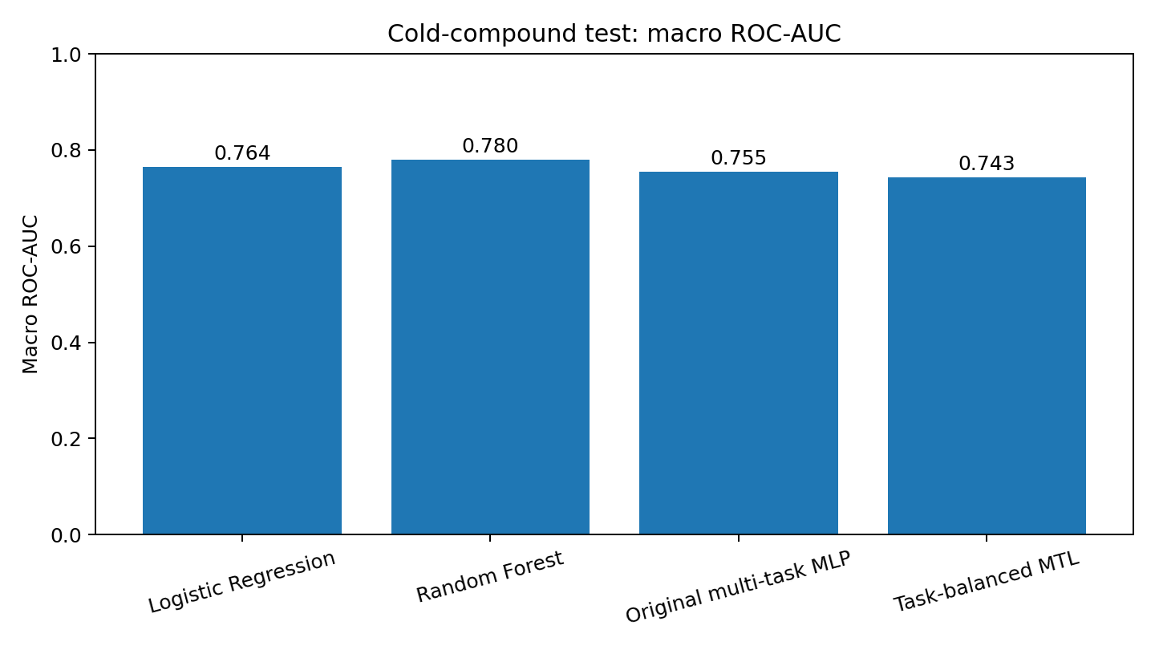
Figure 1. Macro ROC-AUC on the global cold-compound test set.
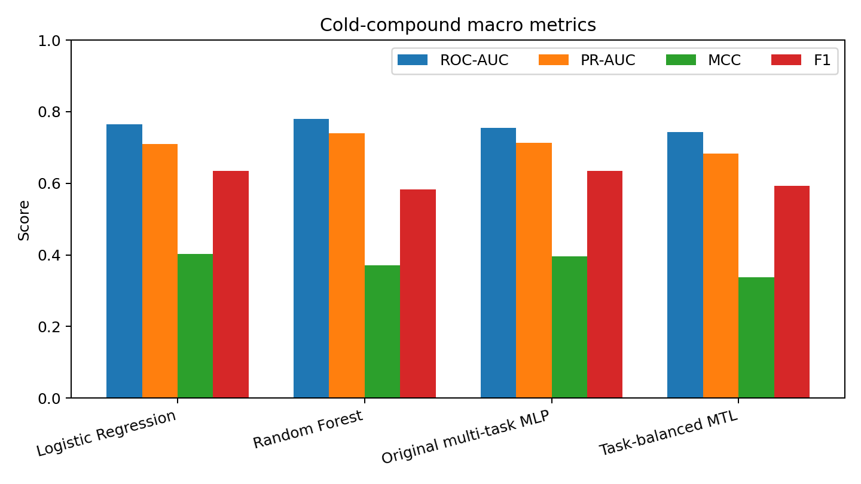
Figure 2. Macro metric comparison on the cold-compound test set.
Random Forest gives the strongest ranking metrics. Logistic Regression gives the strongest threshold-based MCC and F1, indicating a different precision/recall trade-off. The original MTL ROC-AUC (0.755) is below both single-task baselines; task-balanced MTL is lower (0.743). Therefore the current results do not demonstrate a general aggregate advantage for MTL.

6.1 Per-isoform cold-split metrics
Isoform | Model | ROC-AUC | PR-AUC | MCC | F1 | Accuracy
CYP1A2 | LR | .821 | .783 | .442 | .727 | .695
CYP1A2 | RF | .788 | .782 | .359 | .667 | .678
CYP1A2 | MTL | .747 | .754 | .347 | .627 | .678
CYP2C19 | LR | .702 | .635 | .198 | .514 | .605
CYP2C19 | RF | .740 | .668 | .338 | .455 | .721
CYP2C19 | MTL | .783 | .691 | .430 | .647 | .721
CYP2C9 | LR | .777 | .638 | .445 | .630 | .752
CYP2C9 | RF | .808 | .730 | .380 | .587 | .723
CYP2C9 | MTL | .759 | .633 | .458 | .628 | .766
CYP2D6 | LR | .781 | .766 | .475 | .630 | .726
CYP2D6 | RF | .779 | .742 | .355 | .539 | .669
CYP2D6 | MTL | .754 | .749 | .351 | .615 | .677
CYP3A4 | LR | .740 | .723 | .452 | .673 | .726
CYP3A4 | RF | .783 | .778 | .423 | .667 | .714
CYP3A4 | MTL | .733 | .734 | .397 | .653 | .701

MTL is strongest by ROC-AUC on CYP2C19 among the three original model families and has competitive MCC on CYP2C9, but it is not best on every isoform. This suggests possible selective transfer rather than universal transfer. CYP2C19 cold-test n=43, so point estimates remain uncertain.

7. Results: scaffold split
Model | Macro ROC-AUC | Macro PR-AUC | Macro MCC | Macro F1
Logistic Regression | 0.738 | 0.668 | 0.366 | 0.651
Random Forest | 0.764 | 0.736 | 0.313 | 0.523
Multi-task MLP | 0.712 | 0.651 | 0.323 | 0.620

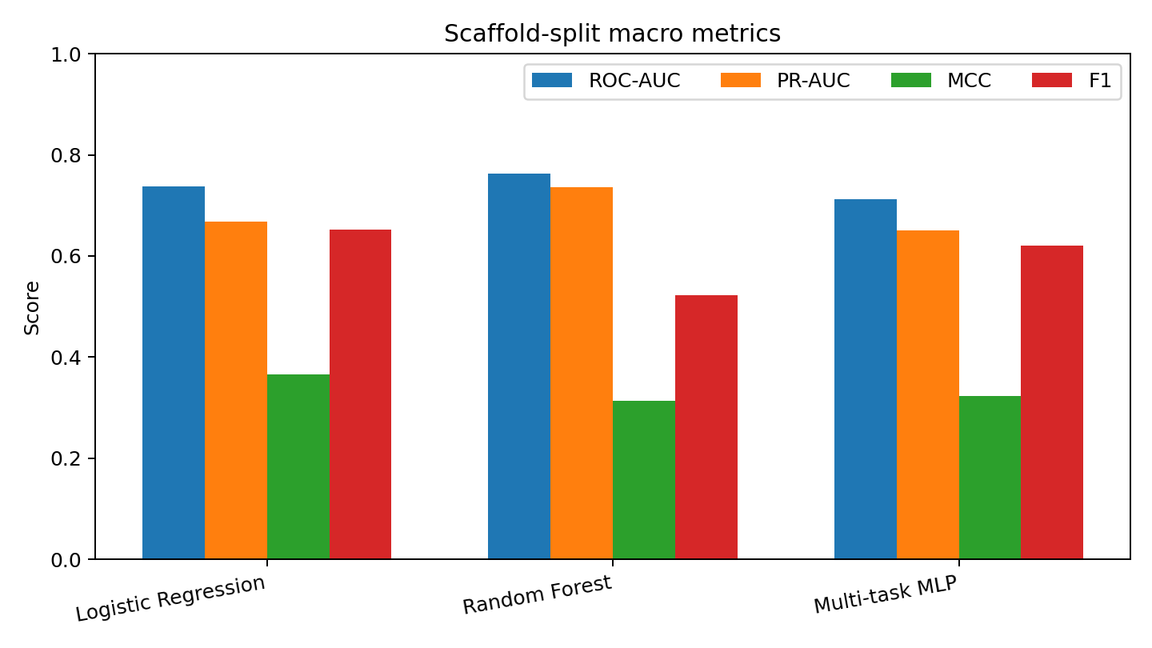
Figure 3. Scaffold-split aggregate metrics.
Random Forest leads macro ROC-AUC (0.764) and PR-AUC (0.736); Logistic Regression leads MCC (0.366) and F1 (0.652). MTL does not lead any listed aggregate metric. Scaffold test sizes are CYP1A2 n=53, CYP2C19 n=23, CYP2C9 n=152, CYP2D6 n=125 and CYP3A4 n=208. CYP2C19 scaffold results are especially uncertain due to the small test set.

8. Structural interpretation and applicability domain
Fingerprint-bit importance and representative RDKit fragments were examined. High-ranking bits include generic carbon-, oxygen- and nitrogen-containing environments, carbonyl-associated fragments, aromatic fragments and halogenated environments. These are hypothesis-generating observations only: hashed fingerprint bits can map to different environments, importance does not show direction or causality, and fragment importance alone does not prove a biochemical mechanism.
Maximum Tanimoto similarity to training molecules was used as a structural-familiarity proxy. Median maximum training similarity for cold-split test compounds was CYP1A2 0.267, CYP2C19 0.286, CYP2C9 0.612, CYP2D6 0.445 and CYP3A4 0.474. Scaffold-split medians were 0.269, 0.289, 0.394, 0.377 and 0.383 respectively. Similarity is not calibrated uncertainty. For CYP2C9, correct cold predictions generally had higher mean max similarity than incorrect predictions; this was not universal across isoforms. A chirality diagnostic found 126 train/test pairs with chirality-insensitive Morgan Tanimoto 1.0 but no exact canonical-SMILES overlap; with chirality enabled, 116 fell below 1.0. This is a representation diagnostic, not by itself proof of leakage.

9. Error analysis
Cold Logistic Regression on CYP1A2 had recall 0.889, specificity 0.531 and error rate 0.305. Cold Random Forest on CYP2D6 had recall 0.414, specificity 0.894 and error rate 0.331. Scaffold Logistic Regression on CYP3A4 had error rate 0.389. These examples illustrate different false-positive/false-negative trade-offs. Such summaries are threshold-dependent; per-isoform confusion matrices and examples should be retained in the project results folder.

10. Reference literature review

Primary high-impact reference
Bender, A., Thomas, M. C., Scannell, J. W. et al. (2026). “Artificial intelligence in drug discovery — what it is, where we stand and the path forward.” Nature Reviews Drug Discovery. Published 7 August 2026. DOI: https://doi.org/10.1038/s41573-026-01496-2. Article: https://www.nature.com/articles/s41573-026-01496-2. Official metrics: https://www.nature.com/nrd/journal-impact (2025 JIF 91.2).
The perspective argues that benchmark performance alone does not establish clinical utility, and discusses conditional biological data, problem specification, validation shortcomings and reproducibility. For this project, it motivates explicit label definitions, preserving missing isoform coverage, testing both compound and scaffold novelty, reporting per-isoform performance, and disclosing external-validation gaps. This is a broad drug-discovery perspective, not a CYP-specific algorithm paper.

CYP-specific companion paper
Fang, J. et al. (2024). “Prediction of Cytochrome P450 Substrates Using the Explainable Multitask Deep Learning Models.” Chemical Research in Toxicology 37(9), 1535–1548. DOI: https://doi.org/10.1021/acs.chemrestox.4c00199. Publisher: https://pubs.acs.org/doi/10.1021/acs.chemrestox.4c00199.
This directly studies the same five isoforms and reports an average test AUC of 0.908 for its selected multitask approach, with SHAP/attention and substructure mining for interpretation. Do not compare this number as if it were measured on the same dataset and split protocol. The useful lesson is that multi-task transfer and explainability should be tested under clearly described validation conditions.

11. Requirement audit
Requirement | Status | Evidence / remaining action
Dataset curation/schema mapping | Implemented in reported analysis | Retain raw data; document invalid SMILES and source-schema mismatch.
Single-task baselines | Implemented | Logistic Regression and Random Forest per isoform.
Shared MTL and incomplete labels | Implemented | Masked loss; missing labels are not negatives.
Per-isoform ROC-AUC/PR-AUC/MCC/F1 | Available in results summary | Ensure both protocols have complete tables in final local report.
Macro ROC-AUC | Available | Defined as equal-weight mean across five isoforms.
Cold-compound split | Implemented | 2,141 compounds; zero exact canonical-SMILES overlap.
Scaffold split | Implemented | No shared scaffold groups reported.
Structural analysis | Partially complete | Interpret fingerprint importance cautiously.
Error analysis | Implemented | Threshold-dependent findings.
Applicability domain | Partially complete | Similarity proxy; not calibrated uncertainty.
External/experimental validation | Not completed | Must be explicitly disclosed.
JIF >40 reference | Selected | NRDD 2025 JIF 91.2; include direct CYP paper as companion.
README/end-to-end execution | Needs local verification | Run all notebooks from a clean environment and confirm paths/dependencies.
Working software prototype | Not confirmed | No finished application is evidenced in the results summary.

This audit is based on the available project results summary, not a fresh execution of every notebook on the user’s Windows machine. Verify notebook paths, dependencies, checkpoint loading and output regeneration before submitting.

12. Limitations and responsible use
- Labels may reflect heterogeneous experimental conditions and source-specific substrate definitions.
- The input is a 2D fingerprint; enzyme structure, binding pose, assay context and kinetic rates are not modeled.
- CYP2C19 scaffold test n=23 makes its estimates particularly uncertain.
- No independent external validation or wet-lab CYP assay validation is documented.
- Tanimoto similarity is a familiarity proxy, not calibrated uncertainty.
- Fingerprint importance is not causal evidence.
- Do not use these outputs for clinical dosing, drug-interaction, safety or regulatory decisions.

13. Conclusion
The project compares single-task and multi-task CYP substrate classifiers under global cold-compound and scaffold-disjoint protocols. Random Forest gives the strongest aggregate ranking metrics, while Logistic Regression gives stronger threshold-based MCC/F1. MTL shows selective isoform-level strengths but no consistent macro advantage. The defensible contribution is the explicit leakage-aware evaluation, incomplete-label handling and error/applicability-domain analysis—not universal MTL superiority or clinical readiness.

References
- Bender et al. (2026). Nature Reviews Drug Discovery. https://doi.org/10.1038/s41573-026-01496-2
- Fang et al. (2024). Chemical Research in Toxicology. https://doi.org/10.1021/acs.chemrestox.4c00199
- Deep-PK data portal. https://biosig.lab.uq.edu.au/deeppk/data/
- Nature Reviews Drug Discovery journal metrics. https://www.nature.com/nrd/journal-impact

