# E-Learning

# What Is E-Learning

**learning by utilizing electronic technologies for accessing educational curriculums outside of traditional classrooms**.

**A learning system based on formalized teaching but with the help of electronic resources** is known as E-learning. While teaching can be based in or out of the classrooms, the use of computers and the Internet forms the major component of E-learning.

* **E-learning can be carried out via the consumption of videos, PDF documents, slideshows and word documents. Thanks to the availability of these resources, it’s incredibly easy for anybody to teach themselves a new skill at their own pace.**

**Terminology / Terms**

* **4 stages of eLearning course development**
* Analysis. In the analysis phase, a course creator must remember to do an in-depth study of the target audience.
* Design and develop.
* Course evaluation and testing.
* LMS hosting. (The hosted LMS is **an alternative to SaaS learning management systems**. This is where you have to install hardware or software onto your device to access training courses, which means that a lot of times, accessibility to your learning tools is limited.)
* **Types of E learning platform** 
  1. Synchronous Online Courses - Synchronous learning means that **although you will be learning from a distance, you will virtually attend a class session each week, at the same time as your instructor and classmates**. The class is a firm, weekly time commitment that cannot be rescheduled.

**Example -** Educational video conferences, interactive webinars, chat-based online discussions, and lectures that are broadcast at the same time they delivered

* 1. Hybrid Courses - Hybrid courses **offer you the advantages of online education as well as in-class learning**. Usually, in this format, you get to learn a section of the curriculum in-person, inside a classroom, while some parts are instructed in online classes.

**Example –**in USproviding lectures on online as well as offline mode and started as Hybrid as well in which 2 day online and 3 day offline classes they introduced it is also called as combination

* 1. Providing Continuity - Continuity E-Learning is **the experience students will have when school remains in session, but when students are not allowed to physically attend school because of an unforeseen school closure event**, like the (COVID-19) Pandemic. Distributing Materials.
  2. Creating Content. - The procedure of creating content in an e-learning **determines the usefulness of the module so developed**. E-learning content development process is the most important part of the complete e-learning creation.
  3. Curating Content - Content curation in eLearning is **the process of collecting and filtering relevant information about a particular subject matter and presenting it in an organized way**. The process benefits your learners, as it helps save them time from reading through irrelevant information to get what they need. **(Not Mandatory)**

**Methodology**

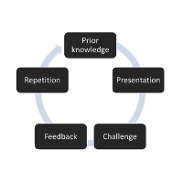

# KT/ Domain knowledge-

* **Domain** - E-learning
* E-Learning Websites

1. Bartleby
2. Khan Academy (US)
3. Vedantu
4. Udemy
5. Unacademy
6. Skill share
7. EdX
8. FootPrint
9. Splash Learn
10. Byjus

* **Application –** byjus, Unacademy, Akash-Byjus, Khan Academy

# Project-

* Project 🡪 E-learning

# Project-

**Q. Tell me about your project? Tell me Business and technical flow of your project?**

## Business Flow-

* Project domain – **Education (**Edtech, distance online education, mobile learning**)**
* Project Name – Bartleby
* Client name – **Barnes & Noble**
* **Client business** – Sell the Learning Plans, Online/Offline/Hybrid Courses to student and Earn revenue from it. Bartleby also coordinate with some schools and teach courses to students as per agreement with schools.

**Business flow –**

**Bartleby**

Sell Course to small/medium scale Tutors with bond and limit

Sell Course to School/ Colleges/ University with collaboration and approvals

Sell Course to Students/ Parents

Charity/Donation through End User/Customer

**Revenue**

* When student search for online courses on website or search colleges on Social media then their details with email ID, contact saved to data base of Bartleby/Un-academy
* That data is stored in data base and distributed to volunteers to call the students/Parents and after calling their details are distributed in following category.

1. Diamond lead (Rank 1 interested)
2. Gold lead (Rank 2 interested)
3. Silver lead (Rank 3 interested)
4. Interested for next year
5. Closed

* After calling through business Associate through CRM Application
* CRM Application (**Customer relationship management**) – **Customer relationship management is a process in which a business or other organization administers its interactions with customers, typically using data analysis to study large amounts of information.**

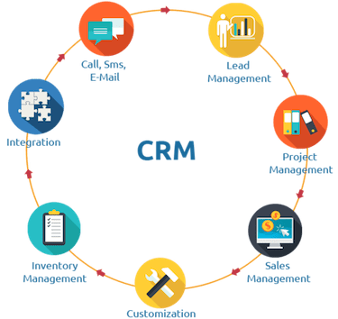

## After calling to student / Parents and finally if they buy online course then They categorised as following

1. **Annex (Access) Level 1 Student (Example:) -** As **Annex** level 1 students buy course with One year Package that’s why they have following access
2. Live Lectures
3. Recorded videos in students log in with Permanent Access
4. Curriculum with last 5 years of question paper with Solution/ Sample Papers/
5. Online pdf of books / Assignment
6. Weekly Test with guidance sessions
7. If buy hybrid course can visit class twice a week
8. Buy course virtual only then can attend through Tab/laptop/mobile
9. **Annex (Access) Level 2 Student () -** As **Annex** level 2 students buy course with 3 months/6 months Package that’s why they have following access
10. Online Lectures only
11. Recorded Videos with temporary Access
12. Last 2 Year Question Papers with Solutions/Sample Papers
13. 2 Test in a month
14. Hybrid/Combination option not available for the course
15. Curriculum
16. **Annex (Access) Level 3 Student () -** As **Annex** level 3 students those who have do Registration, create account and Profile on Application and those who booked free demo. They have following access
17. Free Recorded video Lecture (1 for each subject)
18. Last Year Question Papers with Solution (only 1)
19. All courses broachers
20. Curriculum
21. 1-week free trial with course contents