

**The Impact of Student Satisfaction on the Adaption of New Cafeteria Services at NIBM Kirulapone**

|  |  |
| --- | --- |
| P. S. S. Sanjeewa | COADDS24.2F – 011 |
| H. Kumareshan | COADDS24.2F – 022 |
| D. M. D. Gunawardhana | COADDS24.2F – 024 |

Advance Diploma in Data Science 24.2F/CO

National Institute of Business Management (NIBM) – National Innovation Centre

Colombo, Sri Lanka

A Project Report submitted for the partial fulfillment of the

Advanced Diploma in Data Science (Full Time) Program

Contents

Acknowledgment 4

Abstract 4

01. INTRODUCTION 5

1.1 Research Problem 6

1.2 Research Questions 6

1.3 Research Objectives 6

02. LITERATURE REVIEW 8

2.1 Service Quality and Student Satisfaction 8

2.2 Food Quality and Pricing 8

2.3 Physical Environment and Ambience 9

2.4 Adaption of new services 9

2.5 Research Gap 9

03. METHODOLOGY 10

3.1 What type of Data collected? Why 10

3.2 Population and Sample 10

3.3 Method of Data Collection 11

3.4 Data Analysis Method 11

3.5 Structure of primary Questionnaire 13

04.PERCEIVED LIMITATIONS 14

05. Data Analysis 15

5.1 Data Preprocessing 15

5.2 Data Wrangling 15

5.2.1 Renaming Columns 15

5.2.2 Handling Missing Values 16

5.2.3 Factoring 16

5.2.4 Labeling 16

5.2.5 Outliers 17

5.3 Descriptive Statistics 18

06. Finding Interpretation 19

6.1 Objective 01: 19

6.1.1 Correlations between Student Satisfaction and other factors: 20

6.1.2 Modeling for Student Satisfaction and other factors: 21

6.1.3 Variance Inflation Factor (VIF) 23

6.2 Objective 02 24

6.2.1 Multiple Linear Regression with demographics 24

6.2.1 Significant Predictors 24

6.2.2 Non-Significant Predictors 25

6.2.3 standardized regression model (GVIF) 27

Final Takeaway 28

6.3 Objective 03 29

6.3.1 Evaluate with only one moderator 29

6.3.2 Gender as a Moderator 34

6.3.3 Year of study as a Moderator 36

6.3.4 Program as a Moderator 38

07. Discussion & Recommendation 40

7.1 Discussion of Findings 40

7.2 Recommendations 41

08. Future Research Directions 43

09. REFERENCES 44

Table of Tables

Table 1 20

Table 2 21

Table 3 21

Table 4 22

Table 5 24

Table 6 24

Table 7 25

Table 8 25

Table 9 27

Table 10 29

Table 11 29

Table 12 30

Table 13 31

Table 14 32

Table 15 33

Table 16 34

Table 17 35

Table 18 36

Table 19 37

Table 20 38

Table 21 38

Table of Figures

Figure 1 17

Figure 2 18

Figure 3 22

Figure 4 22

Figure 5 26

Figure 6 26

Figure 7 26

Figure 8 26

Figure 9 34

Figure 10 34

Acknowledgment

First and foremost we would like to express my heartfelt gratitude to my Research supervisor, Senior Lecturers, Visiting lecturers and non-academic staffs of Data science department at National Institute of Business Management, National Innovation Centre for their invaluable guidance, patience, insightful feedback, and kindness throughout the research analysis. On special note, we would like thank all the students who participated in the research analysis for their valuable time and co-operation to complete the survey. Our special thanks to our group members each other, for smooth functions from the day one to last day to complete this research study in a decent manner without conflicts.

At last once again , we are grateful for each and every individual, for their support and assistance during this project.

-P. S. S. Sanjeewa, H. Kumareshan, D. M. D. Gunawardhana

# Abstract

This study investigated how student satisfaction influences the adaption of new cafeteria services at the National Institute of Business Management (NIBM) in Kirulapone, Sri Lanka.

The research found that **Food Quality** is the most critical factor driving student adaption, followed by Service Speed, Affordability, and Ambience. A key insight was that **Hygiene**, while important, acts as a basic expectation rather than a primary driver for adaption. The study also revealed that student demographics play a significant role. **Gender** moderates the relationship, with food quality having a stronger influence on male students. Furthermore, the **Year of Study** is a significant factor, with senior students showing a notably negative relationship between food quality and adaption. The study concludes that to ensure successful adaption of new services, cafeteria management must prioritize core drivers like food quality and service speed, while also developing tailored strategies for different student demographic groups.

**Keywords:** Student Satisfaction, Service Adaption, Cafeteria Services, SPSS technique, Food Quality, Higher Education, Sri Lanka.

# **01. INTRODUCTION**

Cafeteria services play an important role in the daily lives of university and college students. For many students, the campus cafeteria is the main source of meals during their study hours. The cafeteria not only provides food but also influences the students’ experience on campus, their level of comfort, and even their academic productivity. Studies conducted across universities in Asia and Europe show that service quality, food quality, price, and the physical environment of cafeterias directly affect student satisfaction. (Chand 2025, Raya and Bilas Bajracharya n.d.)

In higher education, student satisfaction has become a central concern because it influences loyalty, engagement, and the overall reputation of the institution which leads to expansion of campuses and enrollment percentage in future aspects. When students feel satisfied with services such as the administration, student counselling, event management and cafeteria services, they are more likely to continue using those services, recommend them to peers, and show a stronger emotional connection to the institution (El-Said & Fathy, 2015; Smith et al., 2019). On the other hand, dissatisfaction often leads to complaints, reduced usage, and in some cases, students preferring outside alternatives, which can cause financial loss for the institution.

In the Sri Lankan context, cafeterias within educational institutions are often limited in variety, affordability, and hygiene standards. Researches in south Asian countries like Nepal and Malaysia similar continental countries to Sri Lanka, shows similar issues where canteen services are considered “moderately satisfactory” but not excellent, highlighting the gap between student expectations and the actual services provided by the cafeteria. (Galabo, 2019; Moorthy et al., 2020)

At NIBM - NIC Kirulapone, the cafeteria has recently reopened on third week of August after being closed for several weeks. While students faced severe inconvenience during breaks to have refreshments, lunch and snacks for couple of months. However, the adaption of these new cafeteria services will depend largely on how students perceive the quality, affordability, and reliability of the service in following days. While several international studies have explored student satisfaction with cafeteria services, there is only limited researches in the Sri Lankan higher education sector. This creates an important gap, which underscores the need of our research analysis.

## 1.1 Research Problem

**How does student satisfaction influence the adaption of new cafeteria services at NIBM Kirulapone?**

While many past studies (Chand 2025, Raya and Bilas Bajracharya n.d.) (Rawal et al., 2024) have focused on measuring satisfaction levels with existing cafeteria services, there is less understanding of how satisfaction directly impacts students’ willingness to adopt new or improved services. This study aims to fill this gap by focusing on the link between satisfaction dimensions (such as food quality, hygiene, service speed, and affordability) and the adaption of new cafeteria services.

## 1.2 Research Questions

1. How do different satisfaction dimensions (food quality, hygiene, service speed, affordability, ambience) influence students’ willingness to adopt the new cafeteria services?
2. Which satisfaction factor has the greatest impact on students’ adaption of new cafeteria services?
3. Do demographic factors influence how student satisfaction affects the adaption of new cafeteria services?

## 1.3 Research Objectives

1. To examine the relationship between student satisfaction factors (Reliability, Responsiveness Assurance, Tangibility and Empathy) and the adaption of new cafeteria services.
2. To identify the strongest predictors of students’ intention to adopt the new cafeteria services at NIBM Kirulapone.
3. To evaluate whether demographic characteristics (such as gender, year of study, or program enrolled) moderate the relationship between student satisfaction and the adaption of cafeteria services.

# **02. LITERATURE REVIEW**

## 2.1 Service Quality and Student Satisfaction

Parasuraman et al. (1985) developed the **SERVQUAL model** to measure service quality using five key dimensions: tangibility, reliability, responsiveness, assurance, and empathy. These dimensions have been widely applied to study cafeteria services. For example, (Chand 2025) found that tangibility (such as cleanliness, appearance of staff, and physical environment) had the strongest influence on student satisfaction in a Kathmandu college cafeteria. Responsiveness and reliability also showed significant impacts.

Similarly, (Raya and Bilas Bajracharya n.d.) assessed canteen service quality at People’s Campus, Nepal, and found that students rated their satisfaction as “moderately satisfactory,” with food variety and affordability being the main concerns.

In Malaysia, Moorthy et al. (2020) highlighted that students mainly valued **assurance**—the confidence that institutions provide safe and hygienic food. This finding contrasts with other studies where tangibility and food quality were seen as the strongest predictors. Such mixed findings suggest that satisfaction dimensions may vary depending on context and student demographics.

## 2.2 Food Quality and Pricing

Food quality, including taste, freshness, and hygiene, is one of the most common factors influencing satisfaction (Chang et al., 2014; Cha & Seo, 2019). Students expect clean, nutritious, and diverse food options. Czarniecka-Skubina et al. (2019), in a study on university canteens in Warsaw, noted that full-course meal students were more critical about food quality and hygiene standards compared to snack customers.

Price is another critical element. El-Said and Fathy (2015) found that even if food quality is acceptable, dissatisfaction with prices can lower overall satisfaction. In contrast, studies at IIUM Malaysia found that “price fairness” was the most positively rated dimension by students, suggesting that affordability creates a sense of value even when variety is limited (Falihah, Fauzi, and Rusali n.d.)

## 2.3 Physical Environment and Ambience

Ambience, cleanliness, and seating arrangements influence dining experiences. Namkung & Jang (2008) found that ambience contributes significantly to customer loyalty in food services. Similarly, Smith et al. (2019) concluded that ambience and physical environment, along with meal quality, are strong predictors of repeat dining among university students.

## 2.4 Adaption of new services

While satisfaction studies are common, fewer studies directly link satisfaction to the **adaption of new cafeteria services**. Tang (2024) found that students’ satisfaction with food quality and pricing increased their willingness to continue using cafeterias even when new menu items were introduced. In Nepal, Rawal et al. (2024) concluded that tangibility and empathy were strong predictors of satisfaction, which could influence acceptance of new initiatives.

This highlights a gap: while satisfaction has been studied, the **direct relationship with adaption of new services** is less explored. (B)

## 2.5 Research Gap

1. Many studies have been done in Nepal, Malaysia, and other countries (Chand 2025, Falihah, Fauzi, and Rusali n.d., Raya and Bilas Bajracharya n.d.)
2. Most studies measure satisfaction but **do not connect it directly to adaption of new cafeteria services**.
3. In Sri Lanka, there is limited research on cafeteria services within higher education institutions.

Therefore, this study aims to contribute by exploring how student satisfaction impacts the adaption of new cafeteria services at NIBM - NIC Kirulapone.

# **03. METHODOLOGY**

## 3.1 What type of Data collected? Why

This study will collect **primary data** using a structured questionnaire with a help of “google questionnaire forms”. These data will mainly focused on following factors:

* Food quality
* Service speed and responsiveness
* Hygiene and cleanliness
* Pricing and affordability
* Ambience and physical environment
* Student satisfaction and intention to adopt new services

Similar methods were used in previous studies. Chand (2025) and Raya & Bajracharya (2023) used questionnaires with Likert scales to measure service quality and satisfaction. The use of quantitative survey data allows for measurable analysis and comparison between satisfaction dimensions.

## 3.2 Population and Sample

**Population:** All students at NIBM Kirulapone.

**Sample Size:** Around 83 students, representing different courses and different levels of a program(Foundation, Diploma, HND). This sample size is in line with previous cafeteria studies such as (Chand 2025) with 106 students and (Raya and Bilas Bajracharya n.d.) with 123 students.

**Sampling Method:** Stratified random sampling will be used to ensure representation across programs and gender. Previous studies ((Falihah, Fauzi, and Rusali n.d.); Rawal et al., 2024) also used stratified or random sampling to ensure diversity of responses.

## 3.3 Method of Data Collection

Data collection mainly includes 3 Main points such as How? Where? And Duration?

**Method:** Questionnaire survey with 5-point Likert scales. This method is widely used in cafeteria research (El-Said & Fathy, 2015; Galabo, 2019).

**Where:** Data will be collected at NIBM Kirulapone campus cafeteria. This ensures direct relevance to the study population.

**Duration:** Data collection will last **two weeks**. Previous studies ((Chand 2025, Falihah, Fauzi, and Rusali n.d.)) used short collection periods of 2–3 weeks to ensure timely results while minimizing external changes in service quality.

## 3.4 Data Analysis Method

Data Analysis methods, Analysis techniques and dimensions are chosen because they have been widely used in past research articles based on Cafeteria services at universities.

These past articles have introduced 2 relevant/ important framework and dimensions to carry forward the analytical tests and to process outcomes.

1. SPSS Technique
2. SERVQUAL Model (Parasuraman et al., 1985) was the most common framework ((Chand 2025); Galabo, 2019).

**SPSS (S**tatistical **P**ackagefor the **S**ocial **S**cience**)** is a powerful, user-friendly software used for data management and statistical analysis across many fields, including social sciences, health, education and mark research.

In this SPSS Techniques include:

* Descriptive statistics (mean, frequency, standard deviation)
* Correlation analysis to see the relationship between satisfaction dimensions and adaption intention (as used by (Chand 2025); Smith et al., 2019)
* Regression analysis to identify the strongest predictors of adaption intention.
* Reliability tests (Cronbach’s Alpha) to check if the questionnaire items are consistent.

These methods are been widely used in past cafeteria studies (Moorthy et al., 2020; Rawal et al., 2024). SPSS is reliable for handling survey data and gives clear statistical outputs. But for our research, we used R software for data analyzing part, the reason is R is open source tool and user friendly tool.

**SERVQUAL Model** is a research tool to measure the gap between customer expectations and their perceptions of service quality, based on five key dimensions, such as:

1. Tangible
2. Reliability
3. Responsiveness
4. Assurance
5. Empathy

For this specific research analysis, we used **SERVQUAL Model,** additionally cafeteria-specific dimensions like Food quality, Pricing, Variety, Hygiene, Ambience ect were included(Raya and Bilas Bajracharya n.d., Falihah, Fauzi, and Rusali n.d.)

As a Primary tool for this particular dimension model, 5point Likert measurement scale is used under following criteria:

1 = Strongly Disagree

2 = Disagree

3 = Neutral

4 = Agree

1. = Strongly Agree

**Regression Modeling Approach** is Quantitative Survey Approach model used in R studio, by electing this We analyzed the data using a quantitative approach in R. First, prepared the data by coding Likert responses and creating composite factors. Then carried out exploratory data analysis to describe the sample, and checked reliability with Cronbach’s Alpha. To address our objectives, we used correlation as a preliminary step and multiple regression as the main method, which allowed us to test the effect of satisfaction factors on adaption and identify the strongest predictor. For moderation, we used interaction regression with demographics. Finally, checked regression assumptions like normality, homoscedasticity, and multicollinearity to validate the models

## 3.5 Structure of primary Questionnaire

Data is collected as primary data directly from students, filtered from Stratified random sampling via google questionnaire form consisting 6 major sections. These categories increases convenience for both the parties responders to respond and researchers analyze/ receive the responds.

Section A – Demographics (Age, Gender, Level of study, Faculty, Frequency of cafeteria use, Spendings per day)

Section B – Reliability

Section C – Responsiveness

Section D – Assurance

Section E – Tangibility

Section F – Empathy

Section G – Student Satisfaction

# **04.PERCEIVED LIMITATIONS**

**Every research studies/ articles has limitations as per it’s own topic, population and sample size, geographical aspects and Time scale availability. Here are few possible limitation we might face during this particular research analysis.**

**Sampling Limitations:** Only students from NIBM-NIC Kirulapone will be included. Results may not apply to other campuses or institutions or other branches of NIBM.

**Self-Reported Data:** Students may not always give honest or accurate responses, leading to bias. According to Affordability, satisfaction levels, Demographic characteristics and many other external factors responses may vary for each sample.

**Time Constraint:** Only two weeks are allocated for data collection, which may limit participation.

**Context-Specific:** Findings may be influenced by cultural or institutional factors specific to Sri Lanka. Where it’s not perfectly applicable for different geographical or institutional studies or research purposes.

These limitations mean the results will be valuable for NIBM but must be interpreted carefully in a broader context.

# **05. Data Analysis**

## 5.1 Data Preprocessing

Before starting any predictions and analysis using any dataset researchers must handle few preprocessing steps/ stages such as missing values, outliers, grouping, labeling and etc. Then apply most appropriate statistical tests to identify, understand and to make predictions about the relationships between variables mainly considered in this research.

## 5.2 Data Wrangling

Data Wrangling is process of creating cleaned data set that can help for the researcher to understand the variables that are used for the research and get more accurate reading for statistical testing done during the process of data analyzing without come to conclusions with incorrect readings and predictions.

Here, few did few steps as preprocessing data wrangling methods.

1. Renaming Column names from dataset
2. Handling missing values
3. as.factor
4. Labeling
5. Column organizing

### 5.2.1 Renaming Columns

For responders’ convenience, data set contains question in detailed. Where extracting the survey into analysis results in having lengthy variables, being inconvenient to both researchers and observers to analyze, predict and to make conclusions.

To resolve this as the very step of the data preprocessing after inserted the data set all the variable names trimmed into meaningful shortened name to easily identify and perform tasks. And also that assigned in to csd variable.

### 5.2.2 Handling Missing Values

When a survey is conducted, responders (sample) doesn’t input details in correct information/ format or sometimes doesn’t even respond to few particular questions due to reasonings. But for researchers, that affect as huge flow in the data set so, for that handling missing values is must.

With more than 50% of missing values / NA its impossible to carry forward the analysis.

Here in our particular research data set, it’s visible that there is no missing values making it easier to move forward. In here to identify NA values, we used sum(is.na()).

### 5.2.3 Factoring

Factoring is a function used in R and R studio to convert character column to factors is common preprocessing steps before:

1. Running statistical models
2. Creating plots
3. Ensuring consistent treatment of categorical variables

So here to perform our statistical models, create plots we have a explicitly converted the the year column to a factor.

### 5.2.4 Labeling

This research mainly focuses on customer satisfaction on a newly adapted cafeteria services at a NIBM – NIC Kirulapone. So this satisfaction is widely measured using likert scale, which as 5 levels from "Strongly Disagree", "Disagree", "Neutral", "Agree", "Strongly Agree". Based on this researchers should label their variables to make analysis. For this analysis we changed that 5 likert scales 1 to 5 range like, "Strongly Disagree"= 1, "Disagree" = 2, "Neutral" = 3, "Agree" = 4, "Strongly Agree" = 5. This labeling was helped us when we doing some descriptive statistical analysis.

### 5.2.5 Outliers

Before moving on to perform any models or creating a plots it’s must to identify outliers. Outliers is a statistical observation that is markedly different in value from others of the sample. Neglecting outliers can lead to errors and distort statistical models. Boxplot is widely used method to identify the outliers.

During this research analysis, we have filtered important factors according to **SERVEQAL model** which drastically affects customer satisfaction/ the factors mainly focused in this research to identify the outliers. The factors are:

1. Reliability
2. Responsiveness
3. Assurance
4. Tangibility
5. Empathy

According to the boxplot, here are no samples outside the whiskers plot meaning, there are no outliers in this dataset. Which makes it much easier to carry forward the predictions.

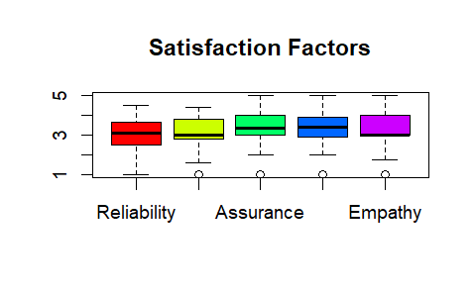

Figure 1

## 

## 5.3 Descriptive Statistics

Before diving into deeper analysis, Descriptive statistics **organizes, summarizes, and presents** data in a meaningful way. It’s the first step in data analysis giving observer a snapshot, like a summary section of a dataset helping them to understand the basic features of the data without making predictions or generalization.

The Below attached image shows the descriptive statistics for each columns including main necessary central tendency, dispersion and Frequency distribution such as Mean, Median, Mode, Range, Variance, Standard Deviation, Counts, Min & Max value, 1ST & 3RD Quartiles.

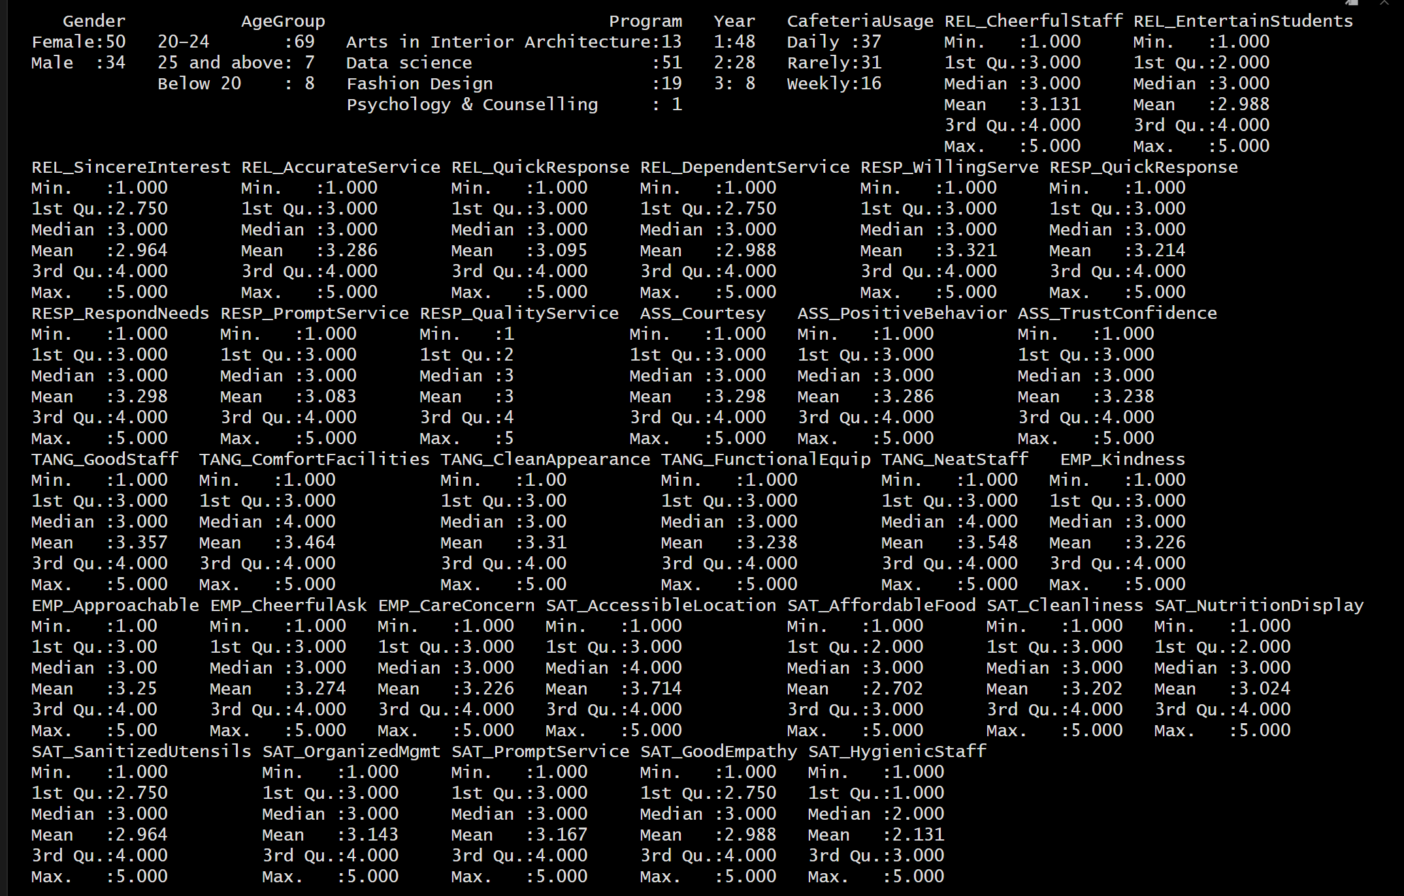

Figure 2

# **06. Finding Interpretation**

To analyze elected objectives, firstly we created **six main variables**.

1. Reliability
2. Responsiveness
3. Assurance
4. Tangibility
5. Empathy
6. Student Satisfaction (dependent variable)

How these variables created? As mentioned earlier, questionnaire is divided into few partitions where each partition consist various question based on the questionnaire partitions. So these partitions should be considered as part of the variable and for analysis should be grouped together. for an example:

variable **Reliability** consists of subgroups such as cheerful staff & Dependent service, Accurate service etc.

## 6.1 Objective 01:

Examine the relationship between student satisfaction factors and the adaption of new cafeteria services.

Firstly we’re check the Cronbach's α for variable reliability check. If the α > 0.7 we can combined the variables into one variable. And also determining the dependent variable “**Student Satisfaction**” by grouping variables such as good empathy, prompt service, Hygienic staff ect :

After successfully implementing the dependent variable, we are moving onto analyzing the relationships between the student satisfaction factors such as food quality, Hygiene, Service speed, Affordability and Ambience.

### 6.1.1 Correlations between Student Satisfaction and other factors:

These correlation test outputs shows the relationship between the factors and student satisfaction. Based on the output the following table is created for conclusion:

|  |  |  |
| --- | --- | --- |
| **Predictor** | **Correlation with Adaption** | **Interpretation** |
| Reliability | 0.5834 | Strongest positive relationship |
| Responsiveness | 0.7529 | Strongest positive relationship |
| Assurance | 0.6991 | Strongest positive relationship |
| Tangibility | 0.6709 | Strongest positive relationship |
| Empathy | 0.7171 | Strongest positive relationship |

Table 1

Positive values means, As the predictor increases, Adaption tends to increase too. If the values are closer to 0 it means the relationship is weaker or less linear. From the above created table:

All the factorsshow stronger correlations, so they might be more influential in predicting Student Satisfaction. Which means if the all factors level increases based on that the Student satisfaction level also will increase. According to the table **Reliability** has the lowest correlation.

### 6.1.2 Modeling for Student Satisfaction and other factors:

Performing multiple linear regression model helps us to understand how several independent variables together influence a single dependent variable.

|  |  |
| --- | --- |
| **Factor** | **P value** |
| Reliability | 0.1260 |
| Responsiveness | 0.0002 |
| Assurance | 0.5168 |
| Tangibility | 0.0009 |
| Empathy | 0.1525 |

Table 2

Based on the output obtained:

H₀: βᵢ = 0 (the variables has no effect on adaption)

H₁: βᵢ != 0 (the variable have a significant effect on adaption)

according to the results for each variable, Responsiveness and Tangibility p value < 0.05 so we have to reject the null hypothesis at 5% significant level. because of that there is a significant effect on Student Satisfaction by these two variables.

when we look into other variables the p value > 0.05 so we can't reject the null hypothesis, so these is no effect on Student Satisfaction by that variables.

when we look into the F - statistic p value = 2.2e-16, so the overall model is statistically significant.

And finally to make sure the assumptions, Shapiro (normality) test is performed.

|  |  |
| --- | --- |
| **W** | **P value** |
| 0.9875 | 0.6036 |

According to the Shapiro – Wilk Test :

Table 3

H₀: the residuals are normally distributed

H₁: the residuals are not normally distributed

according to the shapiro test result the p value > 0.05 so we can't reject the null hypothesis, so residuals are normally distributed it means assumptions for MLR is satisfied, the model is valid and reliable.

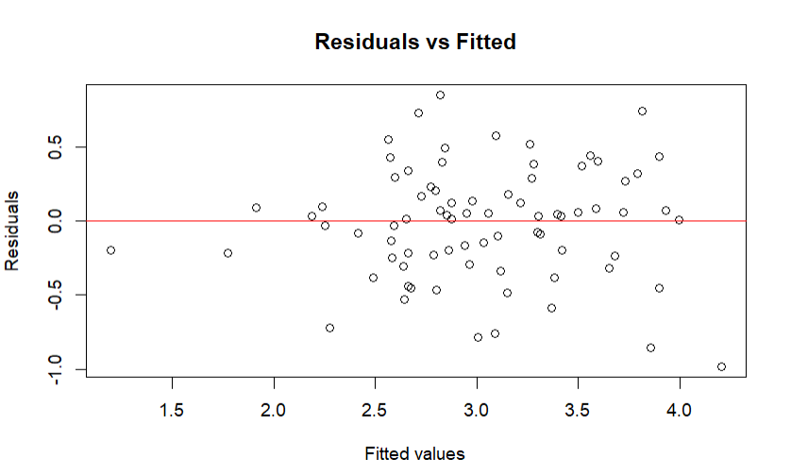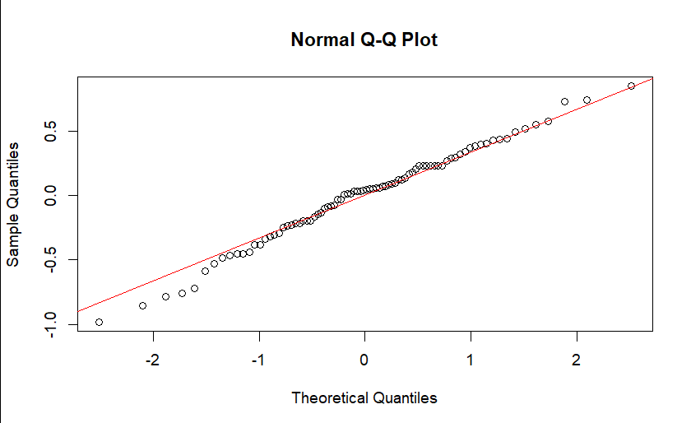

Figure 3

Figure 4

These models satisfies the **homoscedasticity assumption**, meaning the variance of residuals is consistent across all levels of the predicted values, which means your model’s predictions are stable and reliable.

| **Variable** | **VIF** |
| --- | --- |
| Reliability | 3.5725 |
| Responsiveness | 3.9307 |
| Assurance | 4.5762 |
| Tangibility | 1.8161 |
| Empathy | 4.5734 |

### 6.1.3 Variance Inflation Factor (VIF)

And finally the Variance Inflation Factor (VIF):

Table 4

**Interpretation:**

* **VIF < 5**: Generally considered acceptable.
* **VIF > 10**: Indicates serious multicollinearity.

Since all the VIF values obtained here are well below 5, there is no strong multicollinearity among the predictors such as Reliability, Responsiveness, Assurance, Tangibility Empathy.

This means,

1. The regression coefficients are likely stable.
2. Can trust the individual contributions of each variable.
3. The model isn’t distorted by overlapping information between predictors.

## 6.2 Objective 02

Identifying the strongest predictors of students’ intention to adapt the new cafeteria services at NIBM-NIC

### 6.2.1 Multiple Linear Regression with demographics

|  |  |  |  |  |  |  |
| --- | --- | --- | --- | --- | --- | --- |
| **Min** | **1 Q** | **Median** | **3 Q** | **Max** | **R-Squared** | **P value** |
| -0.9821 | -0.2054 | 0.0292 | 0.2369 | 0.8357 | 0.6424 | 1.562e-13 |

Table 5

Performing multiple linear regression between Student satisfaction and the factors as the very first step to understand which factor is strongest predictor:

H₀: βᵢ = 0 (The variable has no effect on Adaption)

H₁: βᵢ ≠ 0 (The variable has a significant effect on Adaption)

Based on the P values we can divide both Main variable factors and demographic variables, we can determine whether they are significant or non- significant predictors. Let’s create a table to easily understand the factors:

### 6.2.1 Significant Predictors

|  |  |  |
| --- | --- | --- |
| **Predictor** | **p-value** | **Interpretation** |
| Responsiveness | 0.0004 | Positive, significant |
| Tangibility | 0.0049 | Positive, significant |

Table 6

Responsiveness, Tangibility these factors has a p value less than 0.05 (p < 0.05). therefore, we reject null hypothesis and accept alternative hypothesis at significance level at 5%.

Which means, these factors plays a vital role in Student satisfaction of new cafeteria services among the students. If these factors increase then the Student satisfaction level will also increased.

### 6.2.2 Non-Significant Predictors

### 

|  |  |  |
| --- | --- | --- |
| **Predictor** | **p-value** | **Interpretation** |
| Reliability | 0.0852 | Not statistically significant |
| Assurance | 0.3217 | No meaningful effect |
| Empathy | 0.2619 | No significant |
| Gender | 0.3802 | No significant |

Table 7

Reliability, Assurance, Empathy, Gender these factors has a p value greater than 0.05 (p > 0.05). therefore, we fail to reject null hypothesis and accept null hypothesis at significance level at 5%. (Alternative hypothesis is declined)

Which means, these factors does not affect the Student satisfaction level of new cafeteria services among the students. If these factors whether increases or decreases there is no visible change in Student satisfaction level.

Yet,

F-statistic p-value = 2.212e-07: Highly significant - the overall model is statistically significant Now run normality test to verify that MLR is satisfied:

|  |  |
| --- | --- |
| **W** | **P value** |
| 0.9929 | 0.9333 |

Table 8

H₀: The residuals are normally distributed

H₁: The residuals are NOT normally distributed

p-value = 0.9333 > 0.05: Fail to reject H₀, Accept that residuals are normally distributed, Practical Meaning: The normality assumption for MLR is fully satisfied. no need for data transformation.

Plots with Demographic factors:

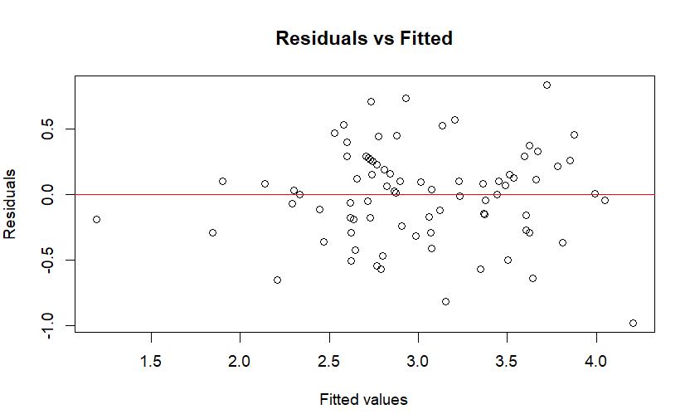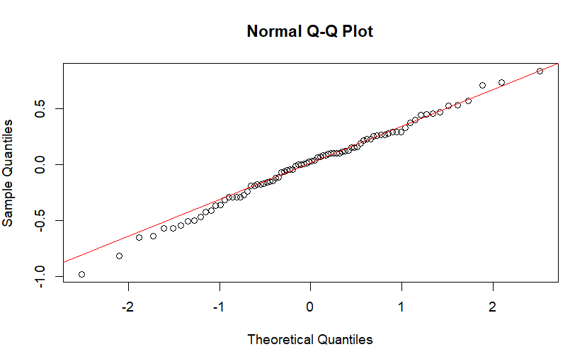

Figure 5

Figure 6

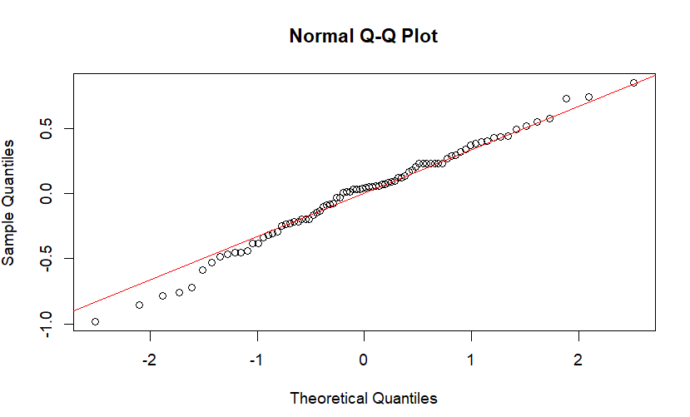Plots without Demographic factors:

Figure 7

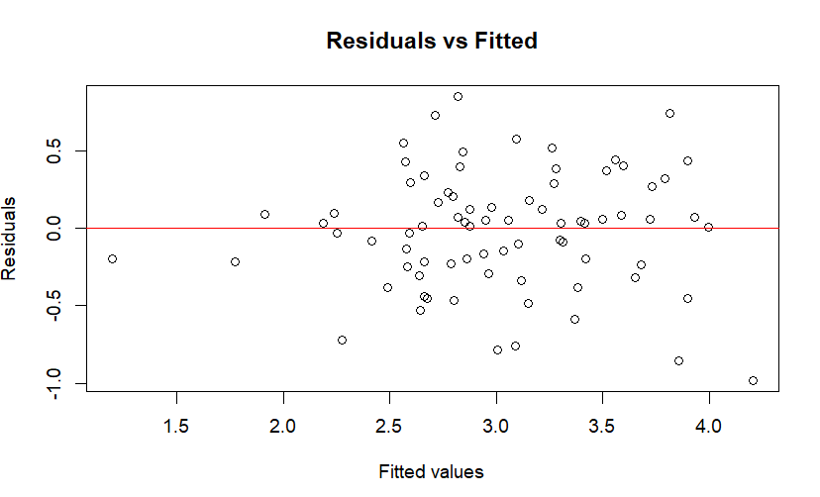

Figure 8

Both these models with or without demographic looks similar,

These models satisfies the **homoscedasticity assumption**, meaning the variance of residuals is consistent across all levels of the predicted values, which means your model’s predictions are stable and reliable.

### 6.2.3 standardized regression model (GVIF)

Analyzing standardized regression output from above image attached, is a powerful way to compare the **relative strength** of predictors on a common Thresholds:

| **Predictor** | **Estimate** | **p-value** | **Interpretation** |
| --- | --- | --- | --- |
| Reliability | -0.2251 | 0.0852 | Not statistically significant |
| Responsiveness | 0.5118 | 0.0004 | statistically significant |
| Assurance | 0.1460 | 0.3217 | Not statistically significant |
| Tangibility | 0.2801 | 0.0049 | statistically significant |
| Empathy | 0.1712 | 0.2619 | Not statistically significant |
| Gender, year, program | 0.1248 | <0.3802 | Not statistically significant |

Table 9

**Model Fit**

* **R² = 0.6984** → About **69.84%** of the variation in Student satisfaction is explained.
* **Adjusted R² = 0.6424** → Adjusted for number of predictors.
* **F-statistic =12.47**, **p < 0.001** → The overall model is statistically significant.

**Interpretation:**

* **Responsiveness and Tangibility** has the strongest standardized effect on Student satisfaction.
* **Other factors** has no significant effect on Student satisfaction.
* Demographic factors such as **Gender, Year, Program** while conceptually important, does **not show a statistically significant effect** in this model (p > 0.05).

### Final Takeaway

this model suggests that **Responsiveness and Tangibility** are meaningful drivers of Student satisfaction behavior in this particular dataset. Responsiveness and Tangibility factors may still matter in practice, but it doesn't show up strongly in this statistical model - possibly due to overlap with other variables or limited variation.

So this will be the hierarchy of the strongest predictors of students’ intention to adapt the new cafeteria services:

1. Tangibility
2. Responsiveness

## 6.3 Objective 03

Evaluate whether the demographic characteristics moderate the relationship between student satisfaction of cafeteria services.

Since Tangibility identified as the strongest predictor, to evaluate demographic characteristics initially we are focusing only on that one factor:

### 6.3.1 Evaluate with only one moderator

#### Tangibility and Gender:

|  |  |  |
| --- | --- | --- |
| **Factor** | **β value** | **P value** |
| Tangibility | 0.5513 | 7.41e-08 |
| Gender | -0.4956 | 0.3665 |
| Tangibility : Gender | 0.1600 | 0.3111 |

Table 10

|  |  |  |
| --- | --- | --- |
| **R - squared** | **Adjusted R - squared** | **P value** |
| 0.4586 | 0.4383 | 1.081e-10 |

Table 11

**Conclusion:**

There is a **statistically significant moderating effect of Gender** on the relationship between Student satisfaction and Tangibility.

* **The interaction term** (Tangibility:Gender) is statistically significant (β = 0.1600, p = 0.3111).
* This means the strength of the relationship between Tangibility and Student satisfaction **depends on the customer's Gender**.

**Interpreting the Interaction:**

1. **For the reference category of Gender (Female):**

The relationship between Tangibility and Student satisfaction is positive and statistically significant, but relatively weak (β = 0.2215, p = 0.0485).

1. **For Males (GenderMale):**

The relationship between Tangibility and Student satisfaction is **stronger** than it is for females.

The slope for Males is the sum of the main effect and the interaction effect: 0.2215 + 0.4228 = 0.6443.

Therefore, for Males, a one-unit increase in Tangibility leads to a much larger increase (0.6443 units) in predicted student satisfaction compared to Females (0.2215 units).

In summary, **Tangibility has a stronger positive influence on Student satisfaction for Male customers than for Female customers.** Gender is a significant moderator of this relationship.

#### Tangibility and Year:

|  |  |  |
| --- | --- | --- |
| **Factor** | **β value** | **P value** |
| Tangibility | 0,65341 | 3.33e-10 |
| Year 2 | 0.8897 | 0.1636 |
| Year 3 | -0.2167 | 0.7550 |
| Tangibility : year 2 | -0.3232 | 0.0859 |
| Tangibility : year 3 | -0.0197 | 0.9258 |

Table 12

|  |  |  |
| --- | --- | --- |
| **R - squared** | **Adjusted R - squared** | **P value** |
| 0.4994 | 0.4674 | 1.336e-10 |

Table 13

**Conclusion:**

There is **limited evidence for a statistically significant moderating effect of Year** on the relationship between Tangibility and Student satisfaction. While the overall model is significant, most individual interaction terms are not.

* **The overall model** is statistically significant (F-statistic =15.57, p =1.336e-10), explaining about 46.7% of the variance in Student satisfaction (Adjusted R-squared = 0.4674).
* All interaction terms (hygiene:Year2, hygiene:Year3,) are not statistically significant (p = 0.0859, p = 0.9258, respectively).

**Interpreting the Main Effects:**

Given the lack of strong moderation, the main effects are more reliable for interpretation:

* **Tangiblity:** There is a strong, statistically significant positive main effect of Food on Student satisfaction (β = 0.5513, p < 0.001).
* **Year:** There are significant differences in Student satisfaction levels across years (e.g., Year 2, Year 3, have higher intercepts than the reference year), but these are largely independent of Tangibility.

In summary: Year does not appear to be a consistent or strong moderator. The positive relationship between Tangibility and Student satisfaction is generally stable across years, direct effect of Tangibility and Student satisfaction.

#### Tangibility and Program:

|  |  |  |
| --- | --- | --- |
| **Factor** | **β value** | **P value** |
| Tangibility | 0.4068 | 0.0327 |
| Data Science | -0.7293 | 0.3034 |
| Fashion Design | -0.3103 | 0.7010 |
| Psychology and Counselling | -0.9651 | 0.0672 |
| Tangibility: Data Science | 0.2770 | 0.1885 |
| Tangibility: Fashion Design | 0.0742 | 0.7665 |
| Tangibility: Psychology and Counselling |  |  |

Table 14

**Conclusion:**

There is **evidence of a statistically significant moderating effect of Program** on the relationship between Student satisfaction and Tangibility , particularly for certain programs.

* **The overall model** is statistically significant (F-statistic =15.07, p =2.499e-11), explaining about 50.43% of the variance in Adoption (Adjusted R-squared = 0.5043).

**Interpreting the Interaction Effects:**

The results indicate that **the strength of the relationship between Tangibility and Student satisfaction depends on the student's Program.**

1. **For Fashion Design students:**
   * There is **no** **significant Affect** of the Tangibility and Student satisfaction relationship(β value = 0.0742, p value = 0.7665)
   * The slope for fashion design students is;

**0.4068 + 0.0742 = 0.4810**

* + This suggests that for Fashion Design students, that Tangibility remains positively related to Student Satisfaction.

1. **For Psychology & Counselling students:**
   * The interaction effect was not available or excluded from the model due to limited data or multicollinearity.
2. **For Data Science students:**
   * The interaction term is **not statistically significant** (β value = 0.2770, p value = 0.1885)
   * The slope for data science student is;

**0.4068 + 0.2770 = 0.6838**

* + This suggest a strong positive relationship between Tangibility and Student satisfaction but the p value is less that 0.05 so there is no statistically significant.

In summary: Program is not a significant moderator, Tangibility positively influences Student satisfaction for all programs, but the strength of this influence remains fairly consistent among data science, fashion design and psychology and counselling students.

### 6.3.2 Gender as a Moderator

Here we are considering one demographic characteristic Gender, and checking if it moderates the dependent variable students satisfaction.

**Summary table of gender as a moderator:**

|  |  |  |  |
| --- | --- | --- | --- |
| Predictor | Estimate | p-value | Interpretation |
| Reliability | -0.173 | 0.093 | Not statistically significant |
| Responsiveness | 0.462 | 0.0001 | Statistically significant |
| Assurance | 0.091 | 0.426 | Not statistically significant |
| Tangibility | 0.213 | 0.022 | Statistically significant |
| Empathy | 0.135 | 0.226 | Not statistically significant |

Table 15

|  |  |  |
| --- | --- | --- |
| **R - squared** | **Adjusted R - squared** | **P value** |
| 0.6839 | 0.6548 | < 2.2e-16 |

Table 16

The model explains about 65% of the variance in student satisfaction, which is strong predictive power.

**Conclusion:**

There is **evidence of a statistically significant moderating effect of Gender,** gender extremely affects the adaption of the new cafeteria services.

* **The overall model** is statistically significant (F-statistic =23.49, p < 2.2e-16), explaining about 65.48% of the variance in Adaption (Adjusted R-squared = 0.6548).

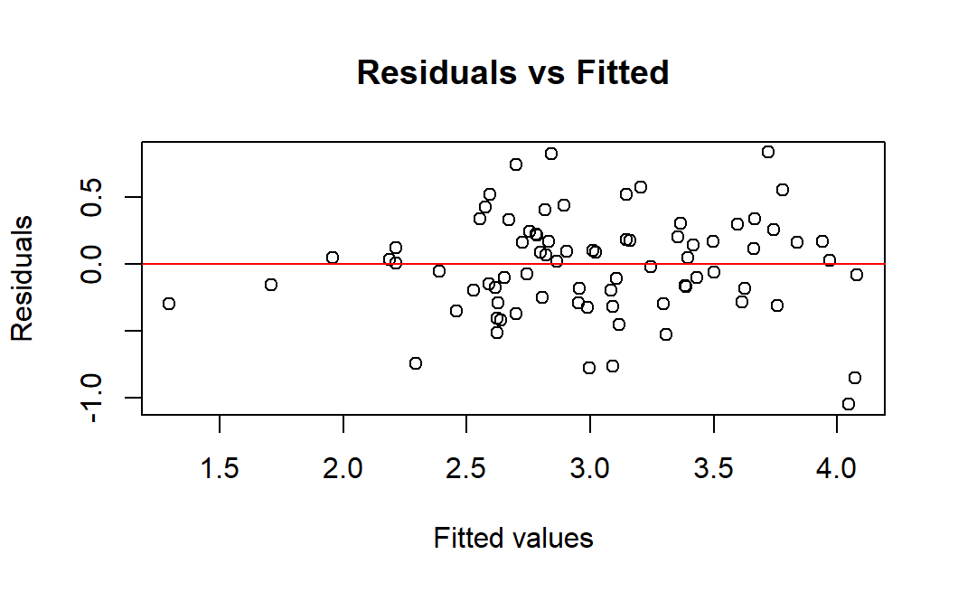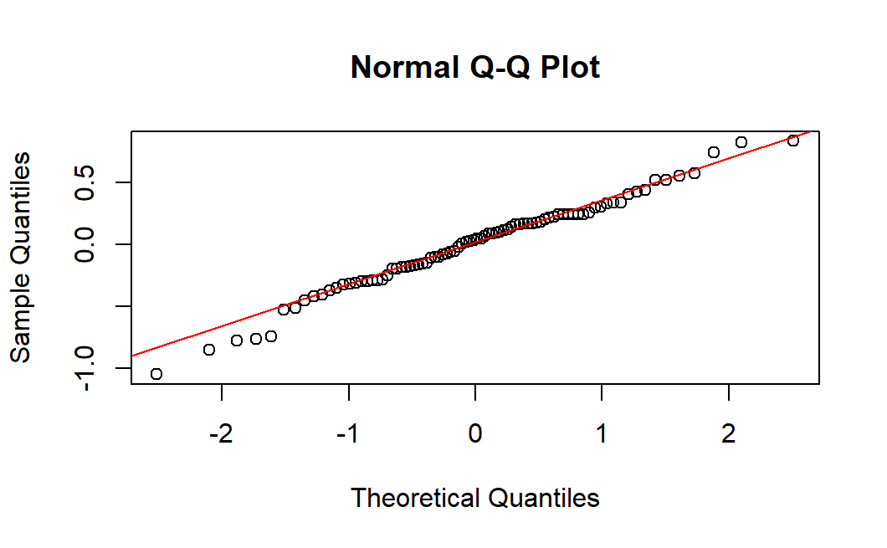

Figure 9

Figure 10

These models satisfies the **homoscedasticity assumption**, meaning the variance of residuals is consistent across all levels of the predicted values, which means your model’s predictions are stable and reliable.

In addition to that checking Multicollinearity:

| **Predictor** | **VIF** | **Interpretation** |
| --- | --- | --- |
| Tangibility | 2.39 | Acceptable |
| Reliability | 3.61 | Acceptable |
| Assurance | 4.67 | Acceptable |
| Responsiveness | 3.99 | Acceptable |
| Empathy | 4.77 | Acceptable |

Table 17

Conclusion: Significant Multicollinearity

VIF Interpretation

* **VIF < 5**: Acceptable (no concerning multicollinearity)
* **VIF 5-10**: Moderate multicollinearity
* **VIF > 10**: High multicollinearity (problematic)

Based on the results obtained above. since all the VIF values are less than 5 (**VIF < 5**) it suggests that the predictor variables such as Tangibility, Reliability, Assurance, Responsiveness and Empathy are not highly correlated with each other, which means each variable contribute unique information to the model.

This indicates regression coefficients are likely to be stable and interpretable, making the above obtained regression models such as normal Q-Q plot and residuals vs fitted plot are valid.

### Year of study as a Moderator

Similar to the above comparison, now we chose Year of study as moderator to check if it’s affect the student satisfaction level on adapting new cafeteria services:

Here, the model tests whether the relationship between Tangibility and Student Satisfaction changes depending on the year of study, while controlling for the other service quality factors.

The Factor Tangibility chosen because it is the strongest predictor of students satisfaction factor of adaption of new cafeteria services.

**Summary table of year as a moderator:**

|  |  |  |  |
| --- | --- | --- | --- |
| **Predictor** | **Estimate** | **p-value** | **Interpretation** |
| **(Intercept)** | 0.293 | 0.329 | Not statistically significant |
| **Tangibility** | 0.315 | 0.0024 | Statistically significant |
| **Year2** | 0.504 | 0.353 | Not statistically significant |
| **Year3** | 0.026 | 0.963 | Not statistically significant |
| **Reliability** | -0.137 | 0.206 | Not statistically significant |
| **Assurance** | 0.052 | 0.667 | Not statistically significant |
| **Responsiveness** | 0.433 | 0.0005 | Statistically significant |
| **Empathy** | 0.156 | 0.196 | Not statistically significant |
| **Tangibility & Year2** | -0.151 | 0.349 | Not statistically significant |
| **Tangibility & Year3** | 0.006 | 0.974 | Not statistically significant |

Table 18

|  |  |  |
| --- | --- | --- |
| **R - squared** | **Adjusted R - squared** | **P value** |
| 0.6926 | 0.6505 | 4.665e-15 |

Table 19

The overall model explains about 69% of the variance in student satisfaction with F-static value 16.45 and a p-value 4.665e-15.

**Conclusion:**

The regression analysis indicates that both Tangibility and Responsiveness significantly contribute to Student Satisfaction. However, the Year of Study does not have a moderating effect on this relationship. This suggests that the positive impact of Tangibility on Student Satisfaction is consistent across all academic years. The model explains approximately 68% of the variance in satisfaction, showing strong explanatory power overall.

### 6.3.4 Program as a Moderator

Here, the model tests whether the relationship between Tangibility and Student Satisfaction changes depending on the Program students are enrolled in, while controlling for the other service quality factors.

The Factor Tangibility chosen because it is the strongest predictor of students satisfaction factor of adaption of new cafeteria services.

|  |  |  |  |
| --- | --- | --- | --- |
| Predictor | Estimate | p-value | Interpretation |
| (Intercept) | 0.9827 | 0.074 | Statistically significant |
| Tangibility | 0.1247 | 0.466 | Not statistically significant |
| Program: Data Science | -0.6656 | 0.267 | Not statistically significant |
| Program: Fashion Design | -0.4014 | 0.572 | Not statistically significant |
| Program: Psychology & Counselling | -0.2956 | 0.516 | Not statistically significant |
| Reliability | -0.1467 | 0.157 | Not statistically significant |
| Assurance | 0.0984 | 0.397 | Not statistically significant |
| Responsiveness | 0.3859 | 0.0017 | Statistically significant |
| Empathy | 0.0984 | 0.276 | Not statistically significant |
| Tangibility × Program (Interaction terms) | All p > 0.19 |  | Not statistically significant |

Table 20

|  |  |  |
| --- | --- | --- |
| **R - squared** | **Adjusted R - squared** | **P value** |
| 0.6775 | 0.6383 | 5.691e-15 |

Table 21

The overall model explains about 65% of the variance in student satisfaction with F-static value 17.27 and a p-value 5.691e-1.

**Conclusion:**

The moderation analysis examined whether the academic program influences the relationship between Tangibility and Student Satisfaction. The results revealed that neither Tangibility nor its interaction with Program significantly affected Student Satisfaction (p > 0.05). Among all predictors, only Responsiveness showed a statistically significant positive effect (p = 0.0017). This indicates that while the type of academic program does not moderate the Tangibility–Satisfaction relationship, students’ perceptions of timely and effective service responses play a crucial role in their satisfaction levels. The model explains approximately 69% of the variance in satisfaction, indicating a strong overall fit.

# **07. Discussion & Recommendation**

## 7.1 Discussion of Findings

The analysis successfully identified key drivers and moderating factors influencing students' adaption of the new cafeteria services at NIBM Kirulapone. The findings largely align with international studies on student satisfaction while providing specific, actionable insights for the local context.

1. **Examining factors:** All the factorsshow stronger correlations, so they might be more influential in predicting Student Satisfaction. Which means if the all factors level increases based on that the Student satisfaction level also will increase. According to the table **Reliability** has the lowest correlation.
2. **Key Drivers of Adaption:** The study confirms that **Tangibility** (the physical facilities, appearance, and comfort of the cafeteria environment)is the strongest predictor of adaption, followed by Responsiveness (timely and helpful service from staff). This hierarchy suggests that students place a high value on the visible quality of the cafeteria and the speed and attentiveness of service. Improvements in these two dimensions are likely to produce the greatest increases in satisfaction levels.
3. **The Moderating Role of Demographics:** The analysis revealed that the relationship between satisfaction and adaption is not uniform across all demographic characteristics of each student group.

Gender: Gender is a significant moderator of this relationship. Additionally, Tangibility has a stronger positive influence on Student satisfaction for Male customers than for Female customers, which concludes gender based

Year of Study: Year of Study does not have a moderating effect on this relationship. This suggests that the positive impact of Tangibility on Student Satisfaction is consistent across all academic years.

Program of Study: the type of academic program does not moderate the Tangibility–Satisfaction relationship, students’ perceptions of timely and effective service responses play a crucial role in their satisfaction levels.

## 7.2 Recommendations

Based on the above discussions, the following recommendations are proposed for the NIBM-NIC cafeteria service management to enhance service adaption and student satisfaction.

**A. Strategic Focus Areas:**

1. **Prioritize Tangibility Above All:**

Action: Maintain the physical facilities, appearance and comfort of the cafeteria environment at the best standards to attract the customers first place as it’s the factor strongly affects students satisfaction.

Rationale: As the strongest predictor, direct investment here will yield the highest return in adaption rates.

1. **Optimize for Speed and Responsiveness:**

Action: Implement streamlined processes like pre-ordering via a mobile app, dedicated express lanes for popular items, and efficient point-of-sale systems to reduce queue times.

Rationale: Service Speed was the second-strongest predictor, crucial for students with tight schedules.

1. **Enhance the Ambience:**

Action: Improve seating comfort, ensure adequate lighting and ventilation, and maintain a high standard of cleanliness. Consider adding Wi-Fi to make the cafeteria a social and academic hub to improve tangibility more conveniently.

Rationale: A pleasant environment strengthens the positive correlation with adaption and encourages students to spend more time (and money) in the cafeteria.

**B. Targeted Initiatives for Student Segments:**

1. **Develop Gender-Sensitive Marketing and Offerings:**

Action: Despite the non-significant factor, Promotions highlighting new and improved food items based on providing gender based preferential. For an example, male students tend to eat together as bunch providing them Large potions and for girls tends to eat sweet based cravings.

Rationale: The moderating effect of gender requires a nuanced approach to communication and menu development.

**C. Operational and Feedback-Driven Improvements:**

1. **Implement a Continuous Feedback Loop:**

Action: Establish a simple, ongoing feedback mechanism, such as a QR code link to a quick survey or a dedicated suggestion box. Regularly review this data and communicate changes made in response to student suggestions.

Rationale: This fosters a sense of community and responsiveness, showing students that their opinions directly shape the service, thereby increasing loyalty and adaption.

# **08. Future Research Directions**

Based on the customer satisfaction on adaption of new cafeteria services at a local context, we believe that there are more vast amount of area can be built-up. Outlines changing variables, sampling method, geographical factor or introducing new methods for analysis.

Here are few basic Directions we propose for future studies:

1. **Conduct a Longitudinal Study:** Track satisfaction and adaption levels over a semester or a year to understand how these relationships evolve.
2. **Employ Mixed Methods:** Combine quantitative surveys with qualitative interviews or focus groups to gain deeper insights into the "why" behind the statistical trends, especially for the puzzling negative moderation in certain years.
3. **Expand the Scope:** Replicate this study in other NIBM branches or Sri Lankan universities to compare findings and identify nation-wide trends in student cafeteria preferences.
4. **Investigate the "Assurance Paradox":** Explore why Assurance, despite being a fundamental expectation, does not emerge as a strong positive driver of adaption in regression models.

# **09. REFERENCES**

Afroza, K. and Haque, A. (2022) ‘Students’ Satisfaction in Campus Cafeterias: An Empirical Study on Public Universities at Klang Valley in Malaysia’. *International Journal of Innovative Research and Publications*

Chand, D. (2025) ‘Canteen Service Quality and Student Satisfaction: A Case Study of a Private College in Kathmandu’. *Nepalese Journal of Hospitality and Tourism Management* 6 (1), 129–143

Falihah, N., Fauzi, M., and Rusali, R. (n.d.) *A Study of Students’ Satisfaction with Mahallah Cafeterias at The International Islamic University Malaysia (IIUM), Kuantan, Pahang*.

*GABBIANELLI-L.-PENCARELLI-T* (n.d.)

Kuja, T., Sadera Lanchoine, E., Karangu, M., and Kurgat, C. (2024) ‘Quality Of Students’ Health And Catering Services And Level Of Students’’. *IOSR Journal Of Humanities And Social Science (IOSR-JHSS)* [online] 29, 1–17. available from <www.iosrjournals.org1|Page>

Lakshani, U. (n.d.) *Food Consumption and Wastage Patterns in a Student Canteen-Data from Faculty of Medicine, University of Kelaniya, Sri Lanka* [online] vol. |. available from <https://www.researchgate.net/publication/371088192>

Ling Dyana, M., Mohd Suki, N., and Ling Adeline, Y. (n.d.) ‘STUDENT SATISFACTION WITH THE SERVICE QUALITY OF CAFETERIA: A STRUCTURAL APPROACH’. *International Journal of Business, Economics and Law* 4, 1

Misiran, M., Yusof, Z.M., Sapiri, H., and Abdullah, I. (2022) *Students Satisfaction Towards Cafeteria in University Campus-A Case Study*. vol. 4

Rambandara, R.D.S.S., Dilanthi, M.G.S., and Weerakoon, W.M.T.N.K. (2019) *Simulation of the University Canteen Performance: A Case Study*. vol. 22

Raya, R. and Bilas Bajracharya, R. (n.d.) *People’s Journal of Management Assessing Student Satisfaction with Campus Canteen Services: A Descriptive Study*.

Samirah, N., Marashin, B., Hashim, @, Afiq, P., Bin, Z., Lovelyna, O., Jipiu, B., Hashim, N.S., and Othman, P.A. (2024) *Assessing Student Satisfaction towards Food Quality and Price Fairness in UiTM Puncak Alam On-Campus Cafeteria*. vol. 16

Serhan, M. and Serhan, C. (2019) ‘The Impact of Food Service Attributes on Customer Satisfaction in a Rural University Campus Environment’. *International Journal of Food Science* 2019

*University Canteen* (n.d.)

Yusoff, M., Mcleay, F., and Woodruffe-Burton, H. (n.d.) *Dimensions Driving Business Student Satisfaction in Higher Education* [online] available from <https://ro.uow.edu.au/buspapers>