Contents
Brief 1
Technical breakdown of the creation of the website 1
Additional Requirement 3
Critical Reflection 4

Brief
Hello,
I selected the BibPlanetarium project brief for this project. The main aim of this project was to:
i) Create a landing page that gives an overview of the Milky Way galaxy
ii) Create landing pages related to specific planets
iii) including images and videos to make the website interactive.
I provide an in-depth discussion of how I achieved each of these requirements.

Technical breakdown of the creation of the website
I began by creating a BigPlanetarium project folder in VS Code and then subfolders of HTML, CSS, JavaScript, and images. I also copied all the pictures I would use and put it in the images folder where I could easily access it.
I started with the semantic HTML as I developed the site. I coded the site using semantic HTML5 elements that would help in simplifying the content and rendering it easily readable.
The main components are:
- A <header> containing the site title and a tagline.
- A <nav> element with navigation links for easy page switching.
- A <main> element with different <section> blocks for the content.
- A <footer> for copyright information.
Each page such as the Jupiter page has its own section where there is certain information about the planet, image but a video has been inserted and there is a button to display interesting facts about the planet. I also made sure that I included a logical structure in headings (<h1> < h2> < h3>) to ensure that the website is more visible and search engine friendly. I also included alt attributes that described images, and this is essential for screen readers. The header which contains a centrally placed links navigation is positioned at the bottom of the page under the header. Each link is visually altered on hover and focus on the keyboard to add a shadow of a glowing text, and this enhances usability and accessibility. The navigation links are arranged in a vertical way on small screens such as phones to enable easy tapping.
After this was done, I started to style the webpage with CSS. I developed the primary stylesheet in order to regulate the overall way the site appeared. I imported fonts- Poppins and Montserrat, which were obtained on Google Fonts. The bold and futuristic headings are stipulated in Poppins, and the text of the body is stipulated in Montserrat to enhance the readability. The font size, and spacing were also eliminated so that the headings are visible enough with no congesting of the page.
The entire website uses a dark theme to reflect the space aesthetic. I designed a background of starfields with several radial gradients which I animated with CSS keyframes to create an image of stars gradually floating and twinkling. The starMove animation is a subtle movement of the stars in the background whereas the twinkle animation is an alteration of the intensity of the stars to create a shimmering effect. This animation is continuous and builds a dynamic background that adds to the theme.
For layout, I relied on Flexbox, as well as CSS Grid, based on the context. The planet grid is built on CSS Grid because it allows the automatically creation of the number of columns according to the size of the screen. This creates the layout to be responsive and to be compatible on desktop and mobile devices. On separate planet pages such as Jupiter, I applied Flexbox to side by side align the textual and images on bigger screens and stack them one over the other on smaller screens. The header uses a bright linear gradient background and shadow of text glow to appear conspicuous. I used big fonts in the headers to create a bold and impactful appearance of the site. As an illustration, the font size of the main site title is 4.8rem to take up the page in the right way.
To maintain the sci-fi theme, I made the card-like sections semi-transparent in dark backgrounds with glowing shadows of blue. These areas are rounded and padded in order to make the text readable. I also added responsive design in form of media queries. This makes sure that the layout scales gracefully to smaller screens through the scaling of fonts and resizing of images.
I used YouTube videos as the source of multimedia content. To ensure responsiveness and style, I also encased these <iframes> into boxes using CSS in which I made their width to 100 per cent with max-width based on bigger screens, rounded corners, and glowing shadows. I also made these video containers keyboard focusable with tabindex="0" and added ARIA attributes like aria-label and aria-described by for accessibility.
I used JavaScript to make the site more interactive. For instance, the “Show Jupiter Facts” button cycles through an array of facts stored in JavaScript. Each click updates a text container with a new fact, as in the figure below,
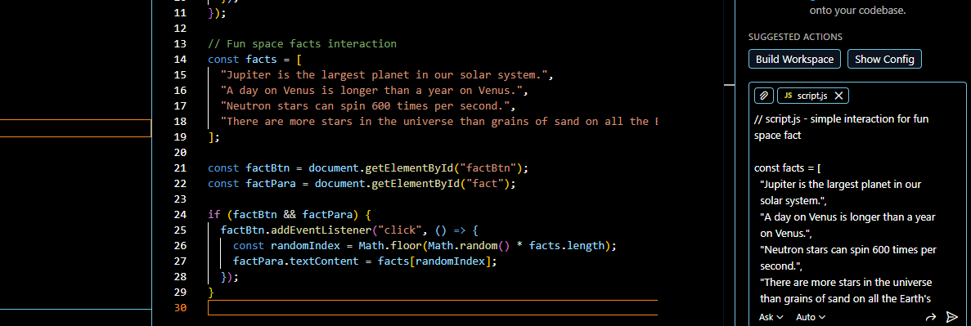
This script listens for button clicks and cycles through the facts, providing users with new information each time.

Additional Requirement
Another priority in the development of my selected client brief was to develop an interactive, interesting, and accessible educational website that is not only based on statical information. To address this need, I worked to meet best practices in visual design, interactivity, and accessibility, without complicating the site to make it easily navigable and comprehensible to such a wide audience.
I also added interactive “Show Facts” button in the planet pages using JavaScript to increase user interaction. Rather than presenting all the information simultaneously, I decided to show the facts dynamically when the user presses the button. This approach encourages exploration and keeps the interface clean. Technically, this was achieved by storing facts in arrays and using event listeners to cycle through them on each button click. This demonstrates my ability to use basic DOM manipulation and JavaScript logic to control content dynamically.
The inclusion of animated stars throughout the site was another significant choice to assert the space theme. I achieved this requirement by using pure CSS animations instead of JavaScript because they provide better performance and animations. I was able to achieve a small starfield effect by stacking several radial gradients and animating the background position, which never takes over and has no impact on accessibility.
Accessibility was an important consideration in the website design. I also made keyboards accessible to all the interactive elements by making the buttons and links focusable and also provided visible focus states. I wrote semantic HTML, ARIA labels, use of descriptive alt text of images, and accessible titles of <iframes> to accommodate screen readers.

Critical Reflection
In my opinion, this project has been very insightful because it has taught me what my strengths and weaknesses are as a developer. The unified design of space is one of the strongest qualities of the project. The animated background and the use of the same colour scheme, as well as the use of the images of the planet turns out to be crucial in creating the immersive experience, which, in its turn, supports the educational purpose of the site. The interactive Show Facts buttons are also value-added, as they give the impression of communicating with the user rather than bombarding the user with a lot of textual information.
My emphasis on accessibility is another strength. With semantic HTML, ARIA labels, and elements navigable with a keyboard and descriptive alternative text, I made sure that the web site can be used by a greater number of users including the ones who use assistive technologies. This is a sign of increasing the understanding of the concept of inclusive design, which I view as one of the most valued competencies in web development today.
However, it still can be made better in several ways. Despite the fact that the site is nice to view, its layout can be enhanced using more advanced responsive designs. Smaller screen sizes make certain components more stacked oriented than dynamic oriented. CSS grid would be more actively employed in my future work, together with flexbox, to create web page designs that would be more dynamic and responsive.
Another area that I would like to work on as my future project is content management. The facts about the planets are now hard-coded in JavaScript arrays. I would think about loading the content dynamically by use of JSON files or API that would make the site more maintainable and scalable. I would also give myself time in planning the site architecture before coding. The initial layout of wireframes and component plans would reduce the repetition process and increase consistency. The project has, however, boosted my knowledge in HTML and CSS and JavaScript and enabled me to know which issues I must improve in order to ensure that my future projects will be more efficient and fine-tuned.

