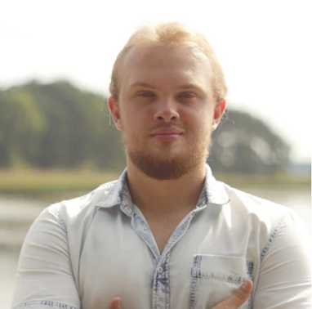  PAWEŁ BRYSCH  CONTACT  LANGUAGES |  | ABOUT ME  I am a former math competitor, who relatively lately discover that AI is not only a matter of science-fiction books. My goal is to become fluent in AI/Data Science industry one day.  WORK EXPERIENCE  ZF Group, Lodz, Poland 9 mos  - Python Developer (Oct 2019 – Present · 6 mos)  Developing document generating desktop application:  - Most of layers: (Python 3.6)  - Frontend: (Javascipt, Electron, node.js)  - Deployments, releases: (Jenkins)  - Tests: (integration and unit, TDD, pytest, unittest)  - Performance tuning: (cython)  - Reviews, code management: (BitBucket, Git)  - Other: (Jira)  - Software Tester (Jul 2019 – Sep 2019 · 3 mos)  SKILLS  Python:  - syntax: fluency in usage of decorators, generators, context managers etc..  - tests: pytest (fixtures, parameterization), unittest (mocking);  - code performance: cython.  PostgreSQL:  - writing queries;  - setting up a database server.  Data analysis:  - hypothesis testing;  - linear regression conducting;  - data visualization (I can implement graphics framework, if it is needed. Please look at my personal project).  PERSONAL PROJECTS  “Applying Evolutionary 07/2018 – 01/2019  Artificial Neural Network  into 2D cars”  (youtube link, Github_link)  Used technologies:  - laungage: (Python 3)  - ML tools: (Keras, DEAP)  - gamedev tool: (pygame)  Solved problems:  - applying genetic algorithm into neural network as chromosome;  - creating methods to save/load repeatedly nested containers of data;  - tune models in order to find solution.  EDUCATION  Doctor of Medicine (MD), 2013 – 2019  Medical University of Lodz  ACHIEVEMENTS  Laureate in Polish Mathematical Olympiad 2013  (9th place in country)  Wyrażam zgodę na przetwarzanie moich danych osobowych dla potrzeb niezbędnych do realizacji procesu rekrutacji (zgodnie z Ustawą z dnia 29.08.1997 roku o Ochronie Danych Osobowych; tekst jednolity: Dz. U. 2016 r. poz. 922).
  +48 787 983 046
  pawel.brysch@gmail.com
  English | B2

