Rehabilitation of wrist injuries
Paweł Kazimierczak, Javier Tejedor Granado, Jean-Luc Fael Bernabé, European School of Alicante

Motivation
Injuries of the hand and wrist account for approximately 20% of visits to emergency departments (De Putter et al., 2012).
This high number of injuries can lead to a need for wrist rehabilitation. Due to the increasing health care costs, we did a low-cost wrist rehabilitation glove. 35.59% of hand and/or wrist injuries are extensor and flexor tendon injuries (Özgen et al., 2021), so the glove is supposed to rehabilitate this area to avoid long-term injuries, but it can rehabilitate every area of the wrist. After a hand or wrist fracture, usually, there is needed rehabilitation to gain strength in the immobilized areas, sometimes the time that you spend with the physical therapist is not enough, so you need to rehabilitate the wrist at home, but the current wrist-rehabilitation prototypes are extremely expensive, and many people cannot afford them. In 2007 the average cost (based on time deployment, medical staff, and materials) of the rehabilitation unit was 179580 U.S. dollars (De Putter et al., 2012).
The goal of our prototype is to allow everyone to have access to it thanks to its low cost. The wrist injuries, as we saw before, are a very common injuries and rehabilitation is a very important to regain motor abilities (Meng et al., 2015). However, the medical devices for wrist rehabilitation are lacking.

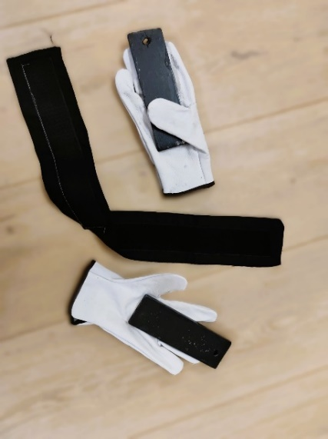
The project
This project aims to creation of a cheap tool facilitating rehabilitation of wrist injuries. To do this, we have designed a glove attached with an elastic band to a fabric placed on the upper arm (check photo on the left). This method allows the patient to easily alter the resistance of the elastic band based on the rehabilitator's suggestions by moving the fabric through the arm.
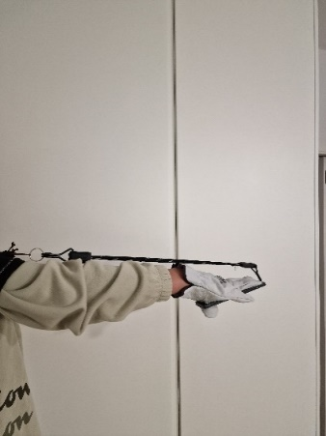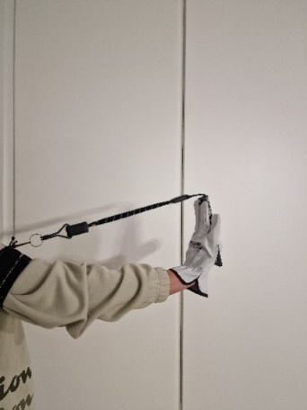
Most of the materials used in this project are recycled, cheap, and readily available and the use of plastic is minimal. The glove is durable so it can be used in multiple rehabilitation processes. Strengthening all movements of the wrist can be done by wearing only one glove.

Procedure
In order to test the functionality of the glove we used the prototype on 3 patients for 4 weeks and collected the results every week, based on how many kilos they can move with their wrist. At week 0 we measured the initial strength for comparison of the weekly improvement. All the measures were collected with the help of a precise weight scale. Patient 1, which is a boy of the age of 14, and his health was perfect, worked on all the movements, while the patient 2, a woman of the age of 47 with a perfect health status, and the patient 3, a boy of 16, which was in the rehabilitation process after a wrist fracture, only worked on the Flexion and Extension. The detailed logbook of the experiment is detailed in the annex.
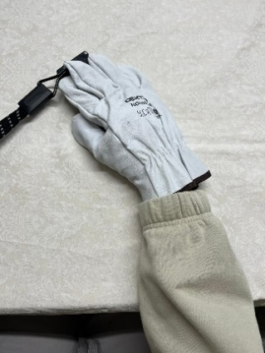
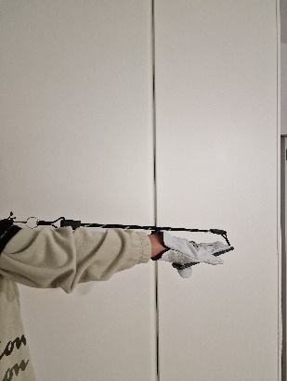
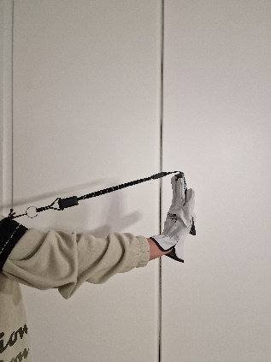
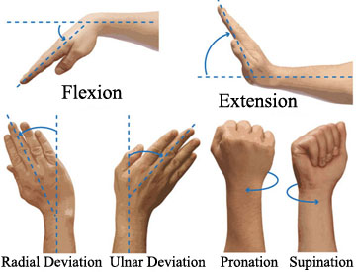
Flexion
Extension
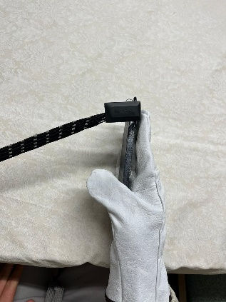
Pronation, Supination

Radial and Ulnar Deviation

Data analysis
Flexion and Extension.
When we analyze the results, we can see that patient 3 had the best results, with a 42.89% improvement when comparing to the initial values. The average percentage of improvement is 33.54%. We can also see that the % of improvement increased more in the first week, than in the other ones, but it was always positive. We can observe that the number of repetitions was a very important point.
The following table shows how many kilograms each patient could move at the end of each week of practice.
 | Week 0 | Week 1 | Week 2 | Week 3 | Week 4
Patient 1 | 5.23kg | 5.78kg | 6.12kg | 6.66kg | 6.92kg
Patient 2 | 4.72kg | 5.18kg | 5.46kg | 5.72kg | 5.92kg
Patient 3 | 4.36kg | 4.85kg | 5.21kg | 5.76kg | 6.23kg

Radial deviation and Ulnar deviation
Radial and Ulnar deviation.
At the end of the program the patient was able to gain a 21.86% improvement compared to the beginning of the experiment. We can see that at the end he was able to move 4.07kg, which is 0.44kg more than at the beginning. We were not able to achieve so great results in the Radial, and Ulnar deviation than in the Flexion and Extension, but at least the improvement was always positive, and we were able to increase this 10%. Maybe when practicing harder, this can be increased. When observing the % of improvement, we can analyze that every week, the patient was able to improve less. This makes sense, because it is easier to improve when the initial values are lower, than if they are higher.
The following table shows how many kilograms the patient could move at the end of each week of practice.
Week 0 | Week 1 | Week 2 | Week 3 | Week 4
3.34kg | 3.63kg | 3.82kg | 3.98kg | 4.07kg

Pronation and Supination
Pronation and Supination.
At the end of the month the patient was able to move 3.13kg, 0.76kg more than in the beginning, which represents an improvement of 32.07% in comparison to the beginning of the program. In the first week, the patient improved fast, but then he started to improve slower, and the final values where lower than we expected them to be, but we are still happy with the improvement.
The following table shows how many kilograms the patient could move at the end of each week of practice.
Week 0 | Week 1 | Week 2 | Week 3 | Week 4
2.37kg | 2.68kg | 2.83kg | 3.02kg | 3.13kg

Conclusions
After analysis of the results of the flexion and extension, we can see that patient 3 had the best results, with a 42.89% improvement when comparing to the initial values. The average improvement of participants is 33.54%. The worst result that we got was from patient 2, he improved his strength by 25.42%, which is much less than patient 3. We think that that is caused because patient 2 was doing only 3 series of 20 repetitions 3 times a day, while patient 3 was doing 4 series of 25 repetitions 4 times a day. In the other movements we were not able to achieve similar results. In the radial deviation and ulnar deviation, we achieved an improvement of 21.86% and in the pronation and supination, we achieved an improvement of 32.07%, which is not bad, but is much lower than the flexion and extension.

Our project demonstrated that even with a cheap and relatively simple tool, it is possible to increase wrist strength. This is very promising, but it needs further investigation.

Limitations and indications for further research
Our sample was relatively small, and we were not able to find a large group of people who suffered a wrist injury. We conducted experiments on 2 healthy patients, and 1 after an injury, but we were able to show that our tool helps them to improve wrist strength. In the future, we may be able to work with a larger group of people who suffered wrist injuries. Ideally, we could assign some of them to the “control group” that would not use our tool. We would register their progress similarly as for a group of patients using our tool. Then we could compare the progress of the group using our tool with a similar group of patients that were not using it. This would increase our confidence in usability of or tool for rehabilitation.
We also noted that not all the patients were exercising regularly according to our instructions. To increase their motivation, we could increase the attractiveness of the exercise by adding some interactive elements, such adding some sensors to our tool that would move virtual objects in a game for instance.

Annex

Week 1, Patient 1
Flexion and extension
At the beginning, the first patient was able to move 5.23kg. After the first week, he was able to do 3 series of 20 repetitions 3 times a day, and his strength increased to 5.78 kilos. This means that his strength increased by 10.516 %. The patient did not feel any pain or discomfort.

Week 1, Patient 2
Flexion and extension
In the beginning, the second patient was able to move 4.72kg. During the first week, he tried to do 3 series of 20 repetitions 3 times a day, but he felt a slight discomfort, so he reduced the repetitions to 15, but he still managed to improve his strength to 5.18kg. This means that his strength increased by 9.745 %. The patient did not feel any pain or discomfort after changing the repetitions.

Week 1, Patient 3
Flexion and extension
At the beginning, the first patient was able to move 4.36kg. After the first week, he was able to do 3 series of 20 repetitions 3 times a day, and his strength increased to 4.85kg. This means that his strength increased by 11.238 %. The patient did not feel any pain or discomfort. This is the best result we achieved in the first week, probably because of the low initial strength.

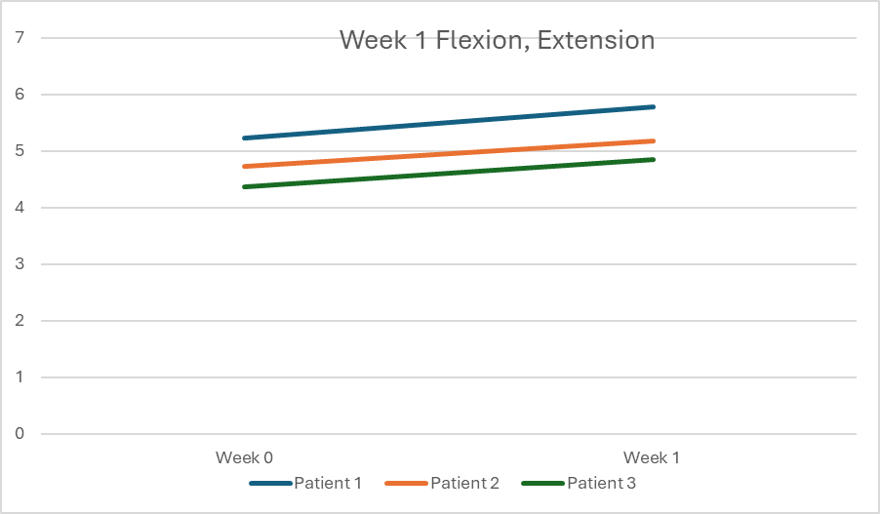

 | Week 0 | Week 1
Patient 1 | 5.23kg | 5.78kg
Patient 2 | 4.72kg | 5.18kg
Patient 3 | 4.36kg | 4.85kg

The strength of the 3 patients in the first week evolved in a pretty similar way. Besides the low initial values, the percentage of the increase was higher than what we expected. The average percentage of strength gain was 10.5% in comparison to the week 0.

Week 2, patient 1
Flexion and Extension
After the first week, the patient could move 5.78kg, but now after the second week, the patient can move 6.12kg. At the beginning of the week, he performed 3 series of 20 repetitions, 3 times a day, but on the third day, he started doing 3 series of 30 repetitions 3 times a day. The patient with respect to week 0 has had an improvement of 17.017% and with respect to week 1 the patient has had an improvement of 5.882%, this is pretty low when comparing it to the first week. He has not had any discomfort or pain.

Week 2, Patient 2
Flexion and Extension
At the beginning of the program, the second patient could move 4.72kg, then after a week of practice, he was able to move 5.18kg which was a fair value. Now, after the third week, he was not able to increase his strength so much as after the first one. This patient after the second week could move 5.46 kilos, which means that he could move 0.28 more kilos than before, this is 5.405% more than after the first week, and 15.67% more than in the beginning. The patient did not feel discomfort. He was still doing 3 series of 15 repetitions 3 times a day to avoid injuries.

Week 2, Patient 3
Flexion and Extension
This patient had a very impressive improvement compared to the other ones. At the beginning of the rehabilitation, he could move 4.36kg, then, after the first week, he managed to move 4.85kg. After the second week, he increased his strength exceptionally, he was able to move 5.21 kg which means that he increased his strength by 0.36 kg, which is a 7.42% more than the other week. This is not higher than the 0–1-week increase, but it is much higher than the other patients' result. In comparison to the beginning of the experiment, he improved his strength by 19.5%, which is much higher than the other patients. This patient was doing 4 series of 20 repetitions 3 times a day the whole week, he has not felt any discomfort.

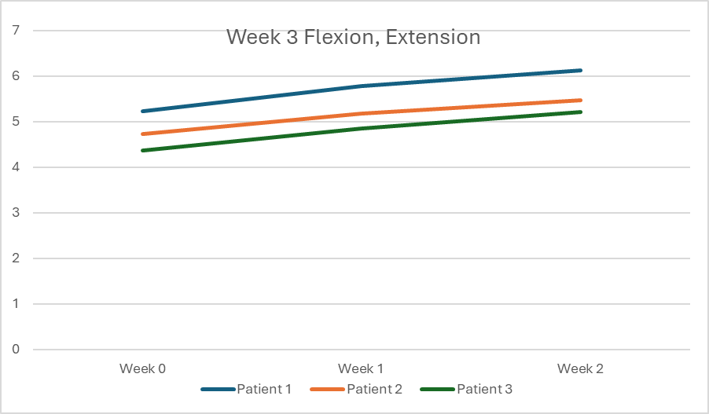
 | Week 0 | Week 1 | Week 2
Patient 1 | 5.23kg | 5.78kg | 6.12kg
Patient 2 | 4.72kg | 5.18kg | 5.46kg
Patient 3 | 4.36kg | 4.85kg | 5.21kg

When analyzing the results, we can see that the gain is much lower than after the first week. Patient 3 has improved the best, like after the first week, the average percentage of strength gain in comparison to the first week was 6.24%, 4.26% lower than after the first week.

Week 3, Patient 1
Flexion and Extension
After the second week, the patient was able to move 6.12kg, After the third week he was able to move only 0.54kg more, that means that he was able to move 6.66kg, which is an 8.82% more than what he can move after the second week, that is strange and impressive because it's a better improvement than in the second week, we believe that this happened because he started doing 4 series of 30 repetitions 3 times a day. Fortunately, he does not feel any discomfort or pain.

Week 3, Patient 2
Flexion and Extension
After the second week, this patient could move 5.46kg, but he was doing only 3 series of 15 repetitions 3 times a day, so he decided to do 3 series of 20 repetitions 3 times a day to avoid injuries. Unfortunately, at this moment after the third week, his strength got a bit stuck, and he only improved it by a 4.76%, being able to move 5.72kg. His health was amazing, and he did not feel any discomfort.

Week 3, Patient 3
Flexion and Extension
At the beginning of this week, this patient could move 5.21kg, but after a week of doing 4 series of 25 repetitions 4 times a day, he reached a particularly important improvement. At the end of the week, he was able to move 5.76kg, which is higher than the second patient, this means that his strength improved by 10.557%. These are impressive results, but they are understandable because of the high practice.

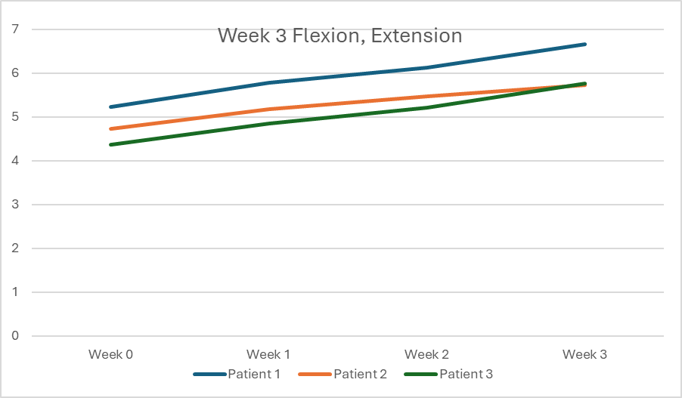
 | Week 0 | Week 1 | Week 2 | Week 3
Patient 1 | 5.23kg | 5.78kg | 6.12kg | 6.66kg
Patient 2 | 4.72kg | 5.18kg | 5.46kg | 5.72kg
Patient 3 | 4.36kg | 4.85kg | 5.21kg | 5.76kg

When analyzing the result, we can see that the strength grew more than in the second week in patients 1 and 3, we think that this is caused because of the regular practice. We can see that now patient 3 can move more kg than patient 2. That is caused because patient 2 is only doing 3 series of 20 repetitions 3 times a day to avoid eventual discomforts related to using our tool.

Week4, Patient 1
Flexion and Extension
This week, the patient did 4 series of 30 repetitions 3 times a day, but his strength has not improved so much, he was able to move 6.92kg after this week, which is 3.904% better than the last week 6.66kg. He has not felt any discomfort. The 6.92kg (which is the final strength that we managed to achieve) is 1.43kg better than at the beginning. That means that he has 32.31% more strength than at the beginning.

Week 4, Patient 2
Flexion and Extension
At the end of the final week, the patient was able to move 5.92kg, which is a 3.5% improvement in comparison to the strength in the third week. This patient was doing 3 series of 20 repetitions 3 times a day, when comparing the final data to the beginning we can see that he managed to move 1.2kg more which is a 25.42% of improvement. The patient does not feel any pain or discomfort; he felt a slight discomfort only in the first week.

Week 4, Patient 3
Flexion and Extension
At the end of this week, the demanding work of this patient paid off, because he was able to move 6.23kg, which is 8.16% more than the 5.76kg of the last week. When we compare this data to the beginning of the program, we can see that his strength increased by a 42.89%, this is the best result that we collected, because we managed to almost double the initial strength, and the best part is, that the patient has not felt any pain during all the practice.

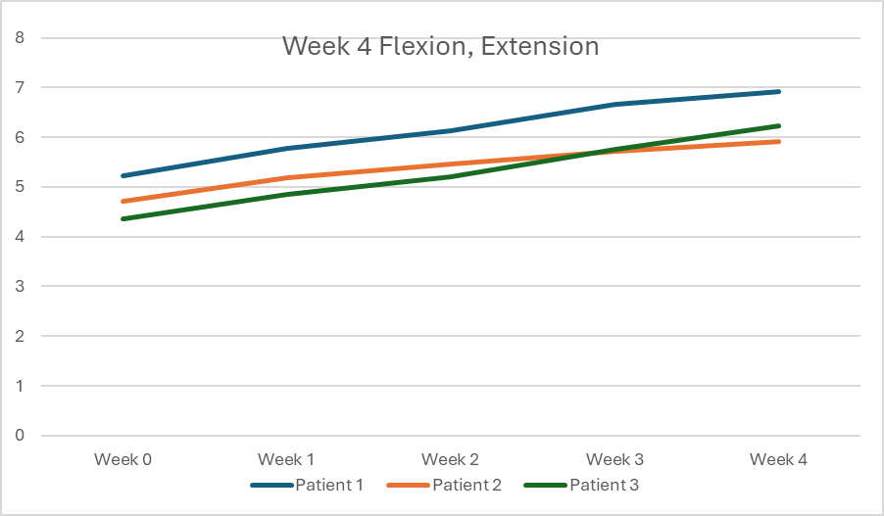
 | Week 0 | Week 1 | Week 2 | Week 3 | Week 4
Patient 1 | 5.23kg | 5.78kg | 6.12kg | 6.66kg | 6.92kg
Patient 2 | 4.72kg | 5.18kg | 5.46kg | 5.72kg | 5.92kg
Patient 3 | 4.36kg | 4.85kg | 5.21kg | 5.76kg | 6.23kg

When we analyze the results, we can see that patient 3 had the best results, with a 42.89% improvement when comparing to the initial values, the average percentage of improvement is 33.54%. We can see that the results are quite different, but we can easily explain that, because of the extreme care to avoid injuries of the patient 2, And the high starting value of the patient 1.

Week 1
Radial deviation and Ulnar deviation

Week 0 | Week 1
3.34kg | 3.63kg

Unfortunately, in this movement we were not able to achieve as satisfactory results as in the flexion and extension. Before the first week of this movement, the patient was able to move 3.34kg, after this week, he was able to move 3.63kg, which is an 8.68% improvement. He was doing 3 series of 20 repetitions 3 times a day.

Week 2
Radial deviation and Ulnar deviation

Week 0 | Week 1 | Week 2
3.34kg | 3.63kg | 3.82kg

In this week, the patient was still doing 3 series of 20 repetitions 3 times a day, he was able to move 3.82kg, which is 0.19kg more than the last week, that stands for 5.23% kilograms more than the data of the previous week, or 14.37% more than the initial values.

Week 3
Radial deviation and Ulnar deviation

Week 0 | Week 1 | Week 2 | Week 3
3.34kg | 3.63kg | 3.82kg | 3.98kg

The patient has increased the repetitions to 25, so he was doing 3 series of 25 repetitions 3 times a day, consequently his strength increased by 4.19%, which means, that he was able to move 3.98kg.

Week 4
Radial deviation and Ulnar deviation

Week 0 | Week 1 | Week 2 | Week 3 | Week 4
3.34kg | 3.63kg | 3.82kg | 3.98kg | 4.07kg

At the end of the program the patient was able to gain 2.26% of strength compared to week 3, and 21.86% compared to the beginning of the experiment. We can see that at the end he was able to move 4.07kg, which is 0.44kg more than at the beginning.

Week1
Pronation and Supination
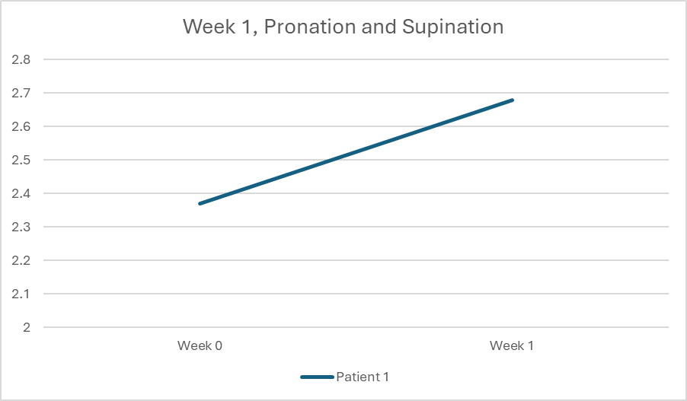
Week 0 | Week 1
2,37kg | 2.68kg

We can see that before the program the patient was able to move 2.37kg, and after the first week he is able to move 2.68kg, which is a 13.08% improvement; this is the best result that we achieved in all the movements. The patient was doing 3 series of 30 repetitions 4 times a day, he has not felt any pain.

Week 2
Pronation and Supination
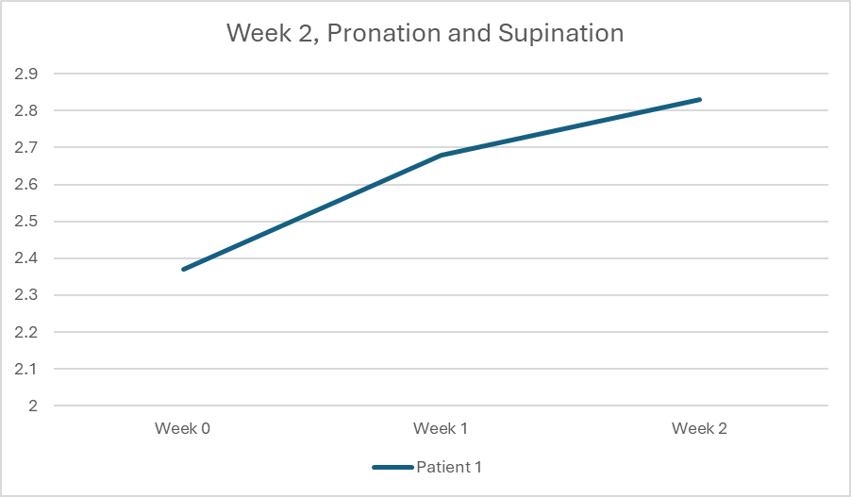
Week 0 | Week 1 | Week 2
2.37kg | 2.68kg | 2.83kg

In the second week the patient could move 2.83kg, that is 0.15kg more than the last week, and it represents a 5.20%. The patient was doing 3 series of 30 repetitions 4 times a day but has not felt discomfort. The overall improvement has been 19.40%.
Week 3
Pronation and Supination
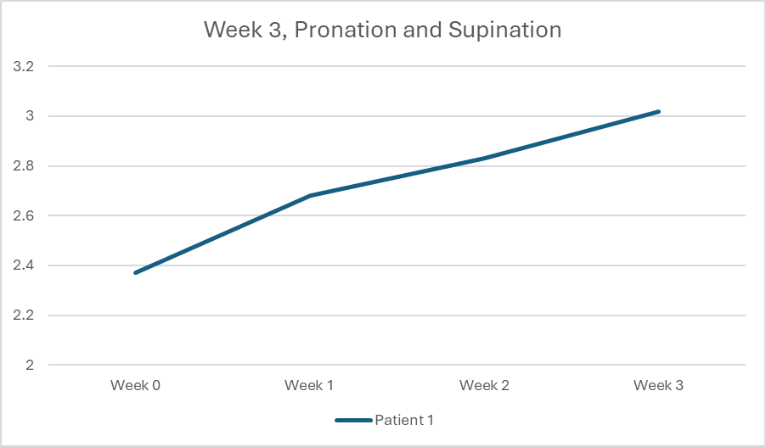
Week 0 | Week 1 | Week 2 | Week 3
2,37kg | 2.68kg | 2.83kg | 3.02 kg

In this week, the patient was doing 4 series of 30 repetitions 3 times a day, after the whole week, he was able to move 3.02kg, which is a 6.71% of improvement, it is higher than the week before (week 3). The patient has not felt any discomfort or pain.

Week 4
Pronation and Supination
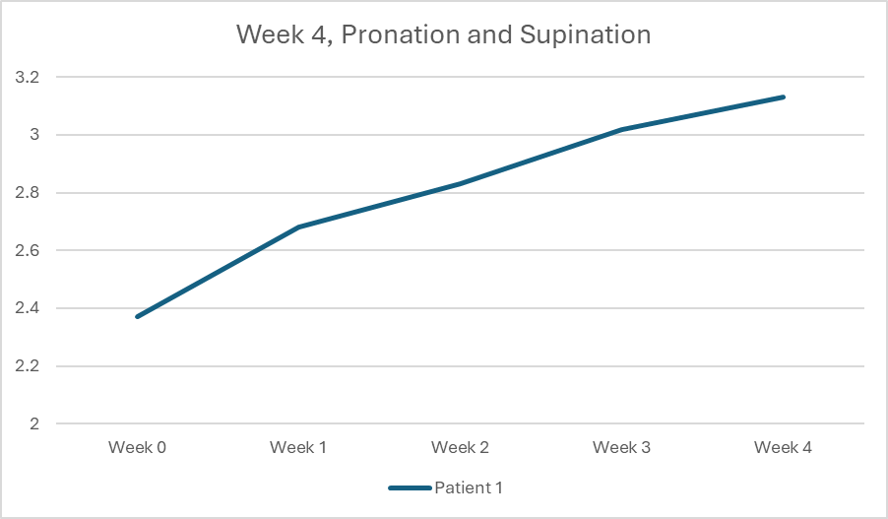
Week 0 | Week 1 | Week 2 | Week 3 | Week 4
2.37kg | 2.68kg | 2.83kg | 3.02kg | 3.13kg

In this week, the patient was still doing 4 series of 30 repetitions 3 times a day, at the end of the month he can move 3.13kg, 0.76kg more than in the beginning and 0.11kg more than after the third week, which represents an improvement of 3.64% in comparison to the third week, and a 32.07% in comparison to the beginning of the month. The patient has not felt any discomfort or pain.

Bibliography:

De Putter, C. E., Selles, R. W., Polinder, S., Panneman, M. J. M., Hovius, S. E. R., & Van Beeck, E. F. (2012). Economic Impact of Hand and Wrist Injuries: Health-Care Costs and Productivity Costs in a Population-Based Study. Journal of Bone and Joint Surgery, 94(9), e56. https://doi.org/10.2106/JBJS.K.00561
Meng, W., Sheng, B., Klinger, M., Liu, Q., Zhou, Z., & Xie, S. Q. (2015). Design and control of a robotic wrist orthosis for joint rehabilitation. 2015 IEEE International Conference on Advanced Intelligent Mechatronics (AIM), 1235-1240. https://doi.org/10.1109/AIM.2015.7222708
Özgen, M., Merve Aydoğan, A., Uygur, A., Armağan, O., Berkan, F., & Mutlu, F. (2021). Rehabilitation cost share and cost analysis of traumatic hand injuries: Our single-center results. Turkish Journal of Physical Medicine and Rehabilitation, 67(3), 308-314. https://doi.org/10.5606/tftrd.2021.5457

