**ANACONDA**

Anaconda is a Python distribution. It is good for data science and machine learning. It simplifies package management and deployment. The distribution includes: Python programming language, many data-science packages, Jupyter notebook, conda (package manager), cmd.exe prompt, and many other stuff. Once Anaconda is installed the environment is ready to run some Python programs. Sometimes there is need to install other packages using conda package manager.

Anaconda installer: <https://www.anaconda.com/products/individual>

* Links to different version of installers (Windows, Linux, Mac) are at the bottom of the page (almost bottom)
* FAQ: <https://docs.anaconda.com/anaconda/user-guide/faq/>
* No need to preinstall Python, create environmental PATH
* No need to uninstall previous version of Python. It will install its own version.

**JUPYTER NOTEBOOK**

Anaconda has Jupyter notebook. At first open Anaconda (it takes a while to open it). Next choose Jupyter notebook. It runs in a browser. You can write code and narrative text. It is easy to run code. It gives nice output. You can see the output after every step of a code, just below the code.

Some basic options below.

Create/rename/move folder or file:

Navigate to workspace (AnacondaWorkspace or wherever you want):

-> create new folder: click ‘New’ on the right side -> choose ‘Folder’

-> rename folder: tick the box on the left, the options will show up above (rename/move/delete folder)

-> create file: click ‘New’ on the right -> choose Python3. It creates file that executes Python code, that is why you choose Python 3. The file will appear in browser. It has few common options like ‘File’ where you can rename it.

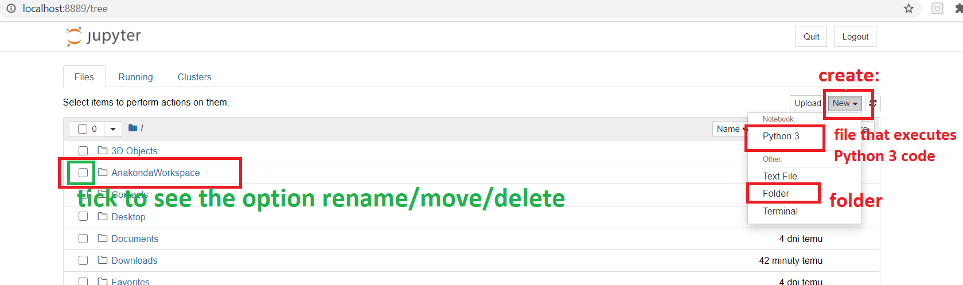

Jupyter uses inputs fields for writing a code. You can write each line or multiple lines of code in each input field. You can run/execute code in each input separately from other inputs. There is also option to run the whole script.

You can store values in variables. They are visible to the code in other input fields.

Most used options are visible above Jupyter file as icons: save, add new input field, cut input field, …, run, stop execution, restart kernel. Code is executed in Kernel (doesn’t matter what it is). Once the Kernel is restarted, all values cached in variables are gone.

Here is just a simple code to demonstrate, how Jupyter works:

-> write simple arithmetic code i.e. 1 + 1 into ‘In’ field (do not put semicolon at the end of expression as Python doesn’t use it). Run code. Output of the code is not assigned to any variable, so the output is given straight away.

-> assigned value to a variable. Run code. Data are cached.

-> insert just a name of variable to input field. When run it gives output. Do not need to use any method like System.out.println(a) to output data.

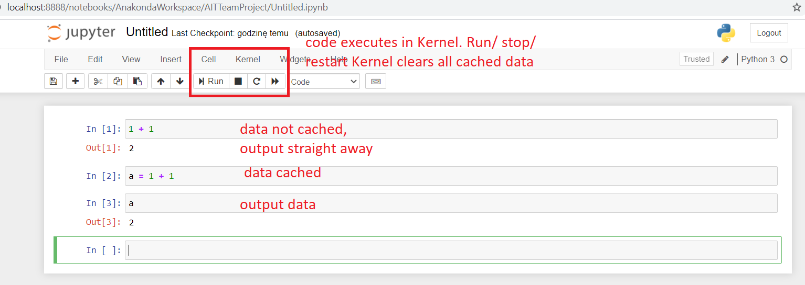

**CONDA – do not need it now**

Conda is the package manager that is installed with Anaconda: https://conda.io/en/latest/

To use Conda run the CMD.exe prompt from Anaconda. Or set up PATH environment to Conda if used with Windows command prompt.