Loan Prediction Using Support Vector Machine (SVM)

Submitted By: Priyanka Subhash Pawar
Submitted To: Naviotech Solution Pvt.Ltd
Date: March 2026

Abstract
This project focuses on predicting whether a loan application will be approved or not using a Machine Learning classification algorithm. The dataset contains applicant details such as Gender, Married status, Dependents, Education, Income, Loan Amount, and Property Area. A Support Vector Machine (SVM) model is implemented using Python and Scikit-learn. The model is trained and evaluated to measure prediction accuracy.

Introduction
Loan approval prediction is an important application of Machine Learning in the banking sector. Banks receive many loan applications and need to decide whether to approve or reject them. In this project, a Support Vector Machine (SVM) algorithm is used to classify loan applications based on applicant information.

Problem Statement
To develop a Machine Learning model that can accurately predict loan approval status (Approved / Not Approved) using applicant data.

Objectives
- To understand classification using SVM algorithm.
- To preprocess and clean dataset.
- To train and test the machine learning model.
- To evaluate model performance using accuracy score.

Dataset Description
The dataset includes the following features:
- Gender
- Married
- Dependents
- Education
- Self Employed
- Applicant Income
- Loan Amount
- Property Area
- Loan Status (Target Variable)

System Requirements
- Software Requirements:
Python
NumPy
Pandas
Seaborn
Scikit-learn

Methodology
- Import required libraries.
- Load dataset using Pandas.
- Handle missing values.
- Convert categorical values into numerical form.
- Split data into training and testing sets (90% training, 10% testing).
- Train SVM model.
- Evaluate model using accuracy score.

Model Used: Support Vector Machine (SVM)
Support Vector Machine (SVM) is a supervised learning algorithm used for classification problems. It separates data into different classes using a hyperplane. In this project, a linear kernel is used.

Training Process
The model is trained using training dataset and evaluated using testing dataset. Accuracy score is calculated using sklearn.metrics.accuracy_score function.

Results

Accuracy on Training Data: 0.7986 (79.86%)
Accuracy on Test Data: 0.8333 (83.33%)
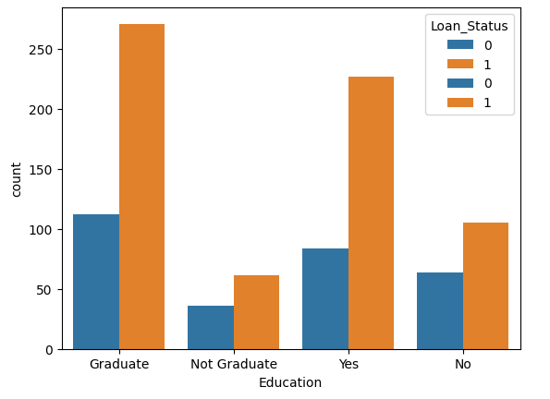

Applications
- Bank loan approval systems
- Financial risk analysis
- Credit scoring systems

Advantages
- Good performance on classification problems.
- Effective in high dimensional spaces.
- Simple and efficient implementation.

Limitations
- Accuracy depends on quality of dataset.
- Requires proper parameter tuning.
- May not perform well with very large datasets.

Future Scope
The project can be improved by using advanced algorithms such as Random Forest or Logistic Regression. The model can also be deployed as a web application for real-time prediction.

Conclusion
The Loan Prediction project successfully demonstrates the implementation of a Support Vector Machine for classification. The model achieved 79.86% training accuracy and 83.33% testing accuracy. This system can assist banks in making faster and more accurate loan approval decisions.

References
- Scikit-learn Documentation
- Python Documentation

