An Introduction to HPC and Scientific Computing

CWM, Department of Engineering Science

University of Oxford

Karel Adámek

**Practical 6: Introduction to the CUDA programming language**

This practical will review examples showed in the lecture. First example is ‘Hello world’ example which is then expanded to demonstrate scheduling of threads, warps and blocks on the GPU. Second example it kernel for vector addition, where importance of correct memory access is demonstrated. The practical ends by writing a code which calculates decimation of a series of integer numbers.

The learning outcomes of this practical are:

* To be become familiar with code structure when using GPUs.
* To know how to write kernel and configure them.
* To understand scheduling of thread, warp and block execution of GPUs.

All practical sessions for this course will be carried out on the Universities ARCUS-HTC computer. To understand how to use ARCUS-HTC see the introduction video and for more details watch the video demonstrations in lecture 3. As a reminder:

1. Connect to the university VPN (instructions can be found on canvas).
2. Open MobaXterm (Windows) or XQuartz (Mac) and open a ssh session.
3. Connect to “oscgate” by:
   1. Setting “*remote host*” to be oscgate.arc.ox.ac.uk
   2. Tick “*specify username*” and set it to teachingXY (where this is the username we have issued you with)
4. This will open a shell, from here you can connect to “arcus-htc” using ssh as follows:

ssh –CX [teachingXY@arcus-htc](mailto:teachingXY@arcus-htc.arc.ox.ac.uk)

Where teachingXY is the account that we have issued you with.

**Instructions for this practical**

1. If you have not done so clone the github repo for this CWM. To do this, at the command prompt type:

$ module load git

$ git clone <https://github.com/wesarmour/CWM-in-HPC-and-Scientific-Computing-2020.git>

If you have already cloned the repo, pull it again to ensure you are working with the most up-to-date codes:

$ module load git

$ git pull

1. Next you should navigate to the examples directory in the prac6 folder:

$ cd CWM-in-HPC-and-Scientific-Computing-2020/practicals/prac6/examples/

1. When logged into the Arcus-HTC head node, you will need to use the command

module load gpu/cuda

The first part of this practical is to review examples given on the lecture. These are in ‘code’ directory of this practical. These examples are

1. helloworld,
2. helloworld_scheduling,
3. vector_addition,
4. vector_addition_memory.

Please follow instructions contained in the code files themselves.

**Decimation**

Second part of the practical is to write a code which calculates decimation of a series of integer numbers.

Decimation is where we divide a series of numbers into distinct series of sets which contain two neighbouring numbers. These number are then added together to create a new series. The algorithm is shown in the figure 1.

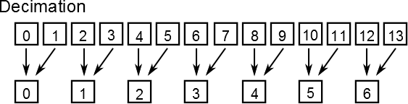

Figure 1: Decimation, two neighbouring numbers are added together to create new series of numbers.

For example if we have a series of numbers {1,2,5,7,3,8} the decimation will perform {1+2, 5+7, 3+8}

The code with description and specific tasks which needs to be completed are describe in the code itself.