**Functions**

A function is a named sequence of statements that take some inputs, perform some operations, and produce results. The operation of a function occurs when it is called. Rather than writing the same code for different inputs repeatedly, we can call a function instead of writing the same code over and over again.

**Function declaration**

int sum(int x);

**Function definition**

A function definition is consists function header and function body

return_type function_name (para1, parm2,…., parmN)

{

// body of the function

}

Example

int sum(int a, int b, int c)

{

return a + b + c;

}

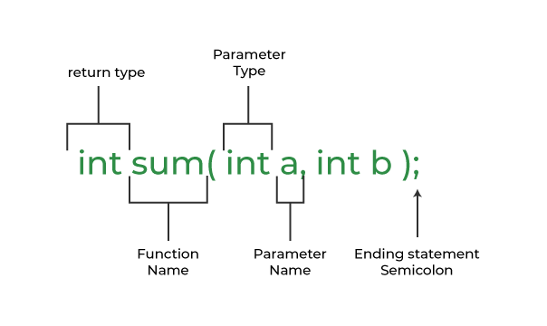

**Function call**

to use a function we need to call it and we call it like this sum(3, 4)

**Two types of function**

1. User defined function
2. Library functions (built-in function)

**Example of built-in functions (library functions)**

pow(x, y) calculates the value x to power y. #include <math.h>

printf() formats and prints characters to stdout #include <stdio.h>

scanf() reads data from stdin #include <stdio.h>

sqrt(x) calculates the square root of x #include <math.h>

**why we need functions**

* Makes the computation logically simple
* Makes the program text clearer (by name the computation)
* Makes it possible to use the function in more than one place in our program

The data-type and the type of the return value must match.