EMMC驱动学习

emmc 基础知识

emmc文件结构

Emmc 软件框架
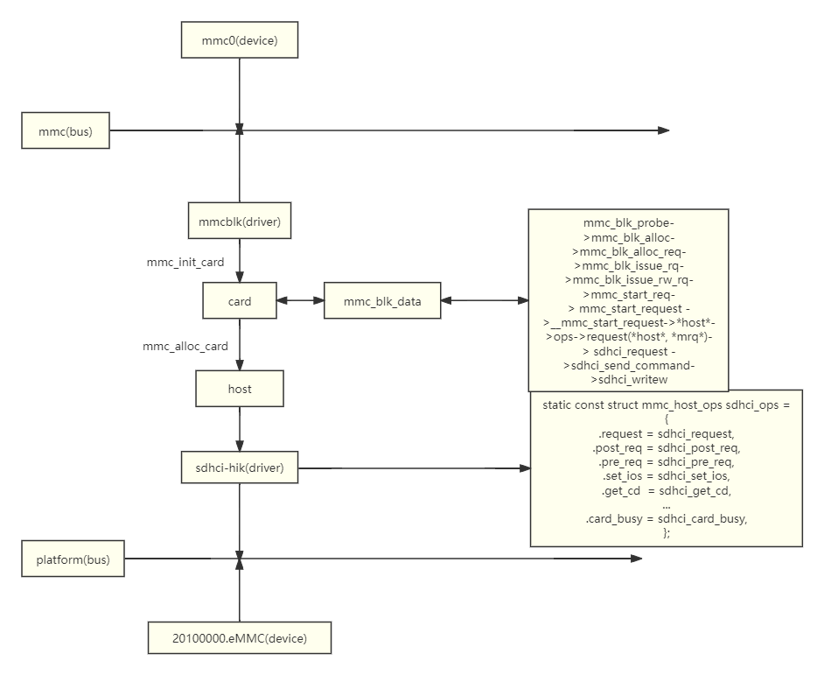

2.1 Core文件夹下的代码

2.1.1 core.c

static int __init mmc_init(void)
｛
ret = mmc_register_bus();
if (ret)
goto destroy_workqueue;
｝

2.1.2 bus.c
/*mmc 总线类型*/
static struct bus_type mmc_bus_type = {
.name = "mmc",
.dev_groups = mmc_dev_groups,
.match = mmc_bus_match,
.uevent = mmc_bus_uevent,
.probe = mmc_bus_probe,
.remove = mmc_bus_remove,
.shutdown = mmc_bus_shutdown,
.pm = &mmc_bus_pm_ops,
};
/*mmc 总线挂载的驱动和设备是不用校验名字直接匹配的*/
static int mmc_bus_match(struct device *dev, struct device_driver *drv)
{
return 1;
}

/*mmc 向系统中注册mmc总线*/
int mmc_register_bus(void)
{
return bus_register(&mmc_bus_type);
}

/*申请内存卡，并将卡绑定在对应的host上*/
struct mmc_card *mmc_alloc_card(struct mmc_host *host, struct device_type *type)
{
struct mmc_card *card;

card = kzalloc(sizeof(struct mmc_card), GFP_KERNEL);
if (!card)
return ERR_PTR(-ENOMEM);

card->host = host; //将card绑定在host上

device_initialize(&card->dev);

card->dev.parent = mmc_classdev(host);
card->dev.bus = &mmc_bus_type; //将card绑定在mmc总线上
card->dev.release = mmc_release_card;
card->dev.type = type;

return card;
}

/*mmc 向系统中注册mmc总线*/
int mmc_register_bus(void)
{
return bus_register(&mmc_bus_type);
}

mmc_add_card
mmc_remove_card

2.2 host文件夹下的代码
struct mmc_host *mmc_alloc_host(int extra, struct device *dev)

2.2.1 sdhci
sdhci_pltfm_init
->sdhci_alloc_host
->mmc_alloc_host
->mmc_rescan
->mmc_rescan_try_freq
->mmc_attach_mmc
->mmc_attach_bus
->mmc_ops

