AI-POWERED DATA ANALYSIS REPORT
The Role of Artificial Intelligence in NGOs and Social Impact Organizations

Prepared By:
Pawni Verma

AI Data Analytics Internship

Submitted To:
InAmigos Foundation

Date
29 June 2026

Prepared using Microsoft Excel, Microsoft Word, and AI-assisted Research Tools

1. Executive Summary:
This report explores the role of Artificial Intelligence in improving the efficiency of NGOs through research, fundraising, volunteer management, and decision-making. AI-generated insights were organized and analysed using Microsoft Excel, resulting in an interactive dashboard that highlights major application areas, benefits, and sector-wise adoption. The findings demonstrate how AI can help organizations improve productivity and maximize social impact.

2. Introduction:
Artificial Intelligence (AI) is transforming the way organizations operate across different sectors, including non-profit organizations (NGOs). Traditionally, NGOs have relied heavily on manual efforts for fundraising, volunteer coordination, report preparation, and research. With advancements in AI, many repetitive tasks can now be automated, allowing organizations to focus more on creating social impact.

This report explores how AI technologies are currently being used by NGOs and examines the major benefits, application areas, and future opportunities. The analysis is supported through research using AI-assisted tools and presented with an interactive Excel dashboard for better visualization.

3. Objectives:
The objectives of this report are:
✔ To understand how AI is transforming NGO operations.
✔ To identify major application areas of AI.
✔ To study the benefits of AI in social impact organizations.
✔ To analyze trends using Excel charts and dashboards.
✔ To understand how AI can improve decision-making and operational efficiency.

4. Research Methodology:
The research for this report was conducted using a combination of AI-powered research tools and publicly available information. The process included:
Selecting a relevant social-impact topic.
↓
Collecting information from trusted online sources.
↓
Using AI tools to summarize research findings.
↓
Organizing the collected information in Microsoft Excel.
↓
Creating charts and dashboard visualizations.
↓
Interpreting trends and preparing the final report.

5. Key Findings:
Area | Observation
Research | Most common AI application in NGOs
Content Creation | AI speeds up proposal and report writing
Fundraising | AI predicts donor behaviour
Volunteer Management | AI helps assign volunteers efficiently
Report Writing | Automated report generation saves time

6. Dashboard Analysis:
The dashboard below summarizes the research findings using visual charts and key performance indicators. It highlights AI applications in NGOs, sector-wise adoption, and the major benefits of AI implementation.

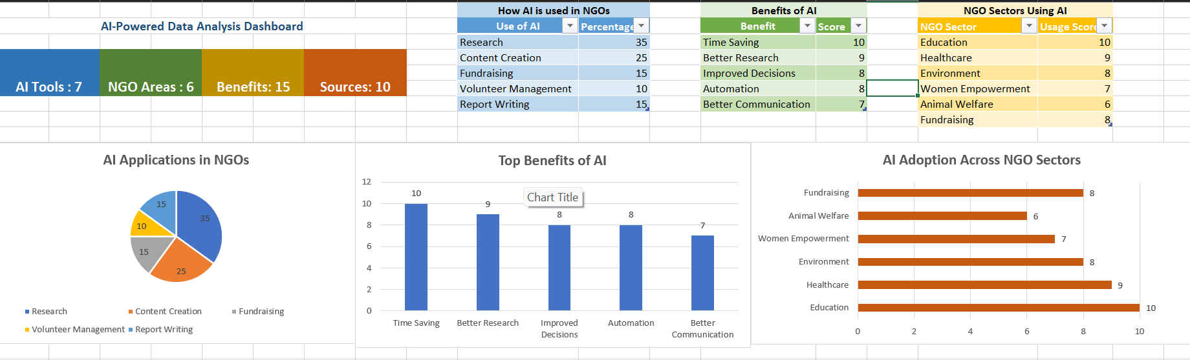

7. AI Tools Used:
Tool | Purpose
🤖 ChatGPT | Research
📊 Excel | Dashboard
📝 Word | Report
🔍 Google | Research
☁ Drive | Storage

8. Recommendations:
✔ Adopt AI for repetitive administrative tasks.
✔ Use dashboards to monitor NGO performance.
✔ Train volunteers in AI-assisted workflows.
✔ Ensure ethical and responsible AI implementation.

9. Conclusion:
Artificial Intelligence has become an important technology for modern NGOs by improving efficiency, reducing manual workload, and supporting better decision-making. The analysis conducted in this report demonstrates that AI can significantly enhance research, fundraising, communication, and volunteer management. With responsible implementation, AI has the potential to help NGOs maximize their social impact while optimizing available resources.

10. References:
OpenAI. ChatGPT. - https://chatgpt.com
Microsoft Learn. - https://learn.microsoft.com
UNICEF. - https://www.unicef.org
World Economic Forum. - https://www.weforum.org

