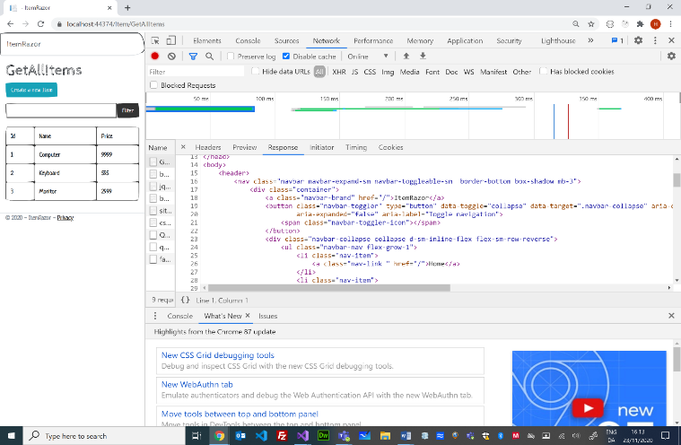

2

2

1

1

Registrering af Service

Injection af JsonFileItemService I ItemService

Injection af JsonFileItemService I ItemService

ItemServicel.cs

JsonFileItemServicel.cs

GetAllItems.cshtml.cs

Startup.cs

HTTP-Response

|  |  |  |
| --- | --- | --- |
| Protocol | Status-code | Phrase |
| HTTP/1.1 | 200 | OK |
| Body | | |
|  | | |

HTTP-Request

|  |  |  |
| --- | --- | --- |
| Method | URL | Protocol |
| GET | http://localhost:44374/Item/GetAllItems | HTTP/1.1 |

public class JsonFileItemService

    {

        public IWebHostEnvironment WebHostEnvironment { get;}

        public JsonFileItemService(IWebHostEnvironment webHostEnvironment)

        {

            WebHostEnvironment = webHostEnvironment;

        }

        private string JsonFileName

        {

            get { return Path.Combine(WebHostEnvironment.WebRootPath, "Data", "Items.json"); }

        }

        public IEnumerable<Item> **GetJsonItems()**

        {

            using (var jsonFileReader = File.OpenText(JsonFileName))

            {

                return JsonSerializer.Deserialize<Item[]>(jsonFileReader.ReadToEnd());

            }

        }

Razor Pages Arcitecture (Service – Dependency Injection)

C/ Henrik Høltzer – Zealand 23.11.2020

  public void ConfigureServices(IServiceCollection services)

        {

            services.AddRazorPages();

            services.AddSingleton<ItemService, ItemService>();

            services.AddTransient<JsonFileItemService>();

        }

public class ItemService

    {

        private List<Item> items;

        private JsonFileItemService JsonFileItemService { get; set; }

        public ItemService(**JsonFileItemService jsonFileItemService**)

        {

            JsonFileItemService = jsonFileItemService;

            items = JsonFileItemService.**GetJsonItems().**ToList();

        }

        public IEnumerable<Item> **GetItems()**

        {

            return items;

        }

 public class GetAllItemsModel : PageModel

    {

        private ItemService itemService;

        public List<Models.Item> Items { get; private set; }

        public GetAllItemsModel(**ItemService itemService**)   
        {

            this.itemService=itemService;

        }

      public IActionResult **OnGet()**

        {

            Items = itemService.GetItems().ToList();

            return Page();

        }

Items

GetAllItems.cshtml

Item.cs

ItemService.cs

JsonFileItemService.cs

GetAllItems.cshtml.cs

Controller

Items

ViewModel

**OnGet(){…}**

**DI**

**DI**

Item.json

Data

Services

AddItems(…)

**GetItems(…)**

Service

SaveJsonItems(…)

**GetJsonItems(…)**

Service

Models

Model

Router

Middelware

ViewEngine

Kestrel (IIS-Web Server)

Dispatcher

Razor Pages

View

PageModel

**HTML + C#**

**HTML**